**ENGINEERING CLINICS**

**REPORT**

**E-COMMERCE MARKET SPEND OPTIMIZATION**

**INTRODUCTION:**

E-commerce platforms such as Amazon, eBay run hundreds of millions of auctions to sell advertising opportunities. Online advertising plays a crucial role in connecting advertisers and audiences , and generates tremendous value for E-commerce platforms. There are different types of online advertising which includes performance-based advertising, branding guaranteed advertising. We focus on the performance-based advertising in the paper. In this marketplace, advertisers can specify the maximum daily amount they are willing to pay and get the audience through various pages in E-commerce platform. The objectives of performance-based advertisers are usually to spend out the budget to maximize the performance goals (e.g., clicks, conversions as many as possible). Meanwhile, the ad serving system is optimizing revenue on behalf of the platform.

One of the central issues for the ad serving system of E-commerce platform is matching ads to requests with these objectives above, which can be formulated as a constrained optimization problem. There are many challenges to achieve all the objectives simultaneously in a complex competition environment. Each individual campaign has its own budget and performance goal, and there are hundreds of thousands of campaigns which compete with each other to acquire inventory in the marketplace. These varieties make the optimization extremely difficult. In this paper, we present our work on optimal delivery in E-commerce platform, which can be formulated as a constrained optimization problem that maximizes specified goals and subjects to budget constraints.

## **CONCEPTUAL STUDY OF THE PROJECT:**

Generating accurate and reliable sales forecasts is crucial in the E-commerce business nowadays. E-commerce platform contains large number of related products, in which sales demand patterns in different advertising platforms can be correlated.

Accurate forecast of demand of a particular product in various marketing platforms can lead to huge savings in market spend and increased reach product marketing ,thereby increasing business profit. Optimization of Budget Allocation for marketing a specific product between different platforms of advertisement is based on category, product name, interest, impression ,clicks in social media.

**OBJECTIVES OF THE SOLUTION :**

The project mainly aims to

* Optimise allocation of budget for marketing a business product in various top social media marketing platforms.
* It divides the total budget allocated for Marketing a product between the various chosen social medias, based on the previous dataset ,which contains views of a category or product in multiple social medias over a period of time.

**SCOPE OF THE PROJECT:**

Minimize the budget spent on various social media platforms to promote their products

**EXISTING SOLUTION:**

* Know what drives ROI
* Present marketing as an investment
* Use your sales funnel to apply your budget
* Use data to prove what works in marketing
* Start small and get granular
* Be flexible with your marketing budget
* Comparing advertising to Sales Percentage

**LITERATURE REVIEW:**

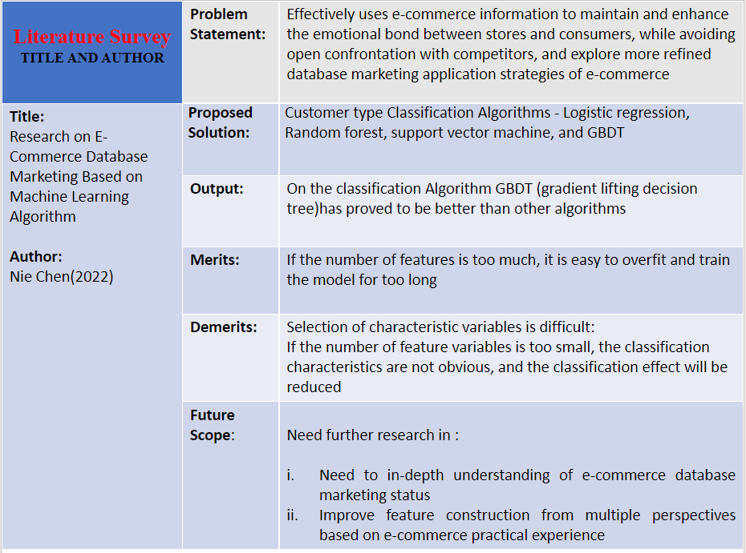

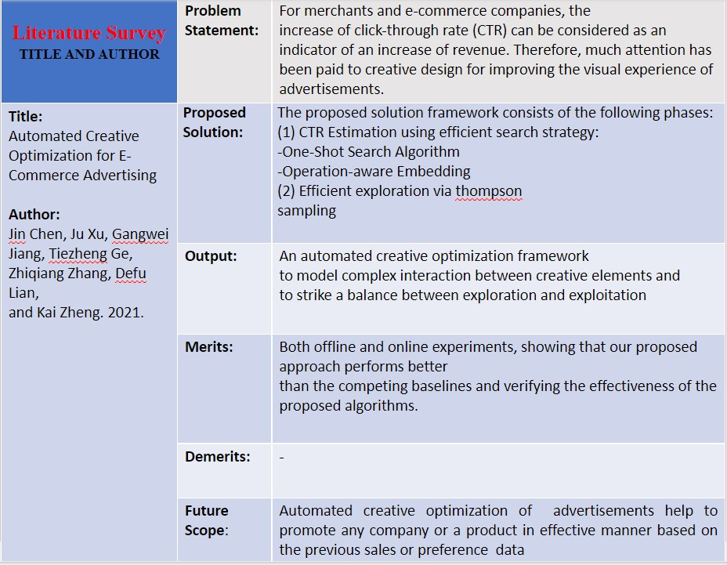

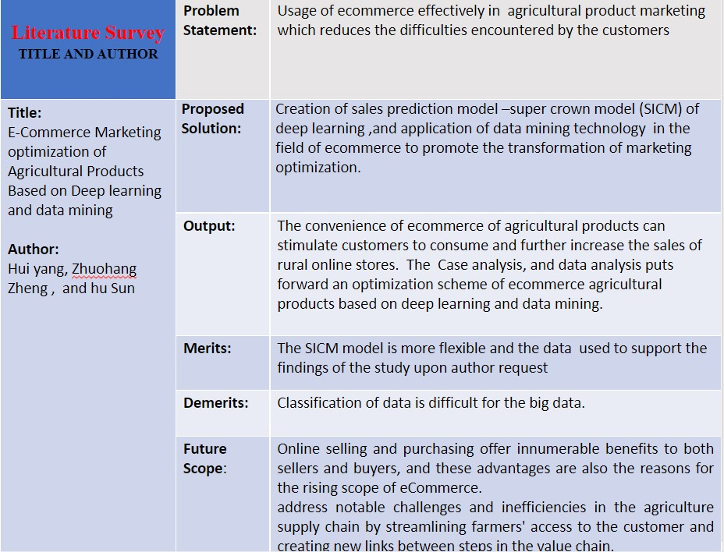

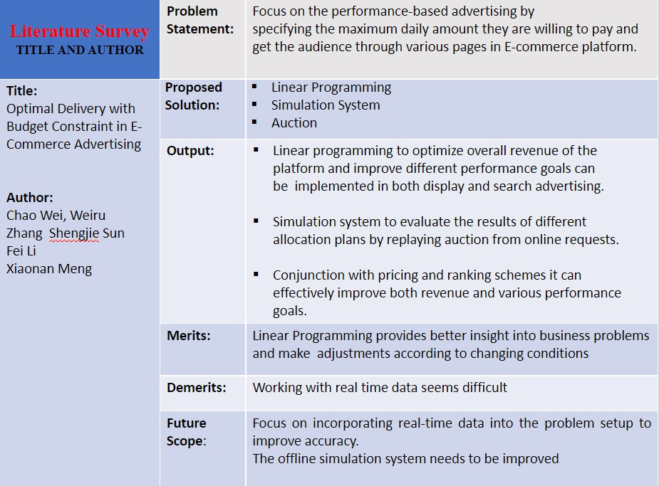

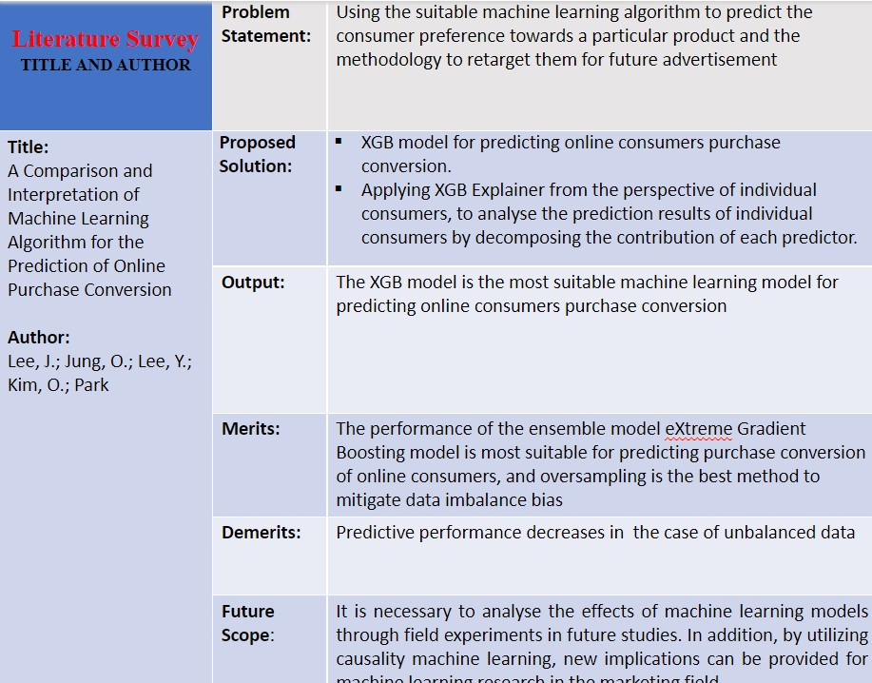

**PROBLEM DEFINITION:**

Generating accurate and reliable sales forecasts is crucial in the E-commerce business nowadays. E-commerce platform contains large number of related products, in which sales demand patterns in different advertising platforms can be correlated. Optimization of Budget Allocation for marketing between different platforms of advertisement based on CPC(cost per click), YTD(year to date), indeed the previous dataset.

Accurate forecast can lead to huge savings and cost reduction thereby increasing business profit

# **PROPOSED SYSTEM :**

In this paper we have developed models based on several algorithms, which is used to optimize budget for marketing a specific product in various marketing platforms. For instance, if a burger company decides to advertise its product in social media platforms,

**BLOCK DIAGRAM:**

.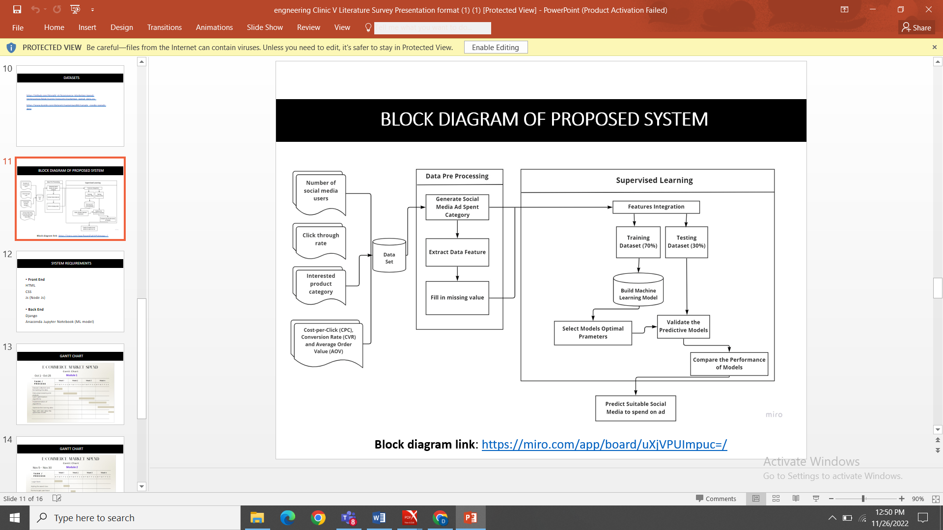

**MODULES:**

**Module 1:**

1.Dataset Collection and Formatting of Data

2.Data preprocessing

3.Data Analysis

**Module 2:**

4. Learn Optimization algorithms

5.Developing Machine Learning models by Implementation of Algorithms

6.Analyse the accuracy rate of algorithms

7.Optimise the training data

8.Test with test Data with the Optimised model

**IMPLEMENTATION**:

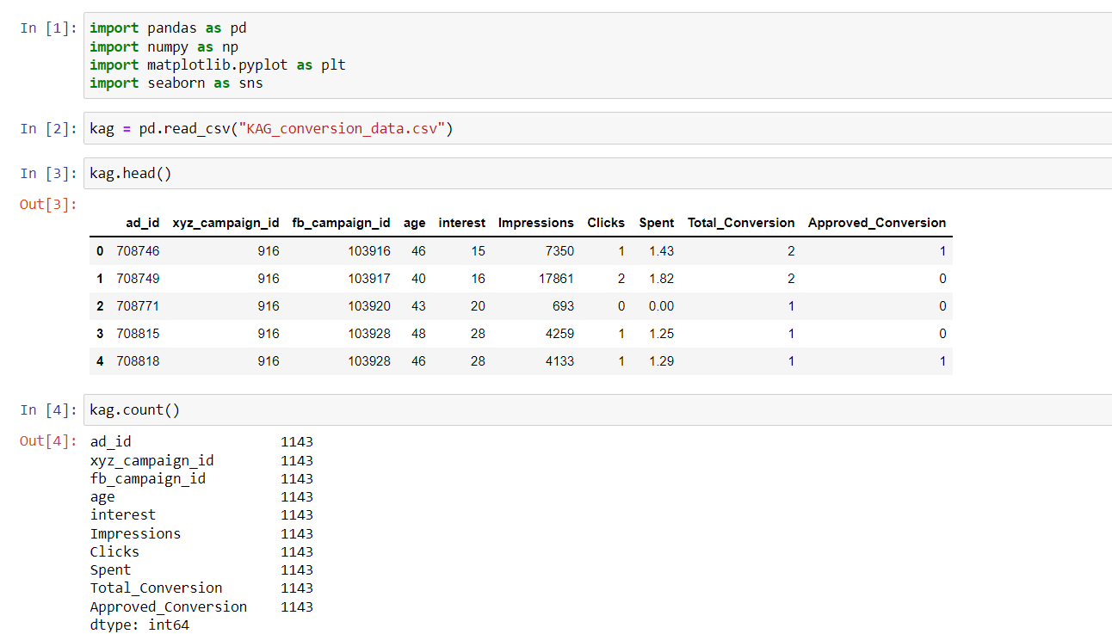

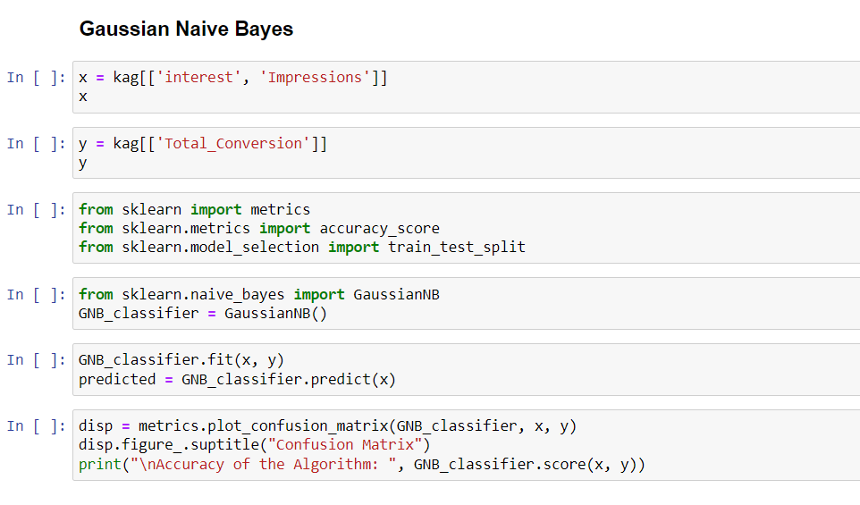

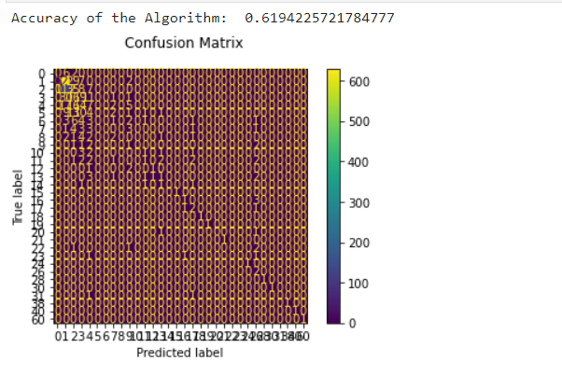

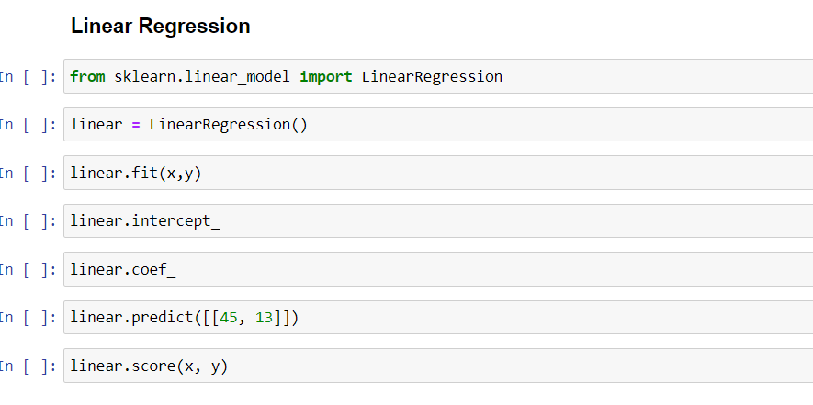

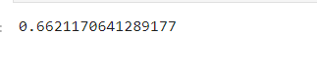

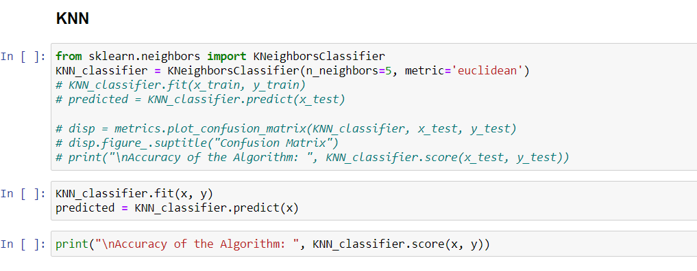



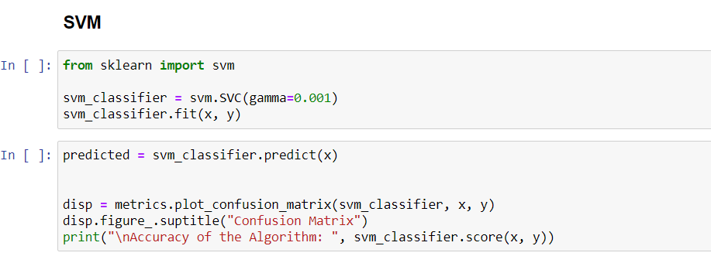

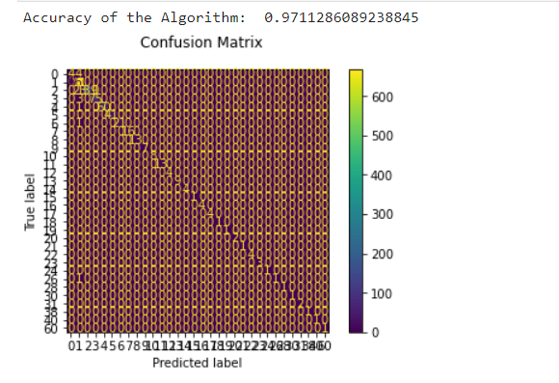

**REFERENCES:**

Chen, N., 2022. Research on E-Commerce Database Marketing Based on Machine Learning Algorithm. *Computational Intelligence and Neuroscience*, *2022*

Yang, H., Zheng, Z. and Sun, C., 2022. E-Commerce Marketing Optimization of Agricultural Products Based on Deep Learning and Data Mining. *Computational Intelligence and Neuroscience*, *2022*.

Wei, C., Zhang, W., Sun, S., Li, F., Meng, X., Hu, Y., Lee, K.C. and Wang, H., 2019, October. Optimal Delivery with Budget Constraint in E-Commerce Advertising. In *2nd Workshop on Online Recommender Systems and User Modeling* (pp. 46-58). PMLR.

Lee, J., Jung, O., Lee, Y., Kim, O. and Park, C., 2021. A Comparison and Interpretation of Machine Learning Algorithm for the Prediction of Online Purchase Conversion. *Journal of Theoretical and Applied Electronic Commerce Research*, *16*(5), pp.1472-1491.