Tire Research & Recommendation
2024 Winnebago Solis 59P
Ram ProMaster chassis • Stock wheels • LT225/75R16
Research date: September 1, 2026

1. Mission and Priorities
The Solis will spend substantially more time on highways and wet pavement than on forest roads. The goal is a highway-friendly all-terrain tire with excellent wet-weather confidence, stability, comfort, noise and reasonable fuel economy, while providing a meaningful improvement on gravel and forest roads.
Priority | Weight
Highway handling & stability | 25%
Wet pavement | 20%
Road noise & ride comfort | 15%
Fuel economy / rolling resistance | 15%
Gravel & forest roads | 15%
Snow / ice | 5%
Sidewall / rough-road durability | 5%

2. Vehicle and Fitment
Winnebago lists the 2024 Solis 59P at 8,900 lb GVWR, with a 4,629 lb front GAWR and 5,291 lb rear GAWR. It has a 159-inch wheelbase. The current vehicle is already using LT225/75R16 tires, so this study keeps the stock tire size and stock wheels rather than introducing clearance, gearing or offset variables.
Final fitment should always be checked against the tire placard on the actual van and the actual axle weights. Maximum tire load is not a substitute for the manufacturer's inflation requirements.

3. Shortlist
• Falken Wildpeak A/T4W — leading candidate
• General Grabber APT — highway-oriented A/T
• Yokohama Geolandar A/T G015 — road-friendly A/T
• BFGoodrich All-Terrain T/A KO3 — more rugged/off-road-biased
• Toyo Open Country A/T III — strong on/off-road compromise

4. Tire Photo Gallery
The photos are representative product images for visual comparison. Appearance can vary by size and sidewall treatment; they are not fitment evidence.
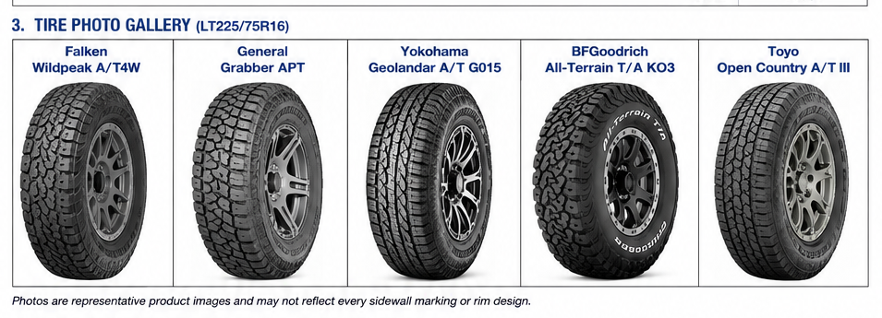
Embedded representative product images — appearance may vary by size/sidewall treatment.

4. Comparison
Tire | Highway / Wet | Noise / Comfort | Fuel Economy | Gravel / Forest | Verdict
Falken Wildpeak A/T4W | Excellent | Very good | Good | Excellent | ★★★★★ Best overall
General Grabber APT | Excellent | Excellent | Very good | Good–very good | ★★★★½ Highway-biased
Yokohama G015 | Excellent | Excellent | Very good | Good–very good | ★★★★½ Road-friendly
BFG KO3 | Excellent | Very good | Good | Excellent+ | ★★★★ Toughest
Toyo Open Country A/T III | Very good–excellent | Very good | Good | Excellent | ★★★★ Strong alternative
Ratings are comparative judgments for this use case, not laboratory measurements. Manufacturer specifications, independent testing/consumer data and owner reviews are treated as different evidence types.

5. Falken Wildpeak A/T4W
Current leading choice. Tire Rack's LT225/75R16 information shows strong dry and wet traction and high comfort scores. Owner feedback frequently describes the A/T4W as quiet, comfortable and predictable for an A/T tire. A recent review reported good pavement performance in variable conditions after 15,000 miles. These reviews are not Solis-specific and should be treated as supporting evidence. For this Solis, it offers the best balance of highway civility and useful gravel/forest-road capability.

6. General Grabber APT
The strongest highway-biased alternative. General describes it as an on-road all-terrain tire and emphasizes quiet operation, cut/chip resistance and even wear. Tire Rack's current survey shows strong wet and dry scores and high comfort/treadwear scores. A verified owner review reported very good rain and snow handling with minimal noise. Trade-off: it is less aggressive off pavement than the Falken or KO3.

7. Yokohama Geolandar A/T G015
A road-friendly A/T worth keeping in the final round. Its appeal is civilized highway behavior with useful gravel/light off-road capability. It deserves special attention if noise, comfort and wet-weather manners ultimately outweigh maximum rough-road durability.

8. BFGoodrich KO3
The KO3 is the most compelling choice if the mission shifts toward tougher terrain. Tire Rack owner feedback includes strong wet traction and good comfort/noise reports. It is more off-road-oriented than necessary for the stated highway-first mission, so it is not currently the first choice.

9. Toyo Open Country A/T III
Toyo positions the A/T III as an on-/off-road tire with responsive on-road handling, wet performance, durability and a quiet ride. It remains a credible alternative, but the newer Falken A/T4W currently appears to be the better match for this Solis.

10. Noise and Fuel Economy
Moving from a conventional highway/commercial tire to an A/T can increase noise and rolling resistance. The A/T4W is notable because owner feedback frequently describes it as quiet for an A/T. MPG results are inconsistent: some owners report little change while others report a small penalty. No exact MPG loss should be promised.
Staying with LT225/75R16 is preferred. Larger/wider tires would add weight, rolling resistance and possible clearance variables without being necessary for the stated mission.

11. Costco
As checked September 1, 2026, Costco's public tire results showed LT225/75R16/E products including Firestone Transforce HT3 and Bridgestone Blizzak LT. I did not find the Falken A/T4W, General APT, Yokohama G015, BFG KO3 or Toyo A/T III in Costco's public search results for this exact size. Costco notes that availability changes and recommends checking with a local Tire Center when a tire is not shown online.
Costco says its installation package includes rotation, balancing, nitrogen inflation and warranty coverage for mileage, road hazard and manufacturer's defects. Availability and pricing should be rechecked immediately before purchase.

12. Current Recommendation
1. Falken Wildpeak A/T4W — BUYER'S LEADING CHOICE
Best balance of highway handling, wet-road confidence, comfort/noise and enough capability for gravel and forest roads.
2. General Grabber APT — BEST HIGHWAY-BIASED ALTERNATIVE
Especially attractive if highway civility becomes more important than off-pavement capability.
3. Yokohama G015 — ROAD-FRIENDLY ALTERNATIVE
Keep in the final round for its road manners and wet-weather reputation.
Before purchase, verify the exact load/speed designation, tire-placard requirements, stock-wheel fitment and delivered installed price.

Appendix A — Sources
Winnebago — 2024 Solis specifications
https://www.winnebago.com/models/product/specifications/motorhomes/camper-van/2024-solis
Winnebago — 2024 Solis brochure
https://www.winnebago.com/Files/Images/Winnebago/brochures/2024/Solis-Brochure-August-24.pdf
General Tire — Grabber APT specifications
https://generaltire.com/tires/light-trucksuv/grabber-apt/specs
Tire Rack — General Grabber APT LT225/75R16 reviews
https://www.tirerack.com/tires/tires.jsp?partnum=275R6GRAPT&tireMake=General&tireModel=Grabber+APT
Tire Rack — Falken WildPeak A/T4W LT225/75R16 reviews
https://www.tirerack.com/tires/tires.jsp?autoMake=RAM&autoModClar=LT225%2F75-16+Light+Truck&autoModel=ProMaster+1500&autoYear=2022&partnum=275SR6WPAT4W
Tire Rack — BFGoodrich KO3 LT225/75R16 reviews
https://www.tirerack.com/tires/tires.jsp?partnum=275SR6KO3RWL&tireMake=BFGoodrich&tireModel=All-Terrain+T%2FA+KO3
Toyo Tires — Open Country A/T III
https://www.toyotires.com/product/open-country-at3/
Costco Tires — tire shopping and installation
https://tires.costco.com/
Costco — Firestone Transforce HT3 LT225/75R16/E result
https://tires.costco.com/SearchResultsByItemOrPart?ItemNo=1889577

Appendix B — Review Evidence Notes
Owner reviews vary with vehicle weight, tire pressure, alignment, climate, road surface and driving style. Reviews from pickups/SUVs are therefore used only to identify recurring tire characteristics, not to predict exact Solis MPG, stopping distance or noise.
The most valuable next evidence would be additional reviews from ProMaster/Solis camper owners using the exact LT225/75R16 size. Those can be added before the final purchase decision.

Appendix C — Tire Photo Sources (reference links)
1. Falken Wildpeak A/T4W — Discount Tire product image
https://cdn.discounttire.com/sys-master/images/h2e/hb3/11081183395870/tire_falken-wildpeak-a-t4w_bsw_front_Medium.jpg
2. General Grabber APT — OK4WD product image
https://cdn11.bigcommerce.com/s-gf7vfbmiio/images/stencil/500x659/products/61492/618691/Grabber_APT_Lt3Q__59990.1723560331.png?c=1
3. Yokohama Geolandar A/T G015 — MonotaRO product image
https://media.monotaro.id/mid01/big/Otomotif%2C%20Truk%20%26%20Sepeda%20Motor/Ban%2C%20Bagian%20Kaki%20Mobil/Ban/Tires%20for%20Forklift%20Trucks%20%26%20Construction%20Machinery/YOKOHAMA%20Ban%20Mobil%20GEOLANDAR%20A%2FT-G016/P102253339-1.jpg
4. BFGoodrich All-Terrain T/A KO3 — TFS Wheels product image
https://tfswheels.com/cdn/shop/files/bfgoodrich-all-terrain-t-a-ko3-lt285-55r20_3_048b2cca-dd3a-4c34-ac92-2c92bfea7d93.jpg?v=1773943744&width=1200
5. Toyo Open Country A/T III — RideStyler product image
https://api.ridestyler.net/tire/image?Height=550&Key=3764acce-4d8c-42cb-bca0-bae367430492&PositionX=1&PositionY=1&TireFitmentResourceType=2&TireModel=b2f3203b-e07d-42aa-acd0-120ff4287497&Width=550

