Below are list of problems that we are facing with current implementation of PDF-renderer APIs:

1) Certain PDFs show up in contras color, where background color is black and font color is white. But actual pdf has black fonts and white background.

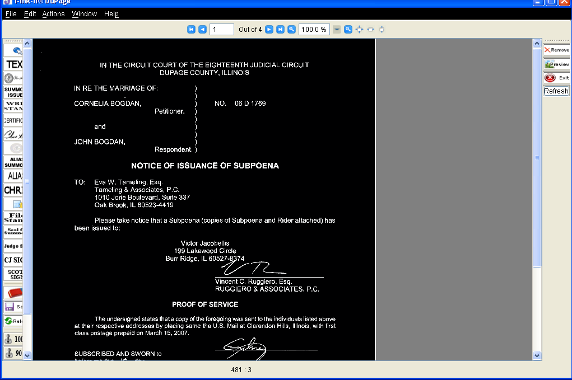

2) In some PC, first page is not loading properly; this is issue with APIs demo as well, user either has to interact with page or try to scroll up and down, doing so user can see actual page rendering fine.

