worksheet 34: BuildHeap and Heap Sort Name:

Worksheet 34: BuildHeap and Heap Sort
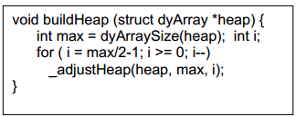
In preparation: If you have not done so already, you should complete Worksheet 33 to learn more about the heap data structure.
In some applications it is useful to initialize a Heap with an existing vector of values. The values are not assumed to be organized into a heap, and so a routine named buildHeap is invoked for this purpose.
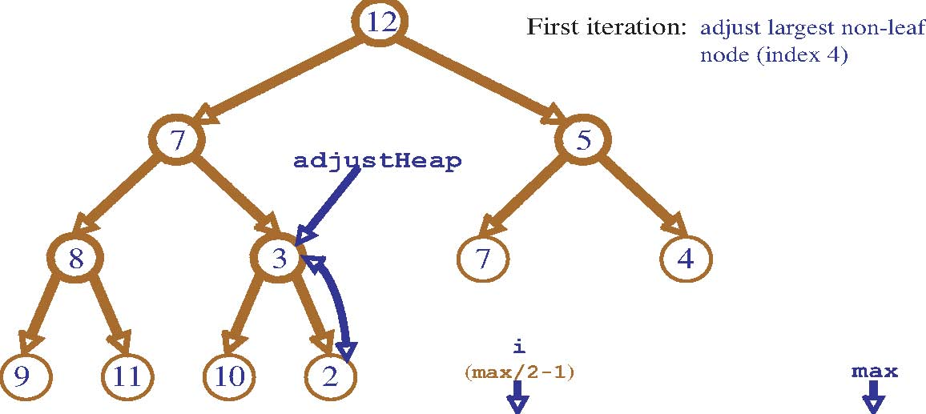
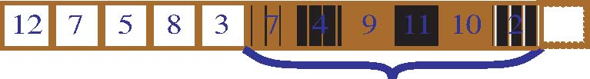

All values indexed after max/2 are leaves, and are therefore already a heap. The first value that could potentially not be a heap is found at max/2. Walking backwards from this value until the root is reached eventually makes all nodes into a heap.
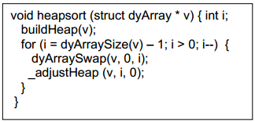
The heap data structure provides an elegant technique for sorting a vector. First form the vector into a heap. To sort the vector, the top of the heap (the smallest element) is swapped with the last element, and the size of the heap is reduced by 1 and readjusted. Repeat until all elements have been processed.
worksheet 34: BuildHeap and Heap Sort Name:
Simulate execution of the Heap sort algorithm on the following values:
9 3 2 4 5 7 8 6 1 0
First make the values into a heap (the graphical representation is probably easier to work with than the vector form). Then repeatedly remove the smallest value, and rebuild the heap.
9
1
6
0
3
8
4
2
7
5
9
1
6
0
3
8
4
2
7
5
9
1
6
0
3
8
4
2
7
5
9
4
6
5
3
8
1
2
7
0
9
1
6
5
3
8
4
2
7
0
9
1
6
0
3
8
4
2
7
5
9
1
6
0
3
8
4
2
7
5
9
1
6
0
3
8
4
2
7
5
9
1
6
0
3
8
4
2
7
5
9
1
6
0
3
8
4
2
7
5
9
1
6
0
3
8
4
2
7
5
9
1
6
0
3
8
4
2
7
5
9
4
6
5
3
8
1
2
7
0
9
1
6
0
3
8
4
2
7
5
9
1
6
0
3
8
4
2
7
5
9
1
6
0
3
8
4
2
7
5
9
4
6
5
3
8
1
2
7
0
9
1
6
0
3
8
4
2
7
5
9
1
6
0
3
8
4
2
7
5
9
1
6
0
3
8
4
2
7
5
9
4
6
5
0
8
1
2
7
3
9
1
6
0
3
8
4
2
7
5
9
1
6
0
3
8
4
2
7
5
9
1
6
0
3
8
4
2
7
5
9
4
6
5
3
8
1
2
7
0
9
1
6
0
3
8
4
2
7
5
9
1
6
0
3
8
4
2
7
5
9
1
6
0
3
8
4
2
7
5
9
4
6
5
0
8
1
2
7
3
9
1
6
0
3
8
4
2
7
5
9
1
6
0
3
8
4
2
7
5
9
1
6
0
3
8
4
2
7
5
9
4
6
5
3
8
1
2
7
0
9
1
6
0
3
8
4
2
7
5
9
1
6
0
3
8
4
2
7
5
9
1
6
0
3
8
4
2
7
5
9
4
6
5
0
8
1
2
7
3
9
1
6
0
3
8
4
2
7
5
9
1
6
0
3
8
4
2
7
5
9
1
6
0
3
8
4
2
7
5
9
4
6
5
3
8
1
2
7
0
9
1
6
0
3
8
4
2
7
5
9
1
6
0
3
8
4
2
7
5
9
1
6
0
3
8
4
2
7
5
0
9
6
5
1
8
4
2
7
3

