Clinton Hawkes

[hawkesc@oregonstate.edu](mailto:hawkesc@oregonstate.edu)

CS475-400

Project #3

1. I chose to implement seasonal fires for my own-choice quantity. My quantity, represented as a percent for the chance of fires, is dependent upon temperature and precipitation. The higher the temperature and the lower the amount of precipitation, the greater the chance of fires that will burn the grain and kill off the deer. Every iteration calculates the chance of fire, and if the chance is above 0%, the grain height is burned by that value. So, if the chance of fires is 20%, grain height is reduced by 20%.

Deer are also affected by the FireOdds quantity. If the FireOdds is above 0%, the deer will die twice as fast. This means if the height of the grain is less than the number of deer, the deer will decrease by 2 each iteration until the height of the grain becomes greater than the number of deer or the number of deer equals 0.

I calculated FireOdds using the following code:

float tempFire = 1;

float tempHeat = NowTemp - 15.;

float tempRain = 28. - NowPrecip;

if((tempHeat + tempRain) > 0) {

tempFire -= SQR((tempHeat + tempRain)) / 2000.;

The value of tempFire is the number to multiply NowHeight by to get the height after the fire. The actual odds of a fire can be found using (1 – tempFire).

1. Below are all the values generated by my program. There is also a table below each graph showing this information with the axis values swapped. (I added NowYear just to make finding the beginning/end of each year easier)

|  |  |  |  |  |  |  |
| --- | --- | --- | --- | --- | --- | --- |
| NowYear | NowMonth | NowNumDeer | NowHeight | NowPrecip | NowTemp | FireOdds |
| 2020 | 0 | 1 | 8.064 | 24.768 | -0.727 | 0 |
| 2020 | 1 | 2 | 22.408 | 31.267 | 7.22 | 0 |
| 2020 | 2 | 3 | 27.165 | 29.565 | 9.464 | 0 |
| 2020 | 3 | 4 | 19.545 | 32.362 | 23.518 | 0.9 |
| 2020 | 4 | 5 | 9.305 | 32.879 | 22.075 | 0.2 |
| 2020 | 5 | 6 | 0 | 25.367 | 22.548 | 5.2 |
| 2020 | 6 | 4 | 0 | 12.194 | 24.505 | 32 |
| 2020 | 7 | 2 | 0 | 6.433 | 26.718 | 55.4 |
| 2020 | 8 | 0 | 0 | 3.233 | 19.101 | 41.7 |
| 2020 | 9 | 0 | 0.17 | 7.031 | 15.332 | 22.7 |
| 2020 | 10 | 1 | 3.305 | 3.495 | 9.925 | 18.9 |
| 2020 | 11 | 2 | 10.983 | 15.827 | 8.129 | 1.4 |
| 2021 | 12 | 3 | 19.141 | 19.258 | 0.646 | 0 |
| 2021 | 13 | 4 | 33.116 | 27.886 | 3.236 | 0 |
| 2021 | 14 | 5 | 30.533 | 32.907 | 10.047 | 0 |
| 2021 | 15 | 6 | 17.853 | 37.096 | 18.957 | 0 |
| 2021 | 16 | 7 | 2.615 | 23.971 | 21.395 | 5.4 |
| 2021 | 17 | 5 | 0 | 17.061 | 30.707 | 35.5 |
| 2021 | 18 | 3 | 0 | 13.812 | 29.781 | 42 |
| 2021 | 19 | 1 | 0 | 2.553 | 27.952 | 73.7 |
| 2021 | 20 | 0 | 0 | 6.355 | 18.293 | 31.1 |
| NowYear | NowMonth | NowNumDeer | NowHeight | NowPrecip | NowTemp | FireOdds |
| 2021 | 21 | 0 | 3.691 | 0 | 8.175 | 22.4 |
| 2021 | 22 | 1 | 11.865 | 6.672 | 2.407 | 3.8 |
| 2021 | 23 | 2 | 27.816 | 17.138 | 5.666 | 0.1 |
| 2022 | 24 | 3 | 37.588 | 25.372 | 0.809 | 0 |
| 2022 | 25 | 4 | 45.544 | 27.995 | 7.839 | 0 |
| 2022 | 26 | 5 | 37.628 | 33.895 | 12.702 | 0 |
| 2022 | 27 | 6 | 24.936 | 35.601 | 20.01 | 0 |
| 2022 | 28 | 7 | 9.76 | 24.293 | 17.907 | 2.2 |
| 2022 | 29 | 8 | 0 | 22.465 | 25.208 | 12.4 |
| 2022 | 30 | 6 | 0 | 11.339 | 30.38 | 51.3 |
| 2022 | 31 | 4 | 0 | 3.369 | 19.604 | 42.7 |
| 2022 | 32 | 2 | 0 | 1.874 | 14.031 | 31.6 |
| 2022 | 33 | 0 | 1.027 | 0 | 7.195 | 20.4 |
| 2022 | 34 | 1 | 3.999 | 11.464 | 11.118 | 8 |
| 2022 | 35 | 2 | 14.51 | 12.462 | 6.982 | 2.8 |
| 2023 | 36 | 3 | 23.152 | 26.238 | 8.218 | 0 |
| 2023 | 37 | 4 | 37.243 | 28.88 | 3.438 | 0 |
| 2023 | 38 | 5 | 37.327 | 37.571 | 8.65 | 0 |
| 2023 | 39 | 6 | 24.628 | 29.493 | 22.979 | 2.1 |
| 2023 | 40 | 7 | 9.19 | 28.835 | 27.745 | 7.1 |
| 2023 | 41 | 8 | 0 | 21.99 | 27.887 | 17.9 |
| 2023 | 42 | 6 | 0 | 16.252 | 30.376 | 36.8 |
| 2023 | 43 | 4 | 0 | 5.999 | 19.029 | 33.9 |
| 2023 | 44 | 2 | 0 | 6.156 | 19.687 | 35.2 |
| 2023 | 45 | 0 | 0 | 0.143 | 9.063 | 24 |
| 2023 | 46 | 0 | 11.728 | 9.759 | 5.089 | 3.5 |
| 2023 | 47 | 1 | 23.102 | 14.111 | 8.088 | 2.4 |
| 2024 | 48 | 2 | 35.49 | 23.393 | 7.788 | 0 |
| 2024 | 49 | 3 | 45.236 | 26.074 | 8.097 | 0 |
| 2024 | 50 | 4 | 37.721 | 30.841 | 17.275 | 0 |
| 2024 | 51 | 5 | 27.874 | 35.451 | 15.742 | 0 |
| 2024 | 52 | 6 | 15.174 | 28.773 | 26.123 | 5.4 |
| 2024 | 53 | 7 | 0 | 22.844 | 24.708 | 11 |
| 2024 | 54 | 5 | 0 | 14.936 | 29.385 | 37.7 |
| 2024 | 55 | 3 | 0 | 10.56 | 19.142 | 23.3 |
| 2024 | 56 | 1 | 0 | 4.436 | 19.524 | 39.4 |
| 2024 | 57 | 0 | 0 | 1.461 | 14.185 | 33.1 |
| 2024 | 58 | 0 | 6.444 | 1.998 | 5.136 | 13 |
| 2024 | 59 | 1 | 14.122 | 15.148 | 9.042 | 2.4 |
| 2025 | 60 | 2 | 24.306 | 20.909 | 0.48 | 0 |
| 2025 | 61 | 3 | 41.216 | 27.915 | 5.391 | 0 |
| 2025 | 62 | 4 | 40.117 | 32.669 | 10.46 | 0 |
| 2025 | 63 | 5 | 29.989 | 28.713 | 18.688 | 0.4 |
| 2025 | 64 | 6 | 17.212 | 31.127 | 27.212 | 4.1 |
| 2025 | 65 | 7 | 1.891 | 22.85 | 28.964 | 18.3 |
| 2025 | 66 | 5 | 0 | 18.82 | 24.663 | 17.8 |
| 2025 | 67 | 3 | 0 | 4.284 | 18.307 | 36.5 |
| 2025 | 68 | 1 | 0 | 0.985 | 15.239 | 37.1 |
| 2025 | 69 | 0 | 0 | 0 | 12.098 | 31.5 |
| 2025 | 70 | 0 | 5.785 | 6.711 | 8.19 | 10.5 |
| 2025 | 71 | 1 | 12.505 | 14.177 | -0.623 | 0 |

1. This first graph shows my simulation without including FireOdds variable information. The FireOdds was included in the calculation of everything, it’s just not plotted on the graph. The graphs get a little difficult to read when there are a lot of lines going everywhere, so FireOdds is plotted on the next graph.

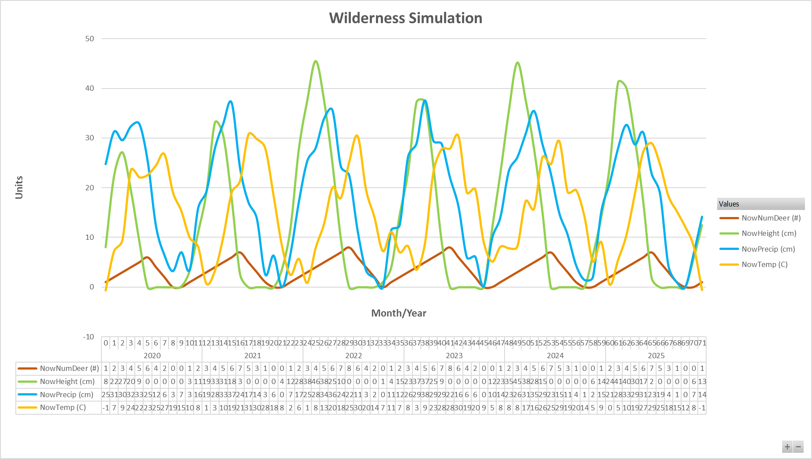

The cycles in my graphs look very similar to the cycles found in the project handout. I noticed that temperature usually peaks in the middle of the year and reaches its lowest values at the end/beginning. Precipitation is usually at its lowest in the late summer/fall and peaks in the spring, much like it does in real life. The timing difference for the cycles of NowTemp and NowPrecip can be attributed to the use of sin and cos for the calculation of these variables. Cos for NowTemp and Sin for NowPrecip.

NowHeight is tied to the temperature and precipitation, so the height of the grain follows a seasonal cycle as well. NowHeight is also dependent upon NowNumDeer, but that shouldn’t attribute to the seasonal cycle. The higher the number of deer the more height is subtracted from the overall height.

NowNumDeer has the simple logic of increasing if NowHeight is greater than NowNumDeer and decreasing if the opposite is true. FireOdds changes this behavior somewhat, and we will talk about that in a moment. There is a well-defined cycle where the number of deer increases from late fall to early summer, and then shoots right back down to zero. This pattern in NowNumDeer’s cycle arise as a result of the cycle in NowHeight.

Now let’s discuss FireOdds, the variable I added to the simulation. Take a look at the following graph:

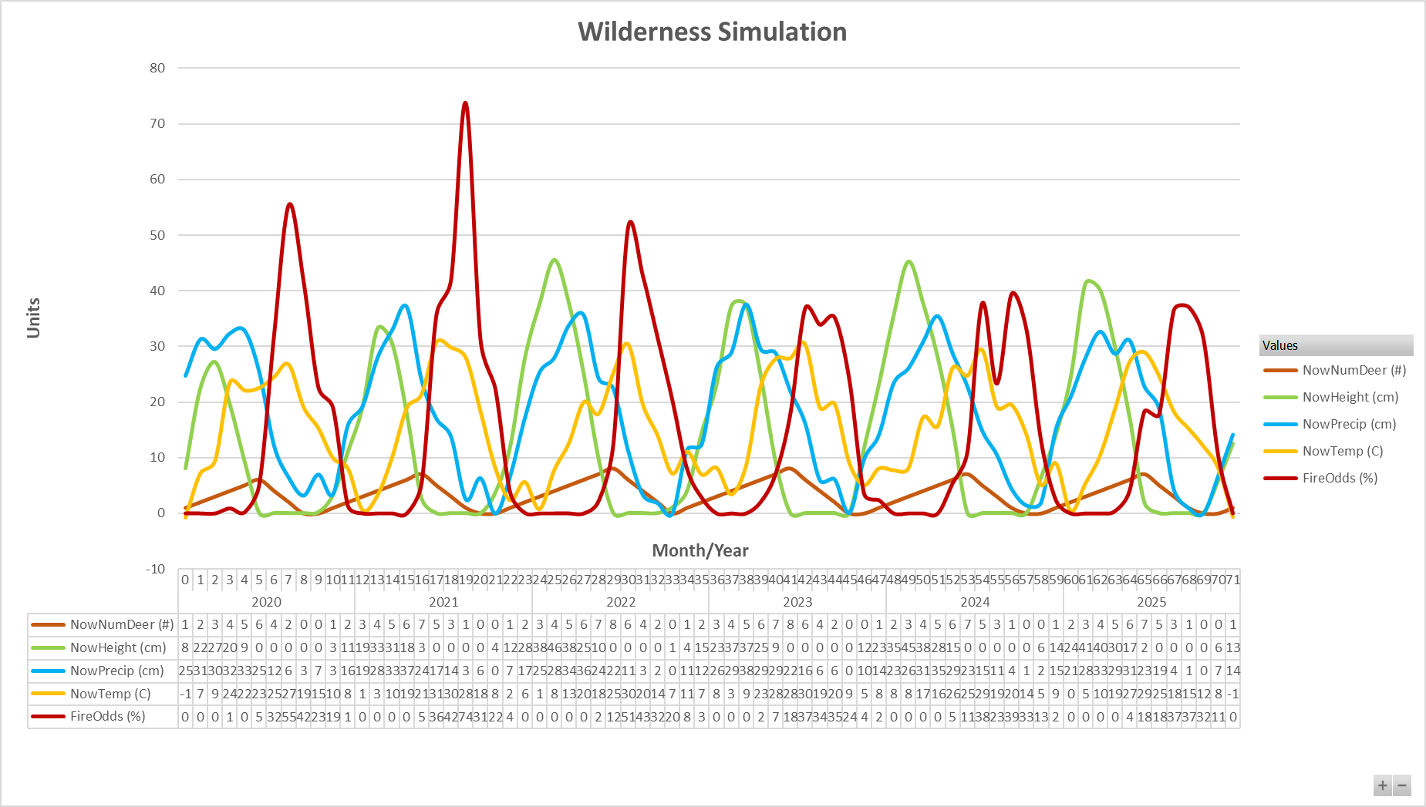

I can see three ways that proves my variable is affecting the simulation correctly.

1. If you compare the slope of the NowNumDeer line when FireOdds is elevated to the simulation without FireOdds included, you will see that the slope is -2 in my simulation vs -1 in the normal simulation. (when decreasing) This is because I have set the number of deer to decrease by two, rather than one, when FireOdds is elevated.
2. Grain seems to be incapable of growing when FireOdds is elevated. This is to be expected. Not only is it the end of the cycle for NowHeight in the normal simulation where the grain hits bottom, the FireOdds increases the severity of the drop and keeps the grain height at zero for several months each year.
3. FireOdds peaks when, both, the temperature peaks and the precipitation bottoms out. This is the behavior I was going for. When the heat is high and the grain is dry, there is a much greater chance that a fire will spark and burn the land.

I noticed that including my FireOdds variable causes a “reset” for the environment every year. Grain and deer are completely eliminated due to the fires. Grain grows and deer reproduce the next year, but the NowHeight and NowNumDeer always return to zero.