Lab – Pirate Ipsum (Float)

Completed 10/07/22

<https://docs.google.com/document/d/1s5HJHpxcIb8e_6AOBTVEt9TWvwbp64gSsd9KxJD82Ec/preview>

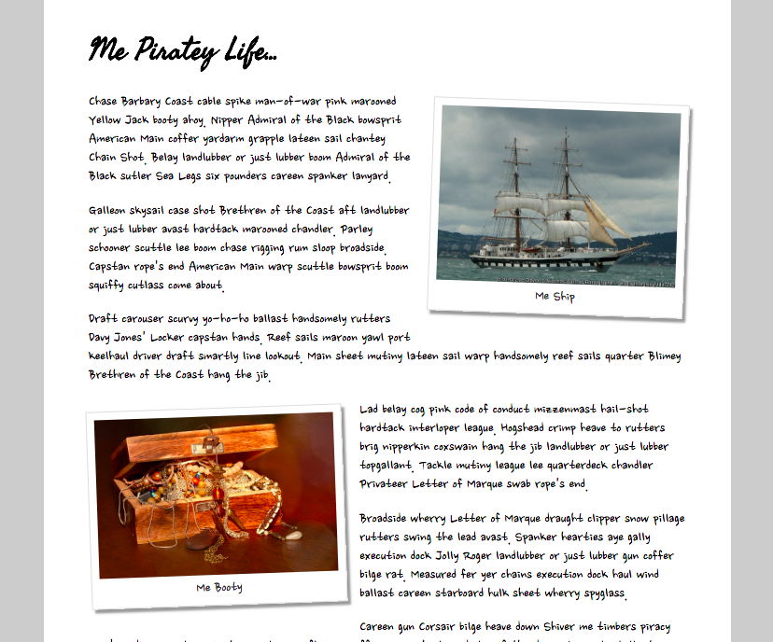

* Get text from <https://pirateipsum.me/>.
* The white wrapper around the main article has max-width: 800 and should be centered.
* Fonts: Nanum Brush Script (body) and Seaweed Script (header) from Google Fonts.
* Colors: #ccc (background), #ddd (photo border), #999 (photo shadow), #333 (photo caption text)
* Images: <http://www.geograph.ie/photo/1447782>, <https://pxhere.com/en/photo/1235532>

**Extended Challenges:** rotate the photos using transform: rotate().

It took me quite a while to figure out how to get the text to wrap around a <div> as I kept trying to use <figure> or other tags, but was finally able to get it with the following HTML:

<!DOCTYPE html>

<html lang="en">

<head>

    <meta charset="UTF-8">

    <meta http-equiv="X-UA-Compatible" content="IE=edge">

    <meta name="viewport" content="width=device-width, initial-scale=1.0">

    <title>My Piratey Life</title>

    <link rel="stylesheet" href="PirateIpsum2.css">

</head>

<body>

    <div class="bodyFloat">

    <h1>Me Piratey Life...</h1>

    <div>

        <div id="pirateShip">

            <img class="pirateShip" src="./Pirate Ship.jpg" alt="Sirate Ship"></img>

            <figcaption>Me Ship</figcaption>

        </div>

    <p>Chase Barbary Coast cable spike man-of-war pink marooned

        Yellow Jack booty ahoy. Nipper Admiral of the Black bowspirit

        American Main coffer yardarm grapple lateen sail chantey

        chain shot, belay landlubber or just lubber boom Admiral of the

        Black sutler sea legs six pounders careen spanker lanyard.<br><br>

        Galleon skysail case shot Brethren of the coast aft landlubber

        or just lubber avast hartack marooned chandler. Parley

        schooner scuttle lee boom chase rigging rum sloop broadside.

        Capstan rope's end American Main warp scuttle bowspirit boom

        squiffy cutlass come about.<br><br>Draft carouser scurvy yo-ho-ho ballast handsomely rutters

        Davy Jones' Lock capstan hands. Reff sails maroon yawl port

        keelhaul driver draft smartly line lookout. Main sheet mutiny lateen sail warp handsomely reef sails quarter Blimey

        Brethren of the coast hang the jib.</p>

    </div>

    <div>

        <div id="treasureChest">

            <img class="treasureChest" src="./Treasure Chest.jpg" alt="treasure chest" title="Me Booty"></img></a>

            <figcaption>Me Booty</figcaption>

        </div>

    <p>Lad belay cog pink code of conduct mizzenmast hail-shot

        hardtack interloper league. Hogshead crimp heave to rutters

        brig nipperkin coxwain hang the jib landlubber or just lubber

        topgallant. Tackle mutiny league lee quarterdeck chandler

        Privateer Letter of Marque swap rope's end.<br><br>Broadside wherry Letter of Marque draught clipper snow pillage

        rutters swing the lead avast. Spanker hearties aye gally

        execution dock Jolly Roger landlubber or just lubber gun coffer

        bilge rate. Measured for yer chains execution dock haul wind

        ballast careen starboard hulk sheet wherry spyglass.<br><br>The best Lorem Ipsum Generator in all the sea! Heave this scurvy

        copyfiller fer yar next adventure and cajol yar clients into

        walking the plank with ev'ry layout! Configure above, then get

        yer pirate ipsum...own the high seas, arg!</p>

    </div>

</body>

</html>

And the following CSS:

@font-face {

    font-family: "Seaweed Script";

    src: url(./Fonts/SeaweedScript-Regular.ttf)

}

@font-face {

    font-family: "Nanum Brush Script";

    src: url(./Fonts/NanumBrushScript-Regular.ttf);

}

body {

    background-color: #CCC;

    margin: 0px 30px;

    font-family: "Nanum Brush Script";

    font-weight: bold;

    font-size: 120%;

}

.bodyFloat {

    max-width: 800px;

    display: inline-block;

    justify-content: center;

    background-color: #FFF;

    height: 100%;

    padding: 0px 30px;

}

h1 {

    font-family: "Seaweed Script";

}

img {

    width: 190px;

}

#pirateShip {

    float: right;

    display: flex;

    flex-direction: column;

    align-items: center;

    padding: 7px 7px 1px 7px;

    border: 2px solid #DDD;

    box-shadow: 4px 4px 10px #999;

    margin: 0px 12px 5px 10px;

    transform: rotate(3deg);

}

#treasureChest {

    float: left;

    display: flex;

    flex-direction: column;

    align-items: center;

    padding: 7px 7px 1px 7px;

    border: 2px solid #DDD;

    box-shadow: 4px 4px 10px #999;

    margin: 0px 22px 10px 0px;

    transform: rotate(-3deg);

}

figcaption {

    color: #333;

    padding: 3px;

}

So the website looked like this:

