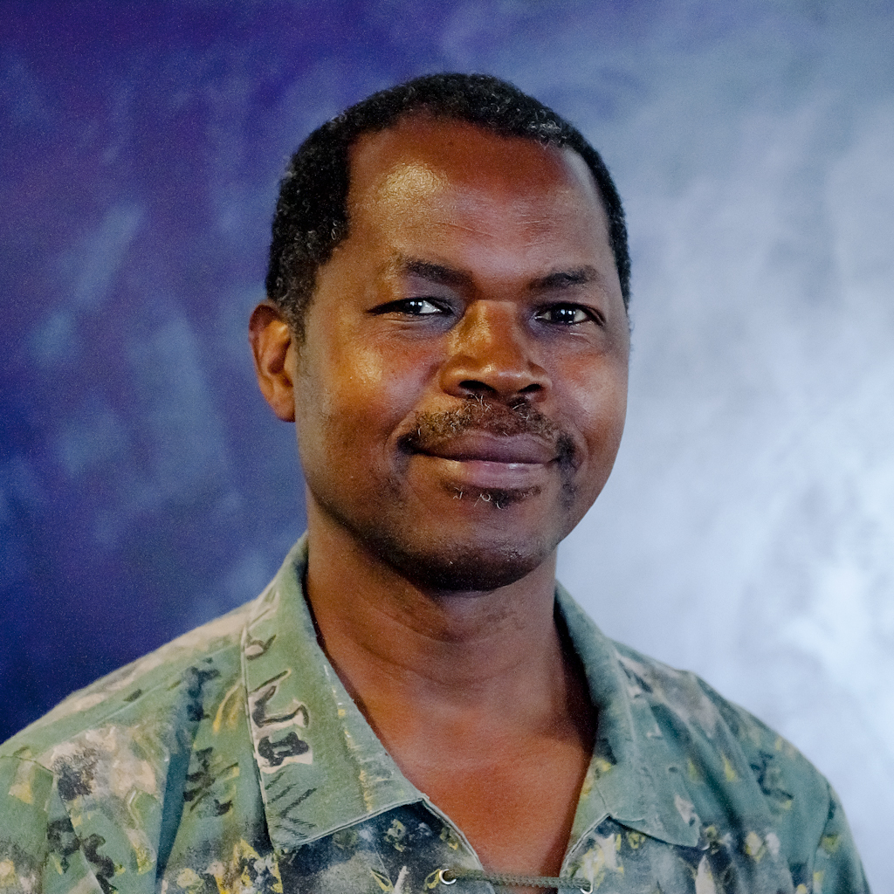

Clinton | 34421 63534 21424 | testemail@gmail.com

# About me

Senior Developer  
Senior IT Specialist

# Work experience

**Self** *Dec 2019-now*Organic Farming

**Inland Revenue** *Jan 2006-Nov 2019*Develop & support Cobol apps; Develop & support Java apps; Configure, support & customise ITSM apps(Remedy/ServiceNow)

**Others NZ** *Apr 2001-Dec 2005*Factory machine operator

**Others Zimbabwe** *1984-Feb 2001*Develop, support, instructor COBOL apps and NCR Operating systems.

# Skills

* **Cobol programming** *30+ yrs*Analyse, develop, test, support, train people to use Cobol.
* **Java programming** *10 yrs*Develop and maintain Java2EE apps.
* **Analysis** *20+ yrs*Apart from developing apps, aslo did most of the analysis work as an Analyst/programmer
* **Testing** *30+ yrs*As an Analyst/Programmer, testing was also part of the deal.