TivaC Lab 9

CPE 403

**Checklist for Lab 9**

* A text/word document of the initial code with comments
* In the document, for each task submit the modified or included code (only) with highlights and justifications of the modifications. Also include the comments.
* Provide a permanent link to all main and dependent source code files only (name them as LabXX-TYY, XX-Lab# and YY-task#)Screenshots of debugging process along with pictures of actual circuit
* Video link of demonstration.

**Code for Experiment**

**Task 1:**

**#include** <stdint.h>

**#include** <stdbool.h>

**#include** <math.h> // Include math functions

**#include** "inc/hw_memmap.h"

**#include** "inc/hw_types.h"

**#include** "driverlib/fpu.h" // Used for floating point

**#include** "driverlib/sysctl.h"

**#define** TARGET_IS_BLIZZARD_RB1 //Used to access API's in ROM.

**#include** "driverlib/rom.h"

**#ifndef** M_PI

**#define** M_PI 3.14159265358979323846

**#endif**

**#define** SERIES_LENGTH 100 // 100 calulations

**float** gSeriesData[SERIES_LENGTH]; // Array for floating pt data

int32_t i32DataCount = 0; // Iteration counter

**int** **main**(**void**) {

**float** fRadians; // floating pt radians

ROM_FPULazyStackingEnable(); // Enable lazy stacking

ROM_FPUEnable(); // Enable FPU

// Using 50 MHz clock

ROM_SysCtlClockSet(

SYSCTL_SYSDIV_4 | SYSCTL_USE_PLL | SYSCTL_XTAL_16MHZ

| SYSCTL_OSC_MAIN);

fRadians = ((2 * M_PI) / SERIES_LENGTH); // Compute radians

// Calculate 100 values

**while** (i32DataCount < SERIES_LENGTH) {

gSeriesData[i32DataCount] = **sinf**(fRadians * i32DataCount); // store sine wave dadta

i32DataCount++; // go to next increment

}

**while** (1)

;

}

**Image of Sine Wave**

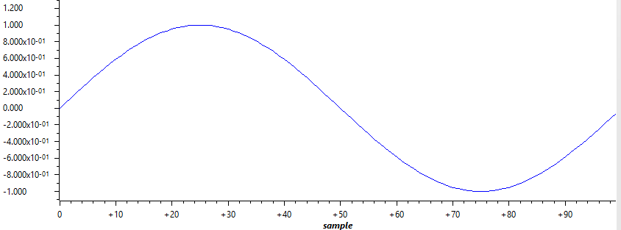

**Task 2:**

**#include** <stdint.h>

**#include** <stdbool.h>

**#include** <math.h> // Include math functions

**#include** "inc/hw_memmap.h"

**#include** "inc/hw_types.h"

**#include** "driverlib/fpu.h" // Used for floating point

**#include** "driverlib/sysctl.h"

**#define** TARGET_IS_BLIZZARD_RB1 //Used to access API's in ROM.

**#include** "driverlib/rom.h"

**#ifndef** M_PI

**#define** M_PI 3.14159265358979323846

**#endif**

**#define** SERIES_LENGTH 1000 // 100 calulations

**float** gSeriesData[SERIES_LENGTH]; // Array for floating pt data

int32_t i32DataCount = 0; // Iteration counter

**int** **main**(**void**) {

**float** fRadians; // floating pt radians

ROM_FPULazyStackingEnable(); // Enable lazy stacking

ROM_FPUEnable(); // Enable FPU

// Using 50 MHz clock

ROM_SysCtlClockSet(

SYSCTL_SYSDIV_4 | SYSCTL_USE_PLL | SYSCTL_XTAL_16MHZ

| SYSCTL_OSC_MAIN);

fRadians = ((2 * M_PI) / SERIES_LENGTH); // Compute radians

// Calculate 1000 values

**while** (i32DataCount < SERIES_LENGTH) {

gSeriesData[i32DataCount] = **cosf**(fRadians * i32DataCount); // store sine wave dadta

i32DataCount++; // go to next increment

}

**while** (1)

;

}

**Image of Cosine Wave**

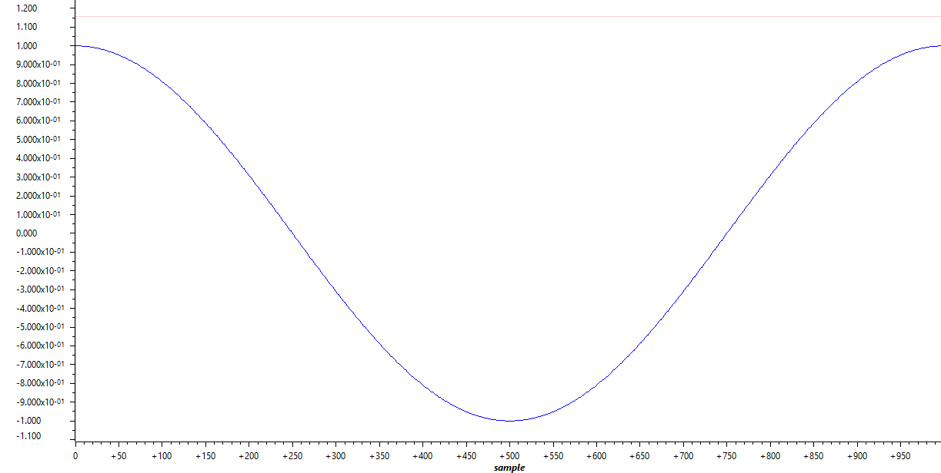

**Video Link to Demo**

NONE