**Analysis of World-wide Video Game Sales**

Clinton Cote

Colorado State University - Global Campus

MIS581 Capstone – Business Intelligence and Data Analytics

Dr. Jamia Mills

March 1, 2025

**Abstract**

The video game industry has become one of the largest entertainment industries in the world. To date, there has not been much research into the sales trends of video games world-wide, specifically differences in genre sales and sales by region. Smaller companies specifically could use more business intelligence and marketing to increase their market share and popularity. Using a dataset that shows sales data of video games sales both by genre and region, analyses will reveal potential targets to maximize the efficiency of both development and marketing teams, which will specifically help those smaller development companies that have not put much effort to the business aspect of their companies. SAS is the main analysis tool that will be used to perform the calculations and visualizations necessary to complete this project. The resultsof the analysis showed that North America is the region that has the highest number of sales compared to the other recorded regions. It was found that there was a statistically relevant difference between the sales of the genres globally and the resulting graph showed that shooter games were the moist popular. It was found that there is no significant difference in the growth of sales between each region. Finally, a bar graph showed that the most popular genre in North America is the action genre followed by the sports genre. The results show that marketing to a specific region is not necessary as there is no difference in sales growth between the regions. This result also speaks to globalization and the fact that video game culture is primarily tied to the internet and global interconnectivity. Therefor, marketing via the internet is the best way to increase sales. Finally, the difference in genre sales points to a target that the companies can use. If smaller companies can focus on the more popular genres and develop high quality action or sports games, they should be able to increase their sales and therefore their market share.

**Analysis of World-wide Video Game Sales**

**Introduction**

One of the most popular forms of media entertainment consumed by the public is video games. Due to the popularity of the industry, there are many companies, both large and small, that develop video games. This creates intense competition between these companies and any advantage that can be gleaned from this research would be of great use to any one of these companies. The popularity and sales of video games has generally increased year to year, so the market can handle many companies participating and selling games. However, there has been a slight drop-off within the past couple years as shown by a visualization presented by Rao (2023). More research into the sales data can potentially expose reasoning for this drop off and possibly provide insight into what can be done by companies to combat that downturn. Market research into video game sales can also assist smaller video game developers with breaking into the market and increasing sales to allow the company to grow. There are also many different platforms on which the video game can be developed. The best way for a video game to find success is to be developed on the correct platforms for the type of video game created.

**Purpose**

The main purpose of this research project is to utilize the information gleaned from market research on video game sales data to increase sales and development efficiency, as well as helping to target marketing strategies. With the recent downturn in video game sales, there needs to be a strategy for development companies to develop the right genre of video games and market those games in the correct manner and marketing to the correct region or the downturn in sales will continue. Analysis will also need to be done to determine the type of video game to develop and which platforms on which to develop. Mobile games tend to require less processing power and therefore are simpler games, but that is also reflected in the price of the individual game. Mobile games tend to be free to maybe $10 while full multi-platform games are generally at least $60 per game. Market research into video game sales should provide some insight into what type of video game to develop to gather more revenue and sales. Marketing can be an extremely costly endeavor for a smaller development company, so it is best to target marketing in a way that the results are maximized with minimal cost. Finding the best-selling genres in the best-selling regions should enable the marketing team to target their advertisements well.

**Objectives**

There are several objectives of this research project. The first objective is to determine the world region that has the largest video game sales. Second, the genre with the highest video game sales needs to be determined. Third, the world region with the highest growth in sales will need to be identified. The final objective is to determine the most popular video game genre in the world region with the highest growth in video game sales.

**Organizational Benefits**

There is a myriad of benefits to the organization depending on the results of the objectives. By identifying the world region with the largest video game sales, the company will be able to know which region to be able to target for video game development and marketing and maintaining those levels of sales. Finding the genre with the most sales, the company can target that genre to maximize the sales. The company can also hire individual designers and developers that are renowned for doing well in that genre. Identifying the region that has the highest growth will enable the company to target that region to be a part of a region that has sales increases. Finally, finding the most popular genre in the region with the highest growth in sales will provide the ultimate target for the company to take advantage of the sales growth. Both development and marketing will need to focus on the genre and region with the highest growth in order to maximize efficiency. While targeting the highest growth is the most important aspect of this research, the company can also utilize the results to find opportunities increase sales in regions that are underrepresented or in genres that are underdeveloped. Increasing marketing in regions with lower sales has a good chance of increasing the sales in that region as long as the marketing is targeted and focused. Britt (2024) found that sales and marketing need to be better aligned in order to maximize performance. When sales and marketing are aligned, the production and development teams can also be more aligned, resulting in a company that is solely focused on a singular goal of increasing sales and market share. This research study on video game sales should provide better information to allow the development, sales and marketing teams to align in a fashion that will increase total sales and therefor profit for the company.

**Research questions**

1. Which world region has the highest video game sales? This question is straightforward and should be fairly easy to determine. The region with the highest sales is important to identify so that the marketing team can be most efficient with where they advertise. More advertising in the place with highest sale will draw more customers’ attentions that are more likely to purchase games.
2. Which video game genre has the highest sales? The question should be relatively easy to answer and is key for the company to determine how to develop games in the future. Once the company is able to identify the highest selling genres, the company will be able to increase efficiency by producing more games of the more popular genres. The increase in efficiency should show an effect of increasing profits as well as market share.
3. Which world region has the highest growth in video game sales? Identifying the region that shows the highest growth in video game sales is extremely important to the success of the company. If the company can get into marketing in the region with the highest growth, sales should be able to take advantage of that growth and increase in the same manner. Targeting higher growth will increase the efficiency of the marketing department, which will also lead to more sales and a higher market share.
4. Which video game genre is most popular in the world region that has the highest growth? This question combines the principles of the 2nd and 3rd research questions. It is the ultimate question to identify a region and a genre to target to maximize both efficiency and profitability for the organization and is the culmination of the entire research project.

**List of hypotheses**

1. Null Hypothesis (H0): There is no statistical difference between world regions' video game sales. H0: μ = μ₀

Alternative Hypothesis: (HA): There is a statistical difference in video game sales by region. HA: μ ≠μ₀

1. Null Hypothesis (H0): There is no statistical difference between video game sales by genre. H0: μ = μ₀

Alternative Hypothesis: (HA): There is a statistical difference in video game sales by genre. HA: μ ≠μ₀

1. Null Hypothesis (H0): There is no statistical difference between video game sales growth by region. H0: μ = μ₀

Alternative Hypothesis: (HA): There is a statistical difference in video game sales growth by region. HA: μ ≠μ₀

1. Null Hypothesis (H0): There is no statistical difference between video game genre sales in the highest growth region. H0: μ = μ₀

Alternative Hypothesis: (HA): There is a statistical difference between video game genre sales in the highest growth region. H0: μ ≠μ₀

**Literature review**

The video game industry seems to have a few large developers that have major business savvy, while there are many smaller developers that excel at the development of unique and creative games but have not embraced the business aspect of running a company. Smaller companies tend to be founded by developers instead of businesspeople. As Sotamaa (2021) found while researching the smaller development companies of Finland, most developers have a passion for games and have honed their development skills without much regard to business skills and acumen. This leaves many smaller companies with great ideas and game designs without the business knowledge to successfully market the game to make a large profit. These kinds of smaller companies could benefit by implementing a team that performs business intelligence and focuses on the business aspect of a development company. Burgess et al. (2024) found that most of these smaller development companies know the need for quality marketing, but the companies’ marketing skills varied widely. They further found that there is an appetite for those smaller businesses to learn how to market successfully, however there is also a large faction that only care about the quality of the art and reject commercial success. While the focus on the artistry is admirable, commercial success and artistry do not have to be in opposition. Higher artistic quality can increase the commercial viability of a video game and vice versa, greater commercial appeal can increase artistic appreciation of the customers. As video games are an artform, there will always be those that will decline the monetization of their art, but there is room for improvement in marketing in the video game industry, especially for smaller studios.

**Importance of marketing**

As shown, there is a dearth of beneficial marketing within the smaller video game development companies. Marketing is necessary to bring awareness of the product to consumers, but it can be resource intensive, so optimizing a marketing strategy is essential for companies without much excess capital. Isoraite (2024) found that a beneficial strategy for smaller, creative companies is guerilla marketing, which uses unconventional means, such as staged actions, planted people at events, or even an exclusivity concept where only the “in” customers know about the product. This is perfect for the smaller developers that concentrate on game quality, however a base knowledge of the product needs to first be established. As initial knowledge of the product is beneficial, even necessary for low-cost marketing, it is reasonable to conclude that marketing a new game to a region with high sales would be most beneficial for a smaller company. Kenton (2024) found that increasing marketing to regions with a solid sales presence will increase market penetration in that area, supporting the strategy to market to regions with high sales volume. Marketing is necessary to increase awareness of the product and therefor sales, but the product itself is key. Suko (2023) determined that the quality of the product has the most significant impact on sales when compared to different marketing strategies. No matter how great the marketing, the customer ultimately has to appreciate the product in order for a company to have sustained success. Additionally, a product’s quality can determine if sales are increased of decreased by word of mouth and customers’ ratings, which will influence other customers who are deciding if they should purchase the product or not.

**Dataset description**

The selected dataset contains 11 different variables ranging from the name of the video game, publisher, genre and platform to the sales in each region and the total sales. There are 7 variables that will be analyzed through the course of this research project. The genre of game is a string variable that contains 12 separate genres. The release year is an integer value. Finally, there are 4 separate regions with the sales amount along with the total sales. The regions are North America, Europe, Japan and all other regions. These last variables are all float variables, so they can contain integers or characters, however all of the observed values are integers.

**Rational for dataset**

This dataset was chosen for this research project for several reasons. First, the dataset contains all of the variables that need to be analyzed in order to determine which region has the highest sales, which genre has the highest sales, which region has the highest growth in sales and which genre is most popular in the region with the highest growth in sales. The dataset contains all the necessary data to identify areas to target to maximize sales. Second, the dataset is large enough to make statistically significant observations while being small enough for the computer to download and process the data. Finally, while the dataset is fairly large, the data itself is fairly clean. After running several summary statistics, it was found that there were not many errors, blank entries, or extreme outliers. Starting with clean data always makes analysis easier and more accurate than trying to delete or replace missing or incorrect values.

**Research methods**

There will be two separate tools that will be used to perform the multiple analyses required for this research paper. First, SAS will be used to perform the numerical calculations. There is going to be a one-way ANOVA test to determine if there is a statistically relevant difference between the genre of video games as far as the total sales. This will be able to identify the most popular genres as far as sales worldwide and determine if the genre has any impact to the sales. Another test will be a 2-way ANOVA comparing the regional sales with genre. The results of this test will be able to show which genres are the most popular in each distinctive region. Kishore et al. (2022) found that a 2-way ANOVA test is able to determine the relationship and statistical significance of 2 variables that each have multiple potential outcomes. If the results are not scientifically relevant, the on-way ANOVA can be ran comparing the genre to each separate region and that should provide an obvious display of which genres are most popular in which regions.

The other tool that was intended to be used was Tableau. Tableau is a program that excels at making visualizations with relative ease. However, there was difficulty in renewing a free student license for Tableau and purchasing the license was prohibitively expensive. Instead, SAS will also be used to create a visualization of the video game sales of the different regions over time. This will allow one to see which region has the highest growth in video game sales and how the sales have changed over time. The graph will be able to provide insight into sales trends. While the line graphs generated by SAS are less customizable, the line graph will be able to display the same information with SAS as with Tableau, albeit with a more bare-bones design. Additionally, another graph will be produced showing sales by genre in the region with the greatest sales growth or the region with the largest sales in general. Instead of a line graph, the best visualization will be a bar graph that will display the sales of each genre. This graph will allow one to identify trends in sales by genre and which genres are the best sellers. This will also be done with the genres in the lowest selling region to determine if there are major differences between genres in each region. While ANOVA tests can determine if differences are statistically significant, the graphs will be able to display minute differences that will not be able to be detected by statistical tests and displays the sales of each genre, so that the medium selling genres can also be determined.

**Limitations**

As with any set of data or research project, there are potential limitations that are presented by both the dataset and the research itself. The first potential limitation is the fact that the sales data is collected over a significant amount of time, so inflation can change what the sales data actually means. For example, say a game costs $20 in 1980, but costs $70 now. It would take the sales of over 3 games to equal the sale of 1 modern game. The best way to adapt this would be to try to account for inflation, but that would be a lengthy modification, and possible not accurate. Another possible solution would be to try to calculate sales by count instead of money, but that would also be difficult to accurately determine. One can reasonable infer that many of the older games are still being occasionally purchased, so the difference in sales price can be assumed to equal out as there is more time for the game to be sold. The second major limitation is that the sales are not separated by year, so the determination of the sales growth rate will have to be determined by the year of release. While this is not the exact measure of sales over the years, it will still show changes in sales year to year, which will still be able to show regions and genres that are experiencing sales growth.

**Ethical considerations**

Ethical considerations are incredibly important for conducting research. much like in business, acting unethically can result in fines, loss of reputation, and potentially invalidation of the research project. Ethics of both the research and the data itself needs to be considered when performing any research project. Heath (2021) contends that just because data is available publicly does not mean that it is ethical to use that data. For data to be considered ethical, it must be collected with consent. In this situation, the sales data is what will be analyzed. As the data was already compiled, one does not know the methodology for collecting the data. However, as it is sales data, it is likely that the data is widely available, especially as the development companies would like to show their sales data for high-performing video games. The data is private as there is not any personal data of data that identifies an individual. Additionally, purchasing a game is essentially giving consent for that data to be collected as the records are entirely collected by the businesses from which the games are purchased. Another consideration is if the data itself is correct. Morelli et al. (2024) found that is essential to have reputable and accurate data in order to make proper conclusions from data analysis. There can be pressure on game development companies to inflate their sales data to increase prestige or investment. There is not much that can be personally done in order to verify that the companies are providing correct data, so for this research project one has to have confidence that the data is correct. The only way one would be able to determine if the data is correct is if a situation occurred where a super popular game, like Mario is outsold by a game that is unheard of. That would indicate fraud within the data or at the very least a major entry error. Based on the fact the data was gathered and available on a widely used website that collects data available for anyone, it is reasonable to assume errors would have been discovered previously. The data collected and used for this research is collected and used ethically.

The purpose, research questions, background, limitations and ethical considerations are necessary steps before the data analyses can be ran and the results gathered. Once the results are gathered, they can then be interpreted and further analyzed to garner conclusions and determine which hypotheses are correct. From there, recommendations can be provided for further studies into the subject.

**Findings**

After performing the statistical analyses discussed in the methodology section of the paper, the null hypotheses of each research question can be determined to be accepted or rejected. The first null hypothesis is that there is no statistical difference in game sales between the recorded regions. This null hypothesis was rejected based on Figure 1. Figure 1 shows that North American sales are obviously larger than any other region. The provided line graph figure

**Figure 1**

*Line Graph of Video Game Sales by Region*

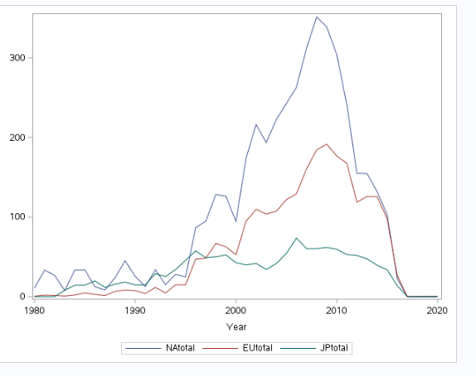

shows that sales were approximately equal between the regions until around 1995 when the sales in North America started to explode. North American sales were significantly larger until around 2015 where the European sales started to be about the same as North American sales. Japanese sales have been relatively consistent until 2017 or so when all sales started to decrease. The reason for this result is that the dataset is sales per game, so newer games do not have as much time to build sales as newer games.

The second null hypothesis is that there is no difference between genres in total global sales. The ANOVA test that was performed can be viewed in Figure 2. The results of the

**Figure 2**

*ANOVA Test of Genres Sales Worldwide*

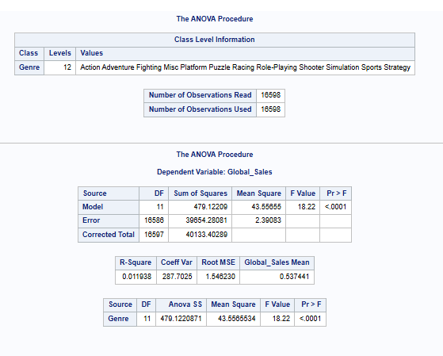

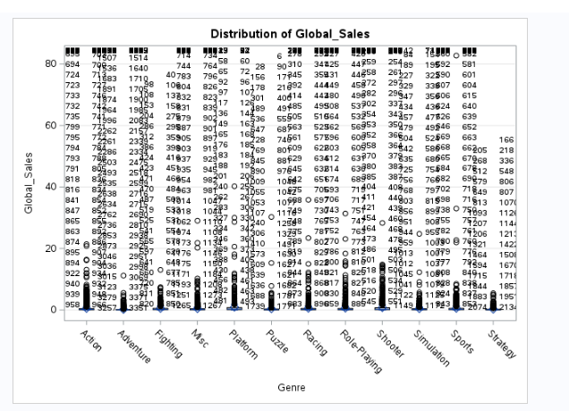

ANOVA test show that the P-value is <.0001. This result confirms that there is a statistically significant difference between the video game genres and their global sales, so the null hypothesis can be rejected. There was effort made to try to clean the resultant graph generated by the ANOVA test function, but to no avail. However, the graph does seem to indicate the Shooter genre was the most popular genre as far as worldwide sales are concerned.

The third null hypothesis is that there is a significant difference of sales growth between the sales regions. This null hypothesis was confirmed as can be seen in Figure 1. The line graph shows that there is no real difference between the recent sales figures in each separate region. The result lends credence to the fact that globalization is a significant factor that allows customers to purchase games developed in any region. This result also supports that the growth pattern of the video game industry is stable and uniform throughout the regions, despite regions that may have larger sales, which is another indicator that globalization is a key factor of the video game market.

The final null hypothesis is that there is no difference between the sales by genre within the highest growth region. While there is no significant difference in growth between the regions, the difference between genres was tested using the North American market, which generated the largest sales. Figure 3 shows the ANOVA test comparing the sales differences by genre in North America. The ANOVA results show there is a statistically significant difference between the popularity of each genre. The null hypothesis that there is no significant difference of popularity

**Figure 3**

*ANOVA test of genre sales in North America*

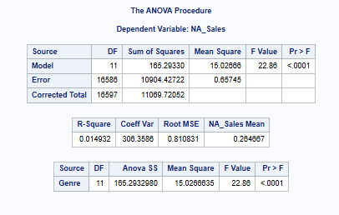

between genres can clearly be rejected. Figure 4 shows the sales by genre in the North American market as a bar graph. The figure shows that adventure games are the most popular genre in

**Figure 4**

*Genre Popularity in North America*

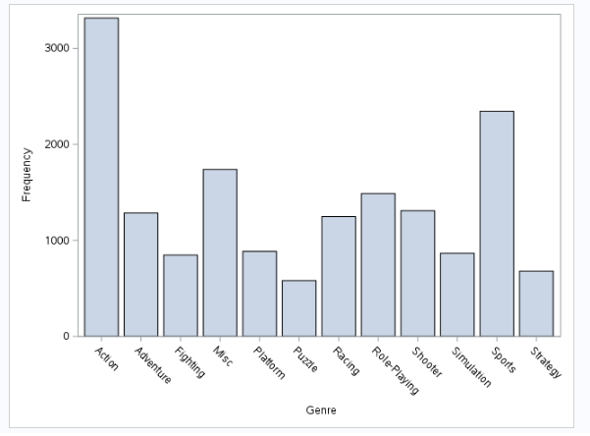

North America, followed by sports games. While it is not a hypothesis generated before performing the analysis, there should be the same assessment done of the lowest sales region in order to develop the best targets for marketing. An ANOVA test was performed to determine if there was a significant difference in genre sales in Japan. Figure 5 shows the result of the

**Figure 5**

*ANOVA test of genre sales in Japan*

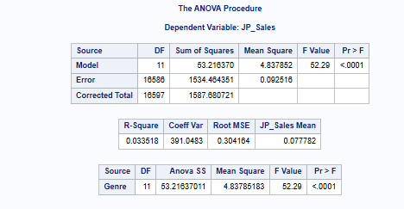

ANOVA test, and the results prove that there is a significant difference in sales between the genres as the P-value is <0.001. Figure 6 shows a bar graph showing the popularity of each genre in Japan, much like the bar graph showing the popularity of each genre in North America. The results of this graph are

**Figure 6**

*Genre Popularity in Japan*

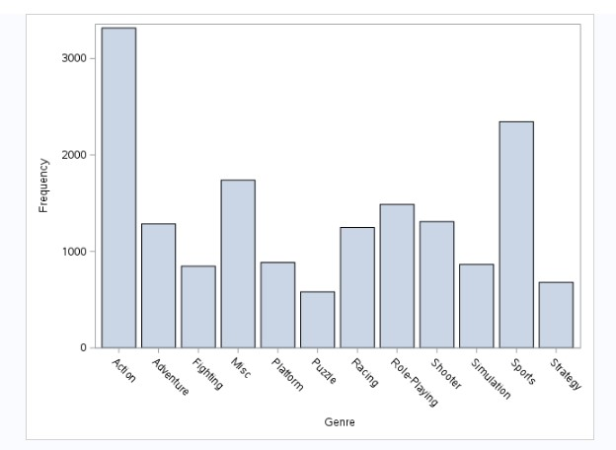

remarkably similar to the graph of North American sales, showing that adventure games are the most popular, followed by sports games.

**Conclusion**

One can glean some significant insights based on the results of this research and the analyses performed. The finding that there is a significant difference in sales between regions can allow developers to target North America for marketing and development as it is the region with the highest sales. Alternatively, marketing can also be used in the Japanese region to try to increase sales as well. However, Japan has a smaller population than the other regions that were analyzed, so it would be difficult to increase sales more than baseline. The best way to make an incursion into the Japanese market is to develop an adventure game that is better than any other adventure game on the market as that is the genre most popular in Japan. Developers can use the results of the last hypothesis to know that adventure and sports games are the most popular games within the North American region and therefore target development of more and better adventure and sports games. Developing games that align to more popular genres will make it more likely that those games are purchased, thereby increasing sales for the development company.

The fact that the third null hypothesis was rejected is also quite significant. As there is no significant difference in the growth rate of video games between regions, one can conclude that the market has reached a point where the video game industry as a whole is stable and the differences in sales are more related to a difference in population as opposed to difference in percentage of population that purchase video games. This can mean that a company will be able to target any region with marketing and have a similar result in regard to the percentage increase of the population buying the specific marketed video game. Essentially, if the percentage change due to marketing will be approximately the same, companies should target the larger market to meaningfully increase sales. The result can also support a potential that the video game industry is truly global, and that marketing should be done using a ubiquitous media source, such as YouTube.

**Recommendations**

The results of this research project have been clear in that there is a significant difference in sales between genres no matter the region. One of the biggest benefits that developers can use based on this research is to primarily focus on the genres that are the most popular. While there is a market for more niche genres which should still be addressed, companies will benefit most by developing quality games within the most popular genres of action and sports. Based on the previous literature mentioned, smaller companies tend to fill the more niche genres, but there is room for small, dedicated, and talented developers to make high quality games in popular genres to gain sales, accolades and recognition. Utilizing the targeted development and targeting of these genres, smaller companies can gain larger market share and begin to compete with the larger developers that tend to throw out schlock just to make easy money. The smaller developers can use business insights to provide the quality for which they pride themselves into genres and regions where profits can also be made. There is precedent for a smaller developer to gain larger market share and become a heavy hitter in game development utilizing the same principles. CD Projekt Red is a Polish developer that began with 3 dedicated developers. They eventually developed an adventure game called *Witcher 3: Wild Hunt* that became incredibly popular and resulted in the company growing to employ thousands internationally. Smaller companies can use analytics to harness their creativity and dedication to quality to focus on developing quality games in popular genres and thereby increase their market share.

Finally, the fact that growth is not significantly different between regions can be utilized to properly market video games. Due to the results, marketing does not need to be targeted regionally. As globalization has increased, more and more people are online and communicate with others internationally. This is especially true of the customers that play video games. Many games allow people all over the world to play together at the same time. Companies can use that knowledge combined with the definitive results of this study to market online, using apps or programs that are used by everyone. Marketing on platforms that are used ubiquitously, like YouTube, TikTok, or other social media platforms, will be most efficient to spread knowledge of the game. In fact, this kind of marketing on the web can encourage discussion of the game between potential customers, which increases awareness with no additional marketing expenditure. Smaller development companies need to selectively target popular genres in which to develop their games while using social media platforms to market their games.

**References**

Britt, P. (2024, November, 1). Marketing, Sales Need Better Alignment. *CRM Magazine, 28*(9). Retrieved from: <https://eds-p-ebscohost-com.csuglobal.idm.oclc.org/eds/pdfviewer/pdfviewer?vid=8&sid=8baf11e6-dc6c-41d6-8232-0cb33482102c%40redis>

Burgess, J., Muscat, A., Grace, A., & Jones, C. (2024_). Local issues and global challenges: understanding the marketing within the Trans-Tasman video game industry. *Creative Industries Journal,* 1-19. Retrieved from: <https://eds-p-ebscohost-com.csuglobal.idm.oclc.org/eds/pdfviewer/pdfviewer?vid=2&sid=78911e5b-8c79-4a10-8575-1a4aa2215b1d%40redis>

Heath, M. (2021). Buried treasure or ill-gotten spoils: the ethics of data mining and learning analytics in online instruction. *Educational Technology Research &Development, 69*(1), 331-334. Retrieved from: <https://eds-p-ebscohost-com.csuglobal.idm.oclc.org/eds/pdfviewer/pdfviewer?vid=10&sid=05ea610c-12f5-4651-8924-403e2239afd3%40redis>

Isoraite, M. (2024). Innovative marketing strategies in entrepreneurship. *Journal of Entrepreneurship & Sustainability Issues, 12*(2), 117-126. Retrieved from: <https://eds-p-ebscohost-com.csuglobal.idm.oclc.org/eds/pdfviewer/pdfviewer?vid=6&sid=e673fd41-cc94-4347-a7f2-874d687c4af2%40redis>

Kenton, W. (2024, May 31). *Market penetration: What it is and strategies to increase it.* Investopedia. Retrieved from: <https://www.investopedia.com/terms/m/market-penetration.asp>

Kishore, k., Jaswal, V., & Mahajan, R. (2022). The challenges of interpreting ANOVA by dermatologists. *Indian Dermatology Online Journal, 13*(1), 109-113. Retrieved from: <https://eds-p-ebscohost-com.csuglobal.idm.oclc.org/eds/pdfviewer/pdfviewer?vid=15&sid=d86c8b01-7cd6-4af9-b1c2-433a0a096e30%40redis>

Morelli, S., Effenberger, N., Schmidt, L., & Ludwig, N. (2024). *Climate data selection for multi-decadal wind power forecasts.* Retrieved from: <https://arxiv.org/pdf/2411.11630>

Rao, P. (2023, December 31). *50 Years of Video Game Industry Revenues, by Platform.* Visual Capitalist. Retrieved from: <https://www.visualcapitalist.com/video-game-industry-revenues-by-platform/>

Sotamaa, O. (2021). Studying game development culture. *Games and Culture, 16*(7), 835-854. Retrieved from: <https://journals.sagepub.com/doi/10.1177/15554120211005242>

Suko, B. (2023). Marketing strategy analysis in increasing sales and product quality to improving sales of Suzuki motorcycles Indonesia. *Dinasti International Journal of Digital Business Management (DIJDBM), 4*(4), 717-732. Retrieved from: <https://eds-p-ebscohost-com.csuglobal.idm.oclc.org/eds/pdfviewer/pdfviewer?vid=20&sid=e673fd41-cc94-4347-a7f2-874d687c4af2%40redis>