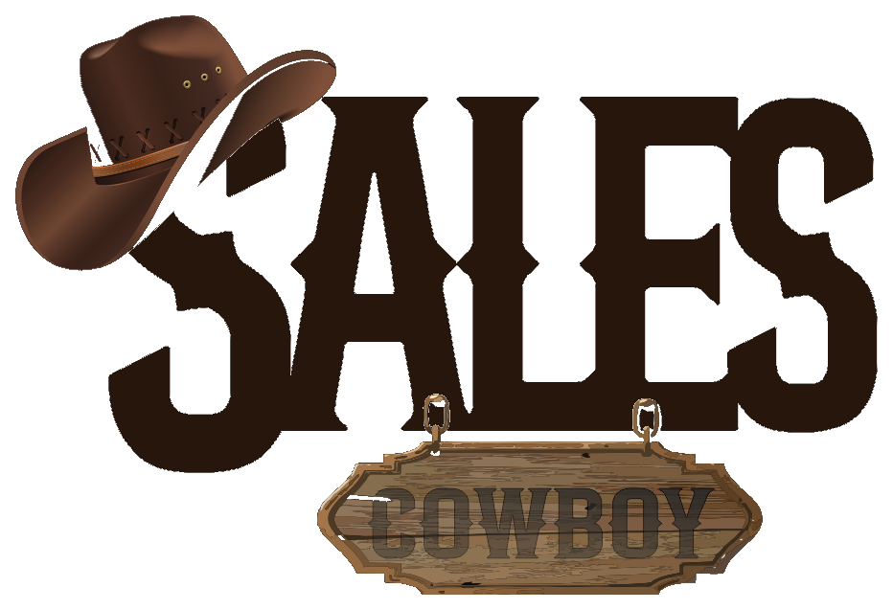 SALES COWBOY  Marketing Solutions • Hospitality Growth & Revenue Engineering  Red Brick House, Peace Land Estate, Ogombo, Ajah, Lagos, Nigeria  hello@salescowboy.com.ng • +234 810 493 3232 • salescowboy.com.ng | [DIGITAL REVENUE & VISIBILITY AUDIT]  REF: AUD-2026-SCM-GOCAP-01  DATE: November 5, 2026  SCORE: 28/100 (CRITICAL)

DIGITAL REVENUE & SEARCH VISIBILITY AUDIT
Target Property: GOCAP GUEST HOUSE & APARTMENTS • 13 Parmor Estate, Off Trademore Phase 3, Airport Road, Lugbe, Abuja
PROPERTY PROFILE & LOCATION PARAMETERS:  Business Name: GOCAP GUEST HOUSE & APARTMENTS  Physical Address: 13 Parmor Estate, Off Trademore Phase 3, Emmanuel Mbaka Blvd, Airport Road, Lugbe, Abuja  Transit Catchment: Nnamdi Azikiwe International Airport Transit Belt  Current Digital Channel: Google Business Profile with only 6 Reviews (No Website, No WhatsApp Automation) | DIGITAL HEALTH SCORE  28/100  CRITICAL LEAKAGE

1. EXECUTIVE SUMMARY & COMMERCIAL DIAGNOSIS
GOCAP Guest House & Apartments sits on a hospitality goldmine: the Airport Road transit corridor in Lugbe, Abuja. Over 15,000 domestic and international passengers land at Nnamdi Azikiwe International Airport daily, generating non-stop search volume for short-stay lodging, flight layovers, airline crew layovers, and business trips.
Yet, our digital revenue audit reveals that GOCAP is currently invisible to over 85% of these high-paying travelers due to three critical digital voids:
THE 3 FATAL REVENUE VOIDS COSTING GOCAP DAILY BOOKINGS
• Google Profile Stagnation (Only 6 Reviews): An inactive listing with zero updates signals to Google's algorithm that the business is dormant, suppressing it in the Google Local 3-Pack.
• Zero Direct Booking Engine (No Website): Potential guests have no website to view room tiers, inspect clean amenities, verify rates, or complete instant card/bank payments.
• No Automated WhatsApp Concierge: In Nigeria, 80%+ of hotel inquiries occur on WhatsApp. Without automated 24/7 availability checks and pay-in-chat checkout, late-night transit bookers are lost to competitors.

2. GOOGLE SEARCH VISIBILITY & GEO-INTENT MATRIX
Search Query Target | Ranking Probability | Algorithmic Reality & Revenue Implication | Strategic Focus
"Hotels in Abuja" | Highly Unlikely (1/10) | Abuja is vast. Broad searches favor luxury hotels in Maitama, Wuse, or Garki. GOCAP will always be filtered out. Competing here wastes ad spend. | De-prioritize broad queries
"Hotels in Airport Road" / "Hotels in Lugbe" | Underperforming (4/10 -> 9/10 Potential) | THE PRIMARY REVENUE GOLDMINE: Google maps actively link Airport Road and Lugbe. When travelers search this corridor, GOCAP should be #1. Currently buried due to only 6 reviews and lack of a website. | Dominate Local 3-Pack
"Hotels near me" | Conditional (3/10) | Appears only when searchers are physically in Lugbe or near the Voice of Nigeria (VON) area. Fails to capture arriving flight passengers before they exit the airport. | Proximity capture
"Lodges / Guest Houses in Lugbe" | High Category Match (5/10) | Highest natural category alignment. However, without transparent pricing, photos, or WhatsApp booking, 70% of viewers bounce to competitors. | Direct Conversion Hub

3. THE 5-POINT TURNKEY TRANSFORMATION BLUEPRINT
Upgrade 1: Modern Direct Booking Website (Mobile-First)
A fast, luxury-themed website showcasing room categories (Standard, Deluxe, Executive Apartments), virtual room tours, transparent pricing, and instant Paystack/Moniepoint checkout. Bypasses 15–20% OTA commission fees and captures 100% direct revenue.
Upgrade 2: Automated 24/7 WhatsApp AI Concierge & Direct Payment Bot
An intelligent WhatsApp bot on GOCAP's business line. Guests can check real-time availability, view photo carousels, pick dates, and pay directly inside WhatsApp. Sends automated booking confirmation vouchers and GPS location pins for easy check-in.
Upgrade 3: Google Business Profile (GBP) Local 3-Pack SEO Dominance
Full metadata optimization for 'Hotels in Airport Road Abuja' and 'Lugbe Guest Houses'. Includes high-res geo-tagged photography and a front-desk QR review acceleration flywheel to scale GOCAP from 6 reviews to 50+ 5-star ratings within 60 days.
Upgrade 4: Visual Social Media Management (Instagram & Facebook)
Consistent, professional social media curation. Production of engaging reels and photo showcases highlighting serene estate security, pristine bedding, 24/7 electricity, air conditioning, and airport transit proximity to build authority.
Upgrade 5: Hyper-Targeted Airport Transit Advertising
Geofenced Meta & Google Ads targeted directly at smartphone users arriving at Nnamdi Azikiwe International Airport searching for short-stay lodging and layover apartments.
4. FINANCIAL ROI & REVENUE GAIN PROJECTION
PROJECTED MONTHLY REVENUE EXPANSION: +₦1.5M – ₦3.5M
• Conservative Projection: Capturing just 2 to 4 additional direct room bookings per night through Google Local 3-Pack placement and instant 24/7 WhatsApp automation.
• Revenue Impact: At an average nightly rate of ₦25,000 – ₦35,000, 2 to 4 extra daily bookings yield ₦1,500,000 – ₦3,500,000+ in additional gross monthly revenue.
• Payback Period: Complete turnkey implementation cost is typically recovered within 30 to 45 days of live launch.

AUDIT COMPILATION & STRATEGIC ENDORSEMENT
COMPILED & ISSUED BY:  SALES COWBOY MARKETING SOLUTIONS  Lead Consultant: Clinton Chukwunyere  Email: hello@salescowboy.com.ng  Tel: +234 810 493 3232  Date: November 5, 2026 | PREPARED EXCLUSIVELY FOR:  GOCAP GUEST HOUSE & APARTMENTS  Attention: Management & Board of Directors  Location: Parmor Estate, Lugbe, Abuja  Status: Confidential Strategic Audit  Action: Implementation Ready

