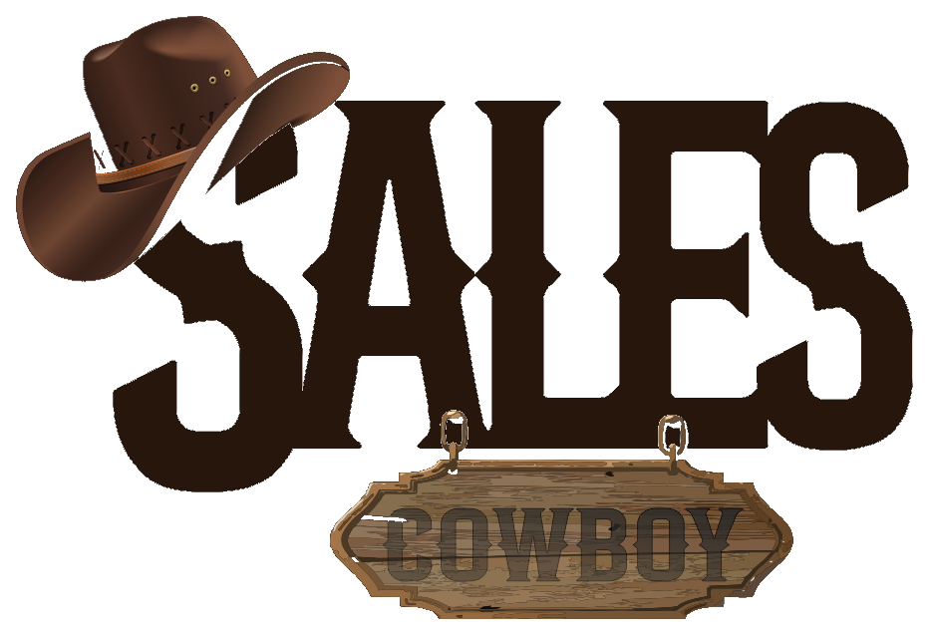 SALES COWBOY  Marketing Solutions • Hospitality Revenue Engineering  36, Arochukwu Street, Uratta East, Owerri North, Imo, Nigeria  hello@salescowboy.com.ng • +234 810 493 3232 • salescowboy.com.ng | DIGITAL REVENUE AUDIT  REF: AUD-CASA-2026-005  DATE: November 06, 2026  STATUS: CONFIDENTIAL
――――――――――――――――――――――――――――――――――――――――――――――――――――――――――――
DIGITAL SEARCH VISIBILITY, REVENUE & SOCIAL MANAGEMENT AUDIT
Direct Booking Engine, Review Acceleration Flywheel, 24/7 WhatsApp AI Concierge & Viral Poolside Social Media
PREPARED FOR (CLIENT):  Casa Urban Guest House  12 Alhaji Amu St, off Saka Jojo by Homat B/Stop, Odogunyan, Ikorodu, Lagos  Phone: +234 802 876 2087 • Hours: Open 24 Hours Daily  Amenities: Swimming Pool, Restaurant, Lounge, Kitchen, Snooker Lounge | PREPARED BY (AUDITOR):  Sales Cowboy Marketing Solutions  Hospitality Revenue Engineering Division  36, Arochukwu Street, Uratta East, Owerri North, Imo, Nigeria  Contact: +234 810 493 3232 • hello@salescowboy.com.ng

HEALTH SCORE  24 / 100  BLIND SPOT ASSET | CRITICAL FINDING: HIGH-VALUE RECREATIONAL ASSETS, ZERO DIGITAL VISIBILITY  Casa Urban Guest House operates an outdoor pool, lounge, restaurant, snooker area, and serviced apartments in the high-density Odogunyan industrial corridor. However, with NO website, only 12 Google reviews (3.8 stars), and a dormant social page with only 15 lifetime posts, your digital presence is virtually invisible. You are losing 90%+ of potential corporate contractors, weekend party-goers, and shortlet guests every week.

0  Direct Website  Zero direct digital room booking | 12  Google Reviews  3.8/5 rating causes buyer doubt | 15  Social Posts  Dormant page looks inactive | 0%  WhatsApp AI Bot  Manual replies; 75%+ inquiry drop
1. THE GUEST BOOKING LEAK FUNNEL (WHERE YOU LOSE REVENUE)
STAGE | GUEST BEHAVIOR | CASA URBAN STATUS | REVENUE IMPACT
1. Google Search | Traveler searches 'Hotels in Odogunyan' or guest house near Lucky Fibres | Only 12 reviews (3.8 stars) and NO website link appears. | 60 Guests Diverted:  Choose rivals with websites & reviews
2. Social Media | Remaining 40 check Instagram/Facebook for pool photos & room rates | Only 15 total posts; page looks dormant and abandoned. | 20 Guests Doubt Legitimacy:  Assume facility is closed or poor
3. Direct WhatsApp | Remaining 20 call or message front desk for pool rates & room tariffs | No 24/7 AI bot. Delayed manual reply or unanswered phone. | 12 Guests Abandon Inquiry:  Slow response kills high-intent leads
4. Walk-In Capture | Only 8 out of 100 potential guests survive and successfully check in | Manual cash/POS handling at the counter. | Net Result: You lose 92 out of 100 potential revenue transactions weekly!
2. THE 4-PILLAR REVENUE MONETIZATION SOLUTION
PILLAR 1: DIRECT HIGH-CONVERTING BOOKING WEBSITE & SHORTLET SHOWCASE
Mobile-first direct booking website showcasing Standard, Deluxe, Luxury, and Serviced Apartment rooms. Dedicated photo galleries for the swimming pool, restaurant, lounge, and snooker lounge. Integrated Paystack / Monnify card and bank transfer checkout (0% intermediary commission).

PILLAR 2: 24/7 AUTONOMOUS WHATSAPP AI CONCIERGE BOT
Sub-15 second automated booking assistant connected to your business WhatsApp. Automatically sends room photos, apartment tariffs, pool entry fees, and kitchen/bar menus. Dispatches instant payment links and issues digital vouchers 24/7.

PILLAR 3: GOOGLE 3-PACK LOCAL DOMINANCE & SMART REVIEW FLYWHEEL
Complete Google Business Profile optimization for Odogunyan and Ikorodu keywords. Deployment of 2x custom acrylic NFC + dynamic QR review stands at the reception desk and pool bar, rapidly scaling verified 5-star Google ratings from 12 to 50+ in 60 days.

PILLAR 4: ACTIVE SOCIAL MEDIA MANAGEMENT & VIRAL POOLSIDE CONTENT ENGINE
Reviving your social media handles with 4–5 weekly high-engagement video reels and TikToks highlighting weekend pool parties, cocktail lounge, snooker competitions, and chef specialties—backed by targeted Meta ad campaigns in Ikorodu, Ketu, and Sagamu.

PROJECTED REVENUE ACCELERATION
+₦1,200,000 – ₦2,800,000 / month
Estimated incremental direct room, shortlet apartment, pool entry, and bar/lounge revenue unlocked by capturing search traffic, automating WhatsApp inquiries, and launching active poolside social media campaigns within 60 days.
3. 4-WEEK RAPID ROLLOUT SCHEDULE
TIMELINE | CORE MILESTONE | DELIVERABLES
Week 1 | Direct Web Engine | Custom mobile booking website build, room & shortlet photo curation, Paystack integration, and GBP profile setup.
Week 2 | WhatsApp AI Concierge | WhatsApp Business API setup, room catalog ingestion, pool & menu rate integration, and automated payment link testing.
Week 3 | Review QR Flywheel | Installation of custom acrylic NFC + QR stands at reception and pool bar, staff review incentive setup, and Google 3-Pack push.
Week 4 | UGC Video & Social Blitz | On-site video shoot (pool, lounge, snooker, rooms), social media relaunch, and hyper-targeted Meta ad campaign activation.

Respectfully submitted,
SALES COWBOY MARKETING SOLUTIONS
Hospitality Revenue Engineering & Growth Division
36, Arochukwu Street, Uratta East, Owerri North, Imo, Nigeria
Direct: +234 810 493 3232 • Email: hello@salescowboy.com.ng

