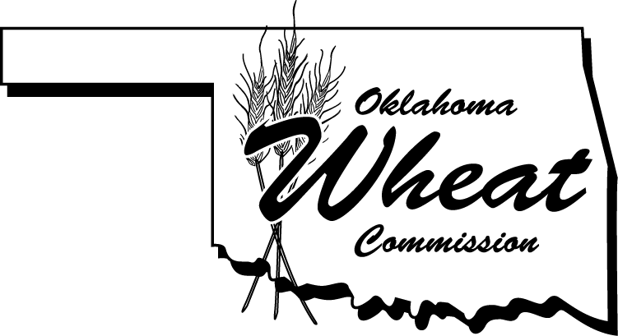
News Release

3800 N. Classen Blvd., Ste. C40, Oklahoma City, OK 73118

(405) 608-4350  fax: (405) 848-0372

www.wheat.ok.gov

e-mail: chris.kirby@wheat.ok.gov

For Immediate Release
December 4, 2014 Contact: Chris Kirby
Director of Marketing & Communications
(405) 608-4350

PORTER, GRIBBLE AND KOCHENOWER RECEIVE STAFF OF LIFE AWARD

ENID - The Executive Director and Board of Commissioners presented the Oklahoma Wheat Commission’s “Staff of Life” award to Dr. David Porter, Department Head of the Plant & Soil Sciences Department at Oklahoma State University, Mr. Roger Gribble, recently retired NW Oklahoma Area Agronomist, Extension Research Specialist and Rick Kochenower, Oklahoma Panhandle Area Agronomist and Extension Research Specialist at their board meeting on Thursday afternoon. This award was given to each individual to honor them for their exceptional leadership and service to the Oklahoma wheat industry.
The Staff of Life is the most prestigious award that is given from the Oklahoma Wheat Commission to individuals who have had a strong commitment and dedication to growing wheat, advancing research or working to expand market promotion in both the domestic and international area for the Oklahoma Wheat industry.
“The Oklahoma Wheat Commission felt it was fitting to give this award at the same time to all three of these individuals not only because they have retired or are retiring with their current positions at Oklahoma State University, but also because all three have left behind a legacy each in their own way. The accomplishments made in creating better research initiatives to help Oklahoma wheat producers for greater competitiveness in the global marketplace is something they collectively have been involved with on many different levels.” said Mike Schulte, Executive Director of the Oklahoma Wheat Commission.

Dr. David Porter has been with Oklahoma State University for 7 years after being with USDA-ARS for 18 years. Dr. Porter’s support for all aspects of the wheat industry including faculty, students, wheat variety development, extension outreach, wheat producers and the Oklahoma Wheat Commission has truly helped the wheat industry progress tremendously in the state of Oklahoma. Dr. Porter will soon be retiring from Oklahoma State University to move to Manila, Philippines, and plans to travel and enjoy his family. Dr. Porter will truly be missed by the wheat industry and the Oklahoma Wheat Commission thanks him for his dedicated service.
Mr. Roger Gribble was with Oklahoma State University and Extension for 32 years recently retiring. Gribble was named Outstanding Extension Educator in 2014, Outstanding Plant & Soil Science Extension Specialist in 1997 and now the OWC Staff of Life Award. Gribble’s dedication to the wheat industry in Oklahoma helped producers and wheat variety development advance during his tenure. Gribble describes his best day was in any wheat field and loved OSU wheat tours! Roger’s retirement plans include his family farm & ranch operation and being a dedicated husband, son, father and farmer.
Mr. Rick Kochenower has been with Oklahoma State University Extension for over 16 years providing expertise and outreach to producers and assistance in the Panhandle of Oklahoma. Kochenower’s favorite work was wheat variety trials in the panhandle, grain sorghum performance trials in the state and no-till rotations in the Great Plains. Kochenower received a patent for his development for Goodwell Bermuda grass, received the Friend of Wheat Award in both Oklahoma & Texas and now the prestigious Staff of Life Award. Rick will soon be leaving his position in Goodwell, OK to pursue his new career and journey in the seed industry.

The Oklahoma Wheat Commission works to promote greater utilization of wheat in both domestic and international markets through research, market development and public education. Five wheat producers representing designated districts across the state serve as the Oklahoma Wheat Commission’s board of directors. Current officers are Don Schieber, Chairman, Ponca City; Kenneth Failes, Vice-Chairman, Cherokee; Tom Stephens, Secretary-Treasurer, Guymon; Michael Peters, member, Okarche; and David Gammill, member, Chattanooga.
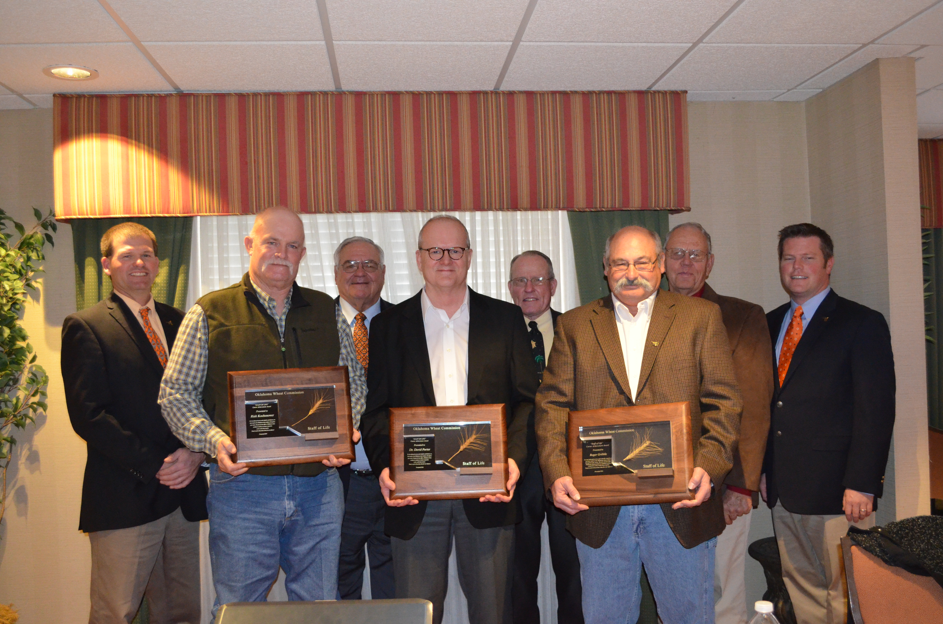
Photo Caption: Back Row: Michael Peters, Oklahoma Wheat Commission Board Member; Don Schieber, Chairman, Oklahoma Wheat Commission; Tom Stephens, Secretary/Treasurer, Oklahoma Wheat Commission; Kenneth Failes, Vice Chairman, Oklahoma Wheat Commission; Mike Schulte, Executive Director, Oklahoma Wheat Commission present the Staff of Life Award to the three individuals in the front row: Rick Kochenower, Oklahoma Panhandle Area Agronomist and Extension Research Specialist; Dr. David Porter, Department Head Plant & Soil Sciences, Oklahoma State University; Roger Gribble, retired NW Oklahoma Area Agronomist and Extension Research Specialist

