**Overview**

1. Homepage - basic info about the schools
   * [x] map of the schools - non interactive, color by level
   * [x] affiliation network
   * [x] word cloud of mission & vision
2. School's page
   * [x] map of locations
     + need to add bus stop
   * [x] radial chart
   * [x] cca, special programs and subjects table
     + [ {'type': 'sport', 'cca': 'basketball'} ]
   * [x] cca achievement heatmap
     + [ {'year': '2011', 'award': gold, 'value': 3} ]
   * [x] cca achievement datatable
     + [ {'year': '2011', 'sport': 'basketball A div', 'award': 'gold' } ]
   * [x] entry score bar average
     + data wrangling to remove the commerce (see eunoia)
     + data wrangling to add primary sch
3. **Home Page**

**Maps**

* Static map of schools (color by level?) + overview data e.g. number of schools with express/NA/tech
* Map of the schools ("school finder")
  + Toggle to see info about the school - choose to see all pri/sec/jc/poly/etc - ~~further options based on that~~
  + ~~Clicking functionality - click on X school show charts e.g. bar chart of types of ccas~~ (Feature moved over to school’s page, in order to have less clutter on landing page)
* ~~Map of schools and public transport?~~ 
  + ~~map bus stop and mrt~~
  + ~~let them click on house, calculate distance to school or find schools within certain radius~~ (Did not fit into theme of website)
* 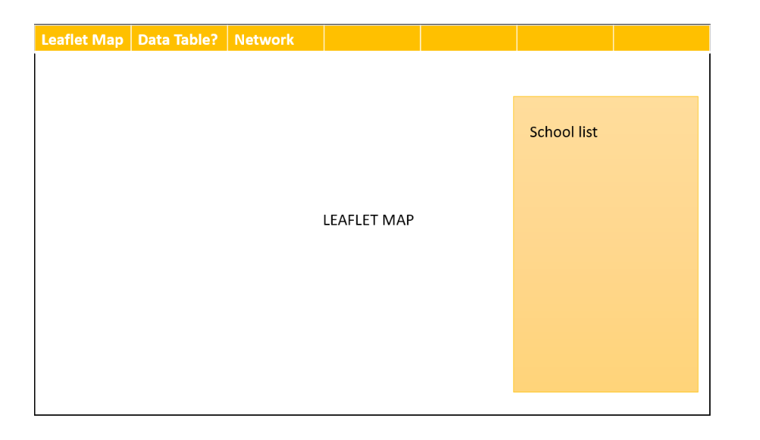~~layout~~ (Designed scrapped for in place for a more landing page layout, rather than a web app as the first screen)
* Animation: using keyframes on load
* Choose consistent colour scheme for maps and network graphs
* Create buttons for filtering schools on map using bootstrap
* Add shadows to graphs
* Implement error message if school info is wrong
* Implement autocomplete form for guiding user to appropriate school name input

**Network Graphs**

* graph of school affiliation
  + ~~option 1: have the whole network shown + let user click on a school - all paths connected to school will be highlighted~~ (Too messy with javascript)
  + option 2: click on school and see its subgraph
* ~~school sports~~ (Sports or subjects does not fit into the overview-ish theme of the landing page)
* ~~similarity score based on subjects or sth~~
* ~~Animate on mouseover~~ (javascript renders too slowly, better to render while user is still on landing page)

Word clouds

* Added word clouds based on the mission and vision of schools
* Data to be wrangled externally for speed
* Animated on mouseover

1. School’s Page

* ~~3 Rows 2 Columns layout of school information~~ (Scrapped as this layout would be too cramped and there is limited height on a computer screen)
* 1 row 3 columns of simple graphs, and 1 row 2 columns of data tables
  + If primary school level: order of graphs to be radial chart of school programmes, achievements, and **vacancies**
  + If other levels: order of graphs to be radial chart of school programmes, achievements and **entry scores**
* Move data tables according to cursor on school programmes and/or achievements.
* Add Icons within school info to make paragraphs look less wordy
* Synchronise colour across all graphs and add shadows
* Streamline use of classes and ids in grid layout

1. Others

* Removed bootstrap CSS as 99% of the other css was not used all, copied relevant CSS into file CSS