2022 Final Year Projects

Detailed System Design Document

Sportie shopping Application
Version 00

Group Number: 1
Lastname, Initials, Student number
Lastname, Initials, Student number
Lastname, Initials, Student number
Lastname, Initials, Student number

To be completed by Coordinator
Date Received: _____/_____/_______
Signature: ______________________
Coordinator Notes:
________________________________________
________________________________________
________________________________________

Revision History
Revision Number | Date | Comment
1.0 | Date | Details

Table of Contents
2017 Final Year Projects 1
Detailed System Design Document 1
Name of the System goes here 1
Revision History 2
Table of Contents 3
1. Document Overview 5
Scope 5
Audience 5
Related Documentation 5
Document Conventions 5
2. System Overview 5
Description 5
System Architecture 6
Software Architecture 6
Hardware Architectures 6
3. Hardware Design 6
Hardware Components 6
Computer Systems 6
Peripherals 6
Networks 6
Project Specific hardware items (e.g. Sensors, Transducers, Robotics, Enclosure Design) 7
Hardware Integration 7
Logical Design 7
Physical Design 7
Recovery Design 7
5. Data and Database / Files 8
Data Flow Diagrams 8
Database Design (ERD) 8
6. System Interfaces 8
9. references 9

Document Overview
This System Design Document has been created to streamline and outline the proposed system design for the Sportie Shopping Application. The Sportie shopping application is intended to lessen the burden of door to door acquisition or buying. Customers will have the opportunity to filter products of their choice and browse other items on sale. They will also be able to pick whether to have deliveries made to their door steps. Also the system will simplify the administrator’s task of categorizing every item on the dashboard. By designing, testing, and deploying this System, will be able to serve its purpose in a magnificent way and operate online

Purpose

The purpose of this system design document is to provide a description of how Sportie shoe application is going to operate. The SDD provides a description of the system architecture, software, hardware, database and security. The rapid growth initiatives in the world reflects its compelling advantages, such as enhanced governmental performance, lower cost structure, greater flexibility, broader scale and scope of services, greater transparency, accountability, and faster transactions .The main idea is to give a clearance on how the system is going to be developed from its foundation until the final product and specifying the requirements for building the whole system.

SCOPE

We are group 1 and we are building an integrated application. Our system is called Sportie shoe app, in of which the overall motive behind the system is to make sure that it allows people to buy and sell physical goods, services, and digital products over the internet rather than at a brick-and-mortar location. Through the Sportie shoe application system, a business can process orders, accept payments, manage shipping and logistics, and provide customer service.

Audience

- Customer - the customer will be asked to fill or select a billing address, a shipping address, a shipping option, and payment information such as credit card number
- Salesperson – the person who is selling in the store
- Admin – the person responsible to add/Remove items on the website

Document Conventions

Conventions | Description
Main Title | Font: Arial  Font Style: Bold  Font Size : 14
Sub Title | Font: Arial  Font Style: Bold  Font Size : 12
Body | Font: Arial  Font Style: Normal  Font Size : 12

System Overview
Local companies depend upon the attention and business of their target audiences in order to thrive. The meteoric rise of online shopping presents both challenges and opportunities to accomplish this vital task. The Proposed Sportie shoe application will utilize existing online shopping infrastructure and hardware components to provide a magnificent tool which will standardize and improve the efficiency of online shopping and management capabilities. The move Sportie shoe application will be a way of digitalizing services and approaching the fifth generation technology. By designing, testing, and deploying this System, will be able to serve its purpose in a magnificent way and operate online.

Description
Sportie E-commerce application is the name of the program. Our applications are designed to improve local brand clothing products and give them a voice. With an eye on the global digital internet market, the sporty online shopping app targets young, future designers.
The main functions the system will do:
Our application will operate as follows:
- Customer are going to access service by registration an account and logging into the system.
- Customer will have to create the shopping cart so that buyers may add numerous products into it and check out the whole thing.
- Displaying the reviews of each product from customers.
- Displaying “new on store” products from each category
- Administrator will track and monitor the order in the database
- Administrator will able to give feedback of statistics on products.
Performance
In terms of multitasking is going to be able to process multiple request or purchase made on the site whether virtual or manual, different computation performed by admin and users should be executed with at least 0.01 fault tolerance in the web and database
The database should be able to keep track of all event and able to rollback all faults made to system in a sense where by it should be fine turned.
Dependability
The sportie site is going to be responsive in a manner whereby if some tries to logging with invalid details it should issue or send a message notifying a user that the logins are invalid. In case of payment method it should detect if someone has inserted wrong bank information the system is design to be a hybrid. The system should be able to operate 24/7 and should be user friendly
The server will be configured in such way that it will execute requested information by client’s device.
Database Server
The database server is used to maintain databases that are kept on the server and to grant authorized users access to the data. We're going to make use of the cloud-hosted MS SQL server database. We're going to use a M|S SQL cloud database to store and sync data. Data is synchronized in real time to every connected client and stored as JSON.

Software Architecture
Login page
Any item on the product can be seen, edited, or deleted by the admin. The user may see all the data.
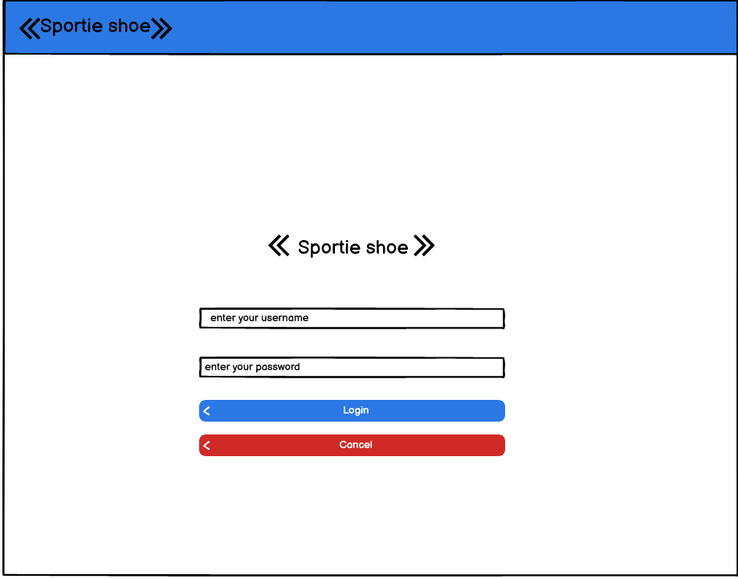

Dashboard page

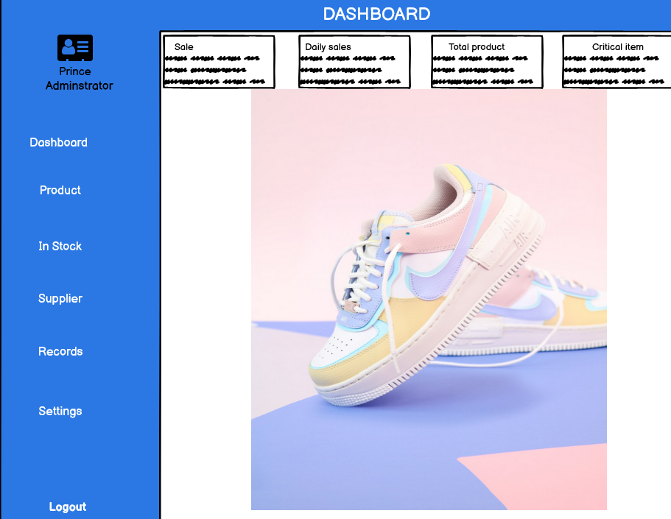

Hardware Architectures

Hhardware interface | s Software interface
Operating system: windows | Microsoft Visual studio 2019 for development using C##
Hardware :1TB | Notepad++
Ram :8 GB | Microsoft SQL management studio 18 for creating organization database
Processor : intel core I5 vPro 8 gen | Microsoft SQL server for Storing the database

Communications Interfaces

The customers can access the web application using the computers, tablets or any smartphone. To access the website, the customer must have an internet connection with 52 kbps dial-up modem and broadband internet, to an internet service provider. Customers must set up an account with their personal email addresses and phone numbers in order to receive notifications from the company. The system will include live chat, which will help with quickly responding to consumer issues and difficulties.

Hardware Design

Hardware Components

Computer Systems
Our application (website and desktop) will run in any android/windows operating system

Peripherals
The mobile application will use Network file system (NFS), Andrew file system (AFS) combined for web and desktop application, common internet file system (CIFS), IP address and HTTP protocol to make request of internet pages and API to connect/provide interface to NAS and manage MS SQL database/ web server database.

Networks
The following protocols will be required because the program connects to our web server database over the internet for customer to connect on daily basis.
HTTP
- Hypertext transfer protocol which is responsible for fetching application files in the web server.
NFS
- Network File System enables Ssystem administrators to share all or a portion of a file system on a networked server to make it accessible to remote computer users.
AFS
- A distributed file system that is conceptually similar to NFS (Network File System) in that it allows you to share disk space among hosts, but AFS accomplishes this in a different way
IP address
- Internet protocol used to monitor the people who are accessing the internet

NAS
- A storage device connected to a network that allows storage and retrieval of data from a centralized location for authorized network users and heterogeneous clients.

Hardware Integration

Logical Design
The application is going to connect to our webserver database to store and retrieve data.

Physical Design
Connectors such as Wi-Fi and data connection are going to be used instead of physical cables since students counselling online communication is a mobile based application.

Recovery Design
There must be a computer at the side where we are going to store our data for recovery purposes. The reason why we have computer that is connected to our webserver database is to store our data for recovery in case of a database crash

Figure 3.1: sportie online shopping Architecture
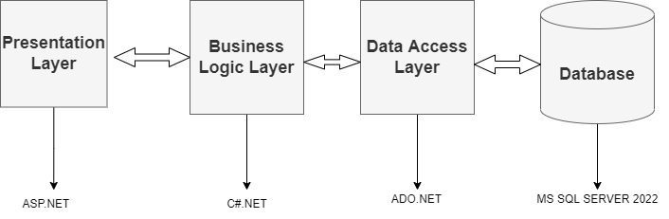

Data and Database / Files

Data Flow Diagrams

The classic visual representation of how information moves through a system is a data flow diagram (DFD). A tidy and understandable DFD can graphically represent the appropriate quantity of the system demand. It can be done manually, automatically, or both. It demonstrates how information enters and exits the system, what modifies the data, and where information is kept.
A DFD's goal is to outline the scope and boundaries of a Sportie shopping application as a whole. It can be utilized as a communication tool between a system analyst and any participant in the sequence that serves as the foundation for system redesign. The DFD is also known as a bubble chart or data flow graph.
Levels in Data Flow Diagrams (DFD)
Any level of abstraction for a system or piece of software can be performed using the DFD. In reality, DFDs can be divided into stages that signify a growth in functional detail and information flow. In DFD, levels are denoted by the numbers 0, 1, or 2. The data flow diagram in this example has three main levels: 0-level DFD, 1-level DFD, and 2-level DFD.

DFD Level 0 for Sportie shopping application
DFD Level 0 identifies the boundaries between a system's environment and the entities that interact with it. Sportie shopping application is also shown in this figure at a high level.

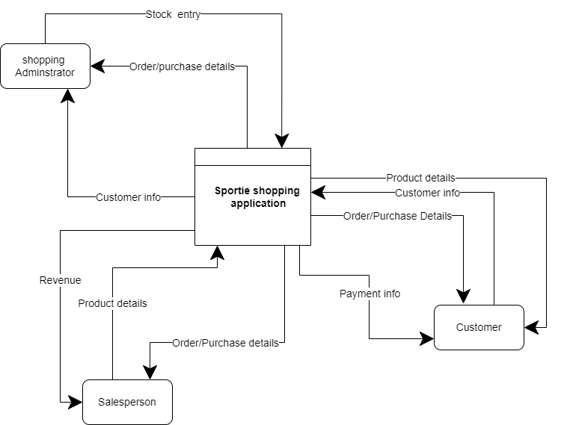

To set up the project context, the graphic displays the primary process in a single node. This background concisely illustrates how the project functions. The user inputs data into the system, which subsequently outputs results to them. In addition to this, the diagram will make it clear that data flow is already present.
Level 1 DFD for Sportie shopping application
In the context diagram, the Sportie shopping application DFD Level 1 is the "detonated view." Its purpose is to clarify the idea that is derived from the context diagram.
Level 1 specifically displays Sportie shopping application DFD Level 0's more comprehensive features. This is done to make the pathways (flow) of the data clear and show how it changes from input to output.

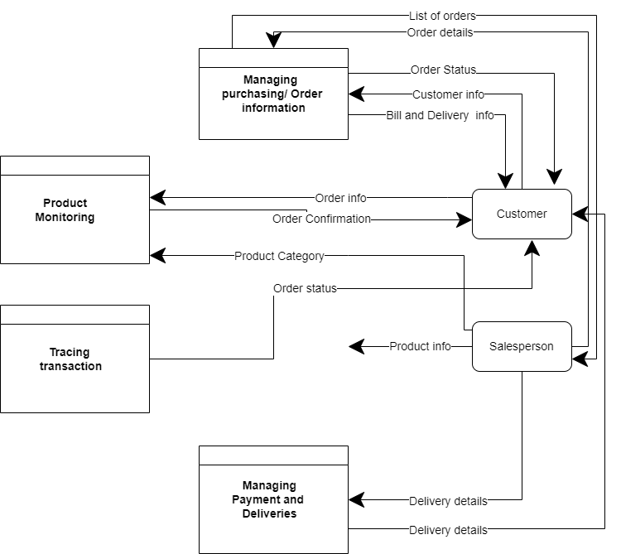
The created diagram depicts four distinct scenarios: management of client information, management of orders or reservations, management of delivery schedules, and management of transactions and payments.
Level 2 DFD for Online Shopping System
The data flow diagram's Level 2 DFD for the Sportie shopping application also has the maximum level of abstraction. The concept from DFD level 1 is also expanded upon at this level. Both the data that flows and the level 1 sub processes are included.

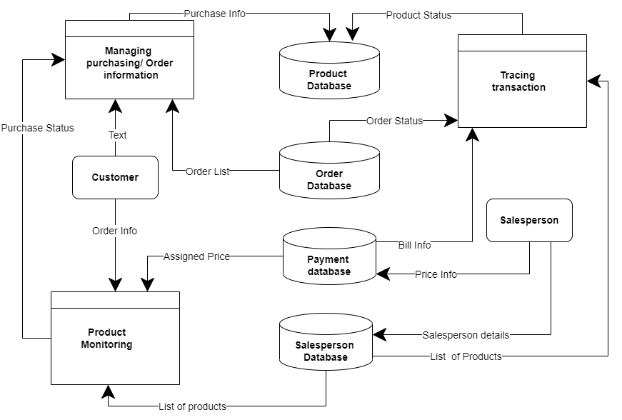

Database Design (ERD)
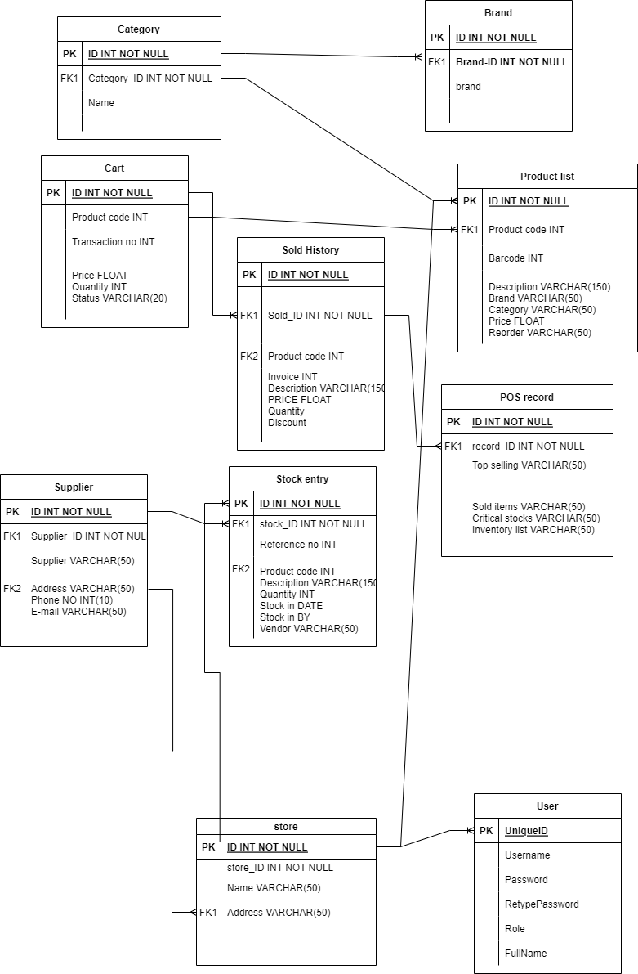

System Interfaces
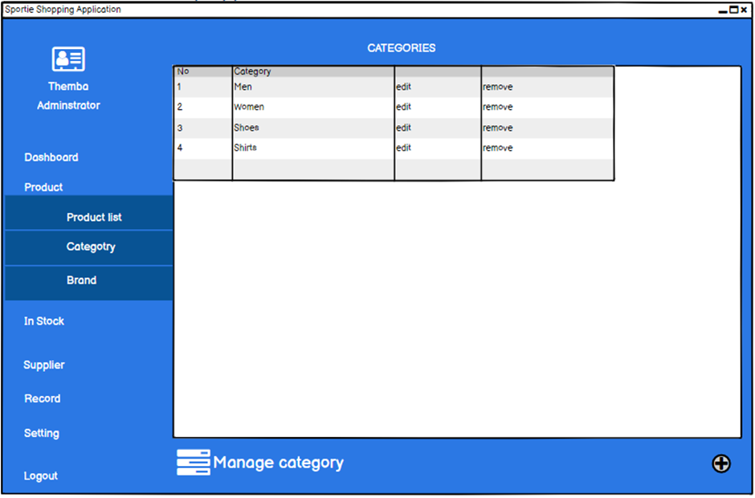

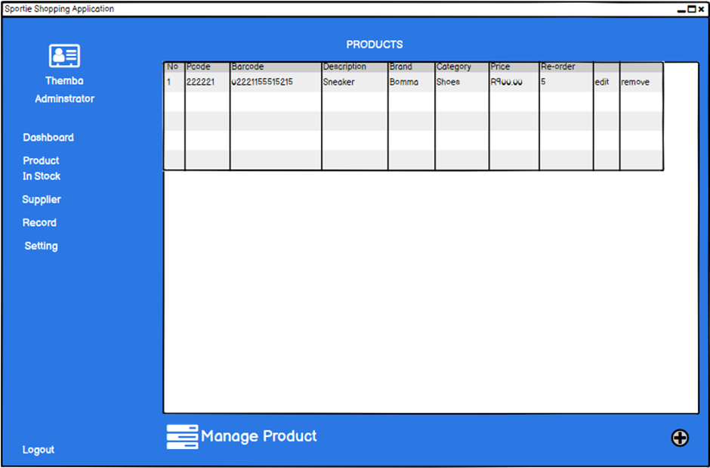

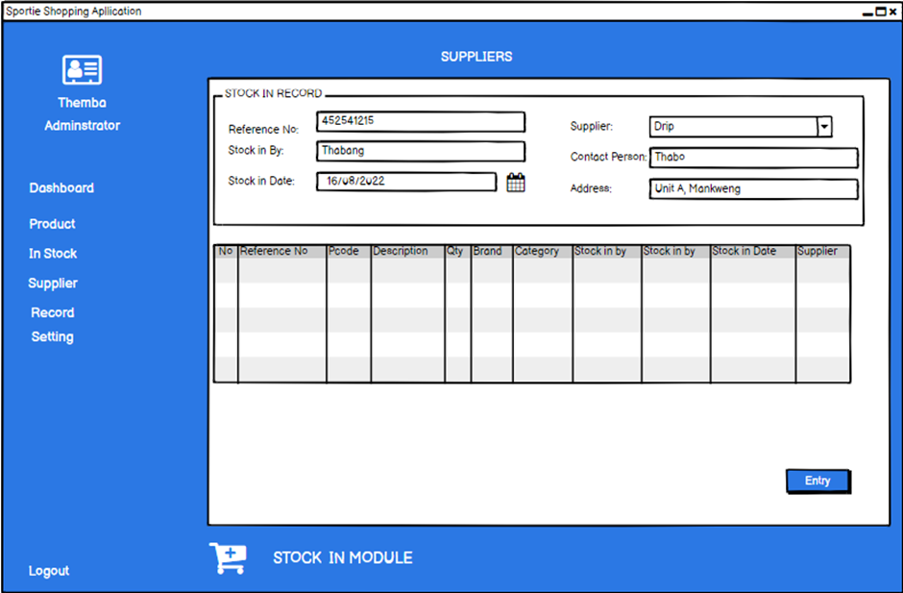
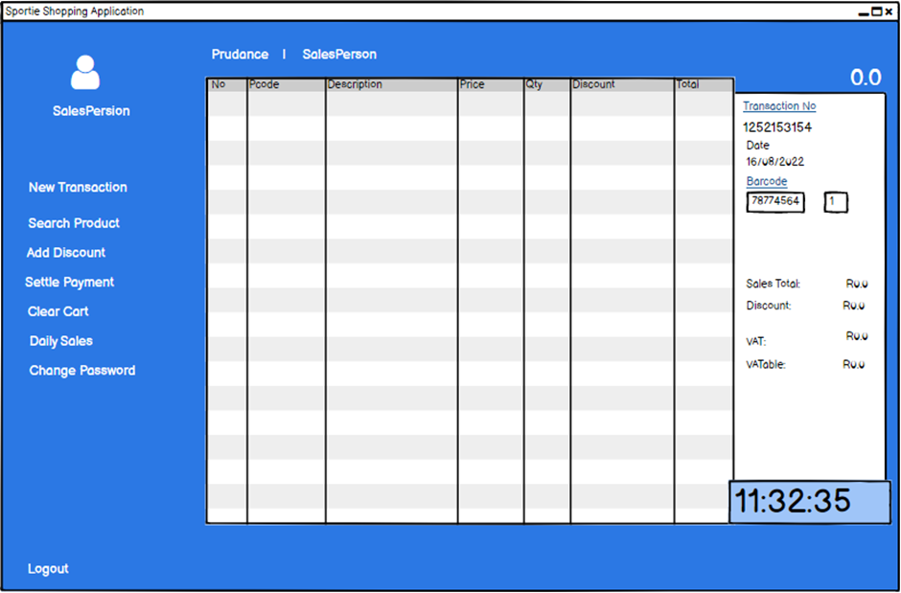

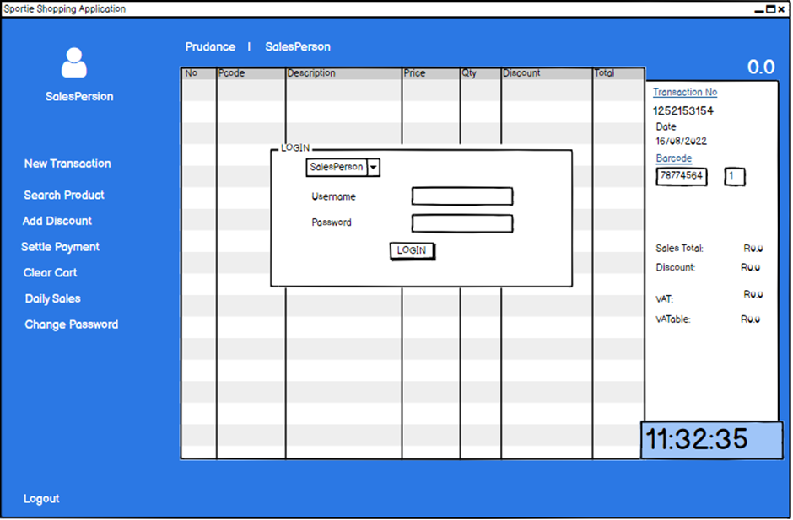

references
1. IEEE Recommended Practice for Software Requirements Specifications," IEEE Std 830-1998
2. HTML5: - http://www.w3schools.com/
3. CSS3: - http://www.w3schools.com/
4. JAVA Script: - http://www.w3schools.com/
5. Database: https://krazytech.com/projects
6. C#: https://www.tutorialspoint.com/csharp/index.htm
7. Mokhov, S. (2010). Selected Project Requirements. In Concordia University. http://users.encs.concordia.ca/~c55414/selected-project-requirements.txt
8. Team 1, 2010. Software Design Documentation, UUIS. Last Modified: Apr. 29, 2010.

