Clint Valentine

BIOL6309 module08

11/21/2016

**Comparing Strains of Helicobacter pylori**

**Compare strain Helicobacter pylori 26695 (AE000511.1) to the two other strains using mummer and then visualize mummerplot:**

AE000511.1 *vs.* CP000241.1

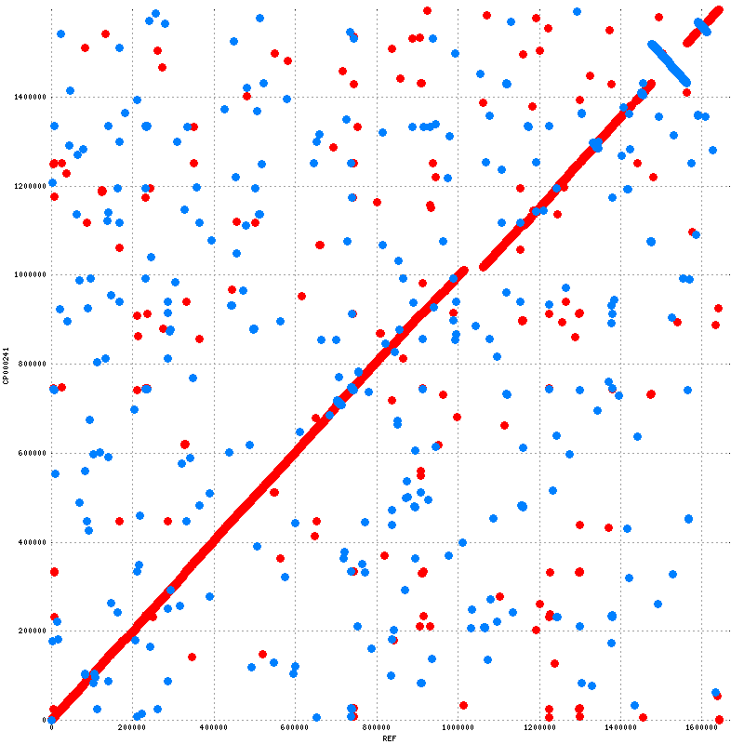

AE000511.1 *vs.* AE001439.1

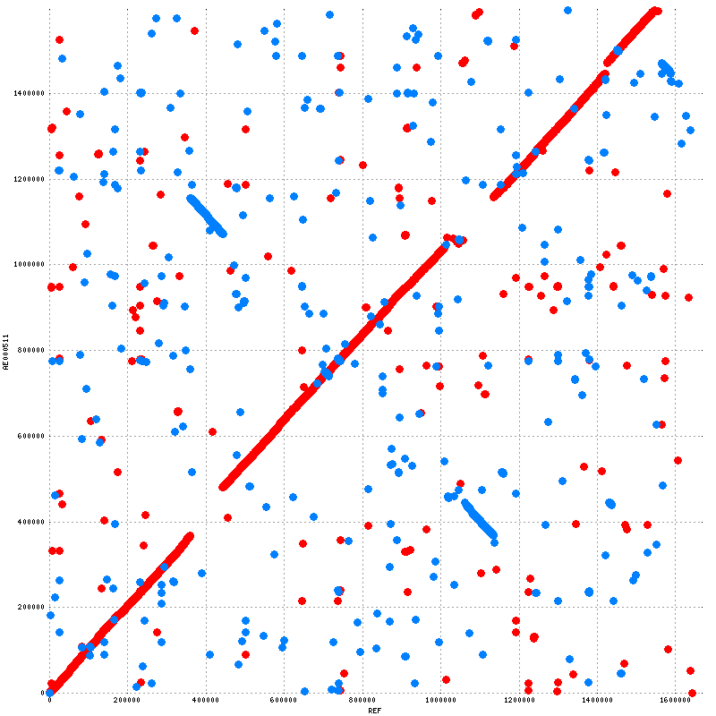

Overall the genome for *Helicobacter pylori* 26695 (AE000511.1) looks most similar in structure to *Helicobacter pylori* HPAG1 (CP000241.1) where there is a small deletion and one small inversion. There is greater structural dissimilarity between AE000511.1 and *Helicobacter pylori* J99 (AE001439.1) as evident by what appears to be a reciprocal translocation. Both segments of the translocation have also inverted in orientation as they now face an opposite direction. Few other differences (indels) exist between the two compared genomes against AE000511.1 as evident by little interruption from the x = y trend line.

**Promer Search of AE000511.1 *vs.* AE001439.1**

**What differences do you see between the plots from the mummer output and the promer output?**

The promer output (below) shows a higher conservation of sequence as immediately evident by the lack of ‘noise’ outside the y = x trend line. There is little other difference between the two plots.

AE000511.1 *vs.* AE001439.1 (promer)

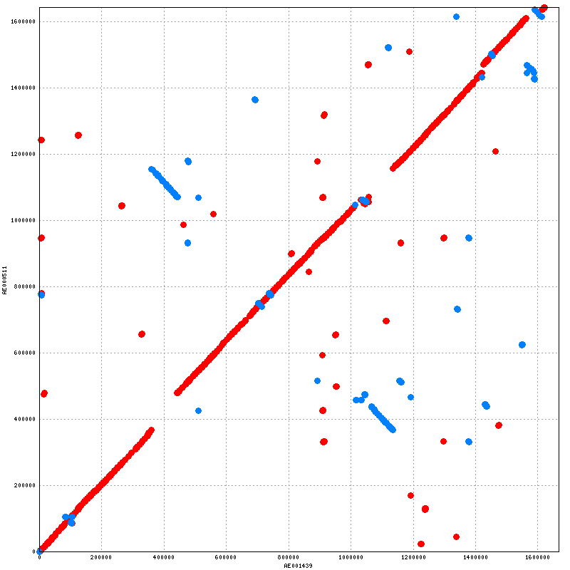

**Which one displays a stronger signal?**

The promer output displays a stronger signal.

**Which plots displays more noise?**

The mummer output displays more noise.

**Why does one display a stronger signal?**

Protein sequences diverge slower than their corresponding DNA. Protein sequences are directly responsible for functional roles within the cell and have less degrees of freedom when it comes to divergent evolution and mutation accumulation. DNA, however, is less responsible as a whole to the functional role of protein as it contains many intron sequences and synonymous coding patterns that are resilient to mutation effect on protein function.