Clint Steadman

CSD340 Mod 6.2 Assignment

2/4/23

Kevin’s website

* Front-end Style Guide
  + Selected Google fonts

<https://www.abigailregucera.com/blog/best-free-font-pairings>

* + Selected Color palette

<http://paperheartdesign.com/blog/color-palette-pretty-in-pink>

* Wireframes, sketches, or prototypes

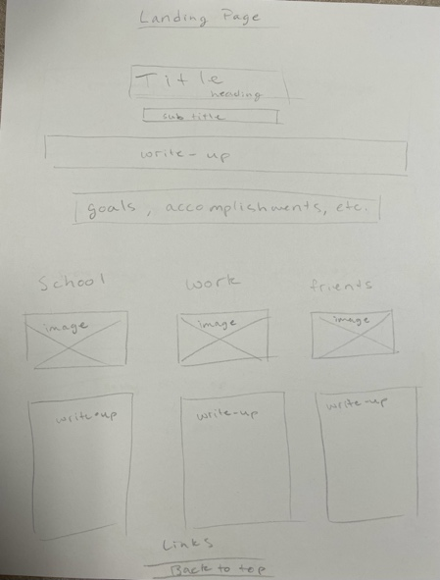

* At least one completed interview of the subject (the document must contain a minimum of 10 interview questions and responses from the subject).

1.     Background and where I grew up:

* + - My name is Kevin Meza. I was born in Miami, FL, I’m 33 years old (MY JESUS YEAR), and I’m a Virgo! My dad is Mexican and my mom is Salvadorian and I was raised Cuban in Miami. My first language is Spanish and I learned English in school. While I was in remedial classes for so long, I thought I was fine after my first year… I felt so silly for so long because I was excelling way too quickly and I was ready for something more my pace.

2.     Current field or industry:

* + - Lolololol I have always loved dancing but I could never do it! I was raised in the church and it wasn’t really a thing that a boy could do… so I finally took the plunge once I graduated high school and left the church. I took my first dance class at a cheerleading studio and I’ve never looked back. I took it really seriously and wanted to be the best at it. I’m now a performer at Disney World and have been there for 11 years!

3.     What do I love most about my job?

* + - My job is, for the most, part stress-free. I love how I can clock in, do my job, and leave everything at work and come home to relax. I also love that I can perform for a living! It’s kind of hard to say that nowadays and I feel incredibly blessed.

4.     Particularly memorable experience I’ve had in my career?

* + - I opened up the Star Wars: Galactic Starcruiser experience in Disney World as my droid friend, SK-620. It’s honestly soooo cool! Something of this size and caliber has never been attempted before and it’s so exciting being on the cutting edge of entertainment. It has really tested a lot of skills I never thought I’d ever need to use… like stealth! Make no waves or commotion while secretly operating a droid two feet away from people.

5.     What are your hobbies and interests outside of work?

* + - I love playing video games, consuming media like TikTok, frolicking in beautiful weather and eating adventurous food. I also love kitties! I want to pet all the kitties that want pets! I love holding them and kissing them and touching their little toe beans. If I could have one last day on Earth, it would be spent in a kitty cuddle puddle. I also do photography on the side, I love taking photos of friends by providing headshots, family photos and photos of their pets.

6.     Challenge I’ve faced and overcame it:

* + - This is gonna get a little serious. Oops. One of my biggest challenges was honestly coming out of the closet. I was enthralled in the church culture and I couldn’t escape it as much as I wanted to. I felt trapped, like I had no exit plan. It was awful! I’m so glad that I had the courage to leave the church and discover who I was in spite of it. I just remember being so scared of being alone and having no more support system, but I knew I had to find my chosen family. And now I’m so much happier than before!

7.     Long term career goals:

* + - That’s a very good question. Uhm… I don’t have a clue. I’m winging it as we speak. I’m going to school for Software Development but will I love it or will it just have to be a survival job? If the job pays well then I’ll have to see where this takes me. As of now, it’s all a big question mark. And I’m at peace with that.

8.     Person whose had a big impact in my life:

* + - OOO! I talk about this all the time. My friend, Annie Segarra, has been such an influential force in my life. I give her credit for giving me a backbone. I was so meek and quiet and wanting to just please everyone that I didn’t have my own opinion. Whenever I had someone walk all over me, she came behind and figuratively smacked my back and told me to stand up for myself. With a lot of tough love over the years, I have become the headstrong person that I am.

9.     Values or qualities that are important to you.

* + - I love passion—in whatever sense it is! I love seeing the fire behind someone’s eyes! When someone talks passionately about their favorite subject, their whole demeanor changes. Everything lights up and becomes that much more important. I also enjoy a good sense of humor. Dad jokes. Punny jokes. All of these have a straight shot to my heart.

10.  Share a moment of success or accomplishment that you’re particularly proud of.

* + - I don’t think this will be the most successful thing that I have done but one thing that I’m so glad to have done is go back to school! I’ve felt so much embarrassment about not finishing school and its followed me all my adult life. I had a 10 year gap since I last went to any kind of school and I felt like I wasn’t able to reacclimate myself to online classes as an adult, but it’s been an easier transition than I expected. A lot of it has to do with the fact that it’s up to me to better myself and no one will do it for me. I know it’ll be a couple years but I can’t wait to finish and get my degree… so then I can put that as my next moment of success.
* One page (minimum 250 words) inspiration document containing all of the research you completed to gain a better understanding of the subject and their hobbies.

Kevin is a good friend of mine, he’s always happy and loves to feel the energy of those around him. He loves passion—in whatever sense it is! He said, “I love seeing the fire behind someone’s eyes! When someone talks passionately about their favorite subject, their whole demeanor changes. Everything lights up and becomes that much more important…”, and that’s also what you always get when conversing with him. We are fellow performers and we both met working at Walt Disney World. We quickly became friends and now are roommates. In his interview questions he responded with such love about cats. His face lights up every time he sees and interacts with my cat, Lily. He also mentioned that his hobbies include video games but what he didn’t mention was the fact that he LOVES anything that has to do with The Legend of Zelda, especially the title character. Princess Zelda speaks to his inner princess. Not only does he resonate with Princess Zelda, he’s a fan of Princess Peach from Super Mario Bros. and Sailor Moon. The Logo for his Photography business has a yellow moon in it which is a nod to Sailor Moon. Speaking of, he continues his love for seeing “fire behind someone’s eyes” by capturing it in photos. Not only does he work as a full-time performer and go to school, He continues to progress in his photography skills. Kevin is a wonderful friend and all around awesome, fun and loving person. I’m blessed to have him as my friend.

* One page (minimum 250 words) document containing a short bio of the subject

Kevin Meza is a 33-year-old performer at Disney World, who has been working there for 11 years. He was born in Miami, Florida, and raised in a Mexican-Salvadorian household in Miami. His first language is Spanish and he learned English in school. He started his dancing career after leaving the church, where he was raised and didn’t feel free enough to dance how he wanted. Kevin loves his job at Disney World, as it is mostly stress-free and he gets to perform for a living. He was part of the Star Wars: Galactic Starcruiser experience, where he helped opened up the venue working with his droid friend, SK-620. This experience has tested his skills and allowed him to be on the cutting edge of entertainment.

Outside of work, Kevin enjoys playing video games, consuming media like TikTok, spending time in beautiful weather, eating adventurous food, and playing with cats. He also has a passion for photography and loves to take photos of friends, families, and their pets. One of the biggest challenges he faced in life was coming out of the closet, which was a difficult decision for him as he was raised in a church culture. However, he found the courage to leave the church and discover himself, eventually finding his chosen family.

Kevin mentions that the most successful thing that he has done, and so glad to do, is go back to school! He had felt so much embarrassment about not finishing school and that has followed him all his adult life. Kevin is currently studying Software Development and is so proud of how far he’s come, but he does not have a clear career goal yet. He is still figuring things out, and he is at peace with that. Someone he has always admired and loved is his friend Annie. She has had a big impact on his life, giving him the backbone to stand up for himself. He values passion and a good sense of humor in people and exemplifies that by lifting up others around him with a smile.

* Top of Form
* The images you intend to use in the final project
  + 3 Images should be related to the subject's hobbies
    - This will go under the hobby page and should include a small write-up explaining their relevance. Remember, you are trying to build a story/timeline for visitors to follow

<http://www.stickpng.com/search?q=cat&page=1>

<https://pngtree.com/free-png-vectors/cartoon-cat>



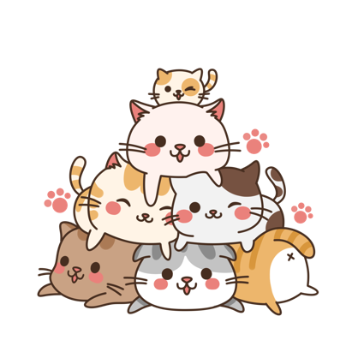

* + 3 images should be related to the subject’s goals, personal accomplishments, or embellishments
    - These will go on the landing page and should include a small write-up explaining their relevance. Remember, you are trying to build a story/timeline for visitors to follow

<https://disneyworld.disney.go.com/star-wars-galactic-starcruiser/overview/>

<https://commons.wikimedia.org/wiki/File:Star_Wars_Galactic_Starcruiser_logo.svg>

<a href="https://commons.wikimedia.org/wiki/File:Star_Wars_Galactic_Starcruiser_logo.svg">The Walt Disney Company / Lucasfilm</a>, Public domain, via Wikimedia Commons



<https://www.nicepng.com/ourpic/u2q8a9u2e6o0u2i1_free-png-disney-logo-png-images-transparent-disney/>

* + 1 image should be a portrait of the subject
    - This image will be added to the About page, above the formalized 250-word write-up

