Part B

1. When a search is performed against a company both the CompanyName and the PersonName should be checked for the search term (currently only the CompanyName is searched against).

As shown below, the system which previously searched for the customer based only on the Company Name now searches for the customer based on both the Company Name and the Person Name.

e.g Below the system is being asked to search for all customer’s who have the letter “a” in the Persons Name or the Company Name.

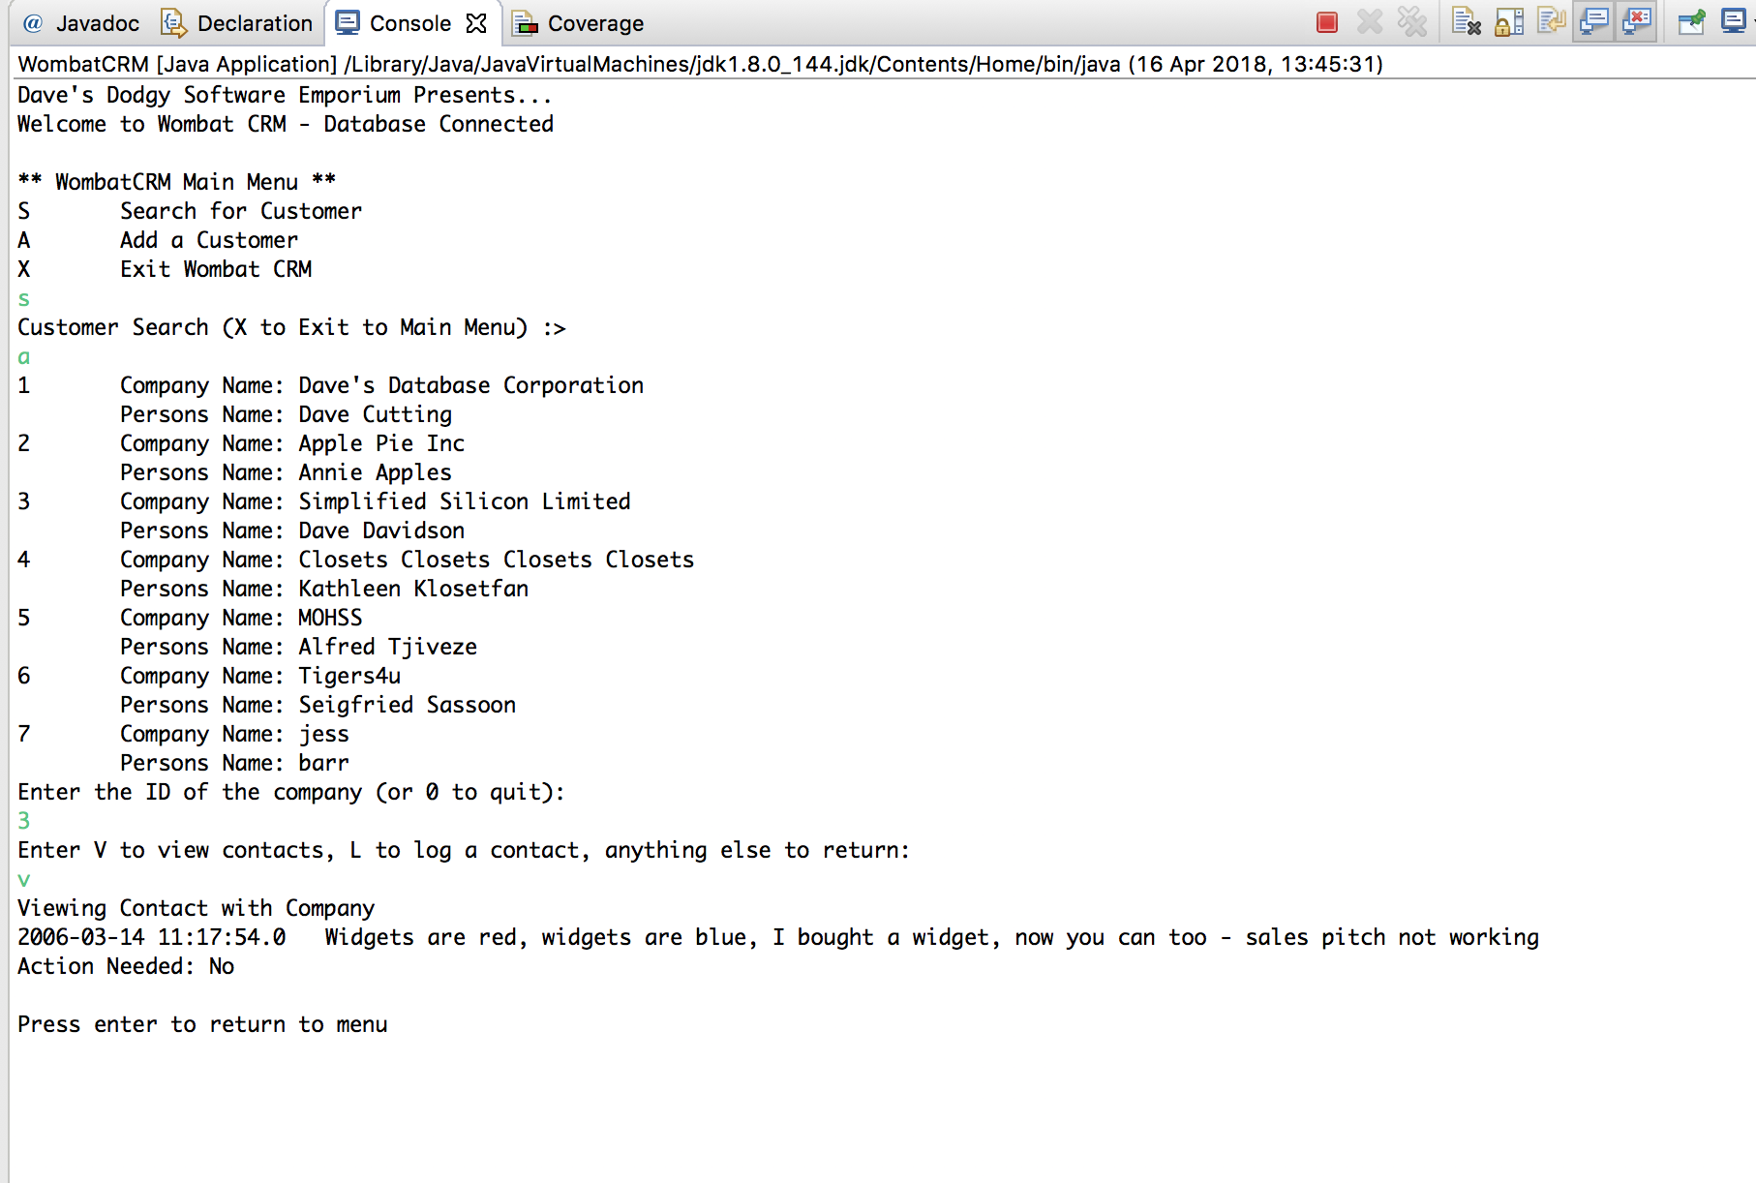

1. When a list of contacts against a company is shown on the screen those that have the visible flag unset (set to 0) should not be displayed.

As shown below, any customer whose visible flag is set to 0 is not shown in the system.

e.g the company with the ID of 3 has 3 contacts but only one is shown in the system.

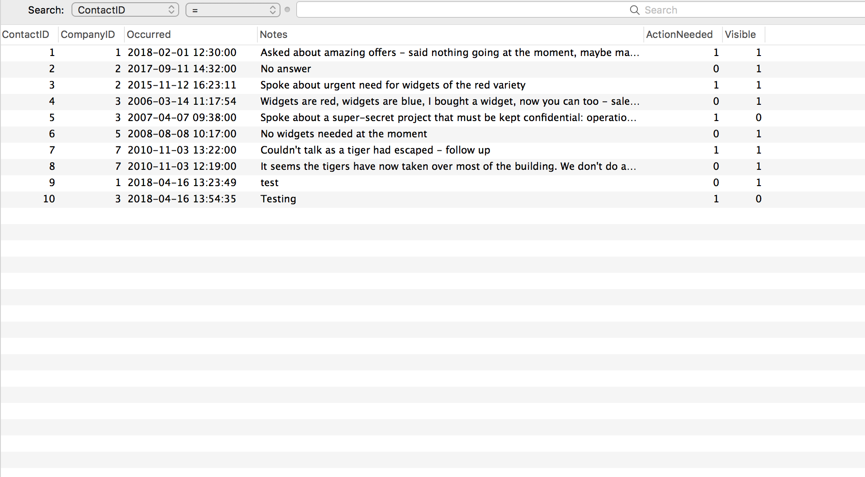

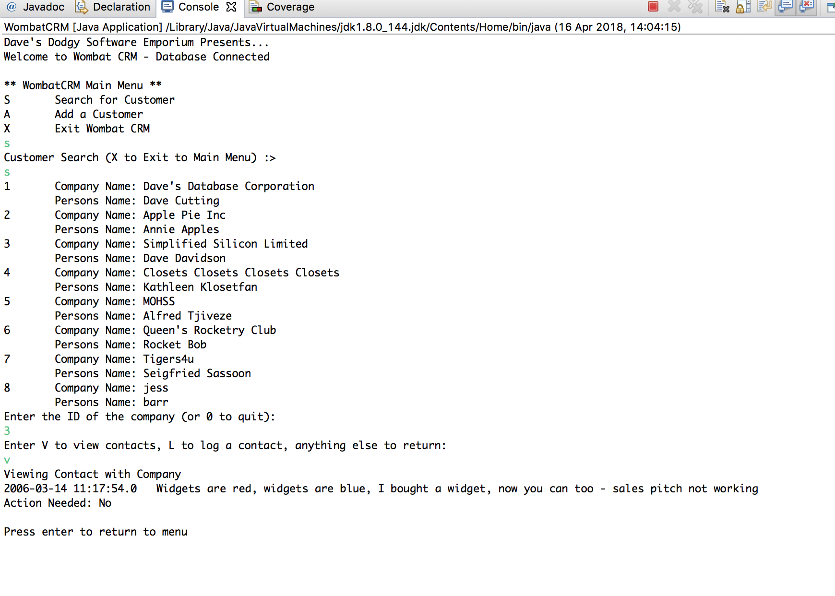

1. When a contact is logged the user should be able to set if it should be visible or not (defaulting to being visible).

As shown below, the customer should only appear if the visibility has been chosen by the user aka if they select “Y”. If the user sets the visibility to “N” the customer should not appear.

