

Eproject

**JAVA Application Designing**

**Library Management System**

|  |  |
| --- | --- |
| **Authors** | **C1808G2 - Group ..** |
| 1. NGUYEN PHUONG MINH THONG – Student1144404 (Leader) 2. MA TRUNG KIEN – Student1144181   3. NGUYEN HONG SON--Student1144387 |
| **Centre Name** | Aprotrain Aptech |
| **Date** | 27th ,September 2019 |
| **Semester** | 2 |
| **Instructor** | PHAN HUU TRI |

**HCM City, 27th September 2019**

**During the time of the second semester , we have been taught and increased JAVA language and coding skills, we made a given-themed project and that’s the Library Management System. This is where Librarians can manage the books’ information , check-in and check-out issued book. Because of the lack of time, there are some features , functions we couldn’t make it but we have done basic ones like Create , Read , Update , Delete , et cetera . Here are some images of the application , tasks , functions of this project.**

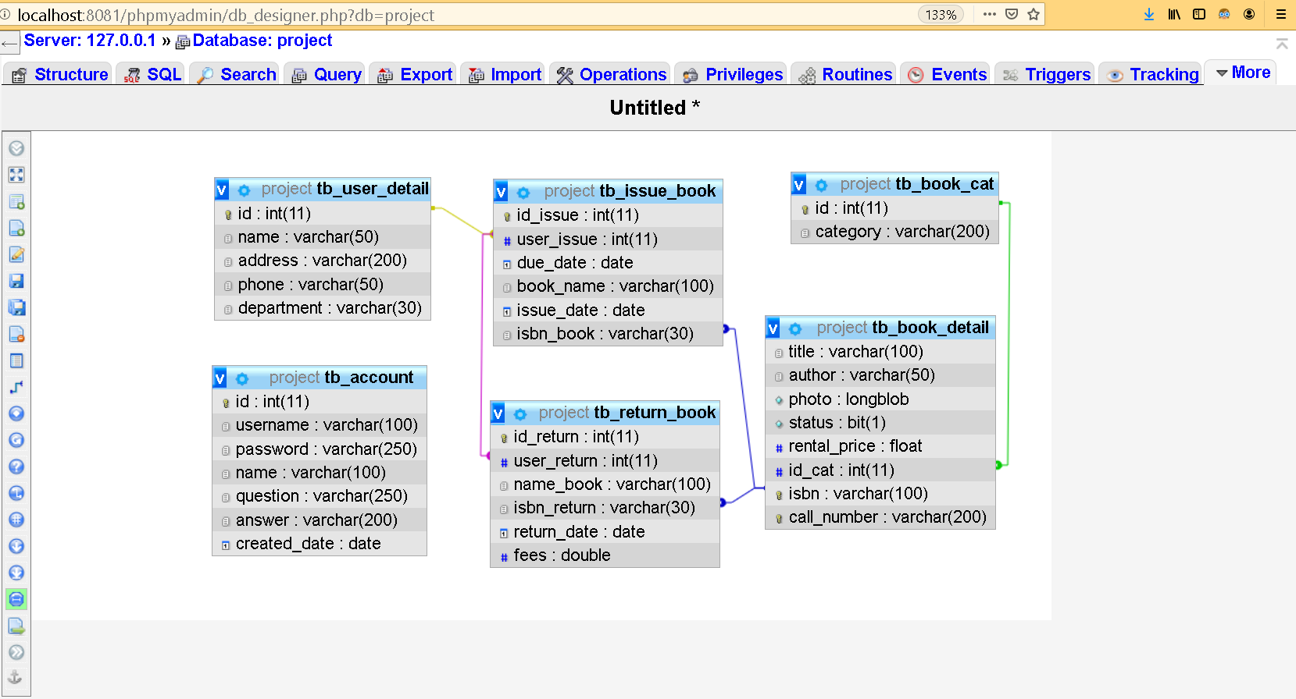

**We use MySQL PHPMyadmin as a database , please install XAMPP and enable both Apache and MySQL , we put the file dtb.sql inside the file .**

**When you import the file name Library into Eclipse to run the app , click on demo -> home and run.**

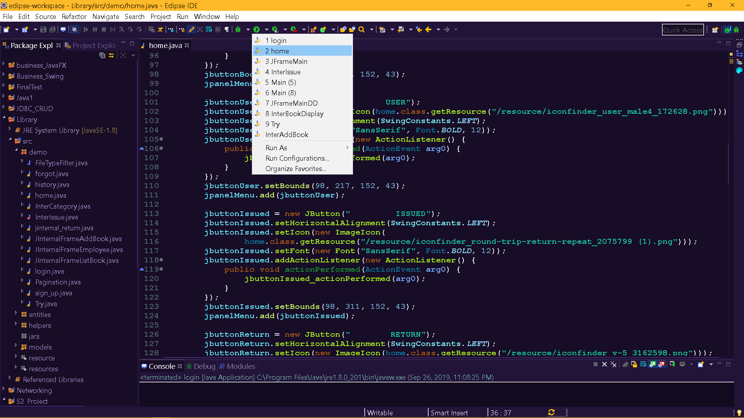

1. INTRODUCTION- ADMIN

The librarian must input their username and password to Log In form in order to access to the application

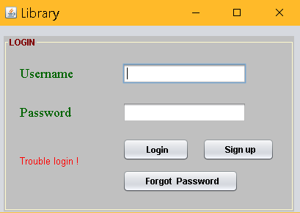

If they don’t have an account yet , there is a Sign Up button for them to create their new account.

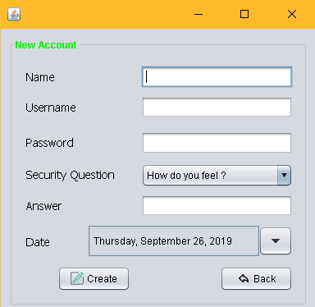

For the new Sign Up , they need to fill the form in with their correct information and then click on the “Create Button”. They have to choose some queries for the further security .

What if the librarian have just forgotten their password , well the solution is at the bottom of the page. 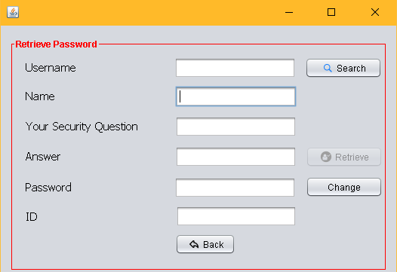

In here , librarian can change the Forgotten password to the new one.

1. This is the HOME page:

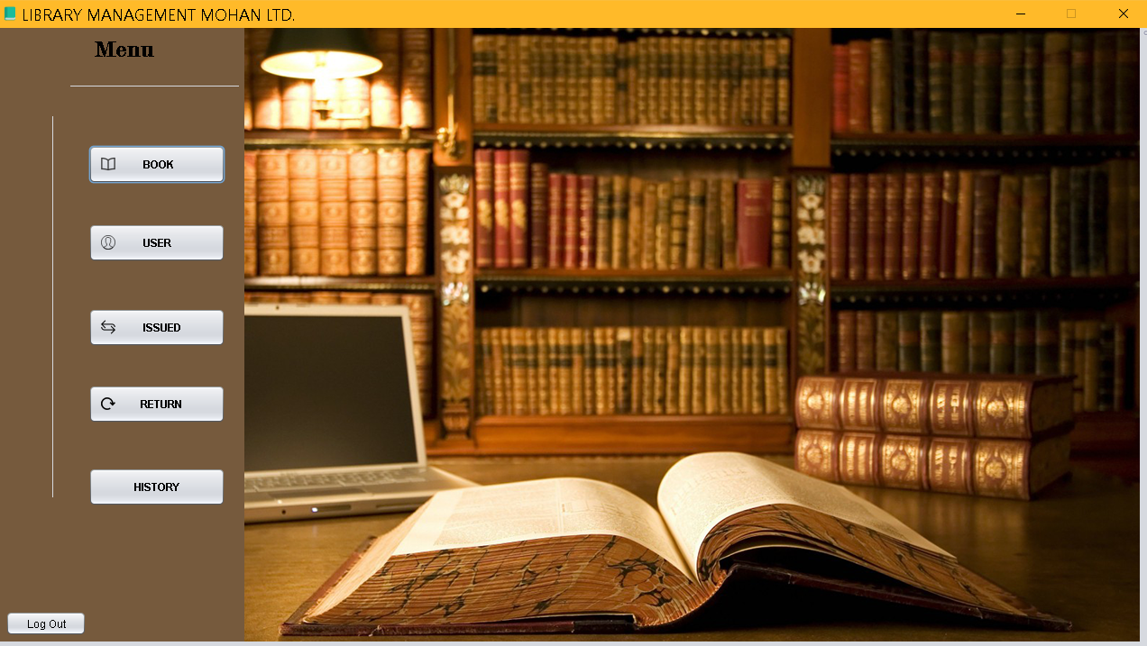

Once the Library has input username and password correctly , they will be able to access to the main page

On the left side , there is a vertical menu of choices , each button stands for its feature.

To the other side , a space that we call “Desktop pane” would contain the coming up pages when we click at one the buttons.

To Add or Update and modify the Category , click on the Book to go for it.

**ADD BOOK** : fill in the book informations

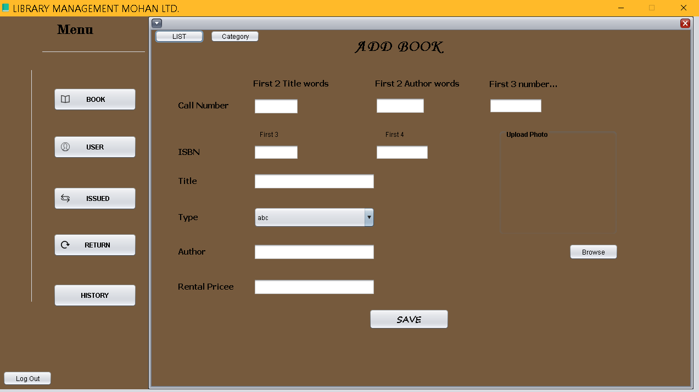

For the Call Number : The first 2 letters is 2 first alphabets of the Tittle , next 2 letters stand for 2 first alphabets of Author’s Name

ISBN: is the chain of 7 unique numbers with the format as NN-NN-NNN , and ISBN will be unique for specific book.

Type: the type of the book like Novel , Self Help…

Author : Name of the person who wrote the book

Rental Price :fee of issue

When all is done , click SAVE

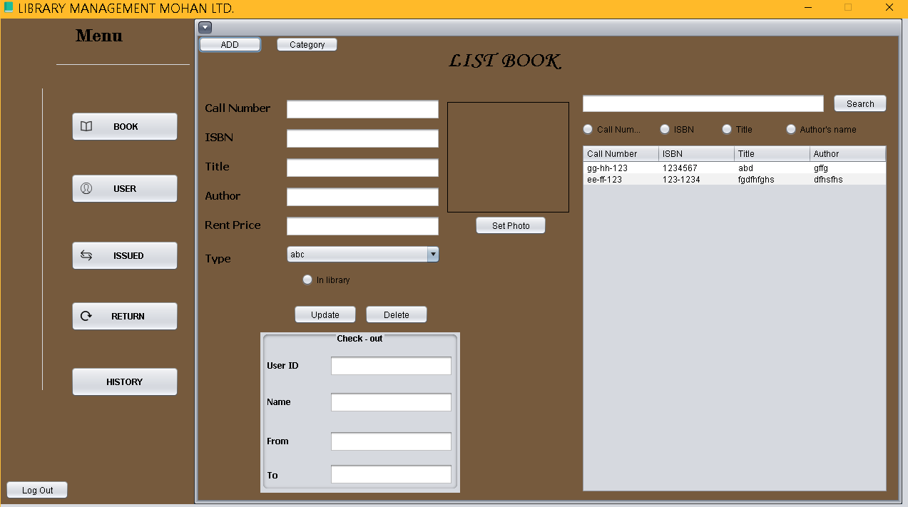

This is where the Librarian can view can seek for book information.

The table at the bottom-right corner contain list of books that available to be issued.

If you want to edit the book information , just click on the row of the book , all infor will be automatically fill in the blanks nearby. From then you can change and click Update to execute the action.

Delete to drop the book.

On the upper-right corner , there is s Search function , just click on one of four Optional Search type below the bar , Call number , ISBN , Title , Author’s Name and then start to search . It will display result of what you chose to search.

---------------------------------------------------------------------------------

If you want to add more Types of book or just Change it , then click at CATEGORY button.

And this is how Category page looks like.

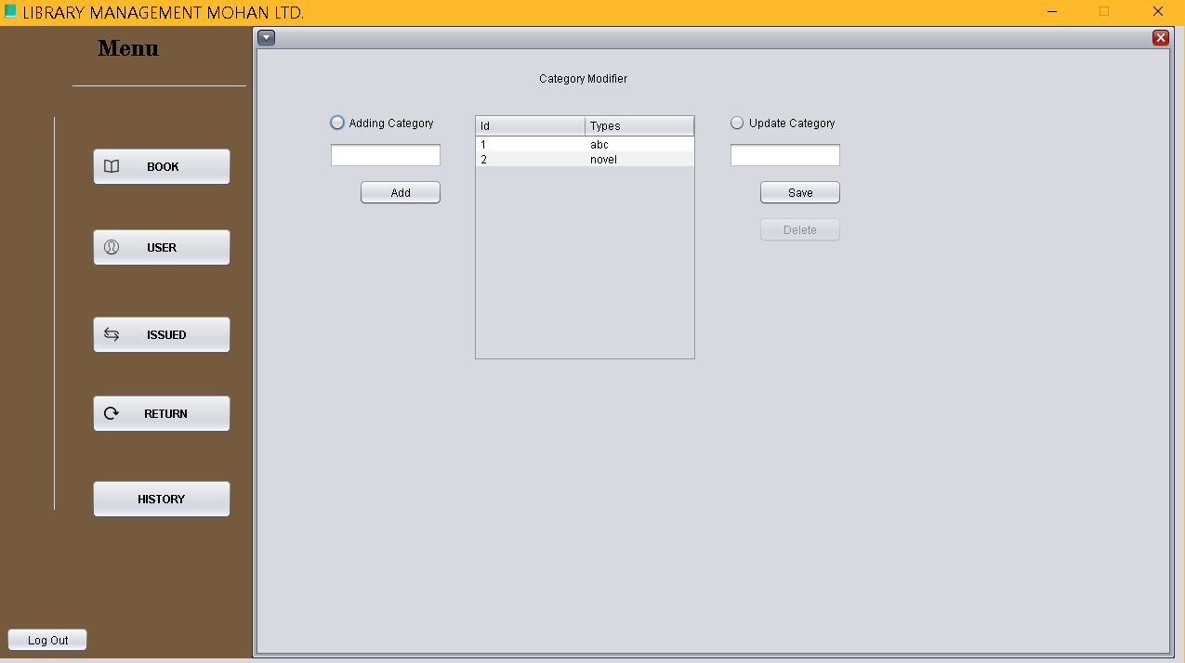

------------------------------------------------------------------------------------

And for the EMPLOYEE , who want to issue or return the book.

Librarian can create an account for employee by clicking to USER button.

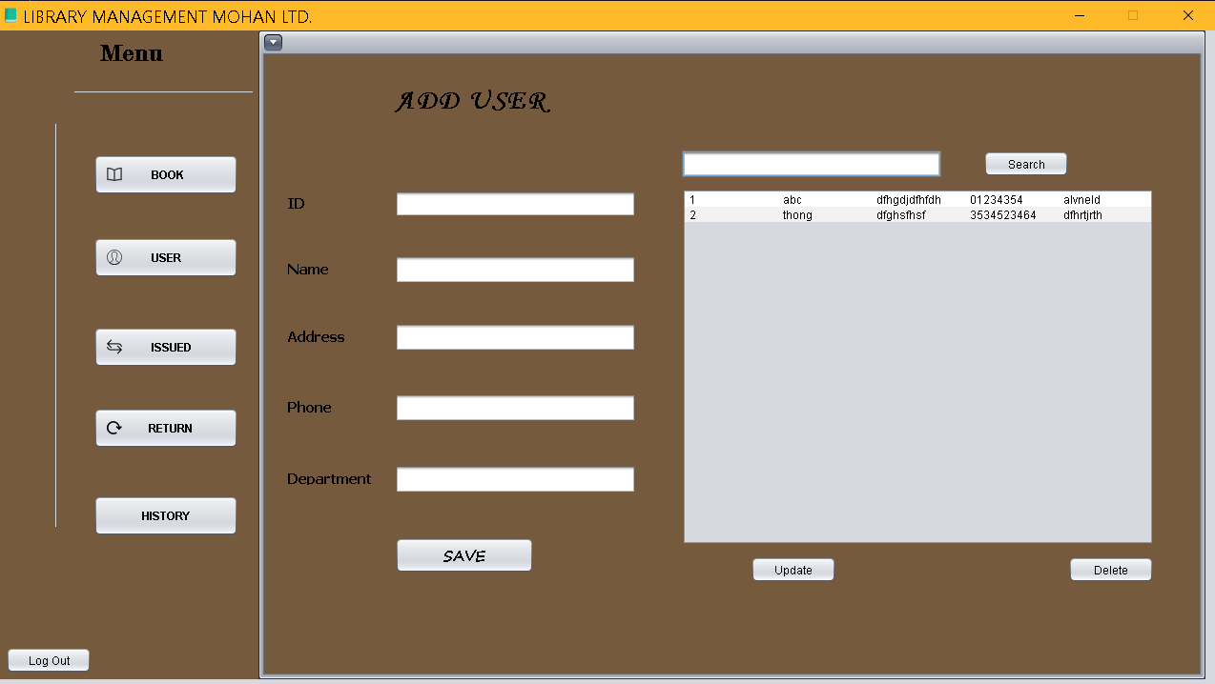

And fill in the form for who want to become a user , just like what you do for Book.

Librarian can update for drop the user information by click on the row of User they want to fix and then modify the information in the blanks and click Update. Delete for dropping the User.

And for the Nerf – Book lover , they are quite interested in books and they’d like to take some to home and for later reading .

Employee (User) bring the book(s) to the Librarian and they will create Issued Bill in order to allow Employee taking the book

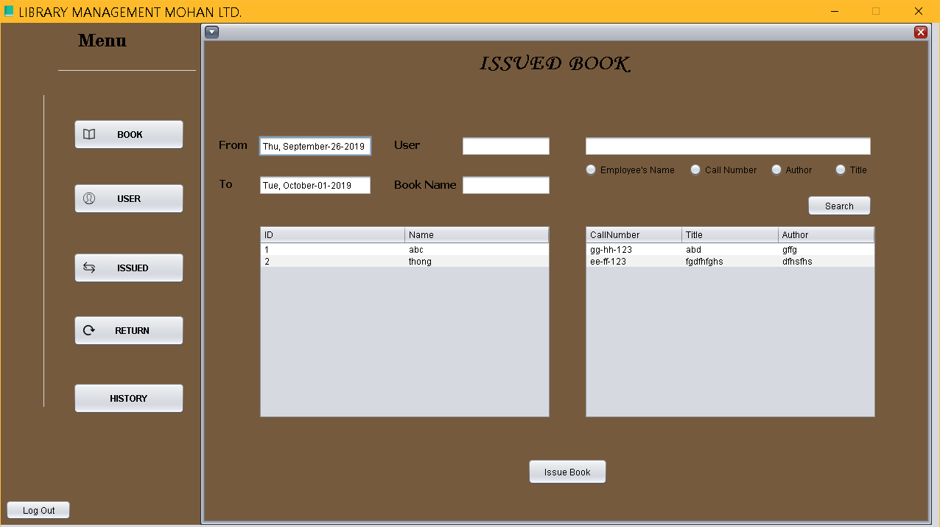

Librarian click on the user want to take book on the left table and the book that he/she would like to take and then click submit -> Issue Book.

Notice : Each book will be borrowed for only 5 days .

And the Search function is just the same like in the Book.

After 5 days , user HAVE TO return it back to the library , if they let it last for longer than Due Date , there’s a punishment..

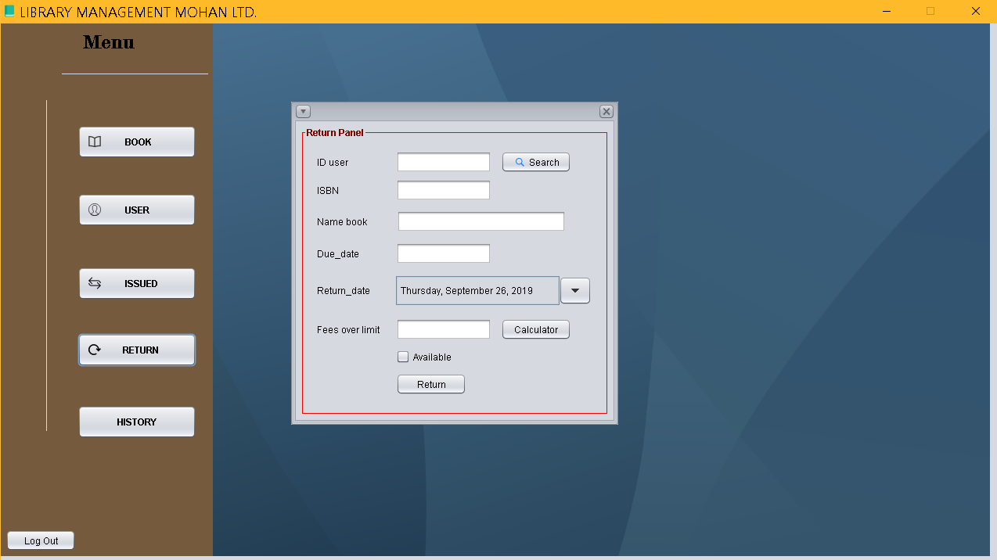

First thing first , LATE FEE :will be added into rental price

User have to pay more 10 cents for each day late.

Librarian can search and display the history of issue book to see who is keeping the book and the book is taking by who.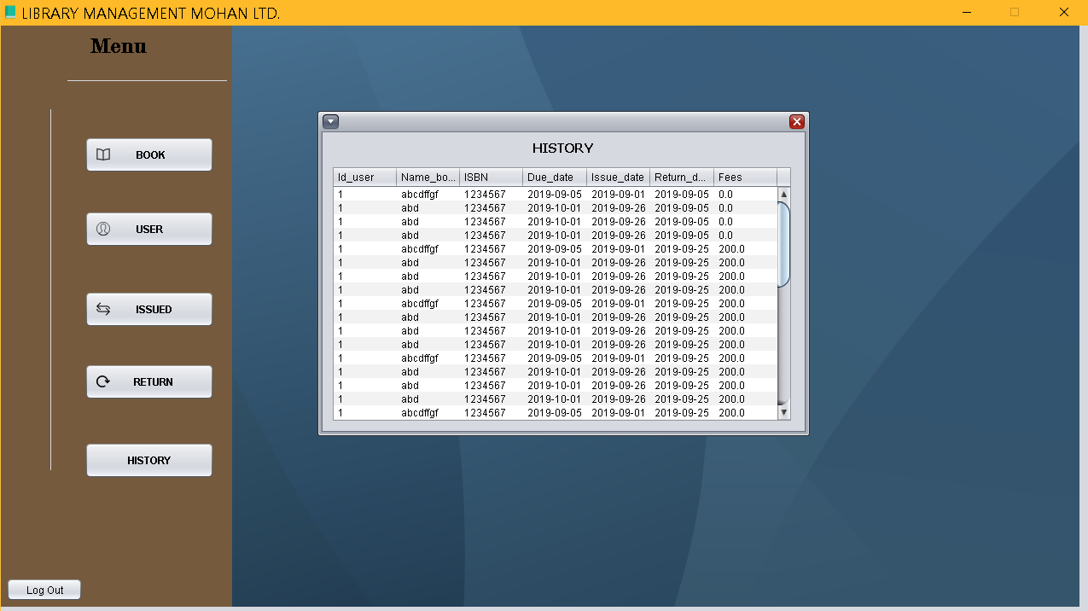

This is the history list ,

|  |  |  |
| --- | --- | --- |
|  |  |  |
|  |  |  |

Top of FormBottom of Form

1. DATABASE: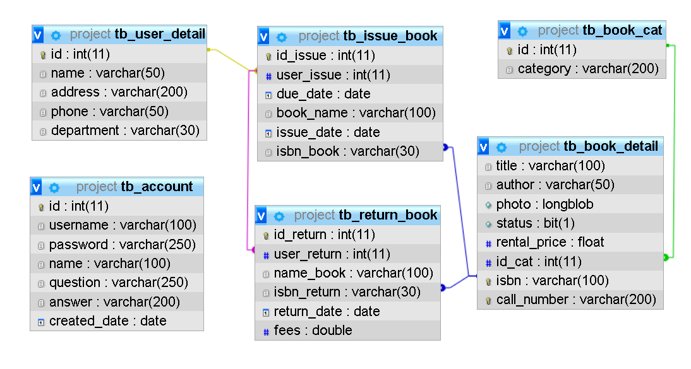

And finally , picture above show the construction of the database.

Database and Admin side wrote by Nguyen Hong Son.

This is the end.

**Thank you for spending your time on reading our project.**



***Nguyen Phuong Minh Thong ,***

***Phan Nhat Vinh***

***and Nguyen Hong Son***

***wrote this project.***

***Approved By(Trainer): Mr.Phan Huu Tri.***