# Chapter 7: GROUPING IN PREHISTORY

Groups, aggregates of phenomena, are the focus of scientific study, for it is phenomena that science seeks to explain. However, it has been argued that, as the device for construction of groups, grouping is entirely inappropriate to scientific endeavor, and that the only groups profitably employed are the *denotata* of classes, especially the *denotata* of paradigmatic classes. To briefly review the rationale for the exclusion of grouping as a device for scientific unit construction: (1) groups constructed by means of grouping devices can have only extensional definitions consisting of a list of members; and (2) thus such units cannot recur through time and space (a requirement of prediction and control) or be shared (the special requirement of the notion culture). Because groups so constructed consist only of their members, they are applicable only to the members originally included and cannot incorporate new information. Such groups are history bound, inappropriate to, and indeed impossible to use for measuring change in either time or space.

The cursory considerations undertaken in this chapter, then, are germane to our purpose only insofar as grouping has been used or suggested in prehistory to create units. The major aim is to identify grouping so that it can be avoided. The identification of groups which are the products of grouping as opposed to groups which are the *denotata* of classes would be an easy matter were it not for a penchant of prehistory's literature to present a description of *denotata* without presenting the classification by means of which the *denotata* were assembled. This procedural error makes it dif6cult to distinguish grouping and classification in the literature, for most of the readily usable criteria are not presented (e.g., explicit definitions). Adding to this difficulty is the lack of problem in many studies. When units are constructed for their own sake or when the “problem” is “description,” the units are not used beyond their names, eliminating any possibility of identifying the nature of the unit from its characteristics of use. This is most unfortunate, for if a unit is employed for some purpose, the use will suffice to distinguish between those units which are the product of grouping and those which are the product of classification. These circumstances are sufficiently common that most units used by prehistorians are amenable to interpretation as either groups or classes. Only when the entire discipline is considered is it possible to assess the nature of the units commonly employed.

Admitting the difficulty of distinguishing grouping from classification in prehistory as a function of the sloppy treatment accorded systematics, all that can be done is point out some of the more frank uses of grouping and the problems which result from these attempts and proposed procedures. From the outset it should be evident that any method, irrespective of its pragmatic utility, can be constructed on paper. The only requirements it must meet are those of logical consistency. Thus it is possible, and, in fact, occurs, that the rationale for some specific study's units may be presented as one or another grouping device, even when the actual procedure has been paradigmatic or taxonomic classification and when the device offered as the rationale could not conceivably have produced the units attributed to it.

Insofar as I am aware, grouping devices have been used as the rationale or proposed as the means of unit construction only at the scales of discrete object and occupation. Both numerical taxonomy and statistical clustering are in evidence for discrete objects, while only numerical taxonomy has been used for occupations. In all cases the units have been labeled with terms used to designate classes so that “type” in the literature can mean either units which are *denotata* of paradigmatic classes or the products of grouping. The remainder of this chapter will attempt to show how grouping has been used, what the characteristics of its use are, and the problems which result.

## Statistical Clustering

In terms of method, there is nothing which can be added beyond what has already been presented in Part I, since that discussion is based largely upon the use of statistical clustering in prehistory. The primary advocate of statistical clustering in prehistory has been A. C. Spaulding, who first detailed the approach in his 1953 “Statistical Techniques for the Discovery of Artifact Types.” The approach begins with a paradigmatic classification. Indeed, Spaulding presents the clearest statement of paradigmatic classification that can be found in the prehistoric literature, being particularly noteworthy in the clear recognition of the dimensional character of the defining modes. The frequency of the definitive modes is tabulated for the collection being considered, and an expected frequency of combinations of the modes in discrete objects assuming a random association of the modes is calculated. Essentially this is a statement or prediction of the number of combinations that will be found strictly as a function of the frequency of the modes. The next step is the tabulation of the actual combinations of modes found in the collection, and the results of this tabulation are compared with the expected frequencies. The outcome of this comparison, which takes into account the size of the sample considered, is the isolation of combinations of modes which cannot be accounted for as the result of random association and vagaries of sample size. There are, of course, two possible kinds of clusters: negative ones, combinations which do not occur or which occur much less frequently than would be predicted on the basis of random association; and positive ones, clusters which occur more frequently than could be predicted on the basis of frequency of the individual modes. The ability to detail what combinations are actually realized out of those combinations that are logically possible is one of the distinct advantages of explicit paradigmatic classification over other kinds of arrangement. It provides immediate feedback in the form of a non-random distribution that the attributes chosen are the products of patterned behavior. Should the distribution be random, it is reasonable to assume that the attributes chosen are not culturally significant in the form in which they have been conceived. The isolation of positive clusters is taken to be a discovery of genuine tendencies on the part of the makers to combine sets of attributes, and the positive clusters labeled types, or rather, potential types. They are potential only, because if two or more significant clusters differ in a few modes (i.e., are closely “similar”), they will be grouped together as a single type of two varieties.

Up to this point in the procedures, there are no serious difficulties. Two sets of classes are in evidence, the modes used to characterize the material and their combinations into paradigmatic classes (Spaulding's attribute combinations). The comparison of the frequency of the modes with the frequency of their combination indicates that the choices of modes are culturally significant. The difficulty arises when those combinations which are heavily represented are singled out as “types,” something quite different from the sense in which type is usually employed, for here the types are directly linked through the counts made of attributes and combinations to a particular body of artifacts. Further, not all the objects in the collection need fall in positive clusters, and those which are infrequently represented are not recognized as types but relegated to the status of “abnormal” combinations of modes. It is likewise entirely possible that no clusters, either positive or negative, might be found, and thus the collection be regarded as having no types or as being all of one type.

What has been done is clear, as is the nature of the units which result from this approach. The *denotata* of paradigmatic classes (termed in the approach “attribute combinations”) at a given location in time and space have been counted and this tabulation compared with a tabulation of the *denotata* of the definitive modes (termed in the approach “attributes”). The comparison of these two sets of *denotata* differing in scale is then used to create units called “types.” The “types” are quite obviously groups of real objects. Any kind of counting requires phenomena, and any kind of units based on count in any fashion are phenomenological, that is, groups. This situation could be treated as a particular case of the general confusion of classes with their *denotata* in prehistory, the name “type” simply being applied to the objects assigned to the type at a given locality, were It not for the lumping of closely “similar” clusters into the same unit as varieties.

Further difficulties arise when the infrequently noted combinations are regarded as abnormal combinations of modes. A combination of modes which is infrequently represented at one locality and point in time, and thus an “abnormal combination,” will usually be in some other locality and time frequently represented and thus at that locality a “type.” Popularity varies through time and space, and units based upon popularity necessarily vary as well. The peculiar consequence of employing statistical clustering is the creation of sets of units unique to each sample location-giving rise to a “rubber yardstick.” Being bound to the occurrence of attribute combinations at specific localities, the meaning of the units will change with the frequency of representation. Types so constructed cannot provide means of either comparing localities with one another or measuring formal change. In short, the units are descriptive and are not capable of providing the terms for explanation. Nor, in the absence of problem, are they testable. Figure 19 presents a comparison of the distribution of *denotata* of paradigmatic classes labeled Type A through Type D with statistical clusters labeled “Type a-Type f.” In this simplified hypothetical case, the vertical axis of the diagram represents time, the width of the curves the frequency of occurrence of *denotata* of paradigmatic classes. The paradigmatic classes do not change through time but rather the frequency of occurrence or the presence and absence of their *denotata* change. All of the localities represented by the bars in the diagram can thus be compared with each other, the paradigmatic classes providing the basis of comparison. The statistical clusters, it will be immediately noted, are restricted to specific localities, being actual groups of artifacts, and thus these units themselves change through time and provide no basis for comparing the various localities. In Situations requiring larger numbers of types, the contrast between clustering techniques for unit construction and paradigmatic classes would be even more dramatic, though more complicated m Its portrayal. The addition of new localities new data will result in a proliferation of the number of cluster but will not affect the number of paradigmatic types.

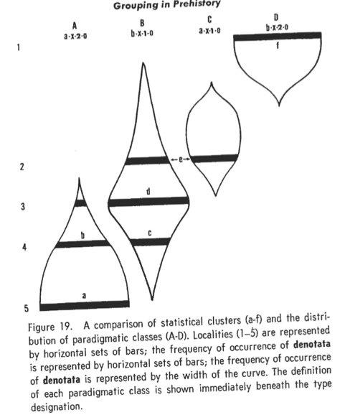

Figure 19. A comparison of statistical clusters (a-f) and the distribution of paradigmatic classes (A-D). Localities (1-5) are represented by horizontal sets of bars; the frequency of occurrence of *denotata* are represented by horizontal sets of bars; the frequency of occurrence of *denotata* is represented by the width of the curve. The definition of each paradigmatic class is shown immediately beneath the type designation.

These difficulties were recognized by Spaulding in, pro.. . f r he clearly states that the types are posing the device, od that further the “types” are restricted “problem” for which the statistical clusters were to provide an order was “description.” Thus, in the absence of any testable, definable goal, there was no means to judge the utility of the results. Any kind of units which provide a means of naming will suffice “description.” No complicated devices are required, nor do they have any demonstrable advantages, save maybe intellectual satisfaction, over any other means of naming.

The publication of this device for unit construction led to a long and rather involved argument in the literature with James Ford, who was using types in the sense used herein (paradigmatic classes). The major components of this argument are listed in the bibliography, and make most useful reading, clearly demonstrating the problems presented by using the term “type” for widely different kinds of units. A careful reading of this argument will also demonstrate the utility of making a distinction between groups and classes in attempting to understand the archaeological literature. As in all cases in which argument is more about words (in this case “type”) than substance, the argument slowly dies instead of being concluded decisively. It is worth pointing out, however, that the statistical cluster has not seen use in prehistory for any operations beyond those kinds of studies in which creating units for their own sake-description is the goal. Spaulding's clear exposition, some of the finest in the archaeological literature, is often cited as the rationale for “type” even when what is actually done is paradigmatic classification such as Ford argued for, though hardly as succinctly.

The discussion of clustering leads rather directly to a larger problem, the quest for “folk classifications.” Presumably this quest is a motivation behind statistical clustering as a means of unit formation, given that one of its stated aims is the discovery of genuine tendencies on the part of the makers to combine modes. Aside from the fact that there is no way to know whether or not the modes initially used were recognized in some cognitive sense by the makers, the irrelevance, indeed the detriment of such “folk classifications” to scientific investigation, has already been argued. It must be emphasized that employing paradigmatic classes in no way prohibits a statement of these combinational tendencies. These variable representations of combinations are, however, statements about the distribution of *denotata*, not characteristics of the classes.

For example, in Figure 19 one may by inspection or by the methods outlined as statistical clustering characterize the time and space represented at Locality 5 by the tendency for a single combination of modes (a-X-2-o), Locality 2 by the tendency for two combinations (a-X-1-o and b-X-1--o) which differ in a single mode, and so on, without binding the analytic units to the circumstances that obtain at any one of these localities. One might further speculate that the people involved in Locality 5 recognized but one type; that those at Locality 4, one type of two varieties; and so forth. Insofar as there are no means available to test these statements they must remain speculations. Folk classes constitute interesting data, artifacts, when and if they can be recovered. They are to be explained; they are not an explanation. The aim of making analytic categories coincident with folk categories quite obviously will always result in the units being groups, since the categories themselves are phenomena. This particular goal evidenced in some archaeological studies is an excellent case in point with regard to the inappropriateness of sociocultural anthropology, from which the notion derives, as a model for prehistoric investigation.

## Numerical Taxonomy

Numerical taxonomy has been proposed as a device for creating units at the scale of discrete objects; however, this is not yet widely practiced. Numerical taxonomy produces groups, and thus the units have the same characteristics as statistical clusters insofar as their utility in scientific endeavor is concerned. They are contingency-bound, undefined and undefinable, and restricted to the material from which they are derived. They cannot serve as the basis for comparison, nor can they incorporate new data without changing the structure of the units. Such groups bear the same relationship to the distribution of paradigmatic classes as do the statistical clusters in Figure 19. The advocacy of numerical taxonomy as a means of unit construction at the scale of discrete objects has followed the systematic exposition of this device in the biological sciences and incorporates the statistical sophistication characteristic of these disciplines.

Far more important than the proposed use of numerical taxonomy at the scale of discrete objects is the widespread use, or at least advocacy, of numerical taxonomy to construct units for aggregates of discrete objects, the scale of phenomena herein called occupations. This use of numerical taxonomy long antedates the appearance of this device in the biological sciences and appears during the 1930's in a non-statistical form. In fact, it is almost the only device explicated in the prehistoric literature for unit construction at the scale of occupation, and this in spite of the fact that the units actually employed are, when identifiable, almost invariably paradigmatic classes.

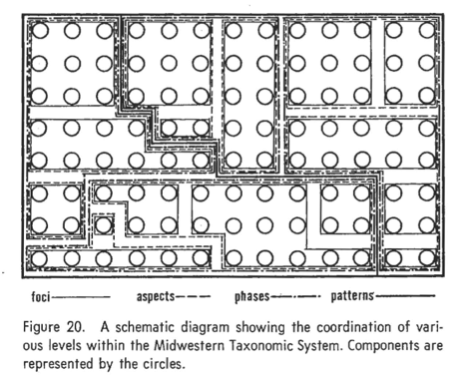

Figure 20. A schematic diagram showing the coordination of various levels within the Midwestern Taxonomic System. Components are represented by the circles.

The general approach is best stated in its early form by William McKern, one of the inventors of the device, in “The Midwestern Taxonomic Method as an Aid to Archaeological Culture Study,” published in 1939. There it is proposed that aggregates of discrete objects, collections which are termed components, be compared with one another in terms of “traits” in order to assess the degree of similarity exhibited between collections. No formal coefficient of similarity or agreement is employed, but, rather, the expression of similarity takes the form of a list of linked (shared) traits and diagnostic (unshared) traits. The linked traits, of course, are the ones used to create the units while the diagnostic ones are to serve the purpose of identification. It is apparent even from the outset that grouping, in this case numerical taxonomy, and classification are undifferentiated in the system, the linked traits clearly belonging to a grouping device, while the diagnostic traits suggest that the groups are to be employed as classes. The lowest-level unit is the component which is considered empirical, that is, part of the phenomenological realm and the referent for the other units in the system. These components are successively grouped on the basis of similarity into foci, aspects, phases, patterns, and bases, with foci being the most similar units, the bases the least similar. It is further observed that styles are linked traits between foci and that as one goes to higher levels the linked traits progressively become fust more technological and then more functional. This generalization, which amounts to saying that styles have smaller distributions than do technologies or functions, admits the possibility of viewing the Midwestern system as a series of classifications, each level being defined by different kinds of criteria. This impression is, however, most superficial. Higher-level units effectively group lower-level units; the components assigned to Focus 1 will not be split among two or three aspects but will belong to the same aspect. The only way in which this coordination of units at different levels may be achieved is the inclusion of all the criteria at the lowest level (focus) and reducing the number to derive the next level, and so forth. Not only are styles linked traits at the level of focus, but so are all the other traits which are linked at higher levels. Thus the difference, for example, between foci and patterns is not in the kind of criteria, but in the number of criteria, which are held in common. This characteristic of coordination of various levels in the Midwestern Taxonomic System is illustrated in Figure 20, in which components are represented by small circles and the various groupings by rectangular boxes. All of the boxes include other boxes and none of them intersect or cross-cut boxes at another level. Figure 21 illustrates the Midwestern system employing a smaller number of components and showing the hierarchic relationships between the various levels of units. The similarity of this figure to the dendrogram in Chapter 4 is apparent, this latter construction being the general structure of numerical taxonomies. The use of the “trait list,” especially in subsequent studies employing the Midwestern Taxonomic System, to characterize all of the contents of components and which then serves as the basis for comparing components to state the similarity between them, presages the polythetic character of modern numerical taxonomy. Importantly, in the 1939 statement of the method McKern emphasizes the phenetic character of the units so formulated. They do not imply “relatedness” or distribution m time and space, but simple formal similarity. This is, of course a function of choosing number of traits (similarity) over kind of trcuts as the means of constructing the units. Because there is no control over the kind of criteria used, the resulting units do no have any specifiable meaning. This is important to note, for Figure 21 could be viewed as a taxonomic classification rather than a numerical taxonomy if it were not clear that similarity, not identity, is the basis for construction. Further, as is clear not only from the early formulations of this system but also in its subsequent use, the units consist not of sets of criteria (such is impossible since they can vary from case to case), but of groups of empirical entities, the components.

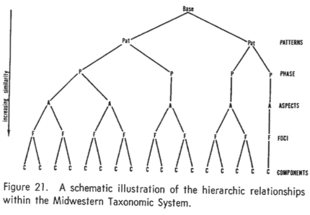

Figure 21. A schematic illustration of the hierarchic relationships within the Midwestern Taxonomic System.

It has been advantageous to give the Midwestern Taxonomic System detailed and specific consideration because this method is the basis, at least technologically, of all the modern units constructed at the scale of occupation. In subsequent use the higher levels, from aspect upward to base, have gradually been abandoned-generally because chronology and developmental constructions were required, and, one may speculate, because there is no directly analogous unit in sociocultural anthropology above the focus which is equated in a general way with society or “culture.” The only major change has been the replacement of the term “focus” with the term “phase” (see Willey and Phillips in bibliography). The notion of “settlement,” introduced in recent years by K. C. Chang, the only unit at this scale which departs from the previous formulations, contains strong elements of the Midwestern scheme. Settlement employed as an empirical unit is almost analogous to component and when employed as a class or when the community concerned is not localized in space analogous to focus or phase.

Regardless of the particular terms used in the statement of the system and the number of units retained, there is one important and rather obvious inconsistency-the definitions of phase (focus) and component and the relationship between the two basic units. Components, it is insisted, are empirical units. Yet they are not. Component, regardless of the names used, is a manifestation of a phase or focus at a given locality. This is, of course, a possible way to state the relationship between a class and its *denotata* at a given point in time and space; however, this statement is not a definition by any standards, for if a component is a manifestation of a phase, then one must have phases before one can have components to be able to identify and bound them. On the other hand, phases are said to be groups of components. One must have the components before one can have the phases. This is an interesting circularity, and one which is entirely predictable. As has been pointed out herein in numerous contexts, the “definitions” of groups are always extensional and thus may always be reduced to a statement that “the group is because the group is.” The simple fact of the matter is that if one follows the published method, one cannot construct either phases or components; yet, of course, components and phases are constructed. The question thus becomes how.

At the root of the difficulties presented by component; phase lies the problem of identifying a phenomenological unit larger than discrete object. The solution offered in the literature, calling phases groups of components, is clearly rhetorical and nothing more. The phenomenological units cannot be components, for one cannot identify components without first having phases, and one is still left wondering what phases are units of. Something of a solution is presented in the Midwestern Taxonomic System itself. It was noted that the explication of the system overtly involves numerical taxonomy, but also implicitly, some kind of classification as well. The “traits” used in constructing the units of the system are categorized as linked when shared and as diagnostic when not shared. The diagnostic/linked categorization is exhaustive. A trait is either linked or diagnostic in a given context. There is, however, a third category of traits, a category which is clearly drawn from some • system other than the explicated numerical taxonomy, namely determinants. Determinants constitute a set of traits which recur as a complex from component to component and which is distinctive of a focus. Clearly the determinants of a focus constitute a post hoc class *significatum*, something quite apart from the system as set forth as a kind of grouping and inconsistent with the system as a whole. Further, since there is no ranking or weighting of the determinant traits, it is reasonable to assume that the determinants of a focus constitute the *significatum* of a paradigmatic class. This is a primary reason that phase was defined as a paradigmatic class of occupations in the previous chapter.

What apparently is generally done by prehistorians, even though explicated ii1 terms of a numerical taxonomy, is paradigmatic classification. This enables one to account for: (1) how it is possible to create phases when the published rationale is insufficient to create them; (2) why only the focus has been seriously retained from the Midwestern Taxonomic System; ( 3) how it is possible to identify new collections with previously established units; and (4) why determinants, inconsistent with the main theme of the Midwestern Taxonomic System, are nonetheless included in it. This eliminates the circularity of the current treatment of component and phase. Component is used to designate the *denotata* of a class, the phase or focus, at a given locality. Because the *denotata* are real and because the actual units being classified lack discreteness, it has been easy to confuse the results of identification with the phenomena for which the classification has been constructed. The relationships between the notions of occupation, phase (focus), and component are illustrated schematically in Figure 22. In this diagram the two columns of boxes represent an ideal stratified site. Those labeled a1y-b2y are occupations, while those labeled I-III represent components. The phases are paradigmatic classes of occupations, the components the *denotata* of each phase. A locality may consist of several occupations all of which belong to the same phase and thus the locality is a single component site. Alternatively, there may be several occupations which belong to different phases, and thus several components will be recognized at the locality such as in Figure 22.

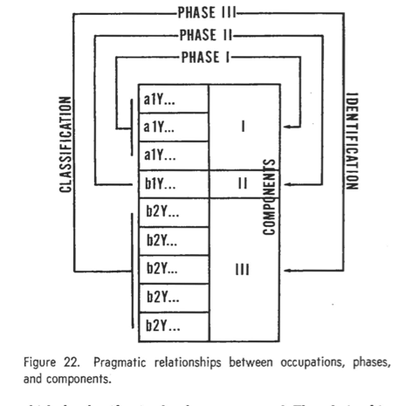

Figure 22. Pragmatic relationships between occupations, phases and components.

Viewing the Midwestern Taxonomic System as a numerical taxonomy employed as a rationale for paradigmatic classification eliminates most of the inconsistency in the literature about units at the scale of occupation. It does not, however, eliminate the difficulties inherent in the scale itself. While phases can be treated as paradigmatic classes, components as their *denotata* at a single location, there still is no general definition of what the phenomenological units are. Phases may be paradigmatic classes, but it is not possible to say, at least theoretically, what they are paradigmatic classes of. That such a glaring deficiency should be encountered is not surprising when one considers the dual role the term component has played-on the one hand as the phenomenological unit, and, on the other, the identified *denotata*. Pinpointing the circularity of the component/phase relationship is the crucial first step in correcting this conceptual deficiency.

Other kinds of arrangement, particularly keys, are used from time to time in prehistory. Their use has been rather straightforward, and there is little difficulty in recognizing keys. The only difficulty that inheres in their use is that ordinarily the classification for which the key has been made is not presented separately from the key so that the user is restricted to the classes of the key in his identifications. An excellent example of the key as used in prehistory is included in the appended reading list (see Schwartz, 1961).

## Summary

Grouping devices both of the kind herein called statistical clustering and numerical taxonomy occur in the prehistoric literature, and, in fact, constitute some of the better theoretical exposition in the discipline. Both clustering and numerical taxonomy can be done with archaeological materials, but, in spite of lip-service to the contrary, neither has been widely employed in problem-solving for rather simple reasons. Their unit products are groups, and groups cannot serve as the basis for either comparison or measurement. They are things to be compared and measured. Further, lacking the feature of recurrence necessary for prediction and explanation, their future utility seems unlikely. In the literature, the major uses to which grouping devices have been put are to provide a rationale for paradigmatic classification (inappropriately) and to pro\-ide names for the units in “description.” Given the inexplicit nature of much prehistoric literature, the identification of the device used to create a set of units is often difficult. In the case of grouping devices, their actual use seems restricted to “descriptive” studies. An ability to distinguish grouping from classification in this context is a moot point; any means of categorizing and naming will suffice, since these kinds of studies have no specifiable problem and thus are not testable. In those cases in which grouping is offered as a rationale for an underlying classification, the use to which the units are put will suffice to indicate the superficial nature of the grouping rationale.

In no fashion is the consideration here any rejection of the techniques of statistical clustering-or, for that matter, numerical taxonomy, but only a rejection of their use as means of formulating units. They are exceedingly useful devices for the description of the characteristics of class *denotata* and their behavior in dimensions of variability. They cannot, however, provide useful analytic units for any science. Their appropriate role lies in the generation and testing of hypotheses about classes, not in the construction of the classes. The degree to which grouping can produce usable units is a direct function of the implicit classifications used (attributes and attribute combinations) by these devices. Treating the grouping techniques as the means of unit formation only further obscures the definition of the classes that they must employ.