Explaining the Spatial Structure of Phases: An Example from the Lower Mississippi River Valley
Carl P. Lipo, Beau J. DiNapoli, and Mark E. Madsen

Abstract
Traditionally, archaeologists group assemblages into phases and assign them community or polity status. Earlier studies have shown that the phases of the Lower Mississippi River Valley do not separate cleanly, but they have not explained what produces their apparent organization. We explain phases using cultural transmission theory in which potters copy near neighbors more than distant ones. Neutral drift makes nearby assemblages alike whether or not groups exist. Settlement is clumped, and a smooth gradient sampled at clumps and sorted by resemblance and proximity looks like a set of groups. We present a method for determining whether a phase restricts copying of variability in decorated pottery. In such cases, the frequencies of artifact classes show what distance-limited copying does not produce: learning concentrated inside and divergence across its edge. We test our method on the decorated-type frequencies of the Late Mississippian St. Francis basin in northeastern Arkansas under the phases Phillips defined, including the Parkin phase, long read as a polity. The phase lines run through sparsely settled country, and hierarchical clustering of site locations alone recovers the phases for all but two assemblages, as expected of units sorted by proximity. The lines separate the assemblages about as well as alternative divisions of the same sites, and the step in similarity across them appears at arbitrary lines as well. Under the same clustering, frequencies simulated with no groups sort into the phases about as readily as the real assemblages when composition is given a quarter of location’s weight or less, and less readily at equal weight and on resemblance alone; the real frequencies’ advantage there is expected, since the phases were drawn from them. The Parkin phase separates the assemblages no better than divisions around random centers, though better than compact ones. The frequencies vary over shorter distances than a copying model predicts, and that variation is not specific to phase borders. Phases therefore do not uniquely capture the basin’s ceramic differentiation, and the assemblages neither require nor exclude restricted copying at their lines. The results do not exclude a Parkin polity, since political boundaries need not coincide with ceramic traditions.
Keywords: cultural transmission, neutral models, frequency seriation, isolation by distance, Mississippian archaeology, Parkin phase

Resumen
Tradicionalmente, los arqueólogos agrupan los conjuntos cerámicos en fases y les atribuyen las cualidades de comunidades o entidades políticas. Estudios anteriores han mostrado que las fases del valle bajo del río Misisipi no se separan con nitidez, pero no han explicado qué produce su aparente organización. Explicamos las fases con la teoría de la transmisión cultural, según la cual los alfareros copian a sus vecinos cercanos más que a los lejanos. La deriva neutral hace que los conjuntos cercanos se parezcan, ya existan o no grupos. Los asentamientos están agrupados, y un gradiente continuo, muestreado en esos agrupamientos y ordenado por semejanza y proximidad, parece un conjunto de grupos. Presentamos un método para determinar si una fase constituye una restricción para la copia de la cerámica decorada. En tal caso, las frecuencias de las clases de artefactos muestran lo que la copia limitada por la distancia no produce: aprendizaje concentrado en su interior y divergencia a través de su límite. Lo ponemos a prueba con las frecuencias de los tipos decorados del Misisipiano tardío en la cuenca del río St. Francis, en el noreste de Arkansas, según las fases definidas por Phillips, incluida la fase Parkin, interpretada durante mucho tiempo como una entidad política. Los límites de las fases atraviesan zonas poco pobladas, y el agrupamiento jerárquico de las ubicaciones de los sitios, por sí solo, recupera las fases para todos los conjuntos salvo dos, como cabe esperar de unidades ordenadas por proximidad. Los límites separan los conjuntos aproximadamente tan bien como otras divisiones de los mismos sitios, y el escalón de semejanza que los cruza aparece también en límites arbitrarios. Con el mismo agrupamiento, las frecuencias simuladas sin grupos se clasifican en las fases aproximadamente con la misma facilidad que los conjuntos reales cuando la composición recibe una cuarta parte del peso de la ubicación o menos, y con menos facilidad cuando pesa tanto como la ubicación o cuenta sola; esa ventaja de las frecuencias reales es esperable, ya que las fases se trazaron a partir de ellas. La fase Parkin no separa los conjuntos mejor que las divisiones en torno a centros aleatorios, aunque sí mejor que las divisiones compactas. Las frecuencias varían a distancias más cortas de las predichas por un modelo de copia, y esa variación no es propia de los límites de las fases. Por lo tanto, las fases no captan de manera exclusiva la diferenciación cerámica de la cuenca, y los conjuntos ni exigen ni excluyen una copia restringida en sus límites. Los resultados no excluyen la existencia de una entidad política en Parkin, ya que los límites políticos no tienen por qué coincidir con las tradiciones cerámicas.
Palabras clave: transmisión cultural, modelos neutrales, seriación de frecuencias, aislamiento por distancia, arqueología misisipiana, fase Parkin

Introduction
Archaeologists have traditionally divided the late pre-contact record of the Lower Mississippi River Valley into spatially and temporally bounded units known as phases. These include the Kent (House 1991), Nodena (Dan F. Morse 1990), Parchman (Starr 1984), Tipton (Smith 1990), Walls (Smith 1990), Jones Bayou (Smith 1990), and Parkin (Phyllis A. Morse 1990) phases. Figure 1 shows four of them, Nodena, Parkin, Walls, and Kent, as Phillips (1970) drew them. The Parkin phase stands out because it contains the Parkin site, the largest moated and palisaded town in the St. Francis basin of northeastern Arkansas. Reconstructions of the Hernando de Soto expedition’s route identify it as Casqui, the seat of a paramount chief the expedition met in 1541 (Hudson et al. 1990; Mitchem et al. 2017; Phyllis A. Morse 1990:125–129). Because of its size, fortification, platform mound, and ethnohistoric identification, Parkin is routinely interpreted as the center of a Mississippian polity, following the long-standing expectation that a ranked society leaves a hierarchy of settlement types and sizes with its center at the top (Peebles and Kus 1977:431). This interpretation claims that the Parkin phase was a bounded, hierarchically organized society with the Parkin site at its head.
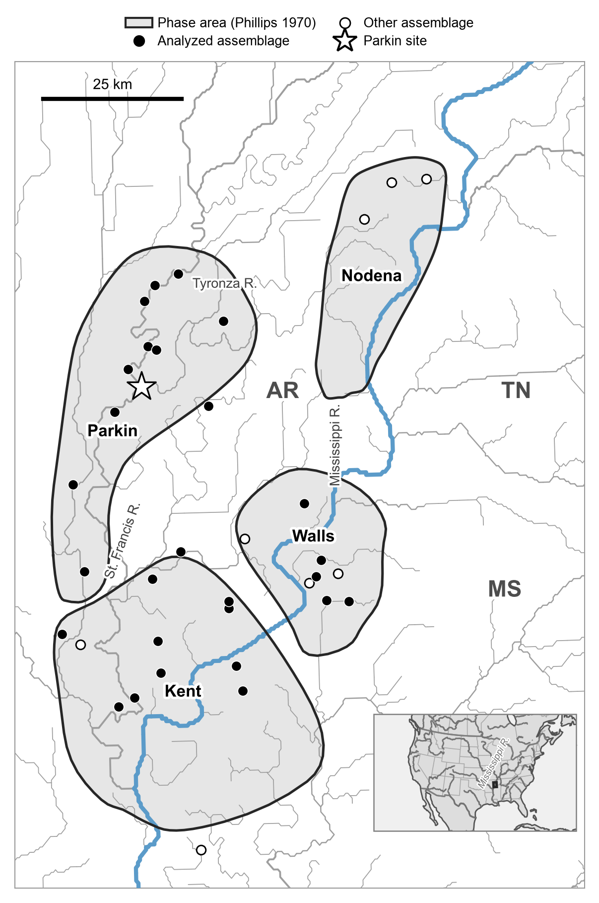
Figure 1. The study area and the late pre-contact phases as Phillips (1970) drew them. The Nodena, Parkin, Walls, and Kent phase areas are redrawn from Lipo (2001:Figure 2.6), after Phillips (1970), and are placed on the map from the survey-quadrangle frame of that figure. Filled circles are the 28 decorated-ceramic assemblages analyzed here, open circles are the eight other assemblages of the 38 used in this study that fall inside the frame, and the Parkin site is starred. Phase areas are drawn over the HydroRIVERS river network (Lehner and Grill 2013), with line width scaled by flow order. The bounded areas illustrate the premise under test, that each hosted a distinct, internally interacting society. The mapped area lies in Arkansas, Tennessee, and Mississippi; Missouri lies just north of the frame. Inset: location in North America.
A phase is a culture-history construct in which a set of assemblages are grouped together because their decorated-class frequencies seriate. This property means they can be placed in one sequence of gradually changing frequencies, and because the sites lie near one another. In the Willey-Phillips framework, the phase is “the practicable and intelligible unit” of archaeological study, defined by traits in space and time with no social criterion (Phillips and Willey 1953; Willey and Phillips 1958:22). Phillips formulated the lower-valley phases tested here within that framework (1970). In practice, however, researchers have treated phases as societies, and the survey phases of the lower valley were built as units “which were also spatial and intended to elucidate sociopolitical boundaries” (Haley 2014). Willey and Phillips (1958:48–50) set out the reasoning that equates phase with society, conceded that “in practice it does not work,” and then proposed that archaeologists “may act as if” phases had social reality. Williams, defining the southeast-Missouri phases, wrote that “in most cases, phase probably equals ‘society’” (Williams 1954:25; quoted in Fox 1998:33). The premise underneath is rarely stated. It holds that assemblages more similar to one another than to their neighbors record a bounded group of people who interacted mainly with each other. Once such a group is paired with a dominant center, the phase becomes a polity, and the social unit has been assumed before any evidence for it has been weighed (Fox 1998).
This point has been raised before. Fox (1998), for example, used cluster analysis and ordination to show that the southeast-Missouri phases fail as both groups and classes, with member assemblages falling into statistical clusters at random rather than by phase. Mainfort (2003) addressed the same issue for the assemblages of the Lower Mississippi Valley. He used an ordination approach to sort ten decorated types from 39 sites and found “little evidence for the integrity of the traditional late period phases,” with no clear grouping even though “most sites assigned to most phases are located in the general vicinity of each other in ordination space” (Mainfort 2003:180). Lipo (2001) reached a similar view through frequency seriation, suggesting that “the phases themselves might be simply arbitrary spatial and temporal slices of a single interacting population that is much larger in size” (Lipo 2001:60). These studies show that the phases do not separate cleanly. None of these investigations, however, explains what the phases are, or why they looked real to the people who drew them. Ordination methods alone cannot explain these units because loosely clustered assemblages can arise from both bounded groups and unbounded copying across distance.
This paper offers and tests an explanation. We ask two questions. First, what explains the phases? We argue that they can follow from how people learn. Potters copy near neighbors more than distant ones, settlements clump, and a smooth gradient in style sampled at those clumps looks like groups. Second, does the Parkin phase, the one unit most often treated as a polity, show anything in its decorated-type frequencies that sets it apart? Both questions can be investigated using the same test. Copying across space produces spatial structure in stylistic frequencies regardless of whatever else is happening. A phase, then, should be identifiable as a restriction on the copying of decorated pottery if its class frequencies show properties that spatially structured drift does not produce. This test is more restrictive than asking whether a society or polity existed. Political affiliation, of course, need not coincide with a ceramic tradition, but ceramics offer empirical evidence in the archaeological record about how social learning was structured. However, pottery can show only whether learning was bounded where the phase lines fall, not whether people were politically organized.
We proceed in two steps. Our primary test concerns the phases as Phillips (1970) formulated in the Lower Mississippi River Valley using assemblage similarity and spatial positions. We then repeat the tests on the table Mainfort (2003) compiled from largely the same collections, under his phase assignments. These follow Phillips’s, with Smith’s (1990) Horseshoe Lake phase split out, and add the phases of western Tennessee (Mainfort 2003:176–177). We use this second analysis to ask whether the results hold on a second tally and a revised set of lines.
The late pre-contact St. Francis basin provides the data for our test. Its decorated assemblages are built from the well-documented decorated classes of the long-established Phillips-Ford-Griffin types (Phillips et al. 1951). European contact and the demographic collapse that followed ended the sequence before any later reorganization could overwrite it (Lipo 2001; Morse and Morse 1996). Like much of the archaeological record, these assemblages are time-averaged surface collections, built up over many years of use and discard. We treat them as the accumulated product of copying across a population, to be measured and explained as they are, rather than as degraded snapshots of a single moment (Dunnell 1995; Holdaway and Wandsnider 2008; Lipo et al. 2015; Neiman 1995; Perreault 2019; Schiffer 1972). Their coarse resolution limits the questions they can answer, but it does not disqualify them.

Why phases look like groups
Our method is built on cultural transmission theory, and it is simple. Potters learned how to decorate pots from others, and the decorations they made reflect who they learned from. Under the neutral model of cultural transmission, decorative variants that make no difference to how a pot performs change in frequency through innovation and chance copying in a finite population of learners, much as selectively neutral alleles do (Bentley et al. 2004; Dunnell 1978; Eerkens and Lipo 2005, 2007; Fogarty et al. 2024; Neiman 1995). Four expectations follow, three about what copying does on its own and one about what a group would add.
Copying falls off with distance. People learn from those they live near and see often, so a potter is more likely to copy a neighbor than someone further away. Under neutral drift, that alone makes nearby assemblages more alike than distant ones, and similarity fades smoothly with distance. Population geneticists call this isolation by distance (Wright 1943), and it has long been noted to drive stylistic frequencies (Neiman 1995; Shennan et al. 2015). It requires no groups. This effect is what copying produces across any landscape with local interaction. It produces between-place differences on its own, because small or poorly connected places drift toward distinctive and idiosyncratic repertoires (Lipo et al. 2021).
Settlement is clumped. People did not live evenly across the basin. Sites concentrate on particular reaches of the basin’s rivers, with less-occupied stretches of land between them. The smooth gradient in style is therefore sampled unevenly, densely in some places and sparsely or not at all in others.
A gradient sampled at clumps looks like groups. Seriation and ordination sort assemblages by resemblance, and the culture historians who drew the phases also sorted them by proximity. On a smooth gradient sampled at clumps, both criteria gather the assemblages of each clump together and draw the lines between clumps. The result looks like a set of distinct groups with boundaries, although nothing in the process that made the type frequencies has a boundary (Lipo et al. 1997, 2021). This is the difference between typological and population thinking (Dunnell 1980; Mayr 1959). Interpreted typologically, a cluster of similar assemblages is a unit with members and an edge. Interpreted as a population, it is a place where a continuous field of copying happened to be sampled.
A bounded interaction group requires more. A group that concentrates learning inside itself and restricts it across its edge leaves properties in stylistic frequencies that spatially structured drift does not produce. These are conceptually detectable as differences between groups larger than what copying across the same map generates. This difference will appear as a step in similarity at the group’s edge, beyond what distance predicts. Boundaries also appear where assemblage styles change fastest, so type frequencies rather than the map reveal them (Crema et al. 2016; Henrich 2001; Henrich and Boyd 1998). Divergence that grows as interaction narrows would be a further sign, but the lack of a detailed chronological record for these deposits makes the record not well-suited for testing this possibility (Supplemental Text). Each of these possibilities has to be evaluated against a model of copying with no groups on the real geography, not against zero, and against other lines drawn across the same map, because any line cut through a gradient separates some difference.
These expectations provide functional means to evaluate the Parkin phase. If the Parkin phase was a polity whose members learned from, married into, and exchanged with one another more than with outsiders, its assemblage composition should stand apart from the rest of the basin by more than copying across distance produces. Assemblages should be more distinctive than what an arbitrary line drawn across the same sites separates. Empirically, there should be a step in similarity at its edge that other delineations do not show. Alternative models of late pre-contact valley populations do not require these attributes. The alternative finding is that the polities in this part of the valley never achieved regional integration (Rees 2001), consistent with models in which Mississippian polities were weakly consolidated, cycling, and short-lived (Anderson 1996; Beck 2003; Blitz 1999; King and Freer 1995). In the chronicles, Casqui and its neighbor Pacaha appear in open conflict, as peers would, although the same sources have also been read as ranking Casqui below Pacaha (Hudson et al. 1990; Mitchem 2001; Phyllis A. Morse 1990). Settlement form cannot decide between these interpretations, because a large center with a palisade and a platform mound is as compatible with competing peer communities as with a consolidated hierarchy (King and Freer 1995; Rees 2001).

Materials and methods

Data
In this study, we test the phase assignments defined by Phillips (1970). The ceramic data are decorated-class counts from the Lower Mississippi Valley Survey collections of Phillips, Ford, and Griffin (1951), as compiled by Lipo (2001). We use decorated classes only because the neutral model applies to stylistic variation, variants whose frequencies change through copying and chance rather than through how a pot performs (Dunnell 1978; Neiman 1995). Plain wares track vessel function, paste, and site activities, none of which a copying model represents. Combining the frequency of plain and decorated classes also mixes factors driving relative investment in decorating ceramics, a process driven by factors beyond social learning and copying. In Mainfort’s (2003) table of the same collections, Mississippi Plain and Bell Plain make up ca. 87 percent of the typed sherds. Ten decorated classes remain. Following Lipo (2001), to increase sample sizes and to ensure consistent identification, we pool sherds from Barton Incised, Kent Incised, and Mound Place Incised. We also pool the painted types Old Town Red, Nodena Red and White, and Avenue Polychrome. Each class is a culture-history type, a unit of measurement built by analysts, not a category assumed to have existed in the past.
Of the 38 assemblages used in this study, 20 come from Lipo’s compilation, which adds controlled surface collections and limited excavation in 1996 and 1997 at seven sites (Lipo 2001), and 18 consist of the original survey counts from Phillips, Ford, and Griffin (1951). Mainfort (2003) compiled a separate table of 39 sites, each with at least 800 sherds, drawn largely from the same survey files with additional sources (Mainfort 2003:182). Because his counts are not entirely independent of ours, we do not combine them. Nor do we make his table the primary dataset. His assignments revise Phillips’s with phases defined later (Smith 1990), and his table is not a larger sample once it is restricted to decorated classes: at a minimum of 100 decorated sherds, it holds 29 sites and 13,296 sherds in five phases, two of which have only four and three sites, against the 28 assemblages and 14,101 sherds analyzed here. We therefore analyze his table and his phases separately, as a second case.
An assemblage takes the phase of the area it lies in, using the phase areas of Phillips (1970) as Lipo (2001:Figure 2.6) mapped them (Figure 1). An assemblage that lies inside no area takes the nearest one. Two assemblages of the matrix, Parchman and Salomon in Coahoma County, Mississippi, lie south of the mapped areas and are not assigned. We include only assemblages with at least 75 decorated sherds. At that count, the $F_{ST}$ that sampling alone produces between two assemblages drawn from one profile has a median of 14 percent of the observed five-cluster value, and its 95th percentile falls below that value (Supplemental Text). The Nodena phase keeps a single assemblage of that size, Carson Lake, and is not carried as a phase of one. These rules leave 28 assemblages holding 14,101 decorated sherds (median 251 per assemblage, range 79 to 1,709) in three phases: Parkin with 12 assemblages, Kent with 11, and Walls with 5. Twenty-six lie inside a phase area. The other two, Cramor Place and Holden Lake, lie 1.0 km outside the nearest area, within the drafting error of the source map. We georeferenced each assemblage from the Lower Mississippi Survey site files. We obtained settlement attributes from a regional database (Lipo and Dunnell 2007).
Two properties of our data limit what any transmission analysis can claim. The assemblages are time-averaged, so sherds made at different times are counted together, which distorts diversity and neutrality measures in proportion to how long variants remain in use (Madsen 2012; Miller-Atkins and Premo 2018). The neutral model also describes people copying one another, whereas an assemblage counts durable objects, so the model’s expectations apply only approximately to this record (Crema et al. 2024).

Chronology
Radiocarbon determinations compiled by Mainfort (2001), calibrated against IntCal20 (Reimer et al. 2020), place about three-quarters of the summed probability between the mid-thirteenth and the mid-seventeenth centuries (median AD 1428; Parkin, AD 1483). The summed probability does not fall at the contact interval: the century after AD 1541 holds as much of it as the century before, and it falls in the century after that (Supplemental Text). A calibration plateau across the contact interval prevents year-scale resolution (Holland-Lulewicz and Ritchison 2021), and only four dated proveniences match our assemblages. We therefore order the assemblages by the first axis of a correspondence analysis of their decorated-class frequencies (Figure 2) (Baxter 1994; Peeples and Schachner 2012; Smith and Neiman 2007). That axis follows geography more closely than time. Its rank correlation with latitude is +0.77, and latitude and longitude together account for 63 percent of its variance. Kent Place and Hollywood, the two earliest dated deposits, lie at the same end as Clay Hill, the latest (Haley 2014; House 1993:23) (Supplemental Text). Fortunately for our analysis, an order along the axis is an order in space at least as much as in time, and none of our phase-line tests depends on it.
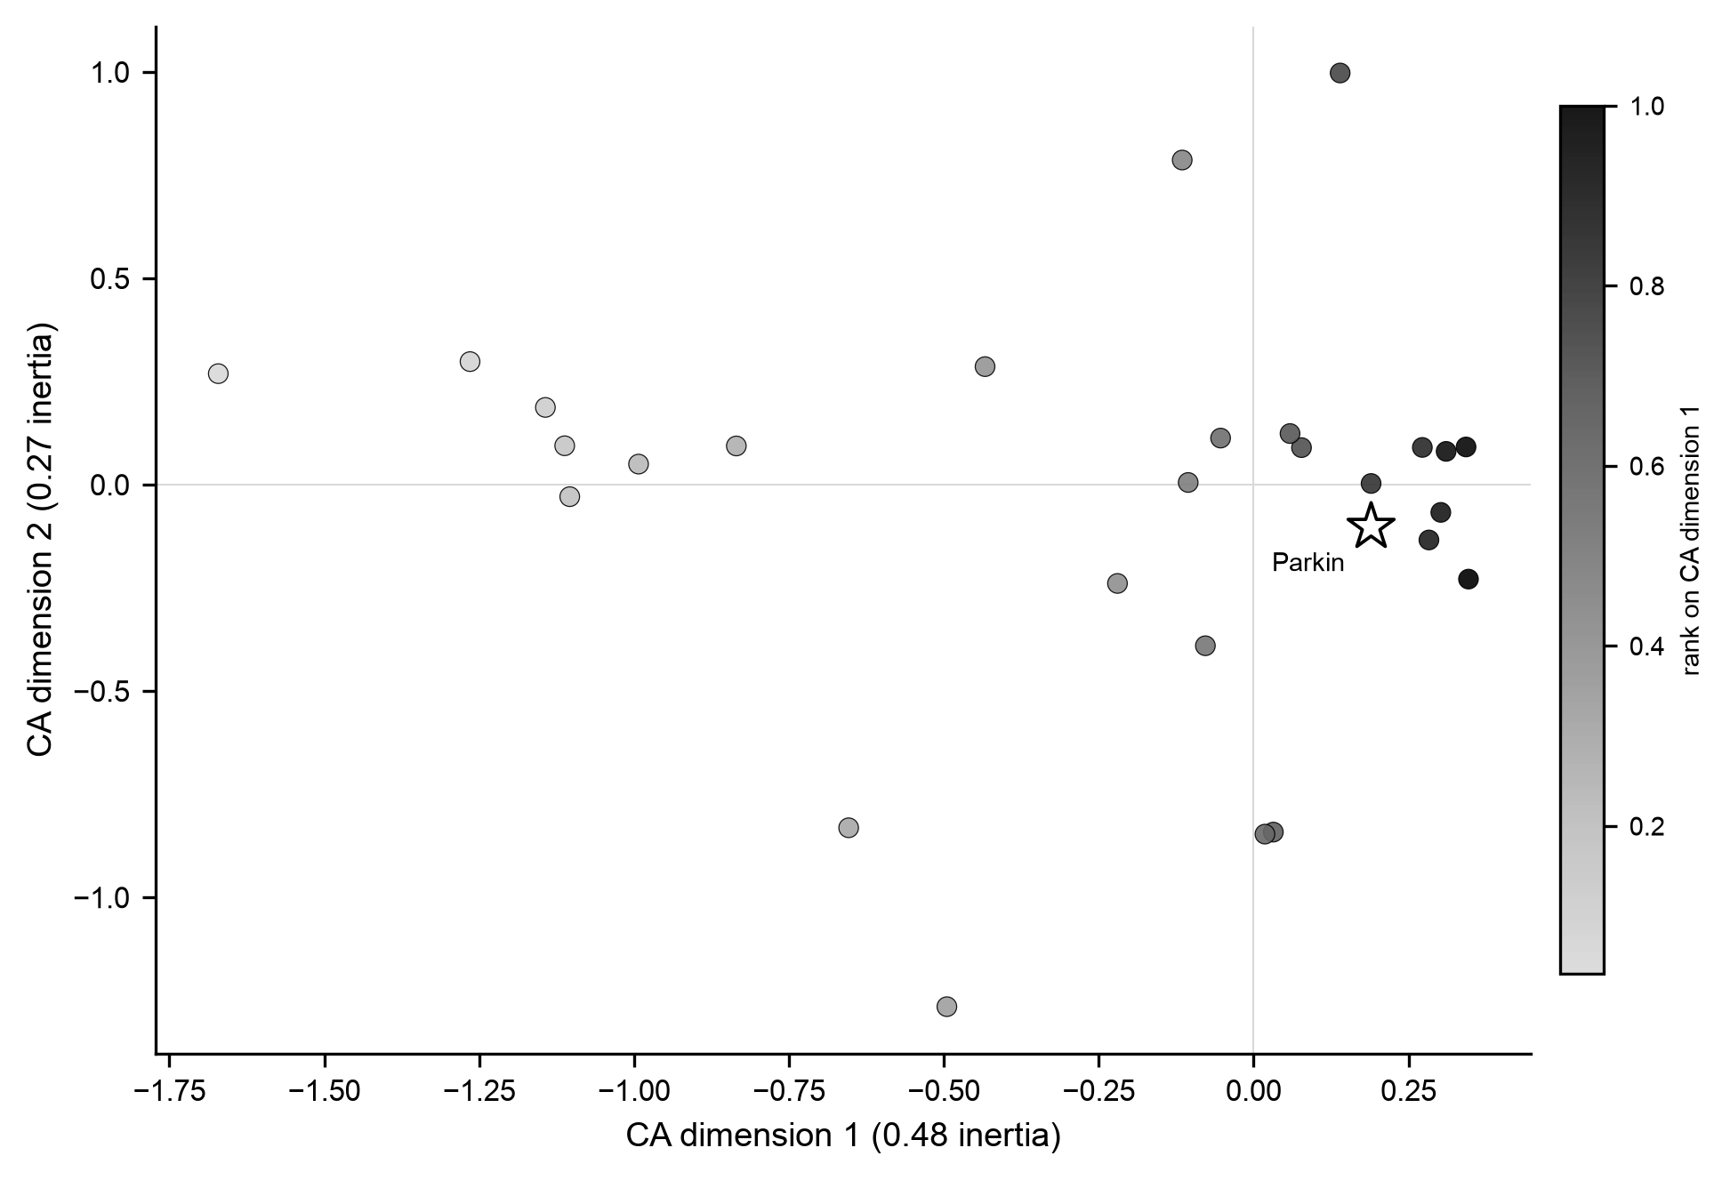
Figure 2. Correspondence-analysis seriation of the 28 decorated assemblages, plotted on the first two dimensions and colored by rank on the first (oriented, as in every analysis, in the direction the pooled calibrated medians of the four radiocarbon-dated assemblages weakly favor; they do not establish it). Parkin is the starred marker. The assemblages form a continuum rather than discrete clusters, echoing Mainfort’s (2003) independent ordination.

Measures
Two measures underpin our tests. The first is a cultural version of Wright’s $F_{ST}$ (Bell et al. 2009; Wright 1951), which indicates how much variation in decoration lies between groups rather than within them. We measure decorated diversity with the Gini-Simpson index, the probability that two sherds drawn at random belong to different classes, and cultural $F_{ST}$ is how much more diverse the pooled assemblages are than the average group, as a fraction of the pooled diversity, weighted by assemblage size. This is Nei’s (1973) diversity form of the index. When all groups draw on one shared pool, it sits near zero. As groups favor distinct repertoires, it climbs. The second measure is the boundary excess. Similarity between assemblages, measured with the Brainerd-Robinson coefficient (Brainerd 1951; Robinson 1951), normally fades smoothly with distance. The boundary excess is how much more similarity is lost across a line than distance predicts, a step in similarity at the line. We compare pairs of assemblages on the same side of a line with pairs on opposite sides at matched distances, in four distance bins, and average the differences over the bins that hold at least five pairs of each kind.
Before looking at the phases, we established that cultural $F_{ST}$ can detect a boundary on a record like this one. On synthetic assemblages built to match the real record, at its real sample sizes, positions, and time-averaging, with groups of known strength imposed, cultural $F_{ST}$ tracked the imposed groups steadily. We found that three other measures often used for the purpose, the departure from unbiased copying (Neiman 1995; Shennan and Wilkinson 2001), the breakdown of a single seriation into several (Lipo et al. 2015), and the boundary excess, do not sufficiently detect boundaries under real-world conditions (Supplemental Text, Figures S1 to S3). We therefore draw inferences about groups from cultural $F_{ST}$, and use the step in similarity to describe what the copying model misses and to ask whether the phase lines show more of it than other lines do.
Spatial divisions of the basin other than the phases are formed by k-means on the assemblage coordinates. The site layout is best described by two clusters, as the silhouette score indicates, which rewards compact, well-separated clusters. Because cultural $F_{ST}$ depends on how many pieces the basin is cut into, we also fit a model with no divisions. It treats decorated-class composition as a continuous surface over the map, with a separate term for site-specific deviations, and asks how well that surface describes the record. It is a description, not a test for groups: a group whose members lie near one another shares a composition that a smooth surface can absorb at the sampled sites, so the model cannot tell continuous copying from groups aligned with geography.

Neutral copying on the real map
The central comparison runs a copying model with no groups on the real geography of the St. Francis River basin using assemblage data and asks whether it reproduces the record. The model follows the finite-population network model of Lipo, DiNapoli, Madsen, and Hunt (2021). Each assemblage is a node holding a finite population of learners, who copy decorated classes mostly within their node and occasionally from other nodes, with a probability that falls off with distance measured along the rivers. New variants enter at a constant rate, proportional to each class’s share of the region’s pooled counts, reflecting that types lump unequal numbers of decorative variants. We call this the copying model. It contains no groups. We pool deposition over a trailing window of eight time steps to reproduce time-averaging, and we subsample the simulated assemblages to match each real assemblage’s sherd count.
A copying model’s predictions about differences between groups depend on population size, innovation rate, and mixing rate together, so we first tune those three to reproduce the diversity within the real assemblages, including mean within-assemblage diversity, mean number of classes present, and the diversity of all assemblages pooled. None of these involves the groups being tested. We search a grid of 297 combinations and keep those whose simulations match all three summaries within 10 percent, confirmed by rerunning each matched combination fifty times (Supplemental Text). Among the confirmed combinations, we use the one that produces the most between-group difference, so the comparison is as favorable to the no-groups model as the grid allows.
To give the phases a fair chance to be groups, we also ran the model with two properties a bounded group would have. First, we simulate copying across the phase lines weakened to between half and three percent of its strength. Second, we add new variants in each phase drawn from a partly reordered version of the regional profile, so that new styles arise locally. We ran each of the 16 combinations of those settings 300 times. An approximate Bayesian posterior over them indicates which the record favors (Supplemental Text).

Tests of the phase lines and of the Parkin phase
We conduct five tests to ask whether the phase lines behave as group edges would. First, we compare the between-group $F_{ST}$ and boundary excess under the phase assignments with alternative divisions of the same assemblages into groups of the same sizes, drawn around randomly placed centers or made as spatially compact as possible. We state each comparison as the posterior probability that the phase lines separate type frequencies better than an alternative (see Statistical approach). Simulations with copying restricted at the phase lines show whether this comparison could detect such a restriction. Second, we cluster the assemblages, by $k$-means and by Ward linkage, using site coordinates and decorated-class composition together, vary how much weight composition carries, and measure agreement with the phase assignments with the adjusted Rand index (Hubert and Arabie 1985), which averages zero for unrelated divisions and one for identical ones. Third, we map the local rate of composition change and ask whether the phase lines fall where it changes fastest. Fourth, we run the copying model on the real map of the valley and cluster its simulated assemblages the same way we cluster the real assemblages. Fifth, we ask whether the phase lines run through gaps in late-period settlement, using sites independent of the analyzed assemblages.
We test the Parkin phase the same way, dividing the basin into the Parkin phase and the rest, against the copying model and against arbitrary divisions of the same sizes. A polity should also leave traces outside the ceramic assemblages. We describe the distribution of maximum mound height within the basin, the only size attribute the regional compilation records for most sites, as context for whether sites form the hierarchy of settlement types and sizes that Peebles and Kus (1977:431) take as a correlate of ranked society. As a comparison, we also draw on evidence from Cobb’s (2000) analysis of the production and distribution of Mill Creek chert hoes, goods whose control would mark economic centralization.
The second case applies the first two tests, together with a search for the most spatially compact division, to Mainfort’s (2003) counts under his own phase assignments. It asks whether the results depend on the tally or on the particular lines. His table is a second count of largely the same collections, and his scheme differs from Phillips’s at the Horseshoe Lake phase and in western Tennessee. If the phases marked bounded groups, the two schemes should locate the same boundaries where they cover the same ground. We do not run the copying model on his table, since the model is calibrated to our matrix, so the second case cannot show whether his phases differ by more than copying alone produces.

Statistical approach
Every inference in this paper is Bayesian, and the numbers we report fall into three kinds: posterior quantities, which state what the record implies about a quantity once we carry through the uncertainty in its counts; predictive checks, which compare the record with what a simulation model produces; and descriptive statistics. No inference about the record rests on a significance test or a p-value. Because the three kinds answer different questions, we identify each result below by the kind of number it is.
Sampling is the first source of uncertainty. Each assemblage is a finite sample of sherds, so its class proportions are uncertain, and more so for a small assemblage than for a large one. We represent that uncertainty with a posterior distribution over each assemblage’s proportions: with a multinomial likelihood for the counts and a Dirichlet(1/2) prior on the proportions (the Jeffreys prior for this likelihood), the posterior is a Dirichlet distribution with parameters equal to the counts plus one half. Drawing proportions from it repeatedly, 2,000 times for $F_{ST}$ and 500 times for the slower boundary excess, and recomputing a statistic on each draw gives that statistic’s posterior distribution. We report its median and a 95 percent credible interval (the 2.5th to 97.5th percentiles of the draws); given the counts and the prior, the quantity lies in that interval with probability 0.95. When the phase lines are compared with alternative divisions, each draw is scored against 20 alternatives of each kind (10 for the boundary excess) chosen at random from 300, and the posterior probability that the phase lines separate the assemblages better is the share of all these comparisons they win. A probability of 0.57 therefore means that, allowing for sampling error in every assemblage, the phase lines beat a randomly chosen alternative in somewhat more than half of the comparisons. Where a probability or a share rounds to zero, we give the number of comparisons or runs behind it, since the true value is then known only to be smaller than that resolution.
Our spatial model with no divisions is a Bayesian hierarchical model written in Stan and fitted by Hamiltonian Monte Carlo (Carpenter et al. 2017). We report its spatial share as a posterior median with a credible interval, and we report its priors, convergence diagnostics, and checks against quantities it was not fitted to in the Supplemental Text.
In contrast, the copying model is a simulator with no likelihood we can write down, and we use it in two ways. As a predictive check, we run it repeatedly at a fixed, calibrated combination of population size, innovation rate, and mixing rate, compute on each simulated dataset the same statistic computed on the record, and report the median and 95 percent range (the 2.5th to 97.5th percentiles) of the simulated values together with the share of runs reaching the observed value (Gelman et al. 1996). A small share says that the model rarely produces what the record shows. It measures fit and is not compared with a threshold. Because the parameters are fixed at calibrated values rather than drawn from a posterior, the check carries no uncertainty about them. We address this by repeating the key comparisons at the six most favorable calibrated combinations. A 95 percent range and a 95 percent credible interval should not be confused: the first describes how much a statistic varies under a model, whereas the second describes a quantity of the record. The second use of the simulator is approximate Bayesian computation over the 16 settings of the bounded-groups model (Beaumont et al. 2002). Each setting receives the same prior probability, and a setting’s posterior probability is its share of the 5 percent of all runs whose summary statistics lie closest to the record’s. Since 12 of the 16 settings include a copying boundary, the prior probability of a boundary is 0.75, and the evidence lies in how far the posterior moves from that value. To judge that movement, we pass simulated records with and without a built-in boundary through the same procedure and report where the record’s value falls relative to them.
Rank correlations, the adjusted Rand index, silhouette scores, and the percentile of a division among alternatives are descriptive. Each summarizes the record or a set of divisions, and none carries an inferential claim by itself.

Results

What spatially structured drift explains
Neutral copying on the real map accounts for most of what the basin’s decorated-type frequencies show. Tuning the model to the record’s diversity matched 51 of the 297 combinations on the six-run screen, and 48 still matched when rerun fifty times (Supplemental Text, Figure S7). At the matched combination most favorable to it (2,000 learners per node, an innovation rate of 0.001, and a mixing rate of 0.02), copying with no groups reproduces the fading of similarity with distance (observed correlation of similarity with distance along the rivers -0.20, against a simulated 95 percent range of -0.48 to +0.04) and the difference between the two spatial clusters the site layout supports (Table 1).
A model with no divisions at all describes the record adequately. On the logit scale of its latent class probabilities, it assigns 98.7 percent of the variance among assemblages to the spatial surface (posterior median; 95 percent credible interval 95.4 to 100 percent) and little to independent site deviations, and it reproduces the observed between-cluster $F_{ST}$ at three clusters, the fading of similarity with distance, and the spread of diversity among assemblages (Supplemental Text). In other words, the high spatial share does not distinguish a continuous copying process from groups aligned with geography. The surface can also bend over short distances, so it carries variation that the copying model, taken next, does not produce.
Table 1. Observed between-group cultural $F_{ST}$ against the neutral copying model, which contains no groups. Model values are the median and 95 percent range over 300 runs at the matched combination most favorable to the model. The last column gives the share of runs reaching the observed value there and, in parentheses, the range of that share across the six most favorable combinations that passed the confirmation. Radius is the root-mean-square distance from an assemblage to its group’s center. A share of 0 percent means none of the 300 runs; a frequency below about 0.3 percent is not an impossibility. Divisions finer than four clusters are reported in the Supplemental Text; from eight clusters on, at least one cluster holds a single assemblage.
Division | Groups | Radius (km) | Observed | Model median (95 percent range) | Runs reaching observed
Two spatial clusters | 2 | 16.6 | 0.0062 | 0.0021 (0.0002 to 0.0108) | 12% (8 to 13%)
The phases | 3 | 14.1 | 0.0123 | 0.0024 (0.0004 to 0.0104) | 1% (0 to 3%)
Three spatial clusters | 3 | 12.5 | 0.0156 | 0.0036 (0.0006 to 0.0132) | 1% (0 to 2%)
Four spatial clusters | 4 | 10.3 | 0.0186 | 0.0040 (0.0011 to 0.0135) | 1% (0 to 1%)
The model does not account for everything. Between phases, it matches the observed difference in 1 percent of runs at the most favorable combination and in 0 to 3 percent across the six, and at three and four spatial clusters it matches the observed value in 0 to 2 percent of runs at each of the six (Table 1). The assemblages vary over shorter distances than calibrated copying does. The step in similarity across the phase lines also exceeds the model. The boundary excess is +7.7, against a simulated median of +1.2 (95 percent range -3.3 to +6.7), and 1 percent of 300 runs reach it. This additional variation is not due to sampling. Redrawing every assemblage from the basin’s pooled profile at its own sherd count gives between-cluster differences near zero (Supplemental Text).
The next section asks whether that additional variation follows the phase lines. What produces it is a separate question, and the model can narrow it without settling it (Table 2). We relaxed four model simplifications one at a time at the calibrated combination, and evaluated every variant, including the baseline, by the same three criteria: whether its median reaches the observation, how often its runs reach it, and whether the record’s diversity stays matched (Supplemental Text). No variant that keeps diversity matched brings its median up to the observed four-cluster value, and one reaches the three-cluster value only at its strongest setting. Among the variants that keep diversity matched, two raise the share of runs reaching those values, one markedly and one slightly, and the others leave it within two points of the baseline. Letting new styles arise somewhat locally, each of the two spatial clusters drawing its new variants from a slightly different version of the regional profile, raises it from 2 and 1 percent in baseline runs with the same seeds to 44 and 41 percent when a quarter of the classes are reordered (300 runs each); with the phases as the areas and a fifth of the classes reordered, 30 percent of runs reach the observed between-phase value (the grid that treats the phases as groups; Supplemental Text). Copying that falls off over a short straight-line distance (6 km) raises it to 7 and 5 percent. Unequal site populations and shorter fall-off along the rivers raise it further but break the diversity match; not recalibrated, they are unsupported rather than excluded. These runs do not resolve the grain of local innovation. The settings that fit use areas the size of half the basin (the two clusters, 16.6 km in radius; Table 1). With five or eight neighborhoods of sites as the areas, runs reach the three- and four-cluster values in 13 to 30 percent of cases but break the diversity match, so those settings are unsupported at this calibration. With each site drawing its own new variants, runs reach those values no more often than the baseline does: 2 and 0 percent at the one strength that keeps diversity matched, a small dose that changes the profile of only 15 percent of sites, and 2 and 1 percent at a dose comparable to the weakest two-cluster setting, where the diversity match breaks (Supplemental Text). None of these variants restricts who copies whom, and the test cannot tell whether local innovation followed the phases or any other division of the basin.
Restricting copying across the phase lines, the property that would make the phases groups, also increases both statistics. With copying across the lines cut to 3 percent of its strength, 22 percent of runs reach the observed between-phase $F_{ST}$ and 38 percent reach the observed step at the lines. The copying model, however, cannot distinguish the two. The posterior probability of a copying boundary at the phase lines is 0.75, the same as its prior. On simulated records with a built-in boundary, the same procedure returns a median of 0.79 to 0.94 (40 test records per setting), and on records without one, a median of 0.66. The record’s value falls between the two and has not moved from the prior, so the model neither supports nor excludes a boundary. Three arbitrary divisions with the phases’ group sizes, run through the same analysis, give 0.70 to 0.85. The comparisons of where the lines fall, taken up next, bear more directly on the question, although they too discriminate only moderately.
Table 2. The accounts of the basin’s decorated-type frequencies tested here, what each predicts, and how it fared. Every copying-model account is read on the same three criteria: whether its median between-group $F_{ST}$ reaches the observed value, the share of its runs reaching the observed value (predictive coverage), and whether it keeps all three within-assemblage diversity summaries within 10 percent of the observed values. Shares for the relaxations are from 300 runs at the calibrated combination, scored at three and four spatial clusters, where the baseline falls short; the baseline row gives the range across the six leading combinations (Table 1), and the same seeds as the relaxations give 2 and 1 percent. Relaxations are one at a time and not recalibrated. Full grids and diagnostics are in the Supplemental Text.
Account | What it predicts | Outcome
Neutral copying across space (baseline) | Differences among assemblages and the decrease in similarity with distance, with no group anywhere | Adequate at coarse scale only. Diversity matched; covers the decrease with distance and the two-cluster difference (12 percent of runs), but runs reach the three- and four-cluster values in 0 to 2 percent and the between-phase value in 0 to 3 percent
Bounded groups, judged by where the lines fall | Lines where the assemblage composition changes; lines the assemblages recover better than the map; lines that separate the assemblages better than other lines | Not resolved. The lines separate the assemblages about as well as alternative divisions (posterior probabilities 0.57 and 0.72), and hierarchical clustering of site locations alone recovers them for all but two assemblages, while composition changes slowly along them at bandwidths of 10 to 15 km; in simulation at the calibrated combination the real score is common with no restriction and less common with a strong one, which weighs weakly against a restriction and excludes neither
Bounded groups, judged by the copying model | Higher between-group $F_{ST}$ and a step in similarity at the lines | Not distinguished from local innovation; posterior 0.75 against a prior of 0.75, and 0.70 to 0.85 for arbitrary divisions
Unequal site populations; shorter or differently shaped fall-off along the rivers | Faster drift at small or isolated sites | Not supported at the calibrated combination. Raise the share of runs reaching the finer-scale values appreciably only where they break the diversity match
Unequal accumulation spans | More distinct narrow deposits | No effect on the two-cluster differentiation; not rescored at finer scales
Copying falling off over 6 km of straight-line distance | Differentiation over shorter distances | Adequate by coverage. Diversity matched; 7 and 5 percent of runs reach the three- and four-cluster values; medians fall short
New styles arising locally, with neutral copying otherwise | Higher differentiation with no change in diversity | Adequate by coverage. Diversity matched; 28 to 50 percent of runs reach the three- and four-cluster values at reordered shares of 0.2 to 0.3; the median reaches the three-cluster value only at 0.3 and falls short at four clusters, and simulations are widely spread

Where the phase lines fall
If the phases marked restrictions on copying, their lines should separate the assemblages better than other lines and fall where composition changes fastest. On the first, the comparison is close to even. On the second, the lines fall where composition changes slowly.
The phase lines separate the assemblages about as well as alternative divisions of the same sites. With the uncertainty in every assemblage’s counts carried through, the between-phase $F_{ST}$ has a posterior median of 0.0121 (95 percent credible interval 0.0101 to 0.0144). Divisions of the same assemblages into groups of the same sizes around randomly placed centers give a median of 0.0112, and divisions drawn to be as compact as possible give 0.0103. The posterior probability that the phase lines separate the assemblages better than a division around random centers is 0.57, and better than a compact division is 0.72 (Figure 3B, C). The similarity step at the lines gives the same answer. The boundary excess at the phase lines has a posterior median of +7.3 (95 percent credible interval +4.6 to +9.8), and its direct value of +7.7 lies above the copying model’s range, but arbitrary divisions of the map show a similar step, with a median of +6.3 for divisions of both kinds, and the posterior probability that the phase lines show more is 0.58 and 0.65. On both measures the phase lines do somewhat better than the alternatives, by margins that leave the comparison open. The shorter-range variation the copying model misses is a property of the basin’s assemblages, however they are divided, and the phase lines capture about as much of it as other lines do.
This comparison responds to restricted copying at the lines, but it does not discriminate sharply. In records simulated at the calibrated combination, with copying across the phase lines cut to 3 percent of its strength, the phase lines separate the simulated assemblages better than a median of 83 percent of same-size divisions around random centers and 79 percent of compact ones, versus 38 percent of each with no restriction. The real phase lines, scored the same way, beat 64 and 58 percent. The simulated distributions overlap widely (Supplemental Text, Figure S8). A score as low as the real one against random-center divisions occurs in 78 percent of records simulated without a restriction and 29 percent with the strongest (100 records per setting), and against compact divisions in 66 and 28 percent. The separation is smaller at two other diversity-matched combinations (Supplemental Text). The real score therefore lies above the middle of the unrestricted records and below the middle of the strongly restricted ones. It is unremarkable under either. A score this low is between two and three times as common without a restriction as with the strongest one, which weighs weakly against a restriction at the lines and does not exclude one. The step in similarity is no more informative: the real lines beat 76 and 84 percent of the alternatives, above the median without restriction (65 and 63 percent) and at or below the medians with copying restricted (86 to 92 and 84 to 94 percent).
The phase division is not the map’s most compact one. Its within-group spread is 197.5 km² per assemblage, against 157.1 km² for the tightest three-way division of these assemblages at these group sizes that our search found. A search that minimizes spatial spread and is not based on type frequencies did not return the phase division in any of 1,000 random starts (mean adjusted Rand index with the phases 0.53), and 41 percent of the compact divisions and 15 percent of those around random centers are tighter than the phases.
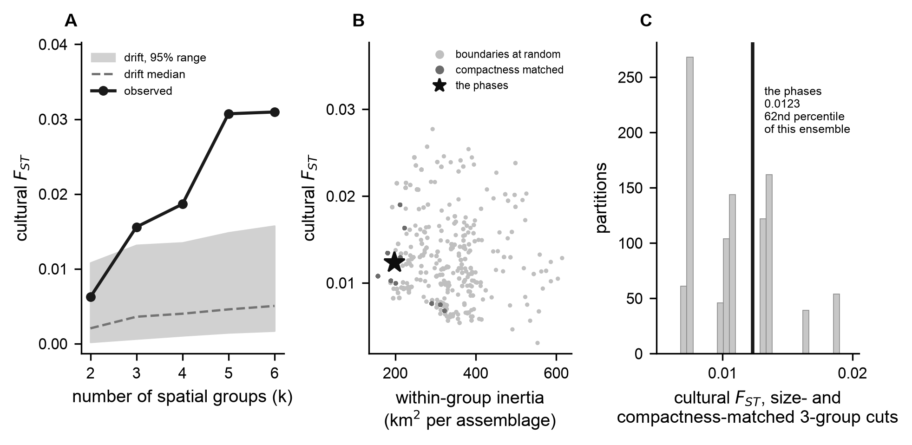
Figure 3. Scale and boundaries. (A) Observed between-cluster cultural $F_{ST}$ against the neutral copying model as the basin is divided into two through six clusters. The observed value lies inside the model’s range at two clusters and above it from three. (B) Within-group spatial spread against cultural $F_{ST}$ for divisions with the phases’ group sizes around randomly placed centers (light) and drawn to minimize spread (dark); the star is the phase division. Differentiation is unrelated to compactness among the random divisions (Spearman -0.02) and falls as spread rises among the compact ones (-0.63); 15 percent of the random divisions and 41 percent of the compact ones are tighter than the phases. (C) The phase division’s $F_{ST}$ (solid line) against the compact divisions sits at the 62nd percentile of their range.
At smoothing scales near the site spacing, the reconstructed phase boundaries run through areas where composition changes slowly. These boundaries are our reconstruction. Every point on the map goes to its nearest analyzed assemblage, those areas are merged by phase, and the boundaries are the edges where two phases meet. They are not the outlines of Figure 1, which leave unassigned ground between the phase areas. Mapping the local rate at which composition changes across the basin with a 15 km bandwidth (Figure 4A), an edge between communities should appear as a ridge of fast change. The reconstructed boundaries do not follow ridges. Median change along them is 0.0103 per kilometer, against 0.0117 along boundaries built the same way from 200 same-size divisions around randomly placed centers, which places them at the 8th percentile of those divisions (Figure 4B). The ranking is low at 10 to 15 km but not at 20 to 30 km, where the reconstructed boundaries sit at the 40th to 46th percentiles, and on this sampling geometry it discriminates weakly. On the coarser grid used for the simulations, where the real boundaries sit at the 7.5th percentile, a score that low occurs in 12 percent of records simulated without a restriction and 3 percent with copying across the lines cut to 3 percent (Supplemental Text). The turnover map therefore describes where composition changes and adds little independent weight against a boundary.
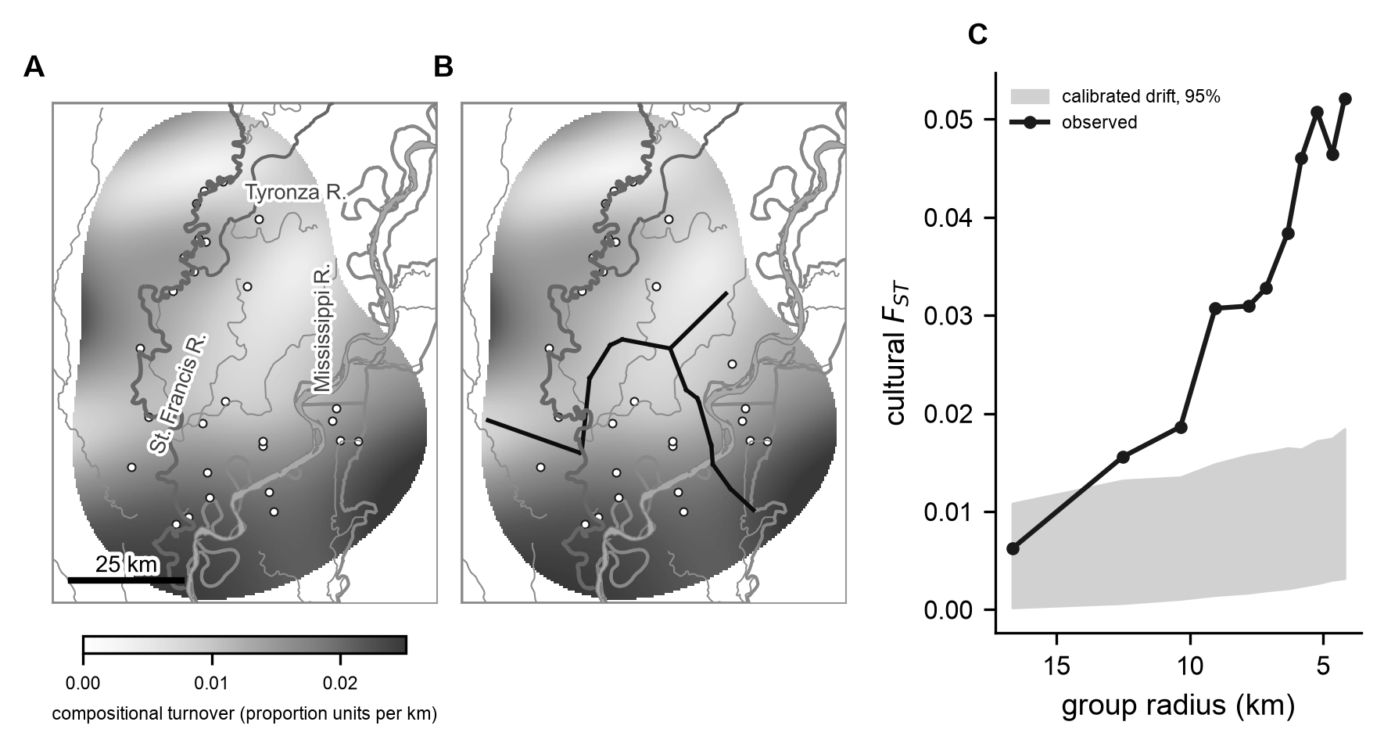
Figure 4. Composition as a continuous surface. (A) The local rate of change in the ten decorated-class proportions, computed on a 220 by 220 grid with a 15 km Gaussian bandwidth and masked where fewer than two assemblages support the estimate. Circles are assemblages. (B) The same surface with the reconstructed phase boundaries overlaid: the edges between territories built by giving every point on the map to its nearest analyzed assemblage and merging those areas by phase. At this bandwidth, the rate of change along them sits at the 8th percentile of the boundaries of 200 same-size divisions around randomly placed centers; the ranking is low at 10 to 15 km but not at 20 to 30 km (Supplemental Text). (C) Observed cultural $F_{ST}$ against cluster radius in kilometers, with the neutral copying model’s range behind it, from coarse to fine. The observed value lies inside the range at a 17 km radius and above it from 13 km. Below a radius of about 6 km, the clusters begin to isolate single assemblages, so the finest divisions should not be read as structure.
Clustered hierarchically, location recovers the phases for all but two assemblages. Clustering the assemblages on their coordinates alone by Ward linkage agrees with the phase assignments at an adjusted Rand index of 0.740, and the only assemblages it places with another phase are Big Eddy and Castile Landing, the two in the narrow southern arm of Phillips’s Parkin area, which it groups with Kent. $K$-means on the coordinates gives 0.480 (Figure 5), no better than the 0.485 that divisions with the phases’ group sizes around random centers reach, because it also groups the four easternmost Kent assemblages (Beck, Belle Meade, Commerce, and Hollywood) with Walls. Adding assemblage composition brings $k$-means to the same 0.740, from a quarter of the coordinates’ weight up to equal weight, with the same two assemblages misplaced, and it does not raise the Ward value. Composition alone gives 0.358 and misplaces six of the 26. If Big Eddy and Castile Landing are counted as Kent, Ward linkage on the site map alone reproduces the scheme exactly (Supplemental Text). The two assemblages placed by the nearest phase area rather than by lying inside one are excluded from these scores, since measuring a geographic rule against geography would be circular.
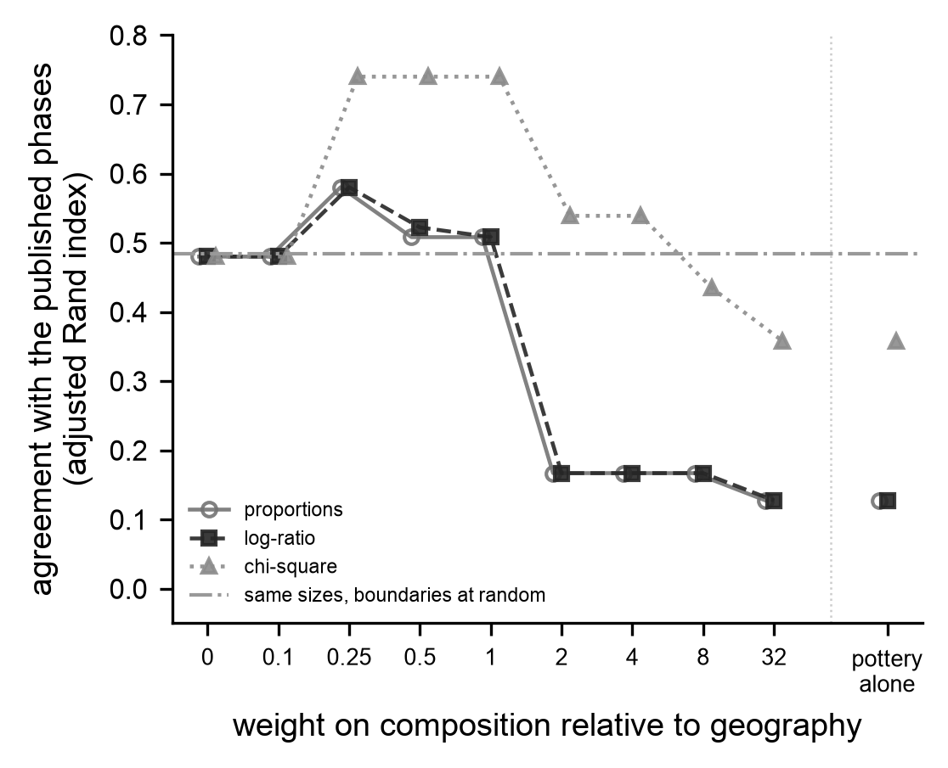
Figure 5. What recovers the phases. Agreement with the phase assignments, measured by the adjusted Rand index over the 26 assemblages inside a phase area, as the median over 40 seeds, for clusterings on site coordinates and decorated-class composition as the weight on composition varies. Zero weight is the site map alone. Three composition transforms are shown; the text quotes the chi-square transform, the only one with no free parameter. The dash-dotted line is the agreement reached by divisions with the phases’ group sizes around random centers. The clusterings shown are by $k$-means. Agreement with the site map alone sits at that line and rises to 0.740 as composition enters; Ward linkage reaches 0.740 on the site map alone (text).
Most assemblages fit their own phase, and some fit two. We compared each assemblage’s decorated-class profile with the pooled profile of each phase, leaving the assemblage out of its own phase’s pool. Of the 28, 22 are closest to their own phase with a posterior probability above 0.75. Four are closer to another phase: Big Eddy, Holden Lake, and Turnbow to Kent, and Belle Meade to Parkin. Two are not clearly placed, with probabilities of 0.60 and 0.40 for their own phase: Castile Landing, nearly as close to Kent as to its own Parkin, and Mound Place, slightly closer to both Kent and Parkin than to its own Walls (Supplemental Text). Castile Landing shows how a line through this record can be drawn either way. It lies 12 km from the nearest Kent assemblage and 16 km from the nearest Parkin assemblage, and its pottery is nearly as close to Kent as to Parkin.
Under Ward linkage, assemblages made by copying with no groups sort into the phases about as readily as the real assemblages when composition is given a quarter of location’s weight or less, and less readily at equal weight and on composition alone. We ran the copying model on the real site map 300 times, sampled its type frequencies using the assemblage sherd counts, and clustered each simulated record the same way as the real one (Figure 6). Under Ward linkage, with a quarter weight on assemblage composition, the simulated records agree with the phases at a median of 0.740, the real record’s value, and 68 percent of them reach it. At half weight, 36 percent do. At equal weight, the simulated median falls to 0.487, and 6 percent reach the real 0.740. The decline is not steady: at twice the coordinates’ weight, the real record’s own agreement falls to 0.454, and 46 percent of simulated records reach it. Based on type frequencies alone, the real record’s agreement of 0.358 lies near the top of the simulated range (median 0.098, 95 percent range -0.045 to 0.416), and 6 percent of simulated records reach it. $K$-means gives the same result at equal weight and on composition alone (6 and 5 percent). At a quarter weight it shows a wider gap (13 percent), because in the real record the pottery corrects the division $k$-means makes of the site map, and in most simulated records it does not. A culture historian sorting drift-made assemblages mainly by proximity would have found much the same phases. Sorted mainly by resemblance, the real assemblages line up with the phases better than most simulated ones do. Part of that is expected by construction. Phillips distinguished the phases using the frequencies of these types (Mainfort 2003:177), so the frequencies that defined a phase recover it better than frequencies that did not, and the comparison cannot show that the structure marks a restriction on copying.
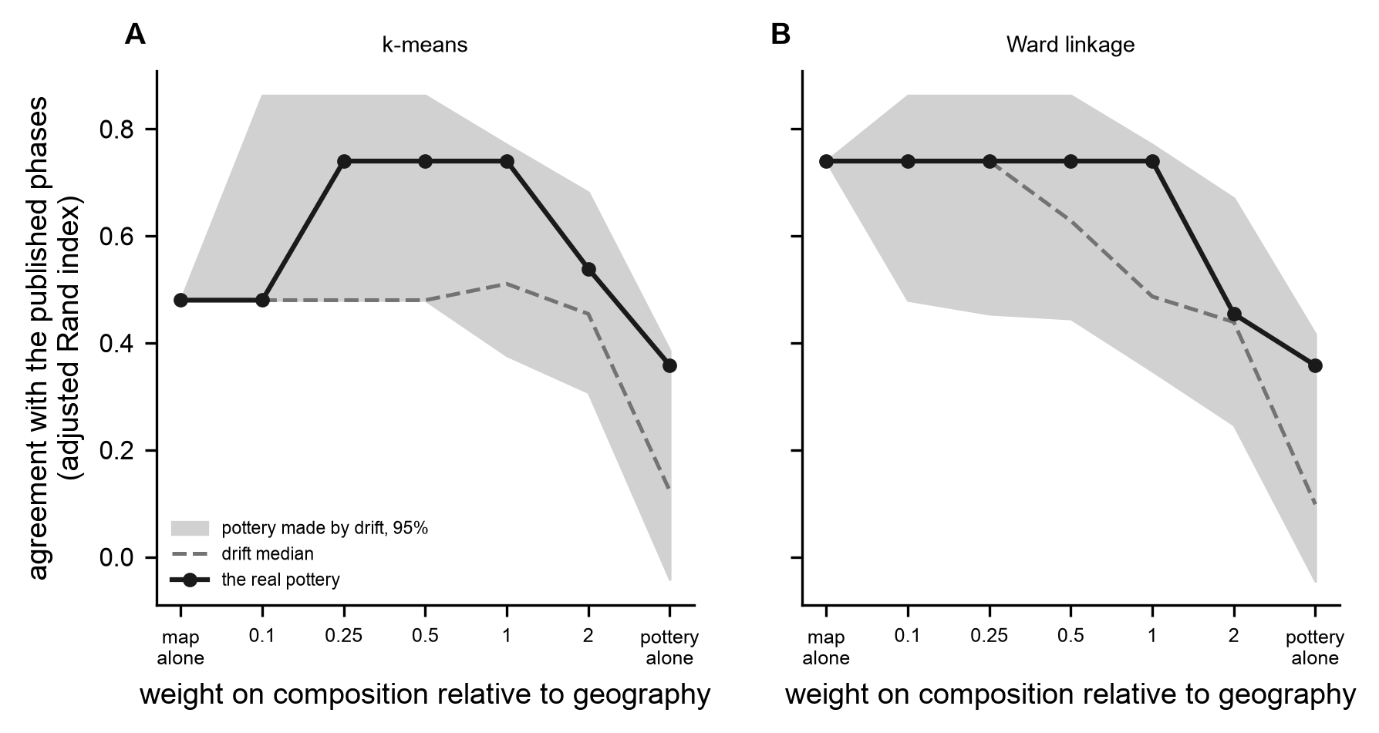
Figure 6. Would a culture historian have found these phases in ceramic assemblages made by copying with no groups? Agreement with the phase assignments, by adjusted Rand index over the 26 assemblages inside a phase area, as the weight on decorated-class composition relative to site coordinates varies from the map alone to assemblage type frequencies alone. Assemblages are clustered by $k$-means (A; the median over 10 seeds) and by Ward linkage (B). The line with markers is the real record; the dashed line is the median and the band the 95 percent range over 300 runs of the neutral copying model, which contains no groups, sampled at the real sherd counts and clustered the same way. The zero-weight point is identical by construction.
The phase lines run through sparsely settled country. The settlement compilation records 81 sites with a late pre-contact component in the mapped area, and dropping the 28 within a kilometer of an analyzed assemblage leaves 53 whose positions are independent of the analyzed locations. Measured at a 5 km scale, 94 percent of same-size divisions around random centers and 100 percent of compact ones run through denser late-period settlement than the phase lines do (Figure 7), and the result is similar at the other two scales tested, 98 and 100 percent at 3 km and 89 and 86 percent at 8 km. The clumps the phases gather are clumps of settlement with less-occupied land between them. Rivers partly explain settlement clumping. Late-period sites lie a median 1.7 km from a major river, against 3.4 km for random points in the same area, but points placed as close to the rivers as the sites are come out randomly spaced (Clark-Evans ratio 0.98 against the sites’ 0.67). Assemblage clumps form on particular reaches of riverways for reasons proximity alone does not explain.
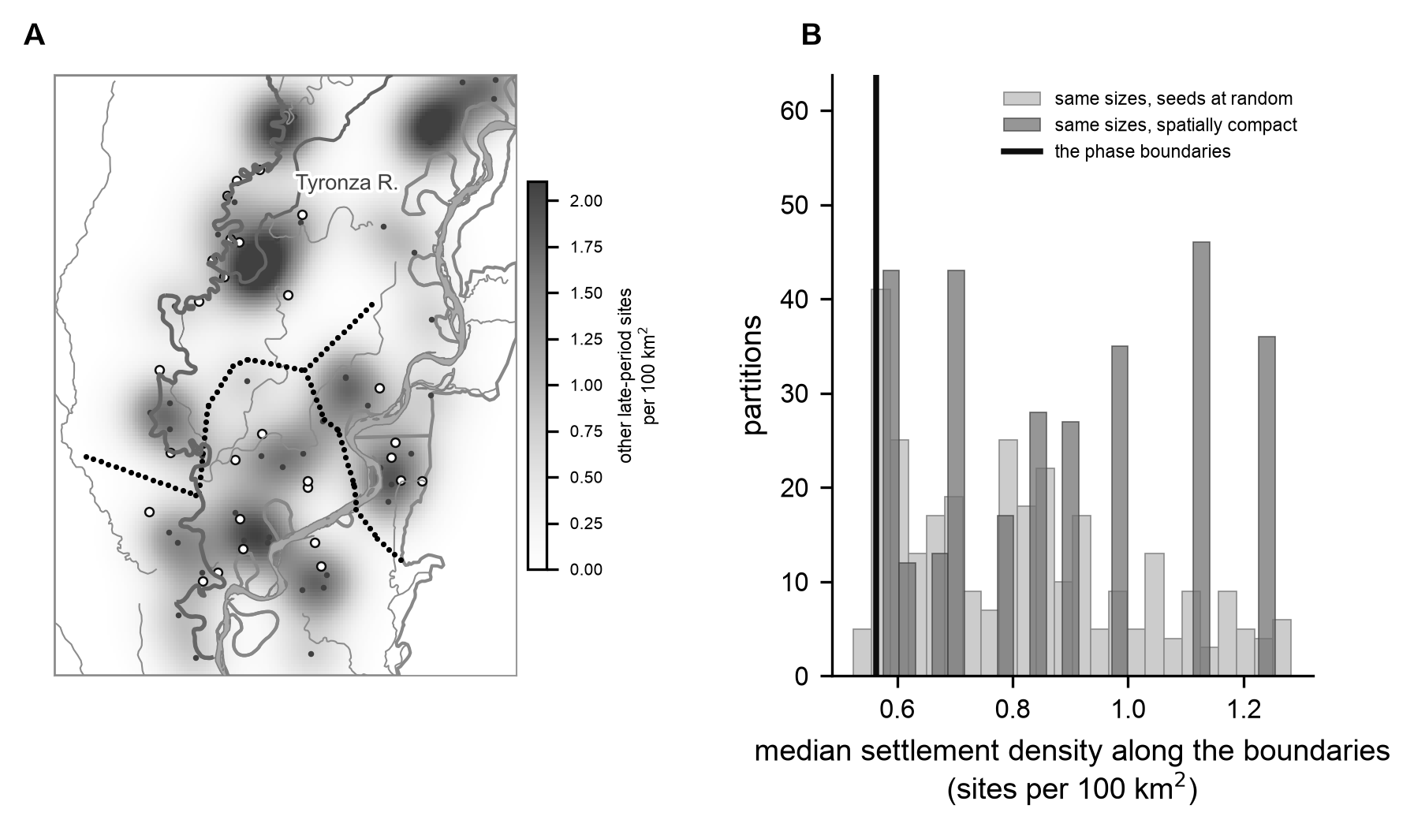
Figure 7. Do the reconstructed phase boundaries follow gaps in settlement? (A) Density of the 53 late-period sites more than 1 km from any analyzed assemblage (small dots; 5 km bandwidth), with the assemblages as open circles and the reconstructed phase boundaries (territory edges built as in Figure 4B) as points. (B) Median settlement density along the reconstructed phase boundaries (vertical line) against the same quantity for the boundaries of 300 divisions with the phases’ group sizes, around random centers (light) and drawn to be compact (dark).

Does the Parkin phase stand apart?
The Parkin phase is close to the northern of the two spatial clusters the site layout supports, although the two divisions are no longer the same one (adjusted Rand index 0.857). Its difference from the rest of the basin is a cultural $F_{ST}$ of 0.0067, which the copying model reaches in 8 percent of runs at the most favorable combination and 4 to 9 percent across the six (model median 0.0018, 95 percent range 0.0002 to 0.0101). Of the divisions tested, only the two-cluster division is reproduced more often, partly because a division into two large groups yields a smaller $F_{ST}$.
Whether the Parkin line separates the assemblages better than other lines depends on the kind of line. With uncertainty in the counts carried through, the Parkin-versus-rest $F_{ST}$ has a posterior median of 0.0066 (95 percent credible interval 0.0052 to 0.0083), compared with 0.0062 for same-size divisions around random centers and 0.0057 for compact ones. The posterior probability that the Parkin line separates the assemblages better is 0.52 against divisions around random centers and 0.94 against compact ones. The step in similarity across the Parkin line, a boundary excess of +5.7 (posterior median +5.9, 95 percent credible interval +3.5 to +8.3), lies within what copying alone produces (simulated median 0.0, 95 percent range -3.9 to +5.9; 3 percent of 300 runs reach it), and arbitrary lines drawn across this map show the same step. The posterior median is also +5.9 for divisions of both kinds, and the posterior probability that the Parkin line shows more is 0.43 and 0.49. The assemblage composition sets the Parkin phase apart from its neighbors about as much as it sets apart a comparably sized piece of the basin around a random center, and more than the compact two-way divisions do. This comparison has little power for a single line, however. In simulations with copying across the phase lines, the Parkin phase’s edge among them, cut to 3 percent, the Parkin line beats a median 72 percent of random-center divisions, against 58 percent with no restriction, and a score as low as the real one (58 percent) occurs in 23 and 52 percent of simulated records. The compact two-way divisions are few and similar, so the comparison with them carries less weight (Supplemental Text). The record therefore cannot exclude restricted copying at the edge of the Parkin phase. However, the assemblage composition shows nothing that requires it.
Two further descriptions of the basin place Parkin in context, although neither tests it. Deterministic seriation of the basin assemblages returns 34 maximal co-seriable groups at a continuity threshold of 0.1, none larger than four assemblages, and 18 of the 28 assemblages belong to more than one (Figure 8). Overlapping orderings of this kind are what a continuous field too varied to fit one ordering would produce, but the recovery experiment showed that seriation structure cannot detect imposed groups at this resolution, and we have not validated the overlap statistic separately, so the overlap is consistent with the absence of closure rather than evidence against it. Parkin belongs to three groups, a bridge between orderings but not the most connected one: Barton Ranch, Rose Mound, and Williamson each belong to six. Lipo, Madsen, and Dunnell (2015) found the same position and read it as a possible sign of emerging hierarchy.
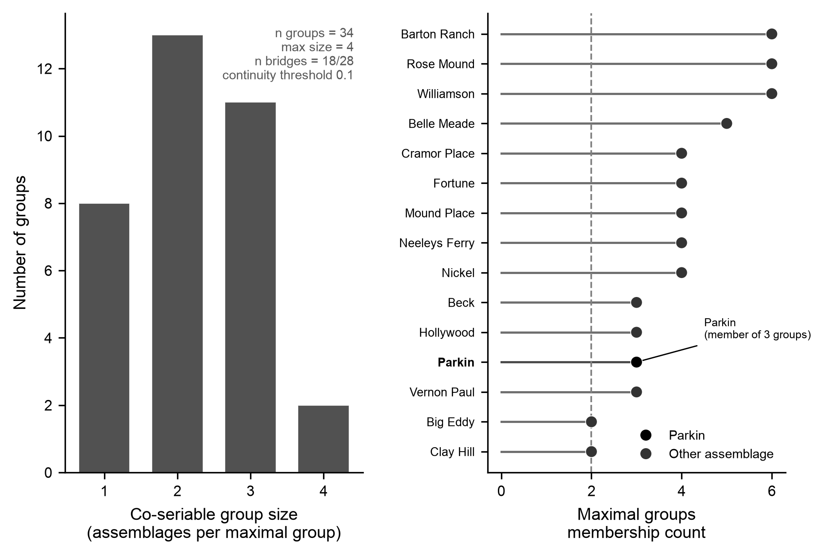
Figure 8. Deterministic seriation structure of the basin assemblages. Left: the distribution of co-seriable group sizes, a fragmented structure of 34 maximal groups with a maximum size of four. Right: the most connected assemblages ranked by the number of groups they belong to, with Parkin highlighted as a bridge (member of three groups) between orderings rather than at the center of one. The overlap statistic is descriptive; it has not been validated as a detector of closure (Supplemental Text).
The settlement record is the second description. Parkin’s principal mound is a flat-topped platform 6.5 m (21.3 ft) high on the western edge of the site, overlooking the St. Francis River, with six smaller mounds near it; the site covers 17 acres (6.9 ha), is ditched on three sides, and its deposits rise 3 m above the floodplain (Morse 1981, 1990). Its mound is the second tallest of the 55 basin sites with a recorded height, behind one at 23 ft, and the tallest exceeds the second by a ratio of only 1.08 (Figure 9). Parkin’s height comes from excavation reports, whereas the others come from a regional compilation without per-site sources, so the series mixes measurement sources. Mound heights form a graded series with no gap at the top. Maximum mound height is a limited proxy for political rank: it records the final size of one construction, not the organization that built it, and a graded series fits more than one form of ranking, so it describes the settlement record without testing for an administrative tier. Regional evidence on the chert-hoe economy is similar: autonomous workshops made Mill Creek hoes at the source and moved them largely down the line, with elites at consuming centers gaining at most privileged access (Cobb 2000:75, 154, 198). That evidence is not basin-specific and cannot test Parkin’s position locally.
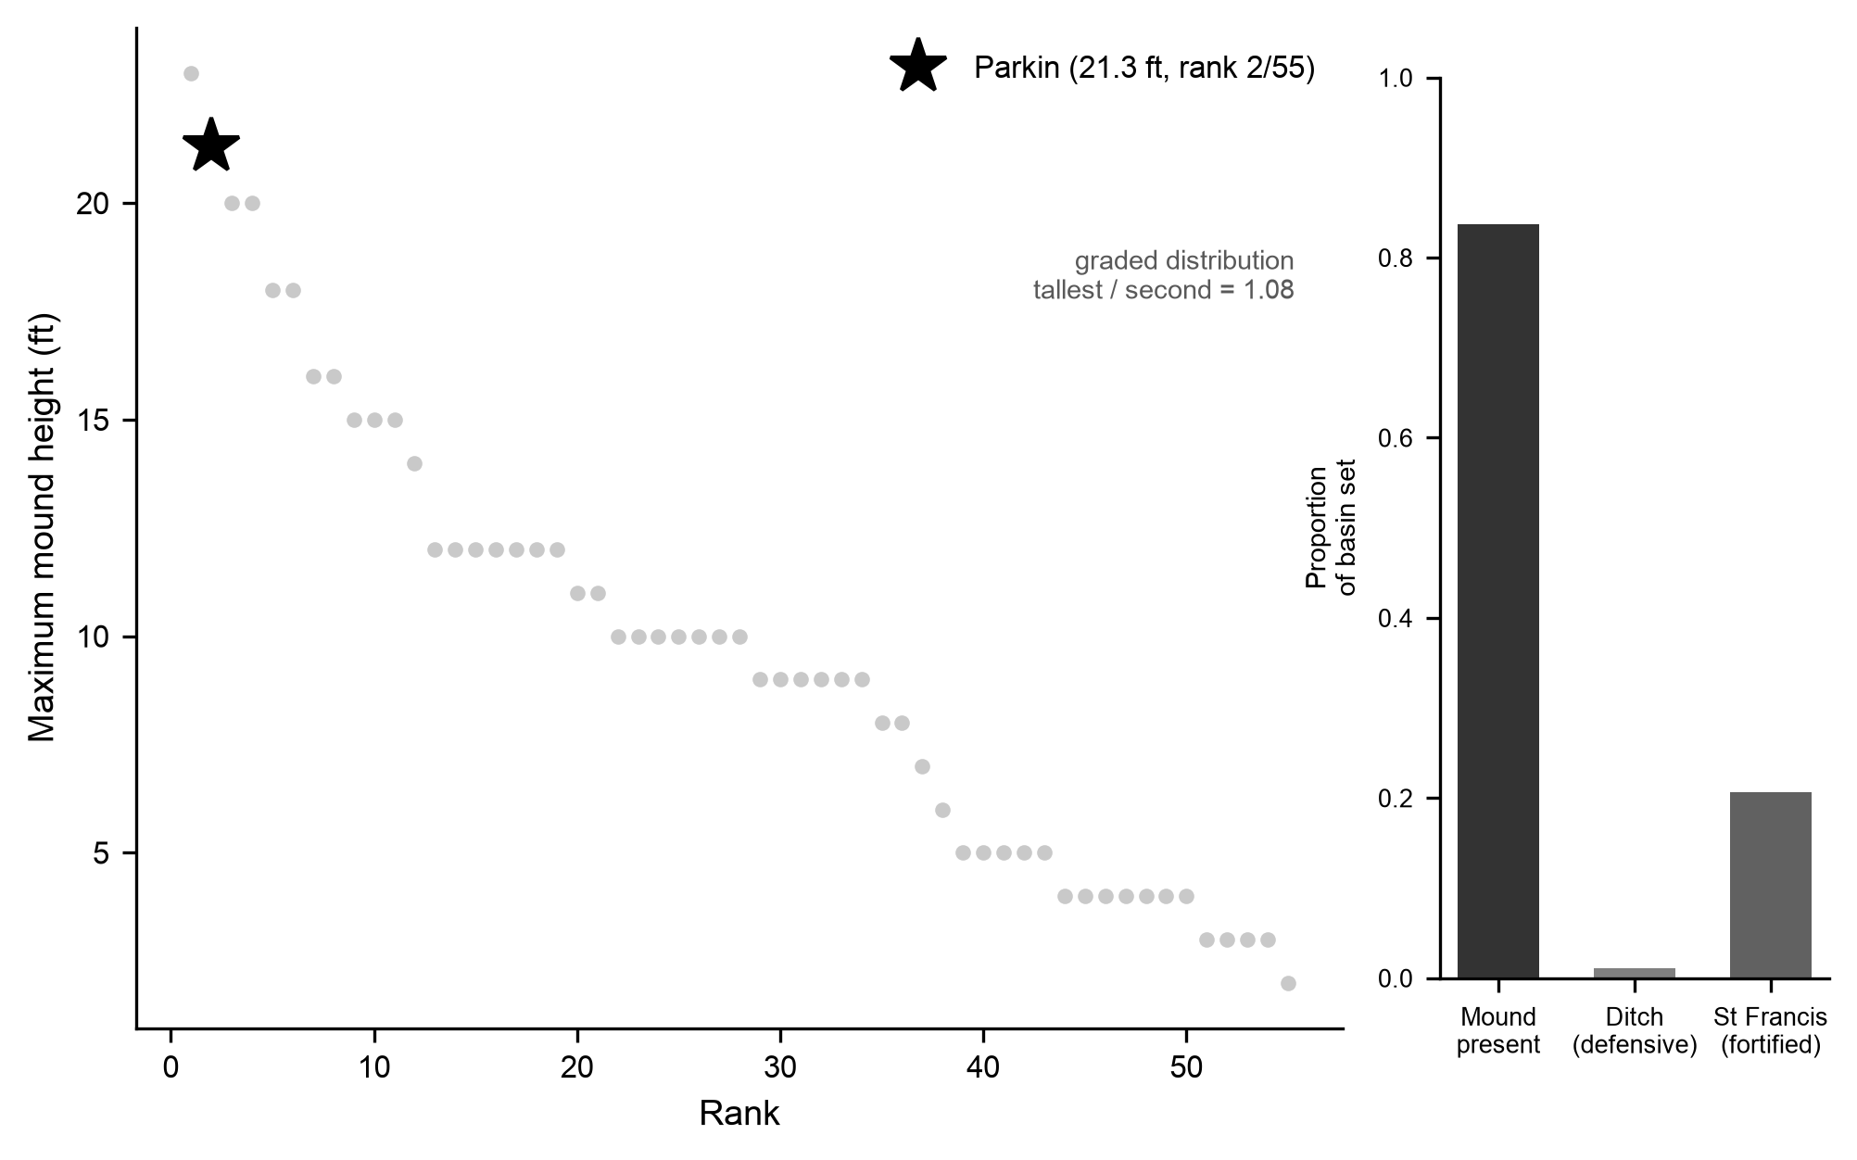
Figure 9. Settlement cross-check. Left: maximum mound height ranked across the basin, the one size attribute the regional compilation records for most sites, from sources that are not uniform (mound area is recorded as zero for Parkin and is not used). Parkin’s principal mound is 21.3 ft (6.5 m) after Morse (1981, 1990), second among the 55 basin sites with a recorded height; the compilation otherwise used gives Parkin 23 ft, and we substitute the excavated value. The distribution is graded, with no gap at the top (tallest-to-second ratio 1.08). Right: the proportion of sites with a mound, a defensive ditch, and St. Francis-type fortification across the basin set (n = 92).

A second tally under a revised scheme
Mainfort (2003) compiled his table from much the same sites and assigned them to phases following Phillips, with two kinds of change (Mainfort 2003:176–177). He adopted Smith’s (1990) Horseshoe Lake phase, which takes Belle Meade and Beck from Phillips’s Kent phase and Mound Place from his Walls phase, together with Young, which lies inside Phillips’s Walls area. He also added Smith’s Tipton and Jones Bayou phases in western Tennessee, which Phillips’s scheme does not reach. His table places Carson Lake in Walls, although his text treats it as a Nodena site (Mainfort 2003:176–181). Where the two schemes cover the same ground, they differ at these five sites.
We ran the phase-line tests on Mainfort’s own counts, using decorated types only and his assignments, with a minimum of 100 decorated sherds. The resulting 29 sites fall in five phases: Kent with 9 sites, Parkin with 7, Walls with 6, Horseshoe Lake with 4, and Jones Bayou with 3 (Figure 10). His table overlaps ours at 21 sites, so this is a second tally of largely the same material rather than an independent record.
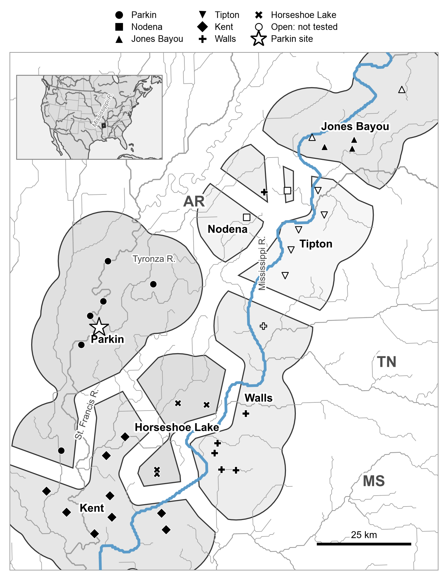
Figure 10. The phases as Mainfort (2003) assigned them: the 39 sites of his table, in seven phases. The territories are our construction from his assignments, not lines he drew. Every point on the map goes to its nearest site and those areas are merged by phase, so a phase can fall in more than one piece, as Walls and Nodena do. Filled markers are the 29 sites the second case tests, those with at least 100 decorated sherds in the five phases that keep at least two such sites; open markers are his other ten sites. The Parkin site is starred. Hydrography as in Figure 1.
Location again carries part of the scheme. The site map alone agrees with Mainfort’s assignments at an adjusted Rand index of 0.54; assemblage-type frequencies alone, 0.25; and same-size divisions around random centers, 0.31 (Figure 11A). Giving composition half the weight of the coordinates raises the agreement to 0.66; at the other weights tested it is at or below the map alone. His lines separate the assemblages more clearly than the three phases do on our matrix. The between-group $F_{ST}$ under his phases has a posterior median of 0.046 (95 percent credible interval 0.041 to 0.051), against 0.030 for same-size divisions around random centers and 0.032 for compact ones, and the posterior probability that his delineations separate the assemblages better than such a division is 0.96 and 0.94. The compactness search never produces his groups. The two results are not directly comparable, since his table reaches into western Tennessee and divides its sites into five phases. At the four contested sites that can be tested, the assemblage data do not consistently favor either scheme. Belle Meade and Mound Place lie closer to the phase Mainfort assigns, and Beck and Young to the phase the primary analysis assigns (Figure 11B). Carson Lake cannot be compared, because his table holds no other Nodena site with 100 decorated sherds (Supplemental Text).
The second case agrees with the primary one in part. On both tallies, location recovers much of the scheme, and the phase lines separate the assemblages at least as well as arbitrary lines. On Mainfort’s table, with five phases reaching into Tennessee, they separate them clearly better (probabilities of 0.96 and 0.94, against 0.57 and 0.72 for the three phases). Neither result shows that the phases mark bounded groups, since both schemes were drawn using the frequencies of these types and location still recovers part of each. Where the two schemes disagree, at the Horseshoe Lake phase, the assemblages do not decide between them.
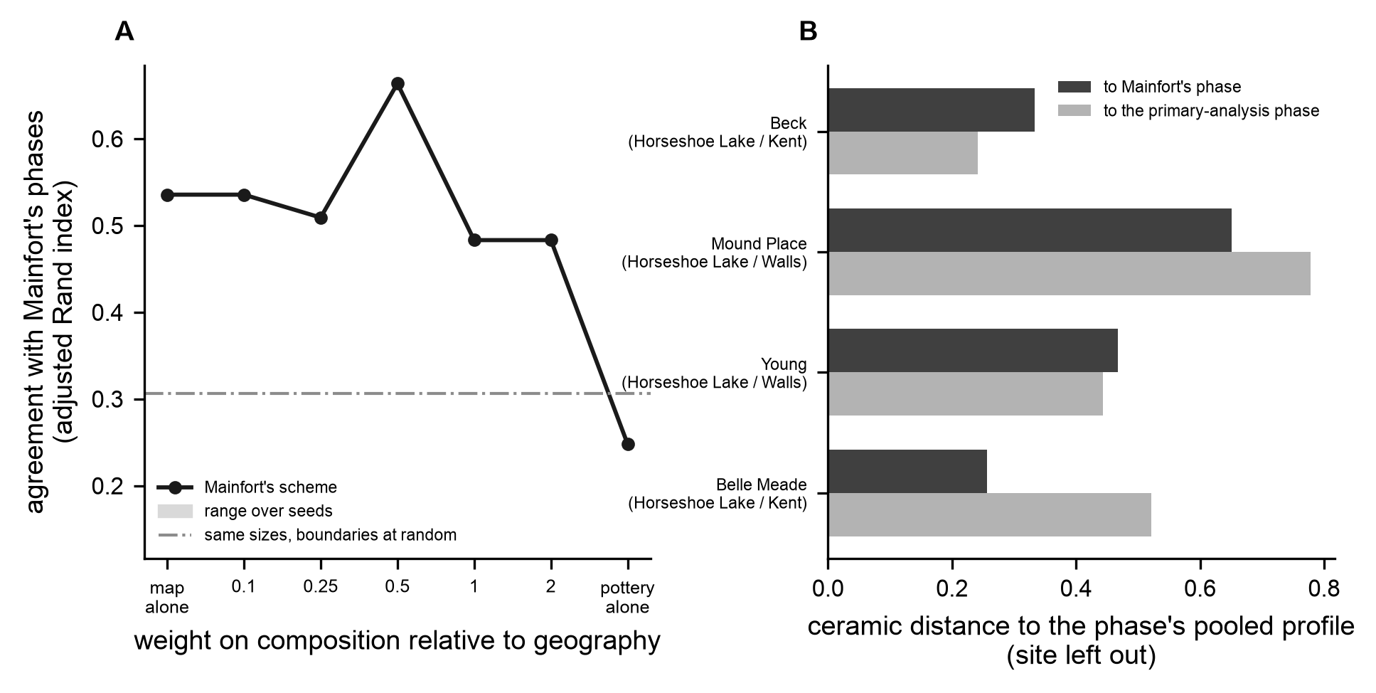
Figure 11. The second case: the phase tests on Mainfort’s (2003) table, under his phases. (A) Agreement with his assignments, by adjusted Rand index over the 29 sites with at least 100 decorated sherds, for clusterings on site coordinates and decorated-class composition as the weight on composition varies from the map alone to assemblage composition alone; the 40 seeds give the same value at every weight, so the band showing their range has no width, and the dash-dotted line is the agreement reached by same-size divisions around random centers. (B) For four of the five sites the two schemes assign differently (Carson Lake has no other tested site in its primary-analysis phase and is not shown), the chi-square distance from the site’s profile to the pooled profile of the phase Mainfort assigned (dark) and of the phase the primary analysis assigns (light), with the site itself left out of both.

Discussion

What explains the phases
The results bear on three different kinds of claim, and they support each to varying degrees. The first is descriptive adequacy: a smooth surface over the map describes the variation among assemblages well, and calibrated copying with no groups reproduces the fade of similarity with distance and the two-cluster difference. The second is mechanism. The phases have the properties expected of units built by sorting a clumped record by resemblance and proximity. Their lines run through sparsely settled country, and hierarchical clustering of site locations alone recovers them for all but two assemblages. Copying with no groups is sufficient for much of this, but not all of it. Assemblages copied without groups sort into the phases about as readily as the real ones under hierarchical clustering when composition is given a quarter of location’s weight or less, and less readily at equal weight and on resemblance alone, and the calibrated model falls short of the differences among the phases, as it does for the spatial divisions of the basin into three or more clusters. The third is boundary evidence, whether the phase lines mark restrictions on copying. Here the result is open. The phase lines separate the assemblages about as well as alternative divisions of the same sites, somewhat better than compact ones, and the step in similarity across them appears at arbitrary lines as well. In simulation at the calibrated combination, the real score is common without any restriction at the lines and less common, though not rare, with a strong one, so the comparison leans weakly against a restriction and excludes neither possibility.
The culture historians who drew the phases were responding to something real, a gradient in style sampled at clumped settlements. The assemblages do not show that the lines they drew also marked the edges of bounded learning, and they do not exclude it. Where the lines cross occupied ground, they are arbitrary in the way a gradient makes them. Six of the 28 assemblages do not clearly fit their own phase best, and Castile Landing fits Parkin and Kent about equally well.
This accounts for the pattern Mainfort (2003:180) reported but could not explain: phase members lying “in the general vicinity of each other in ordination space” while forming no groups. Nearness in an ordination is nearness on the ground, seen through the assemblages. His table adds a second tally. There the site map alone agrees with his scheme at 0.54, and his lines separate the assemblages better than arbitrary ones. The tests can therefore favor a set of phase lines, and on our matrix they favor Phillips’s only weakly. A phase also folds time into space. McNutt, Franklin, and Henry (2012:247) describe the Walls phase as “a developmental lineage” spanning roughly two centuries, so the members of a phase need not even be contemporaneous. The interpretation is not new to the regional literature. McNutt (1996:250) wrote of the southern phases, Walls, Horseshoe Lake, Kent, and Parchman among them, that “the distinctions that one tries so desperately to make between the phases involved are little more than comments on local elaborations—ceramic drift, if you will—of the basic pottery complexes possessed by peoples involved in this expansion.” The comparison adds a test of that reading: whether the Parkin, Kent, and Walls phase lines behave as edges of bounded learning.
The assemblages carry one property the calibrated copying model does not produce, and it concerns a small part of the variation. Mean diversity within an assemblage is 95 percent of the diversity of all assemblages pooled (0.563 against 0.592), and the three phases account for about 1 percent of it ($F_{ST}$ 0.012). Within that small part, the assemblages vary over shorter distances than calibrated copying would, so divisions into three or more groups differ more than the model predicts, and arbitrary divisions of the map show a step in similarity of about the size seen at the phase lines. That variation is not specific to the phase lines or to Parkin, since other divisions of the map capture about as much of it, and it remains incompletely explained. New styles arising somewhat locally, and copying that falls off over a few kilometers, both make the observed differences more common in simulation while keeping the record’s diversity matched (Table 2). Both are still neutral copying, and both are themselves geographic. The simulations do not fix the scale of either. Local innovation fits with areas the size of half the basin, its finer-grained settings either break the diversity match or are weakly tested, and the short fall-off raises the shares only slightly. One reading, which we offer as a hypothesis and have not tested, is that interaction was concentrated in the area a community used from day to day, a few kilometers around a settlement, as would be expected of farmers, hunters, and fishers who drew on local resources. We treat these as mechanisms the record is consistent with rather than ones it demonstrates. Part of the variation may also be chronological, a matter of age that an order derived from the same frequencies cannot separate from place.

Parkin and the polity
Parkin was the basin’s largest town and had one of its tallest mounds, and its prominence was real. The decorated-type frequencies, however, do not show a boundary in ceramic learning at the edge of the Parkin phase. The phase is close to the northern of the two clusters the regional map supports. Its difference from the rest of the basin is one the copying model reproduces more often than any division but the two-cluster one, the step in similarity at its edge lies within what copying alone produces, and divisions around random centers separate the assemblages as well as its boundary does, although compact ones do not. Because a single line gives these comparisons little power, restricted copying at the phase’s edge cannot be excluded, but nothing in the frequencies requires it.
The arguments usually offered for a Parkin polity do not supply the missing signal. The argument that Parkin, on poor soil, must have drawn tribute from productive neighbors (Phyllis A. Morse 1990:124) assumes the tribute it concludes, and Morse (1990:123) also notes that Parkin’s position below the confluence of the St. Francis and Tyronza gave it control of river travel, which accounts for its prominence as well as extraction does. Skeletal evidence that people at a mound center ate better than people at a nearby village comes from Hollywood, one of the assemblages analyzed here. Compared with a village of fourteen individuals (Ross-Stallings 2017), a health difference between two sites need not arise from an extractive hierarchy. The region’s own history also offers a precedent for separating polity from a ceramically defined phase. Coosa, the best-documented Mississippian paramountcy, spanned two ceramic traditions and site clusters that were separable at the phase level, and political affiliation rather than shared decoration bound them together (Anderson 1996:250–251). A polity need not coincide with a phase, and the reverse inference, from one phase to one polity, has no warrant on its own. If the polity the De Soto expedition met was at Parkin, the evidence for it lies in ceremony, fortification, and settlement size. The decorated pottery is silent on it rather than evidence against it.

Limits
Four limits bound these conclusions. The first is resolution. On a record of this size, only cultural $F_{ST}$ can detect groups, and only groups that follow geography closely enough to be captured by spatial divisions; social divisions that cut across the map could raise $F_{ST}$ at spatial divisions without being identified as groups, and closure carried purely by conformity within one pool would escape detection (Supplemental Text). The second is chronology. Radiocarbon dates match only four assemblages, and the seriation axis follows latitude more closely than age. The phase-line tests do not depend on it, and the copying-model comparison gives nearly the same answer when all assemblages are treated as contemporaneous, but the record cannot say whether any difference grew through time; within its limits, it shows none (Supplemental Text). The third is time-averaging, which damps differences between assemblages (Kidwell and Tomašových 2013; Perreault 2018; Tomašových and Kidwell 2009; Youngblood et al. 2023). We built it into the copying model, so its cost is already in the reported ranges. The fourth is the copying model itself. Which combination is most favorable to it depends on the random seeds used to rank them, so we report the key comparisons across six (Table 1). The model distinguishes a copying boundary at the phase lines from new styles arising locally only weakly, so the conclusion about the phases rests on how their lines compare with other divisions of the map and what could have drawn them, rather than on the model’s failure to find restricted copying.

What this approach contributes to the study of social units
Our approach rests on two requirements that apply beyond this case. Before treating a similarity pattern as the result of differential social interaction, the record must be shown to detect a social boundary. Here, we show that $F_{ST}$ is the one measure of four that can do this with assemblage-scale data that includes time aggregation. Before a model of copying with no groups is credited with reproducing a record, it must be shown to fit that record’s own diversity. The second requirement changed our own results: calibrated, the model is narrower than an uncalibrated one and shows the shorter-range variation it misses. A model that is run at the wrong diversity is easily credited with structure it cannot produce, just as a localized neutral process is easily mistaken for biased copying when diversity is taken at face value (Premo 2016; Premo and Scholnick 2011; Schneider et al. 2016). Our approach also asks a question ordination alone cannot. We ask not whether the phases separate, but whether their delineations separate the assemblages better than other lines drawn across the same map. These are standards of measurement for an evolutionary archaeology that has long been clearer about what evolves than about how to measure it (Dunnell 1995; Lipo et al. 2015; Neiman 1995).
For the St. Francis Basin assemblages, the shorter-range variation and Parkin’s role would be better tested with stratified, excavated assemblages with independent radiocarbon dates, compositional and petrographic evidence for where assemblages were made, and exchange, mortuary, and dietary records (Cobb 2000; Ross-Stallings 2017).

Conclusion
The phase is the unit on which Lower Mississippi Valley culture history is built, and it often carries an unstated claim: that assemblages grouped by seriation and proximity record a community, and at Parkin, a polity. Earlier work showed that the phases do not separate cleanly. This paper tests whether the phases of the St. Francis basin, as Phillips defined them, coincide with restrictions on the copying of decorated pottery, and offers an explanation for their apparent organization. The phases have the properties of units sorted by resemblance and proximity from a clumped record. Their lines run through sparsely settled country, and hierarchical clustering of site locations alone recovers them for all but two assemblages. They do not uniquely capture the basin’s decorated-ceramic differentiation. Alternative spatial divisions of the same sites capture about as much of it, and the step in similarity at the phase lines appears at arbitrary lines as well. Pottery made by copying with no groups sorts into the phases about as readily as the real pottery under hierarchical clustering when composition is given a quarter of location’s weight or less. On resemblance alone, the real pottery fits the phases better than most simulated pottery does, but the same frequencies were used to draw them. On a second tally under a revised scheme, location again recovers much of the scheme, and the phase lines separate the assemblages more clearly. Spatially structured copying, sampled at clumped settlements and sorted by resemblance and proximity, remains a plausible account of how the phases came to look like groups, but the calibrated model does not reproduce them in full.
These results weaken the use of phase membership alone as evidence of bounded ceramic interaction communities. They do not exclude a Parkin polity, whose political boundaries need not have followed ceramic traditions, nor restrictions on copying at the phase lines, and the additional variation at finer scales remains incompletely explained. Before a phase is interpreted as a bounded community, its frequencies should show what copying across distance does not produce, and its lines should separate the assemblages better than other lines drawn across the same map.

Data and Code Availability
All data and code needed to reproduce the analyses and figures reported here are openly available at https://github.com/clipo/phases. Upon publication, we will release a versioned snapshot of the repository at https://doi.org/10.5281/zenodo.20796240. The repository includes decorated-ceramic class counts, georeferencing and radiocarbon data, the full analysis procedure, and instructions for reproducing all results and figures. The neutral copying model is implemented in src/mls_emergence/transmission/spatial.py and analyses 47 and 50, which write every simulation, the calibration series, and a configuration fingerprint. The code is released under the MIT License, and the data under a Creative Commons Attribution 4.0 International license.

References
Anderson, David G. 1996. Fluctuations Between Simple and Complex Chiefdoms: Cycling in the Late Prehistoric Southeast. In Political Structure and Change in the Prehistoric Southeastern United States, edited by John F. Scarry, pp. 231–252. University Press of Florida, Gainesville.
Baxter, M. J. 1994. Exploratory Multivariate Analysis in Archaeology. Edinburgh University Press, Edinburgh.
Beaumont, Mark A., Wenyang Zhang, and David J. Balding. 2002. Approximate Bayesian Computation in Population Genetics. Genetics 162(4):2025–2035.
Beck, Jr., Robin A. 2003. Consolidation and Hierarchy: Chiefdom Variability in the Mississippian Southeast. American Antiquity 68(4):641–661. https://doi.org/10.2307/3557066.
Bell, Adrian V., Peter J. Richerson, and Richard McElreath. 2009. Culture Rather Than Genes Provides Greater Scope for the Evolution of Large-Scale Human Prosociality. Proceedings of the National Academy of Sciences 106(42):17671–17674. https://doi.org/10.1073/pnas.0903232106.
Bentley, R. Alexander, Matthew W. Hahn, and Stephen J. Shennan. 2004. Random Drift and Culture Change. Proceedings of the Royal Society B: Biological Sciences 271:1443–1450. https://doi.org/10.1098/rspb.2004.2746.
Blitz, John H. 1999. Mississippian Chiefdoms and the Fission-Fusion Process. American Antiquity 64(4):577–592. https://doi.org/10.2307/2694206.
Brainerd, George W. 1951. The Place of Chronological Ordering in Archaeological Analysis. American Antiquity 16(4):301–313.
Carpenter, Bob, Andrew Gelman, Matthew D. Hoffman, Daniel Lee, Ben Goodrich, Michael Betancourt, Marcus Brubaker, Jiqiang Guo, Peter Li, and Allen Riddell. 2017. Stan: A Probabilistic Programming Language. Journal of Statistical Software 76(1):1–32.
Cobb, Charles R. 2000. From Quarry to Cornfield: The Political Economy of Mississippian Hoe Production. University of Alabama Press, Tuscaloosa.
Crema, Enrico R., Eugenio Bortolini, and Mark Lake. 2024. How Cultural Transmission Through Objects Impacts Inferences about Cultural Evolution. Journal of Archaeological Method and Theory 31:202–226. https://doi.org/10.1007/s10816-022-09599-x.
Crema, Enrico R., Anne Kandler, and Stephen Shennan. 2016. Revealing Patterns of Cultural Transmission from Frequency Data: Equilibrium and Non-Equilibrium Assumptions. Scientific Reports 6:39122. https://doi.org/10.1038/srep39122.
Dunnell, Robert C. 1978. Style and Function: A Fundamental Dichotomy. American Antiquity 43(2):192–202. https://doi.org/10.2307/279244.
Dunnell, Robert C. 1980. Evolutionary Theory and Archaeology. In Advances in Archaeological Method and Theory, Volume 3, edited by Michael B. Schiffer, pp. 35–99. Academic Press, New York.
Dunnell, Robert C. 1995. What Is It That Actually Evolves? In Evolutionary Archaeology: Methodological Issues, edited by Patrice A. Teltser, pp. 33–50. University of Arizona Press, Tucson.
Eerkens, Jelmer W., and Carl P. Lipo. 2005. Cultural Transmission, Copying Errors, and the Generation of Variation in Material Culture and the Archaeological Record. Journal of Anthropological Archaeology 24(4):316–334. https://doi.org/10.1016/j.jaa.2005.08.001.
Eerkens, Jelmer W., and Carl P. Lipo. 2007. Cultural Transmission Theory and the Archaeological Record: Providing Context to Understanding Variation and Temporal Changes in Material Culture. Journal of Archaeological Research 15(3):239–274. https://doi.org/10.1007/s10814-007-9013-z.
Fogarty, Laurel, Anne Kandler, Nicole Creanza, and Marcus W. Feldman. 2024. Half a Century of Quantitative Cultural Evolution. Proceedings of the National Academy of Sciences 121(48):e2418106121. https://doi.org/10.1073/pnas.2418106121.
Fox, Gregory L. 1998. An Examination of Mississippian-Period Phases in Southeastern Missouri. In Changing Perspectives on the Archaeology of the Central Mississippi River Valley, edited by Michael J. O’Brien and Robert C. Dunnell, pp. 31–58. University of Alabama Press, Tuscaloosa.
Gelman, Andrew, Xiao-Li Meng, and Hal Stern. 1996. Posterior Predictive Assessment of Model Fitness via Realized Discrepancies. Statistica Sinica 6(4):733–807.
Haley, Bryan S. 2014. The Big Picture at Hollywood: Geophysical and Archaeological Investigations at a Mississippian Mound Centre. Archaeological Prospection 21(1):39–47. https://doi.org/10.1002/arp.1477.
Henrich, Joseph. 2001. Cultural Transmission and the Diffusion of Innovations: Adoption Dynamics Indicate That Biased Cultural Transmission Is the Predominate Force in Behavioral Change. American Anthropologist 103(4):992–1013. https://doi.org/10.1525/aa.2001.103.4.992.
Henrich, Joseph, and Robert Boyd. 1998. The Evolution of Conformist Transmission and the Emergence of Between-Group Differences. Evolution and Human Behavior 19(4):215–241. https://doi.org/10.1016/S1090-5138(98)00018-X.
Holdaway, Simon J., and LuAnn Wandsnider (editors). 2008. Time in Archaeology: Time Perspectivism Revisited. University of Utah Press, Salt Lake City.
Holland-Lulewicz, Jacob, and Brandon T. Ritchison. 2021. How Many Dates Do i Need? Using Simulations to Determine Robust Age Estimations of Archaeological Contexts. Advances in Archaeological Practice 9(4):272–287. https://doi.org/10.1017/aap.2021.10.
House, John H. 1991. Monitoring Mississippian Dynamics: Time, Settlement, and Ceramic Variation in the Kent Phase, Eastern Arkansas. PhD thesis, Southern Illinois University at Carbondale, Carbondale.
House, John H. 1993. Dating the Kent Phase. Southeastern Archaeology 12(1):21–32.
Hubert, Lawrence, and Phipps Arabie. 1985. Comparing Partitions. Journal of Classification 2:193–218.
Hudson, Charles, Marvin T. Smith, and Chester B. DePratter. 1990. The Hernando de Soto Expedition: From Mabila to the Mississippi River. In Towns and Temples Along the Mississippi, edited by David H. Dye and Cheryl Anne Cox, pp. 181–207. University of Alabama Press, Tuscaloosa.
Kidwell, Susan M., and Adam Tomašových. 2013. Implications of Time-Averaged Death Assemblages for Ecology and Conservation Biology. Annual Review of Ecology, Evolution, and Systematics 44:539–563. https://doi.org/10.1146/annurev-ecolsys-110512-135838.
King, Adam, and Jennifer A. Freer. 1995. The Mississippian Southeast: A World-Systems Perspective. In Native American Interactions: Multiscalar Analyses and Interpretations in the Eastern Woodlands, edited by Michael S. Nassaney and Kenneth E. Sassaman, pp. 266–288. University of Tennessee Press, Knoxville.
Lehner, Bernhard, and Günther Grill. 2013. Global River Hydrography and Network Routing: Baseline Data and New Approaches to Study the World’s Large River Systems. Hydrological Processes 27(15):2171–2186.
Lipo, Carl P. 2001. Science, Style and the Study of Community Structure: An Example from the Central Mississippi River Valley. BAR International Series 918. Archaeopress, Oxford.
Lipo, Carl P., Robert J. DiNapoli, Mark E. Madsen, and Terry L. Hunt. 2021. Population Structure Drives Cultural Diversity in Finite Populations: A Hypothesis for Localized Community Patterns on Rapa Nui (Easter Island, Chile). PLoS ONE 16(5):e0250690. https://doi.org/10.1371/journal.pone.0250690.
Lipo, Carl P., and Robert C. Dunnell. 2007. Prehistoric Settlement in the Lower Mississippi Valley: A Critical Review. In Time’s River: Archaeological Syntheses from the Lower Mississippi Valley, edited by Janet Rafferty and Evan Peacock, pp. 125–167. University of Alabama Press, Tuscaloosa.
Lipo, Carl P., Mark E. Madsen, and Robert C. Dunnell. 2015. A Theoretically-Sufficient and Computationally-Practical Technique for Deterministic Frequency Seriation. PLOS ONE 10(4):e0124942. https://doi.org/10.1371/journal.pone.0124942.
Lipo, Carl P., Mark E. Madsen, Robert C. Dunnell, and Terry Hunt. 1997. Population Structure, Cultural Transmission, and Frequency Seriation. Journal of Anthropological Archaeology 16(4):301–333. https://doi.org/10.1006/jaar.1997.0314.
Madsen, Mark E. 2012. Neutral Cultural Transmission in Time-Averaged Archaeological Assemblages. arXiv preprint arXiv:1204.2043 [physics.soc-ph].
Mainfort, Jr., Robert C. 2001. The Late Prehistoric and Protohistoric Periods in the Central Mississippi Valley. In Societies in Eclipse: Archaeology of the Eastern Woodlands Indians, a.d. 1400–1700, edited by David S. Brose, C. Wesley Cowan, and Jr. Mainfort Robert C., pp. 173–190. Smithsonian Institution Press, Washington, DC.
Mainfort, Jr., Robert C. 2003. An Ordination Approach to Assessing Late Period Phases in the Central Mississippi Valley. Southeastern Archaeology 22(2):176–184.
Mayr, Ernst. 1959. Typological Versus Population Thinking. In Evolution and Anthropology: A Centennial Appraisal, edited by Betty J. Meggers, pp. 409–412. The Anthropological Society of Washington, Washington, D.C.
McNutt, Charles H. 1996. The Central Mississippi Valley: A Summary. In Prehistory of the Central Mississippi Valley, edited by Charles H. McNutt, pp. 187–. University of Alabama Press, Tuscaloosa.
McNutt, Charles H., Jay D. Franklin, and Edward R. Henry. 2012. New Perspectives on Mississippian Occupations in Western Tennessee and Northwestern Mississippi: Recent Chronological and Geophysical Investigations at Chucalissa (40SY1), Shelby County, Tennessee. Southeastern Archaeology 31(2):231–250.
Miller-Atkins, Galen, and L. S. Premo. 2018. Time-Averaging and the Spatial Scale of Regional Cultural Differentiation in Archaeological Assemblages. STAR: Science and Technology of Archaeological Research 4(1):12–27. https://doi.org/10.1080/20548923.2018.1504490.
Mitchem, Jeffrey M. 2001. A Decade of Hypothesis Testing at the Parkin Site, Arkansas.
Mitchem, Jeffrey M., David W. Stahle, Timothy S. Mulvihill, and Jami J. Lockhart. 2017. Making the Case for the Parkin Site as Casqui: Hernando de Soto’s 1541 Cross.
Morse, Dan F. 1990. The Nodena Phase. In Towns and Temples Along the Mississippi, edited by David H. Dye and Cheryl Anne Cox, pp. 69–97. University of Alabama Press, Tuscaloosa.
Morse, Dan F., and Phyllis A. Morse. 1996. Changes in Interpretation in the Archaeology of the Central Mississippi Valley Since 1983. North American Archaeologist 17(1):1–35.
Morse, Phyllis A. 1981. Parkin: The 1978–1979 Archeological Investigations of a Cross County, Arkansas Site. Arkansas Archeological Survey Research Series 13. Arkansas Archeological Survey, Fayetteville.
Morse, Phyllis A. 1990. The Parkin Site and the Parkin Phase. In Towns and Temples Along the Mississippi, edited by David H. Dye and Cheryl Anne Cox, pp. 118–134. University of Alabama Press, Tuscaloosa.
Nei, Masatoshi. 1973. Analysis of Gene Diversity in Subdivided Populations. Proceedings of the National Academy of Sciences 70(12):3321–3323. https://doi.org/10.1073/pnas.70.12.3321.
Neiman, Fraser D. 1995. Stylistic Variation in Evolutionary Perspective: Inferences from Decorative Diversity and Interassemblage Distance in Illinois Woodland Ceramic Assemblages. American Antiquity 60(1):7–36.
Peebles, Christopher S., and Susan M. Kus. 1977. Some Archaeological Correlates of Ranked Societies. American Antiquity 42(3):421–448. https://doi.org/10.2307/279066.
Peeples, Matthew A., and Gregson Schachner. 2012. Refining Correspondence Analysis-Based Ceramic Seriation of Regional Data Sets. Journal of Archaeological Science 39(8):2818–2827. https://doi.org/10.1016/j.jas.2012.04.040.
Perreault, Charles. 2018. Time-Averaging Slows down Rates of Change in the Archaeological Record. Journal of Archaeological Method and Theory 25(3):953–964. https://doi.org/10.1007/s10816-018-9364-4.
Perreault, Charles. 2019. The Quality of the Archaeological Record. University of Chicago Press, Chicago.
Phillips, Philip. 1970. Archaeological Survey in the Lower Yazoo Basin, Mississippi, 1949–1955, Vol. 60. Papers of the Peabody Museum of Archaeology and Ethnology. Peabody Museum, Harvard University, Cambridge, MA.
Phillips, Philip, James A. Ford, and James B. Griffin. 1951. Archaeological Survey in the Lower Mississippi Alluvial Valley, 1940–1947, Vol. 25. Papers of the Peabody Museum of American Archaeology and Ethnology. Peabody Museum, Harvard University, Cambridge, MA.
Phillips, Philip, and Gordon R. Willey. 1953. Method and Theory in American Archeology: An Operational Basis for Culture-Historical Integration. American Anthropologist 55(5):615–633. https://doi.org/10.1525/aa.1953.55.5.02a00030.
Premo, Luke S. 2016. Effective Population Size and the Effects of Demography on Cultural Diversity and Technological Complexity. American Antiquity 81(4):605–622. https://doi.org/10.7183/0002-7316.81.4.605.
Premo, Luke S., and Jonathan B. Scholnick. 2011. The Spatial Scale of Social Learning Affects Cultural Diversity. American Antiquity 76(1):163–176. https://doi.org/10.7183/0002-7316.76.1.163.
Rees, Mark A. 2001. Mississippian Political Culture: Contrasting Historical Trajectories in Southeastern North America. Ph.D. dissertation, University of Oklahoma, Norman.
Reimer, Paula J. et al. 2020. The IntCal20 Northern Hemisphere Radiocarbon Age Calibration Curve (0–55 Cal kBP). Radiocarbon 62(4):725–757. https://doi.org/10.1017/RDC.2020.41.
Robinson, W. S. 1951. A Method for Chronologically Ordering Archaeological Deposits. American Antiquity 16(4):293–301.
Ross-Stallings, Nancy A. 2017. Center and Satellite: Settlement Hierarchy and Diet on the Late Prehistoric Mississippi Delta. In Bones of Complexity: Bioarchaeological Case Studies of Social Organization and Skeletal Biology, edited by Haagen D. Klaus, Amanda R. Harvey, and Mark N. Cohen, pp. 329–362. University Press of Florida, Gainesville.
Schiffer, Michael B. 1972. Archaeological Context and Systemic Context. American Antiquity 37(2):156–165.
Schneider, David M., Ayana B. Martins, and Marcus A. M. de Aguiar. 2016. The Mutation-Drift Balance in Spatially Structured Populations. Journal of Theoretical Biology 402:9–17. https://doi.org/10.1016/j.jtbi.2016.04.024.
Shennan, Stephen J., Enrico R. Crema, and Tim Kerig. 2015. Isolation-by-Distance, Homophily, and “Core” Vs. “Package” Cultural Evolution Models in Neolithic Europe. Evolution and Human Behavior 36(2):103–109. https://doi.org/10.1016/j.evolhumbehav.2014.09.006.
Shennan, Stephen J., and James R. Wilkinson. 2001. Ceramic Style Change and Neutral Evolution: A Case Study from Neolithic Europe. American Antiquity 66(4):577–593.
Smith, Gerald P. 1990. The Walls Phase and Its Neighbors. In Towns and Temples Along the Mississippi, edited by David H. Dye and Cheryl Anne Cox, pp. 135–169. University of Alabama Press, Tuscaloosa.
Smith, Karen Y., and Fraser D. Neiman. 2007. Frequency Seriation, Correspondence Analysis, and Woodland-Period Ceramic Assemblage Variation in the Deep South. Southeastern Archaeology 26(1):47–72.
Starr, Mary Evelyn. 1984. Parchman Phase in the Northwestern Yazoo Basin. In The Wilsford Site (22-Co-516) Coahoma County, Mississippi: A Late Mississippi Period Settlement in the Northern Yazoo of Mississippi, edited by John M. Connaway, pp. 163–222. Archaeological Report No. 14. Mississippi Department of Archives; History, Jackson, MS.
Tomašových, Adam, and Susan M. Kidwell. 2009. Fidelity of Variation in Species Composition and Diversity Partitioning by Death Assemblages: Time-Averaging Transfers Diversity from Beta to Alpha Levels. Paleobiology 35(1):94–118.
Willey, Gordon R., and Philip Phillips. 1958. Method and Theory in American Archaeology. University of Chicago Press, Chicago.
Williams, Stephen. 1954. An Archeological Study of the Mississippian Culture in Southeast Missouri. PhD thesis, Yale University, New Haven.
Wright, Sewall. 1943. Isolation by Distance. Genetics 28(2):114–138. https://doi.org/10.1093/genetics/28.2.114.
Wright, Sewall. 1951. The Genetical Structure of Populations. Annals of Eugenics 15(1):323–354. https://doi.org/10.1111/j.1469-1809.1949.tb02451.x.
Youngblood, Mason, Helena Miton, and Olivier Morin. 2023. Statistical Signals of Copying Are Robust to Time- and Space-Averaging. Evolutionary Human Sciences 5:e10. https://doi.org/10.1017/ehs.2023.5.

