Supplemental Material
Explaining the Spatial Structure of Phases: An Example from the Lower Mississippi River Valley
Carl P. Lipo, Beau J. DiNapoli, and Mark E. Madsen
Supplement to the main text. References to numbered figures without an “S” (for example, Figure 3) point to the main article.

Statistical conventions
We use the conventions of the main text (Statistical approach), and a few terms recur throughout. A credible interval is the range within which a quantity lies with the stated probability, given the data and the prior. A 95 percent range describes a simulation: it holds the middle 95 percent of the values a statistic takes when a model is run many times with fixed parameters. The share of runs reaching the observed value is the fraction of those runs in which the simulated statistic is at least as large as the one computed from the record, so a small share means the model rarely produces what the record shows. A posterior predictive probability makes the same comparison for a fitted model, using datasets generated from its posterior, and values near 0 or 1 indicate a poor fit. A direct value is computed from the counts as they stand, with no allowance for sampling uncertainty. No inference about the record rests on significance tests or p-values. The one test reported, a Kolmogorov-Smirnov test of rank uniformity in the section on tests of change along the sequence, checks the software’s calibration on simulated data.
Three further terms follow the main text. Closure is the restriction of copying to within a group, the property that would make a phase a bounded group. The 16 versions of the bounded-groups model are settings, and the calibrated parameter sets of the copying model are combinations.

How this supplement is organized
The sections follow the order of the main text. The first four define the measures and ask which of them can detect a bounded group on a record of this size. The next four support choices made in the Methods: the spatial model with no divisions, the minimum sample size, further checks of the measures, and a test of why only cultural $F_{ST}$ can be used. Six sections then document the copying model: how it compares with the record, how it is built and calibrated, how sensitive the comparison is, what happens when its simplifying assumptions are relaxed, what happens when the phases are treated as groups, and how the record differs from it at finer scales. A section on the map of compositional change is included, since it uses the same simulations. The remaining sections cover tests of change along the sequence, the clustering that recovers the phases, the second case, the coordinates, and the radiocarbon chronology.

The four measures in full
We began with four measures, each a different trace that restricted copying should leave in assemblage frequencies. This section defines them. The main text draws its inferences from the third, cultural $F_{ST}$, and uses the fourth, the boundary excess, for description; the sections that follow show why the other two cannot be used on this record.
Departure from neutral copying. Following Neiman (1995), we estimate the transmission parameter $θ$ two ways for each assemblage. The homozygosity estimator uses the unbiased sample homozygosity F=i​ni(ni−1)/[N(N−1)], where $n_{i}$ is the count of class $i$ and $N$ the assemblage size, and inverts the neutral relation $F=1/(1+θ)$ to give $θ_{F}=(1−F)/F$. The richness estimator solves the Ewens (1972) expectation for the number of classes $k$,
$$E[k∣θ,N]=\sum_{i=0}^{N−1}{\frac{θ}{θ+i}},$$
for the $θ_{E}$ that reproduces the observed $k$. Under neutral copying, the two agree. Conformist copying concentrates sherds on common classes, raising $F$ and lowering $θ_{F}$ relative to $θ_{E}$, and a preference for novelty does the reverse. The measure is the ratio $θ_{F}/θ_{E}$, computed within spatial clusters and averaged across them, since pooling assemblages from divergent groups would cancel the effect.
Seriation structure. We use the iterative deterministic seriation method of Lipo, Madsen, and Dunnell (Cowgill 1972; Dunnell 1970; Graves and Cachola-Abad 1996; Lipo et al. 1997, 2015; Lyman and O’Brien 2006; Marquardt 1978; O’Brien and Lyman 1999). A set of assemblages is co-seriable if some ordering makes each decorated class’s frequency curve single-peaked and gapless. We enumerate the maximal co-seriable groups, the largest subsets for which a valid ordering exists, and report their number, their maximum size, and the number of groups each assemblage joins. A single group indicates one interacting community; many small, overlapping groups indicate a field too varied to fit one ordering; many small, separate groups indicate divided learning. Checking every ordering is intractable beyond about fourteen assemblages, so the method builds solutions upward from valid three-assemblage orderings, adding assemblages while every class stays single-peaked and continuous. An ordering breaks when a class is not single-peaked along it or when a class’s relative frequency jumps between adjacent assemblages by more than a continuity threshold, which we set at 0.10. The overlapping structure reported in the main text holds across a range of thresholds. In the recovery experiment and the observed trajectory, the statistic is the number of maximal groups per assemblage within each period, computed the same way. The idealized validation (Figure S1) uses a simpler proxy, the number of fall-then-rise reversals in each class along the supplied order. Neither version includes the bootstrap significance step of the published method.
Between- and within-group variance. Cultural $F_{ST}$ is computed on Gini-Simpson diversity H=1−i​pi2 as
$$F_{ST}=\frac{H_{T}−H_{S}}{H_{T}},$$
where $H_{T}$ is the diversity of the pooled assemblages and $H_{S}$ is the size-weighted mean diversity within clusters, which is Nei’s (1973) diversity form of the cultural $F_{ST}$ of Bell, Richerson, and McElreath (2009). It is zero when clusters share a repertoire and rises as they hold distinct ones.
Boundary excess. We measure Brainerd-Robinson similarity Sij=200−k​|100 pik−100 pjk| between every pair of assemblages. A Mantel correlation cannot separate a sharp boundary from a smooth fade with distance, so within each band of pairwise distance we take the mean within-cluster similarity minus the mean between-cluster similarity and average over bands. Under pure isolation by distance, the excess is near zero; a sharp social boundary makes it large and positive. Spatial clusters come from $k$-means on site coordinates with multiple restarts, with the number of clusters chosen by the mean silhouette.
Trends and subsampling. Each measure’s trend along the sequence is its rank correlation with position. All size-control draws take 50 sherds from each assemblage without replacement; an assemblage of exactly 50 is unchanged. We average the three measures the recovery experiment shows to be unusable over 400 draws. The $F_{ST}$ trend is averaged over 4,000 draws, and we quote the spread of single draws (2.5th to 97.5th percentiles, -0.80 to +0.40) rather than the Monte Carlo error of the mean, because a single draw has a standard deviation of 0.42 and the spread is what says whether the record resolves the trend. All of these condition on the observed assemblages, clusters, and order rather than on uncertainty about deposits, chronology, or model choice.

The idealized validation model
Before applying the measures to the record, we checked that they behave as intended on artificial data in which the process is known. This section describes the simulation that produces those data.
The simulation copies decorated variants under neutral transmission (Bentley et al. 2004; Neiman 1995) and has three controls: how far group class profiles diverge, how strongly potters conform within groups (a frequency-dependent copying bias after Henrich (2001)), and how group profiles are placed on the landscape. Four configurations produce the four processes of Table S1. Bounded groups raise divergence and conformity together across spatially bounded groups. Environmental patchiness holds a fixed difference between groups under neutral copying, keyed to an environmental layout. Conformity in one community raises conformity in a single undivided pool with no divergence. Smooth distance-limited copying produces a gradient under neutral copying. Each configuration produces a sequence of group-by-class samples along an order, and we compute the four measures on each without knowing its source, across 500 random seeds. On the bounded-group runs, we also compute the correlations among the four measures to confirm that the measures move together because of the process and not because they measure the same thing. These assemblages are large and clean (12 groups, several hundred sherds each), so the test shows what the measures can do in principle; the record-matched recovery (Figure S2) shows what survives on the real record.

Can the record detect a boundary?
A process that genuinely divides a population into groups should leave its mark on every aspect of how decoration was copied, whereas a process that only resembles it leaves a mark on some aspects and not others. We therefore began with four measures, each a different consequence of restricted interaction (defined above), and asked which of them this record can use. Only a bounded interaction group drives all four together (Table S1). Environmental patchiness produces spatial structure without departing from neutral copying or breaking the seriation. Conformity within a single community departs from neutral copying without creating any boundaries. Smooth distance-limited copying produces only a fading of similarity with distance. Copying on a finite network is less tidy than that smooth ideal, because chance divergence among places raises $F_{ST}$ and the boundary excess with no social boundary present (Lipo et al. 2021).
Table S1. What each process does to the four measures, and which measure this record can use. A filled circle (●) marks a measure the process drives and an open circle (○) one it does not. The last column reports the record-matched recovery experiment.
Measure | Bounded group | Environmental patchiness | Conformity in one community | Smooth distance-limited copying | Copying on a finite network | Usable on this record?
Departure from neutral copying | ● | ○ | ● | ○ | ○ | No
Breakdown of a single seriation | ● | ○ | ○ | ○ | ○ | No
Between- vs within-group variance (cultural $F_{ST}$) | ● | ● | ○ | ○ | ● | Yes
Boundary excess | ● | ● | ○ | ○ | ● | No
On idealized data, the four measures behave as designed (Figure S1). When interaction narrows toward closed groups, all four rise together, whereas the other three processes move only some of them. Under closure, the four are tightly correlated (mean absolute correlation 0.88), and under the other processes they are nearly independent (0.14 to 0.28), so their joint movement carries information.
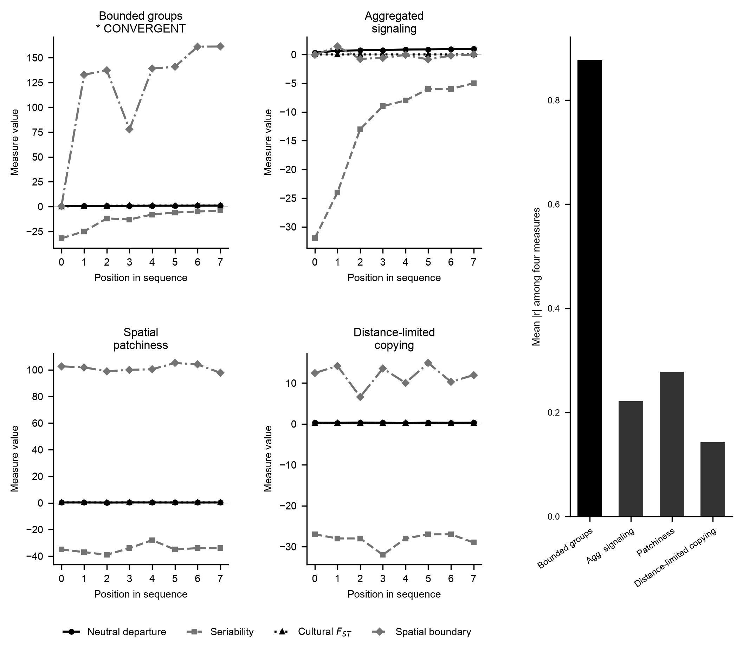
Figure S1. The four measures on idealized data. Trajectories of the four measures along the sequence under each of four simulated processes, using large, clean synthetic assemblages. Only a bounded interaction group drives all four together (starred). Across 500 random seeds, the bounded-group case was identified in 492 (95 percent credible interval 0.97 to 0.99, uniform prior), and none of the three other processes was identified in any of the 500 (upper limit of the 95 percent credible interval 0.007 for each, uniform prior; analyses/04_validation_report.py). Right panel: the mean absolute correlation among the four measures, about 0.88 under closure and 0.14 to 0.28 under the other processes, so their joint movement is informative rather than redundant.
A real record is smaller, noisier, and time-averaged, so a measure that works in principle may fail in practice. We built one synthetic assemblage for each real one, matching its sample size, spatial cluster, and position in the sequence, and imposed closure of known strength s, from 0 (no groups) to 1 (sharply separated groups), increasing along the sequence. We time-averaged the synthetic assemblages by blending neighboring periods, subsampled them exactly as we did the real ones, and asked which measures recovered the imposed closure (Crema et al. 2014; Holdaway and Wandsnider 2008; Kandler and Shennan 2015; Perreault 2019). Only cultural $F_{ST}$ recovers it (Figure S2). It rises steadily as imposed closure increases. The departure from neutral copying does not move in one direction as conformity increases, the boundary excess does not respond to the two spatial clusters the site layout supports, and the number of seriation groups does not rise as closure predicts. The section “Why only cultural $F_{ST}$ can be used” below shows that this reduction is a property of the record rather than of how closure was imposed.
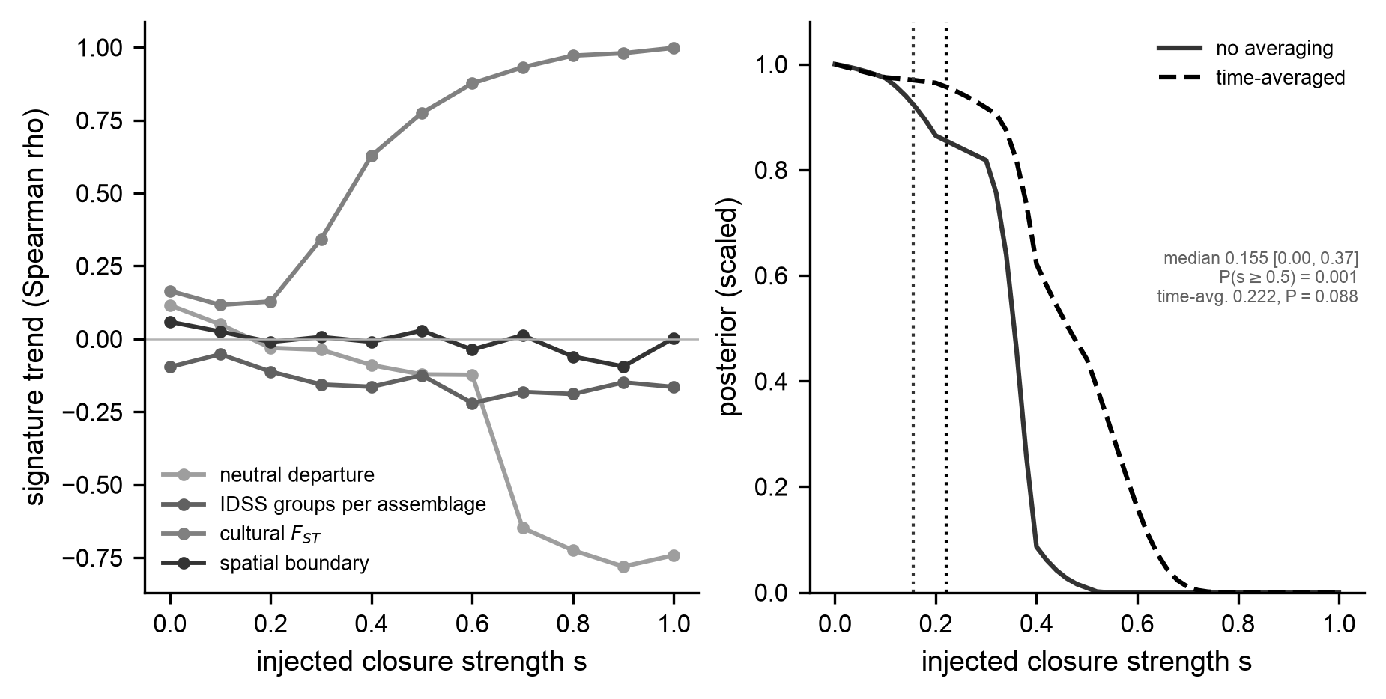
Figure S2. Which measures can detect a boundary on a record like this one. Left: each measure’s response (its rank-correlation trend along the sequence) to closure of known strength imposed on synthetic assemblages built to the real record’s 28 sample sizes, clusters, and sequence positions, subsampled to a common count. Only cultural $F_{ST}$ tracks the imposed closure steadily. Right: the posterior over closure strength given the observed trend, with and without the record’s time-averaging. The median is 0.155 (95 percent credible interval 0.00 to 0.37) without time-averaging and 0.222 (0.00 to 0.565) with it, and the probability of closure of 0.5 or more is 0.001 and 0.088. The observed trend is a rank correlation of -0.048, averaged over 4,000 subsamples, against a draw-to-draw spread of -0.80 to +0.40.
The same simulations let us ask how much closure the basin could contain. For each closure strength, they show how often a trend like the observed one arises, and treating each strength as equally likely beforehand (a uniform prior over s) gives a posterior distribution for the strength. This posterior refers to closure that grows along the sequence; a boundary present from the start would not produce a trend, and the phase-line tests of the main text address that case. If the phases were becoming bounded groups, differences between them should grow as interaction narrows. Along the seriation order, they do not (Figure S3), although that order runs largely south to north rather than early to late, so this test speaks more to change across the basin than to change through time. The raw trend in cultural $F_{ST}$ along the sequence is strongly negative, a rank correlation of -0.80, but that trend is a sampling artifact: assemblage size also rises along the sequence (Spearman +0.61). Once every assemblage is subsampled to a common 50 sherds, the trend averages -0.048 over 4,000 subsamples, and a single subsample returns anything from -0.80 to +0.40. The record therefore shows no trend distinguishable from none. Two of the six periods hold assemblages from a single spatial cluster and carry no between-cluster variance, so the trend rests on four. Read against the recovery experiment, a trend this small corresponds to closure with a posterior median of 0.155 and a 95 percent credible interval of 0.00 to 0.37, with a probability of 0.001 on closure of 0.5 or more. With the record’s time-averaging built into the simulations, the posterior widens to a median of 0.222 and an interval of 0.00 to 0.565, and 9 percent of it lies at 0.5 or above. Reversing the order barely changes this: the median becomes 0.17 (0.00 to 0.39), or 0.25 (0.00 to 0.60) with time-averaging. The record is consistent with no closure and with weak closure growing along the sequence, and shows no moderate or strong closure of that kind.
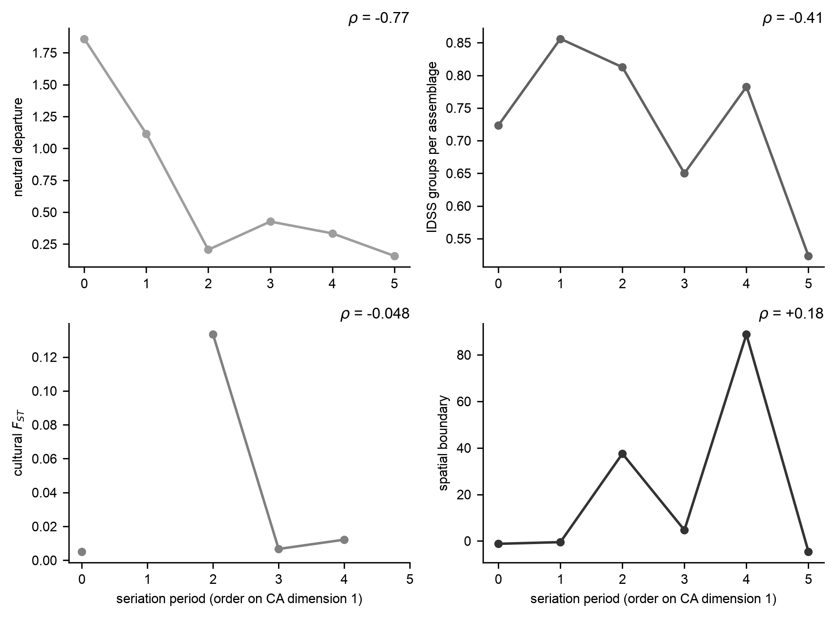
Figure S3. The four measures along the seriation sequence for the 28 basin assemblages in six periods, after subsampling every assemblage to a common 50 sherds. Two periods hold assemblages from a single spatial cluster and so carry no between-cluster $F_{ST}$. Cultural $F_{ST}$, the one usable measure, shows no resolvable trend (rank correlation -0.048 averaged over 4,000 subsamples, against a draw-to-draw spread of -0.80 to +0.40; the raw -0.80 is a sample-size artifact). The other three measures cannot discriminate at this resolution (Figure S2) and are shown for completeness, averaged over 400 subsamples. Each panel is annotated with its rank correlation.

Bayesian estimates of the $F_{ST}$ trend
The section above reports the $F_{ST}$ trend as a rank correlation on subsampled assemblages, which discards most of the sherds in the larger assemblages. Here we estimate the trend from all of the counts. The Balding-Nichols model is fitted to each period, giving a posterior for that period’s $F_{ST}$ whose width reflects how many sherds it holds, and the trend is estimated as a slope across those posteriors. The prior on $F_{ST}$ is Beta(1,10). We chose it because a flat prior, although it looks neutral, predicts far more differentiation than this record could show: with these assemblages it expects a median $F_{ST}$ of 0.236 and places 44 percent of its predictive mass above 0.30, against an observed 0.0062, whereas Beta(1,10) expects a median of 0.026 with 2 percent above 0.30. Because the model treats sampling as part of the data rather than removing it by subsampling, its uncertainty is a credible interval rather than a subsampling spread, and its trend is a slope in $F_{ST}$ units per standardized period rather than a rank correlation. The per-period posteriors are in Table S2.
Table S2. Per-period cultural $F_{ST}$ under the Balding-Nichols model (Beta(1,10) prior; two spatial clusters; six periods). The direct value is the Gini-Simpson estimator of the main text, computed from the counts as they stand. The first and fifth periods hold assemblages from a single cluster, so their $F_{ST}$ is undefined. At this scale, the two ends of the order are places rather than times.
Period | Sherds | Posterior median | 95% credible interval | Direct
1 | - | undefined | - | -
2 | 5,871 | 0.0015 | 0.0005 to 0.0034 | 0.0015
3 | 1,874 | 0.0058 | 0.0027 to 0.0112 | 0.0058
4 | 2,338 | 0.0307 | 0.0213 to 0.0409 | 0.0326
5 | - | undefined | - | -
6 | 813 | 0.0030 | 0.0004 to 0.0089 | 0.0024
Across the four estimable periods, the slope has a posterior median of +0.0009 with a 95 percent credible interval of -0.034 to +0.033, and P(slope > 0) = 0.54 (R-hat 1.006, minimum bulk effective sample size 1,445, 2 divergent transitions of 8,000). Under a uniform prior, it is +0.0013 (-0.033 to +0.038), with P(slope > 0) = 0.55 (R-hat 1.001, 3 divergent transitions). The trend direction is unresolved, consistent with the subsampled rank correlation.

The spatial model with no groups
Cultural $F_{ST}$ can be computed only after the basin has been divided into groups, and its value depends on the division. To describe the record without dividing it, we fitted a model in which composition varies smoothly over the map. This section gives the model, what it can and cannot show, and how well it reproduces the record.
The model treats each assemblage’s decorated-class composition as a multinomial draw whose class probabilities, on the logit scale, sum a class mean, a spatially correlated surface over the assemblage coordinates, and an assemblage-specific term with no spatial structure. The surface has a Matérn-family covariance with amplitude $σ$ and length scale $ρ$, and the assemblage-specific term has standard deviation $τ$. In the version we report, the assemblage-specific term enters the covariance directly rather than as a second latent surface. That halves the number of latent parameters and keeps the two terms from substituting for one another. We report the spatial share, $σ^{2}/(σ^{2}+τ^{2})$, the fraction of the latent, logit-scale variance among assemblages assigned to the spatial surface rather than to independent assemblage deviations. It is a ratio of variance components on the latent scale, not the fraction of observed compositional variation explained. Nor is it a measure of group absence. The surface can take any smooth shape the covariance allows, so the shared composition of a group whose members lie near one another enters through $σ$ at the sampled sites, and $τ$ carries only deviations that are independent from one assemblage to the next (Rasmussen and Williams 2006:Chapter 2). A high spatial share is therefore expected under geographically aligned groups and under continuous copying. We have not fitted the model to simulated bounded groups at these locations, nor compared it with a version with an explicit boundary term, so we use it only to describe the record, and its predictive checks below as evidence that a surface with no explicit divisions describes the record adequately. The length scale has an inverse-gamma prior that places its mass within the range the basin’s geometry can resolve. The models are written in Stan and fitted by Hamiltonian Monte Carlo (rstan 2.32); model files and scripts are in the repository (stan/spatial/, analyses/02_spatial/).
Fitted to the 28 assemblages and ten classes, the spatial share is 0.987 (95 percent credible interval 0.954 to 1.000) in the reported form and 0.987 (0.954 to 1.000) with the assemblage term as a second surface. The data do not determine the length scale. In the reported form, its posterior median is 199 km (95 percent credible interval 92 to 294 km), longer than the basin itself. The sampler reached its maximum tree depth on every iteration with no divergent transitions, indicating that many length scales fit the data equally well (a ridge in the posterior) rather than a sampling fault. Diagnostics for the reported form: R-hat 1.0016, bulk effective sample size 1,891, tail effective sample size 6,247, 0 divergent transitions of 12,000, all 12,000 iterations at the maximum tree depth of 10, E-BFMI 0.685; for the two-surface form, R-hat 1.0050, bulk effective sample size 618, 0 divergences, all iterations at the maximum tree depth, E-BFMI 0.807 (output/findings/gp_basin_fit.md). The spatial share does not depend on which length scale is used, and it is well sampled, whereas the length scale is not. We therefore report the length scale as unresolved, and read the fit as showing no detectable fade in composition across the St. Francis drainage beyond what the surface already carries. Recovery tests on simulated surfaces with known length scales show that this design resolves scales only well below the basin’s extent (analyses/02_spatial/01_recovery.R, analyses/48_length_scale_recovery.py).
The model reproduces quantities it was not fitted to. Its predictive interval for the between-cluster $F_{ST}$ at three clusters is 0.0123 to 0.0192 (median 0.0155) against an observed 0.0156 (posterior predictive probability 0.468). For the fade of similarity with distance, measured here as a rank correlation with straight-line distance, it is -0.383 to -0.296 (median -0.338) against -0.360 (0.835), for mean within-assemblage diversity 0.553 to 0.577 against 0.563 (0.59), and for the spread of that diversity 0.097 to 0.122 against 0.112 (0.258). A surface with no explicit divisions therefore reproduces the observed differentiation at three clusters, which the copying model does not, as well as the fade with distance and the diversity structure. The copying model misses the shorter-range variation, but at the sampled sites it is smooth enough for such a surface to carry it, whether or not it arose at group edges. It describes the pattern rather than a mechanism, so it complements the copying model rather than competing with it.

How cultural $F_{ST}$ depends on the division
The between-cluster $F_{ST}$ depends on how many clusters the basin is cut into. Fitted with the Balding-Nichols model, its posterior median moves from 0.0062 (95 percent credible interval 0.0051 to 0.0076) at two clusters, through 0.0155 (0.0133 to 0.0180) at three, to 0.0302 (0.0267 to 0.0342) at five and 0.0304 (0.0268 to 0.0343) at six, and the intervals at the two ends do not overlap. It also depends on where the cuts fall. The $k$-means division at two clusters is stable, since twenty seeds return it, and unremarkable, at the 43rd percentile of 150 alternative contiguous divisions into two (median 0.0067), but those alternatives range from 0.0018 to 0.0163 between their 5th and 95th percentiles. A quantity this sensitive to how the basin is divided cannot be interpreted by itself. This is why the main text also fits a model with no divisions, and why every between-cluster value is compared against the copying model at the same number of clusters.

The minimum sample size, and why it is 75
This section explains why assemblages need at least 75 decorated sherds to enter the analysis. Cultural $F_{ST}$ computed directly from counts is biased upward by sampling. Two assemblages drawn from the same population of pots differ because each is a finite sample, and the spurious variance between them scales roughly as $1/n$. To find the count at which that artifact becomes small relative to the differences we interpret, we drew pairs of multinomial samples of size $n$ from the basin’s pooled class profile, 4,000 pairs at each size, and computed $F_{ST}$ between them. The two share one profile by construction, so all of the $F_{ST}$ between them is sampling (analyses/82_minimum_sample_size.py). The reference is the observed between-cluster $F_{ST}$ at five clusters, 0.0307.
decorated sherds per assemblage | spurious $F_{ST}$, median | 95th percentile | median as a share of the observed
25 | 0.0146 | 0.0630 | 48%
50 | 0.0070 | 0.0305 | 23%
75 | 0.0044 | 0.0195 | 14%
100 | 0.0034 | 0.0156 | 11%
150 | 0.0023 | 0.0105 | 7%
200 | 0.0016 | 0.0074 | 5%
300 | 0.0011 | 0.0052 | 4%
500 | 0.0006 | 0.0030 | 2%
1000 | 0.0003 | 0.0015 | 1%
At 75 sherds, the median artifact is about a seventh of the observed five-cluster differentiation, and its 95th percentile (0.0195) lies below it, whereas at 50 sherds, the 95th percentile (0.0305) is nearly equal to it. The five-cluster value is the reference because it is the finest division analyzed cluster by cluster (analyses 72 and 85), where clusters hold the fewest sherds and a sampling artifact would matter most. Pooling into clusters shrinks the artifact further: redrawing every assemblage from the pooled profile at its own sherd count gives each five-cluster term at most 0.0003 (the section on the finer-scale differences below). Against the two-cluster value of 0.0062, the artifact is proportionally larger at every sample size, which is why the copying model is always sampled at the real sherd counts: it then carries the same artifact as the data. Above 75, the bias shrinks slowly, by about three percentage points between 75 and 100, while assemblages are lost quickly: a minimum of 100 would remove three more basin assemblages (Davis, Irby, and Grant). The analytic expectation for two equal samples from one profile is close to $1/n$. Mainfort (2003) kept sites with 800 or more sherds in all; decorated sherds are 13 percent of his table, so his rule corresponds to about 100 decorated sherds. The copying model is sampled at the observed sherd counts and carries the same bias, so the model comparison is not distorted by it. The minimum protects readings of single small clusters, where a value computed on a few dozen sherds would be mostly artifact.

Further checks of the measures
Several further checks are provided in the supplementary code. Neiman’s (1995) sample-size diagnostic correlates the two neutrality estimates, and their difference, with assemblage size and with position in the sequence, to separate a transmission signal from a sample-size artifact. Neiman’s squared Euclidean distance between assemblages is computed with its relation to diversity and its trend along the sequence. Measures of clustering tendency on the correspondence-analysis ordination favor a single group: the Hopkins statistic is 0.71, where 0.5 indicates no tendency, the gap statistic favors one cluster, and the best silhouette is 0.54 (Hopkins and Skellam 1954; Rousseeuw 1987; Tibshirani et al. 2001). The assemblages form a near-continuum rather than sharply bounded groups.
The repository also contains a sensitivity grid that we do not use (output/sensitivity_grid.md). It computes raw trends without subsampling, on sets of 38, 36, and 17 assemblages defined by latitude rather than by phase, so its trends carry the sample-size artifact that subsampling removes. Two entries show all three raw trends rising together, and we note this so a reader of the code does not mistake them for a result.
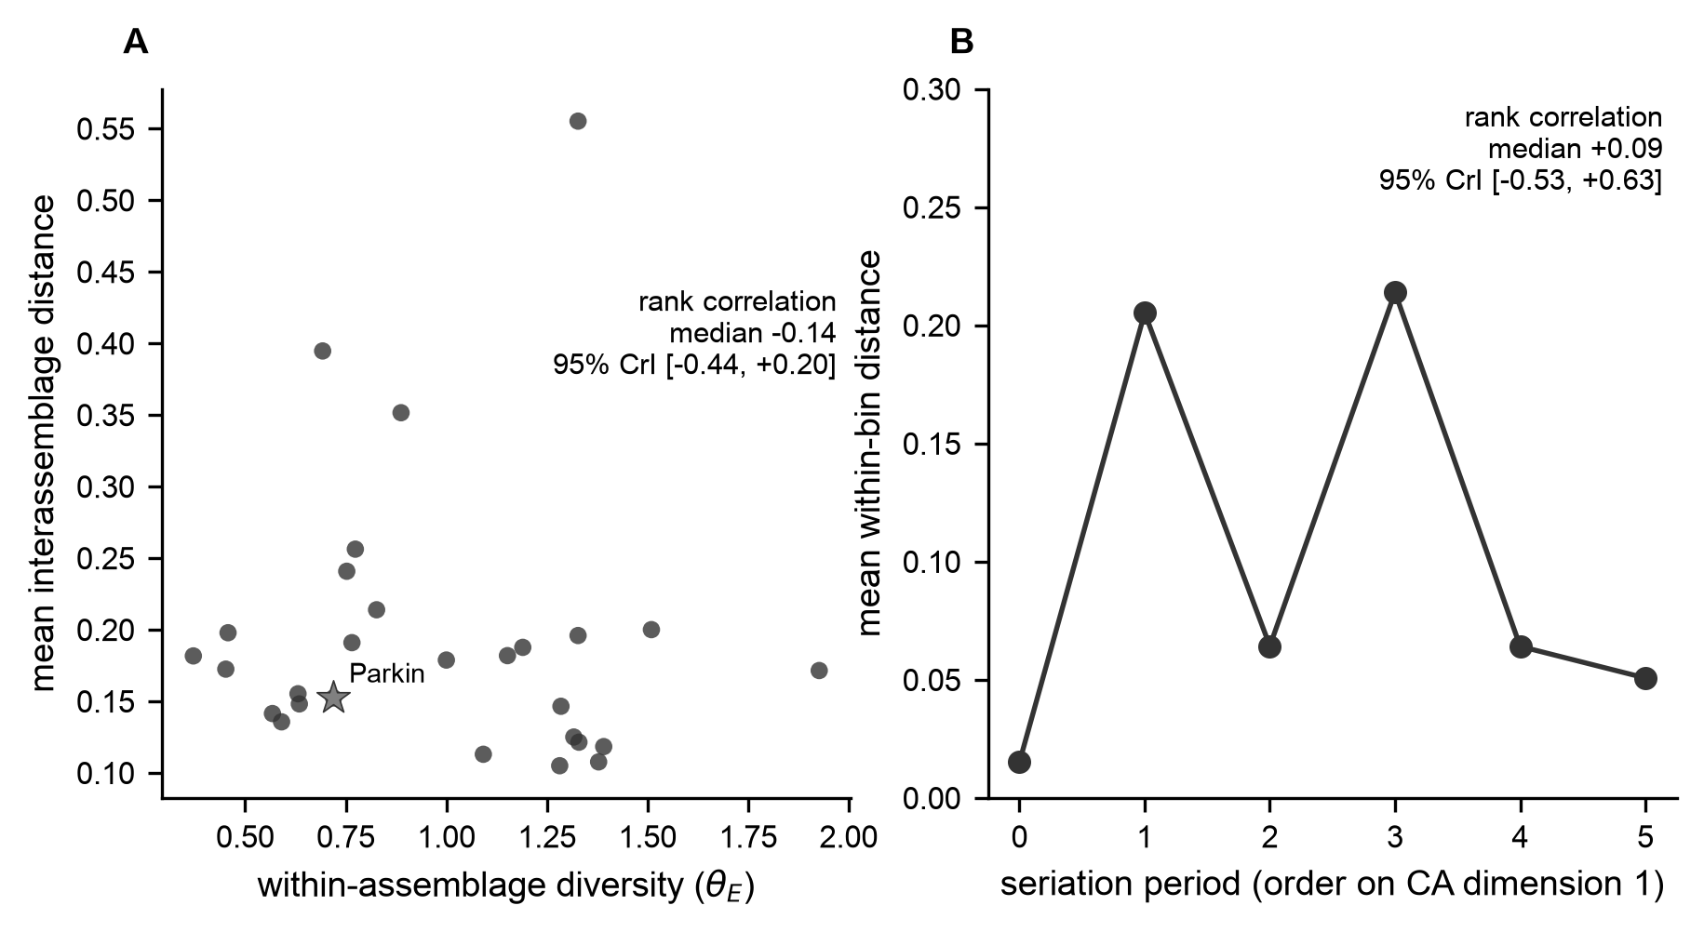
Figure S4. Neiman’s distance between assemblages. (A) Within-assemblage diversity against mean distance to the other assemblages, with Parkin starred. The association is negative (posterior median rank correlation -0.14, 95 percent credible interval -0.44 to +0.20, so P(r < 0) = 0.78), matching the drift signature Neiman (1995) reported at rho = -0.62, rather than the positive relationship bounded groups would produce. (B) Mean within-period distance along the seriation order, showing no resolved trend (posterior median rank correlation +0.09, 95 percent credible interval -0.53 to +0.63 over six periods).

Why only cultural $F_{ST}$ can be used
The recovery experiment imposes closure as divergence between clusters, which is what cultural $F_{ST}$ measures, so the experiment might favor cultural $F_{ST}$ only because the groups were built in the form that the measure detects. We tested this by imposing closure through two further routes, each matched to a different measure, and asking which measure recovers each (analyses/22_generator_diagnostic.py, 60 seeds, the real configuration of 28 assemblages, two clusters, six periods, subsampled to 50). One route raises conformity in a single undivided pool, which the neutral departure is designed to detect. The other groups assemblages into social groups scrambled relative to the spatial clusters, which seriation structure is designed to detect.
Neither route is recovered by the measure designed for it. Under conformity in one pool, the neutral departure falls rather than rises (its mean trend moves by -0.73 between no closure and strong closure) and no other measure responds. Under the scrambled social groups, the seriation measure barely moves (-0.21). $F_{ST}$, by contrast, responds in both cases. In every case, it was scored at the two $k$-means spatial clusters, never at the social groups themselves. Its mean trend rises from +0.01 to +0.96 under spatial divergence and from +0.07 to +0.77 under the scrambled social groups. The second rise happens because three social groups assigned at random over 28 assemblages are unevenly represented in the two spatial clusters, so their divergence leaks into between-cluster variance. Subsampling more deeply, to 100 or 150 sherds, does not rescue the other measures. The reduction to $F_{ST}$ is therefore a property of the record, 28 time-averaged assemblages over ten aggregated classes, rather than of the way closure was imposed. It also sets the limits stated in the main text. Closure carried purely by conformity within one pool moves none of the measures. Social groups that cut across the map can raise $F_{ST}$ at spatial divisions, but none of the four measures identifies them as groups: the only measure designed to register them, seriation structure, does not respond, and every division this study scores is spatial.

The basin comparison in detail
This section compares the record with the copying model in more detail than the main text does. We simulated neutral copying and a bounded-groups variant on the real layout of the 28 assemblages, using the model and calibration described in the next section. The calibration is itself informative. Under uniform innovation, in which the ten classes are interchangeable, one of the 297 parameter combinations (120 learners, innovation 0.0002, mixing 0.2) falls within the 10 percent tolerance on both the six-run screen and the fifty-run check. It sits at the edge of the grid, at the lowest population size and innovation rate swept, and its within-assemblage and pooled diversities of 0.61 and 0.66 in the baseline runs, against 0.56 and 0.59 observed, are 9 and 11 percent above the observed values, so we report it without treating it as a robust calibration. Under pooled-profile innovation, 51 combinations match on the screen and 48 on the check, spanning populations of 120, 2,000 and 10,000 learners, innovation rates of 0.0002 to 0.048, and mixing rates of 0.001 to 0.4 (Table S3). None of the 48 reaches the observed between-cluster $F_{ST}$ at its median; the highest fifty-run median is 0.0028 against 0.0062 observed, and 18 of the 48 include the observation within their 95 percent ranges.
At the matched combination most favorable to the model (2,000 learners, innovation 0.001, mixing 0.02, interaction length 24 km along the rivers), the observed between-cluster $F_{ST}$ of 0.0062 at two clusters lies inside the simulated range of 0.0002 to 0.0112 (median 0.0021, 500 runs). Twelve percent of simulated datasets reach it in seriation order, 13 percent in reverse order, and 18 percent when assemblages are treated as contemporaneous. The model returns a single community in 471 of 500 runs sampled through time. Where it returns two or more, the difference between communities has a median of 0.012 (95 percent range 0.009 to 0.019) against an observed 0.039, which none of those 29 runs reaches, and modularity is near zero in every run (95 percent range up to 0.005) against an observed 0.045. The fade of similarity with distance, measured here as the correlation between similarity and distance along the rivers, falls within the model’s range (observed -0.20; simulated median -0.18, range -0.48 to +0.04). The boundary excess of the spatial clusters is +6.0 in the data, inside the model’s range (-4.5 to +7.3) and the bounded-groups ranges at a copying factor of 0.03 and interaction lengths of 24 km (-3.4 to +18.0) and 12 km (-8.0 to +13.3). Weakening copying across the two clusters raises the median step by step at an interaction length of 24 km and has no consistent effect at 12 km: at a copying factor of 0.03 the median $F_{ST}$ is 0.0071 at 24 km and 0.0033 at 12 km, reaching the observation in 15 and 12 of 30 runs, against medians of 0.0018 and 0.0046 with no boundary in the same 30-run grid; factors of 0.5 and 0.1 give medians of 0.0027 to 0.0053 (Table S4, Figure S5). New variants in this model come from the regional pooled profile, a source with no boundary interruptions; the section on the phases as groups below gives the boundary model local innovation as well.
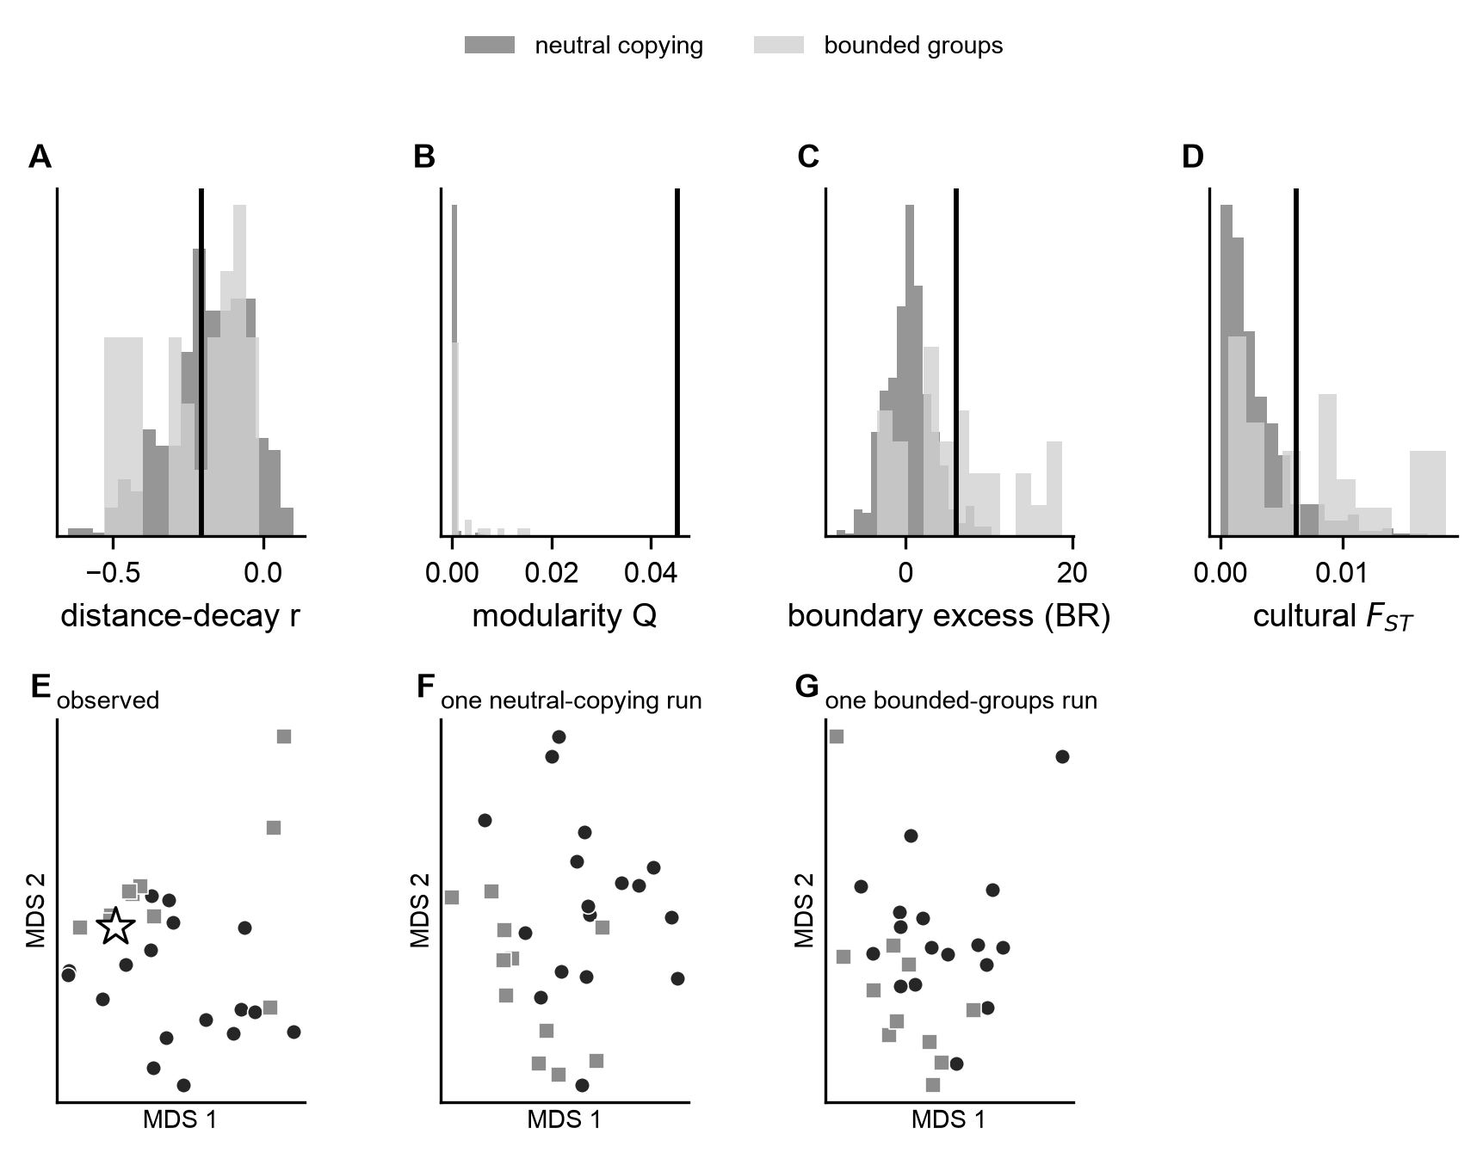
Figure S5. Neutral copying and bounded groups on the basin’s geography, at the calibrated combination. (A to D) The observed fade of similarity with distance, modularity, boundary excess of the spatial clusters, and between-cluster cultural $F_{ST}$ (vertical lines) against the distributions produced by the neutral copying model (dark, 500 runs) and the bounded-groups model at a copying factor of 0.03 (light, 30 runs), both time-averaged and subsampled to the observed counts. The model reproduces the fade with distance and the between-cluster $F_{ST}$ at two clusters; the observed modularity (0.045) lies above both models, and the observed boundary excess lies within both. (E to G) Multidimensional scaling of decorated dissimilarity for the observed assemblages (Parkin starred) and one run of each model; circles and squares are the two spatial clusters.
Table S3. Calibration of the two innovation models to the within-assemblage summaries of the St. Francis basin assemblages. The selected combination is the one, among those still matched on the fifty-run check, with the highest fifty-run median between-cluster $F_{ST}$. Achieved values are medians over the 500 baseline runs.
Set | Innovation model | Matched combinations (of 297; six-run screen / fifty-run check) | Selected N, innovation, mixing | Observed H_S / richness / H_T | Achieved H_S / richness / H_T
St. Francis basin | pooled profile | 51 / 48 | 2,000, 0.001, 0.02 | 0.563 / 6.25 / 0.592 | 0.577 / 6.00 / 0.587
St. Francis basin | uniform | 1 / 1 | 120, 0.0002, 0.2 | 0.563 / 6.25 / 0.592 | 0.612 / 5.79 / 0.656

The neutral copying model and its calibration
This section describes how the copying model works, how we chose its three parameters, how we measure distance, and how we sample simulated assemblages so they can be compared with real ones.
The comparison uses one finite-population network model of decorated-class transmission, run on the real geography of the 28 assemblages. Each assemblage location is a node holding a population of learners. Each generation, a learner copies the class of another learner, drawn from its own node with probability $1−m$ and from another node with probability $m$, the other node chosen with a weight that falls off exponentially with distance along the rivers at length scale $L$. With probability $μ$, the learner instead adopts a class by innovation. The model tracks class frequencies rather than individual learners: next-generation frequencies at each node are a multinomial draw of $N$ learners from the copying-plus-innovation probabilities, which is equivalent to independent learner-by-learner copying. The repertoire is fixed at the ten measured classes. The bounded-groups variant multiplies every copying weight that crosses a specified division by a factor $ℓ$ before normalizing; $ℓ=1$ is copying by distance alone, and 0.5, 0.1, and 0.03 impose progressively stronger boundaries on the basin’s spatial clusters. Each run discards 1,200 burn-in generations and records 90 evenly spaced samples over the next 1,800 generations.
How new variants enter the model depends on what an archaeological class is. Under uniform innovation, the standard K-allele model, an innovating learner adopts any class with equal probability, treating the classes as interchangeable. Under pooled-profile innovation, an innovating learner adopts each class in proportion to its share of the region’s pooled counts, reflecting that the culture-history types lump unequal numbers of underlying decorative variants. The pooled profile carries no information about any division, so it does not build the tested boundary into the model, and neither version introduces a copying bias.
Between-group predictions depend on population size, mixing, and innovation together, so the model is calibrated before any between-group comparison. The calibration uses three within-assemblage summaries that do not involve the tested division: mean within-assemblage Gini-Simpson diversity, mean number of classes present at the observed sherd counts, and Gini-Simpson diversity of the pooled counts. A grid of population size (120, 2,000, and 10,000 learners), innovation rate (0.0002 to 0.2), and mixing rate (0.001 to 0.4) is screened at six runs per combination, with the same sampling through time applied to the data, and a combination is matched when all three simulated summaries fall within 10 percent of the observed values. We then rerun each matched combination fifty times with fresh seeds and recheck the match; the baseline is the combination, among those still matched, with the highest fifty-run median between-cluster $F_{ST}$, so the comparison is as favorable to the model as the grid allows.
We confirm at fifty runs because a median over six runs is noisy, and choosing the highest of about fifty noisy medians selects for chance. The combination ranked first on six runs had a six-run median (0.0042) about twice its fifty-run median (0.0022), and an independent check with fresh seeds gave 0.0020 (output/findings/calibration_stability.md). The check reproduces the six-run ranking only in part: the independent fifty-run medians agree with it at a rank correlation of +0.64, and the two rankings share one of their five leading combinations. Nor is the leading combination sharply identified at fifty runs: the combination the independent check ranks first (120 learners, innovation 0.024, mixing 0.01) is not among the six that lead the calibration’s own fifty-run ranking. We therefore repeat the key comparisons at the six most favorable confirmed combinations (Table S6).
We then run the baseline 500 times, the boundary factors 30 times each at interaction lengths of 12 and 24 km, and seven sensitivity cases (burn-in doubled, a single-class starting state with and without burn-in, and innovation and mixing halved and doubled) 50 times each. In the baseline, sensitivity, and boundary runs of this analysis (Table S4), the share of simulated datasets reaching the observed value is reported as $(e+1)/(R+1)$, where $e$ is the number of runs at or above the observed statistic and $R$ is the number of runs; the scale sweep, combination-sensitivity (Table S6), phases-as-groups, and power tables report the plain share $e/R$. We store every run with a record of the configuration, inputs, source code, and package versions that produced it, and rerun it when any of them changes.
We measure copying distance along rivers because interaction in this settlement system plausibly followed watercourses, and because that choice is more favorable to the model. We build a graph from the mapped hydrography (LMVHydrology centerlines clipped to the basin with a 25 km margin), join vertices within 250 m of one another, keep the largest connected piece, and attach each assemblage to its nearest node, adding the attachment distance at both ends. All 28 assemblages connect, and the mean distance from an assemblage to a mapped channel is 2.69 km. Paths along the rivers are longer than straight lines by a mean ratio of 3.8 and a median of 2.9 per pair; the mean is pulled up by pairs that are close in a straight line but must route around a meander. The pottery does not follow the rivers more closely than it follows straight lines. Decorated-class distance between assemblages correlates with straight-line distance at 0.38 and with river distance at 0.25, and once straight-line distance is held fixed, river distance adds nothing (-0.05). Between assemblages in different phases, straight-line distance correlates at 0.26 and river distance at -0.02. The network is modern hydrography, and the St. Francis, Tyronza, and Mississippi have all moved since these sites were occupied. Both measures are carried through the relaxations below. At every interaction length from 6 to 96 km the median under straight-line distance is at or below the median under river distance at the calibrated combination, so river distance is the choice more favorable to the model.
The assemblages are not contemporaneous, so the simulated field is sampled over time rather than at a single moment. Each simulated assemblage is drawn from the recorded sample matching its real counterpart’s position on the first correspondence-analysis axis and accumulated over a trailing window of eight samples, so that, like a real deposit, it mixes production across a span. The earliest position maps to the end of the first complete window, so every assemblage gets the same window length. Each simulated assemblage is then subsampled to its real counterpart’s sherd count and analyzed exactly as the real ones are, with the same $k$-means clusters, community detection, and $F_{ST}$. Because the dates only weakly indicate which end of the seriation axis is later, every run is also sampled in reverse order and as if contemporaneous, with every assemblage drawn from the final window.
The source of an assemblage’s counts matters little. Within each of the three five-cluster groups holding at least two rows of each kind, we computed the posterior probability that rows carrying the survey’s counts alone differ from rows carrying Lipo’s compilation more than a random split of that group into subsets of the same sizes, with each assemblage’s class proportions drawn from Dirichlet(counts + 1/2) (analyses/78_source_effect.py). It is 0.17, 0.12, and 0.17 in the three. The rows carrying the survey’s counts alone are also the smallest, so source and sample size are confounded throughout.
Because community labels are arbitrary and switch between runs, we summarize the basin’s simulated communities by co-membership (Figure S6). For each assemblage, we record the share of runs in which it falls in the same community as Parkin. Under the calibrated model, that share is 0.95 to 1.00 for every assemblage because the model returns a single community in most runs. Under pooled-profile innovation, the 29 time-sampled runs that return two or more communities give a between-community $F_{ST}$ with a median of 0.012 (95 percent range 0.009 to 0.019), and none reach the observed 0.039. Under uniform innovation, which does not robustly fit the assemblages’ diversity, the observed value falls within a wide interval when assemblages are sampled through time or in reverse order, and above the interval when they are treated as contemporaneous.
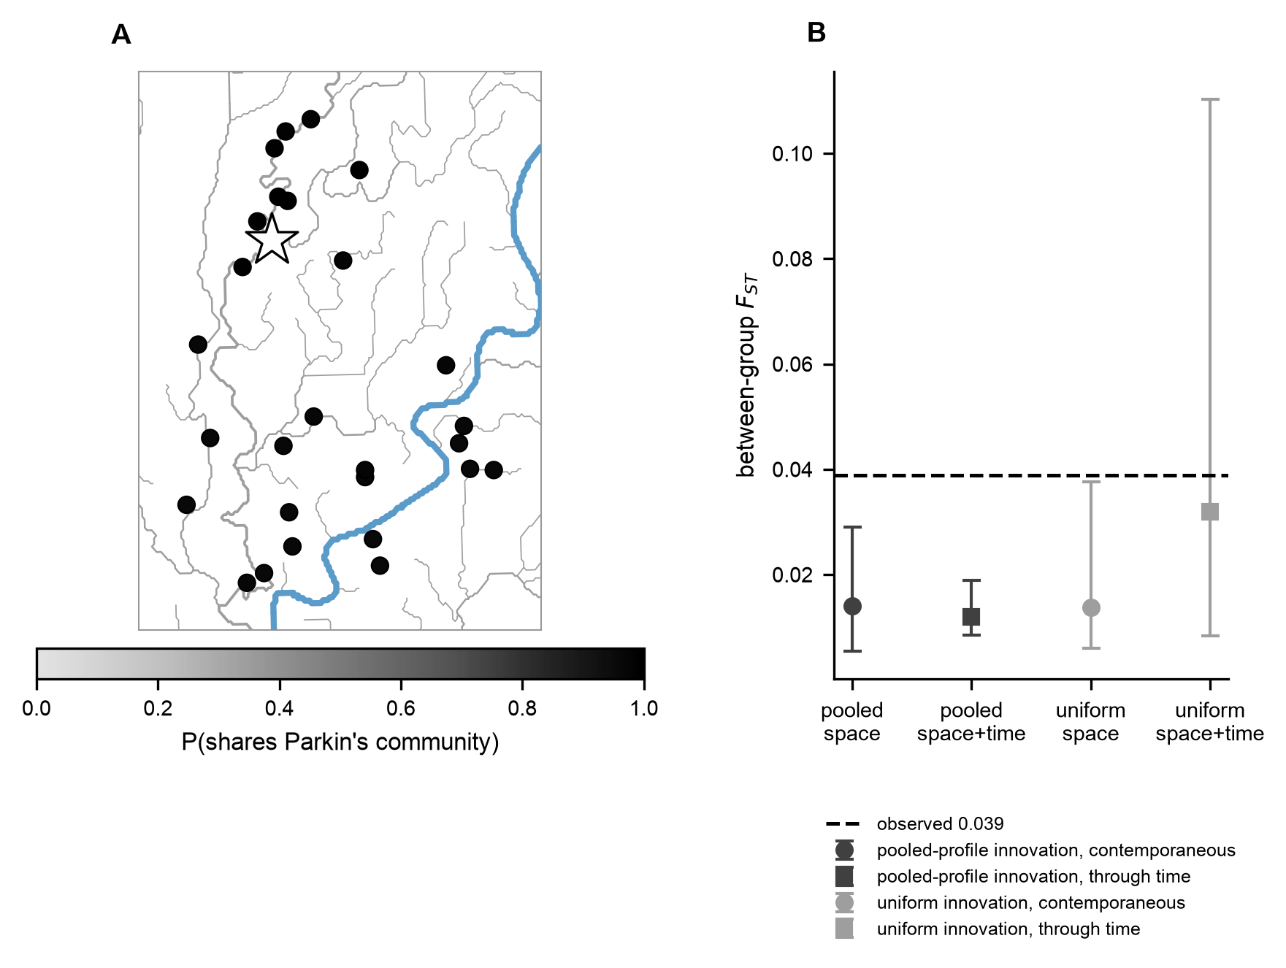
Figure S6. Basin co-membership and community differentiation under the calibrated model, over 500 runs. (A) Each assemblage is shaded by the share of runs in which it falls in Parkin’s community (star). The share ranges from 0.95 to 1.00 throughout because the model returns one community in most runs. (B) Between-community cultural $F_{ST}$ for the observed data (dashed, 0.039) against the model’s medians and 95 percent ranges, sampled as contemporaneous and through time, for pooled-profile (dark) and uniform (light) innovation. The pooled-profile points summarize only the runs returning two or more communities (35 contemporaneous and 29 through time, of 500); the rest return one community and leave the statistic undefined. The observed value lies above them. The uniform model’s wide range reflects a parameterization that does not fit the assemblages’ diversity robustly.

The calibration series and its sensitivity
This section shows every parameter combination tried and how the two-cluster comparison changes when the model settings are varied around the calibrated combination. Figure S7 shows every combination in the calibration series, 297 for each innovation model, plotted by diversity misfit (the root of the summed squared relative error over the three summaries) against median between-cluster $F_{ST}$: the six-run median for unmatched combinations and the fifty-run median for matched ones, the value the selection uses. In the basin, the matched combinations lie below the observed $F_{ST}$ at their medians, and every combination that reaches it at the median lies outside the diversity tolerance (the closest, at a misfit of 0.14, has a richness 14 percent from the observed value). Under uniform innovation, one combination matches at the edge of the grid, and its median (0.0092) lies above the observed value; it is the only matched combination to do so, and it does not fit the diversity robustly. The interchangeable-class model can reach the record’s skewed class profile only as a passing state of strong drift, which removes the rare classes that most assemblages contain.
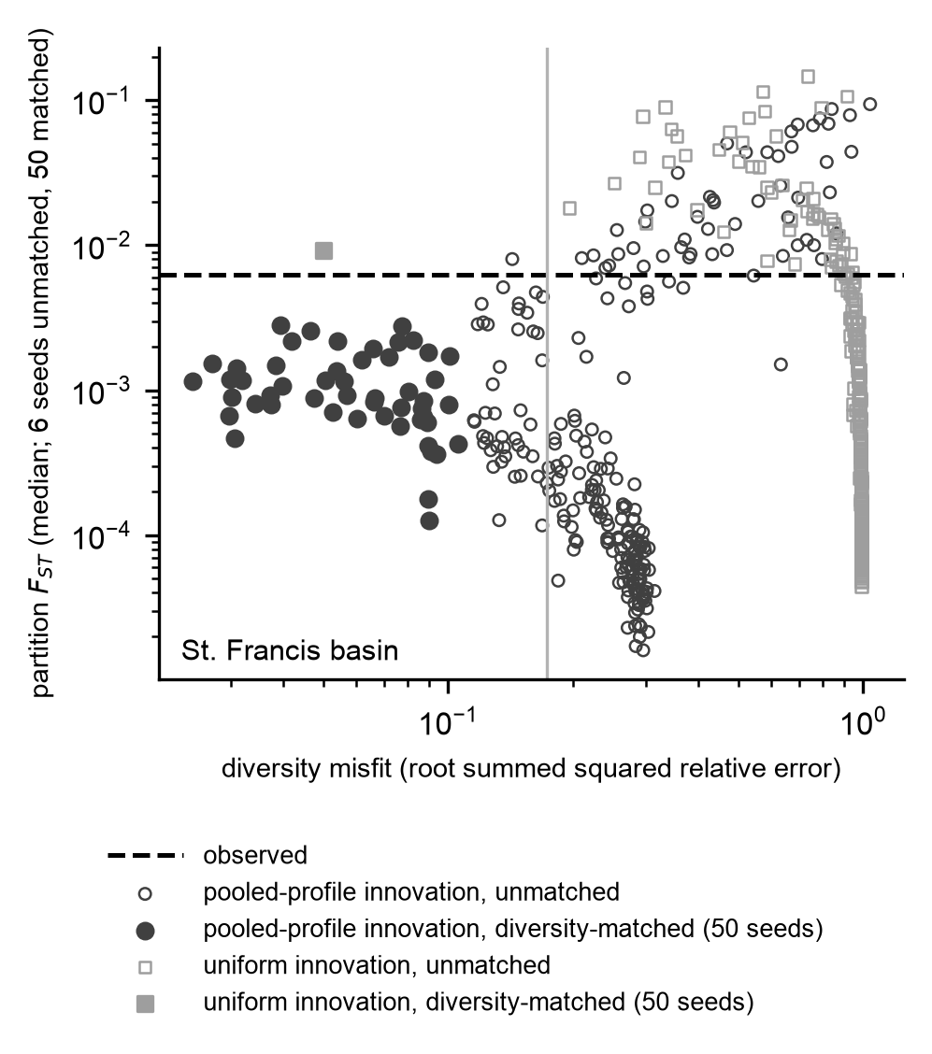
Figure S7. The calibration series. Each point is one parameter combination (population 120, 2,000, or 10,000 learners; innovation 0.0002 to 0.2; mixing 0.001 to 0.4) for the pooled-profile (circles) and uniform (squares) innovation models, placed by its diversity misfit against its median between-cluster $F_{ST}$ (six runs for unmatched combinations, fifty for matched ones). Filled markers match all three within-assemblage summaries within 10 percent. The vertical line is the largest misfit a matched combination can have, so an open marker to its left misses on at least one summary. The dashed line is the observed $F_{ST}$. No matched pooled-profile combination reaches the observed value at its median; the single matched uniform combination (median 0.0092) sits at the edge of the grid and does not fit the diversity robustly.
Table S4. Sensitivity of the calibrated comparison for the pooled-profile model (50 runs per sensitivity case, 30 per boundary case, baseline 500). Entries are the median and 95 percent range of the between-cluster $F_{ST}$, the share of runs reaching the observed value, and the within-assemblage diversity and richness achieved (the median over runs for the baseline and the mean over runs for the other cases).
Set | Case | Median [95%] | Share of runs reaching observed | Within-assemblage diversity | Richness
Basin (observed 0.0062; diversity 0.56, richness 6.2) | baseline | 0.0021 [0.0002, 0.0112] | 0.120 | 0.58 | 6.0
 | burn-in 2,400 | 0.0019 [0.0004, 0.0087] | 0.157 | 0.58 | 6.0
 | single-class start, burn-in | 0.0028 [0.0002, 0.0148] | 0.176 | 0.53 | 5.8
 | single-class start, no burn-in | 0.0053 [0.0004, 0.0180] | 0.412 | 0.38 | 5.2
 | innovation halved | 0.0038 [0.0007, 0.0181] | 0.294 | 0.56 | 5.5
 | innovation doubled | 0.0015 [0.0002, 0.0114] | 0.118 | 0.58 | 6.6
 | mixing halved | 0.0031 [0.0005, 0.0134] | 0.314 | 0.57 | 5.7
 | mixing doubled | 0.0017 [0.0002, 0.0048] | 0.020 | 0.58 | 6.3
 | boundary, multiplier 0.5 (24 km) | 0.0027 [0.0003, 0.0185] | 0.290
 | boundary, multiplier 0.1 (24 km) | 0.0037 [0.0011, 0.0206] | 0.387
 | boundary, multiplier 0.03 (24 km) | 0.0071 [0.0009, 0.0180] | 0.516
The single-class start with no burn-in departs from the calibrated diversity and is reported for completeness rather than as a fitting alternative. The other cases put the share of runs reaching the observed value between 0.02 and 0.31. Doubling the mixing rate, which keeps the diversity close to the record, lowers that share to 0.02, and doubling the innovation rate leaves it at 0.12, so the two-cluster agreement holds at the selected combination, at neighboring innovation rates, and at a lower mixing rate, but not at double the mixing rate. The 30-run boundary cases resolve that share only to about 0.03.

Relaxing four simplifications of the copying model
The calibrated model reproduces the difference between two clusters, although its median falls short. It does not reproduce the larger differences among three or more clusters, where the observed value lies at or beyond the upper edge of the model’s range: outside it with the seeds of Table 1, Table S5, and Table S5a (main text Table 1; Table S5).
The model makes four simplifying assumptions: every site has the same population, copying falls off exponentially with distance along the rivers, every deposit accumulated over the same span, and new variants arise at the same rates everywhere. Any of these could account for the shortfall, so we relaxed each in turn. Each variant is still neutral copying. It is the same model with one assumption changed, run on the basin at the calibrated combination. Every variant, and the baseline, is judged on the same three criteria, kept separate because they answer different questions: whether the median reaches the observation (median discrepancy), how often runs reach it (predictive coverage), and whether all three diversity summaries stay within the 10 percent tolerance (joint fit to diversity). A variant that reaches the observed differentiation only by losing the fit to diversity has exchanged one misfit for another. The tables below give the two-cluster sweeps of analyses 64 and 65, with the median $F_{ST}$, its 95 percent range, the shortfall (observed divided by the model’s median), and whether diversity stays matched; the full series is in output/findings/other_departures.md. The two-cluster value is already inside the baseline’s predictive range, so Table S5a then scores the main settings at three and four clusters and at the phase lines, where the baseline falls short.
We relax each assumption separately, always at the baseline calibration. A variant that breaks the diversity match here might fit after recalibration, which we have not attempted, so a broken match means the variant is unsupported at this calibration, not that it cannot fit.
Table S5a. The main settings of each relaxation scored at every scale, 300 runs each with the seeds of analyses 64 and 65 (analyses/92_relaxations_by_scale.py, output/findings/relaxations_by_scale.md). Local innovation is applied within the two spatial clusters unless the row names a finer grain: neighborhoods are the five- and eight-cluster $k$-means divisions of the site map, and in the last two rows each site draws its own new variants. Entries are the median, 95 percent range, and share of runs at or above the observed value. The baseline row uses analysis 65’s seeds, as do the transport and local-innovation rows; the unequal-population rows use analysis 64’s. Its shares therefore differ slightly from Table 1.
account | setting | two clusters (0.0062) | three clusters (0.0156) | four clusters (0.0186) | the phases (0.0123) | diversity
baseline | calibrated | 0.0017 [0.0002, 0.0113]; 12% | 0.0035 [0.0006, 0.0134]; 2% | 0.0040 [0.0010, 0.0138]; 1% | 0.0024 [0.0005, 0.0098]; 1% | matched
unequal populations | CV 0.5 | 0.0025 [0.0003, 0.0124]; 17% | 0.0044 [0.0009, 0.0146]; 2% | 0.0049 [0.0013, 0.0153]; 1% | 0.0028 [0.0005, 0.0122]; 2% | matched
unequal populations | CV 1.0 | 0.0040 [0.0003, 0.0278]; 37% | 0.0073 [0.0011, 0.0314]; 16% | 0.0078 [0.0016, 0.0314]; 14% | 0.0047 [0.0008, 0.0250]; 15% | broken
unequal populations | CV 1.5 | 0.0052 [0.0003, 0.0379]; 47% | 0.0099 [0.0014, 0.0453]; 29% | 0.0108 [0.0019, 0.0454]; 24% | 0.0067 [0.0010, 0.0325]; 24% | broken
transport | straight-line, exponential, 6 km | 0.0035 [0.0004, 0.0194]; 26% | 0.0049 [0.0011, 0.0208]; 7% | 0.0052 [0.0013, 0.0213]; 5% | 0.0034 [0.0007, 0.0191]; 7% | matched
transport | river, exponential, 6 km | 0.0056 [0.0006, 0.0325]; 45% | 0.0087 [0.0019, 0.0397]; 26% | 0.0114 [0.0033, 0.0427]; 24% | 0.0077 [0.0014, 0.0337]; 29% | broken
transport | river, exponential, 12 km | 0.0047 [0.0004, 0.0247]; 39% | 0.0080 [0.0011, 0.0278]; 16% | 0.0086 [0.0019, 0.0297]; 12% | 0.0055 [0.0008, 0.0249]; 18% | broken
transport | river, gaussian, 24 km | 0.0043 [0.0005, 0.0315]; 38% | 0.0075 [0.0013, 0.0357]; 20% | 0.0089 [0.0022, 0.0372]; 17% | 0.0053 [0.0012, 0.0309]; 19% | broken
transport | river, gaussian, 48 km | 0.0026 [0.0002, 0.0130]; 18% | 0.0042 [0.0007, 0.0163]; 4% | 0.0047 [0.0010, 0.0169]; 1% | 0.0029 [0.0005, 0.0125]; 3% | matched
local innovation | strength 0.2 | 0.0054 [0.0003, 0.0566]; 47% | 0.0071 [0.0011, 0.0588]; 32% | 0.0075 [0.0013, 0.0597]; 28% | 0.0054 [0.0006, 0.0529]; 33% | matched
local innovation | strength 0.25 | 0.0094 [0.0004, 0.0608]; 57% | 0.0110 [0.0011, 0.0634]; 44% | 0.0113 [0.0014, 0.0655]; 41% | 0.0087 [0.0006, 0.0569]; 45% | matched
local innovation | strength 0.3 | 0.0139 [0.0006, 0.0615]; 63% | 0.0157 [0.0013, 0.0649]; 50% | 0.0165 [0.0016, 0.0667]; 47% | 0.0137 [0.0006, 0.0589]; 53% | matched
local innovation, five neighborhoods | strength 0.2 | 0.0050 [0.0004, 0.0448]; 45% | 0.0078 [0.0011, 0.0496]; 22% | 0.0081 [0.0016, 0.0512]; 20% | 0.0058 [0.0007, 0.0435]; 25% | broken
local innovation, five neighborhoods | strength 0.25 | 0.0068 [0.0006, 0.0503]; 52% | 0.0099 [0.0014, 0.0535]; 30% | 0.0107 [0.0017, 0.0545]; 28% | 0.0073 [0.0009, 0.0475]; 33% | broken
local innovation, eight neighborhoods | strength 0.2 | 0.0045 [0.0004, 0.0260]; 37% | 0.0066 [0.0014, 0.0288]; 15% | 0.0073 [0.0018, 0.0298]; 13% | 0.0050 [0.0010, 0.0237]; 19% | broken
local innovation, eight neighborhoods | strength 0.25 | 0.0067 [0.0005, 0.0276]; 52% | 0.0087 [0.0015, 0.0315]; 21% | 0.0096 [0.0021, 0.0318]; 15% | 0.0069 [0.0011, 0.0281]; 23% | broken
local innovation, each site its own | strength 0.1 | 0.0027 [0.0003, 0.0136]; 17% | 0.0043 [0.0007, 0.0149]; 2% | 0.0048 [0.0011, 0.0156]; 0% | 0.0031 [0.0005, 0.0128]; 3% | matched
local innovation, each site its own | strength 0.2 | 0.0031 [0.0005, 0.0131]; 21% | 0.0049 [0.0014, 0.0154]; 2% | 0.0054 [0.0019, 0.0154]; 1% | 0.0034 [0.0008, 0.0127]; 3% | broken
Read on the same criteria as the baseline, two relaxations are adequate by predictive coverage at the finer scales while keeping diversity matched: local innovation, whose runs reach the three- and four-cluster values 28 to 50 percent of the time, and copying that falls off over 6 km of straight-line distance, 5 to 7 percent. Only local innovation at strength 0.3 brings its median to the three-cluster value, and no matched setting brings its median to the four-cluster value. Unequal populations at coefficients of variation of 1.0 and above, and river fall-off at 6 to 24 km, raise coverage further, but only with the diversity match broken; the matched settings of those kinds (a coefficient of 0.5, a Gaussian fall-off at 48 km) barely move it. At two clusters, where the baseline itself covers the observation, the tables below show that several matched settings also cover it (for example, unequal populations at a coefficient of variation of 0.5, range 0.0003 to 0.0124), so that scale does not discriminate among the accounts. These runs do not resolve the grain at which local innovation acts. With five or eight neighborhoods as the areas, 13 to 30 percent of runs reach the three- and four-cluster values, but the diversity match is broken, so by the rule above those settings are unsupported at this calibration. With each site drawing its own variants, the one setting that keeps diversity matched (strength 0.1) reaches those values in 2 and 0 percent of runs, no more than the baseline, but it is a much smaller dose than the two-cluster settings. An area’s profile changes only when two or more of its ten classes are drawn and their reordering is not the identity. Measured over the same runs (output/findings/relaxations_by_scale.md), strength 0.1 changes the profile of 15 percent of sites and moves 2.9 percent of a profile’s frequency to another class on average, against 46 to 70 percent of areas and 9.7 to 17.2 percent of frequency for the two clusters at strengths 0.2 to 0.3. At strength 0.2, a comparable dose (44 percent of sites, 9.6 percent of frequency), site-level innovation still reaches those values in only 2 and 1 percent of runs, with the diversity match broken. The matched evidence is therefore for innovation areas the size of half the basin; a finer grain is neither supported nor excluded.
Unequal site populations (analyses/64_unequal_populations.py). Each site’s population is drawn from a lognormal distribution with a mean equal to the calibrated population, with inequality among sites set by the coefficient of variation (CV).
CV | harmonic mean population | median $F_{ST}$ | 95 percent | shortfall | diversity
0.0 | 2000 | 0.0020 | [0.0002, 0.0116] | 3.1x | matched
0.5 | 1565 | 0.0025 | [0.0003, 0.0124] | 2.5x | matched
1.0 | 1019 | 0.0040 | [0.0003, 0.0278] | 1.6x | broken
1.5 | 669 | 0.0052 | [0.0003, 0.0379] | 1.2x | broken
2.0 | 467 | 0.0073 | [0.0004, 0.0455] | 0.9x | broken
3.0 | 266 | 0.0112 | [0.0007, 0.0866] | 0.6x | broken
Maximum mound height in data/LMVData-22March2006.xls covers 24 of the 28 assemblages and is the only size field with usable coverage. Taking population to scale with height, height squared, or height cubed implies coefficients of variation of 0.92, 1.37, and 1.78, with Morse’s corrected height for Parkin substituted as elsewhere. Across that range, the shortfall runs from about 1.6-fold at a coefficient of 1.0 to 1.2-fold at 1.5, and the observation is passed by 2.0, but the diversity match is lost from 1.0. Inequality increases differentiation, but it also lowers the harmonic-mean population, which speeds drift everywhere and pulls diversity below the observed value.
Transport geography (analyses/65_other_departures.py).
setting | median $F_{ST}$ | 95 percent | shortfall | diversity
river, exponential, 6 km | 0.0054 | [0.0006, 0.0330] | 1.2x | broken
river, exponential, 12 km | 0.0047 | [0.0004, 0.0244] | 1.3x | broken
river, exponential, 24 km | 0.0018 | [0.0002, 0.0114] | 3.5x | matched
river, exponential, 48 km | 0.0008 | [0.0001, 0.0051] | 7.7x | matched
river, exponential, 96 km | 0.0007 | [0.0001, 0.0040] | 9.5x | matched
straight-line, exponential, 6 km | 0.0037 | [0.0004, 0.0195] | 1.7x | matched
straight-line, exponential, 12 km | 0.0010 | [0.0001, 0.0054] | 5.9x | matched
straight-line, exponential, 24 km | 0.0006 | [0.0001, 0.0034] | 10.5x | matched
straight-line, exponential, 48 km | 0.0005 | [0.0001, 0.0035] | 11.5x | matched
straight-line, exponential, 96 km | 0.0005 | [0.0001, 0.0033] | 11.5x | matched
river, gaussian, 6 km | 0.0099 | [0.0011, 0.0547] | 0.6x | broken
river, gaussian, 12 km | 0.0063 | [0.0004, 0.0371] | 1.0x | broken
river, gaussian, 24 km | 0.0044 | [0.0005, 0.0323] | 1.4x | broken
river, gaussian, 48 km | 0.0024 | [0.0002, 0.0128] | 2.6x | matched
river, gaussian, 96 km | 0.0007 | [0.0001, 0.0036] | 9.6x | matched
river, power, 6 km | 0.0020 | [0.0002, 0.0097] | 3.2x | matched
river, power, 12 km | 0.0010 | [0.0001, 0.0055] | 6.0x | matched
river, power, 24 km | 0.0008 | [0.0001, 0.0035] | 8.1x | matched
river, power, 48 km | 0.0006 | [0.0001, 0.0040] | 9.9x | matched
river, power, 96 km | 0.0005 | [0.0001, 0.0030] | 12.6x | matched
These runs vary the distance measure, the interaction length, and the shape of the fade, since an exponential fall-off is an assumption rather than a measurement. Short interaction lengths along the rivers reach or approach the observation, an exponential fade at 6 km with a median of 0.0054 and a Gaussian fade at 6 to 24 km with medians of 0.0044 to 0.0099, but every one of them breaks the diversity match. The best matched setting, a straight-line exponential fade at 6 km, leaves a 1.7-fold shortfall. A power-law fade, with its heavier tail, does no better anywhere.
Unequal accumulation spans (analyses/65_other_departures.py).
setting | median $F_{ST}$ | 95 percent | shortfall | diversity
window 8 +/- 0 | 0.0018 | [0.0002, 0.0114] | 3.5x | matched
window 8 +/- 2 | 0.0019 | [0.0002, 0.0114] | 3.3x | matched
window 8 +/- 4 | 0.0018 | [0.0002, 0.0119] | 3.5x | matched
window 8 +/- 6 | 0.0018 | [0.0002, 0.0113] | 3.4x | matched
An innovation boundary (analyses/65_other_departures.py).
setting | median $F_{ST}$ | 95 percent | shortfall | diversity
boundary strength 0.0 | 0.0020 | [0.0002, 0.0125] | 3.1x | matched
boundary strength 0.1 | 0.0024 | [0.0002, 0.0434] | 2.6x | matched
boundary strength 0.15 | 0.0031 | [0.0003, 0.0530] | 2.0x | matched
boundary strength 0.2 | 0.0048 | [0.0003, 0.0577] | 1.3x | matched
boundary strength 0.25 | 0.0078 | [0.0004, 0.0631] | 0.8x | matched
boundary strength 0.3 | 0.0136 | [0.0004, 0.0626] | 0.5x | matched
boundary strength 0.4 | 0.0218 | [0.0008, 0.0649] | 0.3x | broken
boundary strength 0.6 | 0.0360 | [0.0018, 0.0714] | 0.2x | broken
boundary strength 1.0 | 0.0414 | [0.0108, 0.0727] | 0.2x | broken
In this variant, each cluster draws its new variants from a partly reordered version of the regional class profile, with the strength setting the share of classes reordered, and the table reports 1,200 runs per setting. A reordering keeps the set of class frequencies exactly, so every cluster keeps the same richness and diversity in its source of new variants and differs only in which classes it favors. Using each cluster’s observed profile instead would guarantee the result by construction. We rejected two other ways of building local profiles because each changed something besides which classes are favored: a random (Dirichlet) perturbation of the regional profile made profiles sparser as well as different, lowering mean richness, and mixing the regional profile with a reordered copy flattened it, raising diversity well above the observed value.
Individual runs are widely spread, so the agreement at strengths of 0.2 to 0.25 is between the model’s median and the two-cluster observation rather than between narrow distributions, and at three and four clusters (Table S5a) the medians still fall short while the ranges cover the observation. It identifies a mechanism the record is consistent with, not one it demonstrates, and the mechanism is still neutral copying, with new styles arising locally rather than at the same rates across the basin.

The phases as groups: restricted copying and local innovation together
This section gives the phases both properties a bounded group would have and asks whether the record favors them. The bounded-groups model above draws new variants from one regional pool that no boundary interrupts, so it is at a disadvantage against local innovation, which most often covers the shortfall. Here the phases are the groups, and both properties of a bounded group are given to them together (analyses/84_phases_as_groups.py): copying across phase lines is multiplied by a factor of 1 (no copying boundary), 0.5, 0.1, or 0.03, and each phase draws new variants from a partly reordered version of the regional profile, with 0, 10, 20, or 30 percent of the classes reordered. Each of the 16 settings is run 300 times at the calibrated combination (2,000 learners, innovation 0.001, mixing 0.02), with interaction length 24 km along the rivers, and each run is scored on the between-phase $F_{ST}$, the $F_{ST}$ at the two spatial clusters, the boundary excess at the phase lines, and the three diversity summaries. The observed values are a between-phase $F_{ST}$ of 0.0123 and a boundary excess at the phase lines of +7.7.
copying factor | local innovation | between-phase $F_{ST}$, median [95%] | runs reaching | boundary excess, median [95%] | runs reaching | diversity matched
1 | 0 | 0.0024 [0.0006, 0.0116] | 2% | +1.2 [-3.3, +6.7] | 1% | yes
1 | 0.2 | 0.0056 [0.0006, 0.0407] | 30% | +2.9 [-1.9, +11.4] | 13% | yes
0.5 | 0 | 0.0028 [0.0004, 0.0121] | 3% | +1.8 [-2.7, +8.0] | 3% | yes
0.1 | 0 | 0.0052 [0.0010, 0.0213] | 11% | +4.3 [-1.3, +13.1] | 18% | yes
0.03 | 0 | 0.0062 [0.0013, 0.0237] | 22% | +6.5 [+0.6, +17.8] | 38% | yes
0.03 | 0.2 | 0.0215 [0.0022, 0.1827] | 58% | +20.0 [+1.3, +78.8] | 75% | yes
any | 0.3 | 0.0084 to 0.0491 | 39 to 75% | +3.8 to +35.5 | 17 to 89% | yes at 0.03 and 0.1, no at 0.5 and 1
The full grid is in output/findings/phases_as_groups.md. Without any boundary, copying across distance rarely produces the observed between-phase $F_{ST}$ (2 percent of these 300 runs; 1 percent in the 300 runs of main-text Table 1, which use other seeds), and produces the observed boundary excess in only 4 of 300 runs. At this mixing rate, a copying boundary does move both statistics: cutting copying across the phase lines to 3 percent of its strength lowers the mean share of each site’s between-site copying that crosses a phase line from 0.25 to 0.02, and raises the share of runs reaching the observed values to 22 and 38 percent. Local innovation, with or without a copying boundary, moves them as well.
We summarize the grid with a posterior over its 16 settings, estimated by approximate Bayesian computation. Every setting is treated as equally likely beforehand, the 5 percent of all 4,800 runs whose six standardized summaries lie closest to the record’s are kept, and a setting’s posterior probability is its share of the runs kept. The prior places three quarters of its mass on some copying boundary, which leans toward the groups hypothesis, and three quarters on some local innovation. The posterior probability of a copying boundary is 0.75, and of local innovation 0.68. Across acceptance rates of 1, 2, 5, and 10 percent, and with the summaries restricted to the between-phase $F_{ST}$ and the boundary excess, the first runs from 0.73 to 0.81 and the second from 0.60 to 0.79. To see whether the design could detect a boundary, we drew 40 runs from each of four settings with a boundary built in (copying factor 0.1 or 0.03, local innovation 0 or 0.2) and passed each through the same procedure, leaving the run itself out of the pool it was compared with. The median posterior probability of a boundary was 0.79 to 0.94, against 0.66 for runs from the no-boundary setting. The observed 0.75 lies below the with-boundary range and above the no-boundary value, and it equals its prior: the record does not move the probability of a copying boundary, and the copying model neither requires nor excludes one. Arbitrary divisions of this map give the same reading: with the phases replaced by three divisions with their group sizes around random centers (adjusted Rand index with the phases 0.17 to 0.35) and the whole grid and posterior rerun, the posterior probability of a copying boundary is 0.75, 0.70, and 0.85, and of local innovation 0.70, 0.66, and 0.80 (analyses/90_placebo_divisions.py). Local innovation at 30 percent is least favored (posterior 0.17), and at that setting the diversity match is broken at copying factors of 0.5 and 1.
The same grid was scored on the division of the basin into the Parkin phase and the rest, which is close to, but not identical with, the two spatial clusters (adjusted Rand index 0.86). The observed Parkin-versus-rest $F_{ST}$ is 0.0067 and the boundary excess at the Parkin line +5.7. With neither a copying boundary nor local innovation, 7 percent of runs reach the $F_{ST}$ (median 0.0017, 95 percent range 0.0002 to 0.0112; the runs of Table S6, with other seeds, give 8 percent, 0.0018, and 0.0002 to 0.0101) and 3 percent reach the boundary excess (median +0.0, range -3.9 to +5.9). With copying across the phase lines, the Parkin phase’s edge among them, cut to 3 percent, 33 percent of runs reach the $F_{ST}$ and 28 percent the boundary excess.

The phase lines against other lines
The step in similarity is not specific to the lines where it was measured. With each assemblage’s class proportions drawn from Dirichlet(counts + 1/2), 500 times, the excess at the phase lines has a posterior median of +7.3 (95 percent credible interval +4.6 to +9.8), against medians of +6.3 for same-size divisions around random centers and +6.3 for compact ones, and the posterior probability that it is larger at the phase lines is 0.58 and 0.65 (analyses/86_partition_posterior.py). At the Parkin line it is +5.9 (+3.5 to +8.3), against +5.9 around random centers and +5.9 for compact divisions, with probabilities of 0.43 and 0.49. Draws of the same kind (2,000 of them) give the between-phase $F_{ST}$ a posterior median of 0.0121 (0.0101 to 0.0144), against 0.0112 for divisions around random centers and 0.0103 for compact ones, with posterior probabilities of 0.57 and 0.72 that the phase lines separate the assemblages better, and the Parkin-versus-rest $F_{ST}$ a median of 0.0066 (0.0052 to 0.0083), against 0.0062 and 0.0057, with probabilities of 0.52 and 0.94. On $F_{ST}$ the phase lines do somewhat better than the alternatives, by margins that leave the comparison open, and the Parkin line does better only than the compact divisions.

Could the comparison detect a copying boundary?
We rebuilt simulated records of the grid above with the same seeds, 100 per setting, and asked of each the question asked of the real record: what share of 50 same-size alternative divisions of each kind do the tested lines beat (analyses/89_partition_power.py)? Entries are the median share over simulated records.
copying factor at the phase lines | local innovation | phases: $F_{ST}$, vs random-center / compact | phases: boundary excess, vs random-center / compact | Parkin vs rest: $F_{ST}$, vs random-center / compact
1 | 0 | 0.38 / 0.38 | 0.65 / 0.63 | 0.58 / 0.62
0.1 | 0 | 0.67 / 0.69 | 0.86 / 0.84 | 0.70 / 0.62
0.03 | 0 | 0.83 / 0.79 | 0.92 / 0.94 | 0.72 / 0.62
1 | 0.2 | 0.56 / 0.46 | 0.64 / 0.60 | 0.70 / 0.62
0.03 | 0.2 | 0.95 / 1.00 | 0.96 / 1.00 | 0.88 / 1.00
observed record |  | 0.64 / 0.58 | 0.76 / 0.84 | 0.58 / 1.00
For the three phases the comparison responds: restricted copying at the lines raises the median share of alternatives they beat. Medians alone do not show how strongly the real score weighs against a boundary, so we kept every simulated record (output/findings/partition_power_records.csv), and Figure S8 shows the full distributions. They overlap widely. Against random-center divisions, a score as low as the real 0.64 occurs in 78 percent of records with no restriction, 49 percent at a copying factor of 0.1, and 29 percent at 0.03; against compact divisions, a score as low as 0.58 occurs in 66, 41, and 28 percent. These are counts out of 100 records, so the implied ratios between settings are rough.
We reran the full grid at two additional diversity-matched combinations (10,000 learners, innovation 0.0005, mixing 0.002; and 2,000, 0.002, 0.005). There, the strongest restriction raises the median random-center share to 0.75 and 0.56, up from 0.46 and 0.36 without a restriction, and the real score occurs in 43 and 59 percent of restricted records versus 75 and 77 percent of unrestricted ones (output/findings/partition_power.md).
At the calibrated combination, the real score lies above the median of the unrestricted records and below the median of the strongly restricted ones, and it is unremarkable under either. A score this low is between two and three times as common without a restriction as with the strongest one (78 against 29 percent, and 66 against 28), so it weighs weakly against a restriction at the phase lines and does not exclude one. The real scores are direct values, which is the right comparison here because the simulated records are drawn at the real sherd counts and carry the same sampling noise; the posterior probabilities of analysis 86 (0.57 and 0.72) answer the corresponding question against a larger set of alternatives with the count uncertainty carried through, and give the same reading.
On the boundary excess, the real lines sit above the no-restriction medians and at or below the medians of the restricted rows, so that measure is ambiguous. For the single Parkin line, the comparison has little power. The compact two-group alternatives are few and similar (their median share moves only at the strongest setting), and against random-center divisions a score as low as the real one occurs in 52 percent of records with no restriction and 16 to 36 percent with one at the calibrated combination, so it cannot exclude restricted copying at the edge of the Parkin phase.
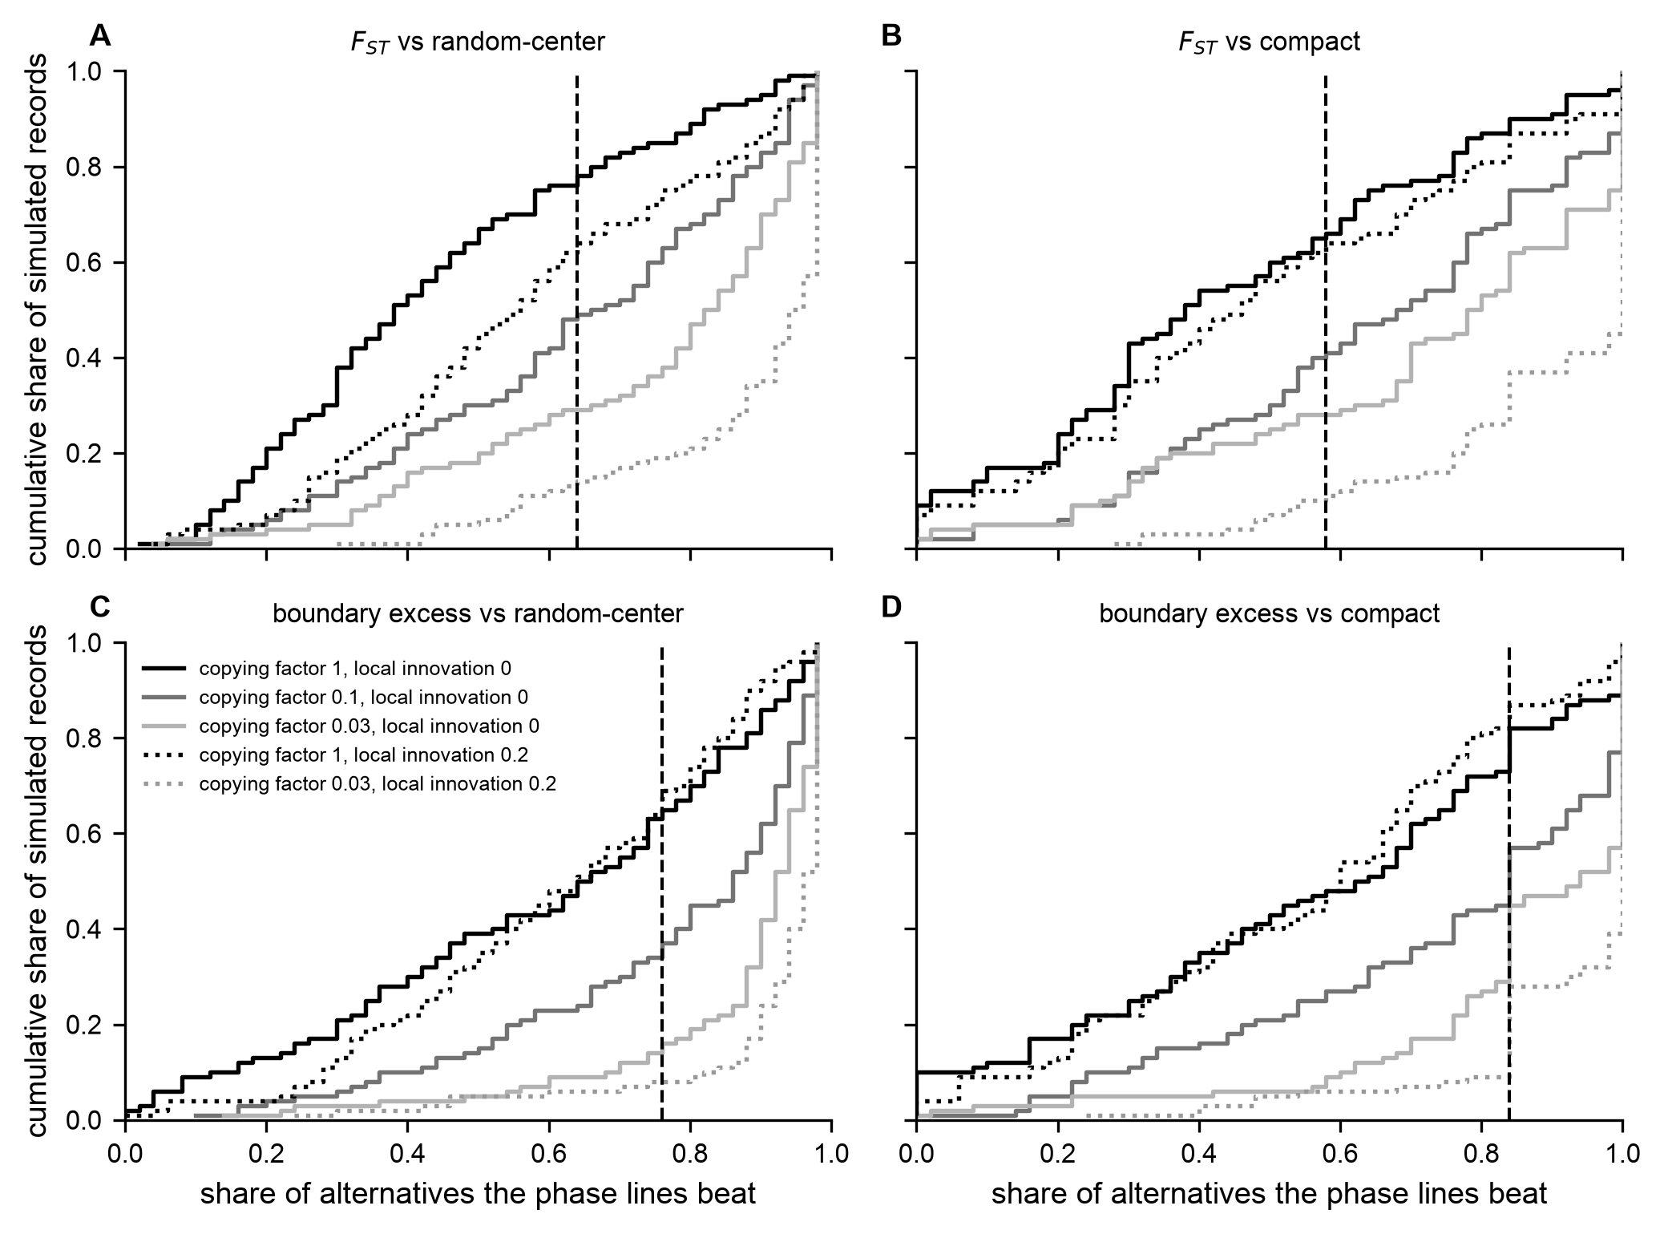
Figure S8. How strongly the phase-line comparison weighs against a copying boundary. Cumulative distributions, over 100 simulated records per setting at the calibrated combination, of the share of same-size alternative divisions the phase lines beat: on between-group cultural $F_{ST}$ against divisions around random centers (A) and compact divisions (B), and on the boundary excess against the same two kinds (C, D). Curves are settings of the phases-as-groups grid (copying factor at the phase lines, and share of classes reordered in local innovation). The dashed line is the real record’s direct score. A restriction shifts the curves to the right, but they overlap widely, and the real $F_{ST}$ scores fall above the median of both settings without a copying boundary and below the median of every setting with one (analyses/89_partition_power.py).

The map of compositional change: smoothing scale and sensitivity
Figure 4 maps how fast assemblage composition changes from place to place, and the main text asks whether the reconstructed phase boundaries run where it changes fastest. This section describes the map and two checks on that comparison. The rate of change at each point is estimated by regressing the ten class proportions on position, with nearby assemblages weighted more heavily than distant ones (Gaussian weights). We then compare the median rate along the reconstructed phase boundaries with the median along the boundaries of 200 same-size divisions around random centers, each turned into territories the same way, by assigning every point to its nearest assemblage and merging by group (analyses/75_groupness_surface.py). This study reconstructs the boundaries from the assemblages’ phases, taken from Phillips’s (1970) phase areas as mapped by Lipo (2001:Figure 2.6), not lines drawn by the original authors. Two checks ask how much weight the comparison can bear (analyses/91_turnover_sensitivity.py, output/findings/turnover_sensitivity.md, 160 by 160 grid, the same 200 alternatives).
bandwidth (km) | median rate along the phase boundaries (per km) | median over alternatives | percentile of the phase boundaries
10 | 0.0159 | 0.0190 | 6
12.5 | 0.0119 | 0.0149 | 0
15 | 0.0104 | 0.0117 | 8
20 | 0.0095 | 0.0098 | 40
25 | 0.0092 | 0.0093 | 41
30 | 0.0091 | 0.0091 | 46
At 15 km this grid gives 0.0104 per kilometer and the 7.5th percentile, where the finer grid of Figure 4 gives 0.0103 and the 8th. The reported bandwidth, 15 km, is among the scales at which the phase boundaries run through the slowest-changing areas; at 20 km and above they are unremarkable. With 28 points, scales finer than the spacing between assemblages cannot be resolved, and broader bandwidths smooth over the contrasts the narrower ones register, so no single scale is privileged.
The second check simulates records from the phases-as-groups grid above, with analysis 84’s seeds, at the real sherd counts, and puts each through the same comparison at 15 km (100 records per setting).
copying factor at the phase lines | local innovation | percentile of the phase boundaries, 5% / 25% / 50% / 75% / 95% over records | records at or below the observed (7.5th) percentile
1 | 0 | 4 / 12 / 21 / 41 / 76 | 12%
0.1 | 0 | 6 / 22 / 41 / 61 / 86 | 7%
0.03 | 0 | 12 / 26 / 48 / 69 / 84 | 3%
0.03 | 0.2 | 14 / 45 / 76 / 84 / 88 | 2%
A copying boundary moves the phase boundaries up the ranking, but the distributions overlap widely, and even with no boundary they rank low (median 21st percentile). Boundaries built this way fall between assemblages, where many assemblages inform the estimate and the estimated rate of change is lowest. The observed position lies in the lower tail of every setting, reached by 12 percent of records without a boundary and 2 to 7 percent with one, so it favors the no-boundary setting by a factor of only about two to six, and with counts this small (2 to 12 records of 100) that ratio is itself poorly determined. The turnover comparison therefore describes where composition changes and adds little independent weight to the partition comparison.

The differences at finer scales
The main text reports that the record differs more among three or more groups than the copying model produces. This section shows that result at every scale and at six calibrated combinations, and then asks where the excess lies and whether sampling could produce it.
Table S5. Observed between-cluster cultural $F_{ST}$ against the calibrated copying model as the basin is divided into more $k$-means clusters, 300 runs at the selected combination, each run scored at every $k$ (analyses/71_scale_sweep.py). The smallest-group column matters: once a cluster holds a single assemblage, it matches its own profile exactly and adds between-group variance for arithmetic, not archaeological, reasons. A share of 0.0% means none of the 300 runs, below about 0.3 percent at this resolution.
$k$ | radius (km) | smallest group | observed | model median [95%] | runs reaching
2 | 16.6 | 11 | 0.0062 | 0.0021 [0.0002, 0.0108] | 11.7%
3 | 12.5 | 9 | 0.0156 | 0.0036 [0.0006, 0.0132] | 1.3%
4 | 10.3 | 5 | 0.0186 | 0.0040 [0.0011, 0.0135] | 0.7%
5 | 9.1 | 4 | 0.0307 | 0.0046 [0.0015, 0.0148] | 0.0%
6 | 7.8 | 4 | 0.0310 | 0.0050 [0.0017, 0.0157] | 0.0%
8 | 6.3 | 1 | 0.0384 | 0.0057 [0.0022, 0.0165] | 0.0%
10 | 5.2 | 1 | 0.0508 | 0.0066 [0.0027, 0.0172] | 0.0%
12 | 4.2 | 1 | 0.0521 | 0.0076 [0.0032, 0.0184] | 0.0%
Table S6. The comparison of the six most favorable combinations that passed the fifty-run confirmation (learners, innovation, mixing), 300 runs each (analyses/88_cell_sensitivity.py, output/findings/cell_sensitivity.md). Entries are the model median, its 95 percent range, and the share of runs reaching the observed value. The six are read from the calibration’s fifty-run ranking, with the selected combination first.
combination | two clusters (0.0062) | Parkin phase against the rest (0.0067) | the phases (0.0123) | three clusters (0.0156) | four clusters (0.0186)
2,000, 0.001, 0.02 (selected) | 0.0021 [0.0002, 0.0108]; 12% | 0.0018 [0.0002, 0.0101]; 8% | 0.0024 [0.0004, 0.0104]; 1% | 0.0036 [0.0006, 0.0132]; 1% | 0.0040 [0.0011, 0.0135]; 1%
10,000, 0.0002, 0.005 | 0.0024 [0.0004, 0.0136]; 13% | 0.0021 [0.0002, 0.0120]; 9% | 0.0028 [0.0006, 0.0124]; 3% | 0.0036 [0.0008, 0.0153]; 2% | 0.0041 [0.0012, 0.0146]; 1%
2,000, 0.002, 0.01 | 0.0016 [0.0002, 0.0083]; 8% | 0.0016 [0.0002, 0.0075]; 4% | 0.0023 [0.0005, 0.0085]; 0% | 0.0032 [0.0007, 0.0107]; 0% | 0.0039 [0.0012, 0.0116]; 0%
10,000, 0.0005, 0.002 | 0.0019 [0.0002, 0.0101]; 12% | 0.0019 [0.0002, 0.0096]; 7% | 0.0028 [0.0005, 0.0102]; 1% | 0.0034 [0.0008, 0.0126]; 2% | 0.0045 [0.0012, 0.0144]; 1%
10,000, 0.001, 0.001 | 0.0016 [0.0002, 0.0104]; 8% | 0.0015 [0.0002, 0.0093]; 7% | 0.0023 [0.0005, 0.0101]; 1% | 0.0033 [0.0007, 0.0128]; 1% | 0.0040 [0.0013, 0.0126]; 0%
2,000, 0.004, 0.002 | 0.0016 [0.0002, 0.0092]; 9% | 0.0015 [0.0002, 0.0092]; 9% | 0.0026 [0.0006, 0.0117]; 2% | 0.0037 [0.0009, 0.0130]; 1% | 0.0049 [0.0013, 0.0142]; 1%
From three clusters on, 0 to 2 percent of runs reach the observed value at each of the six leading combinations (Table S6), and the observed value lies above the model’s 95 percent range at all six combinations at three clusters and at four. The shortfall appears in every cluster but is not even. At five clusters, each cluster’s contribution to the between-cluster $F_{ST}$ exceeds the model’s median contribution 2.7- to 34-fold (analyses/72_excess_locality.py): 34-fold for the cluster holding Clay Hill, Davis, Grant, Kent Place, and Starkley, 8.2-fold around Walls (Irby, Lake Cormorant, Mound Place, Walls, Woodlyn), 4.3-fold for the cluster holding Parkin and nine neighbors, 4.1-fold for the cluster holding Beck, Belle Meade, Commerce, and Hollywood, and 2.7-fold along the Mississippi (Big Eddy, Castile Landing, Cramor Place, Nickel). Dropping any one cluster leaves the overall shortfall between 3.4- and 9.5-fold; the lowest value comes from dropping the first cluster, which carries about half of the observed five-cluster $F_{ST}$.
Three checks ask whether this is an accident of sampling (analyses/85_excess_robustness.py, 300 model runs, 2,000 draws). Redrawing each assemblage from the basin’s pooled profile at its own sherd count gives each cluster a contribution near zero, at most 0.0003 at the 97.5th percentile, compared with observed contributions of 0.0028 to 0.0150. Drawing each assemblage’s class proportions from Dirichlet(counts + 1/2) and dividing each cluster’s contribution by the model’s median gives posterior excesses whose 95 percent credible intervals all lie above 1 (the lowest lower bound is 1.9). Dropping each assemblage in turn from the data and from every model run leaves every multi-assemblage cluster between 1.8 and 34.9 times above the model. The shortfall is therefore not a sampling effect, and no single collection causes it. It is also not a matter of which source the counts came from: rows carrying the survey’s counts alone and rows carrying Lipo’s compilation each fall short of the model when taken separately, by 14- and 5.3-fold, although source and sample size cannot be separated (analyses/78_source_effect.py).

Tests of change along the sequence
The four measures describe the record at points along the sequence, not the changes between them. Two further tests model change directly while allowing for the record’s time-averaging, and three shorter checks follow. All of them depend on the seriation order, which follows geography at least as closely as time, so the main text draws on them only to say that the record shows no resolved change along the sequence.
Copying bias inferred by simulation. We simulate copying scenarios ranging from strongly conformist through neutral to novelty-seeking, keep those that reproduce the real assemblages, and infer the copying bias from the survivors, with time-averaging built into each simulation (Carrignon et al. 2019; Crema et al. 2014, 2016). The model is frequency-dependent copying among the ten classes in a finite population: a class’s adoption weight is proportional to its frequency raised to the power $1+b$, where $b>0$ is conformity, $b<0$ anti-conformity, and $b=0$ neutral copying, with an innovation rate that mixes in a uniform draw from the classes. An assemblage pools production over a window of generations. We placed broad priors on innovation, $b$, population size, and window length, and fitted the model by sequential Monte Carlo approximate Bayesian computation (800 particles, six rounds of shrinking tolerance, local-linear regression adjustment), matching each simulated six-period sequence to the observed diversity trajectory and rank-frequency profile (Beaumont et al. 2002; Toni et al. 2009). The posterior of $b$ is concentrated near neutral, with a mean of +0.003 and a 95 percent credible interval of -0.035 to +0.039 that includes zero, and means of +0.001 to +0.004 across five independent runs (Figure S9A). Its standard deviation is 0.017 against a prior of 0.289, so the data strongly constrain it. P(b > 0) is 0.62 in the primary run and 0.53 to 0.63 across runs, so even the direction of any lean is unstable. Fitting the two halves of the order separately recovers no shift between them (-0.000 and +0.012). Simulation-based calibration over 200 datasets drawn from the prior gives ranks consistent with uniform (Kolmogorov-Smirnov D = 0.088, p = 0.086; Figure S9B), a check of the software rather than of the record (Talts et al. 2018), and an independent rejection-sampling fit agrees (mean $b$ = +0.019, 95 percent interval -0.062 to +0.054).
Two caveats apply. The calibration tests also report coverage of the nominal 95 percent interval at nine fixed values of $b$ (Table S7), and coverage falls to 0.65 at $b=+0.10$ and 0.75 at $b=−0.20$ (output/abc_smc_validation.md). They used 300 particles and five rounds rather than the empirical fit’s 800 and six, and their synthetic data come from the same pooled-population simulator they fit, whereas the real observations are spatially distributed assemblages pooled into six periods. They therefore check the numerical inference under the assumed simulator, not whether that simulator describes how the record formed. We treat the interval as consistent with weak or absent basin-wide conformity, conditional on the pooled model, rather than as a demonstrated exclusion of strong conformity. Because the model pools the whole basin, it also says nothing about localized or group-specific conformity, which the spatial measures and the copying model address.
Table S7. Coverage of the nominal 95 percent posterior interval for the copying bias, from the simulation-based calibration tests (20 datasets per value; 300 particles, five rounds).
True $b$ | Coverage | Mean interval width
-0.40 | 0.95 | 0.26
-0.30 | 0.90 | 0.31
-0.20 | 0.75 | 0.33
-0.10 | 0.80 | 0.35
0.00 | 0.90 | 0.22
+0.10 | 0.65 | 0.25
+0.20 | 1.00 | 0.33
+0.30 | 0.90 | 0.35
+0.40 | 0.90 | 0.36
Direction and stability of change. The second test asks whether the assemblages’ diversity wanders without direction, heads steadily one way, or is pulled back toward a stable value. The distinctions among an unbiased random walk, a directional walk, stasis, and mean reversion (Hunt 2006; Hunt et al. 2008). Rather than choose among the four, we fit the model that contains them and report the two parameters that distinguish them, since unbiased motion, stasis, and mean reversion occupy a single region of parameter space. Along the computed seriation order, decorated-class diversity runs from 0.666 at one end through 0.734 to 0.460 at the other, falling over the second half. Because the dates do not establish which end is later, the sign of any directional change is also unclear. The mean-reversion rate has a posterior median of 0.77 (95 percent credible interval 0.05 to 10.7), spanning the unbiased and stasis limits and so unresolved. The directional drift along the order as computed leans negative but is not resolved (median -0.061, interval -0.154 to +0.035, P(drift > 0) = 0.071). A decline of this kind is, in any case, what drift in a finite population produces, as the predictive check below shows. With six points the reversion rate and the drift remain partly confounded, since relaxation toward a lower optimum can imitate directional loss, which is why we report both parameters rather than a winning model (Figure S9C). Diagnostics for the fit: R-hat 1.008, minimum effective sample size 980, 18 divergent transitions of 8,000 (0.23 percent), E-BFMI 0.61. The companion fit meant to show that the design recovers a directional series did not converge (R-hat 1.18, minimum effective sample size 16, 1,079 divergent transitions of 8,000), so the design’s ability to resolve directional change is not established, and we give the drift estimate no weight (output/findings/tempo_mode_posterior.md).
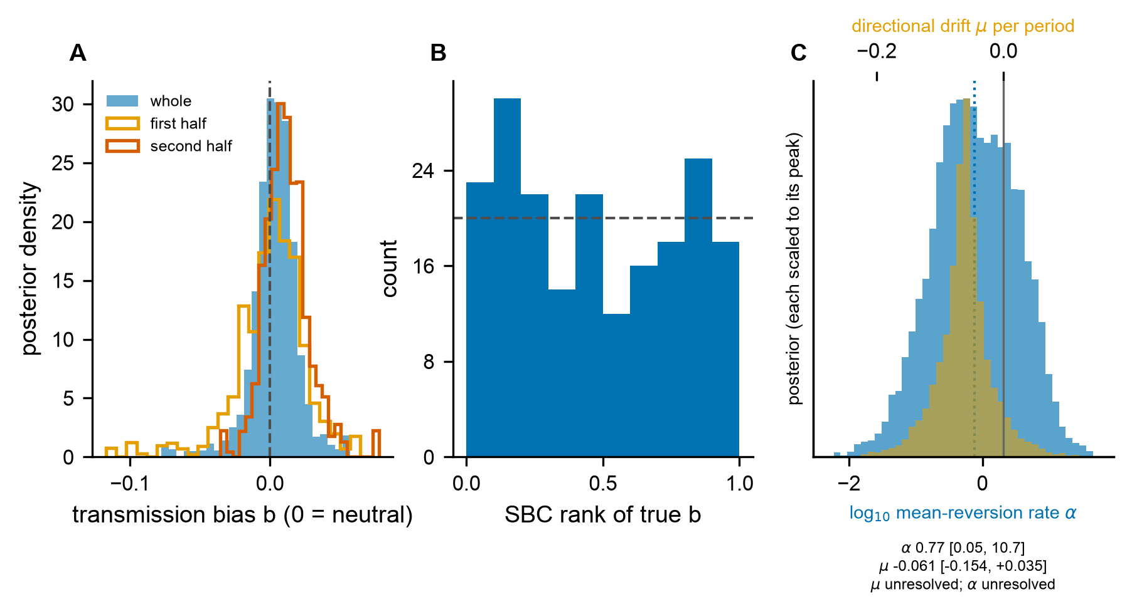
Figure S9. Tests of change along the sequence. (A) Posterior of the copying bias b from the time-averaging-aware inference (b = 0 neutral, b > 0 conformist, b < 0 anti-conformist). The whole-sequence posterior (filled) and the posteriors for the two halves of the order (outlines) are all concentrated near neutral and include zero (see Table S7 for calibration caveats). (B) Simulation-based calibration of that inference: over datasets drawn from the prior, the rank of the true bias within its posterior is consistent with uniform (dashed line), which is consistent with calibration averaged over the prior. It does not establish calibration at every value of b: coverage of the nominal 95 percent interval at fixed values falls to 0.65 at b = +0.10 and 0.75 at b = -0.20 (Table S7), and the check assumes the fitted pooled simulator. (C) Direction and stability of change, showing the posteriors of the mean-reversion rate (lower axis, log scale; the broad histogram) and the directional drift per period (upper axis; the narrow histogram) for the diversity trajectory, each scaled to its own peak. The mean-reversion rate is unresolved (median 0.77, interval 0.05 to 10.7). The directional drift leans negative, but its interval reaches zero (median -0.061, interval -0.154 to +0.035). The companion recovery fit for a directional series did not converge, so the design’s ability to resolve directional change is not established, and this panel is given no weight.
A third test looks for the early-warning signs of a critical transition, a rise in variance and in the similarity of successive values before an abrupt change. This record gives it little to work with: 28 ordered assemblages and a rolling window of 14. The rolling variance along the sequence shows no consistent trend (Kendall tau = +0.09, and -0.22 to +0.58 across the window and detrending choices we tried) and the lag-1 autocorrelation falls rather than rises (tau = -0.75; -0.77 to -0.57), so neither behaves as a critical transition would (output/tempo_mode_ews.md). Because the ordering places similar assemblages next to one another, we do not rely on this test (Dakos et al. 2012; Scheffer et al. 2009).

Three further checks of neutrality along the sequence
The first follows each decorated class as it rises and falls through the sequence and asks whether those changes look like undirected fluctuation from unbiased copying or the directed change a marker would show. We fit the rescaled frequency increments of all ten classes in one hierarchical model with partial pooling, following the frequency increment construction (Feder et al. 2014). The population-level departure from unbiased copying has a posterior median of +0.008 with a 95 percent credible interval of -0.040 to +0.081, where unbiased copying implies zero, and P(departure > 0) = 0.64. Individual classes are not resolved: a class simulated with a substantial true departure is recovered at about a fifth of its size with an interval spanning zero, so the increments support the aggregate statement but not a per-class one.
The second asks whether a neutral model reproduces the observed diversity trajectory (Kandler and Shennan 2013). We draw population size and innovation rate from the posterior of the copying-bias inference and compare the observed trajectory with the resulting predictive distribution. The observed diversity falls inside the 95 percent predictive interval in all six periods, under the pooled posterior and under each of the five sampler seeds taken separately. The pooled posterior predictive probability is 0.885, ranging from 0.634 to 0.915 across seeds. A neutral model is adequate for this trajectory, which is concordance rather than proof that copying was neutral; the predictive interval is wide because population size is itself uncertain.
The third asks whether the assemblages grow more different from one another toward contact, as fragmenting groups would. Neiman’s distance between assemblages shows no resolved trend along the sequence: the posterior median rank correlation between mean within-period distance and position is +0.09, with a 95 percent credible interval of -0.53 to +0.63 over six periods. Distances between the two spatial clusters are only modestly larger than distances within them, a ratio of 1.28, and within-assemblage diversity is weakly and negatively related to an assemblage’s mean distance from the others (posterior median -0.14, 95 percent credible interval -0.44 to +0.20), the direction a single shared community produces (Figure S4) (Neiman 1995).

What recovers the phases, and the problem of zeros
The main text asks whether the site map or the assemblages recover the phase assignments. This section describes how assemblages were clustered on location and composition together, and one choice, the treatment of zero counts, that changes the answer.
Assemblages are clustered in a combined space: site coordinates in kilometers, centered and scaled so that the mean squared pairwise distance is one, joined to decorated-class composition scaled the same way and multiplied by the square root of a weight $w$. At $w=0$, the representation is the site map alone; as $w$ grows, it becomes assemblage composition alone. We compare each clustering with the phase assignments, taken from Phillips’s (1970) phase areas as mapped by Lipo (2001:Figure 2.6), using the adjusted Rand index. We ran three composition transforms, three clustering methods ($k$-means over 40 seeds, each the best of 500 restarts; Ward linkage; and average linkage), and nine weights from the map alone upward, plus composition alone; the full grid is in output/findings/phase_recovery.csv. Two of the 28 assemblages lie inside no phase area and are assigned to the nearest area, a geographic rule, so every value quoted in the main text is computed on the 26 assemblages inside a phase area, apart from the sensitivity case below, which scores all 28. The agreement reached by the site map alone depends on the clustering method. It is 0.480 by $k$-means and 0.740 by Ward linkage and by average linkage, whichever composition transform is used, since at $w=0$ the transform does not enter (output/findings/phase_recovery.md). The difference lies in which assemblages each method places with another phase. Ward and average linkage misplace two, Big Eddy and Castile Landing, both in Phillips’s Parkin area and both grouped with Kent. $K$-means misplaces those two and four more, Beck, Belle Meade, Commerce, and Hollywood, which it groups with Walls. With composition at half the coordinates’ weight and the chi-square transform, all three methods misplace only Big Eddy and Castile Landing. Composition alone misplaces six of the 26 by $k$-means and by Ward linkage and thirteen by average linkage. These lists are from the chi-square transform and, for $k$-means, the first seed.
We also asked of each assemblage which phase its pottery fits best (analyses/96_assemblage_phase_fit.py, output/findings/assemblage_phase_fit.md). The measure is the chi-square distance from the assemblage’s profile to the pooled profile of each phase, with the assemblage left out of its own phase’s pool; each profile is drawn 4,000 times from Dirichlet(counts + 1/2), and the posterior probability that an assemblage fits its own phase is the share of draws in which its own phase is the closest. That probability is above 0.75 for 22 of the 28 assemblages and below 0.25 for four: Big Eddy, Holden Lake, and Turnbow, which are closer to Kent, and Belle Meade, which is closer to Parkin. For Castile Landing it is 0.60 and for Mound Place 0.40: Castile Landing is nearly as close to Kent (distance 0.571) as to its own Parkin (0.555), and Mound Place is slightly closer to Kent and to Parkin (0.496 each) than to its own Walls (0.538). Two assemblages lie nearer a member of another phase than any other member of their own: Castile Landing (12 km from the nearest Kent assemblage, 16 km from the nearest Parkin assemblage) and Clay Hill.
As a sensitivity case, we counted Big Eddy and Castile Landing as Kent and reran the recovery and the phase-line comparison. Ward linkage on the site map alone then reproduces the scheme exactly, as does $k$-means on the map and composition together, and $k$-means on the map alone reaches 0.666 against 0.509 (all 28 assemblages scored). The between-phase $F_{ST}$ has a posterior median of 0.0142 (95 percent credible interval 0.0124 to 0.0162), against 0.0123 and 0.0121 for divisions around random centers and compact divisions, and the posterior probability that the phase lines separate the assemblages better is 0.61 and 0.57, against 0.57 and 0.72 with Phillips’s assignments. The primary analysis keeps Phillips’s assignments.
Class proportions are compositional data, and the centered log-ratio transform is the usual choice. It cannot be applied here without a choice that determines the result. Of the 280 cells in the basin matrix, 105 are zero, and log (0) is undefined. Replacing zeros with a fraction of the smallest positive proportion lets that fraction set how strongly absence counts, and agreement with the phases follows it:
zero convention | adjusted Rand index
pseudocount of 0.5 added to counts | 0.522
floor at 2.0 times the smallest positive proportion | 0.740
floor at 0.5 times the smallest positive proportion | 0.740
floor at 0.1 times the smallest positive proportion | 0.863
All four use the same data, geography, and weight ($w=0.5$); only the zero convention differs, and it moves the answer by about a third of the index’s range. We report the chi-square transform in the main text because it needs no such choice, and we use a pseudocount wherever the log-ratio transform appears. The result is also a caution about the phases themselves: a classification sensitive to which types are absent, applied to assemblages whose sherd counts differ more than twentyfold, will read sampling failure as cultural difference.

The second case: the tests on Mainfort’s (2003) table
The main text analyzes Mainfort’s (2003) table and phases separately from the primary dataset, as a second case. His assignments follow Phillips’s, with Smith’s (1990) Horseshoe Lake phase split out and the phases of western Tennessee added (Mainfort 2003:176–177), and his table is not a larger sample once restricted to decorated classes. This section details that analysis.
Mainfort’s Table 1 gives counts of ten decorated types for 39 sites with 800 or more sherds in all. His types map onto our classes as follows: Barton Incised and Kent Incised join the class that also holds Mound Place Incised, and Old Town Red and Nodena Red and White join the painted class; he does not tally Wallace Incised or Hull Engraved, which are carried as zeros so the class list matches the main analysis. Coordinates come from his own site list where it has them (30 sites), from this project’s assemblage file for eight (four of them with a project correction), and from the settlement compilation for Sweat, and each row of data/processed/mainfort2003_sites.csv names its source; the file is written by scripts/build_mainfort2003_sites.py. The analysis uses decorated types only and sites with at least 100 decorated sherds, stricter than the main analysis’s 75 because the second case should not be the looser test. Nine of his 39 sites fall below that, and Tipton’s one remaining site, Graves Lake, is not carried as a phase of one. The tests are those of analyses/74_phase_partition_test.py and analyses/76_phase_recovery.py, run by analyses/83_mainfort_replication.py under his labels. A second reader checked the transcription of his table against the published page; the one row whose cells do not sum to its printed total, Hatchie (818 against 814), is transcribed correctly, and no analysis uses the printed totals.
weight on composition | agreement with his phases (adjusted Rand index, median over 40 starts)
map alone | 0.536
0.1 | 0.536
0.25 | 0.509
0.5 | 0.664
1 | 0.483
2 | 0.483
composition alone | 0.248
same sizes, boundaries at random (400 draws) | 0.306
All 40 seeds return the same value at every weight.
Under his phases, the cultural $F_{ST}$ is 0.0470 (direct), with a posterior median of 0.0459 (95 percent credible interval 0.0413 to 0.0505) when each site’s class proportions are drawn from Dirichlet(counts + 1/2). Same-size divisions around random centers give a posterior median of 0.0297 and compact divisions 0.0315, and the posterior probability that his lines separate the assemblages better is 0.96 and 0.94 (analyses/86_partition_posterior.py). The compactness search returned his division in none of 1,000 starts.
site | Mainfort 2003 | primary analysis | ceramic distance to his phase | km | ceramic distance to the primary-analysis phase | km
Beck | Horseshoe Lake | Kent | 0.333 | 15 | 0.242 | 14
Belle Meade | Horseshoe Lake | Kent | 0.256 | 13 | 0.521 | 15
Mound Place | Horseshoe Lake | Walls | 0.651 | 17 | 0.778 | 7
Young | Horseshoe Lake | Walls | 0.467 | 13 | 0.443 | 15
Carson Lake | Walls | Nodena | 1.039 | 71 | no other Nodena site at the minimum
Distances are chi-square distances from the site’s profile to the pooled profile of the candidate phase with the site left out, and straight-line kilometers to that phase’s center. His Parkin Punctated counts equal the survey’s at 11 of the 21 shared sites and exceed them at ten (output/findings/matrix_integrity.md), so for those sites this is a second sampling of the same collections; only the western Tennessee sites, from Tennessee Division of Archaeology collections, are material the survey never had. The copying model is not rerun on this table because it is calibrated to the main matrix, and recalibrating it would be a separate study.

Coordinates and datum
Assemblage coordinates come from data/raw/mainfort-pfg-cplXY.txt, with published corrections applied on reading (data/raw/coordinate_corrections.csv): Belle Meade and Beck are moved to author-supplied coordinates inside the sections Phillips, Ford, and Griffin record, and Starkley and Davis (13-N-5) to the survey’s own coordinates, which fall inside their recorded sections (for Davis, SE1/4 SE1/4 of Section 14, T3N R5E, confirmed against the Bureau of Land Management’s cadastral survey layer). Cummins (11-O-4) is moved 22.7 km, from a file coordinate in quadrangle 10-N that belongs to a different site joined on the name (Arkansas record 3PO243, a Dalton site), to the coordinate the From LMV Project sheet of data/raw/mainfort-spatial-data.xlsx gives for it, which lies inside quadrangle 11-O as its designation requires and 0.76 km from the site numbered 4 that Lipo (2001:Figure 2.6) plots there. This correction is provisional until the section Phillips, Ford, and Griffin give for 11-O-4 is supplied. The survey’s coordinates were recorded in the 1927 North American Datum. Reading them in the 1983 datum instead places each point about 209 m south of where the survey placed it, so we convert them. We convert only coordinates that can be derived from the survey: an assemblage coordinate is converted when it lies within 10 m of the survey coordinate for that site read in the 1983 datum. That applies to 19 assemblages, 15 of them in the basin set, each moved 209 m. Eleven further coordinates lie within 100 m of that reading but outside the tolerance (14 to 54 m for the eight in the basin set), which means they were derived another way; eight of them are Mainfort’s own points, and all eleven are left as recorded. Settlement-table rows whose source is the survey (367 rows) are converted the same way. The conversion leaves the $k$-means divisions at two, three, five, and six clusters and their direct $F_{ST}$ unchanged, and changes the division at four clusters (the four-cluster value moves from 0.0194 to 0.0186); every result reported uses the converted coordinates (scripts/measure_datum.py, output/findings/datum_conversion.md).

Radiocarbon chronology
This section gives the radiocarbon evidence for when the basin was occupied and shows why the seriation order cannot be read as a chronology. We calibrated the Mainfort (2001) radiocarbon compilation against IntCal20 (Reimer et al. 2020). Forty determinations come from seven sites in and near the St. Francis basin, nineteen of them from Parkin. The summed probability of the basin dates has a median of AD 1428 (Parkin alone, AD 1483). It places 74 percent of the probability between AD 1241 and AD 1641, spread evenly over those four centuries (18 or 19 percent each), with 16 percent earlier and 10 percent in the century after (Figure S10; output/chronology_14c.md). It does not fall at the contact interval. The century after AD 1541 holds 19 percent, the same as the century before; 29 percent of the basin probability postdates AD 1541 and 18 percent postdates AD 1600. These shares are computed on calendar years AD 1000 to 1749, which assumes that no deposit postdates 1750. Calibrated without that bound, 8 percent of the probability falls after AD 1741, the shares after AD 1541 and AD 1600 become 31 and 21 percent, and the centuries before and after AD 1541 remain equal, at 17 percent each. This is consistent with occupation continuing through the De Soto entrada and declining afterward, although the shape of the calibration curve affects the shape of any summed distribution (Surovell and Brantingham 2007), and the latest tail is partly a product of determinations near the post-1650 plateau.
To test whether the seriation axis tracks calendar time, we pooled the dates of the four proveniences matching our assemblages (Kent Place, Parkin, Neeley’s Ferry, and Clay Hill; 26 dates) and correlated their median calibrated ages with position on the first correspondence-analysis axis. With pooled calibrated medians, the rank correlation is 0.40 in magnitude, with Clay Hill out of order, and it favors orienting the axis the way the analyses do; with one-sigma calibrated midpoints, it is zero. Four points under two reasonable conventions that disagree cannot establish which end of the axis is later.
House (1993:23) reports the Kent and Clay Hill determinations with their contexts. At Kent, one date comes from a house floor (Feature 6, SMU-2102, 600 ± 115 BP) and the other from a post intrusive into it (SMU-2103, 310 ± 90 BP), and an archaeomagnetic date on another feature (Feature 1) falls at AD 1345 to 1380. Pooling the intrusive post with the floor makes the Kent Place median (AD 1466) later than the floor itself. Correcting it would not orient the axis either, because Kent Place, then among the earliest dated sites, and Clay Hill, the latest, sit at the same end of the axis. Hollywood, one of the analyzed assemblages but not in the radiocarbon file, has two calibrated dates reported by Haley (2014) from Johnson and colleagues’ excavations (Johnson et al. 2000:48-49, as cited there): central intercepts of AD 1310, 1355, and 1385 (one-sigma AD 1285 to 1420) for the earliest features, and AD 1405 (1300 to 1435) for the top of Mound A. The uncalibrated ages are not reported, so we have not recalibrated them against IntCal20 or pooled them with the other anchors. Hollywood too lies at the same end of the axis as Kent Place and Clay Hill (ranks 6, 4, and 7 of 28, with Parkin at 21).
The axis follows latitude, with a rank correlation of +0.77 as oriented, and latitude and longitude together account for 63 percent of its variance (analyses/87_axis_geography.py). It is largely a south-to-north gradient in composition, which is what the main text’s argument would lead one to expect, and it is not a reliable proxy for time. The analyses therefore orient the axis in the direction the medians weakly favor, and report every direction-dependent result both ways.
The basin chronology is stable under an alternative compilation: adding the net-new Mississippian dates from the lower-valley radiocarbon database compiled by Jeffrey Alvey (personal communication, 2022), twelve determinations concentrated at Hazel and Upper Nodena, shifts the summed-probability median by eight years, to AD 1436, and leaves the contact decline in place (26 percent of the probability after AD 1541 and 16 percent after AD 1600). Recent AMS dating of the Parkin platform-mound post, interpreted as the base of the cross the De Soto expedition raised at Casqui, places it at cal AD 1445 to 1650 (Mitchem et al. 2017), consistent with the latest occupation inferred here. The individual determinations, with laboratory numbers, ages, calibrated medians, and sources, are listed in radiocarbon_dates_used.csv.
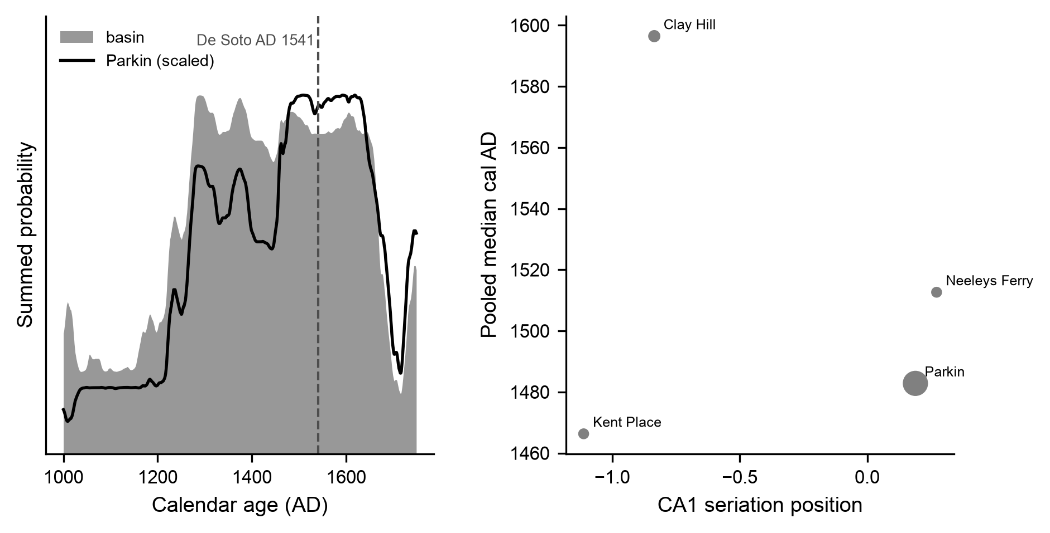
Figure S10. Radiocarbon chronology of the St. Francis basin (Mainfort determinations calibrated against IntCal20). Left: summed probability for the basin Parkin-phase sites (filled) and for Parkin alone (line, scaled), with the De Soto entrada (AD 1541) marked. The summed probability is level from the mid-thirteenth to the mid-seventeenth century, including across AD 1541, and falls after that. Right: position on the first correspondence-analysis axis against pooled median calibrated age for the four proveniences matching the analyzed assemblages (point size proportional to the number of dates). The axis is oriented as in Figure 2 and the analyses; the rank correlation is +0.40, with the late-dated Clay Hill out of order, and four points do not establish the axis’s direction.

References
Beaumont, Mark A., Wenyang Zhang, and David J. Balding. 2002. Approximate Bayesian Computation in Population Genetics. Genetics 162(4):2025–2035.
Bell, Adrian V., Peter J. Richerson, and Richard McElreath. 2009. Culture Rather Than Genes Provides Greater Scope for the Evolution of Large-Scale Human Prosociality. Proceedings of the National Academy of Sciences 106(42):17671–17674. https://doi.org/10.1073/pnas.0903232106.
Bentley, R. Alexander, Matthew W. Hahn, and Stephen J. Shennan. 2004. Random Drift and Culture Change. Proceedings of the Royal Society B: Biological Sciences 271:1443–1450. https://doi.org/10.1098/rspb.2004.2746.
Carrignon, Simon, R. Alexander Bentley, and Damian Ruck. 2019. Modelling Rapid Online Cultural Transmission: Evaluating Neutral Models on Twitter Data with Approximate Bayesian Computation. Palgrave Communications 5:83. https://doi.org/10.1057/s41599-019-0295-9.
Cowgill, George L. 1972. Models, Methods and Techniques for Seriation. In Models in Archaeology, edited by David L. Clarke, pp. 381–424. Methuen, London.
Crema, Enrico R., Kevan Edinborough, Tim Kerig, and Stephen J. Shennan. 2014. An Approximate Bayesian Computation Approach for Inferring Patterns of Cultural Evolutionary Change. Journal of Archaeological Science 50:160–170. https://doi.org/10.1016/j.jas.2014.07.014.
Crema, Enrico R., Anne Kandler, and Stephen Shennan. 2016. Revealing Patterns of Cultural Transmission from Frequency Data: Equilibrium and Non-Equilibrium Assumptions. Scientific Reports 6:39122. https://doi.org/10.1038/srep39122.
Dakos, Vasilis, Stephen R. Carpenter, William A. Brock, Aaron M. Ellison, Vishwesha Guttal, Anthony R. Ives, Sonia Kéfi, et al. 2012. Methods for Detecting Early Warnings of Critical Transitions in Time Series Illustrated Using Simulated Ecological Data. PLoS ONE 7(7):e41010. https://doi.org/10.1371/journal.pone.0041010.
Dunnell, Robert C. 1970. Seriation Method and Its Evaluation. American Antiquity 35(3):305–319. https://doi.org/10.2307/278341.
Ewens, Warren J. 1972. The Sampling Theory of Selectively Neutral Alleles. Theoretical Population Biology 3(1):87–112.
Feder, Alison F., Sergey Kryazhimskiy, and Joshua B. Plotkin. 2014. Identifying Signatures of Selection in Genetic Time Series. Genetics 196(2):509–522. https://doi.org/10.1534/genetics.113.158220.
Graves, Michael W., and C. Kehaunani Cachola-Abad. 1996. Seriation as a Method of Chronologically Ordering Architectural Design Traits: An Example from Hawai’i. Archaeology in Oceania 31(1):19–32.
Haley, Bryan S. 2014. The Big Picture at Hollywood: Geophysical and Archaeological Investigations at a Mississippian Mound Centre. Archaeological Prospection 21(1):39–47. https://doi.org/10.1002/arp.1477.
Henrich, Joseph. 2001. Cultural Transmission and the Diffusion of Innovations: Adoption Dynamics Indicate That Biased Cultural Transmission Is the Predominate Force in Behavioral Change. American Anthropologist 103(4):992–1013. https://doi.org/10.1525/aa.2001.103.4.992.
Holdaway, Simon J., and LuAnn Wandsnider (editors). 2008. Time in Archaeology: Time Perspectivism Revisited. University of Utah Press, Salt Lake City.
Hopkins, Brian, and J. G. Skellam. 1954. A New Method for Determining the Type of Distribution of Plant Individuals. Annals of Botany 18(2):213–227.
House, John H. 1993. Dating the Kent Phase. Southeastern Archaeology 12(1):21–32.
Hunt, Gene. 2006. Fitting and Comparing Models of Phyletic Evolution: Random Walks and Beyond. Paleobiology 32(4):578–601. https://doi.org/10.1666/05070.1.
Hunt, Gene, Michael A. Bell, and Matthew P. Travis. 2008. Evolution Toward a New Adaptive Optimum: Phenotypic Evolution in a Fossil Stickleback Lineage. Evolution 62(3):700–710. https://doi.org/10.1111/j.1558-5646.2007.00310.x.
Kandler, Anne, and Stephen Shennan. 2013. A Non-Equilibrium Neutral Model for Analysing Cultural Change. Journal of Theoretical Biology 330:18–25. https://doi.org/10.1016/j.jtbi.2013.03.006.
Kandler, Anne, and Stephen Shennan. 2015. A Generative Inference Framework for Analysing Patterns of Cultural Change in Sparse Population Data with Evidence for Fashion Trends in LBK Culture. Journal of the Royal Society Interface 12(113):20150905. https://doi.org/10.1098/rsif.2015.0905.
Lipo, Carl P. 2001. Science, Style and the Study of Community Structure: An Example from the Central Mississippi River Valley. BAR International Series 918. Archaeopress, Oxford.
Lipo, Carl P., Robert J. DiNapoli, Mark E. Madsen, and Terry L. Hunt. 2021. Population Structure Drives Cultural Diversity in Finite Populations: A Hypothesis for Localized Community Patterns on Rapa Nui (Easter Island, Chile). PLoS ONE 16(5):e0250690. https://doi.org/10.1371/journal.pone.0250690.
Lipo, Carl P., Mark E. Madsen, and Robert C. Dunnell. 2015. A Theoretically-Sufficient and Computationally-Practical Technique for Deterministic Frequency Seriation. PLOS ONE 10(4):e0124942. https://doi.org/10.1371/journal.pone.0124942.
Lipo, Carl P., Mark E. Madsen, Robert C. Dunnell, and Terry Hunt. 1997. Population Structure, Cultural Transmission, and Frequency Seriation. Journal of Anthropological Archaeology 16(4):301–333. https://doi.org/10.1006/jaar.1997.0314.
Lyman, R. Lee, and Michael J. O’Brien. 2006. Measuring Time with Artifacts: A History of Methods in American Archaeology. University of Nebraska Press, Lincoln.
Mainfort, Jr., Robert C. 2001. The Late Prehistoric and Protohistoric Periods in the Central Mississippi Valley. In Societies in Eclipse: Archaeology of the Eastern Woodlands Indians, a.d. 1400–1700, edited by David S. Brose, C. Wesley Cowan, and Jr. Mainfort Robert C., pp. 173–190. Smithsonian Institution Press, Washington, DC.
Mainfort, Jr., Robert C. 2003. An Ordination Approach to Assessing Late Period Phases in the Central Mississippi Valley. Southeastern Archaeology 22(2):176–184.
Marquardt, William H. 1978. Advances in Archaeological Seriation. In Advances in Archaeological Method and Theory, Volume 1, edited by Michael B. Schiffer, pp. 257–314. Academic Press, New York.
Mitchem, Jeffrey M., David W. Stahle, Timothy S. Mulvihill, and Jami J. Lockhart. 2017. Making the Case for the Parkin Site as Casqui: Hernando de Soto’s 1541 Cross.
Nei, Masatoshi. 1973. Analysis of Gene Diversity in Subdivided Populations. Proceedings of the National Academy of Sciences 70(12):3321–3323. https://doi.org/10.1073/pnas.70.12.3321.
Neiman, Fraser D. 1995. Stylistic Variation in Evolutionary Perspective: Inferences from Decorative Diversity and Interassemblage Distance in Illinois Woodland Ceramic Assemblages. American Antiquity 60(1):7–36.
O’Brien, Michael J., and R. Lee Lyman. 1999. Seriation, Stratigraphy, and Index Fossils: The Backbone of Archaeological Dating. Kluwer Academic/Plenum, New York.
Perreault, Charles. 2019. The Quality of the Archaeological Record. University of Chicago Press, Chicago.
Phillips, Philip. 1970. Archaeological Survey in the Lower Yazoo Basin, Mississippi, 1949–1955, Vol. 60. Papers of the Peabody Museum of Archaeology and Ethnology. Peabody Museum, Harvard University, Cambridge, MA.
Rasmussen, Carl Edward, and Christopher K. I. Williams. 2006. Gaussian Processes for Machine Learning. MIT Press, Cambridge, Massachusetts.
Reimer, Paula J. et al. 2020. The IntCal20 Northern Hemisphere Radiocarbon Age Calibration Curve (0–55 Cal kBP). Radiocarbon 62(4):725–757. https://doi.org/10.1017/RDC.2020.41.
Rousseeuw, Peter J. 1987. Silhouettes: A Graphical Aid to the Interpretation and Validation of Cluster Analysis. Journal of Computational and Applied Mathematics 20:53–65.
Scheffer, Marten, Jordi Bascompte, William A. Brock, Victor Brovkin, Stephen R. Carpenter, Vasilis Dakos, Hermann Held, Egbert H. van Nes, Max Rietkerk, and George Sugihara. 2009. Early-Warning Signals for Critical Transitions. Nature 461(7260):53–59. https://doi.org/10.1038/nature08227.
Smith, Gerald P. 1990. The Walls Phase and Its Neighbors. In Towns and Temples Along the Mississippi, edited by David H. Dye and Cheryl Anne Cox, pp. 135–169. University of Alabama Press, Tuscaloosa.
Surovell, Todd A., and P. Jeffrey Brantingham. 2007. A Note on the Use of Temporal Frequency Distributions in Studies of Prehistoric Demography. Journal of Archaeological Science 34(11):1868–1877. https://doi.org/10.1016/j.jas.2007.01.003.
Talts, Sean, Michael Betancourt, Daniel Simpson, Aki Vehtari, and Andrew Gelman. 2018. Validating Bayesian Inference Algorithms with Simulation-Based Calibration. arXiv preprint arXiv:1804.06788.
Tibshirani, Robert, Guenther Walther, and Trevor Hastie. 2001. Estimating the Number of Clusters in a Data Set via the Gap Statistic. Journal of the Royal Statistical Society: Series B 63(2):411–423.
Toni, Tina, David Welch, Natalja Strelkowa, Andreas Ipsen, and Michael P. H. Stumpf. 2009. Approximate Bayesian Computation Scheme for Parameter Inference and Model Selection in Dynamical Systems. Journal of the Royal Society Interface 6(31):187–202. https://doi.org/10.1098/rsif.2008.0172.

