Supplemental Material
Are the phases real? Distinguishing bounded interaction groups from spatially structured drift in central Mississippi Valley decorated ceramics
Carl P. Lipo and Robert J. DiNapoli
Supplement to the main text. Figure and section references to the main text (for example, Figure 4, Results, Discussion) point to the primary article. Citations resolve against references.bib.

Full specification of the four signatures
Departure from neutral transmission follows Neiman’s application of the infinite-alleles model (Neiman 1995). We estimated the transmission parameter $θ$ in two ways from each assemblage. The homozygosity estimator uses the unbiased sample homozygosity F=i​ni(ni−1)/[N(N−1)], where $n_{i}$ is the count of type $i$ and $N$ the assemblage size, and inverts the neutral relation $F=1/(1+θ)$ to give $θ_{F}=(1−F)/F$. The richness estimator solves the Ewens sampling expectation for the number of types $k$,
$$E[k∣θ,N]=\sum_{i=0}^{N−1}{\frac{θ}{θ+i}},$$
for the value $θ_{E}$ that reproduces the observed $k$ (Ewens 1972). Under neutral drift, the two estimators agree. Conformist copying concentrates frequency on common types, raising $F$ and lowering $θ_{F}$ relative to $θ_{E}$, whereas anti-conformist novelty bias does the reverse. The signature is the ratio $θ_{F}/θ_{E}$, which both detects a departure from neutrality and signs it. Because pooling assemblages from divergent groups cancels out the effect, we computed ratios within spatial clusters and averaged the results across clusters.
Seriation-coherence breakdown follows the deterministic frequency-seriation method of Lipo, Madsen, and Dunnell (Lipo et al. 2015). A set of assemblages is co-seriable if some ordering renders every decorated type’s frequency both unimodal and continuous. We enumerated the complete set of maximal co-seriable groups, the subsets for which a valid ordering exists, and which are maximal under inclusion. A single group indicates one interacting community, whereas a proliferation of small, mutually non-co-seriable groups indicates a fragmented one. We report the number and maximum size of these groups and, for each assemblage, its group-membership count, which identifies the bridge assemblages that join otherwise incompatible orderings. The number of maximal groups is the continuous signature.
The variance partition is a cultural analog of Wright’s $F_{ST}$ computed on Gini-Simpson diversity H=1−i​pi2,
$$F_{ST}=\frac{H_{T}−H_{S}}{H_{T}},$$
where $H_{T}$ is the diversity of the pooled assemblages and $H_{S}$ the size-weighted mean within-cluster diversity (Bell et al. 2009). It is zero when clusters share a repertoire and rises as they come to hold distinct ones.
Spatial assortativity asks whether ceramic similarity follows social rather than geographic distance. We measured Brainerd-Robinson similarity Sij=200−k​|100 pik−100 pjk| between every pair of assemblages. Because a Mantel correlation cannot separate a sharp boundary from a smooth distance decay, we summarized assortativity as a distance-controlled boundary excess. Within each pairwise-distance bin, the mean within-cluster similarity minus the mean between-cluster similarity is averaged over bins. Under pure isolation by distance, similarity depends only on distance, and the excess is near zero. A sharp social boundary makes within-cluster pairs much more similar than between-cluster pairs at matched distance, yielding a large positive excess. Spatial clusters were obtained by $k$-means on site coordinates with multiple restarts, the number of clusters chosen by the mean silhouette.
We combined the four signatures by standardizing each across the ordinal sequence and averaging them, so that no single signature would dominate, and summarized the trajectory as the ordinal slope of the combined score and each component, with rank correlations and bootstrap confidence intervals.

The generative validation model
The validation rests on a generative model with three mechanism-faithful controls: the between-group divergence of type profiles, the strength of within-group conformity, and a spatial rule placing group profiles on the landscape. Four generators instantiate the four processes of Table 1. The bounded-groups generator raises divergence and conformity together across spatially bounded groups. Environmental patchiness holds a fixed between-group difference under neutral within-group copying with an environment-keyed layout. Aggregated signaling raises within-group conformity in a single undivided pool with no between-group divergence. Drift with distance-limited interaction produces a smooth spatial gradient under neutral copying. Each generator emits a sequence of group-by-type slices along an ordinal axis. We ran the four-signature pipeline on each, blind to its source, and recorded which registered as convergent, repeating this across 20 random seeds and computing the correlation matrix of the four signatures on the bounded-groups output to confirm that their joint movement is informative rather than an artifact of redundancy (Figure S4). This idealized test uses large, clean assemblages (12 groups, several hundred sherds each) and establishes that it discriminates in principle. The record-matched, size-controlled recovery in the main text (Figure 4) is what establishes which signatures survive at the resolution of the actual data.
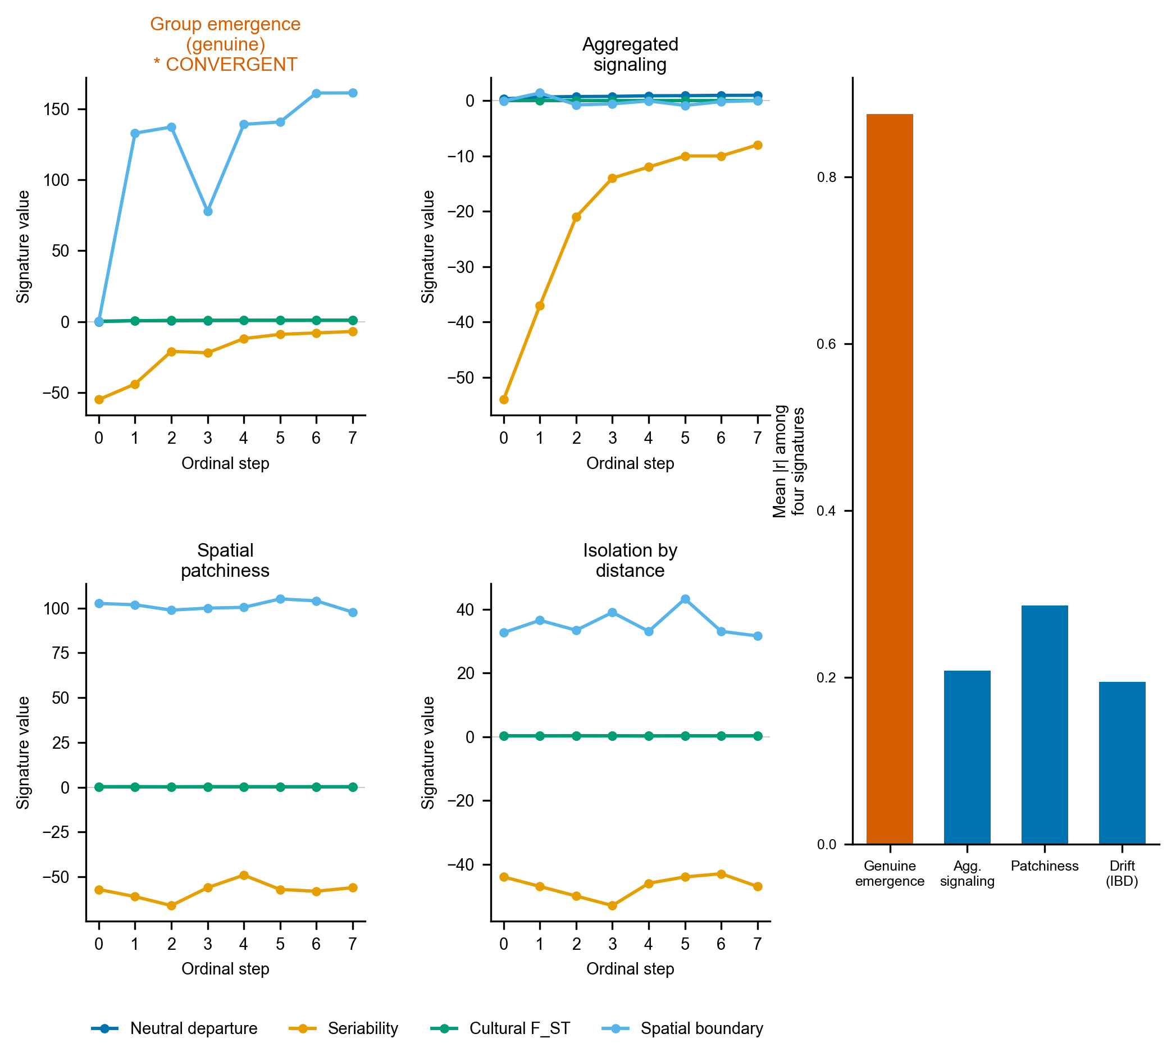
Figure S4. Idealized criterion validation. Four-signature ordinal trajectories under each of the four generative mechanisms on large, clean synthetic assemblages. Only a bounded interaction group drives all four together (starred), and no mimic is flagged as convergent across 20 random seeds (the bounded-groups case flagged in 19 of 20, 95 percent interval 0.75 to 0.99, and no mimic flagged at all, 95 percent upper bound about 0.17). Inset: the signature-independence audit (mean absolute pairwise correlation among the four signatures), high under closure (about 0.88), and low under the mimics (about 0.2). This shows the convergence concept works on idealized data. Figure 4 shows what survives at the record’s resolution.

Robustness checks
Neiman’s sample-size diagnostic for the neutrality estimators supports the Discussion: across the 29 basin assemblages, we computed the homozygosity-based and richness-based estimates of the transmission parameter and their signed difference, and correlated each with assemblage size and with seriation position, following Neiman’s protocol for separating a transmission signal from a sample-size artifact (Neiman 1995). Several further checks support the Results. A forking-paths sensitivity grid recomputes the convergence verdict across twenty-seven combinations of the basin’s spatial cutoff, bin count, and cluster number. The frequency increment test (Feder et al. 2014) is applied to each decorated type’s binned frequency trajectory. Neiman’s squared-Euclidean interassemblage-distance is computed with its diversity-distance relationship and divergence trajectory (Neiman 1995). The alternative basin definition, the stricter watershed rule, is evaluated in full. Clustering-tendency statistics (Hopkins, silhouette, and the gap statistic) on the correspondence-analysis ordination favor a single group, with a maximum silhouette of only 0.47, consistent with a near-continuum rather than sharply bounded ceramic groups. All are provided in the supplementary code. The Neiman interassemblage-distance result is shown in Figure S1.
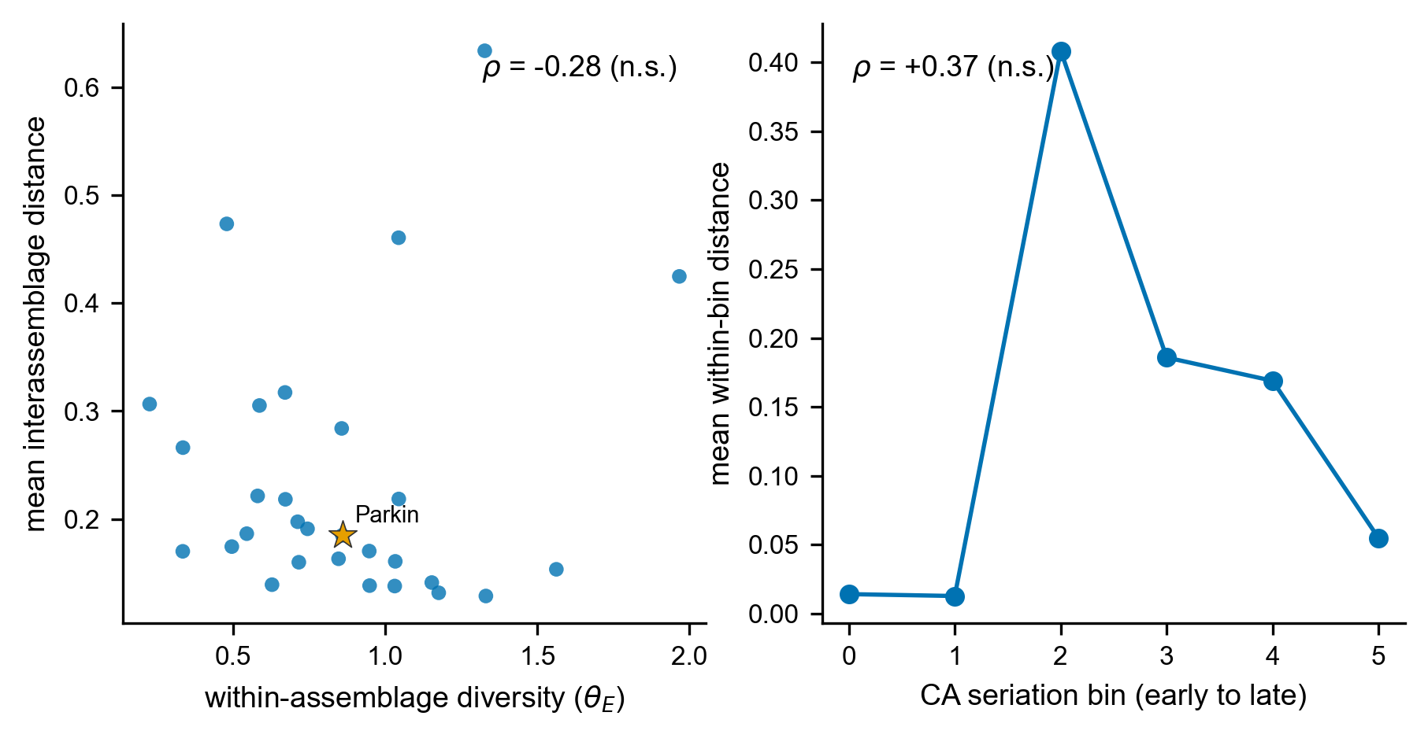
Figure S1. Neiman interassemblage-distance result. (A) Within-assemblage diversity against mean interassemblage distance, with Parkin starred. The weak negative association (Spearman rho = -0.28, not significant) is directionally consistent with the drift signature Neiman (1995) reported at rho = -0.62, not with the positive relationship that bounded, assorting groups would produce. (B) Mean within-bin interassemblage distance along the CA seriation axis. Between-assemblage divergence does not grow toward contact (rho = +0.37, not significant).

The F_ST-led reduction is a property of the record, not the generator
The recovery experiment injects group closure as between-cluster divergence, which is what cultural F_ST measures, so a fair objection is that the experiment merely certifies an F_ST detector recovering an F_ST-shaped signal. We tested this by injecting closure through two further channels, each matched to a different signature, and asking which signature recovers each. A within-group conformity channel raises conformity in a single undivided pool with no between-group divergence, the channel that the neutral departure is built to detect. A non-spatial social channel assembles assemblages into social groups scrambled relative to the spatial clusters, the channel seriation coherence is built to detect. The result is one-sided, and in two ways. First, the conformity channel is recovered by no signature (the neutral departure, which should detect it, inverts rather than rises), and the non-spatial social channel is not recovered by seriation either. Hence, the neutral and seriation signatures fail to register an injected signal even through the channel each is designed for. Second, F_ST is not a clean spatial-divergence detector but a near-omnibus one, responding to group structure, however it is organized. It recovers the spatial-divergence channel strongly (mean trend rising from the null to +0.76 at strong injection) and also recovers the non-spatial social channel (+0.77), because both ultimately raise between-group variance somewhere the partition can see it. The four signatures are therefore not four independent channels, even in this diagnostic. The only one that registers an injected signal at this resolution is F_ST, and it does so for divergence. However, its signal is organized. The reduction to F_ST is a property of the record’s resolution, 29 time-averaged assemblages rarefied to a common count over ten aggregated types, not an artifact of a generator whose closure axis is collinear with F_ST. A rarefaction-depth sweep (the weak signatures climb modestly with more sherds but remain well below F_ST) and a cluster-count sweep (the spatial signature stays weak through k = 5) confirm that the limitation is the record’s size and time-averaging rather than a single tuning choice. The consequence, stated in the Discussion, is that the negative bounds only result in divergence-channel closure. A closure carried purely by conformity or by a non-spatially organized social structure is below detection here at any strength.

Positive control: the basin matches neutral spatial drift
To test what process the basin’s structure matches, rather than only which process it fails to show, we simulated neutral cultural drift on the real coordinate layout of the 29 assemblages, following the finite-population network-drift model of Lipo, DiNapoli, Madsen, and Hunt (Lipo et al. 2021). Each assemblage is a node holding a finite population of learners that copies decorated-type variants within the node and, at a low rate, from other nodes with a probability that decays with geographic distance, with innovation and the record’s trailing-window time-averaging imposed. We compared this neutral model against a bounded-groups model in which interactions are concentrated within spatially contiguous groups, with only a small leak between them, both run on the same coordinates and rarefied to the observed per-assemblage counts. We swept the interaction range (6, 12, and 24 km), the between-node mixing rate (0.02, 0.05, and 0.20), and the innovation rate (0.005, 0.01, and 0.02), in both snapshot and time-averaged form, at 100 seeds per cell, recording for each cell whether the four observed statistics fall inside the neutral null. Across the time-averaged sweep, the region that brackets all four at once is the low-mixing, sub-basin-range corner (24 km, mixing 0.02, innovation 0.01), as reported in Figure S5. At shorter ranges, drift over-produces the distance decay. At higher mixing, it underproduces the structure, so the all-four match holds only in a plausible but specific region of parameter space rather than across the whole parameter space. In every cell, the bounded-groups model overshoots the three structural statistics by roughly two to seven times relative to the observed values, so the contrast between drift, which can reproduce the data, and bounded groups, which cannot, is robust even where the all-four drift match is not. The control also demonstrates that the distance-controlled boundary excess, near zero under smooth deterministic isolation by distance, takes substantial positive values under stochastic neutral drift, so a positive boundary excess does not by itself distinguish a social boundary from drift on a finite network.
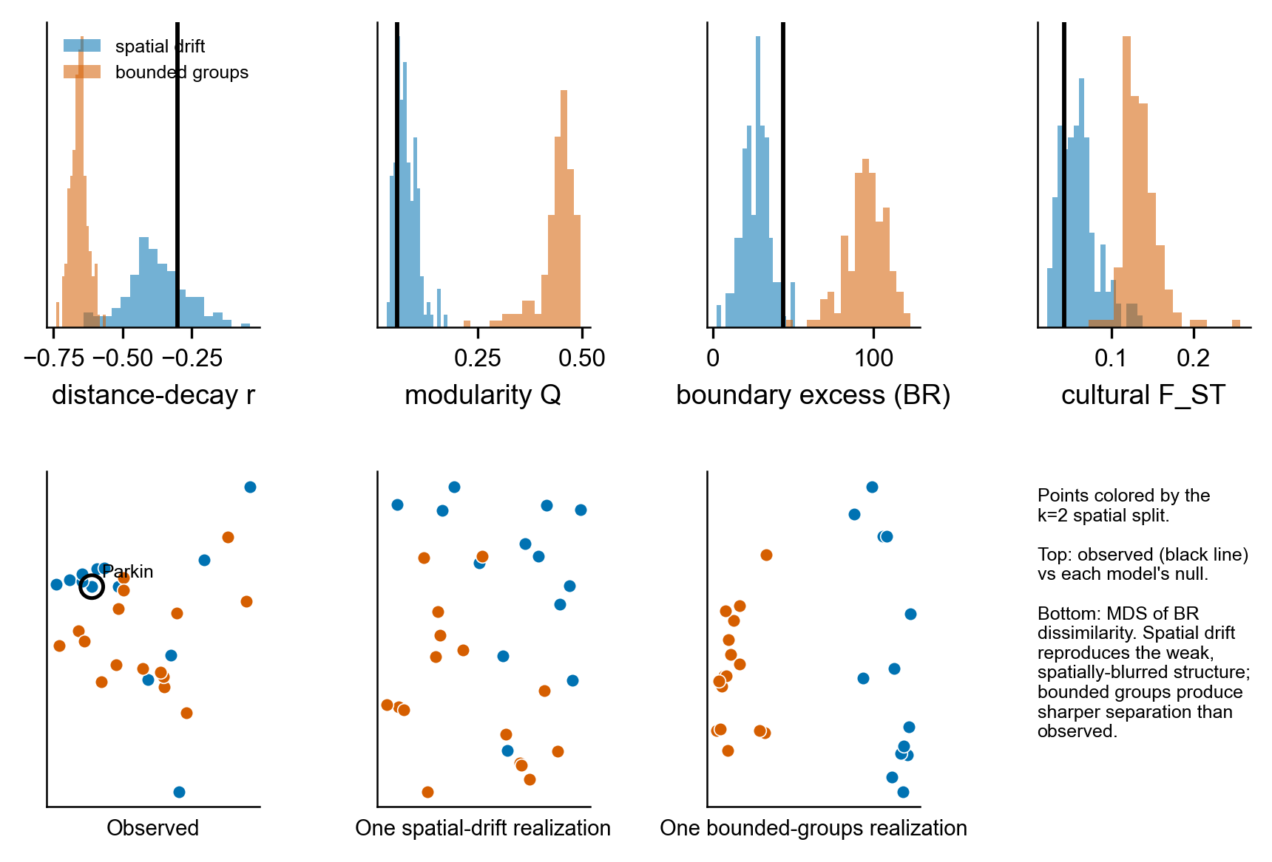
Figure S5. Spatial drift versus bounded groups on the basin geography. Top: the four observed signatures (vertical lines) against the null distributions produced by a neutral spatial-drift model (blue) and a bounded-groups model (orange) on the real coordinate layout, both time-averaged and rarefied to the observed counts. Observed values fall inside the drift distribution and far below the bounded-groups distribution for modularity, boundary excess, and cultural F_ST. Bottom: multidimensional scaling of decorated dissimilarity for the observed assemblages and one realization of each model, spatial drift reproducing the weak, spatially blurred structure while bounded groups produce a sharper split than the data show.

Regional extension: the central-valley and lower-valley assemblages
We extended the analysis to the southeast Missouri survey assemblages of Williams (Williams 1954), comprising 50 collections from 28 sites, digitized from the survey tables and georeferenced using the Lower Mississippi Survey grid. Within the central-valley regions, the decorated-ceramic differentiation is a Woodland-to-Mississippian composition gradient rather than a synchronic structure: a cultural F_ST of 0.11 across physiographic regions collapses to 0.04, near the drift level, once the analysis is restricted to Mississippian types. Between the central and lower valleys, the Phillips-Ford-Griffin assemblages present a different picture. Combining the two into one north-south transect of 133 decorated assemblages, the decline of decorated similarity with distance is itself drift-consistent (Mantel r = -0.55, inside the spatial-drift null). Still, the distance-controlled boundary excess at the central-valley and lower-valley divide is +52 Brainerd-Robinson units, far outside the drift null. The two regions carry mutually exclusive, distinctive repertoires (northern Wickliffe, O’Byam, Matthews, Kimmswick, and Varney Red against southern Barton, Walls Engraved, Carson Red-on-Buff, Avenue Polychrome, and Leland), with even the shared types differing in proportion. Restricting the comparison to types present in both regions, which removes the mutually exclusive distinctive types that carry the strongest temporal contrast, reduces the step but does not erase it: the boundary excess falls to +38 Brainerd-Robinson units. It remains above the neutral-drift null, so the boundary is not solely an artifact of distinctive-type turnover, although the shared types themselves retain some temporal structure. The step is real but confounded by time, because the northern distinctive types are early- to middle-Mississippian and the southern are late (Phillips 1970; Williams 1954), so it cannot be separated from a chronological succession without independent central-valley radiocarbon (Figure S6). It is further confounded by analytical history: the lower-valley assemblages were classified in the Phillips-Ford-Griffin tradition, and the central-valley assemblages were classified separately by Williams, so even shared type names may have been applied to different criteria. The shared-type restriction (boundary excess falling to +38 Brainerd-Robinson units but not vanishing) limits this artifact without removing it, leaving open the possibility that the interaction was continuous across the entire region and that the apparent boundary is a product of two separate collection and analysis histories.
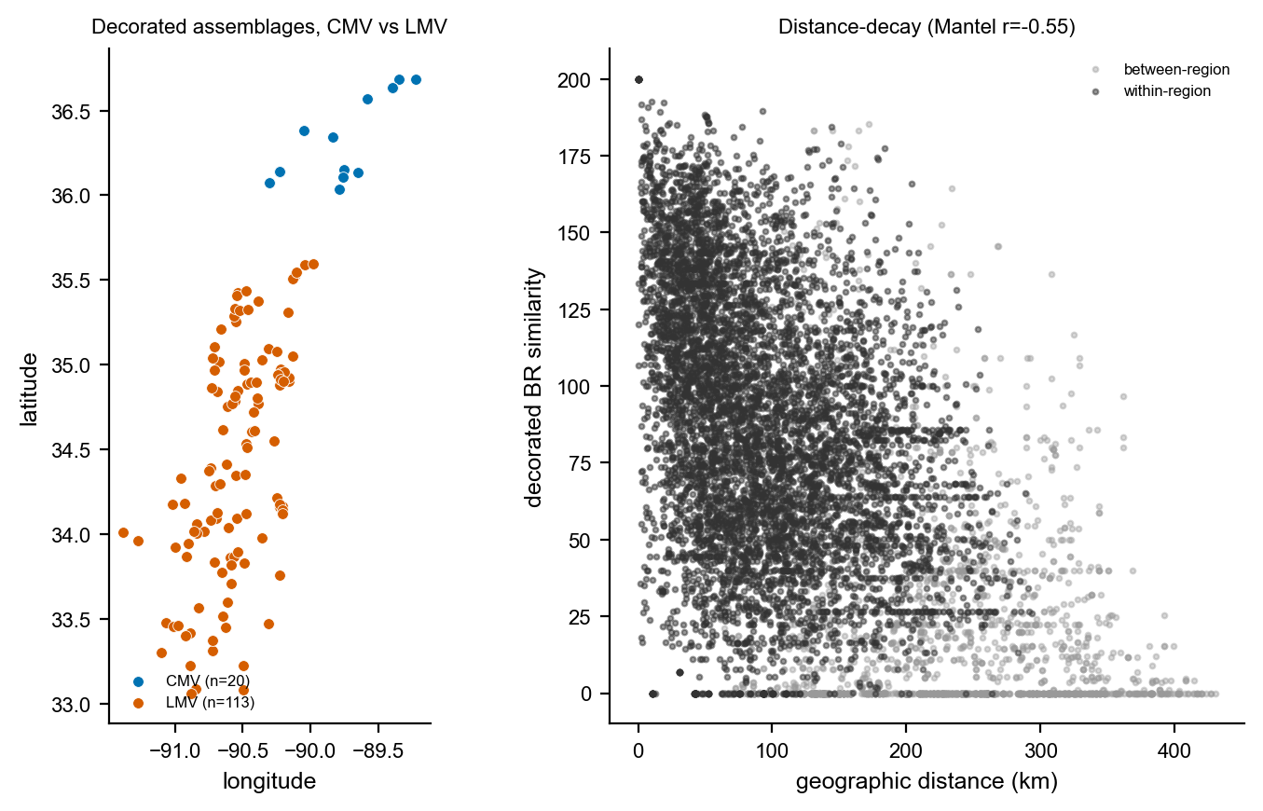
Figure S6. The central-valley and lower-valley transect. Left: the georeferenced decorated assemblages, central-valley (Williams 1954, blue) and lower-valley (Phillips-Ford-Griffin, orange), with the latitudinal gap between the blocks. Right: distance-decay of decorated Brainerd-Robinson similarity across the transect, within-region and between-region pairs distinguished. Similarity declines smoothly with distance as neutral drift predicts, but within-region pairs are markedly more similar than between-region pairs at matched distance, the step at the boundary.

Dynamic-sufficiency tests in the time domain
The four convergence signatures are read as states along the seriation sequence, so on their own they are only partially dynamically sufficient. Two further tests work on the transformation between states, and a third, underpowered probe is reported in the code for completeness. The two we rely on are dynamically and empirically sufficient at once, because each models the change between states while respecting the time-averaged resolution of the record.
The first infers how potters were copying by simulation. We run many copying scenarios, ranging from strongly conformist to neutral to novelty-seeking, and keep only the ones that reproduce the real collections, then read off the kind of copying implied by the surviving scenarios, with the record’s time-averaging built into each simulation (the approximate-Bayesian-computation approach) (Carrignon et al. 2019; Crema et al. 2016). We modeled the basin sequence as frequency-dependent copying among the ten decorated types in a finite population. Each generation, the adoption weight of a type is proportional to its frequency raised to the power $1+b$, where $b>0$ is conformity, $b<0$ is anti-conformity, and $b=0$ is neutral copying, with an innovation rate that mixes in a uniform draw from the set of types. An assemblage pools production over a window of generations, so the time-averaging that distorts the static statistics is built into the generative process rather than corrected after the fact. This is what makes the test both empirically and dynamically sufficient. We drew 40,000 parameter sets from broad priors (innovation rate, bias $b$, population size, and time-averaging window), simulated a six-bin sequence from each, and accepted the 400 parameter sets closest to the observed diversity trajectory and rank-frequency profile, ranked by Euclidean distance over the summary statistics. The posterior of the bias is tightly constrained near neutral, with mean $b=+0.028$ and a 95 percent interval of $−0.021$ to $+0.063$ that includes zero (Figure S4A). The posterior standard deviation is 0.021 against a prior of 0.289, so the data appreciably constrain the bias rather than leaving it at the prior, placing it close to neutral. A weak conformist lean is visible, with $P(b>0)=0.91$, but it is not resolved as a departure from neutral, and refitting the bias separately to the early and late halves of the sequence recovers no shift between them. The inference rules out the strong conformist bias that a marker- or assortment-based dynamic would require by modeling copying dynamics rather than a single static moment. The posterior contraction should be read with one caveat: rejection sampling at a one percent acceptance tolerance is not formally calibrated here, so we present this inference as concordant with the record-matched recovery and the static signatures rather than as a standalone result.
The second test asks, in plain terms, whether the collections’ diversity drifts aimlessly through time, heads steadily in one direction, or is pulled back toward a stable value, by comparing four standard time-series models (an unbiased random walk, a directional walk, stasis, and a mean-reverting Ornstein-Uhlenbeck process) (Hunt 2006; Hunt et al. 2008). For the Gini-Simpson diversity trajectory and for the abundant decorated types, binned along the oriented axis, we fit on the same level vector an unbiased random walk (Brownian motion, the neutral-drift expectation), a general biased random walk (the directional signature a sustained transition would leave), a stasis model (white noise about a constant mean), and an Ornstein-Uhlenbeck model (mean reversion toward an optimum), and compared them by the small-sample Akaike information criterion. The aggregate diversity trajectory favors the unbiased random walk, with an Akaike weight of 0.81 against 0.19 for the directional model and negligible weight for stasis or the Ornstein-Uhlenbeck model. The model comparison has only six points, so it is weak. This result is a concordance rather than a decisive selection (Figure S4B). The diversity trajectory is the trait of interest here, because the correspondence-analysis ordering does not arrange it by construction. Individual-type trajectories more often favor the directional model. That comparison, however, is weak and partly tautological because the seriation axis is designed to maximize monotonic type-frequency turnover, and only three types are abundant enough across the sequence to fit. The robust reading is neutral drift, not a sustained directional transition.
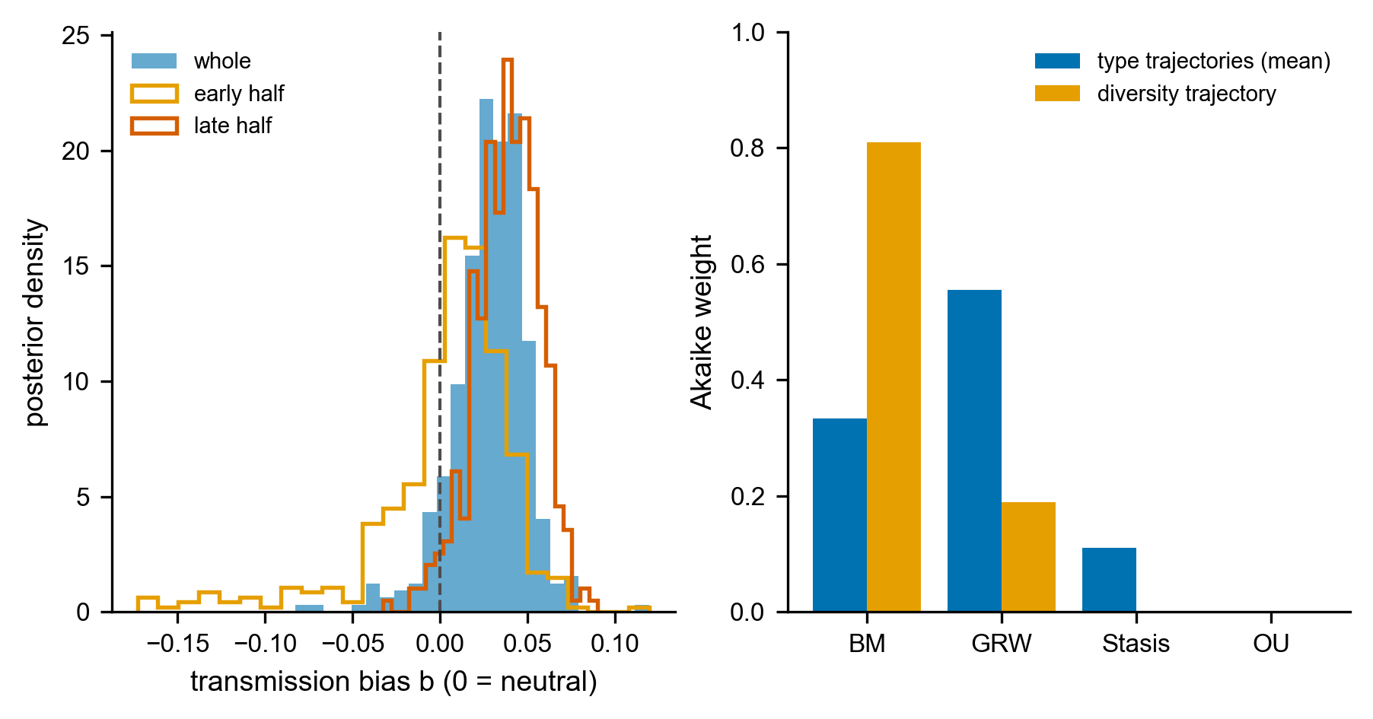
Figure S2. Dynamic-sufficiency tests. (A) Posterior of the transmission-bias parameter b from the generative, time-averaging-aware inference (b = 0 neutral, b > 0 conformist, b < 0 anti-conformist). The whole-sequence posterior (filled) and the early- and late-half posteriors (outlines) are all tightly constrained near neutral and include zero, ruling out the strong conformity a marker dynamic would require. (B) Tempo-and-mode Akaike weights of the four time-series models (BM unbiased random walk, GRW directional walk, Stasis, OU mean reversion) for the Gini-Simpson diversity trajectory and averaged across the abundant type trajectories. The diversity trajectory, which the correspondence-analysis ordering does not arrange by construction, favors the unbiased random walk (neutral drift), a concordance rather than a decisive selection given only six points.
A third probe, for the early-warning signature of a critical transition, is underpowered at this ordinal resolution and does not meet empirical sufficiency: across the correspondence-analysis-ordered sequence the rolling variance shows no rising trend (Kendall tau $=−0.03$) and the lone rise in lag-1 autocorrelation (tau $=+0.78$) is an artifact of the ordering, which places compositionally similar assemblages adjacent, so we report it in the supplementary code but do not rely on it (Dakos et al. 2012; Scheffer et al. 2009).

Radiocarbon chronology
We calibrated the Mainfort compilation of central-valley determinations against IntCal20 (Mainfort 2001). Forty-one determinations come from seven St. Francis Basin Parkin-phase sites, nineteen of them from Parkin. The summed probability distribution of the basin dates concentrates the occupation in the fourteenth to sixteenth centuries, with a median of AD 1422 (Parkin alone, AD 1483), and declines across the contact interval: 29 percent of the basin probability mass postdates AD 1541 and 18 percent postdates AD 1600 (Figure S3). This is consistent with occupation continuing through the De Soto entrada, which the chronicles place at Casqui, and declining thereafter, rather than with a sequence running unbroken into the seventeenth century. However, the protohistoric tail is partly a calibration artifact of low-activity determinations near the post-1650 plateau. To test the assumption that the seriation axis tracks calendar time, we pooled the dates of the five proveniences matching curated assemblages. We correlated their pooled median calibrated ages with CA1 position: Spearman’s r = +0.70 (n = 5, 27 dates pooled), with four sites in calendar order and one late-dated site, Clay Hill, departing from it. The orientation of the axis toward later time is supported but not certain, and we treat directional statements as provisional throughout.
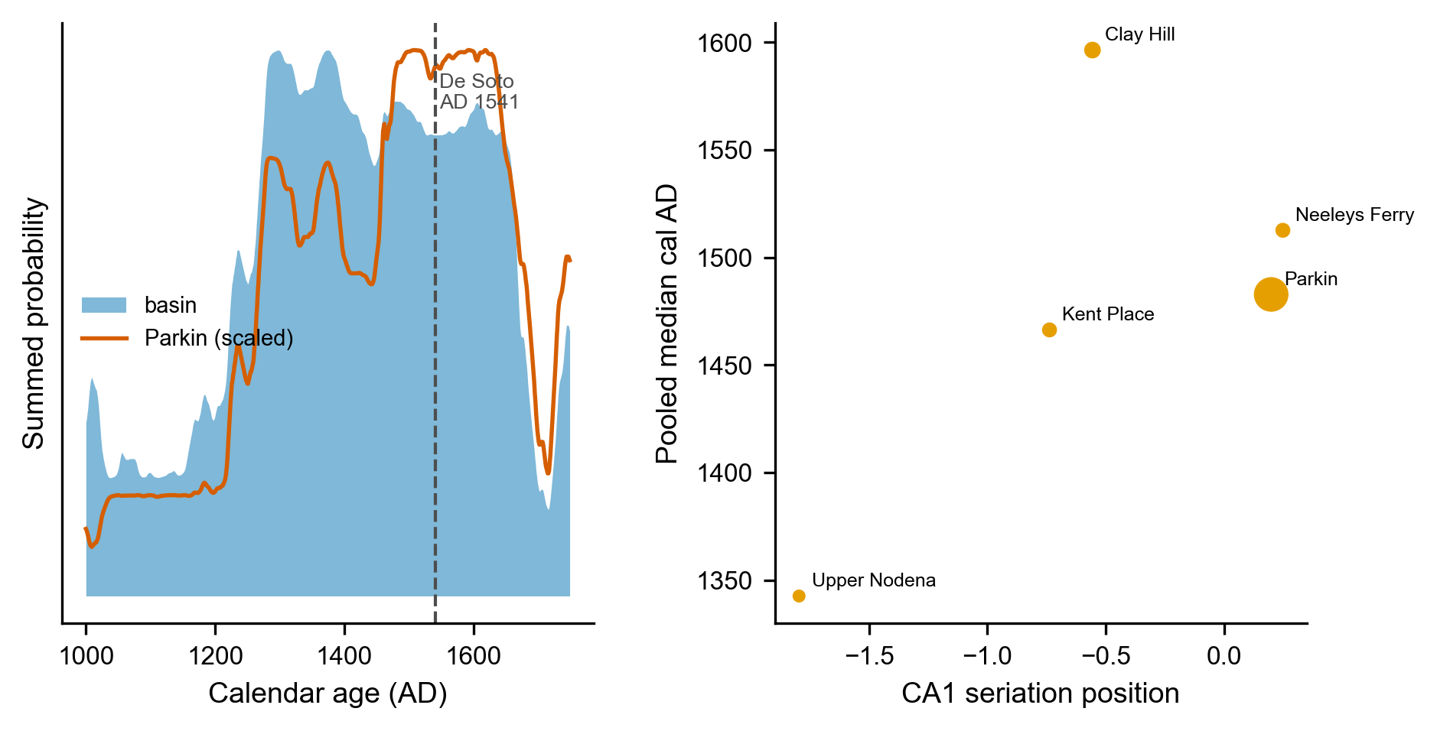
Figure S3. Radiocarbon chronology of the St. Francis basin (Mainfort determinations calibrated against IntCal20). Left: summed probability distribution for the basin Parkin-phase sites (filled) and for Parkin alone (line, scaled), with the De Soto entrada (AD 1541) marked. Occupation concentrates in the fourteenth to sixteenth centuries and declines across contact. Right: CA1 seriation position against the pooled median calibrated age for the five proveniences matching curated assemblages (point size proportional to the number of dates). The axis tracks calendar age (Spearman +0.70) except for the late-dated Clay Hill.

References
Bell, Adrian V., Peter J. Richerson, and Richard McElreath. 2009. Culture Rather Than Genes Provides Greater Scope for the Evolution of Large-Scale Human Prosociality. Proceedings of the National Academy of Sciences 106(42):17671–17674. https://doi.org/10.1073/pnas.0903232106.
Carrignon, Simon, R. Alexander Bentley, and Damian Ruck. 2019. Modelling Rapid Online Cultural Transmission: Evaluating Neutral Models on Twitter Data with Approximate Bayesian Computation. Palgrave Communications 5:83. https://doi.org/10.1057/s41599-019-0295-9.
Crema, Enrico R., Anne Kandler, and Stephen Shennan. 2016. Revealing Patterns of Cultural Transmission from Frequency Data: Equilibrium and Non-Equilibrium Assumptions. Scientific Reports 6:39122. https://doi.org/10.1038/srep39122.
Dakos, Vasilis, Stephen R. Carpenter, William A. Brock, Aaron M. Ellison, Vishwesha Guttal, Anthony R. Ives, Sonia Kéfi, et al. 2012. Methods for Detecting Early Warnings of Critical Transitions in Time Series Illustrated Using Simulated Ecological Data. PLoS ONE 7(7):e41010. https://doi.org/10.1371/journal.pone.0041010.
Ewens, Warren J. 1972. The Sampling Theory of Selectively Neutral Alleles. Theoretical Population Biology 3(1):87–112.
Feder, Alison F., Sergey Kryazhimskiy, and Joshua B. Plotkin. 2014. Identifying Signatures of Selection in Genetic Time Series. Genetics 196(2):509–522. https://doi.org/10.1534/genetics.113.158220.
Hunt, Gene. 2006. Fitting and Comparing Models of Phyletic Evolution: Random Walks and Beyond. Paleobiology 32(4):578–601. https://doi.org/10.1666/05070.1.
Hunt, Gene, Michael A. Bell, and Matthew P. Travis. 2008. Evolution Toward a New Adaptive Optimum: Phenotypic Evolution in a Fossil Stickleback Lineage. Evolution 62(3):700–710. https://doi.org/10.1111/j.1558-5646.2007.00310.x.
Lipo, Carl P., Robert J. DiNapoli, Mark E. Madsen, and Terry L. Hunt. 2021. Population Structure Drives Cultural Diversity in Finite Populations: A Hypothesis for Localized Community Patterns on Rapa Nui (Easter Island, Chile). PLoS ONE 16(5):e0250690. https://doi.org/10.1371/journal.pone.0250690.
Lipo, Carl P., Mark E. Madsen, and Robert C. Dunnell. 2015. A Theoretically-Sufficient and Computationally-Practical Technique for Deterministic Frequency Seriation. PLOS ONE 10(4):e0124942. https://doi.org/10.1371/journal.pone.0124942.
Mainfort, Jr., Robert C. 2001. The Late Prehistoric and Protohistoric Periods in the Central Mississippi Valley. In Societies in Eclipse: Archaeology of the Eastern Woodlands Indians, a.d. 1400–1700, edited by David S. Brose, C. Wesley Cowan, and Jr. Mainfort Robert C., pp. 173–190. Smithsonian Institution Press, Washington, DC.
Neiman, Fraser D. 1995. Stylistic Variation in Evolutionary Perspective: Inferences from Decorative Diversity and Interassemblage Distance in Illinois Woodland Ceramic Assemblages. American Antiquity 60(1):7–36.
Phillips, Philip. 1970. Archaeological Survey in the Lower Yazoo Basin, Mississippi, 1949–1955, Vol. 60. Papers of the Peabody Museum of Archaeology and Ethnology. Peabody Museum, Harvard University, Cambridge, MA.
Scheffer, Marten, Jordi Bascompte, William A. Brock, Victor Brovkin, Stephen R. Carpenter, Vasilis Dakos, Hermann Held, Egbert H. van Nes, Max Rietkerk, and George Sugihara. 2009. Early-Warning Signals for Critical Transitions. Nature 461(7260):53–59. https://doi.org/10.1038/nature08227.
Williams, Stephen. 1954. An Archeological Study of the Mississippian Culture in Southeast Missouri. PhD thesis, Yale University, New Haven.

