Are the phases real? Distinguishing bounded interaction groups from spatially structured drift in central Mississippi Valley decorated ceramics
Carl P. Lipo and Robert J. DiNapoli
Target: American Antiquity. Draft in progress. Heavy model derivation in the Supplemental Text. Citations verified against repo sources, with references in references.bib.

Abstract
The phase is the foundational unit of Mississippian culture history, and it rests on a silent premise: that assemblages more similar to one another than to their neighbors record a bounded social group, a society whose members interacted preferentially among themselves. That premise is rarely tested, and it ignores a strong alternative. Neutral cultural transmission, in which potters copy one another’s decorated styles with no one favoring particular designs, produces the same within-greater-than-between similarity with no bounded groups at all. Style frequencies drift, changing at random from copying alone. When potters interact more with near neighbors than with distant ones, the drift concentrates similar styles in nearby areas, generating apparent clusters from geography rather than from social boundaries. Here, we test, for the late pre-contact central Mississippi Valley, whether decorated-ceramic similarity records bounded interaction groups or spatially structured drift. We compare two generative processes, neutral spatial drift and bounded groups, on the real geography of the assemblages. We calibrate the comparison to the record’s small sample sizes and its time-averaging, the blending of many years of pottery into one surface collection, by a signal-recovery experiment: into synthetic assemblages matched to the real ones, we inject a known group boundary of tunable strength and read off how strong a boundary would have to be before the measures could detect it. We read the result against four transmission signatures and an independent radiocarbon chronology. Within regions, in both the St. Francis basin Parkin phase and the southeast-Missouri survey assemblages of Williams, the decorated-ceramic structure is reproduced by neutral spatial drift under plausible parameters and does not require bounded groups. A bounded-groups process would have marked the record with far sharper structure than it shows. The within-region phase is therefore not demonstrably a bounded interaction group. Parkin, the basin’s tallest-mounded center, is a transmission bridge across orderings rather than the closed core of a society, the same conclusion Fox reached for the southeast Missouri phases using cluster analysis. A boundary that exceeds neutral drift appears only at the larger scale, between the central-valley and lower-valley blocks, where decorated similarity drops more sharply than drift can produce and survives when only shared types are compared. That drop is hard to interpret. It coincides with the early-to-late turnover in pottery types and with the two regions having been collected and classified by different investigators, so it cannot yet be read as a real social boundary rather than a difference in dating or analytical history. The phase, at the scale where it is drawn, is largely indistinguishable from spatially structured drift, and the calibration that licenses this conclusion is the transferable method. Before the similarity structure in ceramic decoration is read as social, the record must be shown to be able to distinguish drift from groups at all.

Introduction
Parkin is the largest of the moated, palisaded towns of the St. Francis basin in northeastern Arkansas, and the chronicles of the Hernando de Soto expedition place it as Casqui, the seat of a paramount chief the expedition encountered in 1541 (Hudson et al. 1990; Mitchem 2001; Morse 1990). On the strength of its size, fortification, platform mound, and ethnohistoric identification, Parkin is routinely read as the center of a Mississippian polity. This chiefdom drew tribute from the smaller villages around it, an inference made explicit by the argument that its position on agriculturally poor soil required surrounding communities to provide it with provisions (Morse 1990). That reading is a specific claim about social structure: that the Parkin phase was a bounded, hierarchically organized society with Parkin at its apex.
Whether it was is an empirical question, and settlement morphology alone cannot answer it, because a primate center, a palisade, and a monumental mound are each as compatible with a landscape of competing peer communities as with a consolidated hierarchy (King and Freer 1995; Rees 2001). The chronicles describe Casqui and its neighbor Pacaha in open conflict, a relationship read both as rivalry between competing peers and as a ranked order in which Casqui stood below Pacaha, so the chronicles do not by themselves establish a single consolidated hierarchy over the Parkin phase (Hudson et al. 1990; Morse 1990). We therefore ask what the material record shows when it is measured rather than read through the polity model. The comparable evidence shows no hierarchy. Within the basin, settlement size is graded rather than redistributive. The regional production and exchange of the capacity-linked chert hoes whose control would mark an economic apex were decentralized (Cobb 2000), and, as we show below, the decorated-ceramic record carries no signature of interaction closing in on bounded groups.
The more revealing question is why Parkin was taken for a polity in the first place, and the answer is in the unit through which the record is read. The Parkin phase is a culture-history construct, a set of assemblages grouped because their decorated-type frequencies seriate together and because the sites cluster in space (Phillips et al. 1951). From its definition, the phase carried a social interpretation. In the Phillips-Ford-Griffin framework, it is the basic space-time-cultural unit. Williams, defining the southeast-Missouri phases on which the regional scheme rests, wrote that a phase probably equals a society (Williams 1954). That equation is the silent premise. It holds that assemblages more similar to one another than to their neighbors record a bounded, mutually interacting social group. Endow such a group with a primate center, and it becomes a polity. The polity reading is therefore built into the unit before any independent evidence of hierarchy is weighed, and the construct has been questioned on exactly this ground. Fox showed, by cluster analysis and ordination, that the southeast-Missouri phases fail as both groups and classes, with their member assemblages assigned to statistical clusters at random rather than segregating by phase (Fox 1998).
The premise is rarely tested, and it ignores a strong alternative. Under the neutral model of cultural transmission, decorated style behaves like a selectively neutral trait whose frequencies drift in a finite population of interacting learners (Bentley et al. 2004; Neiman 1995). When those learners interact more with near neighbors than with distant ones, drift on the spatially structured population generates within-greater-than-between similarity on its own, apparent clusters produced by geography with no bounded group anywhere (Lipo et al. 2021). On this account, a phase is the ordinary residue of continuous, distance-structured interaction, and the very pattern the culture-history tradition reads as a society, assemblages near each other in space and in style, is what spatially structured drift predicts. Telling a real interaction group apart from spatially structured drift requires a test that the tradition never applied, because the seriation coherence and spatial proximity that define the phase are equally the products of drift.
Decorated ceramics are the instrument for the test. Because stylistic variants are copied between potters along social-learning networks, the spatial and temporal structure of decorated-type frequencies records the structure of past interaction, and a genuine social boundary, had one existed, would make learning conformist within groups and divergent between them, fragmenting the single drifting pool that continuous interaction maintains (Lipo et al. 2015; Neiman 1995). The late pre-contact central Mississippi Valley is a favorable place to look, both because its decorated assemblages are well documented and because European contact and the subsequent demographic collapse ended the sequence before any later reorganization could overwrite it (Cobb and Butler 2002). We focus first on the Parkin phase of the St. Francis basin (Figure 1) and then widen the test to the other late-period phases of the valley.
The argument rests on a choice about what the ceramic record is. We do not treat an assemblage as a degraded snapshot of a past behavioral moment, to be restored by correcting for the processes that formed it (Schiffer 1972). We treat it as what it is, a time-averaged accumulation whose decorated-type frequencies are the population-level residue of social learning, to be measured and explained directly rather than reconstructed (Lipo et al. 2015; Neiman 1995). This is an evolutionary position in which the record is the evolving phenotype to be explained rather than a window onto a vanished behavioral system (Dunnell 1995), and it converges with the recognition that the deposit is not a frozen tableau (Binford 1981). The record’s coarse temporal resolution is not a defect to be removed but the scale at which long-term, population-level processes become legible (Holdaway and Wandsnider 2008; Perreault 2019). Time-averaging, therefore, sets the resolution of the question rather than disqualifying it. A reorganization of transmission large enough to matter over the two centuries of the Parkin phase should register in the averaged frequency structure, and the drift-versus-groups test we develop reads that structure directly rather than an imagined moment behind it.
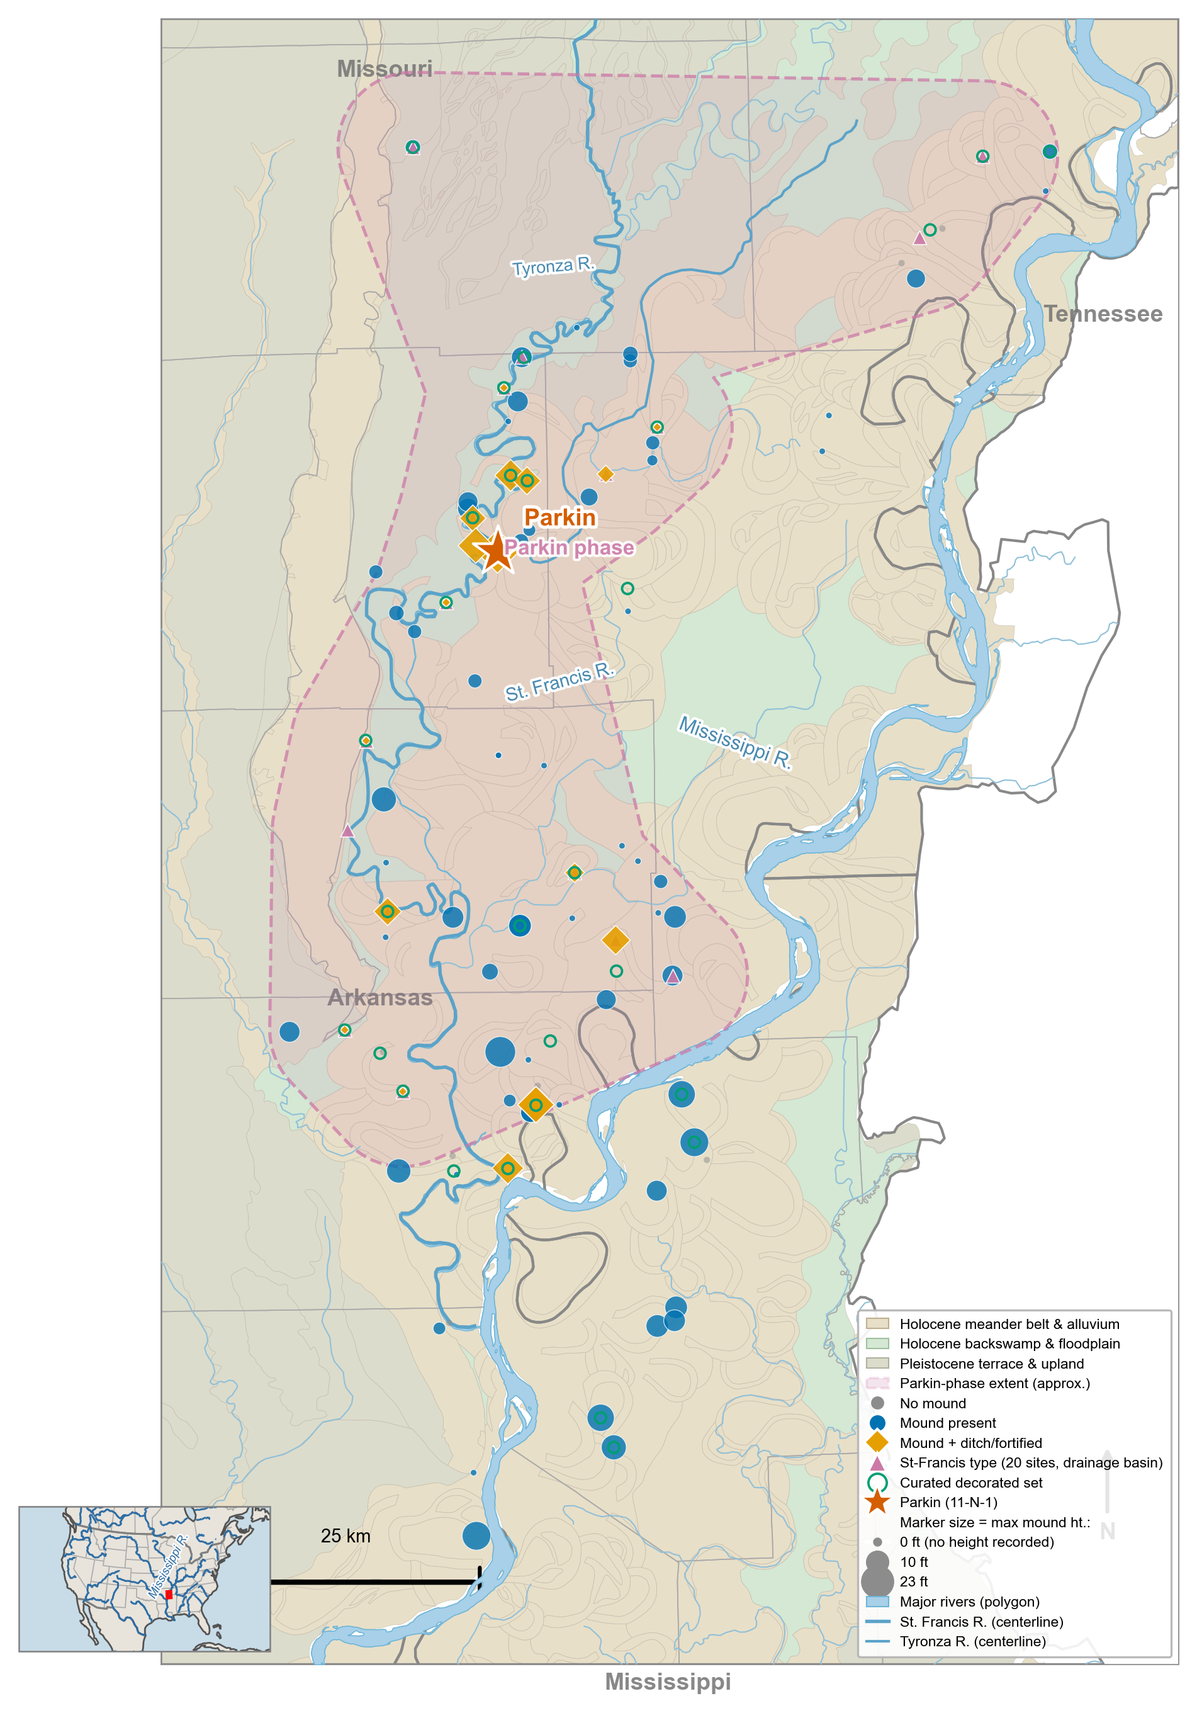
Figure 1. Study area: the St. Francis basin of the central Mississippi Valley, northeastern Arkansas. Decorated-ceramic assemblages and recorded sites are shown on a local hydrology and geomorphology base (the St. Francis, Tyronza, and Mississippi rivers). Marker size scales with platform-mound height. The Parkin site is marked with a star, and the dashed outline indicates the approximate Parkin-phase area. The transmission analysis is restricted to assemblages within 20 km of the St. Francis drainage (the lower Yazoo Basin and Mississippi River-proximal sites are excluded). Inset: location within North America.
No single transmission signature can settle the question, because each is consistent with several processes: a departure from neutral copying, a spatial cline, or a rise in between-group variance can arise from drift, conformity, or environmental patchiness alike, an equifinality, the same pattern reached by different processes, that defeats one-signature inference (Crema et al. 2016; Mesoudi 2021). We therefore compare the two processes in a generative manner. We simulate neutral spatial drift and bounded groups on the real coordinate layout of the assemblages and ask which reproduces the observed structure, using four transmission signatures, departure from neutral copying, breakdown of frequency-seriation coherence, between-group variance, and spatial assortativity, as diagnostics of whether interaction has closed rather than as a stand-alone detector. Because an archaeological assemblage is time-averaged and sampled to varying depth, a signature can register a difference that is an artifact of sampling rather than of transmission, so we calibrate the comparison to the record by a signal-recovery experiment: into synthetic assemblages matched to the real number, sample sizes, and time-averaging we inject a known signal of tunable strength and read off how strong a real boundary would have to be to register. Only a calibrated comparison can license the conclusion that an absence of group structure is real rather than a failure of resolution. This calibration is the transferable contribution, because before any similarity structure is read as social, a record must be shown to be able to distinguish drift from groups at all.
The argument proceeds in three steps. First, we evaluate Parkin as a hierarchy and find that no line of evidence, settlement, exchange, or transmission supports it. Second, we ask what generates the St. Francis basin phase structure, and show that neutral drift on the basin’s geography reproduces the observed signatures. A bounded-groups process would leave a far sharper structure than the data carry. Hence, the phase is a continuous interaction structured by where sites sit rather than a closed group with a boundary, and Parkin is a transmission bridge across orderings rather than the core of one. Third, we widen the test to the other late-period phases of the valley and ask whether any decorated-ceramic boundary exists. A boundary that exceeds neutral drift appears only between the central-valley and lower-valley blocks, and even there, it is confounded with the early-to-late turnover of the type repertoire. It cannot yet be read as a synchronic social division. At the scale where the phase is drawn, it is largely indistinguishable from spatially structured drift, and Parkin is best read as a prominent node in a continuous interaction field rather than the capital of a polity.

Background

The phase, the silent premise, and the drift alternative
The phase concept gives the central-valley record its social structure. A phase is formed operationally, as a set of assemblages that seriate together and cluster in space, but it is interpreted socially, as a bounded interacting community, on the premise that within-greater-than-between similarity records who interacted with whom (Phillips et al. 1951; Williams 1954). The premise is not arbitrary. Under the neutral transmission model, it would hold if learning were confined within social boundaries, so that decoration drifted in separate pools and diverged between them. The difficulty is that the same within-greater-than-between similarity arises with no boundary at all when interaction declines with distance, because spatially structured drift concentrates similarity among near neighbors (Lipo et al. 2021; Neiman 1995). The question the ceramic record must answer is the operational one: does the similarity structure record bounded interaction, or spatially structured drift?
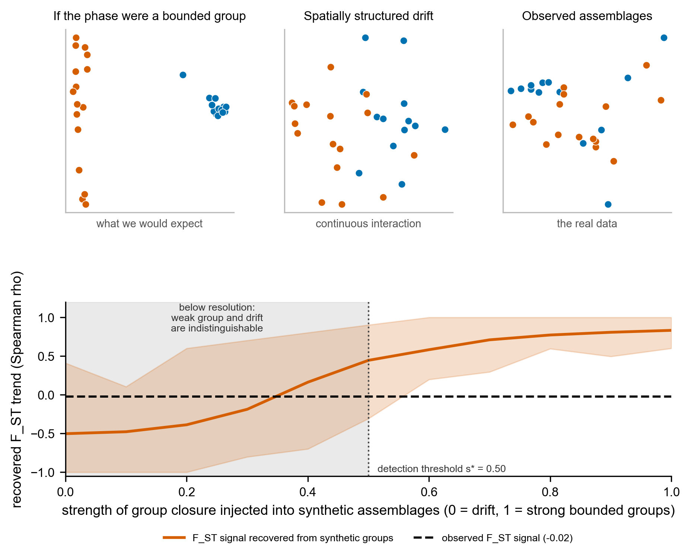
Figure 2. What the test distinguishes, and why the within-basin determination is hard, from synthetic assemblages matched to the record. Top: the basin assemblages in a multidimensional scaling of decorated dissimilarity (points colored by the k=2 spatial split) as they would appear if the Parkin phase were a bounded interaction group (left, sharp clusters), under spatially structured neutral drift (center, a continuous blur), and as observed (right, a blur resembling drift). Bottom: the cultural F_ST signal recovered from synthetic assemblages as the strength of injected group closure rises from 0 (drift) to 1 (strong groups), with the s=0 null band shaded behind it. The signal clears the detection threshold only at s* = 0.5. The observed value (dashed line) lies in the shaded region below s*, where a weak group and pure drift are indistinguishable at this record’s size and time-averaging. This is why a weak within-basin boundary cannot be excluded.

Why ceramics, and the neutral-vs-marker distinction
Decorated ceramics record the structure of social interaction because stylistic variants are copied between potters along social-learning networks. Under the neutral model of cultural transmission, stylistic variants behave like selectively neutral alleles whose frequencies are governed by innovation and drift in a finite population of interacting learners (Bentley et al. 2004; Neiman 1995). Neutral style is the null condition: assemblages drawn from a single interacting community share one drifting pool, and their decorated-type frequencies admit a single battleship-curve seriation (Lipo et al. 2015). Assortment, the tendency for like to learn from like, so that interaction sorts into distinct groups, changes this. If learning becomes restricted within emerging social boundaries, decoration shifts from neutral style toward a marker, transmitted conformist within groups and divergent between them, and the single transmission field fragments. The shift from neutral style to marker is the ceramic expression of interaction closing into a bounded group, and it is what such a group would produce.
The obstacle is that no single frequency pattern identifies its generating process. A departure from neutrality can reflect conformity, an anti-conformist novelty bias, a content bias, or simply the fact that durable objects, rather than people, are the units that accumulate in a deposit (Crema et al. 2016, 2024). The problem is sharpened in archaeological assemblages, which are time-averaged, because aggregation over the use-life of a deposit inflates richness, flattens evenness, and biases neutrality statistics by an amount that depends on the mean lifetime of the variants (Madsen 2012; Premo 2014). The result is equifinality: multiple transmission processes produce the same population-level pattern, so a single statistic cannot recover the process that generated it (Kandler et al. 2017; Mesoudi 2021). This is the inferential wall the test is built to climb, and it is why we do not rest on any one signature.

The central Mississippi Valley case and two competing hypotheses
The late pre-contact central Mississippi Valley supports two readings of the same record, and they make opposite predictions for the transmission signature. The first holds that the region was moving toward greater complexity. In northeastern Arkansas the Parkin phase (ca. A.D. 1400 to 1600, with a thin protohistoric tail, consistent with the basin radiocarbon reported below) is a dense cluster of fortified, moated St-Francis-type towns along the St. Francis and Tyronza rivers, dominated by the Parkin site, a roughly 17-acre palisaded center with a platform mound rising more than 6 m that the De Soto chronicles place as the seat of the paramount of Casqui (Mitchem 2001; Morse 1990). Based on this information, Parkin’s location on agriculturally poor soil suggests that it drew tribute from smaller villages, a hallmark of an emerging chiefly hierarchy (Morse 1990). Because contact and the demographic collapse associated with the protohistoric “Vacant Quarter” (Williams 1990) interrupted the sequence, any such transition would have been truncated before it could consolidate and overwrite its own beginnings (Cobb and Butler 2002; Morse and Morse 1996). We treat this truncation as a working premise rather than a settled fact, since the timing and extent of the Vacant Quarter abandonment relative to the Parkin phase remain debated (Cobb and Butler 2002). The second reading holds that the central valley was a stable, non-consolidated landscape of competing peer polities that never reorganized into a regional hierarchy (King and Freer 1995; Rees 2001). The chronicles describe Casqui and its neighbor Pacaha in open conflict, which fits a landscape of competing peers, though the same sources have also been read as ranking Casqui below Pacaha, and the chronicle ethnography is thin and filtered (Hudson et al. 1990; Mitchem 2001; Morse 1990). The two cannot be separated by settlement morphology alone, because a primate center, fortification, and monumental construction are each compatible with both. They can be separated by whether the transmission record shows interaction closing into bounded groups, which is the test we now construct.

Distinguishing groups from drift
The test rests on one principle: a process that genuinely reorganizes a population into groups leaves a mark on every aspect of how pottery styles were copied, whereas a process that merely mimics group structure marks only some aspects. We track four signatures, each a different consequence of the same underlying change, the closure of interaction, meaning the narrowing of social learning until potters copy within a group and rarely across its edge. We state each first in plain terms, then name its formal measure.
The first asks whether potters copied decorated styles at random or with a bias. Under random copying, two independent ways of gauging a collection’s diversity, one based on how concentrated the common types are and one on the sheer number of types present, give the same answer. Conformity, where everyone converges on the popular types, or a taste for novelty pulls the two apart in opposite directions. Their disagreement, the ratio of a homozygosity-based to a richness-based estimate of the transmission parameter, both detect a departure from random copying and show which way it leans (Neiman 1995; Shennan and Wilkinson 2001).
The second asks whether the collections all belong to one interacting community or to several. Pottery from a single community can be arranged in one orderly frequency seriation, the familiar battleship curves. When learning splits into separate groups with their own repertoires, no single ordering fits, and the collections break into multiple, mutually incompatible seriations. Deterministic frequency seriation counts that fragmentation directly (Lipo et al. 2015).
The third asks how much of the variation in decoration lies between groups rather than within them. This is the ceramic version of a standard population measure of group differentiation, Wright’s F_ST, here computed on Gini-Simpson diversity, and it climbs from near zero as groups come to hold distinct styles (Bell et al. 2009).
The fourth asks whether socially close collections are more alike than collections that are merely close on the map. A genuine social boundary makes pottery within a cluster more similar than pottery in a neighboring cluster at the same distance, over and above the gentle fade of similarity with geographic distance, and we measure that excess, which a plain distance correlation cannot isolate.
Each plausible alternative to a bounded interaction group involves only a subset of these signatures (Table 1). Environmental patchiness, in which similar people occupy distinct ecological zones, produces spatial structure with no departure from neutral transmission and no loss of seriation coherence. Aggregated signaling, the bottom-up regime in which a conformist bias flattens diversity within a single community, produces a departure from neutrality without boundary formation, so seriation remains coherent and between-group variance remains low. Smooth, deterministic drift with distance-limited interaction produces an isolation-by-distance cline, the gradual fade of similarity with distance that follows when people interact mostly with near neighbors, without the sharp boundaries or neutrality departures that mark restricted, assortative learning. A bounded interaction group, in which one assortative process restricts transmission along every dimension, is the only process that drives all four signatures together at full strength. But the table is idealized in a way that matters here: two of the four signatures, between-group variance and the distance-controlled boundary excess, are also driven by stochastic neutral drift on a spatially structured population, which generates patchy divergence and a positive boundary excess with no bounded group anywhere (Results, Figure S5). Their joint movement, therefore, cannot by itself separate a real interaction group from drift. This is why we do not rest on the signatures alone but instead compare the two processes in generative terms on the real geography of the assemblages, using the signatures as diagnostics of where each process leaves its mark.
Table 1. The transmission signatures each process is expected to leave a mark on, where ● marks a signature the process drives and ○ marks one it leaves flat. Only a bounded interaction group drives all four. Each alternative produces a characteristic subset, a pattern our simulation confirms on idealized data (Figure S4). This is an idealized expectation under smooth, deterministic processes, not a claim about what is detectable in a real record, and two qualifications make it motivating rather than operative. First, the generator diagnostic (Supplemental Text) shows that the non-F_ST rows are not realizable at this record’s resolution, because the neutral and seriation signatures fail to register a signal even when one is injected through its own channel, so the detectable discrimination reduces to cultural F_ST (Figure 4). Second, under realistic stochastic spatial drift, the F_ST and spatial-assortativity rows are themselves driven in the absence of a bounded group (Results, Figure S5). The table frames the question. The generative drift-versus-groups comparison, not the table, answers it.
Signature | Bounded interaction group | Environmental patchiness | Aggregated signaling | Drift with limited interaction
Departure from neutral transmission | ● | ○ | ● | ○
Seriation-coherence breakdown | ● | ○ | ○ | ○
Between- vs within-group variance (cultural F_ST) | ● | ● | ○ | ○
Spatial assortativity (boundary excess) | ● | ● | ○ | ○
Convergence of all four | yes | no | no | no
Drift with distance-limited interaction produces a raw decay of similarity with distance. The distance-controlled boundary-excess statistic, however, is near zero under smooth isolation-by-distance, so it drives none of the four. This holds for smooth, deterministic isolation by distance. Stochastic neutral drift on a finite network is less forgiving, generating patchy divergence that registers as a positive boundary excess even in the absence of a social boundary, a mimicry that the record-matched controls expose directly (Results). Aggregated signaling raises the neutrality departure in a single undivided pool without forming the between-group boundaries that the other signatures require.
Because closure, if it occurred, would build up across the sequence, we read convergence as a trajectory: a coherent, same-direction shift in all four signatures across the ordinal sequence of assemblages, concentrated where and when interaction closes into bounded groups. The logic is only as strong as the independence of the signatures, because four measures that were merely redundant would converge trivially. We therefore validate the test on simulated assemblages before applying it, confirming both that convergence arises only when interaction closes into a bounded group and not under any mimic, and that the four signatures are tightly correlated under such closure yet nearly independent under the mimics, so their joint movement is informative rather than automatic. The convergence logic has an archaeological precedent. Neiman showed that two independently derived, theory-grounded measures of the same ceramic data, within-assemblage diversity and between-assemblage distance, converge on the same inference about past interaction, and we generalize that two-measure agreement to four (Neiman 1995). This validates the concept. Whether all four signatures, or only some, can actually deliver it on a record like ours is a separate question that we settle by calibrating the test directly to synthetic data matched to the Parkin assemblages. Both procedures are presented with their methods and outcomes.
A signature is trustworthy to the degree that it meets three conditions, usually treated apart. It should be theoretically sufficient. The transmission model entails its assumptions, so the result is a theoretical claim rather than an analogy. Deterministic frequency seriation is the model case, because the unimodality and continuity it requires are exactly what the neutral model predicts of a single interacting community, and Neiman’s diversity and distance estimators are likewise derived from the model (Lipo et al. 2015; Neiman 1995). It should be dynamically sufficient in Lewontin’s sense, with its state variables and their transformation laws sufficient to carry the system from one state to the next, so that no single time-point statistic can be (Lewontin 1974). And it should be empirically sufficient, matched to the quality of the archaeological record and defined at the time-averaged resolution the deposit preserves rather than at a generational resolution it does not (Holdaway and Wandsnider 2008; Perreault 2019). Our four signatures are theoretically grounded by construction, each entailed by the transmission model. Empirical sufficiency, whether a signature can actually register a signal at the resolution the deposit preserves, is not guaranteed by that grounding, so we test it rather than assume it. The recovery experiment finds only between-group variance empirically sufficient at this record’s resolution. Measured as states along the sequence, the signatures are only partially dynamically sufficient, a gap we close in the discussion with tests that model the transformation between states.

Materials and methods

Data
The ceramic data are the decorated-type counts compiled by Phillips, Ford, and Griffin for the Lower Mississippi Survey, an assemblage-by-type matrix of 266 surface collections from the central valley (Lipo 2001; Phillips et al. 1951). Because the hypothesis concerns the Parkin phase, we restrict the analysis to the St. Francis basin of northeastern Arkansas, defined hydrologically as the assemblages within 20 km of the St. Francis, Tyronza, and L’Anguille drainage (Figure 1). This excludes both the lower Yazoo Basin and the Mississippi River-proximal sites whose late-period centers belong to distinct phases, and it yields 29 decorated assemblages for the transmission analysis and 92 sites for the settlement comparison. A stricter watershed rule, keeping only assemblages nearer the St. Francis system than the Mississippi, gives 19. The verdict reported below is unchanged across both definitions. The two southern St. Francis-type sites the drainage rule excludes, Old Town and Blanchard, lie 28 and 80 km from the St. Francis system and belong to the Mississippi-proximal and lower Yazoo settings rather than to the St. Francis drainage. We georeferenced each assemblage through the Lower Mississippi Survey site files. We used settlement attributes, site size, mound count and height, and the presence of defensive ditches and St-Francis-type fortification, from a regional geographic database (Lipo and Dunnell 2007).
Two properties of the data bound what any transmission analysis can claim, and we treat them as constraints rather than nuisances. The assemblages are time-averaged surface collections, so each aggregate pottery over the use-life of its deposit, and such aggregation distorts diversity and neutrality statistics in proportion to the mean lifetime of the variants (Madsen 2012). The units transmitted are also durable objects rather than potters, which displaces the neutral expectation from the standard population-genetic null (Crema et al. 2024). Absolute chronology is the binding limitation, though the radiocarbon corpus is richer than a bare five-date anchor. The Mainfort compilation yields 109 determinations for the central valley, 41 of them from seven St. Francis basin Parkin-phase sites and 19 from Parkin itself (Mainfort 2001). Calibrated against IntCal20, the basin determinations place the occupation in the fourteenth to sixteenth centuries (summed-probability median AD 1422, Parkin AD 1483) and show a decline across the contact interval, as detailed in the Supplemental Text. A calibration plateau across that interval still defeats year-scale resolution, so we order the assemblages by seriation rather than by calendar age, using the first axis of a correspondence analysis. This ordination arranges assemblages along axes that summarize their decorated-type-frequency differences, as a relative chronological ordinate oriented so that higher positions correspond to later time (Figure 3). Pooling the dates of the five proveniences that match curated assemblages, the pooled median calibrated ages correlate with seriation position at Spearman +0.70 (n = 5, 27 dates pooled), an improvement on the +0.50 of the single-date anchors, with four of the five sites in calendar order and one late-dated site departing from it. The axis, therefore, tracks calendar time, but imperfectly. The trajectory we test is ordinal, not a calendar rate, and the discriminating quantity, the size-controlled F_ST trend, is a magnitude invariant to the axis orientation, so only the directional descriptions of the other signatures depend on the anchor. We return to both limits in the discussion.
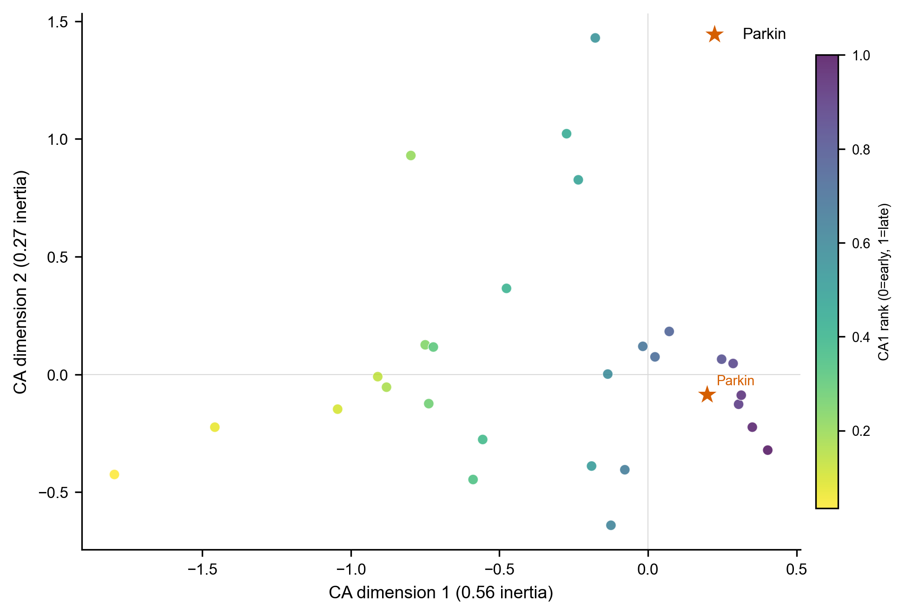
Figure 3. Correspondence-analysis seriation of the 29 basin decorated assemblages, plotted on the first two CA dimensions of the decorated-type frequencies and colored by CA1 rank (the relative chronological ordinate, oriented by the five available radiocarbon dates so that higher rank is later). Parkin is starred. The assemblages form a gradational continuum rather than discrete clusters, echoing the independent NMDS result of Mainfort (2003).

The four signatures
We computed each signature with a published or standard estimator and combined them only at the final step. Departure from neutral transmission follows Neiman’s application of the infinite-alleles model to ceramic assemblages (Neiman 1995). We estimated the transmission parameter in two ways: from the unbiased homozygosity of an assemblage and from its number of types, using the Ewens sampling formula to estimate the number of types expected under random copying, and took the ratio of the two estimates as the signature. Under neutral drift, the two estimators agree. Conformist transmission lowers the homozygosity-based estimate relative to the richness-based one, and anti-conformist novelty bias does the reverse, so the ratio both detects a departure and indicates its direction (Shennan and Wilkinson 2001). Because pooling assemblages from divergent groups cancels the signal, we computed departures within spatial clusters and averaged them.
Seriation coherence follows the deterministic frequency-seriation method of Lipo, Madsen, and Dunnell (Lipo et al. 2015). A set of assemblages is co-seriable if some ordering renders every decorated type both unimodal and continuous, and the method returns the complete set of maximal co-seriable groups. A single group denotes a single interacting community. A proliferation of small, non-co-seriable groups indicates a fragmented one. We report the number and size of these groups and, for each assemblage, the number of distinct groups it joins, which identifies assemblages that bridge otherwise incompatible orderings.
The variance partition is a cultural analog of Wright’s F_ST computed on Gini-Simpson diversity, the chance that two sherds drawn at random from an assemblage are of different types: the difference between the diversity of the pooled assemblages and the mean within-group diversity, divided by the pooled diversity, taken across spatial clusters (Bell et al. 2009). It rises from zero as groups come to hold distinct decorated repertoires. Spatial assortativity measures whether ceramic similarity follows social rather than geographic distance. We computed the Brainerd-Robinson similarity, a standard index ranging from 0 to 200 that indicates how alike two assemblages are in their type proportions, for every pair of assemblages. We tested its association with inter-site distance by a Mantel permutation test, which asks whether two distance matrices, here ceramic dissimilarity and geographic distance, are related. Because a Mantel correlation cannot separate a sharp social boundary from a smooth distance decay, we summarized the result as a boundary-excess statistic, the gap between mean within-cluster and between-cluster similarity after controlling for distance. Smooth isolation-by-distance returns a boundary excess near zero, and a genuine social boundary returns a large positive value. Two corrections are essential before any of these signatures is read. Assemblage sample size trends with seriation position, and several of the estimators are size-sensitive, so we rarefy every assemblage to a common count before scoring each signature as its rank correlation with ordinal position. And which signatures can be trusted at the record’s resolution is not assumed but established by the recovery experiment described next, in which a known closure signal is injected into the real configuration.

Criterion validation by simulation
We validated the test in two stages. The first establishes the principle. A generative model copies decorated variants across groups under three mechanisms: faithful controls, the degree of between-group divergence, and the strength of within-group conformity. A spatial rule places group profiles on the landscape, and four generators instantiate the four processes of Table 1. Run blind through the four-signature pipeline across twenty random seeds, only a bounded interaction group drives all four signatures together, and the signatures are tightly correlated under closure yet nearly independent under the mimics, so their joint movement is informative rather than an artifact of redundancy (Supplemental Text, Figure S4). That test uses large, clean assemblages, and it shows what the test can do in principle, not what it can do on a record like ours.
The second stage is decisive, and its idea is simple. We built synthetic pottery records in which we ourselves controlled whether group structure was emerging, dialed from none to strong, and then asked whether our four measures could see it. Crucially, the synthetic records were matched to the real ones: the same number of collections, the same range of sample sizes, the same blurring of time that surface collections impose. If chiefdom structure had really been emerging at Parkin, this experiment would tell us whether tools like ours, applied to data like ours, would have caught it. Concretely, we generated synthetic assemblages, one per real assemblage, at the real per-assemblage sample sizes, spatial clusters, and ordinal bins, injected a known group-closure signal of tunable strength s (between-group divergence and within-group conformity rising together along the sequence to a maximum of s), and asked which signatures recover it. Two properties of the record make this essential rather than optional. Assemblage sample size trends with seriation position (Spearman rho = +0.59), and several signatures are size-sensitive so that a size-dependent estimator can rise or fall along the axis through sampling alone. We therefore rarefy every assemblage, synthetic and real, to a common count before scoring, thereby removing the confound. And the record is time-averaged, which we reproduce by blending adjacent-bin production within a window. The recovery experiment then asks, at the resolution and sample sizes this record preserves, which signatures can be trusted and how strong a closure would have to be to register. One feature of the calibration is worth noting. Because rarefying the larger, later assemblages to a common count slightly inflates within-cluster diversity and so depresses F_ST toward later positions, the no-closure null itself carries a mild negative trend rather than a flat zero. The detector is calibrated against that null distribution, not against zero, so the false-positive rate is held at five percent regardless, and the empirical value is read against the same null.

The drift-versus-groups comparison
The central test compares two generative processes on the real geography of the assemblages. The neutral spatial-drift model follows the finite-population network model of Lipo, DiNapoli, Madsen, and Hunt (Lipo et al. 2021): each assemblage is a node holding a finite population of learners that copies decorated-type variants from within the node and, at a low rate, from other nodes with a probability that decays with geographic distance, under a fixed innovation rate, with deposition pooled over a trailing window to reproduce the record’s time-averaging. The bounded-groups model is identical except that interaction is concentrated within a small number of spatially contiguous groups, with only a low leak of copying between them, so that learning is restricted within boundaries. Both are run on the observed coordinate layout and rarefied to the observed per-assemblage sherd totals. Both are scored by the same four signatures, along with network modularity, a measure of how strongly the assemblages divide into separate clusters, and the distance decay of similarity. We swept the drift model’s interaction range, between-node mixing rate, and innovation rate, and report the full sweep (Supplemental Text) rather than a single setting. To extend the test to the wider valley, we added the southeast-Missouri survey assemblages of Williams (Williams 1954), digitized from the survey tables, and georeferenced both the Phillips-Ford-Griffin and the Williams assemblages through their Lower Mississippi Survey grid designations against the digitized survey point files, so that the two regions share one coordinate frame. Decorated types were harmonized between the two typologies, both rooted in the Phillips-Ford-Griffin framework, into a common vocabulary, and the between-region comparison was run both on all decorated types and on the types shared by the two typologies (Supplemental Text).

External cross-check
The transmission test stands on its own, but a polity, or any closure of interaction into bounded groups, should also leave non-ceramic traces. We assembled three further lines against which to check it: one genuinely independent of the ceramic data (the lithic exchange economy), one that shares its collection substrate (settlement organization), and one that re-examines the same assemblages by a different method (an independent ordination). We assessed settlement organization using the rank-size distribution of mound area within the basin and the distribution of mound height, asking whether a single center dominates as a redistributive apex or whether size is graded. For the political economy of exchange, we drew on Cobb’s regional analysis of the production and distribution of Mill Creek and Dover chert hoes, the capacity-linked industrial goods whose control would mark economic centralization, rather than measuring it ourselves (Cobb 2000). And we compared our seriation result to Mainfort’s independent nonmetric multidimensional scaling of overlapping late-period assemblages, a published ordination of 39 collections from the central valley and adjacent areas, which tests whether the named phases form discrete bounded clusters or a gradational continuum (Mainfort 2003).

Results
The four signatures distinguish bounded groups from drift in principle, but at this record’s resolution, only one of them registers the difference. The idealized validation behaves as designed: when interaction is made to close into bounded groups all four signatures move together, the drift and other mimics each light only a characteristic subset, and the four are tightly correlated under closure (mean absolute pairwise correlation 0.88) yet nearly independent under the mimics (0.19 to 0.29), so their joint movement is informative rather than redundant (Figure S4). The record-matched recovery is the more informative of the two (Figure 4). When a known group-closure signal is injected at the real configuration and scored after size control, only cultural F_ST tracks it monotonically, climbing from the null toward a strong positive trend as the injected strength rises, where the injected strength s is a dial from 0, pure drift, to 1, strong and sharply bounded groups. The neutral departure is non-monotonic in conformity, the spatial boundary is unresponsive at the three spatial clusters the data support, and seriation coherence responds only weakly. With the false-positive rate held at five percent, F_ST recovers a closure of strength s greater than or equal to 0.5 with power above 0.8, the threshold rising to 0.7 under the record’s time-averaging. The other three signatures are not reliable discriminators at this resolution, and we treat them as weak corroboration only. At this record size and with time-averaging, the one signature that can distinguish a bounded group from drift is between-group variance.
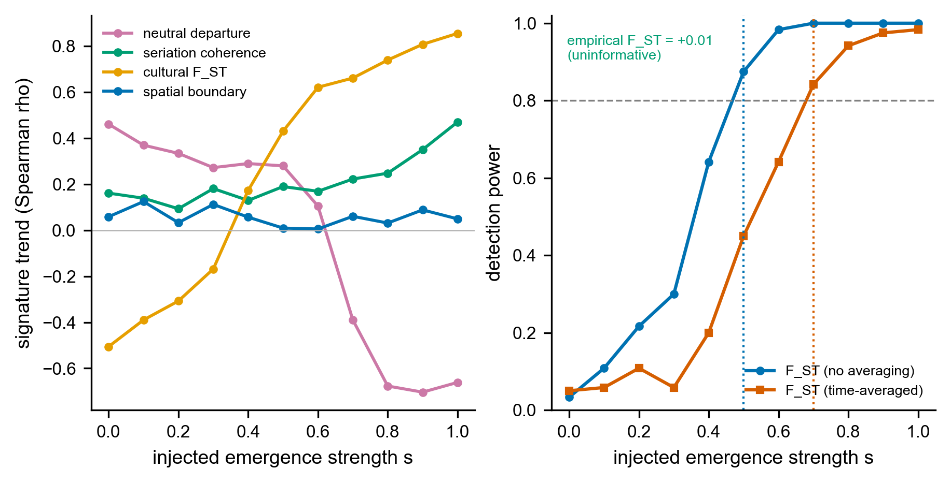
Figure 4. Record-matched, size-controlled signal recovery. Left: each signature’s response (Spearman trend versus ordinal position) to a known group-closure signal injected at the real configuration of 29 assemblages and rarefied to a common count. Only cultural F_ST tracks the injected signal monotonically. The neutral departure is non-monotonic in conformity, the spatial boundary is unresponsive at three spatial clusters, and seriation coherence is weak. Right: detection power of the calibrated F_ST detector against injected strength, with and without the record’s time-averaging (false-positive rate 0.05). F_ST reliably recovers a closure of strength s greater than or equal to 0.5 (0.7 time-averaged). The size-controlled empirical F_ST (+0.01) falls below the resolution limit, its bootstrap interval spanning no closure to a moderate signal.
Applied to the Parkin phase, that one reliable signature shows no closure into bounded groups, and the apparent signals in the others are confounded by sample size (Figure 5). The raw trajectory along the seriation axis seems to dissociate, but two of its trends are sampling artifacts: because assemblage size trends with seriation position, the size-sensitive estimators move with it. Two of the apparent trends are artifacts of sample size. Once every assemblage is trimmed to a common sherd count by rarefaction, cultural F_ST falls from a raw +0.60 to +0.01, and its uncertainty range runs from no closure to a moderate signal, so it is uninformative rather than a resolved positive. The neutrality departure is likewise size-sensitive (its raw -0.94 only weakens to -0.83 under size control), and the recovery shows that it does not track closure in either direction here, so it, too, cannot be read as a transmission signal. On the recovery curve, the size-controlled empirical F_ST corresponds to a nominal injected strength of about 0.35, below the resolution limit. The record, therefore, shows no detectable closure of moderate or greater strength. The negative is informative for a closure of moderate or greater strength, which would have registered and is absent. It cannot exclude a weaker closure that, given a record of this size and time-averaging, is underpowered to resolve. The positive control reported next shows that the structure actually present is what neutral drift produces, so the result is not only that no bounded group is detectable, but also that the data appear in ways consistent with how continuous, spatially structured interaction makes them look.
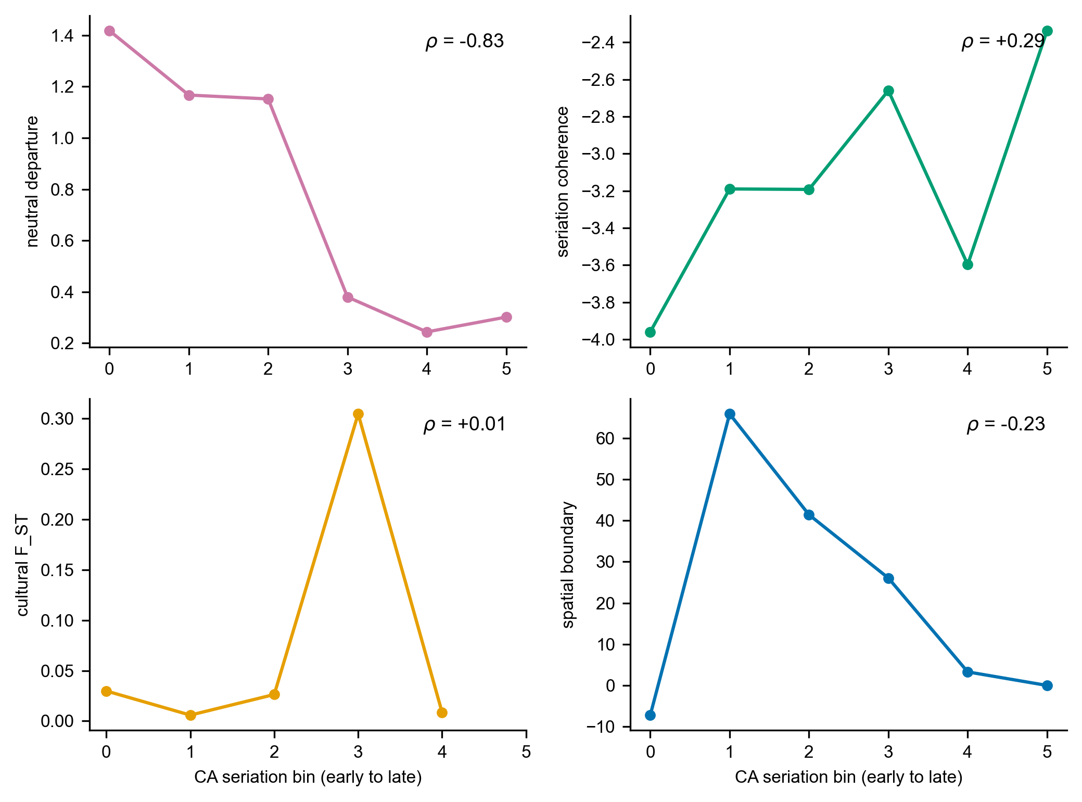
Figure 5. The empirical four-signature trajectory along the CA seriation axis for the St. Francis basin (29 assemblages, six bins), size-controlled by rarefaction to a common count. The reliable signature, cultural F_ST, shows no trend (+0.01, down from a raw +0.60 that was a sample-size artifact). The neutral departure, spatial boundary, and seriation coherence are not reliable discriminators at this resolution (Figure 4) and are shown for completeness. Per-panel rank correlations are annotated.
Three further checks, all pointing the same way, add detail. The first follows each decorated type’s rise and fall through the sequence and asks whether the changes resemble the aimless wobble of unbiased copying or the directed change a deliberate marker would exhibit. Seven of the nine testable types appear to be simple wobble (the frequency increment test) (Feder et al. 2014). The second compares how the collections’ overall diversity changes over time against the range that plain drift would produce, and finds that it stays within that range (a non-equilibrium neutral test) (Kandler and Shennan 2013). The third asks whether the collections grow more different from one another toward contact, as would fragmenting groups. They do not. Neiman’s interassemblage distance shows no divergence trend along the sequence (Spearman rho = +0.37, not significant), the typical difference between spatial clusters is barely larger than the difference within them (a ratio of 1.13), and the more diverse collections are the more central ones, the pattern drift produces in a single shared community (Figure S1) (Neiman 1995). The no-closure verdict is also robust to the analyst’s choices: across twenty-seven combinations of the basin’s spatial cutoff, the number of ordinal bins, and the number of spatial clusters, it appears in none of them, and it holds equally under the watershed and corridor basin definitions. Consistent with the recovery experiment, none of these checks shows a resolvable departure from neutral transmission, and we read them as corroboration of the size-controlled F_ST result rather than as independent signals.
A positive control identifies which of the two processes the basin’s structure matches. Rather than rest on a failure to detect, we asked which of the neutral spatial drift and bounded groups reproduces the observed decorated-ceramic structure. Following the finite-population network-drift model of Lipo, DiNapoli, Madsen, and Hunt (Lipo et al. 2021), we simulated neutral copying on the actual coordinate layout of the basin assemblages, with interaction decaying over distance and the record’s time-averaging imposed, and compared it against a bounded-groups process on the same geography. By sweeping the interaction range, the between-node mixing rate, and the innovation rate, neutral drift reproduces the observed distance decay, network modularity, cultural F_ST, and distance-controlled boundary excess. The region of parameter space that brackets all four at once is a sub-basin interaction range of about 24 km with low between-node mixing. We report the full sweep rather than a single tuned point: at shorter ranges, drift overproduces distance decay, and at higher mixing, it underproduces the structure, so the all-four match holds only in a plausible but specific corner of the space (Supplemental Text). The bounded-groups process, by contrast, overshoots the three structural signatures by roughly two to seven times across its range, leaving far sharper community structure than the data carry. The basin’s decorated-ceramic structure is therefore reproducible by neutral spatial drift under plausible parameters. It does not require bounded groups, which would have left a sharper mark than is present (Figure S5). The control also bounds the spatial signature itself. A positive distance-controlled boundary excess, which we introduced to separate a sharp social boundary from smooth isolation by distance, is reproduced by stochastic neutral drift on a finite network, so on its own it does not certify a boundary. The same conclusion is reached for the phase construct from outside the transmission framework. Fox’s cluster analysis and ordination of the southeast-Missouri assemblages that define the regional phases found them failing as both groups and classes, with assemblages assigned to statistical clusters at random rather than segregating by phase (Fox 1998).
Parkin is a seriation bridge, not the anchor of a bounded community. Deterministic seriation of the basin assemblages returns a deeply fragmented, bridge-dominated structure rather than a single coherent ordering. At a continuity threshold of 0.1, it yields 35 maximal co-seriable groups with a maximum size of four, and 17 of the 29 assemblages belong to more than one group (Figure 6). The absolute counts scale with the threshold, but the fragmented, overlapping topology is stable across thresholds. Parkin is one of these bridge assemblages, a member of four groups and ranked eighth of 29, positioned across orderings rather than at the center of one. The empirical pattern is the one Lipo, Madsen, and Dunnell (2015) reported, with Parkin at the intersection of multiple non-co-seriable orderings rather than at the center of a single closed interaction community (Lipo et al. 2015). They read that bridging position as a possible sign of incipient hierarchy. We read it the other way: a site that bridges several orderings is a hub of interaction, not the seat of a bounded group.
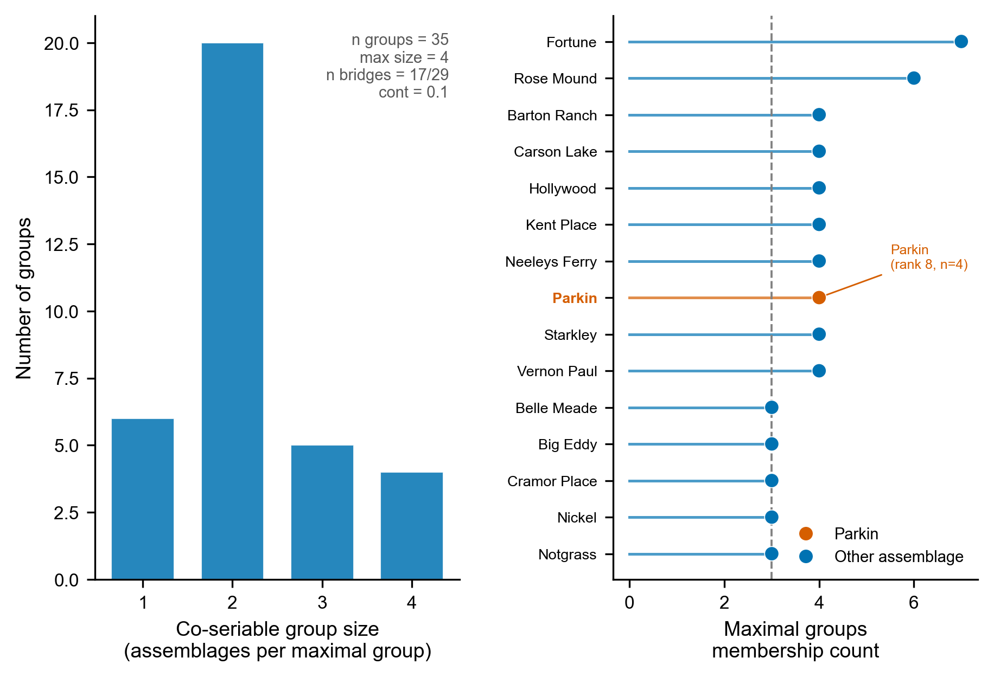
Figure 6. Deterministic frequency-seriation (IDSS) structure of the basin assemblages. Left: distribution of co-seriable group sizes, a deeply fragmented structure (35 maximal groups, maximum size four). Right: the most connected assemblages by group-membership count, with Parkin highlighted as a bridge (member of 4 groups, ranked eighth of 29), positioned across orderings rather than at the center of one bounded community.
Settlement does single Parkin out, but on the comparable evidence, its prominence sits within a graded distribution rather than standing apart as a redistributive apex. Parkin has the basin’s tallest platform mound, at 23 feet, ranking first among the 55 basin sites with a recorded mound height (Figure 7). The distribution is graded, however, with no gap separating Parkin from the next centers, the tallest-to-second ratio being 1.0. The regional database under-records the moated, multi-mound type-site, coding its mound area and defensive ditch as zero (Mitchem 2001; Morse 1990), so we base the settlement comparison on recorded mound height rather than on mound area. Parkin’s roughly 17-acre site area would make it the largest center in the basin, but that figure is the total site area rather than the basal mound area on which the other sites are measured, and we treat it as indicative only. The settlement record thus shows a prominent center within a graded size distribution, not an administrative tier set above the rest, the same picture the transmission test returns (Figure 7).
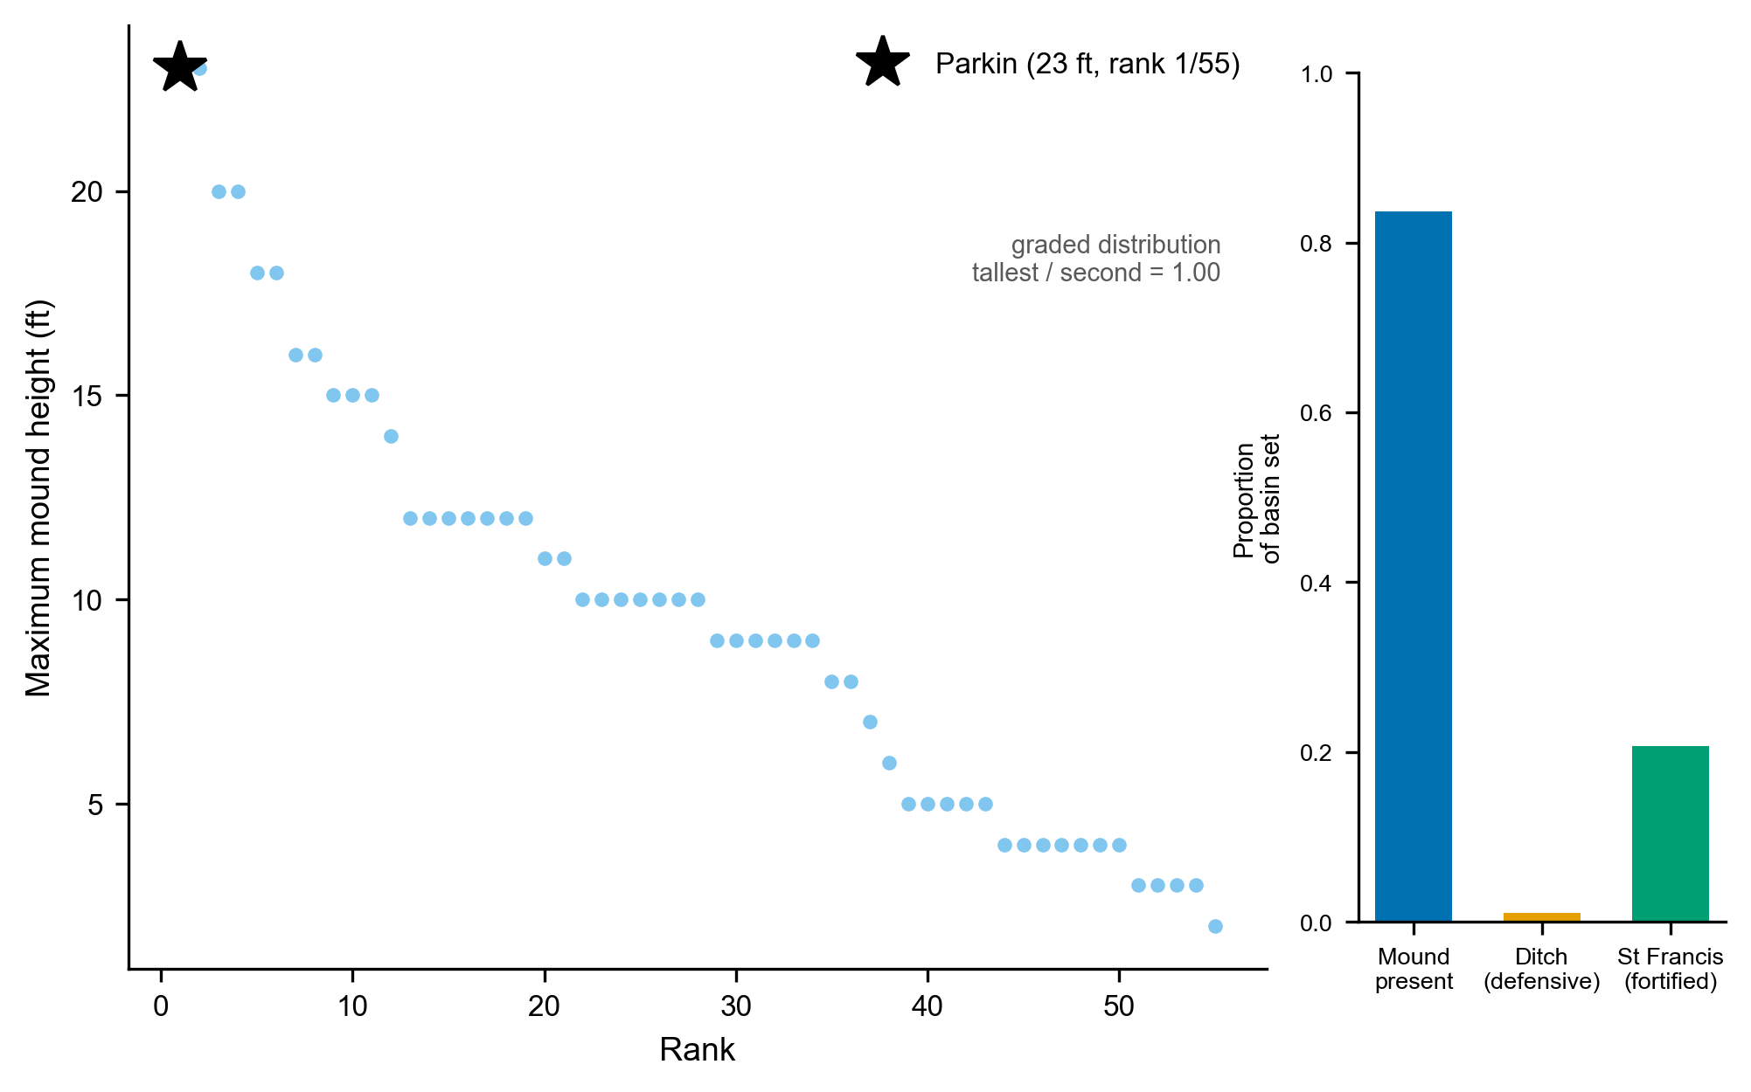
Figure 7. Settlement cross-check. Main panel: within-basin ranking of maximum mound height, the recorded, like-for-like field (Parkin’s mound area is under-coded as zero and is not used). Parkin has the tallest mound (23 ft, rank 1 of 55), but the height distribution is graded, with no gap separating it from the next centers (tallest-to-second ratio 1.0), a prominent center rather than a redistributive apex. Inset: the proportion of sites with a mound, a defensive ditch, and St-Francis-type fortification across the basin set (n = 92).
The non-ceramic evidence converges on the same reading. Mound size within the basin is graded rather than redistributive, and Parkin’s dominance is one of scale rather than of an administrative tier set apart from the rest. The production and exchange of Mill Creek and Dover chert hoes, the capacity-linked tools whose control would mark an economic hierarchy, was decentralized at the regional scale, with distribution following a down-the-line gradient rather than redistribution from a central place (Cobb 2000). This is a regional pattern in which the St. Francis basin participates rather than a basin-internal measurement, so we read it as consistent with, not independent proof of, the absence of economic centralization at Parkin. A separate nonmetric ordination of overlapping late-period assemblages finds that the named phases form a gradational continuum rather than discrete, bounded clusters, the cross-method counterpart of our seriation fragmentation (Mainfort 2003). These lines point in the same direction. Two of them, the settlement organization and the lithic exchange, are independent of the ceramic data, while the ordination shares that substrate and corroborates the seriation result by a different method rather than independently.

Discussion
The three lines of evidence converge on a single reading: the Parkin phase is not a bounded interaction group, and Parkin is not the capital of a polity. Within the St. Francis basin, Parkin is the largest and most monumentally elaborated center. Yet, its decorated-ceramic record shows no closure of interaction into bounded groups, and the structure present is reproduced by neutral drift across the basin’s geography. In contrast, a bounded-groups process would have left a far sharper mark. The settlement and exchange records say the same: mound size is graded rather than redistributive, and the production and exchange of the capacity-linked chert hoes were decentralized (Cobb 2000). We are explicit about the scope of the ceramic claim. The transmission analysis bears on whether interaction closes into bounded, like-with-like groups, not on group-level fitness differences or a new unit of selection, which assemblage data cannot address. What the record shows is that the within-greater-than-between similarity the phase is built on is what spatially structured drift produces, so the phase, at the scale at which it is drawn, marks continuous interaction structured by geography rather than by a bounded society. Parkin’s ceremonial and demographic prominence was real. The polity that prominence is taken to imply is not in the transmission record.
This reading must answer the strongest case for the alternative. The most direct argument for an emerging hierarchy holds that Parkin sits on agriculturally poor soil and so must have drawn tribute from the productive villages around it (Morse 1990). The inference is specific and deserves credit for that, but it is circular. The tribute it concludes is the tribute it assumes, and no independent evidence of tribute flow accompanies it. Parkin’s position at the confluence of the St. Francis and Tyronza is as well explained by control of movement and communication as by extraction, and the transmission and exchange records both show the absence of the centralized control the tribute model requires. A second argument points to skeletal evidence from the lower Mississippi (Yazoo) Delta rather than the St. Francis basin, indicating a better diet at a mound center than at a nearby satellite village, consistent with differential access within a hierarchy (Ross-Stallings 2015). The contrast is real but thin: the satellite sample numbers fourteen individuals, the result is presented as tentative, and a health difference between two sites does not require an extractive hierarchy to produce it. Neither argument supplies the regional, structural signature that the convergence test looks for and does not find.
Three limits bound the result, and the recovery experiment forces the most important of them to the front. At this record’s resolution, the discrimination between a bounded group and drift rests on a single signature, cultural F_ST. That signature is confounded by a sample-size trend along the seriation axis (Spearman rho = +0.59). We removed the confound by rarefying every assemblage to a common count, which collapses the raw F_ST trend from +0.60 to +0.01. We calibrated the detector on synthetic data matched to the record, in which F_ST recovers a moderate-strength closure (s of about 0.5, rising to 0.7 once the record’s time-averaging is imposed), while holding the false-positive rate at 5%. The size-controlled empirical F_ST is uninformative, its bootstrap interval spanning no closure to a moderate signal. The negative is therefore informative for a closure of moderate or greater strength, which would have registered as a resolved positive, but does not. It cannot exclude a weaker closure that a record of 29 time-averaged assemblages is underpowered to resolve, and we state the claim at that bound rather than beyond it. The other three signatures do not track closure reliably here. The neutral departure is due to its non-monotonicity with respect to conformity and size-sensitivity. The spatial boundary is problematic because there are too few spatial clusters, and seriation coherence is weak, so we report them as corroboration rather than as independent confirmations. This reduction is a property of the record. When a known closure signal is injected instead through a within-group conformity channel or a non-spatially-organized social-fragmentation channel, neither the neutral nor the seriation signature recovers it either, so the three weak signatures fail at this resolution regardless of how closure is delivered (Supplemental Text). The price is that the negative bounds are only closure expressed as between-group divergence. The closure carried purely by conformity, or by social structure not aligned with the spatial clusters, would lie below detection in this record at any strength. The second limit is the ordinal chronology. The basin radiocarbon corpus pools to five seriation anchors across a calibration plateau, so the axis is a relative order oriented toward later time at Spearman +0.70, imperfectly. The discriminating quantity, the size-controlled F_ST trend, is a magnitude that does not depend on the axis orientation, and the settlement and exchange lines do not depend on the ceramic chronology at all. The third limit is time-averaging, which damps between-assemblage variation and reduces apparent turnover (Kidwell and Tomašových 2013; Tomašových and Kidwell 2009, 2010). Rather than argue that this makes the absence conservative, we built the damping into the recovery experiment directly, where it raises the detection threshold from s of 0.5 to 0.7, the quantified cost of the record’s temporal mixing. The verdict is stable across the watershed (19 assemblages) and corridor (29) basin definitions. The central methodological finding is that telling a bounded group from drift must be calibrated to the record to which it is applied. The same four signatures that discriminate cleanly on idealized data reduce, on a real time-averaged record of this size, to a single confound-controlled signature, and saying so is what licenses reading the structure as drift rather than weakening the claim.
The contribution has two parts that should be kept distinct. The four signatures distinguish a bounded interaction group from drift in principle, and an idealized simulation confirms that closure drives them together while drift and the other mimics do not (Figure S4). The calibration is the part that travels to real data: it asks, before any similarity structure is read as social, which signatures a given record can support and how strong a closure each could detect, and on the Parkin record, it shows the test reducing to its single most robust component, cultural F_ST. We are explicit about what that costs: had F_ST shown a positive trend, it alone could not have separated a real group from environmental patchiness, which also drives between-group variance (Table 1), so on a positive result, the generative drift-versus-groups comparison, not F_ST alone, would have had to carry the discrimination. The negative is cleaner because the present structure is positively matched by drift and overshot by bounded groups. The transferable claim is therefore the calibration, not a promise that similarity clusters can be read as societies wherever decorated assemblages exist, and it converts a vague question, whether the Parkin phase was a polity, into a specific and answerable one, whether interaction had closed into a bounded group at a strength the record can resolve. For the Parkin phase, the answer is that it had not, within the bounds supported by the record. The polity the De Soto encountered seems to reflect a distinction drawn in ceremonial practices, fortification, and settlement size, not one written into the structure of ceramic transmission.
The test also extends beyond the basin, and the extension is instructive (Figure 8). Applied to the southeast-Missouri assemblages compiled by Williams (Williams 1954), the within-region decorated-ceramic structure is again drift-consistent once the earlier Woodland component is set aside. Therefore, the absence of bounded groups is not peculiar to the St. Francis basin (Figure 9). In both regions, the observed between-cluster F_ST sits at the neutral-drift level and far below the bounded-groups expectation (LMV +0.02, CMV +0.03, against bounded-groups nulls of +0.11 and +0.08), and the assemblages intermix rather than separating into clusters. Between the two regions, a genuine discontinuity does appear. Across the roughly 50 km gap separating the central-valley and lower-valley assemblage clusters, decorated similarity declines by far more than neutral spatial drift would predict for the same geometry, and the two regions carry mutually exclusive, distinctive decorated repertoires (Figure S6). This is the scale-dependent pattern the test is designed to detect, with no closure within regions and a sharp difference between them. We report it as a pattern rather than a verdict, because it is confounded with time.
The distinctive central-valley types are early-to-middle Mississippian, and the distinctive lower-valley types are late (Phillips 1970; Williams 1954), so the step at the boundary cannot be separated from the early-to-late turnover of the repertoire with time-averaged surface collections, and resolving whether the inter-regional boundary is synchronic and social or a chronological succession would require independent radiocarbon control on the central-valley assemblages that the present compilation lacks. A second confound compounds the first. The lower-valley assemblages were collected and classified by Ford, later by Phillips, Ford, and Griffin. In contrast, the central-valley assemblages were collected and classified separately by Williams, so the two blocks differ in analyst, sorting convention, and type definition as well as in space and time. The shared-type restriction guards against the crudest version of this artifact, because a boundary built only from types unique to each typology would vanish when only the types both traditions record are compared, and the boundary does weaken under that restriction without disappearing. Even the shared types, however, may have been sorted to subtly different criteria by the two traditions. We therefore cannot rule out that the apparent central-valley and lower-valley boundary is in part an artifact of two separate analytical histories, and that the possibility of continuous interaction across the whole region, with no real boundary anywhere, remains open. That possibility is part of the question this study raises, rather than a nuisance to be set aside, because a boundary in the data is not yet a boundary in the past. The paper’s point at the local scale applies with equal force between the regions.
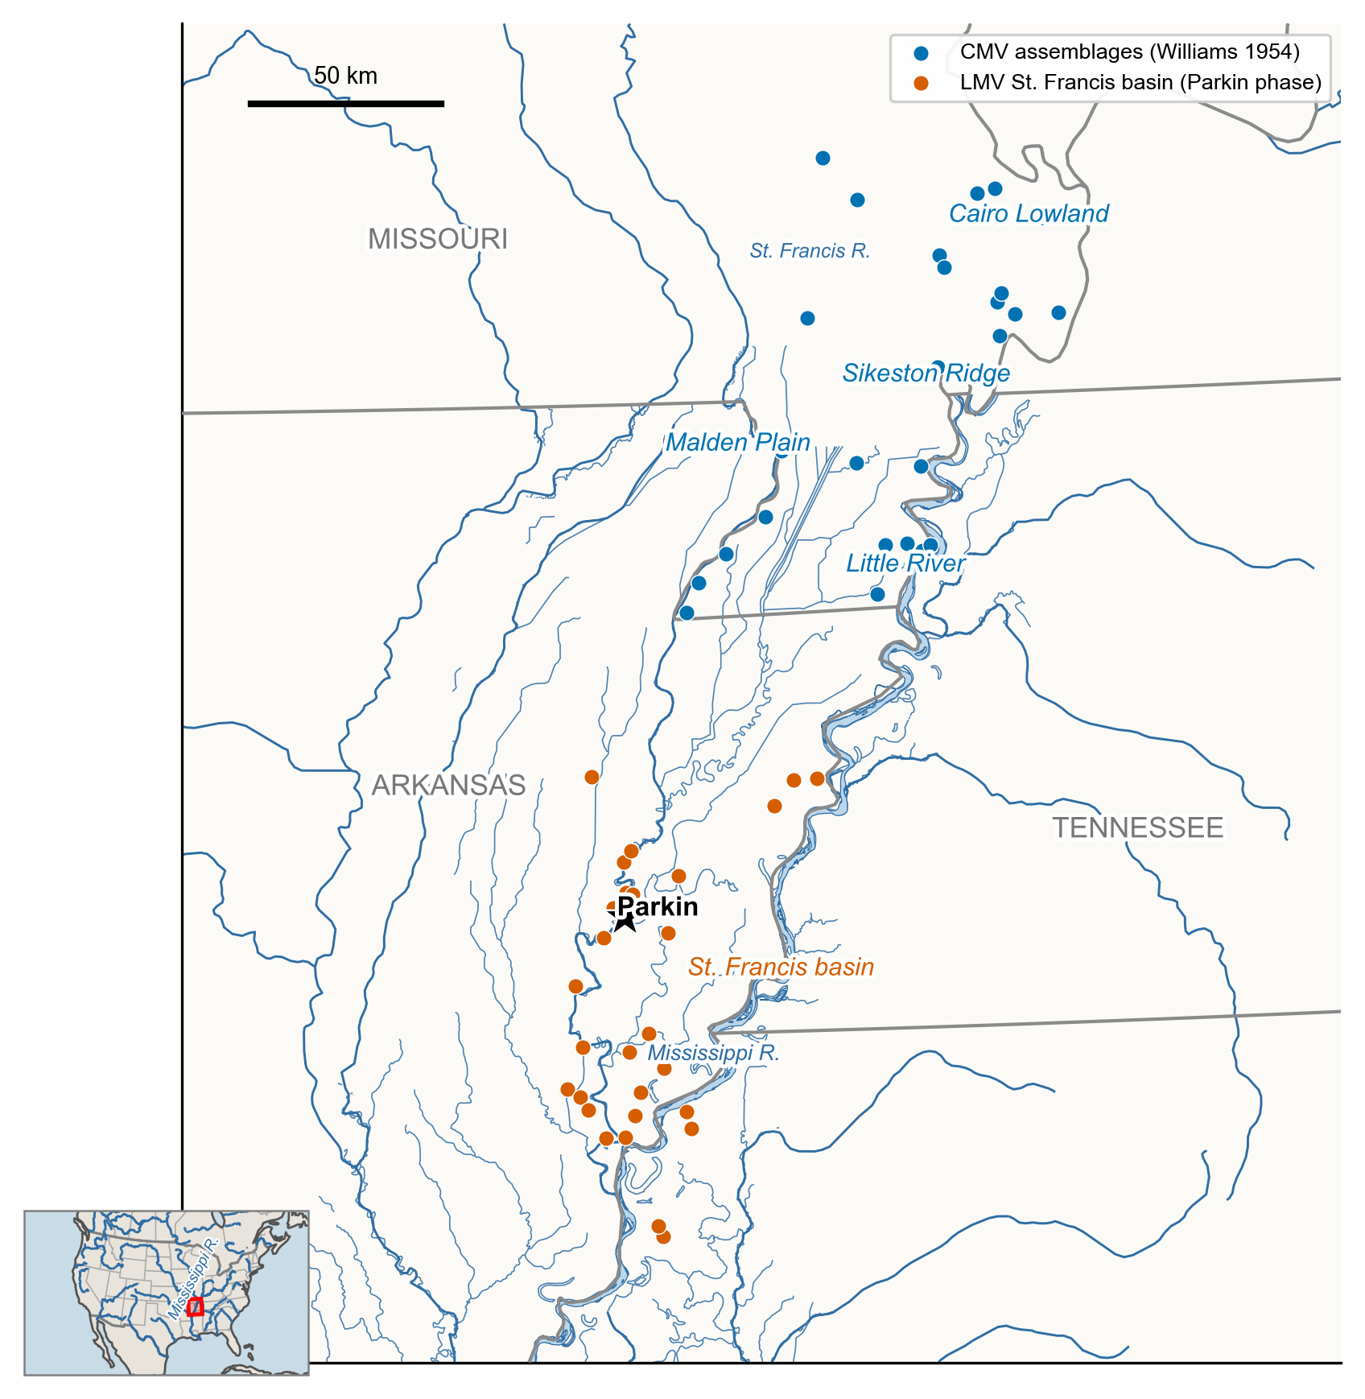
Figure 8. Regional setting of the two-scale comparison. Decorated-ceramic assemblages of the central Mississippi Valley: the southeast-Missouri survey of Williams (CMV, blue) and the lower-valley St. Francis basin Parkin-phase assemblages (LMV, orange), with the gap between the two clusters of collections and Parkin starred. Labels mark the named physiographic phase regions (Cairo Lowland, Sikeston Ridge, Malden Plain, and Little River in the central valley, with the St. Francis basin in the lower valley). Hydrography combines the Lower Mississippi Survey layer with Natural Earth, state boundaries, and the North America locator inset, which are from Natural Earth. The central-valley assemblages were collected and classified by Williams, and the lower-valley assemblages in the Phillips-Ford-Griffin tradition, the separate analytical histories discussed in the text.
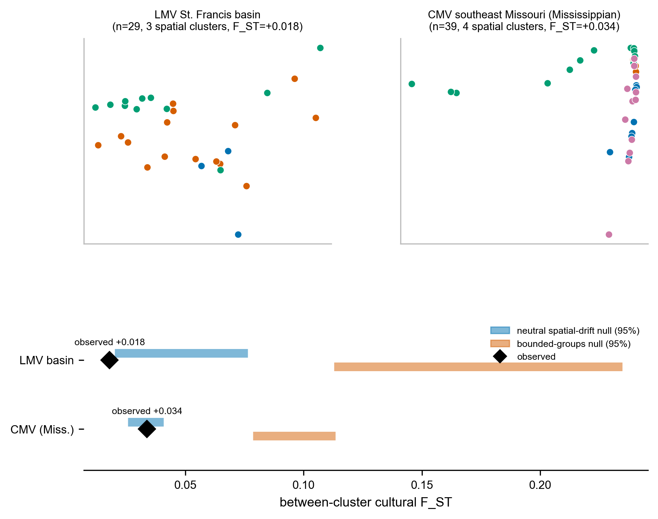
Figure 9. Within-region interaction structure: neither region forms bounded groups. Top: multidimensional scaling of decorated Brainerd-Robinson dissimilarity for the LMV St. Francis basin and for the CMV southeast-Missouri assemblages (Mississippian types only, so the comparison is not driven by the Woodland-to-Mississippian gradient), points colored by within-region spatial cluster, and the assemblages intermix rather than separating into clusters. Bottom: the observed between-cluster cultural F_ST for each region (diamond) against the 95% nulls of a neutral spatial-drift model (blue) and a bounded-groups model (orange) run on the real coordinates and rarefied to the observed counts. In both regions, the observed F_ST sits at the drift level and far below the bounded-groups expectation, so the within-region structure is drift-consistent at both scales.
Beyond the Parkin case, the test proposes a standard of measurement for an evolutionary archaeology that has long been clearer about what evolves than about how to measure it (Dunnell 1995). A signature that interaction has closed into a bounded group should be theoretically sufficient, dynamically sufficient, and empirically sufficient, the last meaning matched to the quality of the record rather than to an imagined snapshot. Ours meet the first by construction, each entailed by the transmission model rather than borrowed by analogy (Lipo et al. 2015; Neiman 1995). The third is that we test rather than assume, which is the point of the recovery experiment: empirical sufficiency is a property a signature has only if it can register a signal at the resolution preserved by the deposit, and, on the Parkin record, only between-group variance qualifies (Perreault 2019). They meet the second only in part, because the signatures measure states along the seriation sequence rather than the transformation between them. We therefore add two time-domain tests that jointly satisfy dynamic and empirical sufficiency. A generative, time-averaging-aware inference fits a frequency-dependent copying model to the whole sequence, with the record’s time-averaging built into the model, and recovers a transmission bias tightly constrained near neutral (95 percent interval -0.02 to +0.06, including zero), which rules out the conformist dynamic a marker would require (Crema et al. 2016). A tempo-and-mode comparison finds the aggregate diversity trajectory best described by neutral drift rather than by a directional, stabilizing, or mean-reverting alternative (Hunt 2006; Hunt et al. 2008). Neither recovers a transition that the static criterion missed, so the negative now holds in the time domain as well as on the static states. A third probe, for the early-warning signature of a critical transition, is underpowered at this ordinal resolution and does not meet the empirical sufficiency criterion, so we report it in the supplementary code but do not rely on it (Dakos et al. 2012; Scheffer et al. 2009). The detail is in the Supplemental Text.

Conclusion
The phase is the unit on which central-valley culture history is built, and it carries a silent claim that assemblages grouped by seriation and spatial proximity record a bounded society. For the Parkin phase, that claim does not survive measurement. Parkin stands apart as the basin’s largest and tallest-mounded center. No line of evidence, settlement, exchange, or ceramic transmission marks it as the apex of a polity, and the within-greater-than-between ceramic similarity that defines the phase is reproduced by neutral drift on the basin’s geography, the ordinary residue of continuous interaction structured by where sites sit. A bounded interaction group would have a sharper structure than the data carry, and Parkin sits across orderings as a transmission bridge rather than at the closed core of one. Extending the test to the wider valley, a decorated-ceramic boundary that exceeds drift appears only between the central-valley and lower-valley blocks, and even there, it is entangled with the early-to-late turnover of the type repertoire. It cannot yet be read as a synchronic social division. The phase, at the scale where it is drawn, is largely indistinguishable from spatially structured drift, which carries a consequence the discipline should weigh: a similarity cluster is not by itself a society, and before a phase is read as a social group, the record must be shown able to tell a real interaction boundary from drift on geography. That calibration, not the phase, licenses a social reading, and, when applied to the central Mississippi Valley, it yields a landscape of continuous interaction with prominent nodes rather than a mosaic of bounded polities.

Supplemental Text

Full specification of the four signatures
Departure from neutral transmission follows Neiman’s application of the infinite-alleles model (Neiman 1995). We estimated the transmission parameter $θ$ in two ways from each assemblage. The homozygosity estimator uses the unbiased sample homozygosity F=i​ni(ni−1)/[N(N−1)], where $n_{i}$ is the count of type $i$ and $N$ the assemblage size, and inverts the neutral relation $F=1/(1+θ)$ to give $θ_{F}=(1−F)/F$. The richness estimator solves the Ewens sampling expectation for the number of types $k$,
$$E[k∣θ,N]=\sum_{i=0}^{N−1}{\frac{θ}{θ+i}},$$
for the value $θ_{E}$ that reproduces the observed $k$ (Ewens 1972). Under neutral drift, the two estimators agree. Conformist copying concentrates frequency on common types, raising $F$ and lowering $θ_{F}$ relative to $θ_{E}$, whereas anti-conformist novelty bias does the reverse. The signature is the ratio $θ_{F}/θ_{E}$, which both detects a departure from neutrality and signs it. Because pooling assemblages from divergent groups cancels out the effect, we computed ratios within spatial clusters and averaged the results across clusters.
Seriation-coherence breakdown follows the deterministic frequency-seriation method of Lipo, Madsen, and Dunnell (Lipo et al. 2015). A set of assemblages is co-seriable if some ordering renders every decorated type’s frequency both unimodal and continuous. We enumerated the complete set of maximal co-seriable groups, the subsets for which a valid ordering exists, and which are maximal under inclusion. A single group indicates one interacting community, whereas a proliferation of small, mutually non-co-seriable groups indicates a fragmented one. We report the number and maximum size of these groups and, for each assemblage, its group-membership count, which identifies the bridge assemblages that join otherwise incompatible orderings. The number of maximal groups is the continuous signature.
The variance partition is a cultural analog of Wright’s $F_{ST}$ computed on Gini-Simpson diversity H=1−i​pi2,
$$F_{ST}=\frac{H_{T}−H_{S}}{H_{T}},$$
where $H_{T}$ is the diversity of the pooled assemblages and $H_{S}$ the size-weighted mean within-cluster diversity (Bell et al. 2009). It is zero when clusters share a repertoire and rises as they come to hold distinct ones.
Spatial assortativity asks whether ceramic similarity follows social rather than geographic distance. We measured Brainerd-Robinson similarity Sij=200−k​|100 pik−100 pjk| between every pair of assemblages. Because a Mantel correlation cannot separate a sharp boundary from a smooth distance decay, we summarized assortativity as a distance-controlled boundary excess. Within each pairwise-distance bin, the mean within-cluster similarity minus the mean between-cluster similarity is averaged over bins. Under pure isolation by distance, similarity depends only on distance, and the excess is near zero. A sharp social boundary makes within-cluster pairs much more similar than between-cluster pairs at matched distance, yielding a large positive excess. Spatial clusters were obtained by $k$-means on site coordinates with multiple restarts, the number of clusters chosen by the mean silhouette.
We combined the four signatures by standardizing each across the ordinal sequence and averaging them, so that no single signature would dominate, and summarized the trajectory as the ordinal slope of the combined score and each component, with rank correlations and bootstrap confidence intervals.

The generative validation model
The validation rests on a generative model with three mechanism-faithful controls: the between-group divergence of type profiles, the strength of within-group conformity, and a spatial rule placing group profiles on the landscape. Four generators instantiate the four processes of Table 1. The bounded-groups generator raises divergence and conformity together across spatially bounded groups. Environmental patchiness holds a fixed between-group difference under neutral within-group copying with an environment-keyed layout. Aggregated signaling raises within-group conformity in a single undivided pool with no between-group divergence. Drift with distance-limited interaction produces a smooth spatial gradient under neutral copying. Each generator emits a sequence of group-by-type slices along an ordinal axis. We ran the four-signature pipeline on each, blind to its source, and recorded which registered as convergent, repeating this across 20 random seeds and computing the correlation matrix of the four signatures on the bounded-groups output to confirm that their joint movement is informative rather than an artifact of redundancy (Figure S4). This idealized test uses large, clean assemblages (12 groups, several hundred sherds each) and establishes that it discriminates in principle. The record-matched, size-controlled recovery in the main text (Figure 4) is what establishes which signatures survive at the resolution of the actual data.
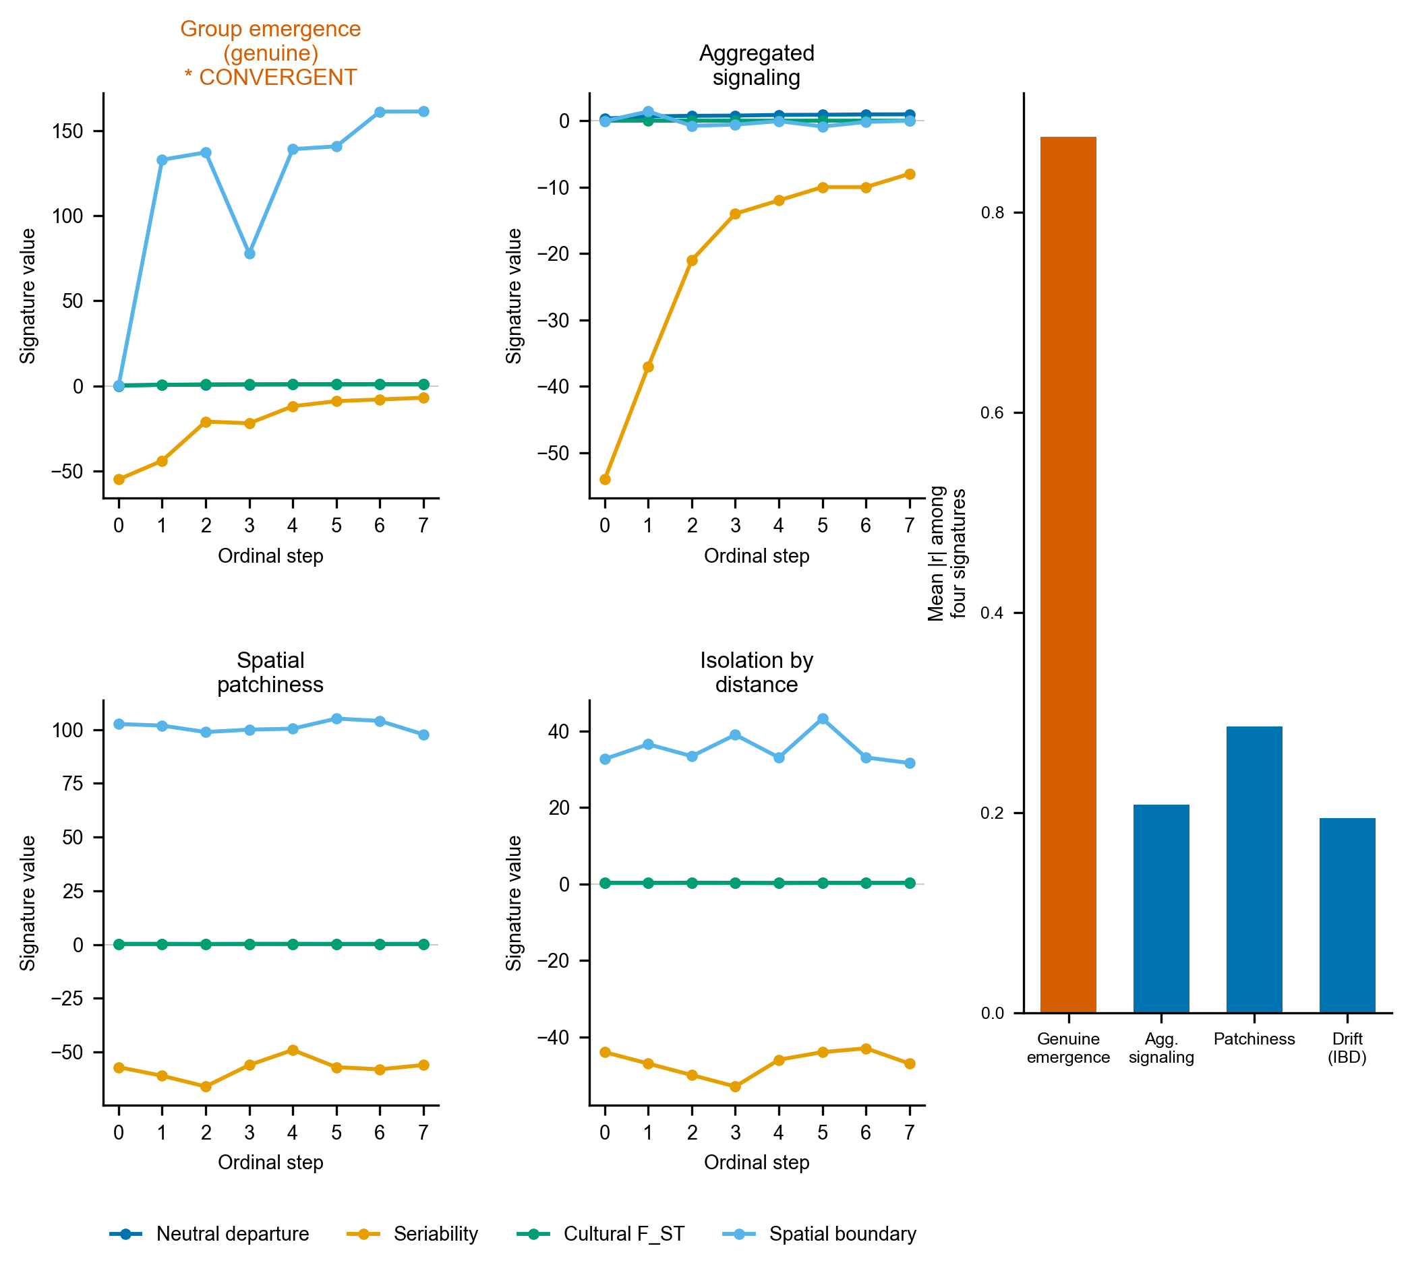
Figure S4. Idealized criterion validation. Four-signature ordinal trajectories under each of the four generative mechanisms on large, clean synthetic assemblages. Only a bounded interaction group drives all four together (starred), and no mimic is flagged as convergent across 20 random seeds (the bounded-groups case flagged in 19 of 20, 95 percent interval 0.75 to 0.99, and no mimic flagged at all, 95 percent upper bound about 0.17). Inset: the signature-independence audit (mean absolute pairwise correlation among the four signatures), high under closure (about 0.88), and low under the mimics (about 0.2). This shows the convergence concept works on idealized data. Figure 4 shows what survives at the record’s resolution.

Robustness checks
Neiman’s sample-size diagnostic for the neutrality estimators supports the Discussion: across the 29 basin assemblages, we computed the homozygosity-based and richness-based estimates of the transmission parameter and their signed difference, and correlated each with assemblage size and with seriation position, following Neiman’s protocol for separating a transmission signal from a sample-size artifact (Neiman 1995). Several further checks support the Results. A forking-paths sensitivity grid recomputes the convergence verdict across twenty-seven combinations of the basin’s spatial cutoff, bin count, and cluster number. The frequency increment test (Feder et al. 2014) is applied to each decorated type’s binned frequency trajectory. Neiman’s squared-Euclidean interassemblage-distance is computed with its diversity-distance relationship and divergence trajectory (Neiman 1995). The alternative basin definition, the stricter watershed rule, is evaluated in full. Clustering-tendency statistics (Hopkins, silhouette, and the gap statistic) on the correspondence-analysis ordination favor a single group, with a maximum silhouette of only 0.47, consistent with a near-continuum rather than sharply bounded ceramic groups. All are provided in the supplementary code. The Neiman interassemblage-distance result is shown in Figure S1.
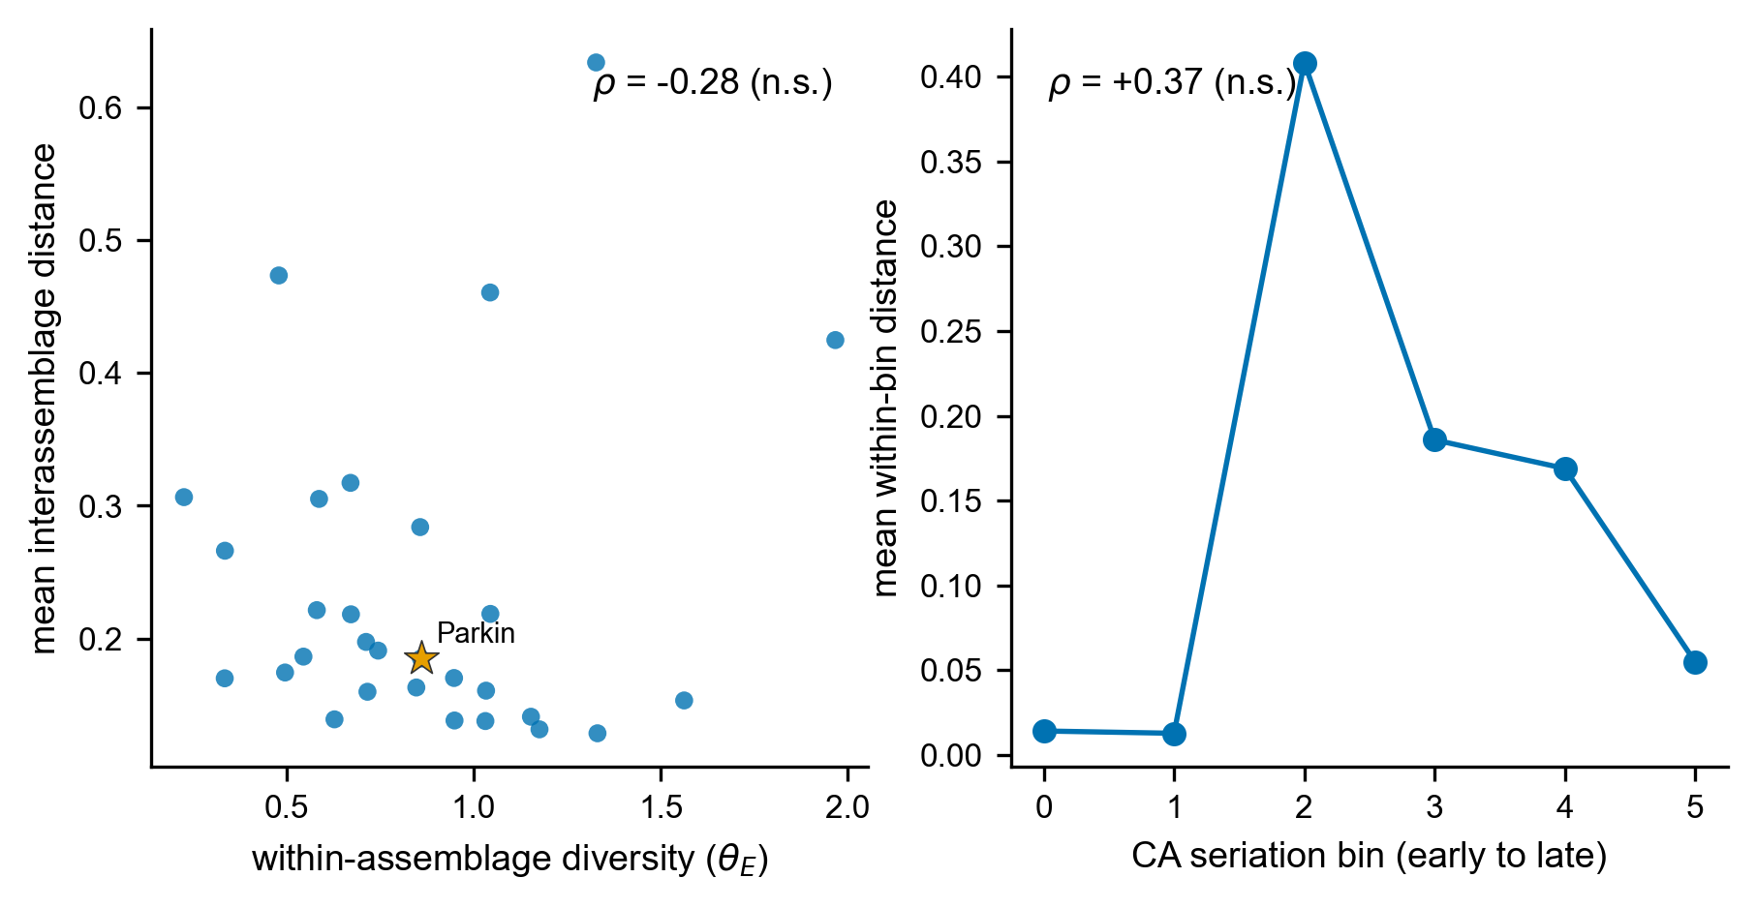
Figure S1. Neiman interassemblage-distance result. (A) Within-assemblage diversity against mean interassemblage distance, with Parkin starred. The weak negative association (Spearman rho = -0.28, not significant) is directionally consistent with the drift signature Neiman (1995) reported at rho = -0.62, not with the positive relationship that bounded, assorting groups would produce. (B) Mean within-bin interassemblage distance along the CA seriation axis. Between-assemblage divergence does not grow toward contact (rho = +0.37, not significant).

The F_ST-led reduction is a property of the record, not the generator
The recovery experiment injects group closure as between-cluster divergence, which is what cultural F_ST measures, so a fair objection is that the experiment merely certifies an F_ST detector recovering an F_ST-shaped signal. We tested this by injecting closure through two further channels, each matched to a different signature, and asking which signature recovers each. A within-group conformity channel raises conformity in a single undivided pool with no between-group divergence, the channel that the neutral departure is built to detect. A non-spatial social channel assembles assemblages into social groups scrambled relative to the spatial clusters, the channel seriation coherence is built to detect. The result is one-sided, and in two ways. First, the conformity channel is recovered by no signature (the neutral departure, which should detect it, inverts rather than rises), and the non-spatial social channel is not recovered by seriation either. Hence, the neutral and seriation signatures fail to register an injected signal even through the channel each is designed for. Second, F_ST is not a clean spatial-divergence detector but a near-omnibus one, responding to group structure, however it is organized. It recovers the spatial-divergence channel strongly (mean trend rising from the null to +0.76 at strong injection) and also recovers the non-spatial social channel (+0.77), because both ultimately raise between-group variance somewhere the partition can see it. The four signatures are therefore not four independent channels, even in this diagnostic. The only one that registers an injected signal at this resolution is F_ST, and it does so for divergence. However, its signal is organized. The reduction to F_ST is a property of the record’s resolution, 29 time-averaged assemblages rarefied to a common count over ten aggregated types, not an artifact of a generator whose closure axis is collinear with F_ST. A rarefaction-depth sweep (the weak signatures climb modestly with more sherds but remain well below F_ST) and a cluster-count sweep (the spatial signature stays weak through k = 5) confirm that the limitation is the record’s size and time-averaging rather than a single tuning choice. The consequence, stated in the Discussion, is that the negative bounds only result in divergence-channel closure. A closure carried purely by conformity or by a non-spatially organized social structure is below detection here at any strength.

Positive control: the basin matches neutral spatial drift
To test what process the basin’s structure matches, rather than only which process it fails to show, we simulated neutral cultural drift on the real coordinate layout of the 29 assemblages, following the finite-population network-drift model of Lipo, DiNapoli, Madsen, and Hunt (Lipo et al. 2021). Each assemblage is a node holding a finite population of learners that copies decorated-type variants within the node and, at a low rate, from other nodes with a probability that decays with geographic distance, with innovation and the record’s trailing-window time-averaging imposed. We compared this neutral model against a bounded-groups model in which interactions are concentrated within spatially contiguous groups, with only a small leak between them, both run on the same coordinates and rarefied to the observed per-assemblage counts. We swept the interaction range (6, 12, and 24 km), the between-node mixing rate (0.02, 0.05, and 0.20), and the innovation rate (0.005, 0.01, and 0.02), in both snapshot and time-averaged form, at 100 seeds per cell, recording for each cell whether the four observed statistics fall inside the neutral null. Across the time-averaged sweep, the region that brackets all four at once is the low-mixing, sub-basin-range corner (24 km, mixing 0.02, innovation 0.01), as reported in Figure S5. At shorter ranges, drift over-produces the distance decay. At higher mixing, it underproduces the structure, so the all-four match holds only in a plausible but specific region of parameter space rather than across the whole parameter space. In every cell, the bounded-groups model overshoots the three structural statistics by roughly two to seven times relative to the observed values, so the contrast between drift, which can reproduce the data, and bounded groups, which cannot, is robust even where the all-four drift match is not. The control also demonstrates that the distance-controlled boundary excess, near zero under smooth deterministic isolation by distance, takes substantial positive values under stochastic neutral drift, so a positive boundary excess does not by itself distinguish a social boundary from drift on a finite network.
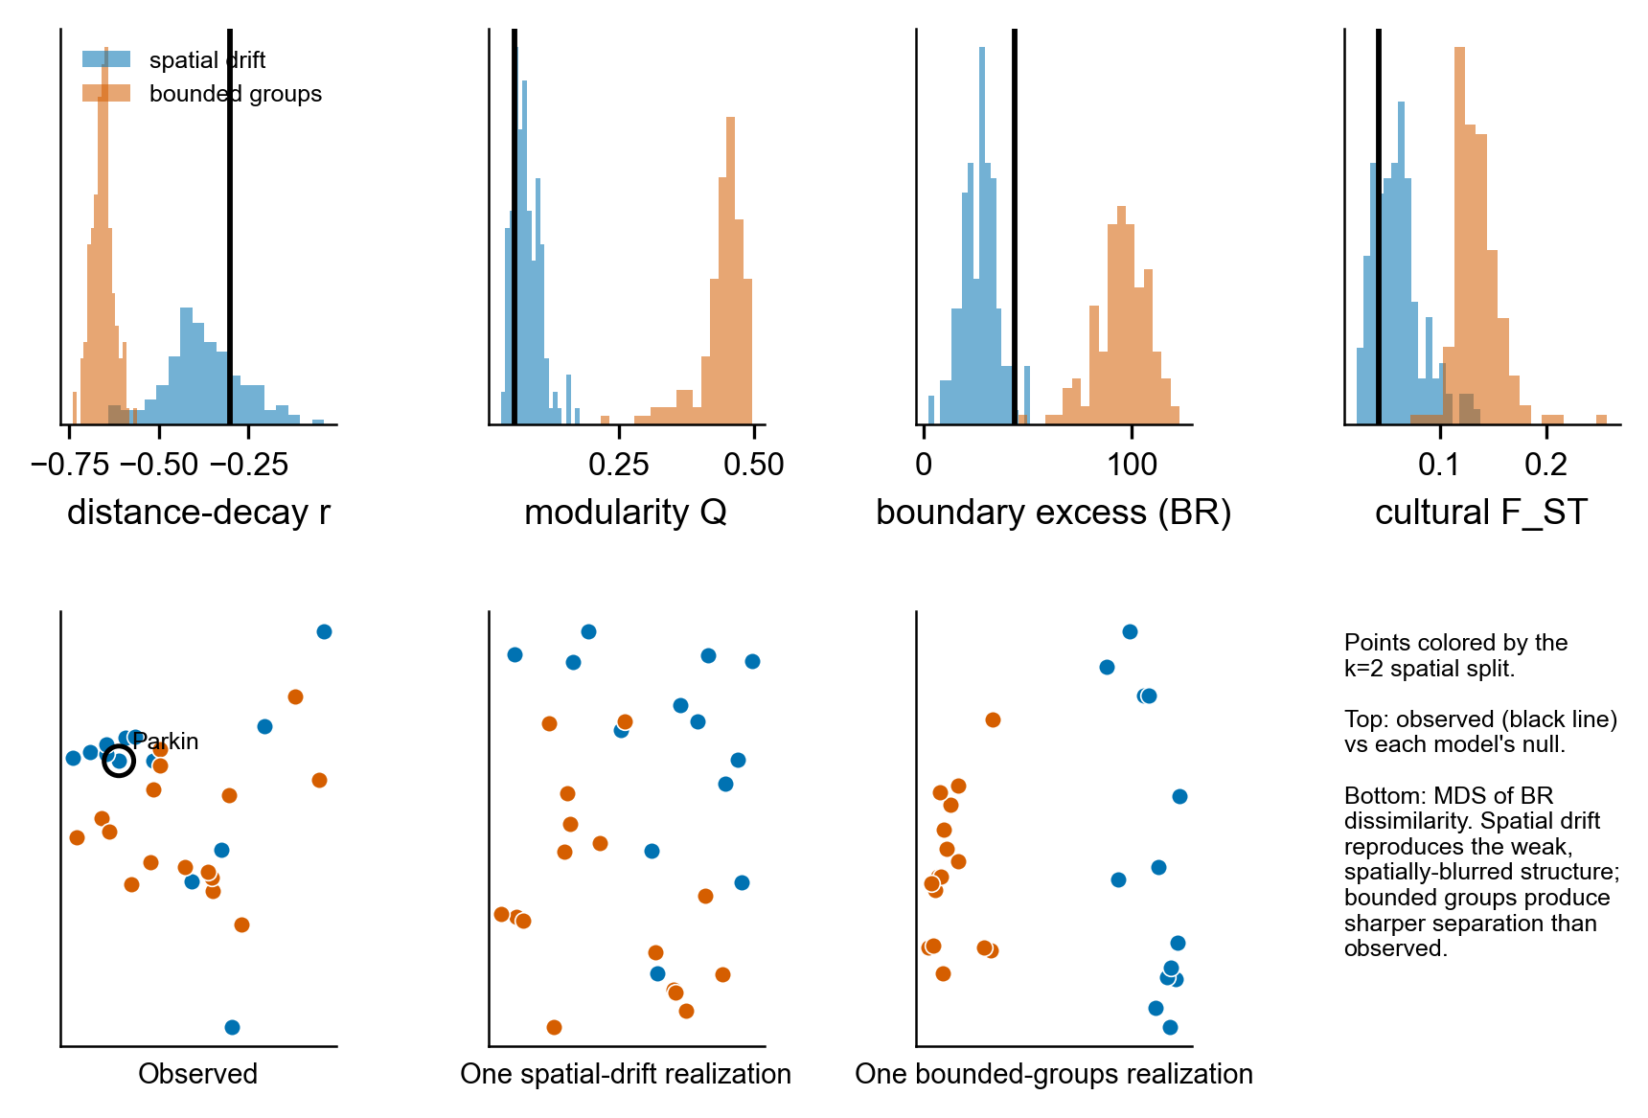
Figure S5. Spatial drift versus bounded groups on the basin geography. Top: the four observed signatures (vertical lines) against the null distributions produced by a neutral spatial-drift model (blue) and a bounded-groups model (orange) on the real coordinate layout, both time-averaged and rarefied to the observed counts. Observed values fall inside the drift distribution and far below the bounded-groups distribution for modularity, boundary excess, and cultural F_ST. Bottom: multidimensional scaling of decorated dissimilarity for the observed assemblages and one realization of each model, spatial drift reproducing the weak, spatially blurred structure while bounded groups produce a sharper split than the data show.

Regional extension: the central-valley and lower-valley assemblages
We extended the analysis to the southeast Missouri survey assemblages of Williams (Williams 1954), comprising 50 collections from 28 sites, digitized from the survey tables and georeferenced using the Lower Mississippi Survey grid. Within the central-valley regions, the decorated-ceramic differentiation is a Woodland-to-Mississippian composition gradient rather than a synchronic structure: a cultural F_ST of 0.11 across physiographic regions collapses to 0.04, near the drift level, once the analysis is restricted to Mississippian types. Between the central and lower valleys, the Phillips-Ford-Griffin assemblages present a different picture. Combining the two into one north-south transect of 133 decorated assemblages, the decline of decorated similarity with distance is itself drift-consistent (Mantel r = -0.55, inside the spatial-drift null). Still, the distance-controlled boundary excess at the central-valley and lower-valley divide is +52 Brainerd-Robinson units, far outside the drift null. The two regions carry mutually exclusive, distinctive repertoires (northern Wickliffe, O’Byam, Matthews, Kimmswick, and Varney Red against southern Barton, Walls Engraved, Carson Red-on-Buff, Avenue Polychrome, and Leland), with even the shared types differing in proportion. Restricting the comparison to types present in both regions, which removes the mutually exclusive distinctive types that carry the strongest temporal contrast, reduces the step but does not erase it: the boundary excess falls to +38 Brainerd-Robinson units. It remains above the neutral-drift null, so the boundary is not solely an artifact of distinctive-type turnover, although the shared types themselves retain some temporal structure. The step is real but confounded by time, because the northern distinctive types are early- to middle-Mississippian and the southern are late (Phillips 1970; Williams 1954), so it cannot be separated from a chronological succession without independent central-valley radiocarbon (Figure S6). It is further confounded by analytical history: the lower-valley assemblages were classified in the Phillips-Ford-Griffin tradition, and the central-valley assemblages were classified separately by Williams, so even shared type names may have been applied to different criteria. The shared-type restriction (boundary excess falling to +38 Brainerd-Robinson units but not vanishing) limits this artifact without removing it, leaving open the possibility that the interaction was continuous across the entire region and that the apparent boundary is a product of two separate collection and analysis histories.
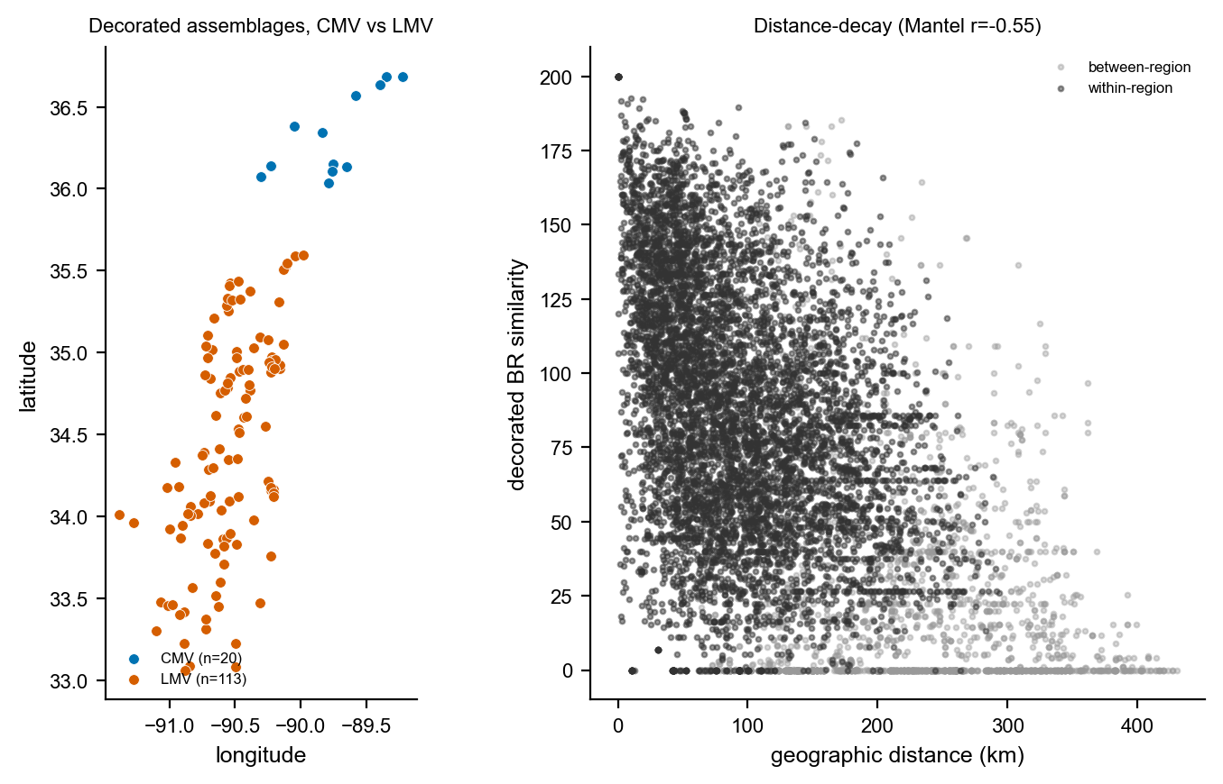
Figure S6. The central-valley and lower-valley transect. Left: the georeferenced decorated assemblages, central-valley (Williams 1954, blue) and lower-valley (Phillips-Ford-Griffin, orange), with the latitudinal gap between the blocks. Right: distance-decay of decorated Brainerd-Robinson similarity across the transect, within-region and between-region pairs distinguished. Similarity declines smoothly with distance as neutral drift predicts, but within-region pairs are markedly more similar than between-region pairs at matched distance, the step at the boundary.

Dynamic-sufficiency tests in the time domain
The four convergence signatures are read as states along the seriation sequence, so on their own they are only partially dynamically sufficient. Two further tests work on the transformation between states, and a third, underpowered probe is reported in the code for completeness. The two we rely on are dynamically and empirically sufficient at once, because each models the change between states while respecting the time-averaged resolution of the record.
The first infers how potters were copying by simulation. We run many copying scenarios, ranging from strongly conformist to neutral to novelty-seeking, and keep only the ones that reproduce the real collections, then read off the kind of copying implied by the surviving scenarios, with the record’s time-averaging built into each simulation (the approximate-Bayesian-computation approach) (Crema et al. 2016). We modeled the basin sequence as frequency-dependent copying among the ten decorated types in a finite population. Each generation, the adoption weight of a type is proportional to its frequency raised to the power $1+b$, where $b>0$ is conformity, $b<0$ is anti-conformity, and $b=0$ is neutral copying, with an innovation rate that mixes in a uniform draw from the set of types. An assemblage pools production over a window of generations, so the time-averaging that distorts the static statistics is built into the generative process rather than corrected after the fact. This is what makes the test both empirically and dynamically sufficient. We drew 40,000 parameter sets from broad priors (innovation rate, bias $b$, population size, and time-averaging window), simulated a six-bin sequence from each, and accepted the 400 parameter sets closest to the observed diversity trajectory and rank-frequency profile, ranked by Euclidean distance over the summary statistics. The posterior of the bias is tightly constrained near neutral, with mean $b=+0.028$ and a 95 percent interval of $−0.021$ to $+0.063$ that includes zero (Figure S4A). The posterior standard deviation is 0.021 against a prior of 0.289, so the data appreciably constrain the bias rather than leaving it at the prior, placing it close to neutral. A weak conformist lean is visible, with $P(b>0)=0.91$, but it is not resolved as a departure from neutral, and refitting the bias separately to the early and late halves of the sequence recovers no shift between them. The inference rules out the strong conformist bias that a marker- or assortment-based dynamic would require by modeling copying dynamics rather than a single static moment. The posterior contraction should be read with one caveat: rejection sampling at a one percent acceptance tolerance is not formally calibrated here, so we present this inference as concordant with the record-matched recovery and the static signatures rather than as a standalone result.
The second test asks, in plain terms, whether the collections’ diversity drifts aimlessly through time, heads steadily in one direction, or is pulled back toward a stable value, by comparing four standard time-series models (an unbiased random walk, a directional walk, stasis, and a mean-reverting Ornstein-Uhlenbeck process) (Hunt 2006; Hunt et al. 2008). For the Gini-Simpson diversity trajectory and for the abundant decorated types, binned along the oriented axis, we fit on the same level vector an unbiased random walk (Brownian motion, the neutral-drift expectation), a general biased random walk (the directional signature a sustained transition would leave), a stasis model (white noise about a constant mean), and an Ornstein-Uhlenbeck model (mean reversion toward an optimum), and compared them by the small-sample Akaike information criterion. The aggregate diversity trajectory favors the unbiased random walk, with an Akaike weight of 0.81 against 0.19 for the directional model and negligible weight for stasis or the Ornstein-Uhlenbeck model. The model comparison has only six points, so it is weak. This result is a concordance rather than a decisive selection (Figure S4B). The diversity trajectory is the trait of interest here, because the correspondence-analysis ordering does not arrange it by construction. Individual-type trajectories more often favor the directional model. That comparison, however, is weak and partly tautological because the seriation axis is designed to maximize monotonic type-frequency turnover, and only three types are abundant enough across the sequence to fit. The robust reading is neutral drift, not a sustained directional transition.
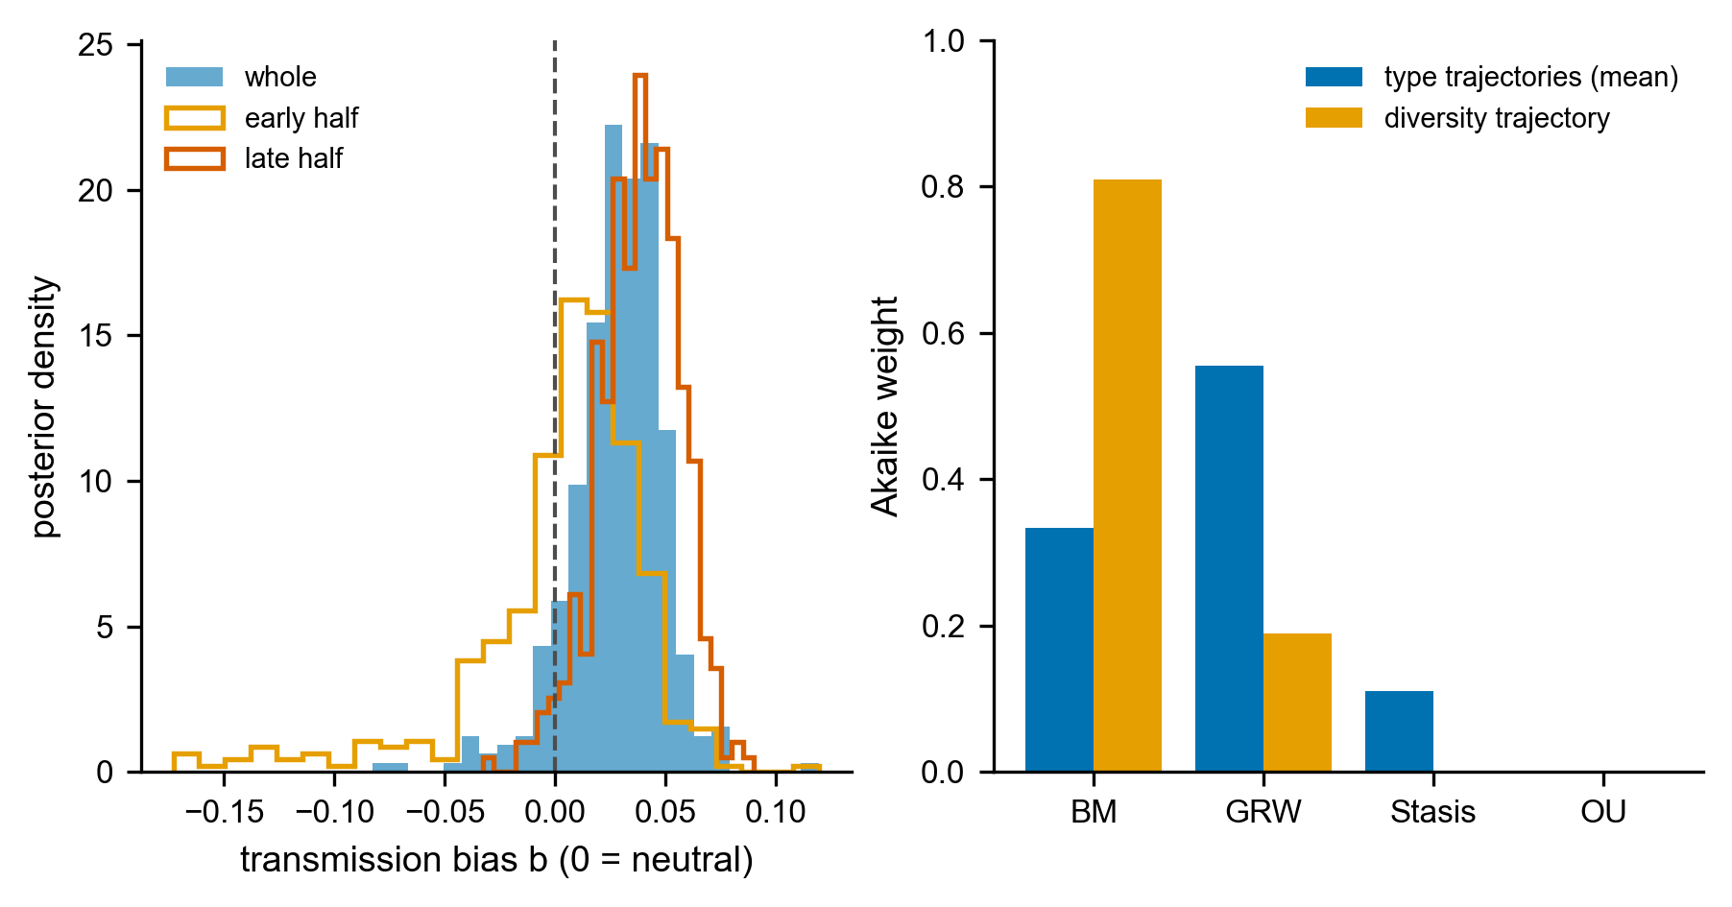
Figure S2. Dynamic-sufficiency tests. (A) Posterior of the transmission-bias parameter b from the generative, time-averaging-aware inference (b = 0 neutral, b > 0 conformist, b < 0 anti-conformist). The whole-sequence posterior (filled) and the early- and late-half posteriors (outlines) are all tightly constrained near neutral and include zero, ruling out the strong conformity a marker dynamic would require. (B) Tempo-and-mode Akaike weights of the four time-series models (BM unbiased random walk, GRW directional walk, Stasis, OU mean reversion) for the Gini-Simpson diversity trajectory and averaged across the abundant type trajectories. The diversity trajectory, which the correspondence-analysis ordering does not arrange by construction, favors the unbiased random walk (neutral drift), a concordance rather than a decisive selection given only six points.
A third probe, for the early-warning signature of a critical transition, is underpowered at this ordinal resolution and does not meet empirical sufficiency: across the correspondence-analysis-ordered sequence the rolling variance shows no rising trend (Kendall tau $=−0.03$) and the lone rise in lag-1 autocorrelation (tau $=+0.78$) is an artifact of the ordering, which places compositionally similar assemblages adjacent, so we report it in the supplementary code but do not rely on it (Dakos et al. 2012; Scheffer et al. 2009).

Radiocarbon chronology
We calibrated the Mainfort compilation of central-valley determinations against IntCal20 (Mainfort 2001). Forty-one determinations come from seven St. Francis Basin Parkin-phase sites, nineteen of them from Parkin. The summed probability distribution of the basin dates concentrates the occupation in the fourteenth to sixteenth centuries, with a median of AD 1422 (Parkin alone, AD 1483), and declines across the contact interval: 29 percent of the basin probability mass postdates AD 1541 and 18 percent postdates AD 1600 (Figure S3). This is consistent with occupation continuing through the De Soto entrada, which the chronicles place at Casqui, and declining thereafter, rather than with a sequence running unbroken into the seventeenth century. However, the protohistoric tail is partly a calibration artifact of low-activity determinations near the post-1650 plateau. To test the assumption that the seriation axis tracks calendar time, we pooled the dates of the five proveniences matching curated assemblages. We correlated their pooled median calibrated ages with CA1 position: Spearman’s r = +0.70 (n = 5, 27 dates pooled), with four sites in calendar order and one late-dated site, Clay Hill, departing from it. The orientation of the axis toward later time is supported but not certain, and we treat directional statements as provisional throughout.
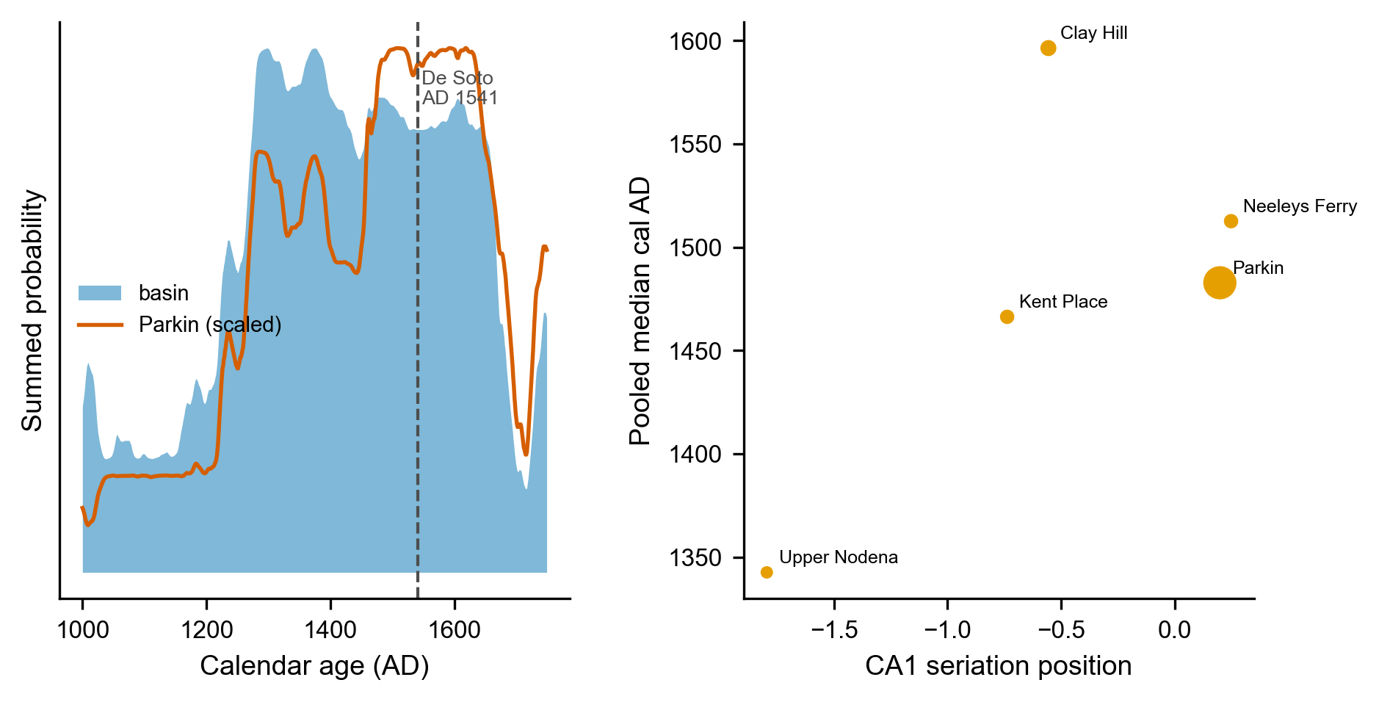
Figure S3. Radiocarbon chronology of the St. Francis basin (Mainfort determinations calibrated against IntCal20). Left: summed probability distribution for the basin Parkin-phase sites (filled) and for Parkin alone (line, scaled), with the De Soto entrada (AD 1541) marked. Occupation concentrates in the fourteenth to sixteenth centuries and declines across contact. Right: CA1 seriation position against the pooled median calibrated age for the five proveniences matching curated assemblages (point size proportional to the number of dates). The axis tracks calendar age (Spearman +0.70) except for the late-dated Clay Hill.

References
Bell, Adrian V., Peter J. Richerson, and Richard McElreath. 2009. Culture Rather Than Genes Provides Greater Scope for the Evolution of Large-Scale Human Prosociality. Proceedings of the National Academy of Sciences 106(42):17671–17674. https://doi.org/10.1073/pnas.0903232106.
Bentley, R. Alexander, Matthew W. Hahn, and Stephen J. Shennan. 2004. Random Drift and Culture Change. Proceedings of the Royal Society B: Biological Sciences 271:1443–1450. https://doi.org/10.1098/rspb.2004.2746.
Binford, Lewis R. 1981. Behavioral Archaeology and the “Pompeii Premise.” Journal of Anthropological Research 37(3):195–208.
Cobb, Charles R. 2000. From Quarry to Cornfield: The Political Economy of Mississippian Hoe Production. University of Alabama Press, Tuscaloosa.
Cobb, Charles R., and Brian M. Butler. 2002. The Vacant Quarter Revisited: Late Mississippian Abandonment of the Lower Ohio Valley. American Antiquity 67(4):625–641.
Crema, Enrico R., Eugenio Bortolini, and Mark Lake. 2024. How Cultural Transmission Through Objects Impacts Inferences about Cultural Evolution. Journal of Archaeological Method and Theory 31:202–226. https://doi.org/10.1007/s10816-022-09599-x.
Crema, Enrico R., Anne Kandler, and Stephen Shennan. 2016. Revealing Patterns of Cultural Transmission from Frequency Data: Equilibrium and Non-Equilibrium Assumptions. Scientific Reports 6:39122. https://doi.org/10.1038/srep39122.
Dakos, Vasilis, Stephen R. Carpenter, William A. Brock, Aaron M. Ellison, Vishwesha Guttal, Anthony R. Ives, Sonia Kéfi, et al. 2012. Methods for Detecting Early Warnings of Critical Transitions in Time Series Illustrated Using Simulated Ecological Data. PLoS ONE 7(7):e41010. https://doi.org/10.1371/journal.pone.0041010.
Dunnell, Robert C. 1995. What Is It That Actually Evolves? In Evolutionary Archaeology: Methodological Issues, edited by Patrice A. Teltser, pp. 33–50. University of Arizona Press, Tucson.
Ewens, Warren J. 1972. The Sampling Theory of Selectively Neutral Alleles. Theoretical Population Biology 3(1):87–112.
Feder, Alison F., Sergey Kryazhimskiy, and Joshua B. Plotkin. 2014. Identifying Signatures of Selection in Genetic Time Series. Genetics 196(2):509–522. https://doi.org/10.1534/genetics.113.158220.
Fox, Gregory L. 1998. An Examination of Mississippian-Period Phases in Southeastern Missouri. In Changing Perspectives on the Archaeology of the Central Mississippi River Valley, edited by Michael J. O’Brien and Robert C. Dunnell, pp. 31–58. University of Alabama Press, Tuscaloosa.
Holdaway, Simon J., and LuAnn Wandsnider (editors). 2008. Time in Archaeology: Time Perspectivism Revisited. University of Utah Press, Salt Lake City.
Hudson, Charles, Marvin T. Smith, and Chester B. DePratter. 1990. The Hernando de Soto Expedition: From Mabila to the Mississippi River. In Towns and Temples Along the Mississippi, edited by David H. Dye and Cheryl Anne Cox, pp. 181–207. University of Alabama Press, Tuscaloosa.
Hunt, Gene. 2006. Fitting and Comparing Models of Phyletic Evolution: Random Walks and Beyond. Paleobiology 32(4):578–601. https://doi.org/10.1666/05070.1.
Hunt, Gene, Michael A. Bell, and Matthew P. Travis. 2008. Evolution Toward a New Adaptive Optimum: Phenotypic Evolution in a Fossil Stickleback Lineage. Evolution 62(3):700–710. https://doi.org/10.1111/j.1558-5646.2007.00310.x.
Kandler, Anne, and Stephen Shennan. 2013. A Non-Equilibrium Neutral Model for Analysing Cultural Change. Journal of Theoretical Biology 330:18–25. https://doi.org/10.1016/j.jtbi.2013.03.006.
Kandler, Anne, Bryan Wilder, and Laura Fortunato. 2017. Inferring Individual-Level Processes from Population-Level Patterns in Cultural Evolution. Royal Society Open Science 4:170949. https://doi.org/10.1098/rsos.170949.
Kidwell, Susan M., and Adam Tomašových. 2013. Implications of Time-Averaged Death Assemblages for Ecology and Conservation Biology. Annual Review of Ecology, Evolution, and Systematics 44:539–563. https://doi.org/10.1146/annurev-ecolsys-110512-135838.
King, Adam, and Jennifer A. Freer. 1995. The Mississippian Southeast: A World-Systems Perspective. In Native American Interactions: Multiscalar Analyses and Interpretations in the Eastern Woodlands, edited by Michael S. Nassaney and Kenneth E. Sassaman, pp. 266–288. University of Tennessee Press, Knoxville.
Lewontin, Richard C. 1974. The Genetic Basis of Evolutionary Change. Columbia University Press, New York.
Lipo, Carl P. 2001. Science, Style and the Study of Community Structure: An Example from the Central Mississippi River Valley. BAR International Series 918. Archaeopress, Oxford.
Lipo, Carl P., Robert J. DiNapoli, Mark E. Madsen, and Terry L. Hunt. 2021. Population Structure Drives Cultural Diversity in Finite Populations: A Hypothesis for Localized Community Patterns on Rapa Nui (Easter Island, Chile). PLoS ONE 16(5):e0250690. https://doi.org/10.1371/journal.pone.0250690.
Lipo, Carl P., and Robert C. Dunnell. 2007. Prehistoric Settlement in the Lower Mississippi Valley: A Critical Review. In Settlement Patterns and Subsistence Systems in the Lower Mississippi Valley, pp. 125–167.
Lipo, Carl P., Mark E. Madsen, and Robert C. Dunnell. 2015. A Theoretically-Sufficient and Computationally-Practical Technique for Deterministic Frequency Seriation. PLOS ONE 10(4):e0124942. https://doi.org/10.1371/journal.pone.0124942.
Madsen, Mark E. 2012. Neutral Cultural Transmission in Time Averaged Archaeological Assemblages.
Mainfort, Jr., Robert C. 2001. The Late Prehistoric and Protohistoric Periods in the Central Mississippi Valley. In Societies in Eclipse: Archaeology of the Eastern Woodlands Indians, a.d. 1400–1700, edited by David S. Brose, C. Wesley Cowan, and Jr. Mainfort Robert C., pp. 173–190. Smithsonian Institution Press, Washington, DC.
Mainfort, Jr., Robert C. 2003. An Ordination Approach to Assessing Late Period Phases in the Central Mississippi Valley. Southeastern Archaeology 22(2):176–184.
Mesoudi, Alex. 2021. Cultural Selection and Biased Transformation: Two Dynamics of Cultural Evolution. Philosophical Transactions of the Royal Society B: Biological Sciences 376:20200053.
Mitchem, Jeffrey M. 2001. A Decade of Hypothesis Testing at the Parkin Site, Arkansas.
Morse, Dan F., and Phyllis A. Morse. 1996. Changes in Interpretation in the Archaeology of the Central Mississippi Valley Since 1983.
Morse, Phyllis A. 1990. The Parkin Site and the Parkin Phase. In Towns and Temples Along the Mississippi, edited by David H. Dye and Cheryl Anne Cox, pp. 118–134. University of Alabama Press, Tuscaloosa.
Neiman, Fraser D. 1995. Stylistic Variation in Evolutionary Perspective: Inferences from Decorative Diversity and Interassemblage Distance in Illinois Woodland Ceramic Assemblages. American Antiquity 60(1):7–36.
Perreault, Charles. 2019. The Quality of the Archaeological Record. University of Chicago Press, Chicago.
Phillips, Philip. 1970. Archaeological Survey in the Lower Yazoo Basin, Mississippi, 1949–1955, Vol. 60. Papers of the Peabody Museum of Archaeology and Ethnology. Peabody Museum, Harvard University, Cambridge, MA.
Phillips, Philip, James A. Ford, and James B. Griffin. 1951. Archaeological Survey in the Lower Mississippi Alluvial Valley, 1940–1947, Vol. 25. Papers of the Peabody Museum of American Archaeology and Ethnology. Peabody Museum, Harvard University, Cambridge, MA.
Premo, L. S. 2014. Cultural Transmission and Diversity in Time-Averaged Assemblages. Current Anthropology 55(1):105–114. https://doi.org/10.1086/674873.
Rees, Mark A. 2001. Mississippian Political Culture: Contrasting Historical Trajectories in Southeastern North America. Ph.D. dissertation, University of Oklahoma, Norman.
Ross-Stallings, Nancy A. 2015. Center and Satellite Settlement Hierarchy and Diet on the Late Prehistoric Mississippi Delta. In, pp. 329–362.
Scheffer, Marten, Jordi Bascompte, William A. Brock, Victor Brovkin, Stephen R. Carpenter, Vasilis Dakos, Hermann Held, Egbert H. van Nes, Max Rietkerk, and George Sugihara. 2009. Early-Warning Signals for Critical Transitions. Nature 461(7260):53–59. https://doi.org/10.1038/nature08227.
Schiffer, Michael B. 1972. Archaeological Context and Systemic Context. American Antiquity 37(2):156–165.
Shennan, Stephen J., and James R. Wilkinson. 2001. Ceramic Style Change and Neutral Evolution: A Case Study from Neolithic Europe. American Antiquity 66(4):577–593.
Tomašových, Adam, and Susan M. Kidwell. 2009. Fidelity of Variation in Species Composition and Diversity Partitioning by Death Assemblages: Time-Averaging Transfers Diversity from Beta to Alpha Levels. Paleobiology 35(1):94–118.
Tomašových, Adam, and Susan M. Kidwell. 2010. The Effects of Temporal Resolution on Species Turnover and on Testing Metacommunity Models. The American Naturalist 175(5):587–606. https://doi.org/10.1086/651661.
Williams, Stephen. 1954. An Archeological Study of the Mississippian Culture in Southeast Missouri. PhD thesis, Yale University, New Haven.
Williams, Stephen. 1990. The Vacant Quarter and Other Late Events in the Lower Valley. In Towns and Temples Along the Mississippi, edited by David H. Dye and Cheryl Anne Cox, pp. 170–180. University of Alabama Press, Tuscaloosa.

