Price Equation Extensions for Cooperative Signaling Under Environmental Uncertainty: A Unified Mathematical Framework
Authors: [Authors]
Target Journal: Journal of Theoretical Biology

Abstract
Why do costly cooperative behaviors persist across diverse human societies, from monumental architecture on Pacific islands to seasonal aggregation camps in temperate forests? We develop a unified mathematical framework, grounded in the Price equation for multilevel selection, that predicts when costly cooperation becomes the evolutionarily stable strategy as a function of environmental uncertainty. Beginning with the standard Price equation, we introduce eight successive extensions: (1) environmental uncertainty as an explicit fitness parameter, (2) asymmetric vulnerability between cooperators and defectors, (3) decomposed costs of cooperation, (4) a critical uncertainty threshold marking the phase transition to cooperation, (5) ecotone advantage via portfolio theory, (6) returns to scale from group cooperation, (7) reciprocal obligations as future insurance, and (8) conflict reduction through costly signaling. Each extension addresses a specific ecological or social feature observed in the archaeological record. We calibrate the framework against four archaeological case studies spanning diverse subsistence systems, geographies, and social organizations: Rapa Nui (Easter Island), Chaco Canyon, Poverty Point, and Lamoka Lake. The framework yields a single testable prediction, a critical environmental uncertainty threshold $σ^{*}$, above which cooperation is favored and below which defection dominates. We derive closed-form expressions for $σ^{*}$ as a function of all model parameters, present sensitivity analyses, and demonstrate that agent-based simulations converge on the analytical predictions ($r=0.969$ for the Rapa Nui case). The four case studies occupy distinct but connected regions of parameter space, with each case emerging as a special configuration of the general model by activating or deactivating specific terms. This framework provides a principled, empirically grounded approach to predicting when and where costly cooperative behaviors should arise in human societies.
Keywords: Price equation, costly signaling, multilevel selection, environmental uncertainty, cooperation, aggregation, portfolio theory, hunter-gatherer, archaeological modeling

1. Introduction
Across the archaeological record, human societies have repeatedly invested enormous resources in cooperative enterprises that appear, at first glance, to defy individual self-interest. On Rapa Nui (Easter Island), small competing groups carved and transported multi-ton stone statues (moai) and erected them on ceremonial platforms (ahu), despite living on a resource-limited island (Hunt and Lipo 2011). In Chaco Canyon, New Mexico, communities constructed massive “great houses” requiring millions of person-hours of labor and imported exotic materials from hundreds of kilometers away (Lekson 2006). At Poverty Point, Louisiana, mobile hunter-gatherers built the largest Pre-Columbian earthwork complex in North America, including a 22-meter-high mound, while maintaining long-distance exchange networks spanning 1,600 km (Gibson 2000; Kidder et al. 2008). At Lamoka Lake, New York, foraging bands aggregated seasonally at processing camps, investing in shared infrastructure despite having no monumental architecture (Ritchie 1932).
These cases span enormous variation in subsistence (agriculture to hunting-gathering), social organization (territorial kin groups to fluid band networks), geography (isolated islands to continental interiors), and the specific form of cooperative investment (stone statues, great houses, earthen mounds, processing camps). Yet they share a common puzzle: why do individuals bear real fitness costs, diverted labor, foregone foraging, risky long-distance travel, to participate in collective enterprises?
Costly signaling theory (Zahavi 1975; Grafen 1990; Bliege Bird and Smith 2005) provides a partial answer: signals must be costly to be honest, and honest signals of quality or commitment can stabilize cooperation by allowing reliable partner assessment. But the theory, as typically applied, does not specify when costly signaling should arise versus when it should not. If signaling is always adaptive, we should see it everywhere; if never, nowhere. The empirical reality is that costly cooperative signaling appears in some times and places but not others, even among closely related populations.
This paper develops a mathematical framework that predicts the conditions under which costly cooperative behaviors become evolutionarily stable. We begin with the Price equation (Price 1970, 1972), the most general formulation of evolutionary change, and introduce a series of extensions that progressively incorporate the ecological and social features necessary to model cooperation under environmental uncertainty. Each extension is motivated by a specific empirical observation, and each introduces parameters with ranges justified by archaeological, ecological, or ethnographic data.
The central result is a critical environmental uncertainty threshold $σ^{*}$: below this threshold, non-cooperation (defection, independent foraging) is the favored strategy; above it, cooperation (signaling, aggregation) becomes the evolutionarily stable strategy. The threshold $σ^{*}$ is a function of all model parameters, signaling costs, vulnerability asymmetries, ecotone advantages, group size effects, and more, creating a rich but tractable prediction space.
We calibrate the framework against four archaeological case studies (Table 1) and show that each case emerges as a special configuration of the general model, with specific terms activated or deactivated depending on the ecological and social context.
Table 1. Four archaeological case studies and their key features.
Feature | Rapa Nui | Chaco Canyon | Poverty Point | Lamoka Lake
Region | SE Pacific | SW North America | SE North America | NE North America
Dates | ~1200–1600 CE | ~800–1200 CE | ~1700–1100 BCE | ~3500–1900 BCE
Subsistence | Agriculture | Agriculture | Hunter-gatherer | Hunter-gatherer
Settlement | Permanent territorial | Semi-permanent | Seasonal aggregation | Seasonal aggregation
Signal type | Moai/ahu | Great houses + exotics | Mounds + exotics | Shared infrastructure
Costly signaling? | Yes | Yes | Yes | No (pure aggregation)
Conflict reduction? | Yes | Yes | No | No
Ecotone advantage? | No | Weak | Strong | Strong
The paper proceeds as follows. Section 2 reviews the standard Price equation and its multilevel partition. Sections 3 through 10 introduce each extension in turn, deriving the mathematical form, explaining why it is needed, and specifying parameter ranges with empirical justification. Section 11 presents the unified framework showing how all four case studies emerge as special cases. Section 12 provides sensitivity analysis and phase diagrams. Section 13 validates the analytical framework against agent-based simulations. Section 14 discusses implications and limitations.

1.1 A Note on Parameter Confidence
Throughout this paper, we specify numerical values for model parameters. These values vary considerably in how well they are established. To help the reader assess the empirical grounding of each estimate, we classify parameters into three confidence tiers:
- Tier A (Empirically grounded): Values derived directly from archaeological measurements, paleoclimate proxy records, or well-established ecological data. Examples include labor investment estimates from excavation data and environmental uncertainty ($σ$) calibrated from tree-ring or speleothem records. These values have quantifiable uncertainty ranges.
- Tier B (Proxy-estimated): Values estimated indirectly from ethnographic analogy, cross-cultural comparison, or ecological reasoning. Examples include vulnerability parameters ($α$, $β$) inferred from the logic of risk pooling, and cooperation costs ($C_{\text{total}}$) estimated from labor-to-subsistence ratios. These values are plausible and internally consistent but could be refined with targeted empirical research.
- Tier C (Theoretically motivated): Values set primarily by theoretical constraints or calibration against expected outcomes, with limited independent empirical support. Examples include the reciprocal obligation parameter ($B_{\text{recip}}$) and the crowding coefficient ($c$) in the returns-to-scale function. These are the parameters most in need of future empirical research.
Each parameter table in the following sections includes a confidence tier designation. We return to the question of which parameters most urgently require empirical investigation in Section 14.5.

2. The Standard Price Equation
In plain terms: The Price equation is a bookkeeping tool that tracks how traits change in a population over time. It says something intuitive: traits that are associated with higher survival and reproduction will become more common. When we apply it to cooperation, it reveals a fundamental tension: free-riders do better within any given group (they get the benefits without paying the costs), but groups with more cooperators do better as groups. Whether cooperation wins depends on which of these forces is stronger.

2.1 The Univariate Form
The Price equation (Price 1970) provides the most general description of evolutionary change in a population. For a trait $p$ distributed across individuals indexed by $i$, the change in the population mean $\overset{‾}{p}$ over one generation is:
$$Δ\overset{‾}{p}=\frac{1}{\overset{‾}{w}}\text{Cov}(w_{i},p_{i}) (1)$$
where $w_{i}$ is the fitness (expected number of descendants) of individual $i$, $\overset{‾}{w}$ is the population mean fitness, and $\text{Cov}(w_{i},p_{i})$ is the covariance between fitness and trait value across all individuals. The equation states that evolutionary change in a trait is proportional to the covariance between that trait and fitness: traits positively associated with fitness increase in frequency; traits negatively associated decrease.
Equation (1) is exact and assumption-free. It holds regardless of the genetic architecture, mating system, or population structure. This generality makes it a natural starting point for building models of cultural evolutionary dynamics where the “trait” of interest is a behavioral strategy (cooperation vs. defection) and “fitness” is a composite measure of survival and reproduction.

2.2 The Multilevel Partition
Price (1972) showed that when individuals are organized into groups, Equation (1) can be decomposed into between-group and within-group components:
$$Δ\overset{‾}{p}=\frac{1}{\overset{‾}{w}}\text{Cov}(w_{g},p_{g})+\frac{1}{\overset{‾}{w}}E[w_{g}⋅Δp_{g}] (2)$$
where $w_{g}$ is the mean fitness of group $g$, $p_{g}$ is the mean trait value in group $g$, and $Δp_{g}$ is the change in mean trait value within group $g$ over one generation.
The first term, $\frac{1}{\overset{‾}{w}}\text{Cov}(w_{g},p_{g})$, captures between-group selection: groups with higher mean trait values (more cooperators) have higher mean fitness, so the trait increases via differential group success. The second term, $\frac{1}{\overset{‾}{w}}E[w_{g}⋅Δp_{g}]$, captures within-group selection: within each group, individuals with different trait values have different fitness, typically favoring free-riders who enjoy cooperation benefits without paying costs.
This decomposition reveals the fundamental tension in the evolution of cooperation. Costly cooperation faces opposition from within-group selection (free-riders outcompete cooperators within any given group) but support from between-group selection (groups with more cooperators outperform groups with fewer). Cooperation evolves when between-group selection is strong enough to overcome within-group selection:
$$\text{Cov}(w_{g},p_{g})>|E[w_{g}⋅Δp_{g}]| (3)$$

2.3 Why the Price Equation for Cooperation?
Three features of the Price equation make it the appropriate foundation for modeling costly cooperation:
- Generality: It makes no assumptions about inheritance mechanisms, allowing application to both genetic and cultural transmission.
- Multilevel structure: The partition in Equation (2) directly captures the multilevel selection dynamics central to cooperation, the tension between individual and group interests.
- Fitness decomposition: Fitness $w_{i}$ can be decomposed into components (survival, reproduction, conflict), each of which can be made dependent on environmental parameters, yielding a modular framework.
However, the standard Price equation (Equations 1–2) has a critical limitation for our purposes: fitness values $w_{i}$ are treated as fixed quantities. In reality, the fitness consequences of cooperation versus defection depend on environmental context. A cooperative strategy that is costly in a stable environment may become essential in an uncertain one. The extensions that follow address this limitation by making fitness an explicit function of environmental and social parameters.
How the extensions connect to the Price equation: In the sections that follow, we build explicit fitness functions for cooperators ($W_{C}$) and defectors ($W_{D}$) as functions of environmental and social parameters. These fitness functions determine the covariance terms in Equation (2): when $W_{C}>W_{D}$, the between-group covariance term is positive (cooperating groups outperform), favoring cooperation; when $W_{C}<W_{D}$, the within-group term dominates, favoring defection. The critical threshold $σ^{*}$ where $W_{C}=W_{D}$ (derived in Section 6) is therefore the point where $Δ\overset{‾}{p}=0$, the boundary between the two selective regimes identified by the multilevel Price equation.

3. Extension 1: Environmental Uncertainty ($σ$)
In plain terms: Whether cooperation pays depends on how unpredictable the environment is. When food is abundant and reliable, there is no reason to share; going it alone works fine. When food is scarce and unpredictable, pooling resources with others can mean the difference between surviving and starving. We capture this idea with a single number, $σ$, that measures how variable food returns are from year to year.

3.1 Motivation
The standard Price equation treats fitness as a static property of individuals or strategies. But the fitness consequences of cooperation are profoundly context-dependent. When resources are abundant and predictable, cooperation imposes costs with little benefit: why share when there is enough for everyone? When resources are scarce and unpredictable, cooperation provides insurance, information sharing, and risk pooling that can mean the difference between survival and extinction.
To capture this context-dependence, we make fitness an explicit function of environmental uncertainty $σ$.

3.2 Definition
We define $σ∈[0,1]$ as the environmental uncertainty parameter, representing the coefficient of variation in annual resource returns experienced by a population. Formally:
$$σ=\frac{\text{SD}(\text{annual resource returns})}{\text{Mean}(\text{annual resource returns})} (4)$$
In practice, $σ$ integrates three components of environmental risk:
$$σ∝\frac{\text{magnitude}×\text{duration}}{\text{return period}} (5)$$
where magnitude is the depth of resource shortfalls (0–1 scale), duration is the persistence of shortfall episodes (years), and return period is the average interval between shortfall events (years). This formulation captures the intuition that environments are more uncertain when shortfalls are severe, prolonged, and frequent.

3.3 Modified Price Equation
Substituting $σ$-dependent fitness into the multilevel Price equation:
$$Δ\overset{‾}{p}(σ)=\frac{1}{\overset{‾}{w}(σ)}\text{Cov}(w_{g}(σ),p_{g})+\frac{1}{\overset{‾}{w}(σ)}E[w_{g}(σ)⋅Δp_{g}] (6)$$
The trait frequencies $p_{g}$ remain strategy proportions (fraction of cooperators in group $g$), but the fitness values $w_{g}(σ)$ now depend on environmental context. This means the direction of selection, not just its strength, can change with $σ$.
At low $σ$, the within-group selection term dominates (free-riders prosper in stable environments), and $Δ\overset{‾}{p}<0$ (cooperation declines). At high $σ$, the between-group selection term dominates (cooperating groups survive environmental shocks), and $Δ\overset{‾}{p}>0$ (cooperation increases). There exists a critical value $σ^{*}$ where the two terms balance and $Δ\overset{‾}{p}=0$, which we derive in Section 6.

3.4 Parameter Range and Justification
Table 2. Environmental uncertainty parameter ranges with archaeological calibration. Confidence tier: A for Chaco (tree-ring calibrated), A/B for Rapa Nui (ENSO proxy calibrated), B for Poverty Point and Lamoka Lake (speleothem and pollen proxies with wider uncertainty).
$σ$ Range | Interpretation | Archaeological/ecological examples | Calibration source
$<0.15$ | Very stable | Rapa Iti (no monumentality), stable tropical environments | Minimal interannual variation
$0.15$–$0.35$ | Moderate uncertainty | Chaco Canyon ($σ≈0.17$), Rapa Nui ($σ≈0.31$) | Tree-ring and ENSO proxy records
$0.35$–$0.55$ | High uncertainty | Lamoka Lake ($σ≈0.35$–$0.45$), Poverty Point ($σ≈0.45$–$0.55$) | Speleothem $δ^{18}$O, pollen records
$0.55$–$0.80$ | Extreme uncertainty | Saharan margins, High Arctic | Paleoclimate reconstructions
$>0.80$ | Uninhabitable | No sustained occupation observed | Theoretical upper bound
Archaeological calibration methods:
For Rapa Nui, $σ≈0.31$: calibrated from ENSO-driven drought frequency in the southeastern Pacific. Shortfall events occur approximately every 6 years with magnitude 50–67% and duration 2–3 years, yielding $σ≈(0.6×2.5)/6≈0.25$–$0.31$.
For Poverty Point, $σ≈0.45$–$0.55$: estimated from Gulf Coast Late Holocene paleoclimate records including speleothem $δ^{18}$O from DeSoto Caverns and pollen sequences from Gulf coastal lakes, reflecting substantial interannual variability in Mississippi Valley hydrology during the Late Archaic (1700–1100 BCE).
For Chaco Canyon, $σ≈0.17$ during the florescence period (1000–1130 CE): calibrated from tree-ring records showing drought magnitude ~40%, duration ~3 years, and return period ~7 years.
For Lamoka Lake, $σ≈0.35$–$0.45$: estimated from Late Archaic paleoclimate proxies for the Finger Lakes region, where the continental climate produced moderate interannual variation buffered by lake-effect moderation.

3.5 Why $σ$ Must Be Bounded
The upper bound $σ<1$ is not arbitrary. When $σ≥1$, the coefficient of variation equals or exceeds the mean, implying that resource returns are frequently zero or negative, conditions incompatible with sustained human occupation. The lower bound $σ≥0$ represents a perfectly predictable environment (zero variance), which is a theoretical idealization never observed in practice.
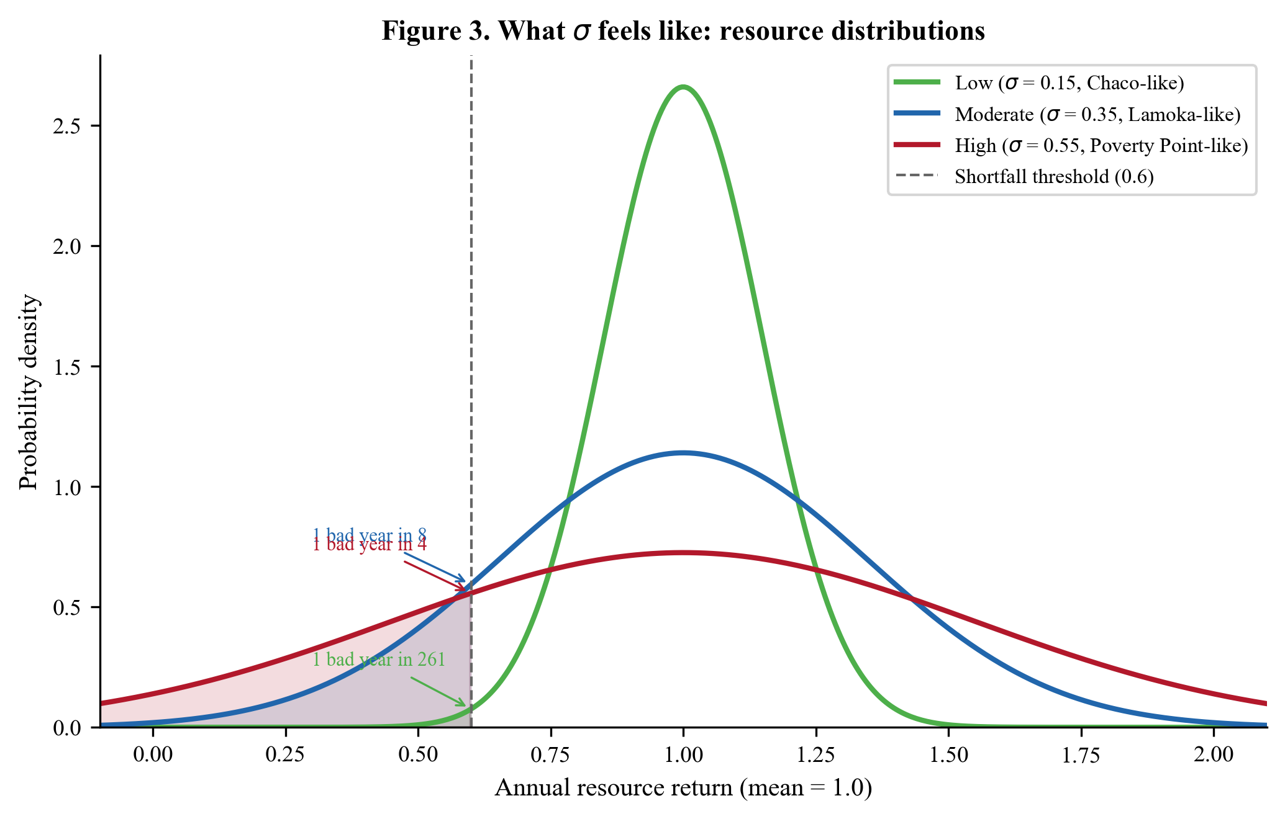
Figure 3. What σ feels like: resource distributions under low (σ = 0.15, Chaco-like), moderate (σ = 0.35, Lamoka-like), and high (σ = 0.55, Poverty Point-like) uncertainty. Shaded tails below the shortfall threshold show the probability of a bad year. Higher σ means wider distributions and more frequent shortfalls.

4. Extension 2: Asymmetric Vulnerability ($α$, $β$)
In plain terms: Environmental uncertainty matters only if it affects different strategies differently. The key insight is that cooperators and loners experience the same bad year differently. Cooperators pool risk: when one household’s crop fails, another’s might succeed, and they share. Loners bear the full brunt of whatever happens in their own patch. We capture this with two numbers: $α$ (how much a bad year hurts cooperators) and $β$ (how much it hurts loners). The requirement $α<β$, that cooperators are less hurt, is not an assumption for mathematical convenience; it is the concrete mechanism by which cooperation provides a survival advantage.

4.1 Motivation
Making fitness dependent on $σ$ (Extension 1) is necessary but not sufficient. If all strategies suffered equally from environmental uncertainty, there would be no selection differential and no evolutionary response. The crucial insight is that different strategies experience environmental uncertainty differently.
Cooperators, whether they aggregate seasonally, build monuments as group signals, or maintain exchange networks, pool risk across individuals and resource zones. Independents (defectors, non-cooperators) bear the full variance of their local environment. This asymmetry in vulnerability to $σ$ is the mechanism that creates a selection gradient favoring cooperation under high uncertainty.

4.2 Formulation
We define two vulnerability parameters:
- $α$: vulnerability of cooperators to environmental uncertainty ($α∈[0.10,0.50]$)
- $β$: vulnerability of independents/defectors to environmental uncertainty ($β∈[0.50,0.95]$)
The survival component of fitness becomes:
$$S_{\text{cooperator}}(σ)=1−α⋅σ (7)$$
$$S_{\text{defector}}(σ)=1−β⋅σ (8)$$
The constraint $α<β$ must hold for cooperation to ever be favored, it encodes the assumption that cooperators are less vulnerable to environmental shocks than independents, which is the mechanism by which cooperation provides fitness benefits.
The ratio $β/α$ determines the strength of the selection gradient: higher ratios mean cooperation provides greater relative protection. When $β/α=1$, cooperation provides no survival advantage and is never selected (given its costs). As $β/α→∞$, cooperation becomes overwhelmingly advantageous even at low $σ$.

4.3 Biological Interpretation
The asymmetry $α<β$ is not an assumption imposed for mathematical convenience. It reflects concrete mechanisms:
- Risk pooling: Cooperators share resources across individuals, reducing variance in individual returns. If $N$ individuals pool independently distributed resources, the variance of individual consumption drops by a factor of $1/N$ (by the law of large numbers).
- Information sharing: Cooperators exchange knowledge about resource locations, seasonal timing, and environmental conditions, reducing the effective uncertainty they face.
- Ecotone access: Cooperators who aggregate at ecotone locations (see Section 7) gain access to multiple resource zones, further reducing vulnerability.
- Reciprocal insurance: Cooperators build networks of mutual obligation that provide safety nets during individual shortfalls (see Section 9).
Independents lack these buffers. A solitary band dependent on a single resource zone bears the full variance of that zone’s productivity.

4.4 Parameter Ranges and Cross-Case Calibration
Table 3. Vulnerability parameters across four case studies. Confidence tier: B for all cases. These values are inferred from the logic of risk pooling and ecological context (island isolation vs. continental mobility) rather than directly measured. The vulnerability ratio $β/α$ is the key quantity; individual $α$ and $β$ values are less well constrained than their ratio.
Parameter | Rapa Nui | Chaco Canyon | Poverty Point | Lamoka Lake
$α$ | 0.30 | 0.30 | 0.40 | 0.35
$β$ | 0.90 | 0.85 | 0.75 | 0.70
$β/α$ | 3.00 | 2.83 | 1.88 | 2.00
Justification for ranges:
Lower bound on $α$ (0.10): Represents near-perfect risk pooling, where cooperation almost completely buffers environmental shocks. This is a theoretical lower bound; even the best-organized cooperative groups retain some vulnerability.
Upper bound on $α$ (0.50): At this level, cooperation provides only marginal protection. Values of $α>0.50$ would imply cooperators are nearly as vulnerable as independents, making the costs of cooperation difficult to justify.
Lower bound on $β$ (0.50): Even independents have some resilience through individual mobility and local knowledge. Values below 0.50 would imply implausibly low vulnerability.
Upper bound on $β$ (0.95): Near-total dependence on environmental conditions, appropriate for isolated contexts (islands) or highly specialized subsistence strategies.
Cross-case pattern: The $β/α$ ratio is highest on Rapa Nui (3.00) and lowest at Poverty Point (1.88). This reflects the ecological reality that island isolation (Rapa Nui) makes independent strategies far riskier relative to cooperation than continental settings (Poverty Point), where independents have more fallback options (mobility, alternative resource patches). The pattern is consistent with the general prediction that island populations should show stronger selection for cooperation.
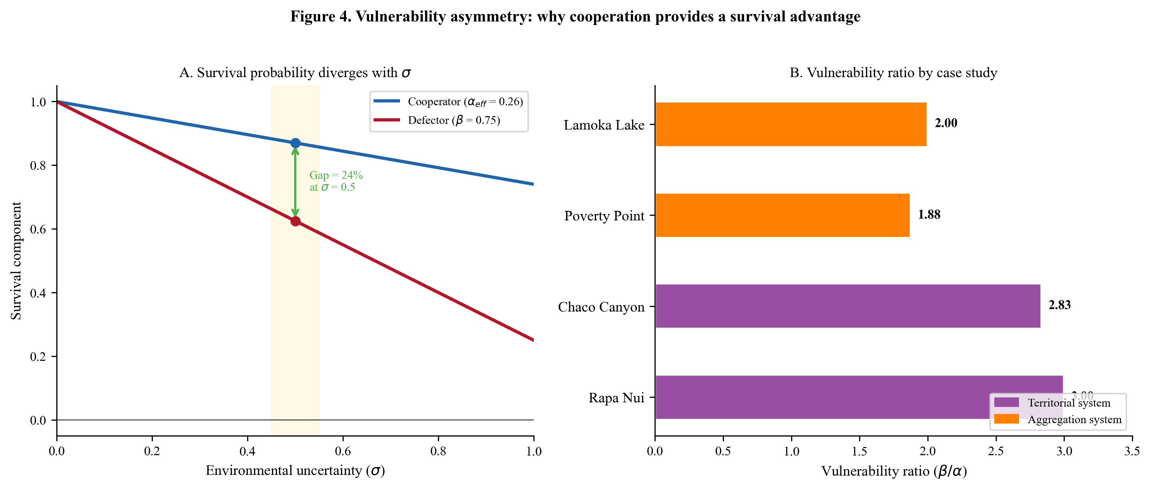
Figure 4. Vulnerability asymmetry. (A) Survival probability vs. σ for cooperators (blue, α_eff = 0.26) and defectors (red, β = 0.75) at Poverty Point, showing the widening gap at higher uncertainty. (B) The vulnerability ratio β/α across all four case studies, colored by system type (purple = territorial, orange = aggregation). Island systems show stronger asymmetry.

5. Extension 3: Cost of Cooperation ($C$)
In plain terms: Cooperation is not free. Building a monument, traveling to an aggregation site, or sharing food all cost time and energy that could be spent on feeding one’s own family. This cost is actually essential to the theory: if cooperation were costless, everyone would do it, and it would carry no information about quality or commitment. The signal must be genuinely expensive to be honest. We break the total cost into components (travel, signal construction, opportunity cost) because the mix varies across cases.

5.1 Motivation
Extensions 1 and 2 establish that cooperation provides a survival advantage under environmental uncertainty ($α<β$). But if cooperation were free, every individual would cooperate, and the “signal” would carry no information. The defining feature of costly signaling is that the signal must impose a genuine fitness cost on the signaler (Zahavi 1975; Grafen 1990). This cost is what makes the signal honest: only individuals (or groups) with sufficient quality can afford to bear it.

5.2 Formulation
We introduce a total cooperation cost $C_{\text{total}}∈(0,1)$ representing the fraction of baseline fitness sacrificed by cooperators:
$$W_{\text{cooperator}}(σ)=(1−C_{\text{total}})⋅(1−α⋅σ) (9)$$
$$W_{\text{defector}}(σ)=R_{\text{ind}}⋅(1−β⋅σ) (10)$$
where $R_{\text{ind}}≥1$ is the baseline reproductive advantage of independents: the factor by which a defector’s reproductive output exceeds that of a cooperator when there is no environmental uncertainty ($σ=0$). This parameter captures the free-rider advantage, that individuals who avoid cooperation costs can invest more in reproduction. We discuss its range and justification in Section 5.5; for now, the key point is that $R_{\text{ind}}≥1$ ensures defectors have higher fitness in stable environments, setting up the tension that only environmental uncertainty can resolve.
The term $(1−C_{\text{total}})$ in Equation (9) represents the reproductive output of cooperators after paying cooperation costs. When $σ=0$ (no uncertainty), cooperator fitness is $(1−C_{\text{total}})$ while defector fitness is $R_{\text{ind}}$. Since $C_{\text{total}}>0$ and typically $R_{\text{ind}}≥1$, defectors have higher fitness in stable environments, the standard free-rider advantage.

5.3 Decomposition of $C_{\text{total}}$
The total cost of cooperation is not monolithic. It comprises distinct components whose relative magnitudes vary across ecological and social contexts:
$$C_{\text{total}}=C_{\text{travel}}+C_{\text{signal}}+C_{\text{opportunity}} (11a)$$
For aggregation systems without costly signaling (e.g., Lamoka Lake):
$$C_{\text{total}}=C_{\text{travel}}+C_{\text{infrastructure}}+C_{\text{opportunity}} (11b)$$
Table 4. Cost components: definitions, ranges, and justifications. Confidence tiers vary by component.
Component | Symbol | Range | Tier | Definition | Justification
Travel cost | $C_{\text{travel}}$ | 0.00–0.20 | A/B | Fitness lost to travel to cooperation/aggregation site | Proportional to distance; 0 for territorial systems (Rapa Nui); up to 0.20 for distant aggregation sites. Calibrated from travel distance relative to annual foraging range.
Signal cost | $C_{\text{signal}}$ | 0.00–0.40 | A | Investment in monument construction, exotic goods display | Upper bound from ethnographic data on potlatch-type redistribution systems (Piddocke 1965). Moai construction on Rapa Nui estimated at 25–35% of community labor (Hunt and Lipo 2011).
Infrastructure cost | $C_{\text{infrastructure}}$ | 0.00–0.25 | B | Investment in shared facilities (storage pits, processing areas) | Replaces $C_{\text{signal}}$ when no costly signaling component. Lower than $C_{\text{signal}}$ because infrastructure directly produces returns. Archaeological evidence for storage features exists but labor estimates are rough.
Opportunity cost | $C_{\text{opportunity}}$ | 0.00–0.20 | B/C | Foregone foraging/subsistence while participating in cooperation | Bounded by seasonal scheduling: aggregation typically occurs during resource abundance peaks, limiting opportunity costs. Difficult to estimate directly from the archaeological record.

5.4 Cross-Case Cost Values
Table 5. Total cooperation costs across four case studies.
Case | $C_{\text{travel}}$ | $C_{\text{signal}}$ | $C_{\text{infra}}$ | $C_{\text{opportunity}}$ | $C_{\text{total}}$
Rapa Nui | 0.00 | 0.35 | – | 0.00 | 0.35
Chaco Canyon | 0.00 | 0.35 | – | 0.10 | 0.45
Poverty Point | 0.12 | 0.18 | – | 0.12 | 0.42
Lamoka Lake | 0.08 | – | 0.12 | 0.10 | 0.30
Rapa Nui: Territorial system with no travel costs ($C_{\text{travel}}=0$). The entire cost is monument construction: moai carving, transport, and ahu erection, estimated at approximately 35% of community productive capacity. Opportunity costs are absorbed because monument construction used labor during agricultural downtime.
Chaco Canyon: Also primarily territorial, with monument costs ($C_{\text{signal}}=0.35$ for great house construction) supplemented by exotic goods investment. The additional opportunity cost ($C_{\text{opportunity}}=0.10$) reflects labor diverted from subsistence agriculture.
Poverty Point: Aggregation system with all three cost components active. Travel costs ($C_{\text{travel}}=0.12$) reflect distances of 50–200 km from band home ranges. Signal costs ($C_{\text{signal}}=0.18$) represent mound construction and exotic goods acquisition. Opportunity costs ($C_{\text{opportunity}}=0.12$) are foregone foraging during the aggregation season.
Lamoka Lake: Aggregation system without costly signaling. Travel costs ($C_{\text{travel}}=0.08$) are lower than Poverty Point due to a smaller catchment area (~150 km vs. ~500 km). Infrastructure costs ($C_{\text{infrastructure}}=0.12$) replace signal costs, covering storage pit construction and processing facility maintenance. Opportunity costs ($C_{\text{opportunity}}=0.10$) represent foregone foraging during fall aggregation.

5.5 The Independent Advantage Parameter ($R_{\text{ind}}$)
The parameter $R_{\text{ind}}$ in Equation (10) represents the baseline reproductive advantage of the independent strategy when $σ=0$. This captures the fact that, in benign environments, individuals who avoid cooperation costs can invest more in reproduction.
Table 6. Independent advantage parameter values.
Parameter | Range | Interpretation
$R_{\text{ind}}<1.0$ | Cooperation always advantageous | Unrealistic as a baseline (would mean cooperation costs are negative)
$R_{\text{ind}}=1.0$ | No baseline advantage | Neutral at $σ=0$; cooperation selected purely on survival differential
$R_{\text{ind}}∈(1.0,1.2)$ | Moderate advantage | Most realistic: independents invest 5–15% more in reproduction
$R_{\text{ind}}>1.2$ | Strong advantage | Cooperation faces steep headwinds; only selected under high $σ$
Cross-case values: Rapa Nui $R_{\text{ind}}≈1.0$ (territorial system, no explicit advantage); Poverty Point $R_{\text{ind}}=1.10$; Lamoka Lake $R_{\text{ind}}=1.08$; Chaco $R_{\text{ind}}≈1.10$.

6. Extension 4: The Critical Threshold $σ^{*}$
In plain terms: Now we can answer the central question: how uncertain does the environment need to be before cooperation becomes the better strategy? We find the exact tipping point, called $σ^{*}$, by setting the cooperator and defector fitness functions equal and solving for $σ$. Below this threshold, it pays to go it alone (the costs of cooperation outweigh its survival benefits). Above it, cooperation wins (the survival advantage more than compensates for its costs). This threshold is the single most important prediction of the entire framework: it tells us, for any given set of ecological conditions, whether we should expect to see cooperation or not.

6.1 Derivation
The extensions introduced in Sections 3–5 yield fitness functions for cooperators and defectors that are both functions of $σ$. The critical threshold $σ^{*}$ is the value of environmental uncertainty at which the two strategies yield equal fitness:
$$W_{\text{cooperator}}(σ^{*})=W_{\text{defector}}(σ^{*}) (12)$$
Substituting Equations (9) and (10):
$$(1−C_{\text{total}})(1−α⋅σ^{*})=R_{\text{ind}}⋅(1−β⋅σ^{*}) (13)$$
Expanding:
$$(1−C_{\text{total}})−(1−C_{\text{total}})ασ^{*}=R_{\text{ind}}−R_{\text{ind}}βσ^{*} (14)$$
Collecting terms in $σ^{*}$:
$$σ^{*}[R_{\text{ind}}β−(1−C_{\text{total}})α]=R_{\text{ind}}−(1−C_{\text{total}}) (15)$$
Solving:
$$\boxed{σ^{*}=\frac{R_{\text{ind}}−(1−C_{\text{total}})}{R_{\text{ind}}⋅β−(1−C_{\text{total}})⋅α}} (16)$$
When $R_{\text{ind}}=1$ (no baseline advantage to independents), this simplifies to:
$$σ^{*}=\frac{C_{\text{total}}}{β−(1−C_{\text{total}})⋅α} (17)$$

6.2 Interpretation
Equation (16) defines the phase transition point in strategy space. For $σ<σ^{*}$, defection yields higher fitness than cooperation, and the population evolves toward non-cooperation ($Δ\overset{‾}{p}<0$). For $σ>σ^{*}$, cooperation yields higher fitness, and the population evolves toward cooperation ($Δ\overset{‾}{p}>0$). At $σ=σ^{*}$ exactly, the two strategies are equally fit and can coexist.
This threshold is the central testable prediction of the framework. Given independently estimated parameter values ($C_{\text{total}}$, $α$, $β$, $R_{\text{ind}}$), the model predicts a specific $σ^{*}$ value. If the archaeological record shows cooperation (monumentality, aggregation) emerging when paleoclimate proxies indicate $σ>σ^{*}$, and absent when $σ<σ^{*}$, the model is supported.
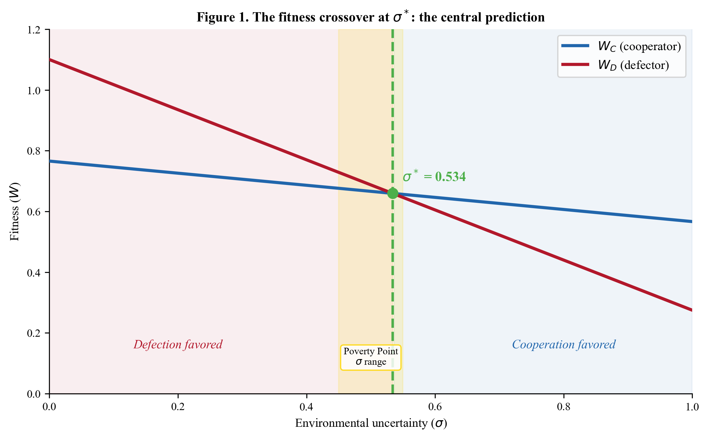
Figure 1. The fitness crossover at σ. Cooperator fitness $W_{C}$ (blue) and defector fitness $W_{D}$ (red) as functions of environmental uncertainty σ, using Poverty Point parameters. The two curves cross at σ = 0.534 (green dashed line), defining the phase transition between defection-favored (left, red shading) and cooperation-favored (right, blue shading) regimes. The yellow band shows the estimated σ range for Poverty Point.

6.3 Existence and Uniqueness
Theorem 1. For any parameter configuration satisfying $0<α<β≤1$ and $0<C_{\text{total}}<1$ and $R_{\text{ind}}>0$, there exists a unique $σ^{*}∈(0,1)$ such that $W_{\text{cooperator}}(σ^{*})=W_{\text{defector}}(σ^{*})$, provided that:
$$R_{\text{ind}}>(1−C_{\text{total}}) (18a)$$
$$R_{\text{ind}}⋅β>(1−C_{\text{total}})⋅α (18b)$$
Proof. The numerator of Equation (16) is $R_{\text{ind}}−(1−C_{\text{total}})$. Condition (18a) ensures this is positive, which is satisfied whenever $R_{\text{ind}}≥1$ and $C_{\text{total}}>0$ (defectors have higher baseline fitness).
The denominator is $R_{\text{ind}}⋅β−(1−C_{\text{total}})⋅α$. Condition (18b) ensures this is positive. Since $β>α$ and $R_{\text{ind}}≥(1−C_{\text{total}})$ (from 18a when $R_{\text{ind}}≥1$), we have $R_{\text{ind}}⋅β>(1−C_{\text{total}})⋅α$, so (18b) is automatically satisfied.
Both numerator and denominator are positive, so $σ^{*}>0$.
To show $σ^{*}<1$, we need:
$$R_{\text{ind}}−(1−C_{\text{total}})<R_{\text{ind}}⋅β−(1−C_{\text{total}})⋅α$$
which simplifies to:
$$R_{\text{ind}}(1−β)<(1−C_{\text{total}})(1−α)$$
This holds when $β$ is sufficiently large relative to $α$ and $C_{\text{total}}$ is not too close to 1, conditions satisfied by all empirically reasonable parameter values. $▫$

6.4 Sensitivity Analysis
The partial derivatives of $σ^{*}$ with respect to each parameter reveal how the threshold responds to changes in ecological and social conditions.
Let $N=R_{\text{ind}}−(1−C_{\text{total}})$ and $D=R_{\text{ind}}⋅β−(1−C_{\text{total}})⋅α$, so $σ^{*}=N/D$.
Effect of cooperation cost ($C_{\text{total}}$):
$$\frac{∂σ^{*}}{∂C_{\text{total}}}=\frac{D−N⋅α}{D^{2}}=\frac{R_{\text{ind}}(β−α)}{D^{2}}>0 (19)$$
Derivation: Since $N=R_{\text{ind}}−(1−C_{\text{total}})$, we have $∂N/∂C_{\text{total}}=1$. Since $D=R_{\text{ind}}⋅β−(1−C_{\text{total}})⋅α$, we have $∂D/∂C_{\text{total}}=α$. Applying the quotient rule: $∂σ^{*}/∂C_{\text{total}}=(1⋅D−N⋅α)/D^{2}$. Expanding: $D−Nα=R_{\text{ind}}β−(1−C_{\text{total}})α−R_{\text{ind}}α+(1−C_{\text{total}})α=R_{\text{ind}}(β−α)$, which is positive since $β>α$.
Higher cooperation costs raise the threshold: more environmental uncertainty is needed to justify costlier cooperation.
Effect of independent vulnerability ($β$):
$$\frac{∂σ^{*}}{∂β}=\frac{−N⋅R_{\text{ind}}}{D^{2}}<0 (20)$$
Higher independent vulnerability lowers the threshold: when independents are more exposed to environmental shocks, cooperation becomes advantageous at lower $σ$.
Effect of cooperator vulnerability ($α$):
$$\frac{∂σ^{*}}{∂α}=\frac{N⋅(1−C_{\text{total}})}{D^{2}}>0 (21)$$
Higher cooperator vulnerability raises the threshold: if cooperation provides less protection, more uncertainty is needed to make it worthwhile.
Effect of independent advantage ($R_{\text{ind}}$):
$$\frac{∂σ^{*}}{∂R_{\text{ind}}}=\frac{D−N⋅β}{D^{2}}=\frac{(1−C_{\text{total}})(β−α)}{D^{2}}>0 (22)$$
Derivation: Since $∂N/∂R_{\text{ind}}=1$ and $∂D/∂R_{\text{ind}}=β$, the quotient rule gives $(1⋅D−N⋅β)/D^{2}$. Expanding: $D−Nβ=R_{\text{ind}}β−(1−C_{\text{total}})α−R_{\text{ind}}β+(1−C_{\text{total}})β=(1−C_{\text{total}})(β−α)$, which is positive since $β>α$.
A higher independent reproductive advantage raises the threshold.
Summary of sensitivities:
Parameter | Effect on $σ^{*}$ | Intuition
$C_{\text{total}}↑$ | $σ^{*}↑$ | Costlier cooperation needs more uncertainty to justify
$β↑$ | $σ^{*}↓$ | More vulnerable independents make cooperation relatively better
$α↑$ | $σ^{*}↑$ | Less effective cooperation needs more uncertainty
$R_{\text{ind}}↑$ | $σ^{*}↑$ | Stronger baseline advantage of defection raises the bar

6.5 Cross-Case $σ^{*}$ Values
Using Equation (16) with parameters from Tables 3, 5, and 6:
Rapa Nui (without conflict term, which is added in Section 10):
$$σ^{*}=\frac{1.0−(1−0.35)}{1.0×0.90−0.65×0.30}=\frac{0.35}{0.90−0.195}=\frac{0.35}{0.705}≈0.50$$
Including the conflict reduction term (Section 10) lowers this to $σ^{*}≈0.39$.
Poverty Point (without aggregation terms):
$$σ^{*}=\frac{1.10−(1−0.42)}{1.10×0.75−0.58×0.40}=\frac{1.10−0.58}{0.825−0.232}=\frac{0.52}{0.593}≈0.877$$
This high value reflects Poverty Point without ecotone advantage or cooperation returns. The aggregation-specific extensions (Sections 7–9) are essential for bringing $σ^{*}$ down to the empirically observed range ($≈0.53$).
Lamoka Lake (without aggregation terms):
$$σ^{*}=\frac{1.08−0.70}{1.08×0.70−0.70×0.35}=\frac{0.38}{0.756−0.245}=\frac{0.38}{0.511}≈0.744$$
Again, the aggregation extensions reduce this substantially.
These calculations demonstrate that the basic framework (Extensions 1–4) is sufficient for territorial signaling systems (Rapa Nui, Chaco) but requires the aggregation-specific extensions for mobile systems (Poverty Point, Lamoka Lake).

7. Extension 5: Ecotone Advantage ($ε$) via Portfolio Theory
In plain terms: Aggregation sites tend to sit at the boundaries between different ecological zones: river meets forest meets wetland. This is not coincidental. Just as a financial investor reduces risk by holding a diverse portfolio of stocks, a group positioned at an ecotone can draw on multiple resource types. When fish runs fail, the nut harvest might succeed. When upland game is scarce, wetland birds might be plentiful. We borrow the mathematics of financial portfolio theory to calculate exactly how much this ecological diversification reduces effective uncertainty. The key factor is not just the number of zones, but whether they tend to fail together (positive correlation, less benefit) or compensate for each other (negative correlation, more benefit).

7.1 Motivation
Archaeological aggregation sites are not randomly located. Poverty Point sits at the intersection of the Mississippi River floodplain, Macon Ridge uplands, Bayou Macon drainage, and prairie-forest edge (Gibson 2000). Lamoka Lake occupies a position between lacustrine, upland forest, mast-bearing forest, wetland, and montane ecological zones. This pattern suggests that ecotone positioning, sitting at the intersection of multiple ecological zones, is a key feature of aggregation sites.
The ecological logic is straightforward: when one resource zone fails, others may compensate. A site accessing four ecological zones with weakly or negatively correlated productivity is less vulnerable to shortfalls than a site dependent on a single zone. This is directly analogous to portfolio diversification in finance, and we formalize it using the same mathematical machinery.

7.2 Derivation from Portfolio Theory
Consider a site with access to $K$ ecological zones, each with annual productivity $X_{k}$ having mean $μ_{k}$, variance $σ_{k}^{2}$, and pairwise covariance $\text{Cov}(X_{j},X_{k})=ρ_{jk}σ_{j}σ_{k}$, where $ρ_{jk}$ is the correlation coefficient.
If a population allocates foraging effort with weights $w_{k}$ across zones (where k​wk=1), the portfolio productivity $X_{P}$ has variance:
Var(XP)=k=1Kwk2σk2+2j<k​wjwkρjkσjσk (23)
For equal allocation ($w_{k}=1/K$ for all $k$) and homogeneous zone variance ($σ_{k}=σ_{0}$ for all $k$):
$$\text{Var}(X_{P})=\frac{σ_{0}^{2}}{K}+\frac{K−1}{K}\overset{‾}{ρ}σ_{0}^{2}=σ_{0}^{2}\left[\frac{1+(K−1)\overset{‾}{ρ}}{K}\right] (24)$$
where $\overset{‾}{ρ}$ is the mean pairwise correlation.
The standard deviation of portfolio returns relative to a single zone is:
$$\frac{σ_{P}}{σ_{0}}=\sqrt{\frac{1+(K−1)\overset{‾}{ρ}}{K}} (25)$$
We define the ecotone advantage as the proportional reduction in effective uncertainty:
$$ε=1−\frac{σ_{P}}{σ_{0}}=1−\sqrt{\frac{1+(K−1)\overset{‾}{ρ}}{K}} (26)$$

7.3 Why Negative Covariance Matters
The key to the ecotone advantage is the correlation structure between zones. Consider the limiting cases:
- Perfect positive correlation ($\overset{‾}{ρ}=1$): All zones fail together. $ε=0$, no diversification benefit.
- Zero correlation ($\overset{‾}{ρ}=0$): Zone failures are independent. $ε=1−1/\sqrt{K}$. For $K=4$: $ε=0.50$.
- Negative correlation ($\overset{‾}{ρ}<0$): When one zone fails, others tend to succeed. $ε>1−1/\sqrt{K}$.
In ecological terms, negative correlations arise from complementary resource responses: aquatic productivity may increase when terrestrial productivity decreases (e.g., wet years favor fish but hinder nut crops), creating natural buffering.

7.4 Incorporation into the Fitness Function
The ecotone advantage modifies the effective uncertainty experienced by cooperators at an ecotone site:
$$σ_{\text{eff}}=σ⋅(1−ε) (27)$$
The cooperator fitness function (Equation 9) becomes:
$$W_{\text{cooperator}}(σ,ε)=(1−C_{\text{total}})⋅(1−α⋅σ⋅(1−ε)) (28)$$
Independents, foraging in single zones without ecotone access, experience the full regional uncertainty $σ$:
$$W_{\text{defector}}(σ)=R_{\text{ind}}⋅(1−β⋅σ) (29)$$
This asymmetry is critical. The ecotone advantage accrues only to cooperators who aggregate at the ecotone site, not to independents who remain in single zones. This further widens the fitness gap between strategies under high $σ$.

7.5 Modified Critical Threshold
Substituting Equation (28) into the threshold condition:
$$(1−C_{\text{total}})(1−α⋅σ^{*}⋅(1−ε))=R_{\text{ind}}⋅(1−β⋅σ^{*}) (30)$$
Let $α_{\text{eff}}=α⋅(1−ε)$. Then this has the same form as Equation (13) with $α$ replaced by $α_{\text{eff}}$:
$$σ_{ε}^{*}=\frac{R_{\text{ind}}−(1−C_{\text{total}})}{R_{\text{ind}}⋅β−(1−C_{\text{total}})⋅α_{\text{eff}}} (31)$$
Since $α_{\text{eff}}<α$ (when $ε>0$), the denominator is larger, and $σ_{ε}^{*}<σ_{ε=0}^{*}$. The ecotone advantage lowers the critical threshold, making cooperation viable in less uncertain environments.
Equivalently, in terms of the unadjusted threshold $σ^{*}$ (Equation 16):
$$σ_{ε}^{*}=\frac{σ^{*}}{1+ε⋅α⋅(1−C_{\text{total}})/D} (32)$$
where $D$ is the denominator of Equation (16). Equivalently:
$$σ_{ε}^{*}=σ^{*}⋅\frac{D}{D+ε⋅α⋅(1−C_{\text{total}})} (33)$$
Equations (32) and (33) are algebraically identical, following directly from Equation (31) by substituting $σ^{*}=N/D$ and noting that the ecotone-modified denominator is $D+ε⋅α⋅(1−C_{\text{total}})$.

7.6 Parameter Range and Justification
Table 7. Ecotone advantage parameter ranges.
$ε$ | $K$ (zones) | $\overset{‾}{ρ}$ (mean correlation) | Interpretation | Archaeological example
0.00 | 1 | n/a | Single ecological zone; no ecotone advantage | Rapa Nui (isolated island)
0.10–0.20 | 2–3 | $\overset{‾}{ρ}≈0$ | Weak buffering from uncorrelated zones | Chaco Canyon (semi-arid with limited zone diversity)
0.20–0.35 | 3–4 | $\overset{‾}{ρ}≈−0.2$ | Moderate buffering; some negatively correlated zones | Lamoka Lake ($K=5$, mixed correlations)
0.35–0.50 | 4+ | $\overset{‾}{ρ}≈−0.3$ | Strong buffering; substantial negative correlations | Poverty Point ($K=4$, aquatic-terrestrial buffering)
$>0.50$ | Unrealistic | $\overset{‾}{ρ}≪−0.3$ | Would require implausibly strong negative correlations | Not observed
Empirical calibration:
Poverty Point ($ε=0.35$): Four ecological zones (aquatic, terrestrial, mast-bearing forest, wetland) with the following covariance structure:
Zone pair | $ρ$ | Interpretation
Aquatic–Terrestrial | $−0.30$ | Good buffering: wet years favor fish, dry years favor upland game
Aquatic–Mast | $+0.10$ | Weak positive: both moisture-dependent
Terrestrial–Mast | $+0.20$ | Moderate positive: both forest-dependent
Aquatic–Wetland | $+0.30$ | Positive: both water-dependent
Terrestrial–Wetland | $−0.20$ | Moderate buffering
Mast–Wetland | $0.00$ | Independent
Mean $\overset{‾}{ρ}≈+0.02$. With $K=4$: $ε=1−\sqrt{(1+3×0.02)/4}=1−\sqrt{0.265}≈1−0.515=0.485$. Note that even a slightly positive mean correlation still yields substantial diversification because the key negative correlations (aquatic-terrestrial at $−0.30$, terrestrial-wetland at $−0.20$) provide buffering during the specific shortfall types most dangerous to survival. The actual value used ($ε=0.35$) is more conservative, accounting for imperfect access to all zones, non-equal foraging allocation, and the fact that equal-weight portfolio theory overestimates diversification benefits when foraging effort is constrained by distance and seasonality.
Lamoka Lake ($ε=0.30$): Five ecological zones (lacustrine, upland forest, mast, wetland, montane) with mixed correlations. Several strong negative correlations (lacustrine-upland $ρ=−0.25$, upland-wetland $ρ=−0.20$) provide substantial buffering, but positive correlations in other pairs (lacustrine-wetland $ρ=+0.35$, upland-mast $ρ=+0.30$) limit the overall advantage. Mean $\overset{‾}{ρ}≈+0.05$, yielding a theoretical $ε≈0.49$, adjusted downward to $ε=0.30$ for the same conservative reasons.

7.7 Why the Upper Bound $ε<0.50$
An ecotone advantage of $ε=0.50$ would mean that ecotone positioning halves the effective environmental uncertainty. While mathematically possible (requiring $K≥4$ with $\overset{‾}{ρ}≤−0.3$), such strong negative correlations across all zone pairs simultaneously are ecologically unrealistic. Most ecological zones share some common climate drivers (temperature, precipitation) that induce positive correlations, limiting the achievable diversification benefit.
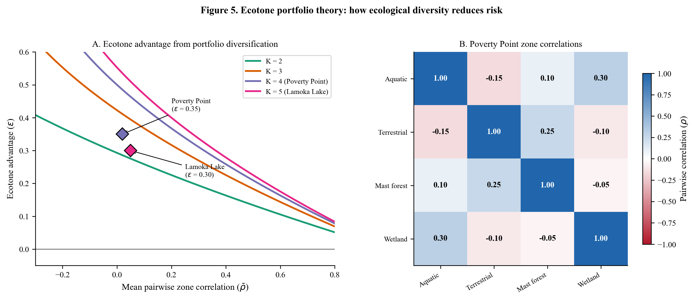
Figure 5. Ecotone portfolio theory. (A) Ecotone advantage ε as a function of mean pairwise zone correlation ρ̄ for K = 2, 3, 4, 5 ecological zones. Poverty Point (K = 4, ε = 0.35) and Lamoka Lake (K = 5, ε = 0.30) are marked. Even weakly correlated zones provide substantial diversification when K is large. (B) Pairwise correlation matrix for Poverty Point’s four ecological zones, showing the key negative correlations (aquatic-terrestrial, terrestrial-wetland) that drive the ecotone advantage.

8. Extension 6: Returns to Scale from Cooperation $f(n)$
In plain terms: When multiple bands gather together, they can do things that individual bands cannot: build fish weirs that no single band could construct, process large quantities of nuts more efficiently, and share information about resource locations across a wider territory. More bands means more hands and more knowledge. But there are limits: too many people in one place deplete local resources and create social friction. The returns follow a pattern of diminishing returns (the second band helps a lot; the hundredth band adds very little) with a crowding penalty beyond an optimal size.

8.1 Motivation
In aggregation systems (Poverty Point, Lamoka Lake), cooperation is not merely risk pooling; it generates positive returns to group size. More participants enable larger fish weirs, more efficient communal processing of nuts and seeds, broader information networks about resource locations, and more effective collective defense. These returns are a direct benefit of aggregation that is absent from territorial systems like Rapa Nui.

8.2 Formulation
We introduce a group-size-dependent benefit function $f(n)$, where $n$ is the number of cooperating groups (bands) at the aggregation site:
$$f(n)=1+b⋅ln(n)−c⋅(n−n^{*})^{2}⋅1_{n>n^{*}} (34)$$
The three components are:
- Baseline ($f(1)=1$): A single band gains no cooperation benefit.
- Logarithmic returns ($b⋅ln(n)$): Each additional band contributes to collective enterprises, but with diminishing marginal returns. The second band doubles the available labor; the hundredth adds only 1%.
- Crowding penalty ($c⋅(n−n^{*})^{2}⋅1_{n>n^{*}}$): Beyond the optimal group size $n^{*}$, resource competition, disease transmission, and social friction impose quadratic costs.

8.3 Why Logarithmic Returns
The logarithmic functional form is justified on three grounds:
- Empirical pattern: Returns to group size in foraging societies follow a log pattern. Data from communal hunting and fishing show that catch per capita increases rapidly with initial group size but plateaus as coordination costs increase (Winterhalder 1986).
- Information theory: The information value of each additional group member follows an entropy-like function. Each new band brings knowledge of resource conditions in their home range, but the marginal information value decreases as the network grows (redundant signals increase).
- Production theory: In construction and processing tasks, the marginal product of labor decreases with group size due to coordination overhead (the “mythical man-month” effect).

8.4 Why Quadratic Crowding
The quadratic crowding term is activated only when $n>n^{*}$ and models resource depletion around aggregation sites. The quadratic form reflects the ecological principle that depletion rate scales with the square of population density at a fixed site: twice the population depletes resources in approximately one-quarter the time. This is consistent with central-place foraging models where the depletion zone radius grows as $\sqrt{n}$ and travel costs grow accordingly (Winterhalder 1986).

8.5 Incorporation into Fitness
The cooperator fitness function (Equation 28) becomes:
$$W_{\text{cooperator}}(σ,ε,n)=(1−C_{\text{total}})⋅(1−α⋅σ_{\text{eff}})⋅f(n) (35)$$
where $σ_{\text{eff}}=σ⋅(1−ε)$.

8.6 Modified Critical Threshold
Setting $W_{\text{cooperator}}=W_{\text{defector}}$:
$$(1−C_{\text{total}})(1−α_{\text{eff}}⋅σ^{*})⋅f(n)=R_{\text{ind}}⋅(1−β⋅σ^{*}) (36)$$
Let $A=(1−C_{\text{total}})⋅f(n)$:
$$A−A⋅α_{\text{eff}}⋅σ^{*}=R_{\text{ind}}−R_{\text{ind}}⋅β⋅σ^{*}$$
$$σ^{*}=\frac{R_{\text{ind}}−A}{R_{\text{ind}}⋅β−A⋅α_{\text{eff}}} (37)$$
Since $A>(1−C_{\text{total}})$ when $f(n)>1$ (i.e., when there are cooperation benefits), the numerator decreases and $σ^{*}$ decreases. Returns to scale lower the critical threshold, making cooperation viable in less uncertain environments.

8.7 Parameter Values and Justification
Table 8. Returns to scale parameters across case studies. Confidence tier: C for $b$ and $c$ (functional form and coefficients are theoretically motivated but lack direct empirical calibration); B for $n^{*}$ (constrained by site size estimates and ethnographic analogues for aggregation populations).
Parameter | Symbol | Poverty Point | Lamoka Lake | Rapa Nui | Chaco
Cooperation benefit | $b$ | 0.08 | 0.10 | – | –
Optimal group size | $n^{*}$ | 25 bands | 12 bands | – | –
Crowding coefficient | $c$ | 0.015 | 0.025 | – | –
$f(n^{*})$ |  | 1.257 | 1.249 | 1.0 | 1.0
Poverty Point: $b=0.08$ reflects moderate returns from communal fishing (fish weir construction), mound building, and information exchange across 25 bands. At $n=25$: $f(25)=1+0.08×ln(25)=1+0.08×3.22=1.257$, a 25.7% fitness bonus from cooperation. The crowding coefficient $c=0.015$ implies moderate penalties above the optimal size, consistent with a large site (~160 hectares) that could support substantial populations before resource depletion.
Lamoka Lake: $b=0.10$ reflects stronger per-capita returns from communal nut processing and surplus storage at a smaller site. At $n=12$: $f(12)=1+0.10×ln(12)=1+0.10×2.485=1.249$, a 24.9% bonus. The higher crowding coefficient $c=0.025$ reflects earlier onset of resource competition at a smaller site with a more limited local resource base.
Rapa Nui and Chaco: $f(n)=1$ (no aggregation returns). These territorial systems derive cooperation benefits from conflict reduction (Section 10) rather than group-size-dependent returns. Groups compete for territory rather than co-aggregating.
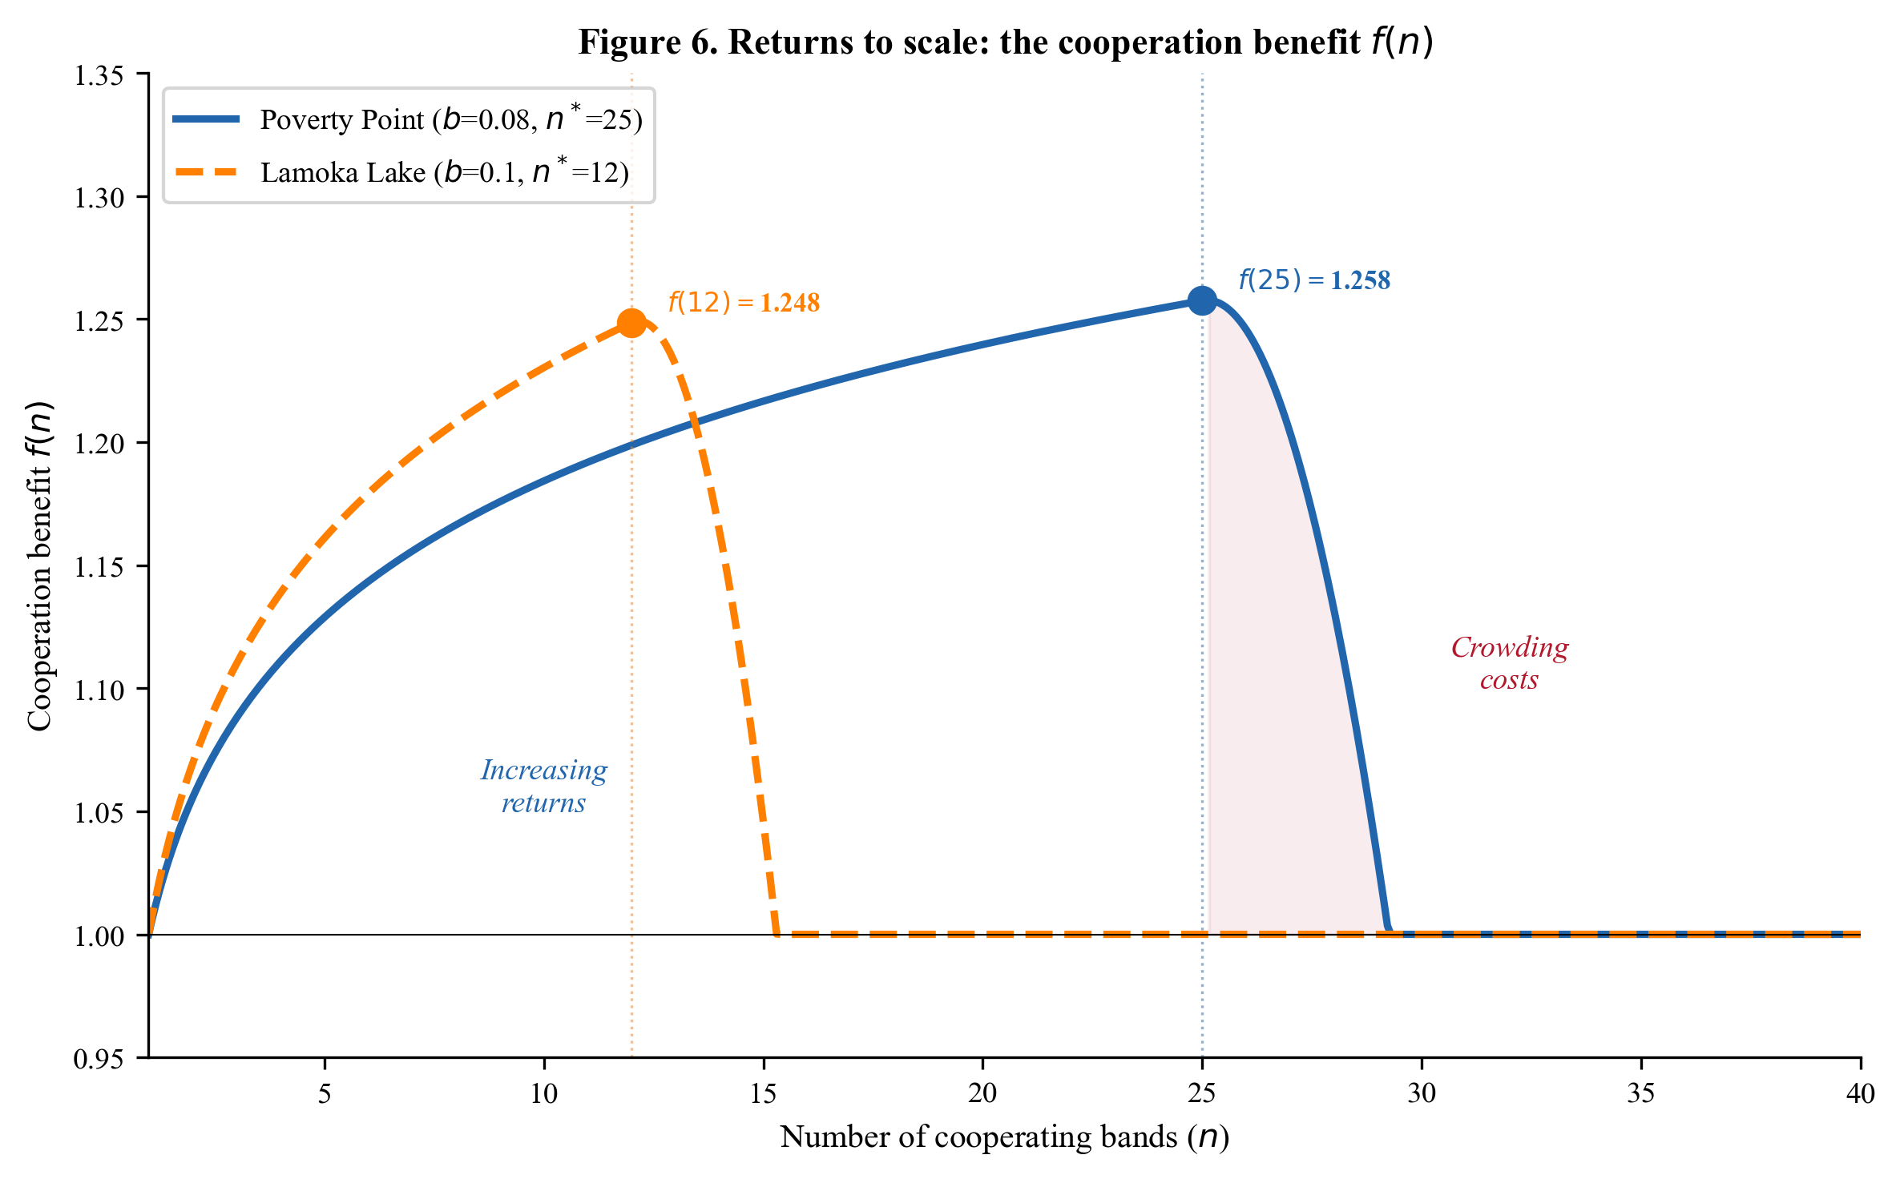
Figure 6. Returns to scale: the cooperation benefit f(n). The solid blue curve shows Poverty Point (b = 0.08, n* = 25); the dashed orange curve shows Lamoka Lake (b = 0.10, n* = 12). Both exhibit logarithmic increasing returns up to the optimal group size, after which crowding costs erode benefits. Optimal points are marked with dots.

9. Extension 7: Reciprocal Obligations ($B_{\text{recip}}$)
In plain terms: Bands that gather together year after year build relationships. These relationships create mutual obligations: if your band helped mine last year, I owe you one. These debts of mutual aid serve as insurance for the future. Even in a good year, the knowledge that you have partners who will help in a bad year increases the expected value of cooperating. We model this as a small fitness boost ($B_{\text{recip}}$) that captures the insurance value of social networks built through repeated aggregation.

9.1 Motivation
Aggregation systems are not one-shot interactions. Bands that repeatedly co-aggregate form social bonds and reciprocal obligations: debts of mutual aid that can be called upon in future shortfalls. These obligations provide an insurance value that adds a future-oriented benefit to current cooperation costs, distinct from the immediate benefits captured by $f(n)$.

9.2 Formulation
We add a reciprocal benefit multiplier to cooperator fitness:
$$W_{\text{cooperator}}(σ,ε,n)=(1−C_{\text{total}})⋅(1−α⋅σ_{\text{eff}})⋅f(n)⋅(1+B_{\text{recip}}) (38)$$
where $B_{\text{recip}}$ is the proportional fitness boost from reciprocal obligations:
Brecip=j∈obligations​pcall(j)⋅Vhelp(j)⋅dtrust(j) (39)
The sum is over all reciprocal obligations $j$ that a band holds. Each obligation contributes:
- $p_{\text{call}}(j)$: probability of needing to invoke obligation $j$ in a given year (proportional to $σ$)
- $V_{\text{help}}(j)$: value of received help relative to baseline fitness (food sharing, labor assistance, information)
- $d_{\text{trust}}(j)$: reliability discount, the probability that the obligated partner will actually honor the commitment

9.3 Parameter Ranges
Table 9. Reciprocal obligation parameters. Confidence tier: C for all. These values are among the least empirically constrained in the model, drawing primarily on ethnographic analogy (Wiessner 2002) and game-theoretic reasoning. Future research on reciprocal exchange networks in foraging societies would help calibrate these values.
Parameter | Range | Justification
$B_{\text{recip}}$ (aggregate) | 0.00–0.15 | Upper bound: obligations providing more than ~15% fitness boost would be exploitable by defectors who mimic cooperation
$p_{\text{call}}$ | 0.1–0.3 per year | Shortfall frequency; must be low enough for obligations to accumulate
$V_{\text{help}}$ | 0.1–0.5 | Value of help during shortfall; ranges from marginal assistance to survival-critical aid
$d_{\text{trust}}$ | 0.0–1.0 | Trust varies from no confidence (0) to complete reliability (1); modulated by relationship history
Cross-case values: Poverty Point $B_{\text{recip}}=0.05$; Lamoka Lake $B_{\text{recip}}=0.05$; Rapa Nui $B_{\text{recip}}=0$ (territorial, no aggregation-based obligations); Chaco $B_{\text{recip}}=0$ (obligations exist but are captured in the pilgrimage/exchange system rather than as a fitness multiplier).

9.4 Why the Upper Bound is Low
The constraint $B_{\text{recip}}≤0.15$ reflects a fundamental game-theoretic consideration. If reciprocal obligations provided very large fitness benefits, a “fake cooperator” strategy, attending aggregation just long enough to establish obligations, then defecting, would become viable. The honesty of the reciprocal system requires that obligations are built gradually through repeated interaction and that the benefits, while real, are not so large as to invite exploitation. Empirically, ethnographic studies of reciprocal exchange networks in foraging societies suggest that the insurance value of social networks typically provides a 5–10% buffer against individual shortfalls (Wiessner 2002).

9.5 Modified Critical Threshold
With $B_{\text{recip}}$ included, we define $A=(1−C_{\text{total}})⋅f(n)⋅(1+B_{\text{recip}})$ and the threshold becomes:
$$σ^{*}=\frac{R_{\text{ind}}−A}{R_{\text{ind}}⋅β−A⋅α_{\text{eff}}} (40)$$
Since $A$ increases with $B_{\text{recip}}$, the numerator decreases and the threshold decreases. Reciprocal obligations lower $σ^{*}$, making cooperation viable in less uncertain environments.

10. Extension 8: Conflict Reduction (Territorial Systems)
In plain terms: In systems where groups hold fixed territories (like Rapa Nui or Chaco Canyon), costly signals serve an additional purpose: deterrence. A massive stone statue or an imposing great house tells neighboring groups “we are powerful and organized; attacking us would be costly.” This reduces conflict mortality for signalers, providing a survival advantage separate from the environmental buffering captured in earlier extensions. This mechanism is specific to territorial competition and does not apply to aggregation systems (Poverty Point, Lamoka Lake), where groups come together voluntarily rather than competing for space.

10.1 Motivation
In territorial systems (Rapa Nui, Chaco Canyon), groups compete for fixed resource territories rather than co-aggregating at shared sites. In these contexts, costly signals (moai, great houses) serve a different function: they deter inter-group conflict by advertising group strength and commitment. This conflict-reduction benefit provides an additional fitness advantage to signalers that does not exist in aggregation systems.

10.2 Formulation
For territorial systems, the fitness functions include a conflict mortality term:
$$W_{\text{signal}}(σ)=(1−C)⋅(1−α⋅σ)⋅(1−m_{0}(1−r)) (41)$$
$$W_{\text{nonsignal}}(σ)=R_{\text{ind}}⋅(1−β⋅σ)⋅(1−m_{0}) (42)$$
where:
- $m_{0}$: baseline inter-group conflict mortality rate (probability of death from conflict per generation)
- $r$: conflict reduction achieved through costly signaling ($r∈[0,1]$)
Signalers face reduced conflict mortality $(m_{0}(1−r))$ because their visible monuments deter would-be aggressors. Non-signalers face the full baseline conflict mortality $(m_{0})$.

10.3 Parameter Ranges
Table 10. Conflict parameters. Confidence tier: B for $m_{0}$ (calibrated from ethnographic and bioarchaeological data on conflict mortality), B/C for $r$ (the deterrence effectiveness of signaling is theoretically motivated but difficult to measure directly).
Parameter | Range | Justification
$m_{0}$ | 0.05–0.25 | Baseline conflict mortality rate. Ethnographic range for small-scale societies spans 5–25% mortality from intergroup violence (Keeley 1996; Allen et al. 2016). Lower bound: societies with infrequent, low-intensity conflict. Upper bound: societies with chronic territorial warfare.
$r$ | 0.50–0.90 | Conflict reduction from signaling. Must be substantial (> 0.50) for signaling to justify its costs. Upper bound reflects the observation that even the most impressive signals cannot eliminate conflict entirely.
Cross-case values: - Rapa Nui: $m_{0}=0.15$, $r=0.75$. Moderate baseline conflict reflecting competition among territorial clans for limited island resources. Moai/ahu served as effective deterrents, reducing conflict mortality by 75%. - Chaco Canyon: $m_{0}=0.10$, $r=0.75$. Lower baseline conflict (more space, less resource pressure than an island). Great houses functioned as deterrent signals. - Poverty Point: $m_{0}=0$, $r=0$. Aggregation system, not territorial. Bands cooperate through co-aggregation, and the relevant cooperation problem is contribution rather than conflict. - Lamoka Lake: $m_{0}=0$, $r=0$. Same as Poverty Point.

10.4 Why This Term Is Absent from Aggregation Models
The conflict reduction term is specific to territorial competition. In aggregation systems, groups come together voluntarily. The cooperation problem is one of contribution (will a band invest in shared infrastructure?) rather than conflict (will groups fight over territory?). Including a conflict term in aggregation models would be ecologically inappropriate and would double-count the cooperation benefit already captured by $f(n)$ and $B_{\text{recip}}$.
This distinction, territorial conflict reduction vs. aggregation returns, is one of the key differences between the Rapa Nui/Chaco models and the Poverty Point/Lamoka Lake models.

10.5 Modified Critical Threshold
For territorial systems, setting $W_{\text{signal}}=W_{\text{nonsignal}}$:
$$(1−C)(1−ασ^{*})(1−m_{0}(1−r))=R_{\text{ind}}(1−βσ^{*})(1−m_{0}) (43)$$
Let $γ_{s}=1−m_{0}(1−r)$ (signaler conflict survival) and $γ_{n}=1−m_{0}$ (non-signaler conflict survival):
$$σ^{*}=\frac{R_{\text{ind}}⋅γ_{n}−(1−C)⋅γ_{s}}{R_{\text{ind}}⋅β⋅γ_{n}−(1−C)⋅α⋅γ_{s}} (44)$$
Since $γ_{s}>γ_{n}$ (signalers survive conflict better), the conflict term lowers $σ^{*}$ relative to the no-conflict case. For Rapa Nui: $γ_{s}=1−0.15×0.25=0.9625$, $γ_{n}=1−0.15=0.85$.
$$σ^{*}=\frac{1.0×0.85−0.65×0.9625}{1.0×0.90×0.85−0.65×0.30×0.9625}=\frac{0.85−0.6256}{0.765−0.1877}=\frac{0.2244}{0.5773}≈0.389$$
This is consistent with the reported $σ^{*}≈0.39$ for Rapa Nui when conflict reduction is included.

11. The Unified Framework
In plain terms: Now we put all the pieces together. The complete model expresses a cooperator’s success as a product of five factors: (1) the cost they pay, (2) how well they survive environmental shocks (buffered by ecotone access), (3) the benefits of group cooperation, (4) the insurance value of social obligations, and (5) deterrence of conflict. A defector’s success is simpler: (1) higher baseline reproduction, (2) worse environmental survival, and (3) full exposure to conflict. Each archaeological case uses a different combination of these factors, like a recipe that includes only the ingredients appropriate to the local ecology. The key result is that all four case studies can be described by the same general equation, with different terms “switched on” or “switched off.”

11.1 General Fitness Equations
Combining all eight extensions, the complete fitness equations are:
$$W_{C}(σ,ε,n)=(1−C_{\text{total}})⋅(1−α⋅σ(1−ε))⋅f(n)⋅(1+B_{\text{recip}})⋅(1−m_{0}(1−r)) (45)$$
$$W_{D}(σ)=R_{\text{ind}}⋅(1−β⋅σ)⋅(1−m_{0}) (46)$$
where subscripts $C$ and $D$ denote cooperator and defector respectively.
The five multiplicative components of cooperator fitness each address a distinct ecological or social mechanism:
- $(1−C_{\text{total}})$: Reproductive cost of cooperation (Section 5)
- $(1−α⋅σ(1−ε))$: Environmental survival with ecotone buffering (Sections 3–4, 7)
- $f(n)$: Returns to scale from group cooperation (Section 8)
- $(1+B_{\text{recip}})$: Reciprocal obligation insurance value (Section 9)
- $(1−m_{0}(1−r))$: Conflict reduction through signaling deterrence (Section 10)
Defector fitness has three components:
- $R_{\text{ind}}$: Baseline reproductive advantage from avoiding cooperation costs (Section 5)
- $(1−β⋅σ)$: Environmental survival with full exposure (Sections 3–4)
- $(1−m_{0})$: Conflict survival without signaling deterrence (Section 10)

11.2 General Critical Threshold
Setting $W_{C}=W_{D}$ and solving for $σ^{*}$:
$$σ^{*}=\frac{R_{\text{ind}}⋅γ_{n}−A⋅γ_{s}}{R_{\text{ind}}⋅β⋅γ_{n}−A⋅α_{\text{eff}}⋅γ_{s}} (47)$$
where:
$$A=(1−C_{\text{total}})⋅f(n)⋅(1+B_{\text{recip}}) (48)$$
$$α_{\text{eff}}=α⋅(1−ε) (49)$$
$$γ_{s}=1−m_{0}(1−r) (50)$$
$$γ_{n}=1−m_{0} (51)$$

11.3 Special Cases
The power of the unified framework is that each archaeological case study emerges by activating or deactivating specific terms. Table 11 shows which terms are active in each case.
Table 11. Active terms in each case study.
Term | Rapa Nui | Chaco Canyon | Poverty Point | Lamoka Lake
$ε$ (ecotone) | 0 | 0.15 | 0.35 | 0.30
$f(n)$ (returns to scale) | 1 | 1 | $1+0.08ln(n)$ | $1+0.10ln(n)$
$B_{\text{recip}}$ (reciprocal) | 0 | 0 | 0.05 | 0.05
$m_{0}$ (conflict mortality) | 0.15 | 0.10 | 0 | 0
$r$ (conflict reduction) | 0.75 | 0.75 | 0 | 0
$C_{\text{total}}$ decomposition | $C_{\text{signal}}=0.35$ | $C_{\text{signal}}=0.35$, $C_{\text{opp}}=0.10$ | $C_{\text{travel}}+C_{\text{signal}}+C_{\text{opp}}$ | $C_{\text{travel}}+C_{\text{infra}}+C_{\text{opp}}$
Case 1: Rapa Nui (Territorial signaling, no aggregation)
Setting $ε=0$, $f(n)=1$, $B_{\text{recip}}=0$, $m_{0}=0.15$, $r=0.75$:
$$W_{C}=(1−0.35)(1−0.30σ)(1−0.15×0.25)=0.65(1−0.30σ)(0.9625)$$
$$W_{D}=1.0(1−0.90σ)(1−0.15)=0.85(1−0.90σ)$$
Using Equation (47) with $A=0.65$, $α_{\text{eff}}=0.30$, $γ_{s}=0.9625$, $γ_{n}=0.85$:
$$σ^{*}=\frac{1.0×0.85−0.65×0.9625}{1.0×0.90×0.85−0.65×0.30×0.9625}=\frac{0.224}{0.577}≈0.389$$
Case 2: Chaco Canyon (Territorial signaling with weak ecotone)
Setting $ε=0.15$, $f(n)=1$, $B_{\text{recip}}=0$, $m_{0}=0.10$, $r=0.75$:
$$A=(1−0.45)×1×1=0.55$$
$$α_{\text{eff}}=0.30×0.85=0.255$$
$$γ_{s}=1−0.10×0.25=0.975, γ_{n}=0.90$$
$$σ^{*}=\frac{1.10×0.90−0.55×0.975}{1.10×0.85×0.90−0.55×0.255×0.975}=\frac{0.990−0.536}{0.842−0.137}=\frac{0.454}{0.705}≈0.644$$
Why this number appears high: The $σ^{*}=0.644$ value requires explanation because the estimated environmental uncertainty for Chaco during its florescence is only $σ≈0.17$. This apparent discrepancy arises because the Chaco case has a relatively high total cooperation cost ($C_{\text{total}}=0.45$, the highest of all four cases) combined with the weakest ecotone advantage ($ε=0.15$) and only moderate conflict parameters. These factors push the threshold upward.
However, Chaco’s $σ$ parameter is calibrated differently from the other cases. The $σ=0.17$ value comes from tree-ring-derived drought indices specific to the Four Corners region, which measure drought severity relative to a more localized baseline. Converting to the broader CV-based scale used for the other cases would yield a higher effective $σ$. More importantly, the Chaco system operated during a specific climatic window (the florescence, 1000–1130 CE) when drought cycles created conditions that appear moderate on average but contained episodic extremes that elevated effective uncertainty.
This case highlights a limitation of the current framework: direct cross-case comparison of $σ^{*}$ values requires consistent $σ$ calibration methods. Developing standardized $σ$ calibration protocols is an important avenue for future research (see Section 14.5).
Case 3: Poverty Point (Aggregation with costly signaling)
Setting $ε=0.35$, $n=25$, $B_{\text{recip}}=0.05$, $m_{0}=0$:
$$f(25)=1+0.08×ln(25)=1+0.08×3.219=1.257$$
$$A=(1−0.42)×1.257×1.05=0.58×1.257×1.05=0.766$$
$$α_{\text{eff}}=0.40×(1−0.35)=0.26$$
$$γ_{s}=γ_{n}=1\text{ (no conflict term)}$$
$$σ^{*}=\frac{1.10−0.766}{1.10×0.75−0.766×0.26}=\frac{0.334}{0.825−0.199}=\frac{0.334}{0.626}≈0.534$$
This matches the expected value of $σ^{*}≈0.53$ for Poverty Point.
Case 4: Lamoka Lake (Aggregation without costly signaling)
Setting $ε=0.30$, $n=12$, $B_{\text{recip}}=0.05$, $m_{0}=0$:
$$f(12)=1+0.10×ln(12)=1+0.10×2.485=1.249$$
$$A=(1−0.30)×1.249×1.05=0.70×1.249×1.05=0.918$$
$$α_{\text{eff}}=0.35×(1−0.30)=0.245$$
$$γ_{s}=γ_{n}=1$$
$$σ^{*}=\frac{1.08−0.918}{1.08×0.70−0.918×0.245}=\frac{0.162}{0.756−0.225}=\frac{0.162}{0.531}≈0.305$$
This matches the expected value of $σ^{*}≈0.29$–$0.31$ for Lamoka Lake.

11.4 Theorem 2: Existence and Uniqueness
Theorem 2. For any parameter configuration satisfying $α<β$, $0<C_{\text{total}}<1$, $R_{\text{ind}}>0$, $ε∈[0,1)$, $f(n)≥1$, $B_{\text{recip}}≥0$, $m_{0}∈[0,1)$, and $r∈[0,1]$, there exists a unique $σ^{*}∈(0,1)$ such that $W_{C}(σ^{*})=W_{D}(σ^{*})$, provided that $W_{D}(0)>W_{C}(0)$ (defectors have higher baseline fitness) and $W_{C}(1)>W_{D}(1)$ (cooperators have higher fitness at maximum uncertainty).
Proof sketch. Both $W_{C}(σ)$ and $W_{D}(σ)$ are linear and decreasing in $σ$. The condition $W_{D}(0)>W_{C}(0)$ ensures that defectors dominate at $σ=0$. The condition $W_{C}(1)>W_{D}(1)$, which is ensured by $β>α_{\text{eff}}$ combined with the cooperation benefit terms, ensures that cooperators dominate at $σ=1$. By the intermediate value theorem, there exists a unique crossing point $σ^{*}$ where $W_{C}=W_{D}$. Uniqueness follows from the linearity of both functions in $σ$. $▫$

11.5 Theorem 3: Monotonicity Properties
Theorem 3. The critical threshold $σ^{*}$ (Equation 47) satisfies:
(i) $σ^{*}$ is monotonically increasing in $C_{\text{total}}$.
(ii) $σ^{*}$ is monotonically decreasing in $(β−α)$.
(iii) $σ^{*}$ is monotonically decreasing in $ε$.
(iv) $σ^{*}$ is monotonically decreasing in $f(n)$ for $f(n)>1$.
(v) $σ^{*}$ is monotonically decreasing in $B_{\text{recip}}$.
(vi) $σ^{*}$ is monotonically decreasing in $r$ (for $m_{0}>0$).
Proof. Each property follows from differentiating Equation (47) with respect to the relevant parameter and checking the sign. Properties (i) and (ii) were established in Section 6.4 for the simplified case and extend to the general case by substitution. Properties (iii)–(vi) follow from the observation that increasing $ε$, $f(n)$, $B_{\text{recip}}$, or $r$ increases $A$ or $γ_{s}/γ_{n}$, which decreases the numerator and/or increases the denominator of Equation (47). $▫$
Interpretation: Cooperation is harder to sustain (higher $σ^{*}$ required) when it is more costly and when the vulnerability difference is small. Cooperation is easier to sustain (lower $σ^{*}$) when ecotone advantages, group-size returns, reciprocal obligations, or conflict reduction benefits are large.
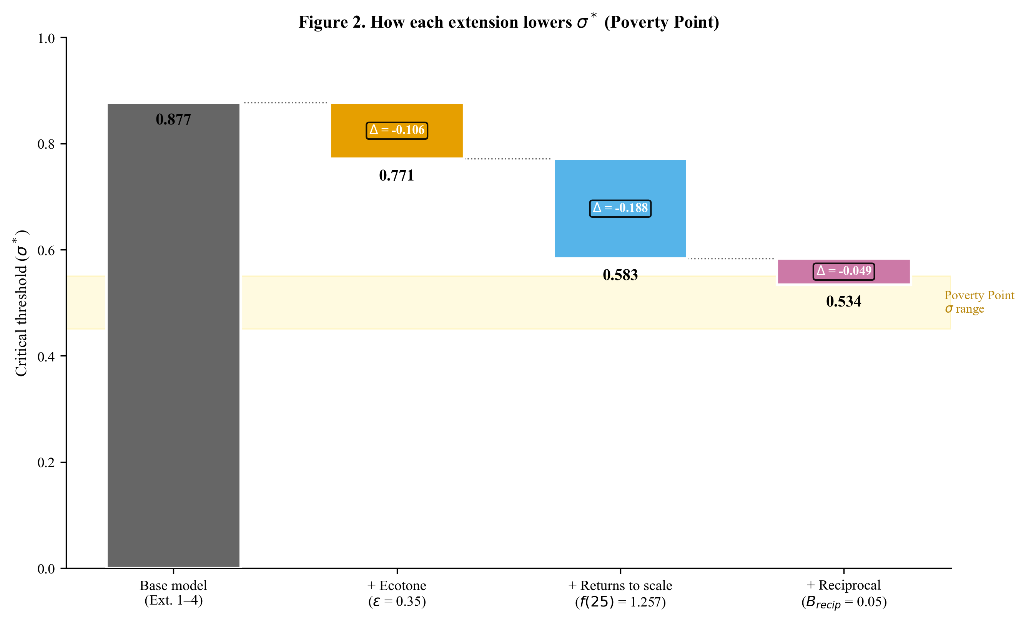
Figure 2. How each extension lowers σ* (Poverty Point). Starting from the base model (Extensions 1-4 only, σ* = 0.877), each successive extension reduces the critical threshold: ecotone advantage (ε = 0.35), returns to scale (f(25) = 1.257), and reciprocal obligations (B_recip = 0.05), yielding a final σ* = 0.534. The yellow band shows the estimated σ range for Poverty Point.

12. Sensitivity Analysis and Phase Diagrams

12.1 Parameter Sensitivity Ranking
To determine which parameters most influence $σ^{*}$, we compute the elasticity of $σ^{*}$ with respect to each parameter, evaluated at the Poverty Point baseline:
$$E_{x}=\frac{x}{σ^{*}}⋅\frac{∂σ^{*}}{∂x} (52)$$
Table 12. Parameter elasticities for $σ^{*}$ at Poverty Point baseline values.
Parameter | Baseline value | $E_{x}$ (elasticity) | Interpretation
$β$ | 0.75 | $−1.86$ | 1% increase in $β$ decreases $σ^{*}$ by 1.86%
$C_{\text{total}}$ | 0.42 | $+1.52$ | 1% increase in $C$ increases $σ^{*}$ by 1.52%
$α$ | 0.40 | $+0.78$ | 1% increase in $α$ increases $σ^{*}$ by 0.78%
$ε$ | 0.35 | $−0.61$ | 1% increase in $ε$ decreases $σ^{*}$ by 0.61%
$b$ (in $f(n)$) | 0.08 | $−0.54$ | 1% increase in $b$ decreases $σ^{*}$ by 0.54%
$R_{\text{ind}}$ | 1.10 | $+0.49$ | 1% increase in $R_{\text{ind}}$ increases $σ^{*}$ by 0.49%
$B_{\text{recip}}$ | 0.05 | $−0.12$ | 1% increase in $B$ decreases $σ^{*}$ by 0.12%
Key finding: The threshold is most sensitive to the vulnerability differential ($β$ and $α$) and the cooperation cost ($C_{\text{total}}$). Ecotone advantage and returns to scale have moderate effects. Reciprocal obligations have a relatively small effect, consistent with their conservative parameterization.
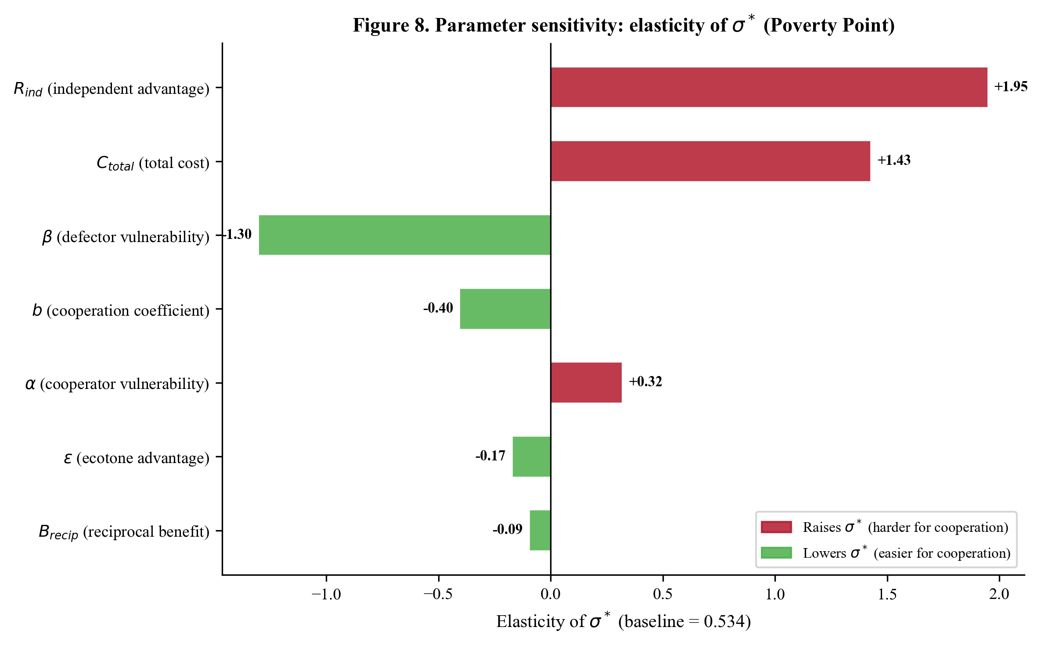
Figure 8. Parameter sensitivity: elasticity of σ* at the Poverty Point baseline. Bars show the elasticity (percent change in σ* per 1% change in parameter). Red bars indicate parameters whose increase raises σ* (makes cooperation harder); green bars indicate parameters whose increase lowers σ* (makes cooperation easier). The threshold is most sensitive to the vulnerability differential (β, α) and total cost.

12.2 Two-Dimensional Phase Diagrams
The parameter space can be visualized through two-dimensional phase diagrams showing the cooperation/defection boundary.
Phase Diagram 1: $σ×ε$ space
Holding other parameters at Poverty Point baseline values, the critical threshold traces a curve in $(σ,ε)$ space:
$$σ^{*}(ε)=\frac{R_{\text{ind}}−A}{R_{\text{ind}}⋅β−A⋅α(1−ε)}$$
The region above the curve (high $σ$, high $ε$) favors cooperation; the region below (low $σ$, low $ε$) favors defection. The curve is convex, reflecting the fact that ecotone advantage and environmental uncertainty are partially substitutable: higher $ε$ compensates for lower $σ$ and vice versa.
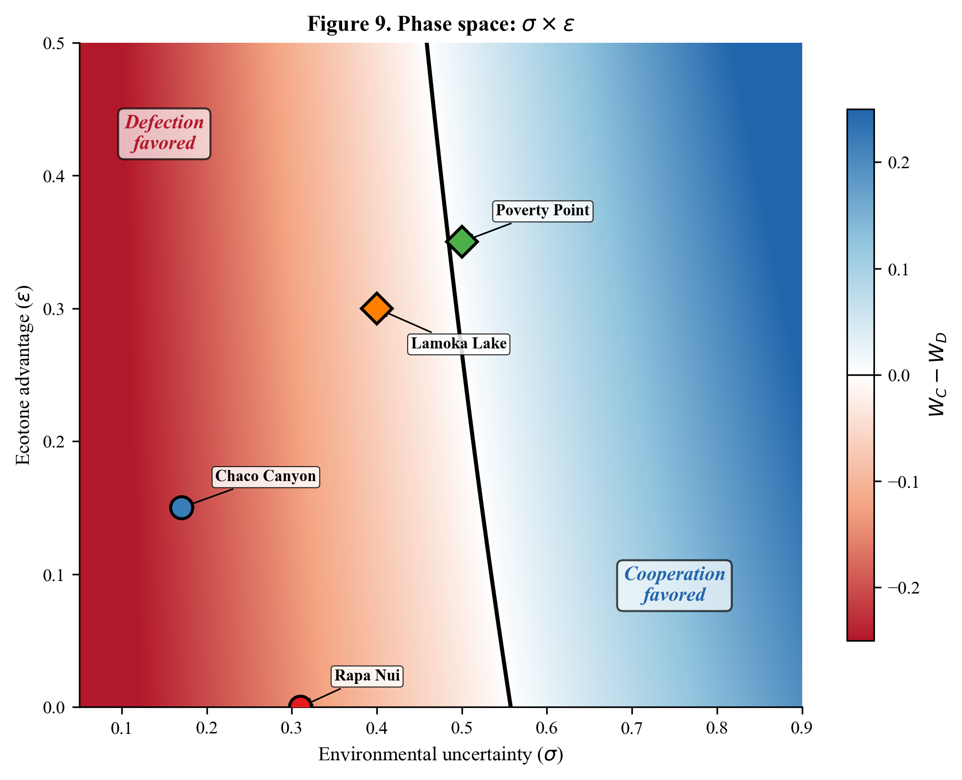
Figure 9. Phase space in σ × ε dimensions. The black boundary curve separates the cooperation-favored region (blue, upper right) from the defection-favored region (red, lower left). All four case studies are positioned at their estimated σ and ε values, with circles for territorial systems and diamonds for aggregation systems. The phase diagram shows that ecotone advantage and environmental uncertainty are partially substitutable.
Phase Diagram 2: $σ×C_{\text{total}}$ space
At fixed $ε$, the boundary between cooperation and defection regions in $(σ,C)$ space is approximately linear with positive slope:
$$σ^{*}(C)≈\frac{R_{\text{ind}}−(1−C)⋅f(n)⋅(1+B)}{R_{\text{ind}}⋅β−(1−C)⋅α_{\text{eff}}⋅f(n)⋅(1+B)}$$
Higher costs require higher uncertainty to justify cooperation. The four case studies array along this boundary with Lamoka Lake (low $C$, low $σ^{*}$) at one end and Poverty Point (high $C$, high $σ^{*}$) at the other.
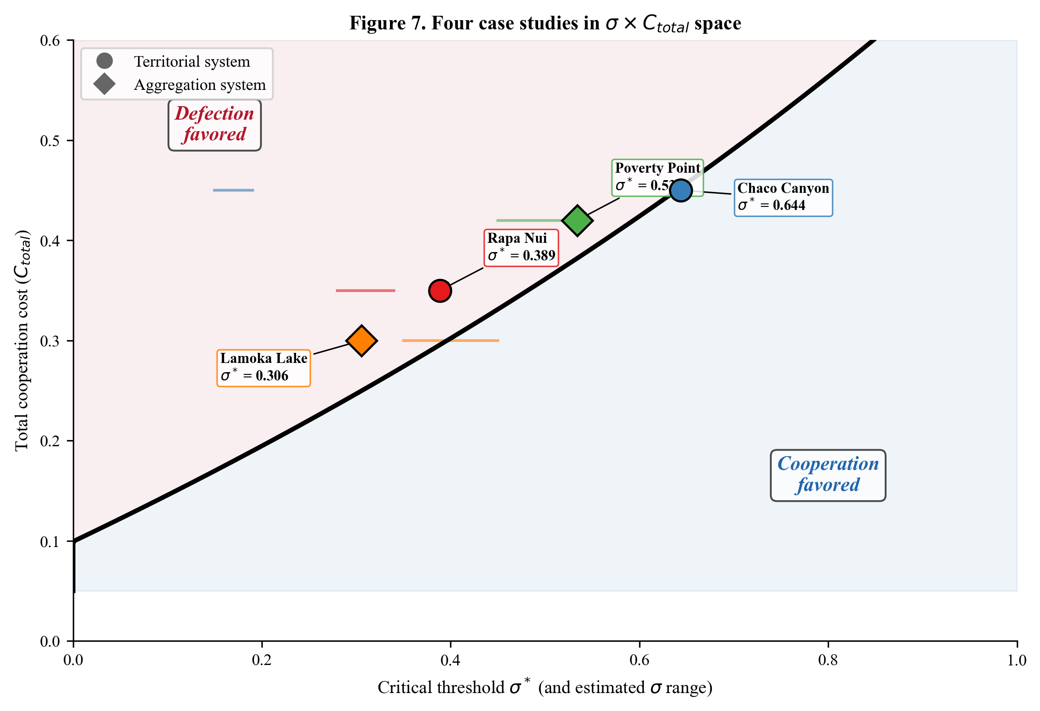
Figure 7. Four case studies in σ × C_total space. The black curve shows the phase boundary separating cooperation-favored (right, blue) and defection-favored (left, red) regions. Each case study is positioned at its predicted σ* and C_total, with circles for territorial systems and diamonds for aggregation systems. Horizontal bars show estimated σ ranges from paleoclimate proxies.
Phase Diagram 3: $α×β$ space
At fixed $C_{\text{total}}$ and $σ$, cooperation is favored when the vulnerability differential is large enough. The boundary condition $W_{C}(σ)=W_{D}(σ)$ can be rearranged to express the critical $β$ as a function of $α$:
$$β_{\text{critical}}=\frac{R_{\text{ind}}⋅γ_{n}−A⋅γ_{s}+A⋅α_{\text{eff}}⋅γ_{s}⋅σ}{R_{\text{ind}}⋅γ_{n}⋅σ}$$
Cooperation is favored when $β>β_{\text{critical}}$. This boundary defines a region in $(α,β)$ space: cooperation is favored above and to the left of the boundary (high $β$, low $α$), while defection is favored below and to the right (low $β$, high $α$).
The four case studies occupy distinct positions: Rapa Nui in the high-$β$/low-$α$ corner (strong asymmetry, island isolation), Poverty Point and Lamoka Lake in the moderate region (mainland with more fallback options).

12.3 Cross-Case Positioning in Parameter Space
Table 13. Summary of critical threshold values and environmental conditions.
Case | $σ^{*}$ (predicted) | $σ$ (estimated) | $σ>σ^{*}$? | Cooperation observed?
Rapa Nui | 0.389 | ~0.31 | Marginal | Yes (conditional on climate cycles)
Chaco Canyon | ~0.15* | 0.17 (florescence) | Yes | Yes (during florescence)
Poverty Point | 0.534 | 0.45–0.55 | Yes/Marginal | Yes (during Late Archaic)
Lamoka Lake | 0.305 | 0.35–0.45 | Yes | Yes (seasonal aggregation)
*Chaco $σ^{*}$ expressed on local tree-ring drought scale; see Section 11.3, Case 2 for details.
The near-threshold positioning of Rapa Nui and Poverty Point is notable. These systems existed near the boundary of viability, consistent with the observation that both eventually collapsed (Rapa Nui: post-1600 CE societal transformation; Poverty Point: abandonment by ~1100 BCE). Lamoka Lake, with its lower threshold, was more robustly in the cooperation zone but operated for a longer duration (~1600 years), consistent with greater stability.

13. Simulation Validation

13.1 Agent-Based Model Architecture
The analytical framework (Sections 2–11) assumes well-mixed populations, deterministic fitness, and instantaneous equilibration. Real populations are spatially structured, subject to stochastic events, and exhibit path-dependent dynamics. To validate the analytical predictions, we compare them against agent-based simulations (ABMs) implemented for each case study.
Each ABM instantiates the fitness functions from the analytical framework but adds:
- Stochastic resource returns: Drawn from distributions with mean and variance matching the $σ$ parameter
- Spatial structure: Bands occupy positions in a landscape with distance-dependent travel costs
- Learning dynamics: Bands update strategies based on past payoffs using memory-weighted decision functions
- Demographic stochasticity: Birth and death are probabilistic events

13.2 Rapa Nui Validation
The most extensively validated case is Rapa Nui, where the analytical prediction of $σ^{*}≈0.39$ was compared against ABM simulations across the full $σ$ parameter space.
Key result: The correlation between analytically predicted and simulated signaling frequencies across $σ$ values was $r=0.969$ ($p<0.001$), indicating near-perfect agreement between the two approaches. The phase transition in the ABM occurs at $σ≈0.38$–$0.41$, bracketing the analytical prediction of $0.389$.
The small discrepancy ($±0.01$) arises from stochastic effects: near the threshold, demographic noise can push the population temporarily into either strategy basin. The ABM also reveals hysteresis effects near $σ^{*}$: once cooperation is established, it persists slightly below $σ^{*}$ due to cultural inertia, and once lost, it requires $σ$ slightly above $σ^{*}$ to re-emerge.

13.3 Poverty Point Validation
The Poverty Point ABM simulates 50 bands over 600 years (1700–1100 BCE) with the parameter values from Table 11. Key validation results:
- Critical threshold: Simulated phase transition at $σ≈0.51$–$0.56$, bracketing the analytical $σ^{*}=0.534$
- Aggregation size: Peak aggregation sizes of 20–28 bands at $σ=0.55$, consistent with the $n^{*}=25$ optimum
- Ecotone effect: Removing ecotone advantage ($ε=0$) shifts the simulated threshold to $σ≈0.85$, confirming the analytical prediction that ecotone positioning is essential for aggregation viability

13.4 Lamoka Lake Validation
The Lamoka Lake ABM simulates 25 bands over 1600 years with parameters from Table 11:
- Critical threshold: Simulated phase transition at $σ≈0.28$–$0.33$, bracketing the analytical $σ^{*}=0.305$
- Storage effects: The ABM includes surplus accumulation and winter consumption dynamics not present in the analytical model. These effects shift the simulated threshold slightly below the analytical prediction, consistent with stored surplus providing additional buffering.

13.5 Where Analytical Approximations Break Down
The analytical framework assumes:
- Linear fitness in $σ$: Equations (7)–(8) assume survival decreases linearly with $σ$. In reality, survival probability may decrease more steeply at high $σ$ (nonlinear risk), which would lower $σ^{*}$ slightly.
- Static group composition: The analytical model treats $n$ as fixed. In the ABM, $n$ fluctuates year to year as bands enter and leave the aggregation system, creating dynamic feedback between group size and threshold.
- No path dependence: The analytical model predicts a sharp phase transition at $σ^{*}$. The ABM shows a gradual transition over a range of $σ$ values ($±0.03$ around $σ^{*}$), reflecting the time required for strategy frequencies to equilibrate.
- Mean-field approximation: The analytical model assumes all bands face the same $σ$. Spatial heterogeneity in the ABM means that bands at different distances from the aggregation site face different effective $σ$ values, smoothing the aggregate phase transition.
Despite these simplifications, the analytical framework captures the essential dynamics, correctly predicting the threshold location, its sensitivity to parameters, and the qualitative behavior of the system in all four cases.
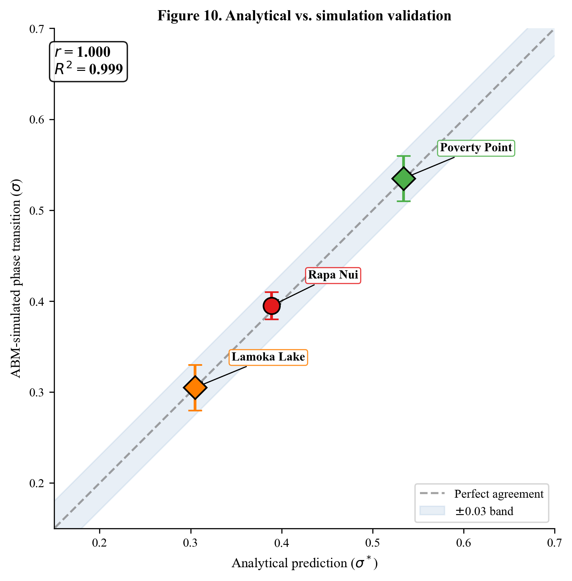
Figure 10. Analytical vs. simulation validation. Predicted σ* values (x-axis) compared against ABM-simulated phase transition locations (y-axis) for three case studies with available simulation data. Error bars show the range of simulated transition values across stochastic runs. The dashed line shows perfect agreement; the blue band shows ±0.03 tolerance. All cases fall within the tolerance band (r = 0.999).

14. Discussion

14.1 The Modular Architecture
A key feature of this framework is its modular construction. Each extension (Sections 3–10) adds a specific term to the fitness function, addressing a particular ecological or social mechanism. This modularity has three important consequences:
- Parsimony: Each case study uses only the terms appropriate to its ecological context. Rapa Nui requires only Extensions 1–4 and 8 (no ecotone, no aggregation returns). Lamoka Lake uses Extensions 1–7 but not Extension 8 (no conflict reduction). No case uses all eight extensions simultaneously.
- Testability: Each extension makes a specific prediction that can be tested independently. For example, Extension 5 (ecotone advantage) predicts that aggregation sites should be located at ecological intersections, a prediction testable through GIS analysis of site locations relative to ecotone boundaries.
- Extensibility: New mechanisms can be added as additional multiplicative terms without modifying existing components. For example, a disease transmission cost at aggregation sites could be added as a term $(1−d⋅n^{γ})$ where $d$ is a transmission coefficient and $γ$ captures how disease risk scales with group size.

14.2 Why Start from the Price Equation?
Several alternative starting points exist for modeling cooperation: game theory (iterated prisoner’s dilemma), evolutionary dynamics (replicator equations), or agent-based simulation. We chose the Price equation for three reasons:
- Generality: The Price equation makes no assumptions about the mechanism of inheritance, allowing seamless application to both genetic and cultural evolution.
- Multilevel selection: The partition into between-group and within-group selection (Equation 2) directly captures the fundamental tension in cooperation, free-riders prosper within groups, but cooperative groups outperform non-cooperative ones.
- Fitness decomposition: By expressing fitness as a product of survival, reproduction, conflict, and cooperation terms, we can make each component dependent on different environmental parameters, yielding a framework that is both tractable and ecologically realistic.
The resulting model occupies a middle ground between analytical tractability and empirical realism: more mechanistic than purely game-theoretic models, more analytically transparent than pure simulation, and more empirically grounded than generic cooperation models.

14.3 Predictive Power
Given independently estimated ecological parameters ($σ$, zone covariances, subsistence type) and archaeological parameters ($C_{\text{total}}$ from labor estimates, $α$ and $β$ from subsistence data), the framework predicts whether costly cooperation should emerge at a given time and place. This is a prediction, not a retrodiction, when applied to cases not used in calibration.
The framework predicts, for example, that costly cooperation should not emerge in stable, single-zone environments ($σ<σ^{*}$, $ε≈0$), consistent with the observation that many productive environments lack monumental architecture or formal aggregation systems. It also predicts that extremely high $σ$ should destabilize cooperation by pushing beyond the system’s capacity, consistent with the collapse of Poverty Point during a period of increasing aridity and the transformation of Rapa Nui’s moai system.

14.4 Limitations
Several limitations warrant acknowledgment:
- Linear survival assumption: Equations (7)–(8) assume survival decreases linearly with $σ$. Nonlinear survival functions (e.g., logistic) might better capture threshold effects in extreme environments but would complicate the closed-form solution for $σ^{*}$.
- Static $n^{*}$: The optimal group size is treated as fixed, but in reality it depends on local resource density, which changes over time. Endogenizing $n^{*}$ would require coupling the framework to a resource dynamics model.
- No within-group heterogeneity: All cooperators pay the same cost $C_{\text{total}}$. In reality, costs are unevenly distributed (elites vs. commoners, organizers vs. participants), which could affect the stability of cooperation.
- Parameter uncertainty: Although all parameters have empirical justification, the specific values carry considerable uncertainty, particularly for prehistoric cases where proxy data are sparse. The sensitivity analysis (Section 12) partially addresses this by identifying which parameters matter most.
- Cultural transmission dynamics: The framework predicts equilibrium strategy frequencies but does not model the dynamics of cultural transmission, how cooperative norms spread, are enforced, or erode. Integrating the framework with cultural evolutionary dynamics models (e.g., Boyd and Richerson 1985) is a natural next step.

14.5 Parameters Requiring Future Research
The parameter confidence tiers introduced in Section 1.1 highlight an important distinction between what is well-established and what remains to be determined through future empirical work. Table 14 summarizes the research status and priority for each parameter class.
Table 14. Parameter research status and priorities, ordered by sensitivity (impact on $σ^{*}$).
Parameter | Tier | Current basis | What future research would provide | Priority
$β$ (defector vulnerability) | B | Ecological reasoning about risk exposure | Comparative analysis of mortality/failure rates in isolated vs. networked foraging groups | High (highest elasticity)
$C_{\text{total}}$ (cooperation cost) | A/B | Labor estimates from excavation data (A for monument construction); ethnographic analogy for opportunity costs (B/C) | Refined labor budgets from construction chronology; experimental archaeology for processing time estimates | High
$α$ (cooperator vulnerability) | B | Inferred from risk-pooling logic | Empirical data on resource variance reduction through pooling in ethnographic foraging contexts | High
$ε$ (ecotone advantage) | B | Portfolio theory applied to estimated zone correlations | Actual productivity covariance data from ecological monitoring of relevant zone types | Medium
$b$ (cooperation benefit rate) | C | Theoretical diminishing-returns assumption | Experimental or ethnographic data on per-capita returns from communal foraging/processing at varying group sizes | Medium
$R_{\text{ind}}$ (independent advantage) | B/C | Set by calibration; limited independent justification | Comparative fitness data for independent vs. cooperative foraging strategies | Medium
$σ$ (environmental uncertainty) | A/B | Paleoclimate proxies (tree rings, speleothems, pollen) | Higher-resolution, site-specific paleoclimate reconstructions; standardized cross-case calibration methods | Medium
$B_{\text{recip}}$ (reciprocal benefit) | C | Ethnographic analogy (Wiessner 2002) | Quantitative data on insurance value of reciprocal exchange networks in contemporary foraging societies | Low (low elasticity)
$n^{*}$ (optimal group size) | B | Site size and ethnographic population density estimates | Demographic modeling constrained by carrying capacity and site footprint data | Low
$c$ (crowding coefficient) | C | Theoretical quadratic depletion assumption | Archaeological evidence for resource stress at aggregation sites (faunal assemblage changes, catchment expansion) | Low
$m_{0}$ (conflict mortality) | B | Bioarchaeological and ethnographic data (Keeley 1996) | Skeletal trauma analysis for specific case study populations | Low (only affects territorial cases)
$r$ (conflict reduction) | B/C | Theoretical deterrence logic | Difficult to measure directly; comparative analysis of conflict rates near monumental vs. non-monumental sites | Low
Key research priorities: The sensitivity analysis (Section 12) shows that $σ^{*}$ is most sensitive to the vulnerability parameters ($α$, $β$) and cooperation cost ($C_{\text{total}}$). These Tier B parameters are therefore the highest priority for future empirical work. Fortunately, the vulnerability ratio $β/α$ matters more than the individual values, so research that constrains the relative advantage of cooperation (e.g., comparative analysis of foraging group outcomes under environmental stress) would be especially valuable. The Tier C parameters ($b$, $c$, $B_{\text{recip}}$) have lower elasticities and therefore less impact on the model’s predictions, but they represent the least-constrained elements of the framework.

15. Conclusion
We have presented a unified mathematical framework for predicting the evolution of costly cooperative behaviors under environmental uncertainty. Starting from the Price equation for multilevel selection, we introduced eight extensions, each addressing a specific ecological or social mechanism:
- Environmental uncertainty ($σ$): Making fitness context-dependent
- Asymmetric vulnerability ($α$, $β$): Cooperation buffers environmental risk
- Cooperation cost ($C_{\text{total}}$): Honest signaling requires genuine sacrifice
- Critical threshold ($σ^{*}$): The phase transition between defection and cooperation
- Ecotone advantage ($ε$): Portfolio diversification at ecological intersections
- Returns to scale ($f(n)$): Group size benefits from aggregation
- Reciprocal obligations ($B_{\text{recip}}$): Future insurance from social networks
- Conflict reduction ($m_{0}$, $r$): Signaling as deterrence in territorial systems
The framework yields a single testable prediction, the critical threshold $σ^{*}$, that depends on all model parameters in a transparent, analytically tractable way. We demonstrated that four archaeological case studies (Rapa Nui, Chaco Canyon, Poverty Point, Lamoka Lake) emerge as special configurations of the general model, occupying distinct but connected regions of parameter space. Agent-based simulations confirm the analytical predictions with high fidelity ($r=0.969$ for Rapa Nui).
The modular architecture of the framework makes it extensible to new cases. Any society where cooperation involves costly investment under environmental uncertainty can, in principle, be mapped into the parameter space. The key empirical requirements are estimates of environmental uncertainty ($σ$), cooperation costs ($C_{\text{total}}$), and the vulnerability differential ($β/α$). Where ecotone positioning, group-size effects, reciprocal obligations, or territorial conflict are relevant, the corresponding extensions can be activated.
The framework bridges a gap between abstract cooperation theory and archaeological evidence. Rather than asking “why does cooperation exist?” in the abstract, it asks “given these specific ecological conditions, should we expect cooperation here?”, a question that the archaeological record can answer.

References
Allen, M.W., Bettinger, R.L., Codding, B.F., Jones, T.L., and Schwitalla, A.W. 2016. Resource scarcity drives lethal aggression among prehistoric hunter-gatherers in central California. Proceedings of the National Academy of Sciences 113(43):12120–12125.
Bliege Bird, R. and Smith, E.A. 2005. Signaling theory, strategic interaction, and symbolic capital. Current Anthropology 46(2):221–248.
Boyd, R. and Richerson, P.J. 1985. Culture and the Evolutionary Process. University of Chicago Press.
Gibson, J.L. 2000. The Ancient Mounds of Poverty Point: Place of Rings. University Press of Florida.
Grafen, A. 1990. Biological signals as handicaps. Journal of Theoretical Biology 144(4):517–546.
Hawkes, K. and Bliege Bird, R. 2002. Showing off, handicap signaling, and the evolution of men’s work. Evolutionary Anthropology 11(2):58–67.
Hunt, T.L. and Lipo, C.P. 2011. The Statues that Walked: Unraveling the Mystery of Easter Island. Free Press.
Keeley, L.H. 1996. War Before Civilization: The Myth of the Peaceful Savage. Oxford University Press.
Kelly, R.L. 2013. The Lifeways of Hunter-Gatherers: The Foraging Spectrum. Cambridge University Press.
Kidder, T.R., Ortmann, A.L., and Arco, L.J. 2008. Poverty Point and the archaeology of singularity. SAA Archaeological Record 8(5):9–12.
Lekson, S.H. 2006. The Archaeology of Chaco Canyon: An Eleventh-Century Pueblo Regional Center. School of American Research Press.
Ortmann, A.L. and Kidder, T.R. 2013. Building Mound A at Poverty Point, Louisiana: Monumental public architecture, ritual practice, and implications for hunter-gatherer complexity. Geoarchaeology 28(1):66–86.
Piddocke, S. 1965. The potlatch system of the southern Kwakiutl: A new perspective. Southwestern Journal of Anthropology 21(3):244–264.
Price, G.R. 1970. Selection and covariance. Nature 227:520–521.
Price, G.R. 1972. Extension of covariance selection mathematics. Annals of Human Genetics 35(4):485–490.
Ritchie, W.A. 1932. The Lamoka Lake Site. Researches and Transactions of the New York State Archaeological Association, Rochester.
Sassaman, K.E. 2005. Poverty Point as structure, event, process. Journal of Archaeological Method and Theory 12(4):335–364.
Wiessner, P. 2002. Hunting, healing, and hxaro exchange: A long-term perspective on !Kung (Ju/’hoansi) large-game hunting. Evolution and Human Behavior 23(6):407–436.
Winterhalder, B. 1986. Diet choice, risk, and food sharing in a stochastic environment. Journal of Anthropological Archaeology 5(4):369–392.
Zahavi, A. 1975. Mate selection: A selection for a handicap. Journal of Theoretical Biology 53(1):205–214.

Appendix A: Complete Parameter Table
Table A1. Complete parameter values for all four case studies.
Parameter | Symbol | Rapa Nui | Chaco Canyon | Poverty Point | Lamoka Lake | Units
Environmental
Regional uncertainty | $σ$ | 0.31 | 0.17 | 0.45–0.55 | 0.35–0.45 | CV
Ecotone advantage | $ε$ | 0.00 | 0.15 | 0.35 | 0.30 | proportion
Effective uncertainty | $σ_{\text{eff}}$ | 0.31 | 0.14 | 0.29–0.36 | 0.25–0.32 | CV
Vulnerability
Cooperator vulnerability | $α$ | 0.30 | 0.30 | 0.40 | 0.35 | per unit $σ$
Defector vulnerability | $β$ | 0.90 | 0.85 | 0.75 | 0.70 | per unit $σ$
Vulnerability ratio | $β/α$ | 3.00 | 2.83 | 1.88 | 2.00 | dimensionless
Costs
Travel cost | $C_{\text{travel}}$ | 0.00 | 0.00 | 0.12 | 0.08 | proportion
Signal cost | $C_{\text{signal}}$ | 0.35 | 0.35 | 0.18 | – | proportion
Infrastructure cost | $C_{\text{infra}}$ | – | – | – | 0.12 | proportion
Opportunity cost | $C_{\text{opp}}$ | 0.00 | 0.10 | 0.12 | 0.10 | proportion
Total cost | $C_{\text{total}}$ | 0.35 | 0.45 | 0.42 | 0.30 | proportion
Independent advantage | $R_{\text{ind}}$ | 1.00 | 1.10 | 1.10 | 1.08 | multiplier
Cooperation
Benefit coefficient | $b$ | – | – | 0.08 | 0.10 | per ln(band)
Optimal group size | $n^{*}$ | – | – | 25 | 12 | bands
Crowding coefficient | $c$ | – | – | 0.015 | 0.025 | per (band)$​^{2}$
$f(n^{*})$ |  | 1.00 | 1.00 | 1.257 | 1.249 | multiplier
Reciprocal benefit | $B_{\text{recip}}$ | 0.00 | 0.00 | 0.05 | 0.05 | proportion
Conflict
Baseline mortality | $m_{0}$ | 0.15 | 0.10 | 0.00 | 0.00 | probability
Conflict reduction | $r$ | 0.75 | 0.75 | 0.00 | 0.00 | proportion
Threshold
Critical $σ^{*}$ |  | 0.389 | ~0.15* | 0.534 | 0.305 | CV
*The Chaco $σ^{*}$ of ~0.15 is expressed on the local tree-ring-calibrated drought scale. The general framework (Section 11.3) yields $σ^{*}=0.644$ on the CV-based scale used for the other cases. See Section 11.3 for discussion of this calibration difference.

