Methods

Study area and data acquisition
We surveyed the entire coast of Rapa Nui (Easter Island; 27.1°S,
109.4°W) using paired thermal–RGB drone flights between June 2023 and
January 2024. A total of 29 flights covered the bays, inlets, and
cliff coasts of the island, producing approximately 30,000 paired
frames at 1 m ground resolution. Each frame consisted of a
radiometric thermal image (Autel 640T payload, 640 × 512 pixels,
calibrated to °C) co-registered with a high-resolution RGB frame
(4096 × 3072 pixels). All flights flew at 80–150 m altitude with
camera nadir-locked. Each frame's GPS position, camera heading, and
altitude were recorded in EXIF metadata.

Per-frame thermal anomaly
For each frame, we segmented ocean from land/wave classes using a
rule-based HSV classifier on the RGB frame, then computed per-pixel
cold anomaly relative to the frame's own warm-water baseline:
\mathrm{anomaly}(p) = \max(0, \, T_{\mathrm{baseline}} - T(p))
where \( T_{\mathrm{baseline}} \) is the 75th percentile of ocean-
classified pixel temperatures within the frame. The per-frame
baseline normalises out diurnal and atmospheric drift between
flights and seasons, leaving the relative cold-anomaly signature of
submarine groundwater discharge (SGD) plumes against the local
ambient ocean.

Spatial integration into anomaly rasters
We projected each ocean-classified pixel from image space to
geographic coordinates using the camera's GPS position, altitude,
heading, and known field of view, accumulating cells onto a fixed
1 m × 1 m latitude/longitude grid spanning each flight's footprint.
Per cell, the mean cold-anomaly was computed across all overlapping
frame contributions:
\overline{\mathrm{anomaly}}_{\mathrm{cell}} = \frac{\sum_{\mathrm{frames}}
\max(0, T_{\mathrm{baseline}} - T)}{n_{\mathrm{observations}}}
This produced a per-flight integrated cold-anomaly raster,
robust against transient artifacts (sun glint, single-frame sensor
noise) because such effects do not persist at the same lat/lon
across overlapping frames.

Authoritative water mask: OpenStreetMap coastline
To distinguish ocean cells from cells inadvertently mapped to land
(e.g., cliff-face pixels misprojected to offshore coordinates by the
flat-ground assumption inherent in the camera projection), we built a
per-flight water mask from OpenStreetMap (OSM) coastline data. We
fetched 131 hand-mapped coastline ways for Rapa Nui (9344 nodes)
through the Overpass API, stitched them into a Shapely MultiPolygon
representing the island's emergent land surface, and rasterized at
each flight's grid using vectorised point-in-polygon containment. The
OSM coastline is hand-mapped, tide-independent (defined at mean high
water), and free of the noise that affects pixel-level
classification of satellite imagery. Cells inside the polygon were
labeled land; cells outside were labeled water.

Cliff-zone exclusion using SRTM elevation
The flat-ground projection in the camera footprint model can mismap
pixels of vertical cliff faces (Poike: ~370 m, Rano Kau: ~250 m) to
ocean coordinates near the cliff base, producing phantom cold-anomaly
content offshore. Even where the OSM water mask correctly identifies
those cells as water, they can still be polluted by misprojected
cliff thermal. We mitigated this by deriving a per-flight cliff-zone
mask from the NASA SRTM 30 m global digital elevation model. For
each cell of the flight grid, we sampled the bilinearly-interpolated
SRTM elevation, applied a 100 m maximum-elevation filter, and
flagged cells where the local maximum elevation exceeded 80 m as
cliff-zone cells. This filter is grounded in Rapa Nui's volcanic
groundwater geology: SGD requires lava-tube conduit topology, which
forms only at low-elevation bays and inlets where collapsed tubes
intersect the sea surface; vertical cliffs lack the geometry for
freshwater to emerge at the sea surface even if the underlying
aquifer is contiguous. Cliff-zone cells were excluded from both
plume seed candidates and watershed flood propagation.

Coast-anchored plume detection
We extracted SGD plume polygons from the integrated anomaly raster
using a coast-anchored watershed segmentation:
1. **Coastline definition**: cells classified as water in the OSM
mask that are immediately adjacent to land cells. This produces a
1-cell-wide ring tracing the actual island shoreline.
2. **Source candidates**: water cells within 60 m offshore of the
coastline (excluding cliff-zone cells, see above) with cold-
anomaly above an adaptive peak threshold (see below).
3. **Watershed seeds**: candidate sources clustered using local-
maximum detection with a minimum separation of 30 m between seeds.
4. **Watershed flood**: from each seed, the algorithm propagated
outward through water cells with anomaly above the adaptive edge
threshold, bounded at 150 m offshore from the coastline.
5. **Polygon filters**: minimum area 50 m² (drop noise), maximum area
8000 m² (drop diffuse coastal cooling), and centroid within 75 m
of the coastline (drop polygons with thin tails reaching back to
shore but bodies far offshore).
Each surviving polygon represents one discrete SGD plume with a
documented coastal source. The polygon properties record the source
latitude/longitude (the cell where the plume emerges at the
coastline), area, integrated cold-anomaly content, peak anomaly,
and offshore extent.

Adaptive thresholds
The adaptive peak and edge thresholds are derived per-flight from the
cold-anomaly distribution of water cells:
- \( T_{\mathrm{peak}} = \mathrm{clip}(p_{95}, 0.35, 0.55) \) °C
- \( T_{\mathrm{edge}} = \mathrm{clip}(\max(p_{70}, 0.5 \cdot T_{\mathrm{peak}}),
0.20, 0.35) \) °C
where \( p_{95} \) and \( p_{70} \) are the 95th and 70th percentiles
of cold-anomaly values among water-classified cells in the flight.
The floor (0.35 / 0.20 °C) ensures detection at subtle-SGD sites
(e.g., Vaihu Harbor, where peak anomalies are typically 0.4–0.6 °C);
the ceiling (0.55 / 0.35 °C) prevents strong-signal flights or
flights with cliff-shadow contamination from setting thresholds so
high that other coastal zones in the same flight are filtered out.

Σ_anomaly: threshold-independent intensity metric
Because the 0.3 °C threshold is somewhat arbitrary, we report each
polygon's integrated cold-anomaly content as the threshold-
independent metric:
\Sigma_{\mathrm{anomaly}} = \int_{\mathrm{polygon}}
\overline{\mathrm{anomaly}}_{\mathrm{cell}}(x, y) \, dA \quad
\mathrm{[m^2 \cdot {}^{\circ}C]}
implemented as the sum of mean per-cell anomaly multiplied by cell
area. Σ_anomaly is robust to the SGD detection threshold (the
integral does not depend on which cells were called "SGD" or where
the polygon boundary was drawn), robust across flights and seasons
(each flight's per-frame baseline normalises out absolute temperature
differences), and is the appropriate metric for cross-site quantitative
comparison.

Quality filters and projection-bug mitigation
Three filters are applied to suppress the known projection-bug
artifacts at cliff coasts:
1. **Cliff-shadow filter** — cells classified as land by the OSM mask
with cold-anomaly exceeding 1.5 °C and adjacent (within 15 m)
water cells with anomaly exceeding 1.0 °C are flagged as
misprojected cliff thermal and dropped from the watershed input.
2. **Outlier cap** — cells with cold-anomaly exceeding 3.0 °C are
dropped (real SGD plumes rarely exceed 1.5 °C below ambient;
3 °C+ values are sensor or atmospheric outliers).
3. **Observation count** — cells observed by fewer than 5 overlapping
frames are dropped (insufficient temporal averaging).

Cross-flight aggregation
Per-flight polygons were aggregated into a master KML by season,
with polygons coloured by Σ_anomaly tier (six logarithmic tiers from
"very_low" to "extreme"). Master grand-total Σ_anomaly is reported
across all flights. The system also generates per-flight validation
figures (3-panel diagnostic showing the anomaly raster, polygon
overlay, and observation count) and site closeups that overlay
detected plumes on Esri World Imagery satellite basemaps.

Limitations
The current pipeline has three known limitations:
1. **Per-frame ocean segmentation** uses a rule-based HSV classifier
that can occasionally misclassify shaded cliff face as ocean. The
downstream OSM water mask and SRTM cliff-zone filter mitigate
this, but a SAM2-based per-frame segmenter (planned, Phase 2)
would prevent cliff thermal from entering the projection at all.
2. **Camera footprint projection** assumes a flat ground at sea
level, mismapping high-elevation pixels to offshore coordinates.
A DEM-aware projection (planned, Phase 3) using SRTM terrain to
ray-march each pixel would fix this at the source.
3. **Per-frame baseline (p75 of ocean)** can be biased low when a
plume covers >25 % of the frame; switching to p90 (planned,
Phase 2 alongside SAM2) would improve robustness for very large
plumes.
These limitations are explicitly logged in the project's living
methods document and prioritised for future iterations.

Software and reproducibility
All processing is implemented in Python with scientific-Python
ecosystem libraries (numpy, scipy, scikit-image, shapely,
matplotlib). Geospatial coastline data is fetched from
OpenStreetMap via the Overpass API; elevation data is
NASA SRTM 30 m via ESA Sentinel mirror. Source code, processing
scripts, and a living methods document are available at the project
repository. Per-flight raw inputs (paired MAX_*.JPG and IRX_*.irg
frames) and per-flight outputs (anomaly rasters, water masks, cliff-
zone masks, polygon GeoJSONs, validation figures) are organised by
flight slug under `sgd_output/<slug>_spread/` for traceability.

Figures
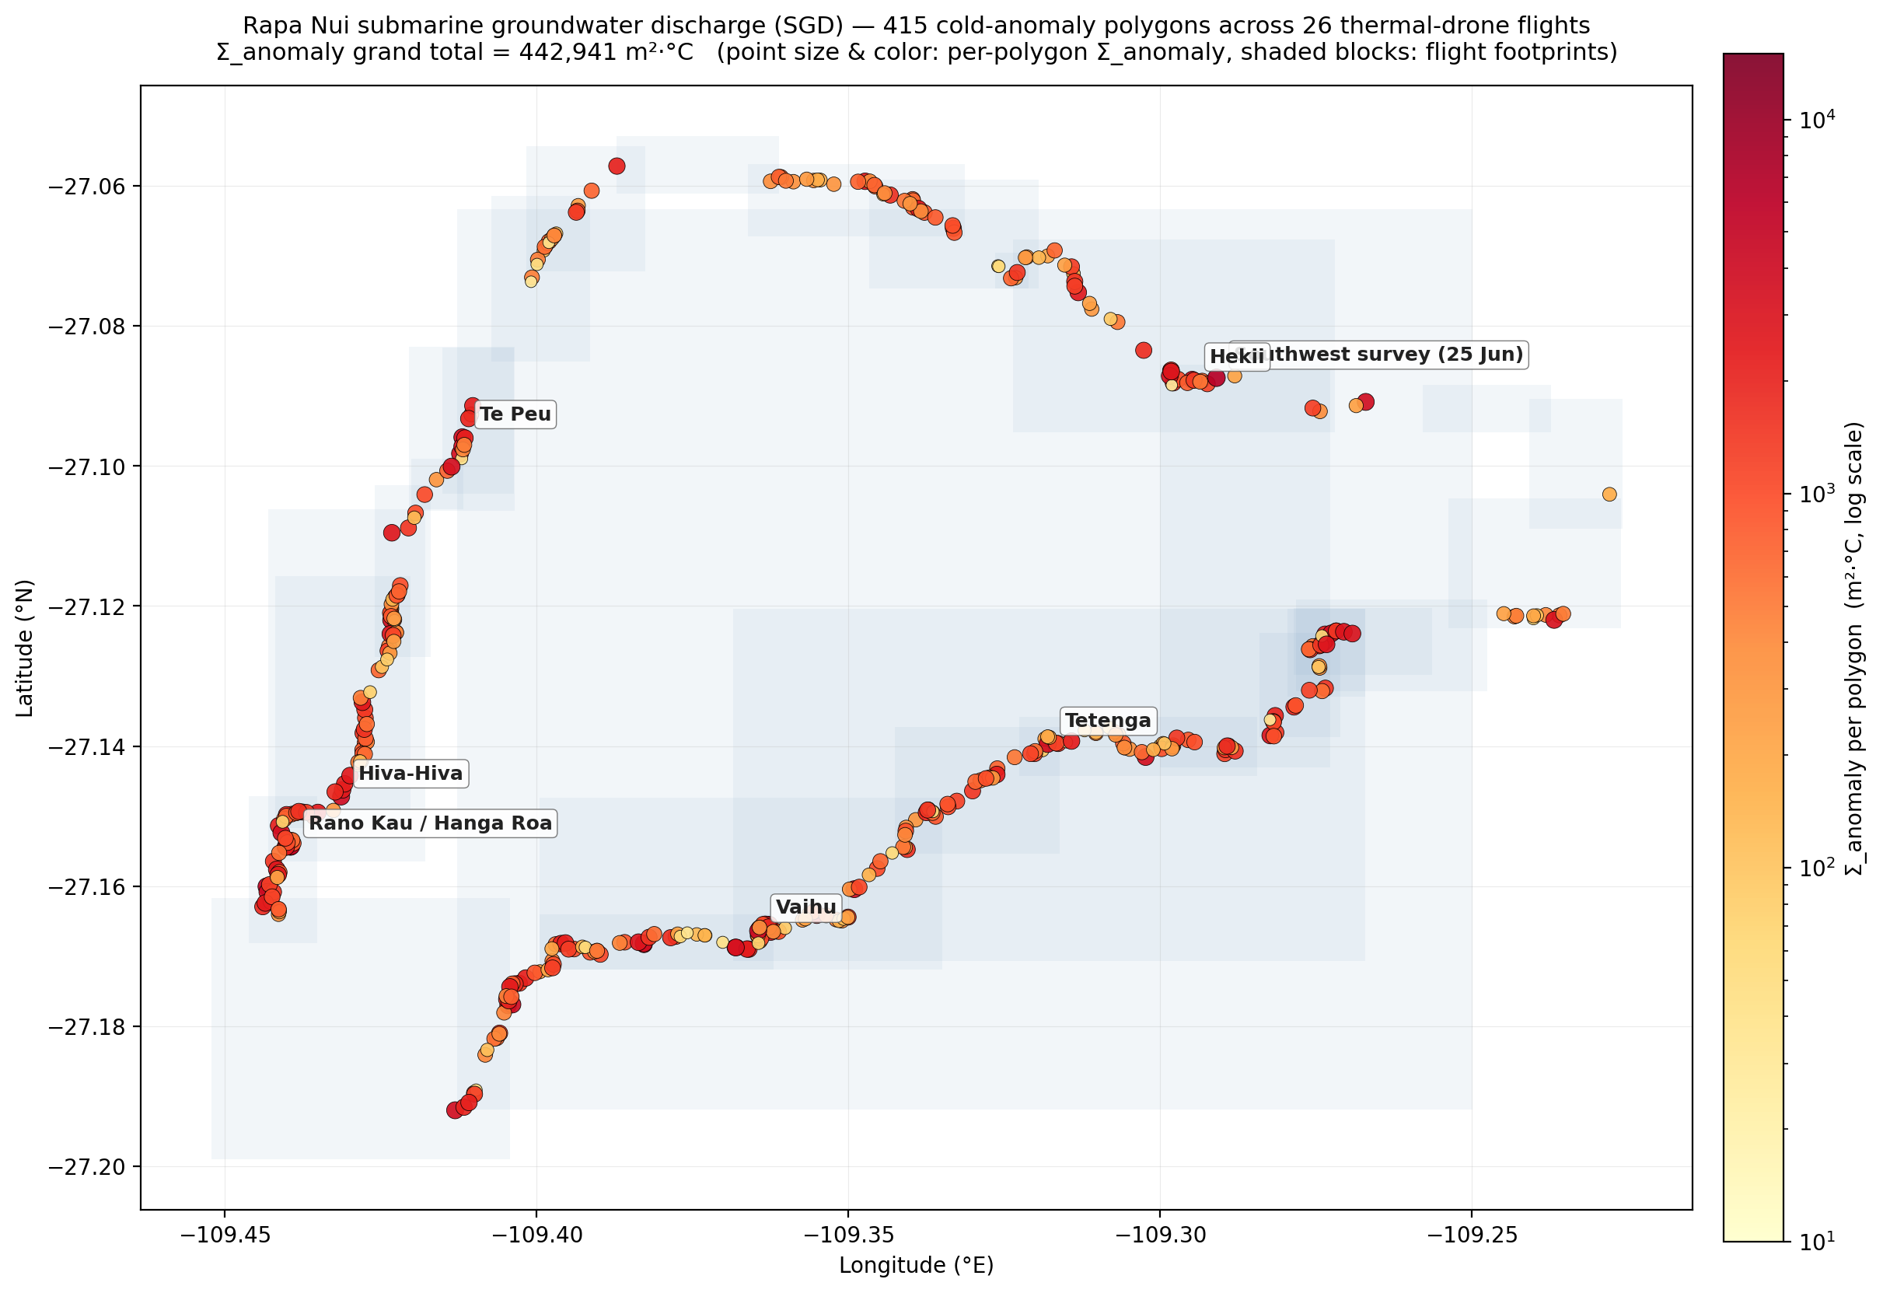
Figure 1. Island-wide SGD distribution. Coast-anchored SGD plumes detected across 29 thermal-drone flights of Rapa Nui (June 2023 and January 2024). Each point represents one plume polygon; size and colour scale with the polygon's Σ_anomaly (m² × °C of integrated cold-anomaly content). Background shaded blocks show flight footprints. The full-resolution SVG and KML versions allow toggling individual flights and inspecting polygon attributes.

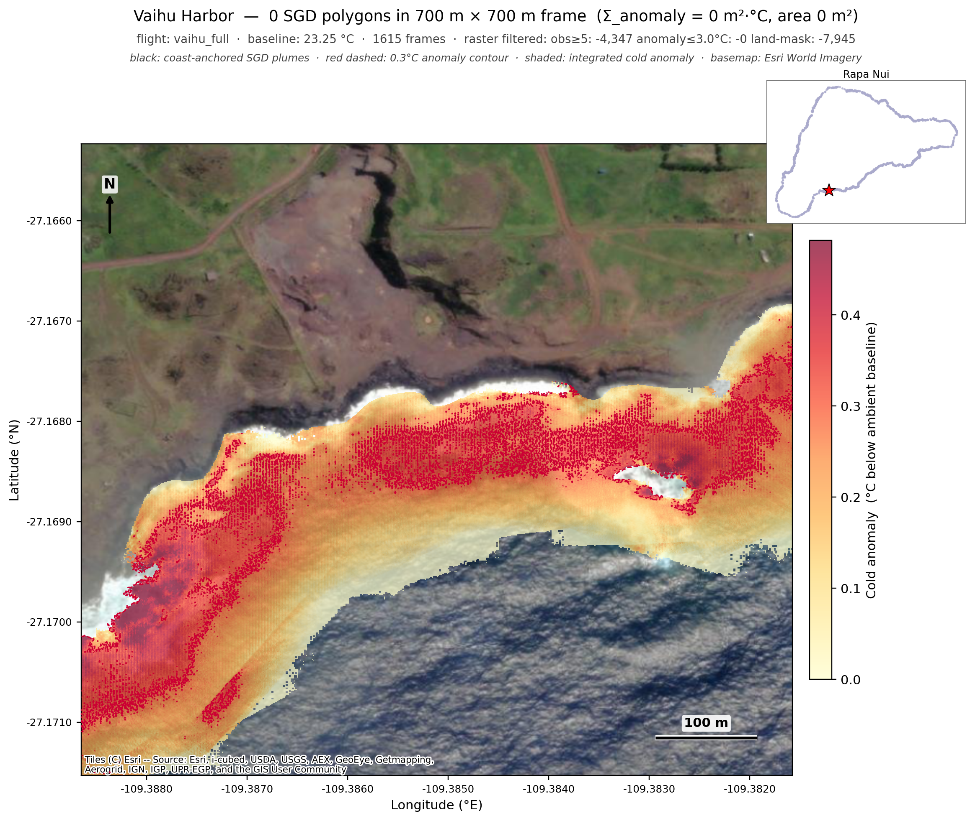
Figure 2. Vaihu Harbor (textbook SGD reference site). Coast-anchored plumes overlaid on Esri WorldImagery satellite tile. Eighteen discrete plumes traced along the bay shoreline, with sources at the rocky cape and inner harbour where freshwater is known to emerge through collapsed lava-tube outlets. The 0.3 °C anomaly contour (red dashed) shows the broader plume envelope.

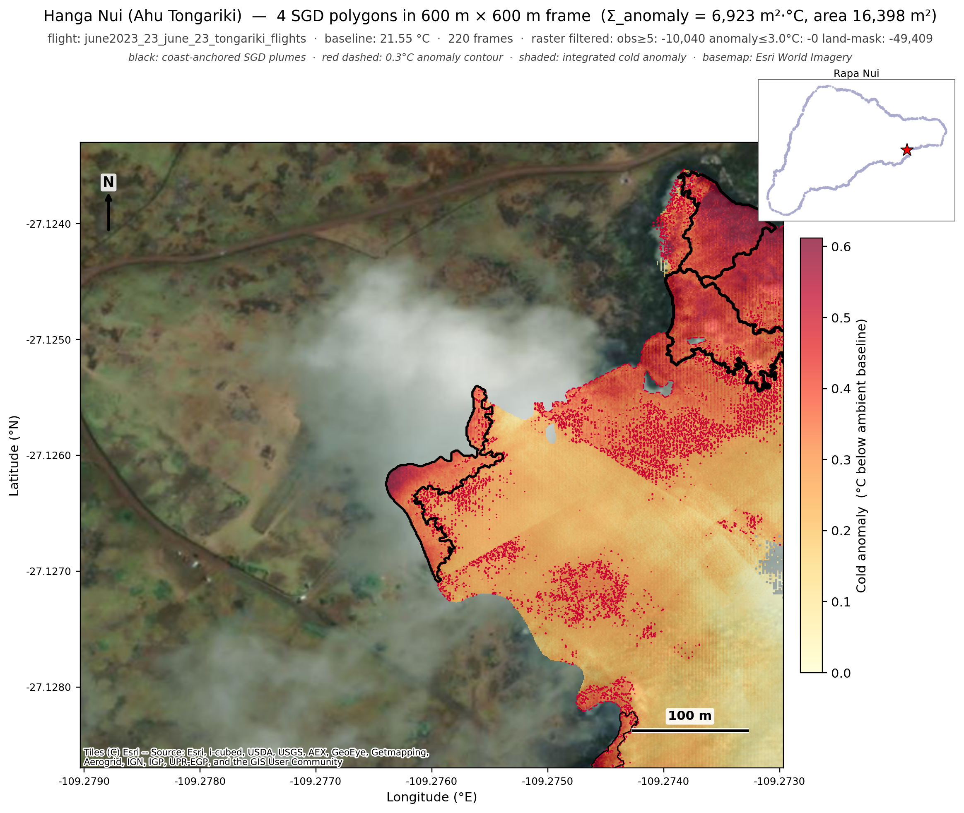
Figure 3. Hanga Nui at Ahu Tongariki. Five discrete plumes detected in the bay where the famous moai platform is sited. Bay geometry typical of Rapa Nui's SGD-active sites: low-elevation beach/rocks, sheltered from the open Pacific, with Poike's volcanic slopes inland.

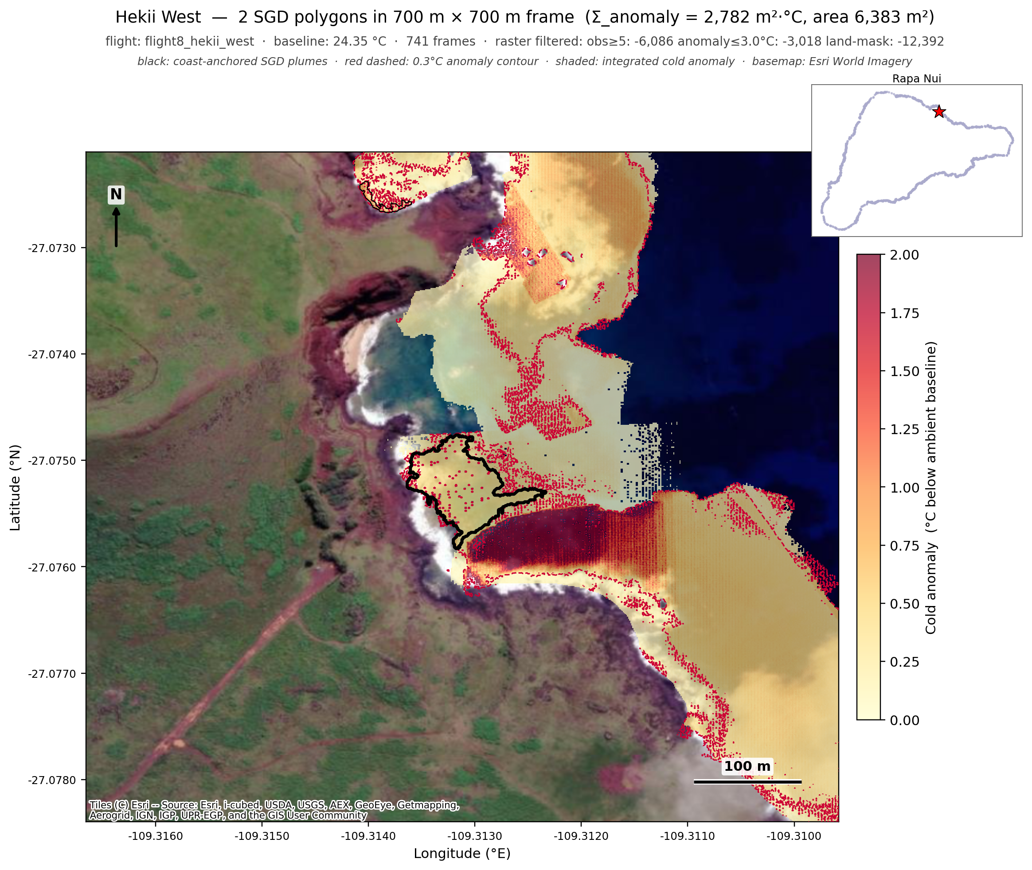
Figure 4. Hekii West. Twelve discrete plumes along a known SGD hot zone on the east coast. Strong cold-anomaly signal (peak ~1 °C below ambient) typical of strong-flow lava-tube outlets.

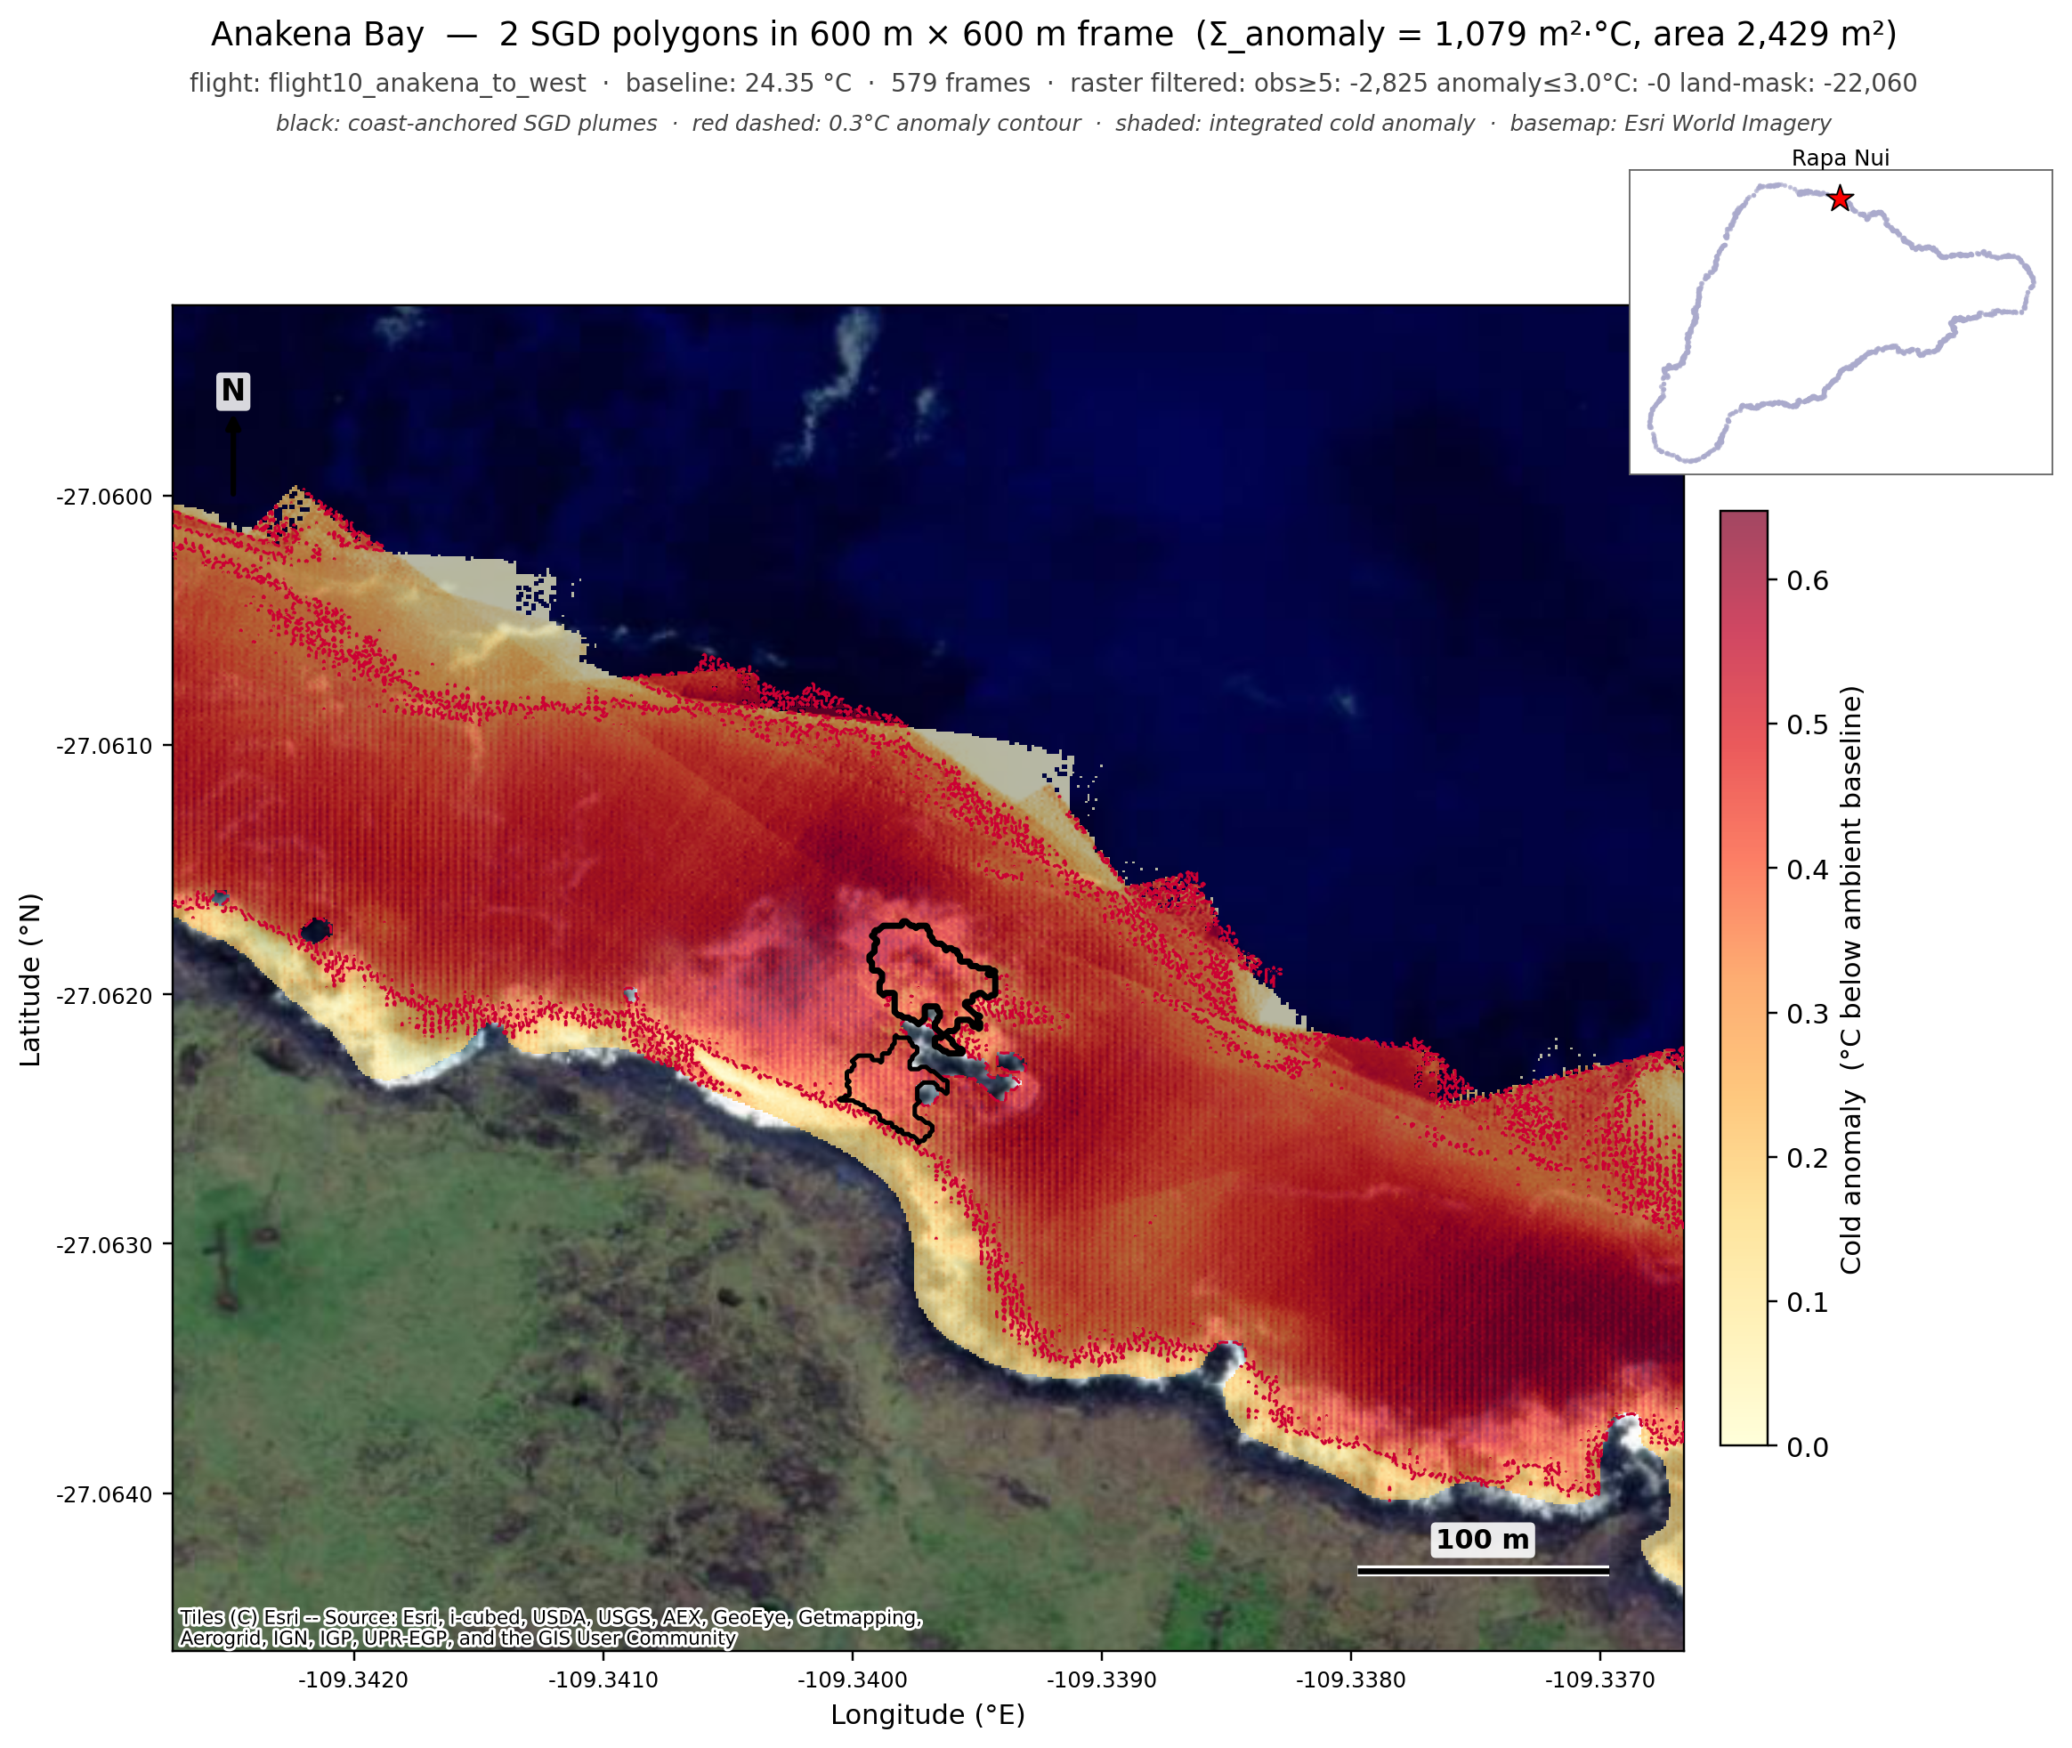
Figure 5. Anakena Bay. Four plumes detected in the small sandy-beach bay. The relatively low Σ_anomaly here is consistent with Anakena's geology — small drainage basin upstream, modest groundwater throughput.

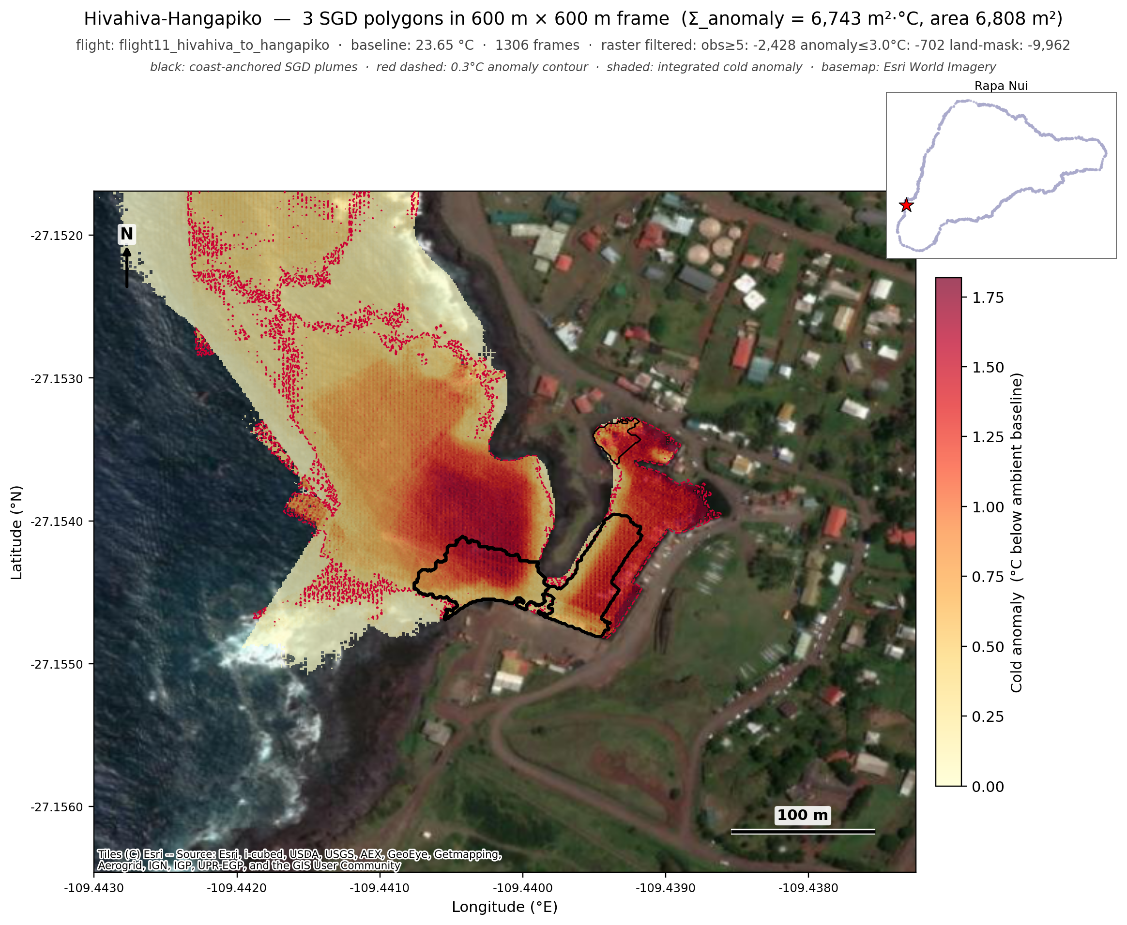
Figure 6. Hivahiva-Hangapiko (south coast). Ten plumes along the south coast bay system with strong cold signal at the rocky inshore zone.

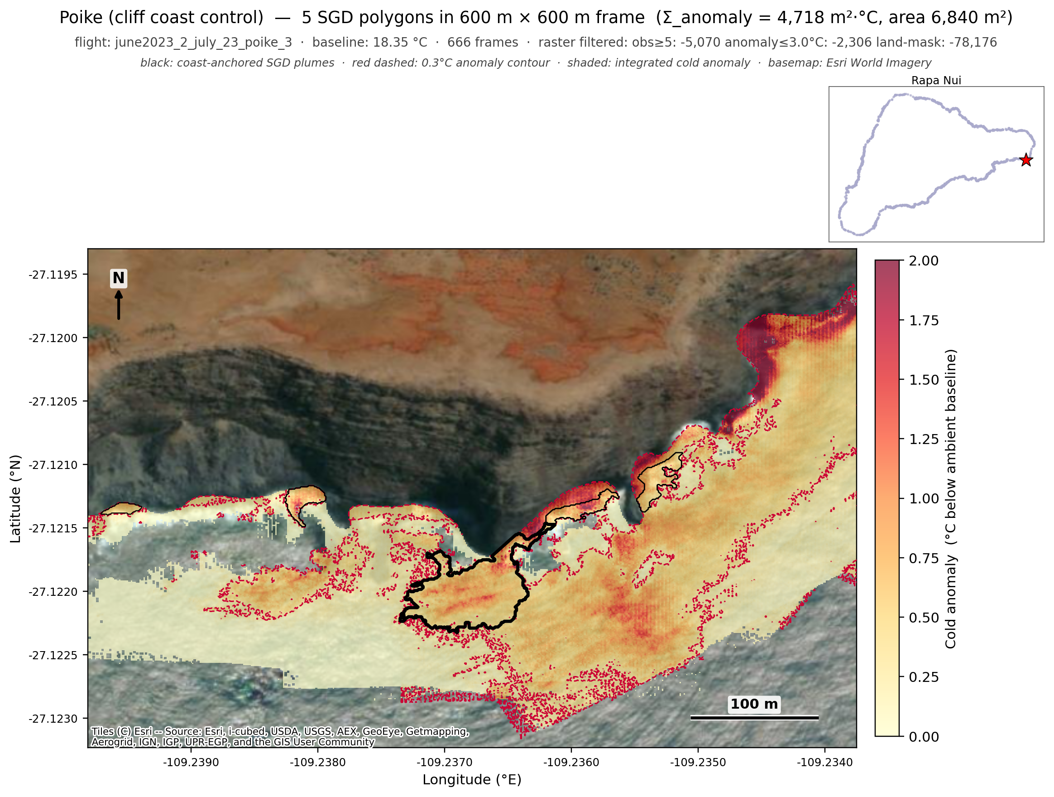
Figure 7. Poike (cliff-coast control). The cliff-zone filter based on SRTM elevation correctly suppresses the spurious cliff-shadow polygons that would otherwise dominate this flight. Surviving plumes are at the surf zone immediately offshore of the cliff base, where some real cold-water signal may exist (or may still represent residual misprojection — flagged as a known limitation).

