Mapping Submarine Groundwater Discharge from UAV Thermal Imagery

A coast-anchored detection pipeline applied island-wide at Rapa Nui (Easter Island)
Whitepaper. Last revised 2026-06-28.

1. Summary
Submarine groundwater discharge (SGD) delivers freshwater, nutrients, and contaminants from terrestrial aquifers into the coastal ocean. It is spatially patchy, often concentrated at a few discrete outlets, and easy to miss with point-sampling surveys. Discharging groundwater is typically 1 to 3 °C cooler than ambient surface seawater, so it leaves a thermal signature that aerial infrared imaging can resolve.
This whitepaper describes an end-to-end pipeline that turns paired thermal and RGB imagery from a consumer survey drone into a quantitative, island-wide map of SGD plumes. The pipeline was developed and validated on a complete thermal survey of the coast of Rapa Nui. Twenty-nine flights covering roughly 30,000 paired frames produce per-flight cold-anomaly rasters, from which a coast-anchored watershed detector extracts discrete plume polygons. Each polygon carries a documented coastal source point and a threshold-independent intensity metric, Σ_anomaly, in units of m²·°C.
The canonical product is a set of 415 coast-anchored plumes spanning the whole island (Figure 1). Each plume is anchored to the shoreline, screened against an authoritative land/water boundary, and filtered to exclude cliff coasts where the island's groundwater geology makes SGD physically implausible. The method is designed to be portable to other volcanic-island and karst coastlines where SGD emerges through discrete conduits.
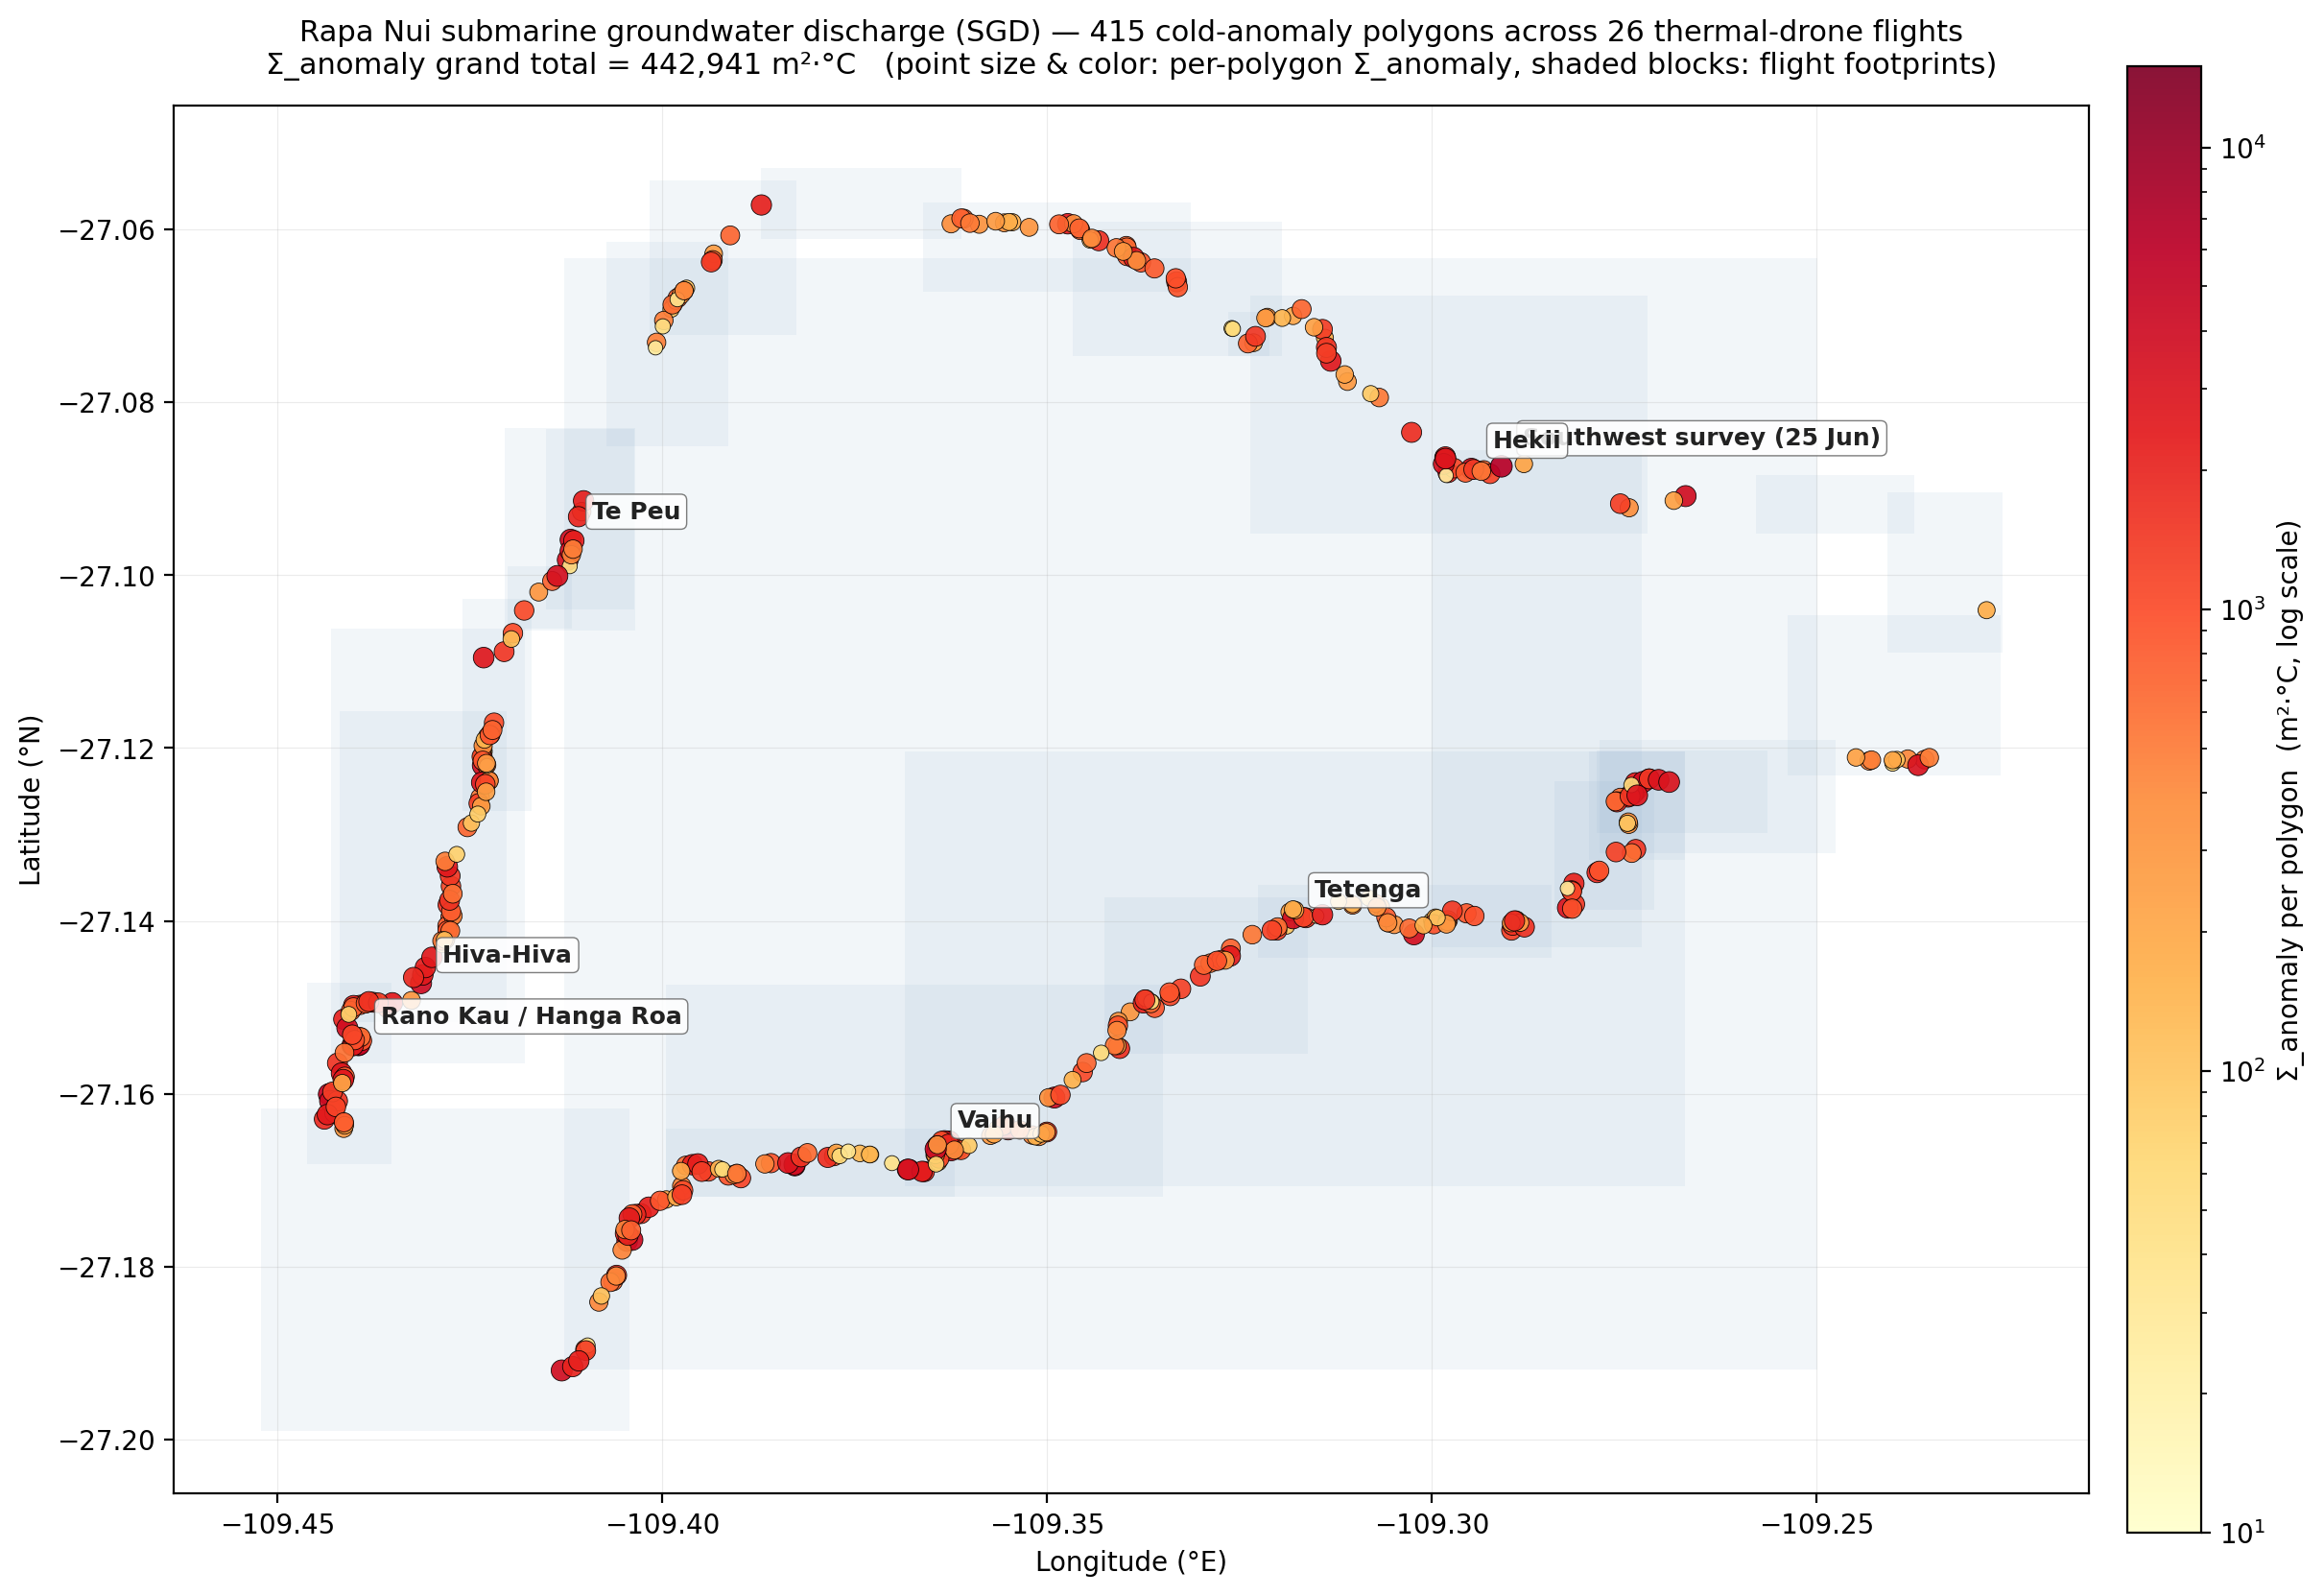
Figure 1. Island-wide SGD distribution. Coast-anchored SGD plumes
detected across 29 thermal-drone flights of Rapa Nui (June 2023 and January 2024). Each marker is one plume polygon. Size and color scale with the polygon's Σ_anomaly (m²·°C of integrated cold-anomaly content). The full-resolution KML version allows toggling individual flights and inspecting per-polygon attributes.

2. The problem
SGD is a globally significant but under-measured part of the hydrological cycle. Where it occurs, it can dominate the local freshwater and nutrient budget of a coastal cell, stimulating productivity in some settings and contributing to eutrophication or contaminant loading in others. On water-scarce volcanic islands it also represents a direct loss of freshwater from a limited aquifer, so knowing where and how much groundwater discharges has practical resource-management value.
The detection problem is fundamentally one of spatial coverage at adequate resolution. Direct methods such as seepage meters, piezometer transects, and geochemical tracer surveys are accurate at a point but labor-intensive and sparse. A field team might survey a few hundred meters of coast over several days and still step over the discrete outlets between sample stations. Satellite thermal imagery covers whole coastlines at once, but its pixels (tens to hundreds of meters) blur all but the largest plumes. Manned thermal aircraft improve resolution at high cost and limited repeatability.
UAV thermal imaging fills the gap. A small drone with a radiometric thermal payload resolves the sea surface at roughly 1 m, deploys on demand, and surveys kilometers of coastline per flight. The remaining difficulty is not acquisition but processing: turning tens of thousands of overlapping thermal frames into a clean, quantitative, false-positive-resistant map of discharge locations. That processing pipeline is the subject of this whitepaper.

3. Survey and data
The reference survey covers the entire coast of Rapa Nui (27.1°S, 109.4°W). Flights were flown between June 2023 and January 2024, twenty-nine in total, spanning the island's bays, inlets, and cliff coasts. Each flight used an Autel 640T payload that captures a radiometric thermal frame (640 × 512 pixels, calibrated to °C) co-registered with a high-resolution RGB frame (4096 × 3072 pixels). Flights flew at 80 to 150 m altitude with the camera nadir-locked, yielding roughly 1 m ground resolution in the thermal band. Each frame records its GPS position, camera heading, and altitude in EXIF metadata. The complete survey comprises approximately 30,000 paired frames.
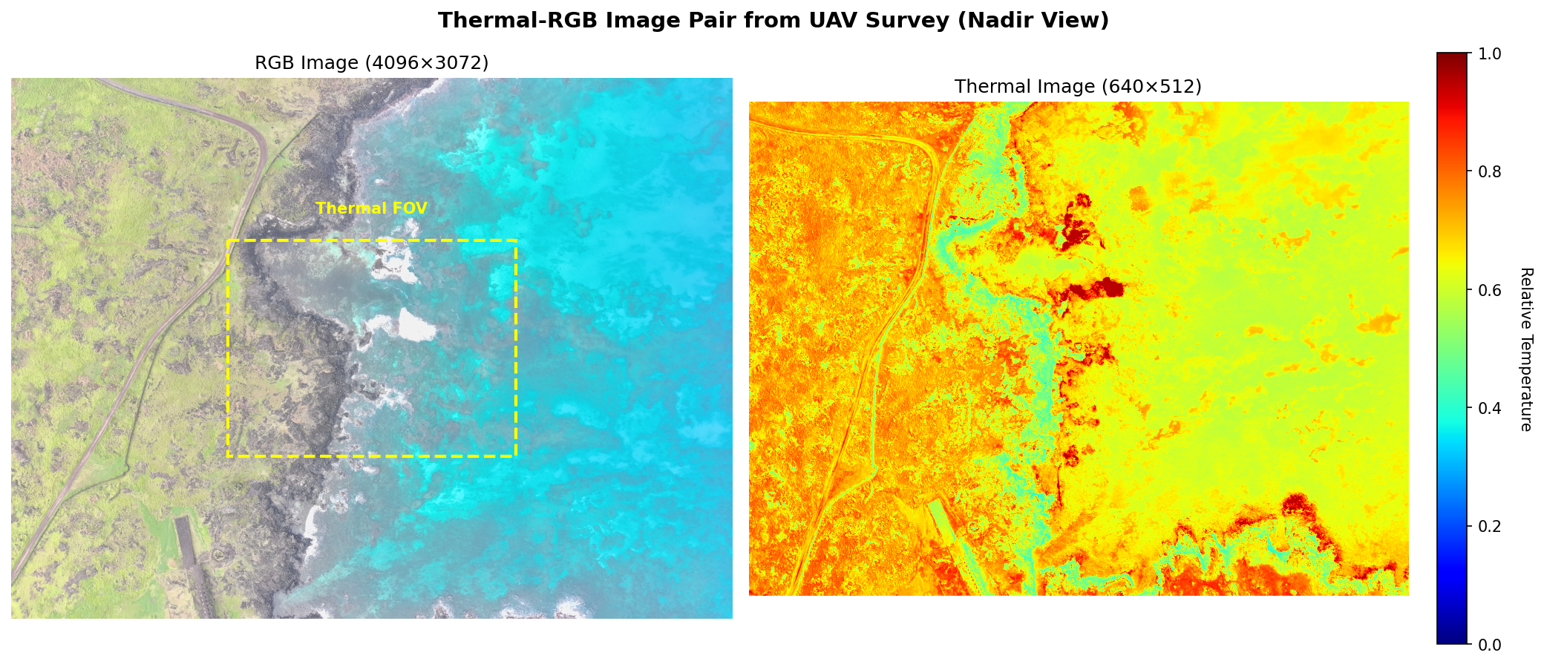
Figure 2. A paired frame from the Autel 640T payload. The radiometric
thermal image (left) is calibrated to °C. The co-registered RGB image (right) is used for ocean/land/wave segmentation and for visual verification.
The two sensors do not share a field of view. The thermal sensor sees a narrower scene than the RGB camera, so the two frames must be geometrically aligned before the RGB segmentation can be applied to thermal pixels. Figure 3 shows the field-of-view relationship that the alignment step resolves.
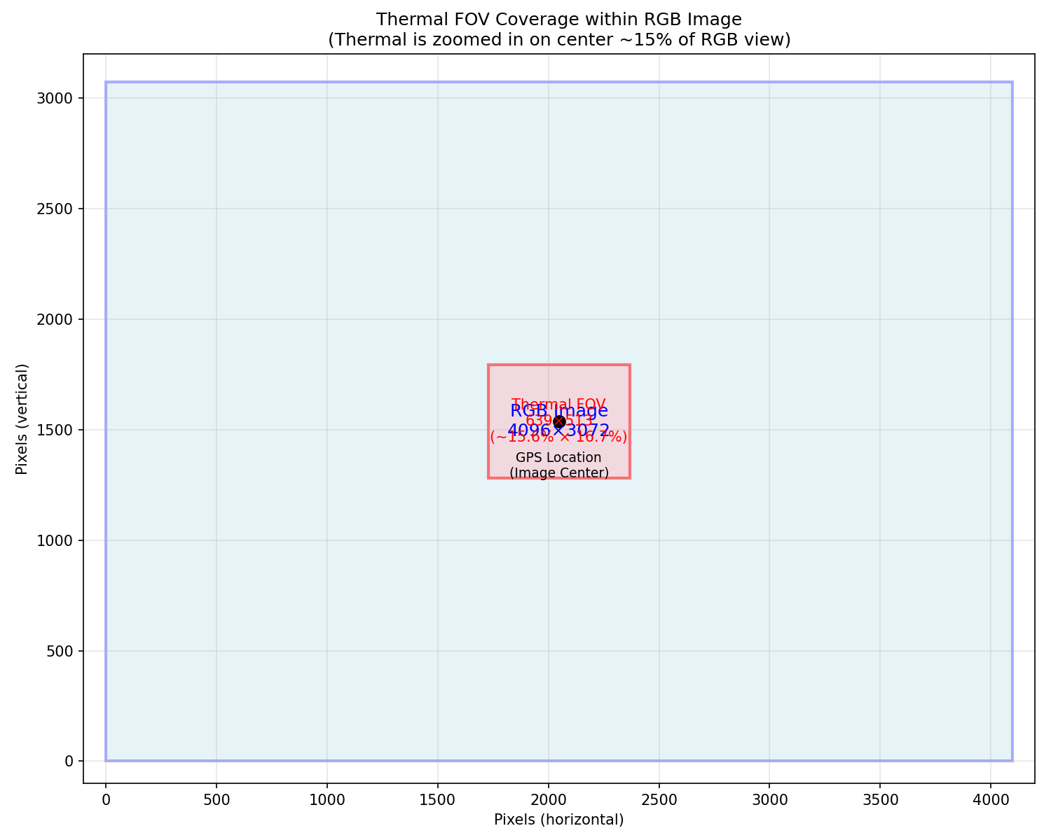
Figure 3. Field-of-view relationship between the thermal and RGB
sensors. The thermal frame covers a sub-region of the RGB frame, so the higher-resolution RGB segmentation is mapped onto the thermal pixels through a fixed geometric transform.

4. Pipeline overview
The pipeline proceeds in five stages, from a single frame to an island-wide plume map:
1. Per-frame anomaly. Segment ocean from land and wave classes in each frame, then compute each ocean pixel's cold anomaly relative to that frame's own warm-water baseline.
2. Spatial integration. Project every ocean pixel to geographic coordinates and accumulate it onto a fixed 1 m grid, averaging across all overlapping frames to suppress transient artifacts.
3. Authoritative masking. Replace pixel-level land/water classification with an OpenStreetMap coastline mask, and exclude cliff zones using an SRTM digital elevation model.
4. Coast-anchored detection. Seed a watershed from the shoreline and propagate outward through cold water, producing discrete plume polygons, each with a documented coastal source.
5. Quantification and aggregation. Compute each polygon's threshold-independent Σ_anomaly and aggregate per-flight polygons into island-wide master products.
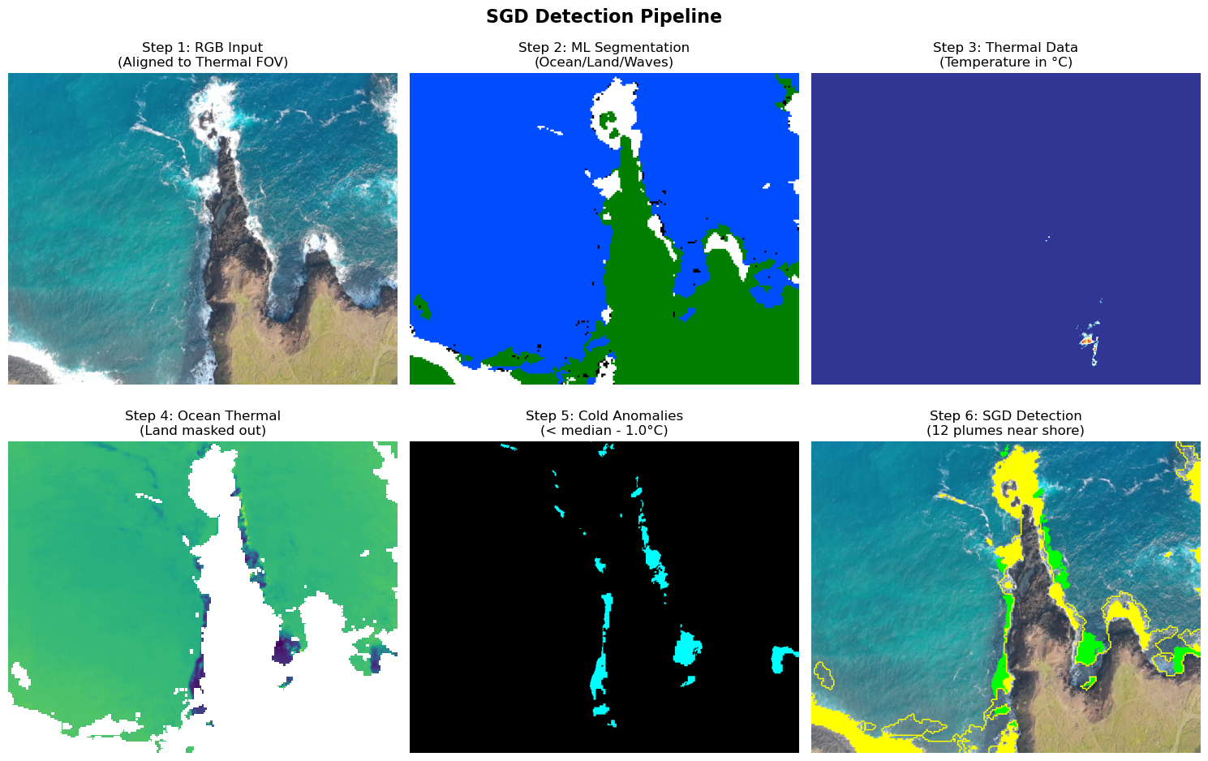
Figure 4. End-to-end detection pipeline, from a single paired frame
through per-frame anomaly, spatial integration, masking, and coast-anchored plume extraction.
The sections that follow describe each stage and the design choices that make the output quantitative and resistant to false positives.

5. Per-frame thermal anomaly
For each frame the pipeline segments ocean from land and wave classes, then computes a per-pixel cold anomaly relative to a baseline derived from that same frame. The baseline is the 75th percentile of ocean-classified pixel temperatures within the frame, and the anomaly at each pixel is max(0, baseline − T_pixel) in °C.
Anchoring the baseline to each frame is what makes the metric comparable across an entire multi-season survey. Absolute sea-surface temperature drifts with time of day, season, atmospheric conditions, and sensor state. A per-frame relative baseline normalizes out that drift and leaves the local cold-anomaly signature of a plume against its immediate ambient water. A plume that is 1 °C below local ambient reads the same whether the flight was flown on a warm afternoon or a cool morning.
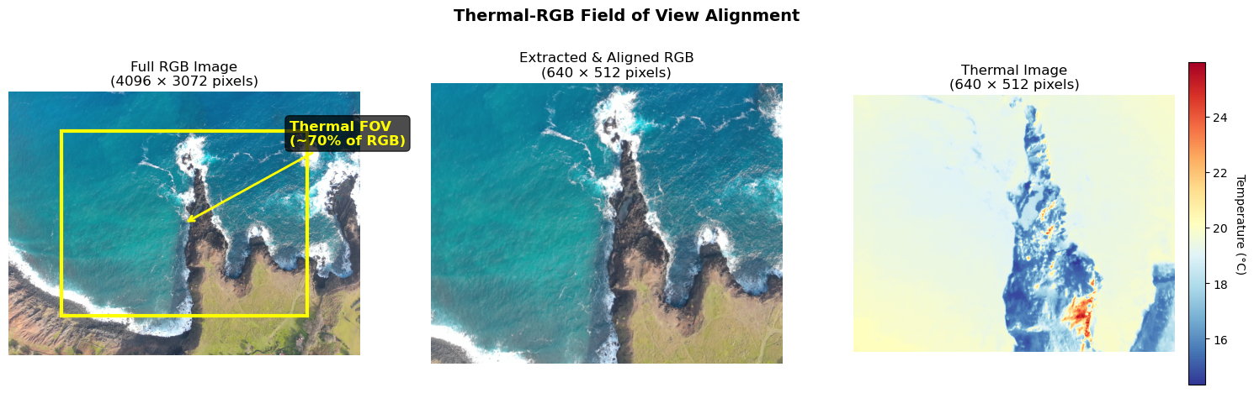
Figure 5. Thermal-RGB alignment underpinning the per-frame anomaly.
Ocean segmentation is computed on the aligned RGB frame and applied to the co-registered thermal pixels, isolating the ocean-only temperature distribution from which the warm-water baseline is taken.

6. Spatial integration into anomaly rasters
Each ocean-classified pixel is projected from image space to geographic coordinates using the camera's GPS position, altitude, heading, and known field of view, then accumulated onto a fixed 1 m × 1 m latitude/longitude grid spanning the flight's footprint. Where many frames observe the same ground cell, their anomalies are averaged: the sum of max(0, baseline − T) over all contributing frames, divided by the cell's observation count.
This multi-frame averaging is the pipeline's primary defense against single-frame artifacts. Sun glint, a momentary reflection, or single-frame sensor noise does not recur at the same latitude and longitude across the many overlapping frames that view a given cell, so it averages toward zero. A real plume, fixed in geographic space, reinforces across every overlapping frame and survives. The output of this stage is one integrated cold-anomaly raster per flight.

7. Authoritative masks: coastline and cliff zones
Pixel-level ocean classification is imperfect, and the camera projection assumes flat ground at sea level. Together these can place land thermal, particularly from vertical cliff faces, at spurious offshore coordinates. Two authoritative masks correct for this.
OpenStreetMap coastline. Rather than rely on per-pixel classification to decide which grid cells are ocean, the pipeline builds a per-flight water mask from OpenStreetMap (OSM) coastline data. It fetches the hand-mapped coastline ways for Rapa Nui through the Overpass API (131 ways, 9,344 nodes), stitches them into a polygon of the island's emergent land surface, and rasterizes that polygon onto each flight's grid. The OSM coastline is hand-mapped, defined at mean high water, and free of the per-pixel noise that affects satellite-image classification. Cells inside the polygon are land, and cells outside are water.
SRTM cliff-zone exclusion. Even with a correct water mask, misprojected cliff thermal can land on genuine water cells near a cliff base. The pipeline removes this by deriving a per-flight cliff-zone mask from the NASA SRTM 30 m digital elevation model. For each grid cell it samples the maximum elevation within a 100 m radius and flags cells where that maximum exceeds 80 m as cliff-zone cells, excluded from both plume seeding and watershed propagation.
This filter is grounded in the island's groundwater geology, not in image statistics. SGD at Rapa Nui emerges through collapsed lava-tube conduits that intersect the sea surface at low-elevation bays and inlets. A vertical cliff face lacks the conduit geometry for freshwater to reach the sea surface even where the underlying aquifer is continuous. Excluding cliff coasts therefore removes a class of physically implausible detections rather than discarding real signal (Figure 6).
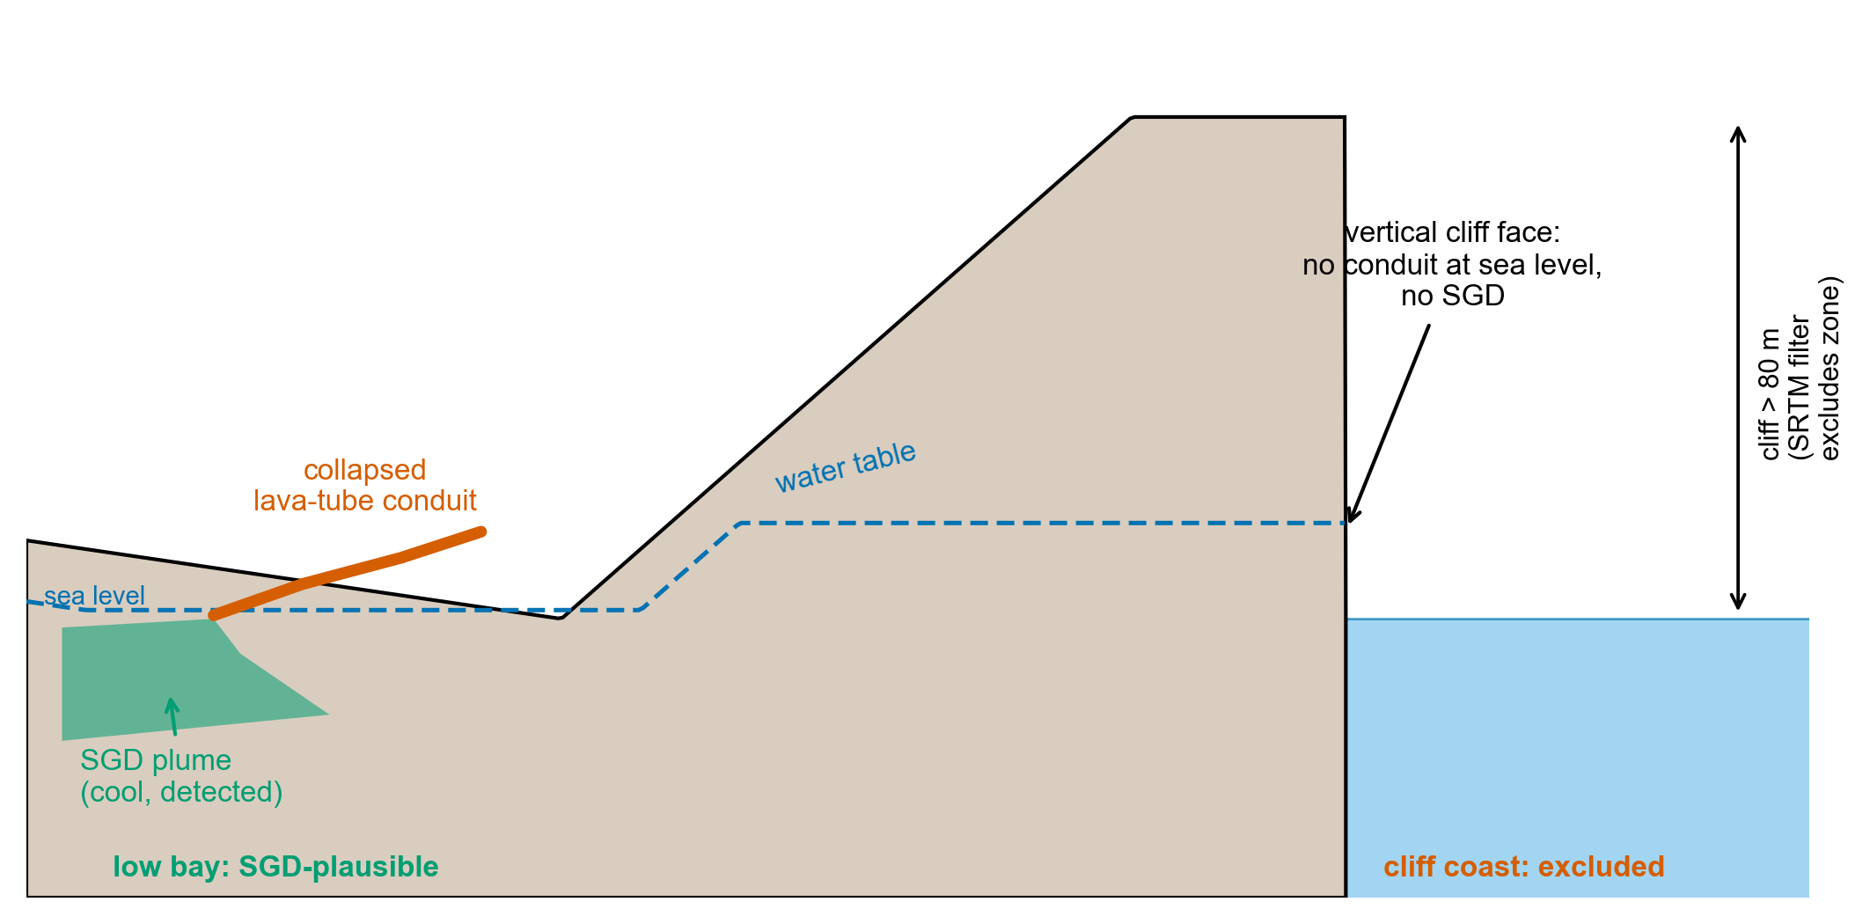
Figure 6. Why cliff coasts are excluded. At a low bay (left) a collapsed
lava-tube conduit delivers cool groundwater to the sea surface, producing a detectable SGD plume. At a vertical cliff (right) the aquifer is truncated by the cliff face with no conduit at sea level, so no plume forms. The SRTM filter flags cells whose local maximum elevation exceeds 80 m and excludes them.

8. Coast-anchored plume detection
Plume polygons are extracted from the integrated anomaly raster by a coast-anchored watershed segmentation. The coastline is defined as water cells (in the OSM mask) immediately adjacent to land cells, a one-cell-wide ring tracing the actual shoreline. Source candidates are water cells within 60 m offshore of that ring, outside cliff zones, with cold anomaly above an adaptive peak threshold. Candidate sources are reduced to local maxima with a minimum separation of 30 m. From each seed, the watershed propagates outward through water cells whose anomaly exceeds an adaptive edge threshold, bounded at 150 m offshore.
Surviving regions pass three polygon filters: a minimum area of 50 m² (drop noise), a maximum area of 8,000 m² (drop diffuse coastal cooling), and a centroid within 75 m of the coastline (drop polygons whose body sits far offshore). Each surviving polygon is one discrete SGD plume with a documented coastal source recorded as source_lat and source_lon.
Adaptive thresholds. The peak and edge thresholds are derived per flight from the cold-anomaly distribution of its own water cells. The peak threshold is the 95th percentile of water-cell anomalies, clipped to 0.35 to 0.55 °C. The edge threshold is the larger of the 70th percentile and one-half the peak threshold, clipped to 0.20 to 0.35 °C. The floor guarantees detection at subtle sites such as Vaihu Harbor, where peak anomalies run 0.4 to 0.6 °C. The ceiling prevents a strong-signal flight, or one with residual cliff contamination, from setting thresholds so high that subtler bays in the same flight are filtered out.
The pipeline produces three parallel polygon products from the same rasters, differing in how aggressively they bound a plume:
Product | Polygons | Description
Coast-anchored (canonical) | 415 | Discrete plumes, each with a documented coastal source. The product used for quantitative cross-site comparison.
Raster watershed | 1,066 | Full plume halos, including the broader cold-water envelope around each core.
Detector | 1,789 | Conservative discrete cores from the detector's spatial-coherence requirement.
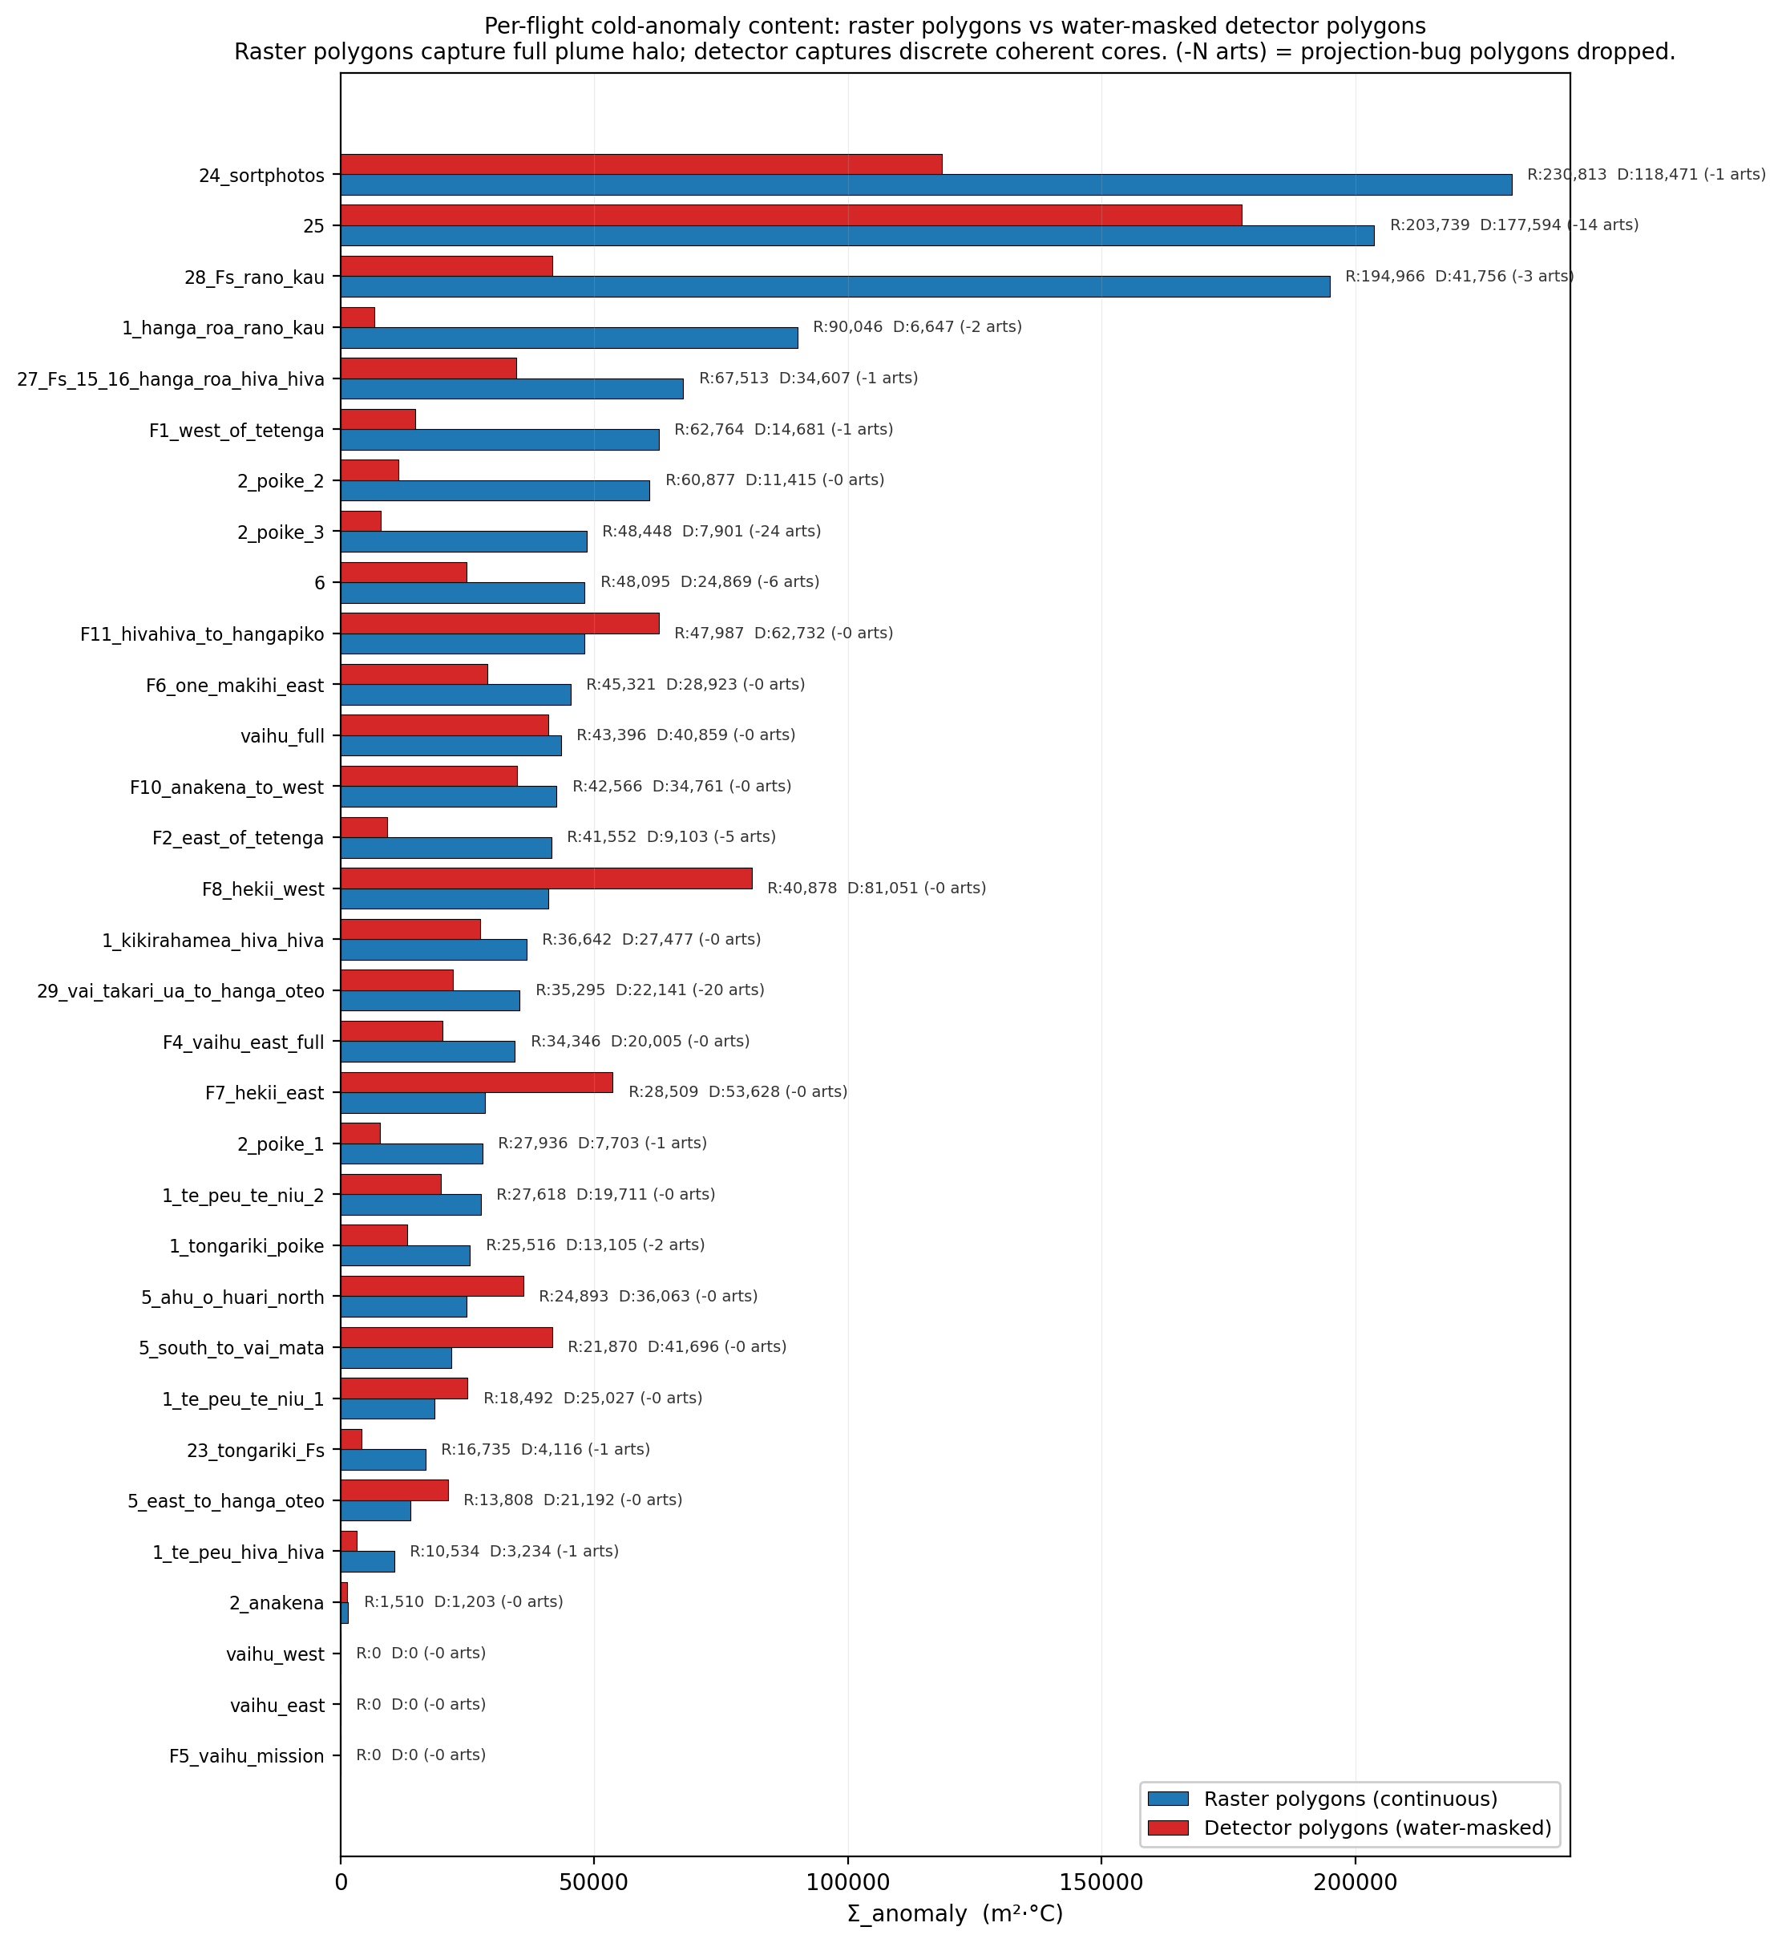
Figure 7. The three polygon products for the same site. The
coast-anchored product (canonical) anchors each plume to a shoreline source. The raster product retains the broader cold halo around each core. The detector product keeps only conservative discrete cores.

9. Σ_anomaly: a threshold-independent intensity metric
Any fixed anomaly threshold is somewhat arbitrary, and reported plume counts and areas depend on where that threshold is set. To compare discharge intensity across sites and seasons without that dependence, each polygon also carries an integrated metric, Σ_anomaly, defined as the integral of mean cell anomaly over the polygon footprint, in units of m²·°C. In practice it is the sum over all cells inside a polygon of the mean per-cell anomaly multiplied by the cell area (Figure 8).
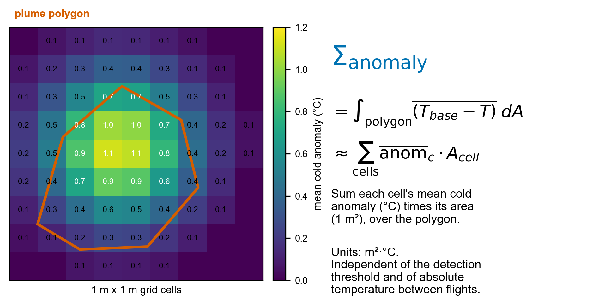
Figure 8. Definition of Σ_anomaly. Each grid cell carries a mean cold
anomaly (°C). Summing that anomaly times the cell area (1 m²) over the plume polygon yields the integrated cold-anomaly content in m²·°C. The metric is independent of the detection threshold and of absolute temperature differences between flights.
Σ_anomaly has three properties that make it the right basis for comparison. It is robust to the detection threshold, because the integral does not depend on which cells were labeled SGD or exactly where the polygon boundary fell. It is robust across flights and seasons, because each flight's per-frame baseline removes absolute temperature differences. And it captures both the size and the intensity of a plume in a single number, which a plume count or a peak temperature alone cannot.
Reported across the whole survey, the master grand-total Σ_anomaly is 8,538,560 m²·°C for the raster product and 1,147,187 m²·°C for the detector product. The raster total is consistently four to six times the detector total because raster polygons include the broader cold-water halo that the detector's spatial-coherence requirement excludes.

10. Results
The island-wide map (Figure 1) shows SGD concentrated at low-elevation bays and inlets and largely absent from cliff coasts, the pattern predicted by lava-tube conduit geology. The strongest flights by integrated Σ_anomaly are the broad south- and north-coast surveys and the major bay systems. Cliff flights rank low once the SRTM filter is applied. Four sites illustrate the range of plume signatures the pipeline resolves.
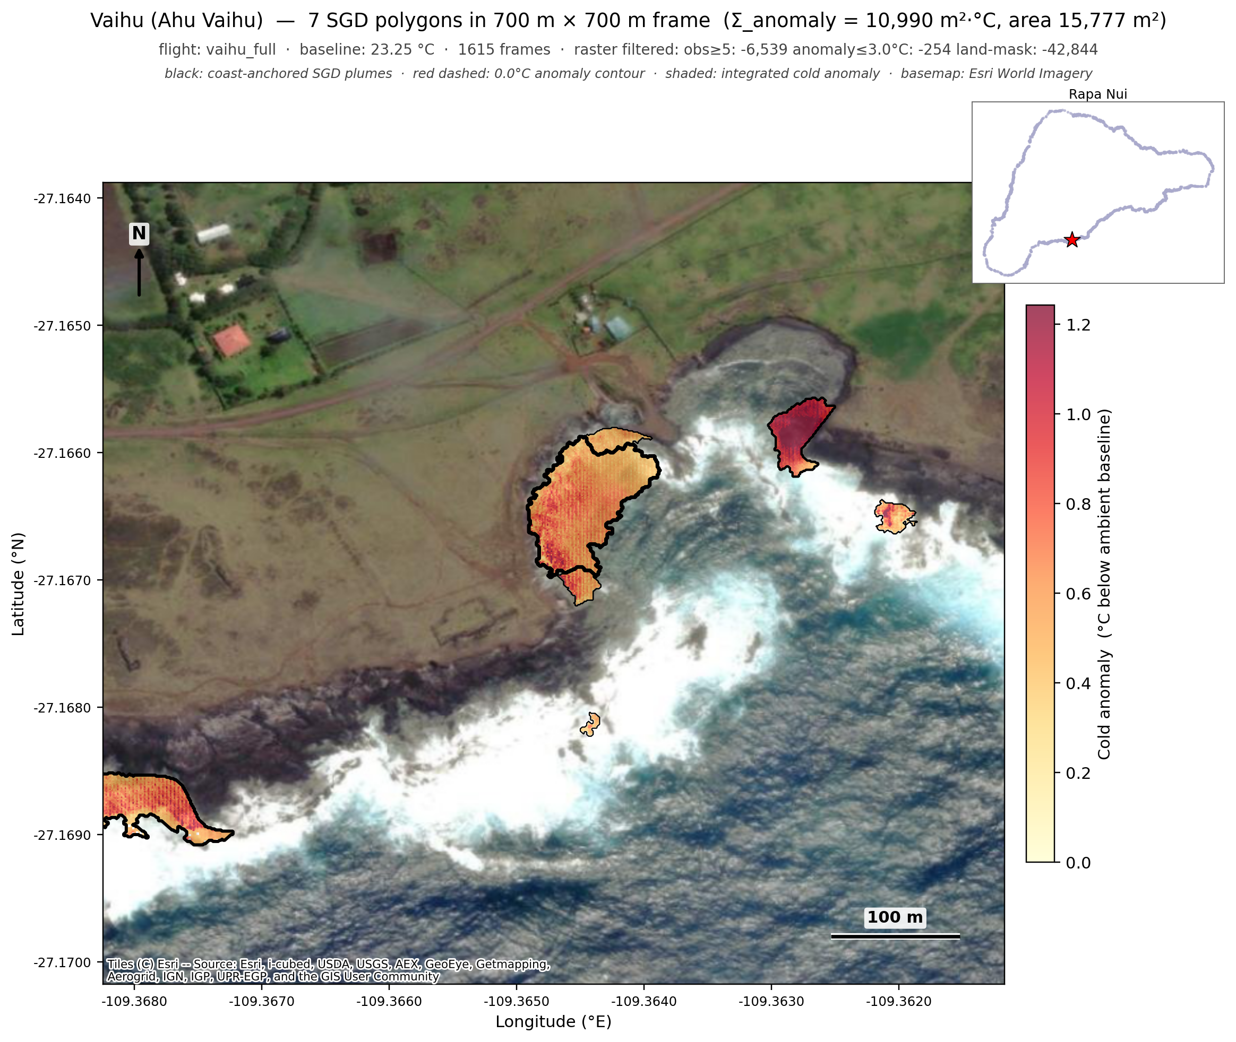
Figure 9. Vaihu (Ahu Vaihu), a textbook SGD reference site on the south
coast. Seven discrete plumes trace the rocky shore and surf zone where freshwater emerges through collapsed lava-tube outlets. Vaihu is a subtle site where peak anomalies run only 0.4 to 0.6 °C, recovered because the adaptive threshold floor keeps detection sensitive there.
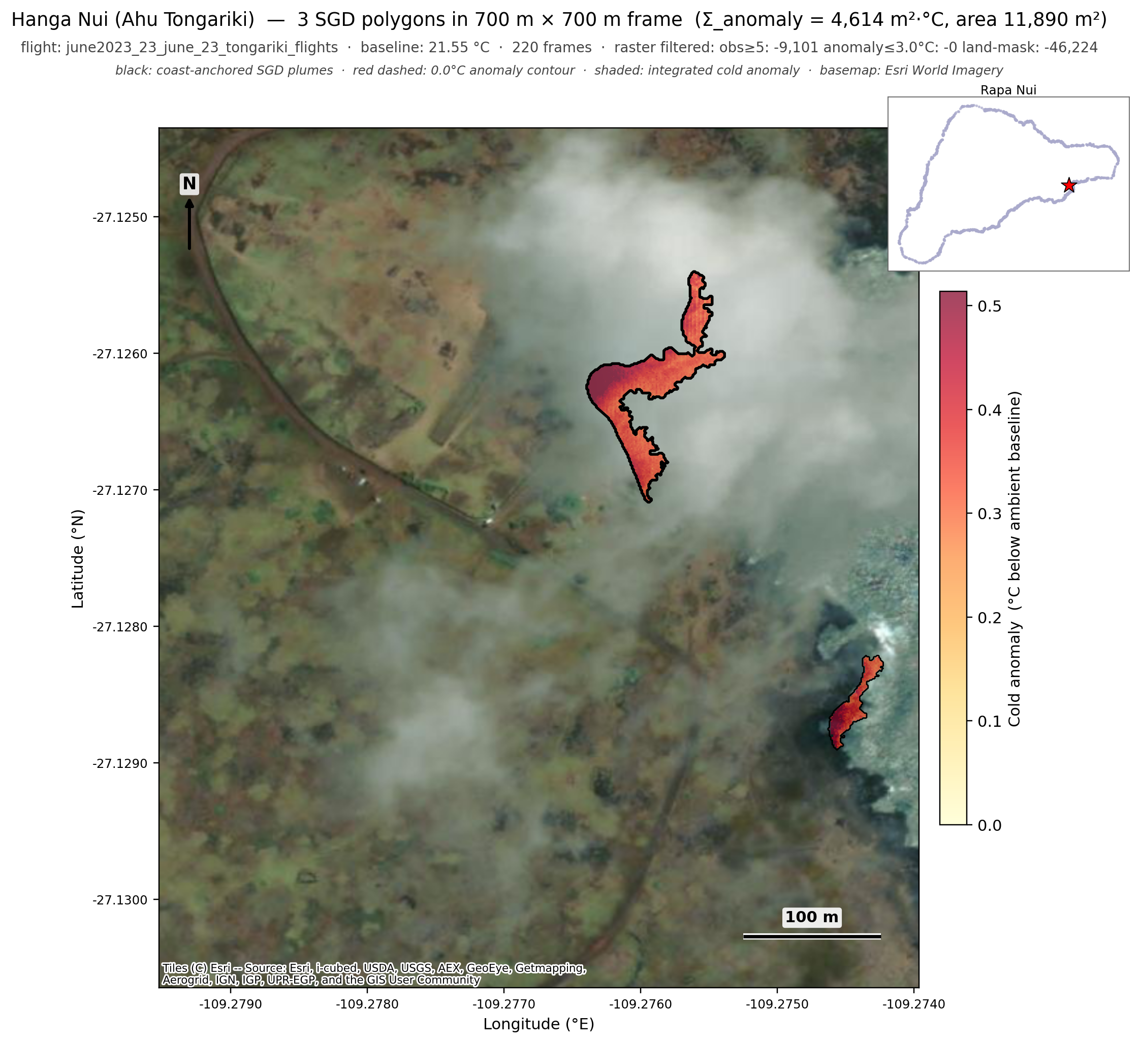
Figure 10. Hanga Nui at Ahu Tongariki. Discrete plumes in the sheltered
bay below the moai platform, with the bay geometry typical of the island's SGD-active sites: low-elevation beach and rocks backed by volcanic slopes.
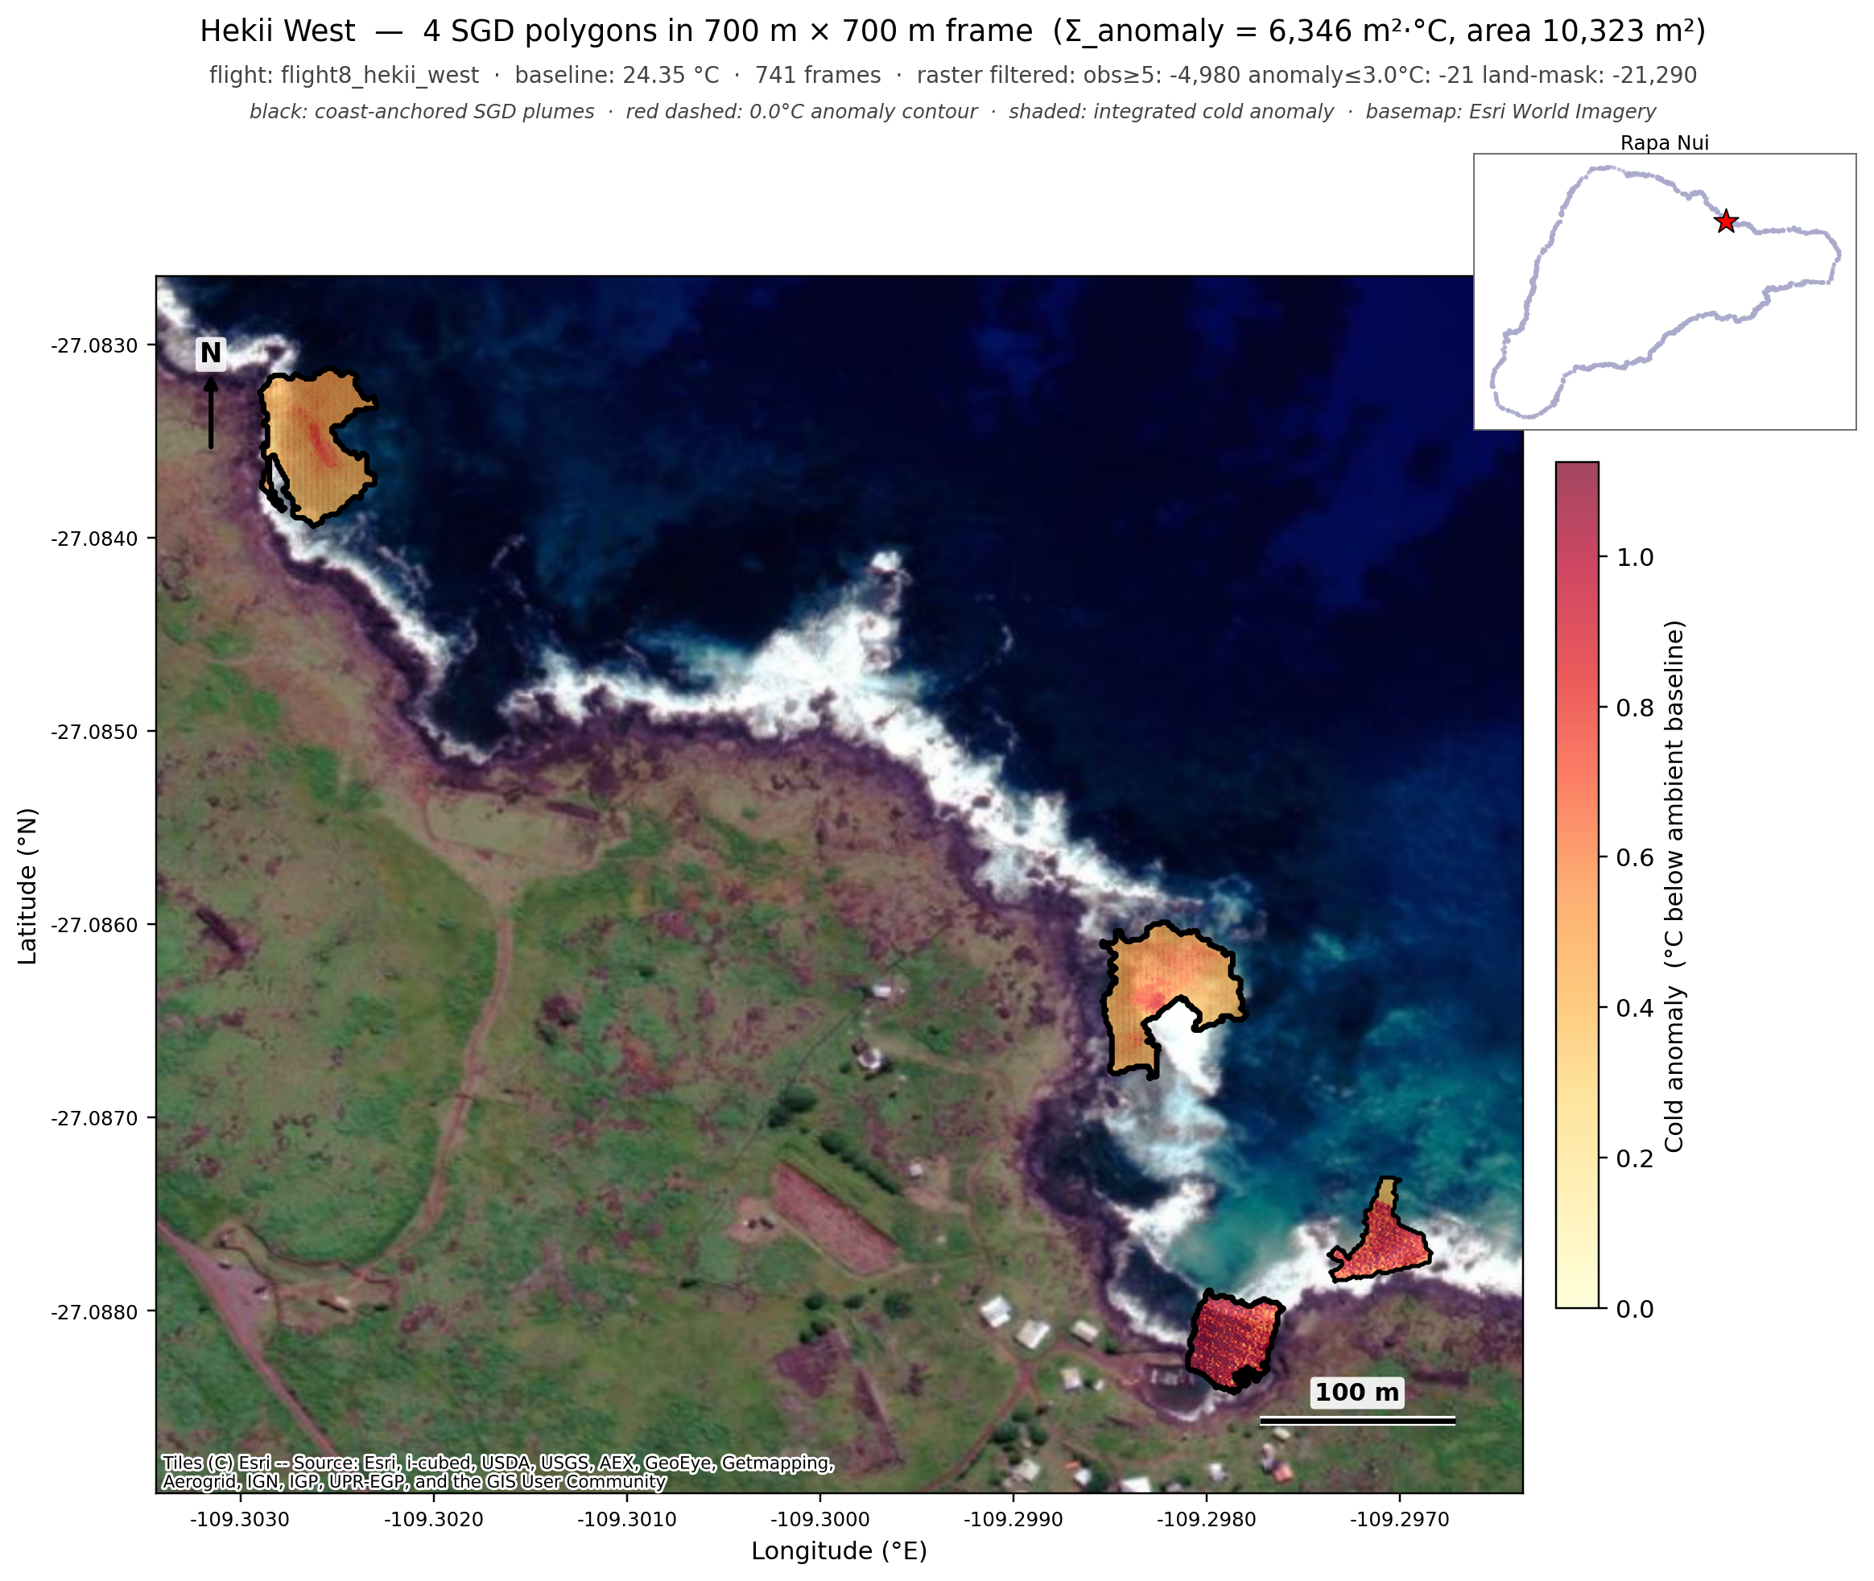
Figure 11. Hekii (north coast). Plumes cluster tightly at a
low-elevation north-coast bay with a strong cold-anomaly signal, the signature of well-developed lava-tube outlets feeding the surf zone. The flight ranks among the highest by Σ_anomaly.
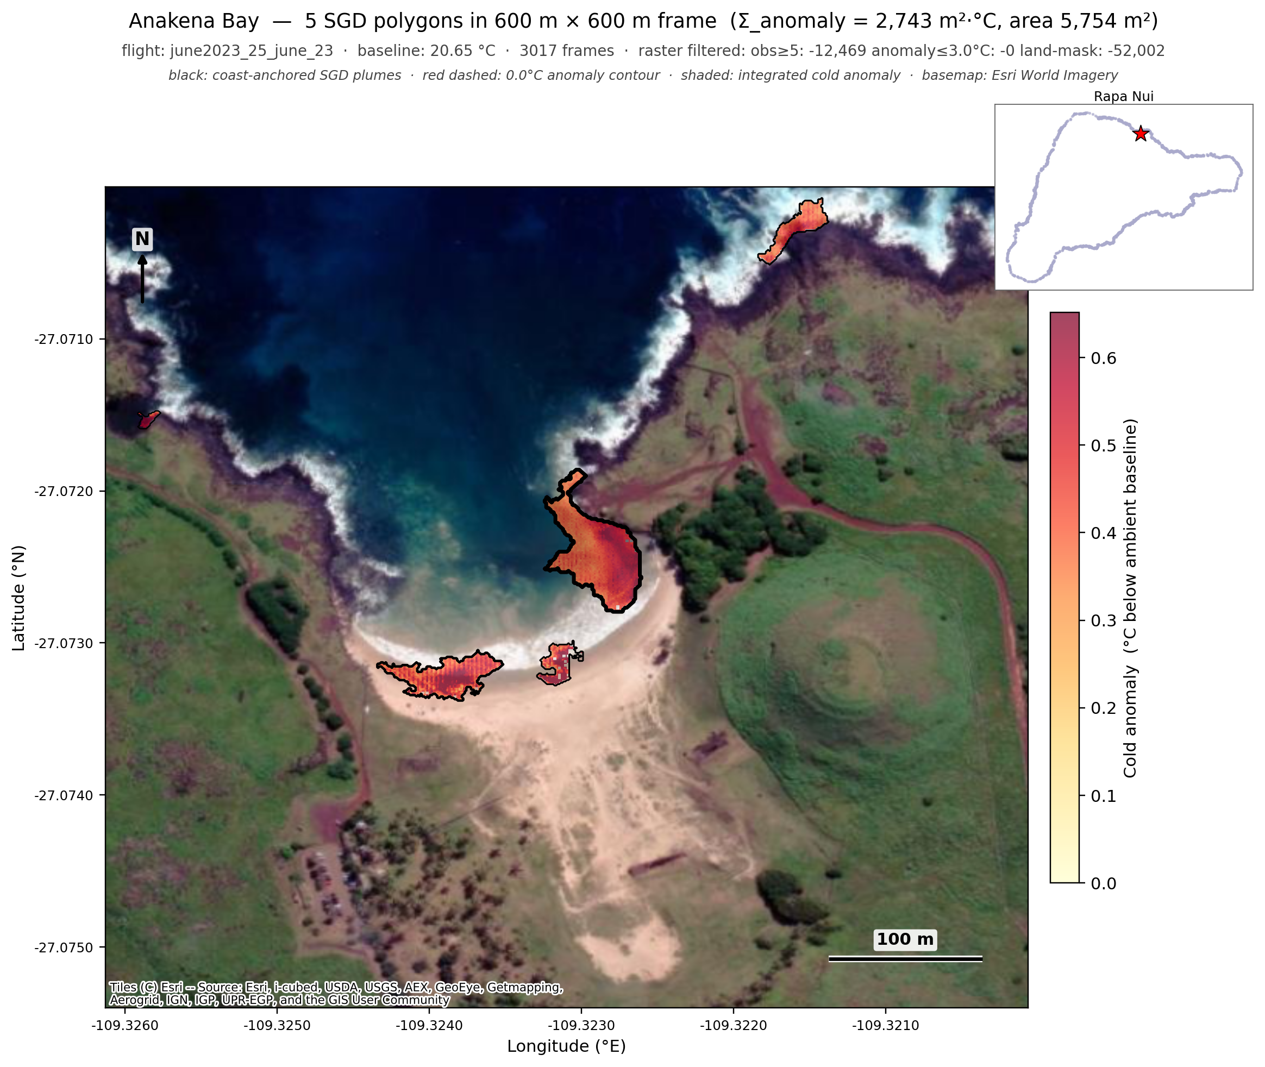
Figure 12. Anakena Bay (Ahu Nau Nau). Coast-anchored plumes at the
iconic sandy beach, with a prominent central plume (peak roughly 1.1 °C below ambient) and smaller satellite plumes along the beach edge and rocky points. Total Σ_anomaly is approximately 2,743 m²·°C across the bay.

11. Validation and limitations
The cliff coasts double as a built-in control. Where the SRTM filter is applied, spurious cliff-shadow polygons that would otherwise dominate a cliff flight are suppressed, and the small number of surviving detections sit at the surf zone immediately offshore of the cliff base. That suppression is the expected behavior and confirms the geological filter is working. Three known limitations remain, each logged in the project's living methods document and prioritized for future iterations.
First, per-frame ocean segmentation uses a rule-based color classifier that can occasionally misclassify shaded cliff face as ocean. The downstream OSM water mask and SRTM cliff filter mitigate this, but a learned per-frame segmenter (planned) would prevent cliff thermal from entering the projection at all.
Second, the camera footprint projection assumes flat ground at sea level, which mismaps high-elevation pixels to offshore coordinates. The OSM and SRTM masks remove most of the resulting artifacts after the fact. A terrain-aware projection that ray-marches each pixel against the SRTM surface (planned, longer-term) would fix the problem at its source.
Third, the per-frame 75th-percentile baseline can be biased low when a plume fills more than about a quarter of a frame, slightly understating very large plumes. Moving the baseline to the 90th percentile (planned) would improve robustness for the largest plumes.
These are bounded, well-understood limitations rather than open questions about whether the method works. The masks and the threshold-independent metric make the canonical product defensible today, and the planned fixes target residual edge cases.

12. Reproducibility
All processing is implemented in Python on the scientific-Python stack (numpy, scipy, scikit-image, shapely, matplotlib). Coastline geometry is fetched from OpenStreetMap through the Overpass API. Elevation is NASA SRTM 30 m. Source code, processing scripts, and a living methods document live in the project repository, with a step-by-step re-run recipe in docs/REPRODUCE.md.
Per-flight raw inputs (paired thermal and RGB frames) and per-flight outputs (anomaly rasters, water masks, cliff-zone masks, polygon GeoJSONs, and validation figures) are organized by flight identifier for traceability. The three island-wide master products are distributed as KML for direct inspection in any geographic viewer:
- rapa_nui_all_sgd_coastal.kml (415 coast-anchored plumes, canonical)
- rapa_nui_all_sgd_sigma_raster.kml (1,066 raster plumes)
- rapa_nui_all_sgd_sigma.kml (1,789 detector polygons)
The method transfers to any coastline where SGD emerges through discrete conduits at low-elevation shores. The two ingredients it needs beyond the drone survey are an authoritative coastline (OSM or a digitized shoreline) and a digital elevation model for cliff exclusion, both freely available for most of the world.

