**UNIVERSITATEA TEHNICĂ A MOLDOVEI**

**FACULTATEA CALCULATOARE, INFORMATICĂ ȘI MICROELECTRONICĂ**

[DEPARTAMENTUL INFORMATICĂ ŞI INGINERIA SISTEMELOR](https://utm.md/subdiviziuni-universitare/facultati/facultatea-calculatoare-informatica-si-microelectronica/catedra-calculatoare/)

**Raport**

**LUCRARE DE LABORATOR NR.1**

**Evaluarea performanțelor**

**A realizat:** St. gr. C-162, Nicolenco Eugeniu

**A verificat:** prof. univ. dr. hab., Emilian Guţuleac

**Chișinău 2018**

**Scopul lucrării:**

Evaluarea performantelor proceselor de calcul.

**Consideratii teoretice:**

Formarea sirurilor de asteptare si servirea cererilor in sistemul de asteptare de regula se fac dupa disciplina de servire FIFO. In unele cazuri, este nevoie de a asigura o alta disciplina de formare a sirurilor de asteptare in dependenta de urgenta cererii, avind o astfel de prioritate de deservire. Servirea cerererilor conform prioritatii relative presupune manifestarea prioritatii numai in momentul elierarii serverului si a selectarii, care va fi definita din sirul de asteptare, adica se va deservi cererea cu prioritate mai mare.

**Parametrii sistemului de asteptare :**

L1=0.35 ; L2=100 ; L3=8.25 ; L4=75 ; L5=1500 ; L6=8.25 ; L7=750 ; L8=250 ; L9= 8.75;

L1€[0.75;1.75] ; M(P8)=1..5

1. **SA: M/COX 3 /k/n/N(FIFO,block).**
2. **Schema si lantul Markov**



1. **Graficul de accesibilitate pentru M(P1)=8 ;**

PositionsList: p1;p2;p3;p4;p5;p6;p7;p8;p9;

M0 = [20,0,0,0,0,0,0,1,0] [t1,t2>M1;\\1;

M1 = [19,0,1,0,0,0,0,0,0] [t1>M2;t3,t4>M3;t3,t5,t7>M6;t3,t5,t8,t10>M0;\\1;0,0476190476190476;0,714285714285714;0,238095238095238;

M2 = [18,1,1,0,0,0,0,0,0] [t1>M4;t3,t4>M5;t3,t5,t7>M9;t3,t5,t8,t10,t2>M1;\\1;0,0476190476190476;0,714285714285714;0,238095238095238;

M3 = [19,0,0,0,1,0,0,0,0] [t1>M5;t6,t7>M6;t6,t8,t10>M0;\\1;0,75;0,25;

M4 = [17,2,1,0,0,0,0,0,0] [t1>M7;t3,t4>M8;t3,t5,t7>M12;t3,t5,t8,t10,t2>M2;\\1;0,0476190476190476;0,714285714285714;0,238095238095238;

M5 = [18,1,0,0,1,0,0,0,0] [t1>M8;t6,t7>M9;t6,t8,t10,t2>M1;\\1;0,75;0,25;

M6 = [19,0,0,0,0,0,1,0,0] [t1>M9;t9,t10>M0;\\1;1;

M7 = [16,3,1,0,0,0,0,0,0] [t1>M10;t3,t4>M11;t3,t5,t7>M15;t3,t5,t8,t10,t2>M4;\\1;0,0476190476190476;0,714285714285714;0,238095238095238;

M8 = [17,2,0,0,1,0,0,0,0] [t1>M11;t6,t7>M12;t6,t8,t10,t2>M2;\\1;0,75;0,25;

M9 = [18,1,0,0,0,0,1,0,0] [t1>M12;t9,t10,t2>M1;\\1;1;

M10 = [15,4,1,0,0,0,0,0,0] [t1>M13;t3,t4>M14;t3,t5,t7>M18;t3,t5,t8,t10,t2>M7;\\1;0,0476190476190476;0,714285714285714;0,238095238095238;

M11 = [16,3,0,0,1,0,0,0,0] [t1>M14;t6,t7>M15;t6,t8,t10,t2>M4;\\1;0,75;0,25;

M12 = [17,2,0,0,0,0,1,0,0] [t1>M15;t9,t10,t2>M2;\\1;1;

M13 = [14,5,1,0,0,0,0,0,0] [t1>M16;t3,t4>M17;t3,t5,t7>M21;t3,t5,t8,t10,t2>M10;\\1;0,0476190476190476;0,714285714285714;0,238095238095238;

M14 = [15,4,0,0,1,0,0,0,0] [t1>M17;t6,t7>M18;t6,t8,t10,t2>M7;\\1;0,75;0,25;

M15 = [16,3,0,0,0,0,1,0,0] [t1>M18;t9,t10,t2>M4;\\1;1;

M16 = [13,6,1,0,0,0,0,0,0] [t1>M19;t3,t4>M20;t3,t5,t7>M24;t3,t5,t8,t10,t2>M13;\\1;0,0476190476190476;0,714285714285714;0,238095238095238;

M17 = [14,5,0,0,1,0,0,0,0] [t1>M20;t6,t7>M21;t6,t8,t10,t2>M10;\\1;0,75;0,25;

M18 = [15,4,0,0,0,0,1,0,0] [t1>M21;t9,t10,t2>M7;\\1;1;

M19 = [12,7,1,0,0,0,0,0,0] [t1>M22;t3,t4>M23;t3,t5,t7>M27;t3,t5,t8,t10,t2>M16;\\1;0,0476190476190476;0,714285714285714;0,238095238095238;

M20 = [13,6,0,0,1,0,0,0,0] [t1>M23;t6,t7>M24;t6,t8,t10,t2>M13;\\1;0,75;0,25;

M21 = [14,5,0,0,0,0,1,0,0] [t1>M24;t9,t10,t2>M10;\\1;1;

M22 = [11,8,1,0,0,0,0,0,0] [t1>M25;t3,t4>M26;t3,t5,t7>M30;t3,t5,t8,t10,t2>M19;\\1;0,0476190476190476;0,714285714285714;0,238095238095238;

M23 = [12,7,0,0,1,0,0,0,0] [t1>M26;t6,t7>M27;t6,t8,t10,t2>M16;\\1;0,75;0,25;

M24 = [13,6,0,0,0,0,1,0,0] [t1>M27;t9,t10,t2>M13;\\1;1;

M25 = [10,9,1,0,0,0,0,0,0] [t1>M28;t3,t4>M29;t3,t5,t7>M33;t3,t5,t8,t10,t2>M22;\\1;0,0476190476190476;0,714285714285714;0,238095238095238;

M26 = [11,8,0,0,1,0,0,0,0] [t1>M29;t6,t7>M30;t6,t8,t10,t2>M19;\\1;0,75;0,25;

M27 = [12,7,0,0,0,0,1,0,0] [t1>M30;t9,t10,t2>M16;\\1;1;

M28 = [9,10,1,0,0,0,0,0,0] [t1>M31;t3,t4>M32;t3,t5,t7>M36;t3,t5,t8,t10,t2>M25;\\1;0,0476190476190476;0,714285714285714;0,238095238095238;

M29 = [10,9,0,0,1,0,0,0,0] [t1>M32;t6,t7>M33;t6,t8,t10,t2>M22;\\1;0,75;0,25;

M30 = [11,8,0,0,0,0,1,0,0] [t1>M33;t9,t10,t2>M19;\\1;1;

M31 = [8,11,1,0,0,0,0,0,0] [t1>M34;t3,t4>M35;t3,t5,t7>M39;t3,t5,t8,t10,t2>M28;\\1;0,0476190476190476;0,714285714285714;0,238095238095238;

M32 = [9,10,0,0,1,0,0,0,0] [t1>M35;t6,t7>M36;t6,t8,t10,t2>M25;\\1;0,75;0,25;

M33 = [10,9,0,0,0,0,1,0,0] [t1>M36;t9,t10,t2>M22;\\1;1;

M34 = [7,12,1,0,0,0,0,0,0] [t1>M37;t3,t4>M38;t3,t5,t7>M42;t3,t5,t8,t10,t2>M31;\\1;0,0476190476190476;0,714285714285714;0,238095238095238;

M35 = [8,11,0,0,1,0,0,0,0] [t1>M38;t6,t7>M39;t6,t8,t10,t2>M28;\\1;0,75;0,25;

M36 = [9,10,0,0,0,0,1,0,0] [t1>M39;t9,t10,t2>M25;\\1;1;

M37 = [6,13,1,0,0,0,0,0,0] [t1>M40;t3,t4>M41;t3,t5,t7>M45;t3,t5,t8,t10,t2>M34;\\1;0,0476190476190476;0,714285714285714;0,238095238095238;

M38 = [7,12,0,0,1,0,0,0,0] [t1>M41;t6,t7>M42;t6,t8,t10,t2>M31;\\1;0,75;0,25;

M39 = [8,11,0,0,0,0,1,0,0] [t1>M42;t9,t10,t2>M28;\\1;1;

M40 = [5,14,1,0,0,0,0,0,0] [t1>M43;t3,t4>M44;t3,t5,t7>M48;t3,t5,t8,t10,t2>M37;\\1;0,0476190476190476;0,714285714285714;0,238095238095238;

M41 = [6,13,0,0,1,0,0,0,0] [t1>M44;t6,t7>M45;t6,t8,t10,t2>M34;\\1;0,75;0,25;

M42 = [7,12,0,0,0,0,1,0,0] [t1>M45;t9,t10,t2>M31;\\1;1;

M43 = [4,15,1,0,0,0,0,0,0] [t1>M46;t3,t4>M47;t3,t5,t7>M51;t3,t5,t8,t10,t2>M40;\\1;0,0476190476190476;0,714285714285714;0,238095238095238;

M44 = [5,14,0,0,1,0,0,0,0] [t1>M47;t6,t7>M48;t6,t8,t10,t2>M37;\\1;0,75;0,25;

M45 = [6,13,0,0,0,0,1,0,0] [t1>M48;t9,t10,t2>M34;\\1;1;

M46 = [3,16,1,0,0,0,0,0,0] [t1>M49;t3,t4>M50;t3,t5,t7>M54;t3,t5,t8,t10,t2>M43;\\1;0,0476190476190476;0,714285714285714;0,238095238095238;

M47 = [4,15,0,0,1,0,0,0,0] [t1>M50;t6,t7>M51;t6,t8,t10,t2>M40;\\1;0,75;0,25;

M48 = [5,14,0,0,0,0,1,0,0] [t1>M51;t9,t10,t2>M37;\\1;1;

M49 = [2,17,1,0,0,0,0,0,0] [t1>M52;t3,t4>M53;t3,t5,t7>M57;t3,t5,t8,t10,t2>M46;\\1;0,0476190476190476;0,714285714285714;0,238095238095238;

M50 = [3,16,0,0,1,0,0,0,0] [t1>M53;t6,t7>M54;t6,t8,t10,t2>M43;\\1;0,75;0,25;

M51 = [4,15,0,0,0,0,1,0,0] [t1>M54;t9,t10,t2>M40;\\1;1;

M52 = [1,18,1,0,0,0,0,0,0] [t1>M55;t3,t4>M56;t3,t5,t7>M59;t3,t5,t8,t10,t2>M49;\\1;0,0476190476190476;0,714285714285714;0,238095238095238;

M53 = [2,17,0,0,1,0,0,0,0] [t1>M56;t6,t7>M57;t6,t8,t10,t2>M46;\\1;0,75;0,25;

M54 = [3,16,0,0,0,0,1,0,0] [t1>M57;t9,t10,t2>M43;\\1;1;

M55 = [0,19,1,0,0,0,0,0,0] [t3,t4>M58;t3,t5,t7>M60;t3,t5,t8,t10,t2>M52;\\0,0476190476190476;0,714285714285714;0,238095238095238;

M56 = [1,18,0,0,1,0,0,0,0] [t1>M58;t6,t7>M59;t6,t8,t10,t2>M49;\\1;0,75;0,25;

M57 = [2,17,0,0,0,0,1,0,0] [t1>M59;t9,t10,t2>M46;\\1;1;

M58 = [0,19,0,0,1,0,0,0,0] [t6,t7>M60;t6,t8,t10,t2>M52;\\0,75;0,25;

M59 = [1,18,0,0,0,0,1,0,0] [t1>M60;t9,t10,t2>M49;\\1;1;

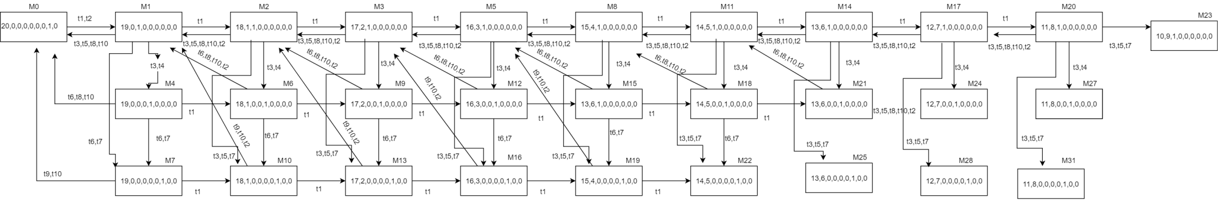M60 = [0,19,0,0,0,0,1,0,0] [t9,t10,t2>M52;\\1;

1. ****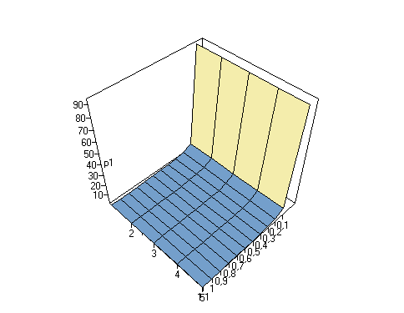**Timpul mediu de asteptare**

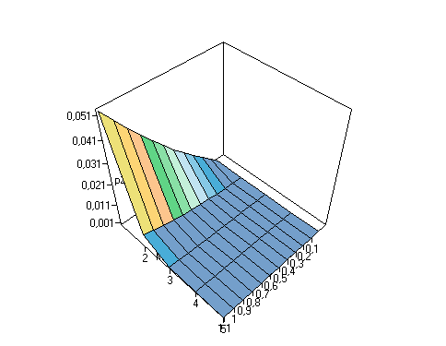

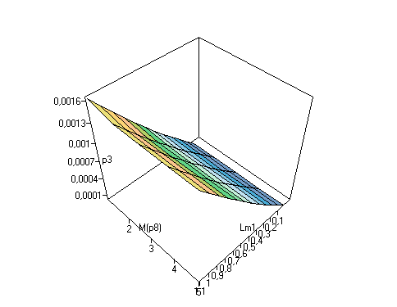

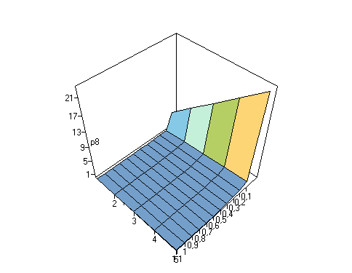

1. 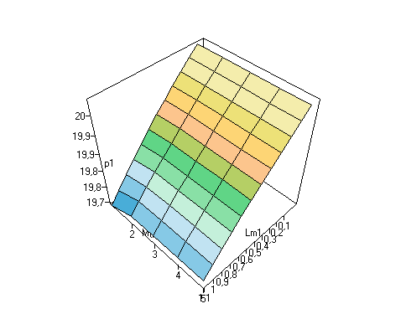**Numarul mediu de jetoane:**

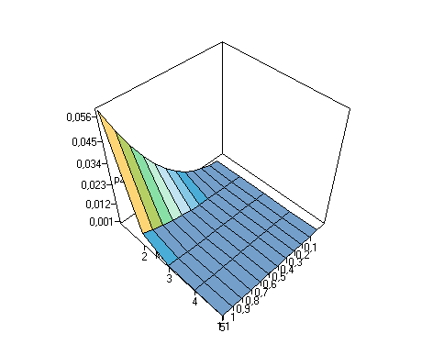

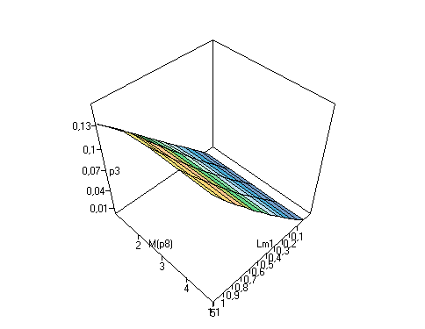

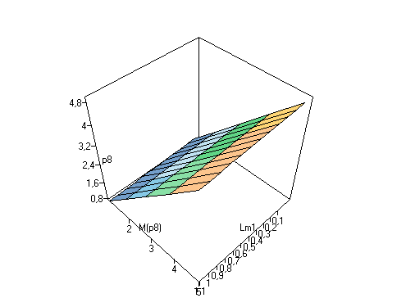

1. **SA : M/H3/k/n/N(FIFO,block).**
2. **Schema si lantul Markov**



1. **Graficul de accesibilitate pentru M(P1)=8 ;**

Totally found markings number = 61

PositionsList: p1;p2;p3;p4;p5;p6;p7;p8;

M0 = [20,0,0,0,0,0,0,1] [t1,t2,t4>M1;t1,t2,t5>M2;t1,t2,t8>M3;\\0.3;0.6;0.1;

M1 = [19,0,1,0,0,0,0,0] [t1>M4;t3,t7>M0;\\1;1;

M2 = [19,0,0,0,1,0,0,0] [t1>M5;t6,t7>M0;\\1;1;

M3 = [19,0,0,0,0,0,1,0] [t1>M6;t9,t7>M0;\\1;1;

M4 = [18,1,1,0,0,0,0,0] [t1>M7;t3,t7,t2,t4>M1;t3,t7,t2,t5>M2;t3,t7,t2,t8>M3;\\1;0.3;0.6;0.1;

M5 = [18,1,0,0,1,0,0,0] [t1>M8;t6,t7,t2,t4>M1;t6,t7,t2,t5>M2;t6,t7,t2,t8>M3;\\1;0.3;0.6;0.1;

M6 = [18,1,0,0,0,0,1,0] [t1>M9;t9,t7,t2,t4>M1;t9,t7,t2,t5>M2;t9,t7,t2,t8>M3;\\1;0.3;0.6;0.1;

M7 = [17,2,1,0,0,0,0,0] [t1>M10;t3,t7,t2,t4>M4;t3,t7,t2,t5>M5;t3,t7,t2,t8>M6;\\1;0.3;0.6;0.1;

M8 = [17,2,0,0,1,0,0,0] [t1>M11;t6,t7,t2,t4>M4;t6,t7,t2,t5>M5;t6,t7,t2,t8>M6;\\1;0.3;0.6;0.1;

M9 = [17,2,0,0,0,0,1,0] [t1>M12;t9,t7,t2,t4>M4;t9,t7,t2,t5>M5;t9,t7,t2,t8>M6;\\1;0.3;0.6;0.1;

M10 = [16,3,1,0,0,0,0,0] [t1>M13;t3,t7,t2,t4>M7;t3,t7,t2,t5>M8;t3,t7,t2,t8>M9;\\1;0.3;0.6;0.1;

M11 = [16,3,0,0,1,0,0,0] [t1>M14;t6,t7,t2,t4>M7;t6,t7,t2,t5>M8;t6,t7,t2,t8>M9;\\1;0.3;0.6;0.1;

M12 = [16,3,0,0,0,0,1,0] [t1>M15;t9,t7,t2,t4>M7;t9,t7,t2,t5>M8;t9,t7,t2,t8>M9;\\1;0.3;0.6;0.1;

M13 = [15,4,1,0,0,0,0,0] [t1>M16;t3,t7,t2,t4>M10;t3,t7,t2,t5>M11;t3,t7,t2,t8>M12;\\1;0.3;0.6;0.1;

M14 = [15,4,0,0,1,0,0,0] [t1>M17;t6,t7,t2,t4>M10;t6,t7,t2,t5>M11;t6,t7,t2,t8>M12;\\1;0.3;0.6;0.1;

M15 = [15,4,0,0,0,0,1,0] [t1>M18;t9,t7,t2,t4>M10;t9,t7,t2,t5>M11;t9,t7,t2,t8>M12;\\1;0.3;0.6;0.1;

M16 = [14,5,1,0,0,0,0,0] [t1>M19;t3,t7,t2,t4>M13;t3,t7,t2,t5>M14;t3,t7,t2,t8>M15;\\1;0.3;0.6;0.1;

M17 = [14,5,0,0,1,0,0,0] [t1>M20;t6,t7,t2,t4>M13;t6,t7,t2,t5>M14;t6,t7,t2,t8>M15;\\1;0.3;0.6;0.1;

M18 = [14,5,0,0,0,0,1,0] [t1>M21;t9,t7,t2,t4>M13;t9,t7,t2,t5>M14;t9,t7,t2,t8>M15;\\1;0.3;0.6;0.1;

M19 = [13,6,1,0,0,0,0,0] [t1>M22;t3,t7,t2,t4>M16;t3,t7,t2,t5>M17;t3,t7,t2,t8>M18;\\1;0.3;0.6;0.1;

M20 = [13,6,0,0,1,0,0,0] [t1>M23;t6,t7,t2,t4>M16;t6,t7,t2,t5>M17;t6,t7,t2,t8>M18;\\1;0.3;0.6;0.1;

M21 = [13,6,0,0,0,0,1,0] [t1>M24;t9,t7,t2,t4>M16;t9,t7,t2,t5>M17;t9,t7,t2,t8>M18;\\1;0.3;0.6;0.1;

M22 = [12,7,1,0,0,0,0,0] [t1>M25;t3,t7,t2,t4>M19;t3,t7,t2,t5>M20;t3,t7,t2,t8>M21;\\1;0.3;0.6;0.1;

M23 = [12,7,0,0,1,0,0,0] [t1>M26;t6,t7,t2,t4>M19;t6,t7,t2,t5>M20;t6,t7,t2,t8>M21;\\1;0.3;0.6;0.1;

M24 = [12,7,0,0,0,0,1,0] [t1>M27;t9,t7,t2,t4>M19;t9,t7,t2,t5>M20;t9,t7,t2,t8>M21;\\1;0.3;0.6;0.1;

M25 = [11,8,1,0,0,0,0,0] [t1>M28;t3,t7,t2,t4>M22;t3,t7,t2,t5>M23;t3,t7,t2,t8>M24;\\1;0.3;0.6;0.1;

M26 = [11,8,0,0,1,0,0,0] [t1>M29;t6,t7,t2,t4>M22;t6,t7,t2,t5>M23;t6,t7,t2,t8>M24;\\1;0.3;0.6;0.1;

M27 = [11,8,0,0,0,0,1,0] [t1>M30;t9,t7,t2,t4>M22;t9,t7,t2,t5>M23;t9,t7,t2,t8>M24;\\1;0.3;0.6;0.1;

M28 = [10,9,1,0,0,0,0,0] [t1>M31;t3,t7,t2,t4>M25;t3,t7,t2,t5>M26;t3,t7,t2,t8>M27;\\1;0.3;0.6;0.1;

M29 = [10,9,0,0,1,0,0,0] [t1>M32;t6,t7,t2,t4>M25;t6,t7,t2,t5>M26;t6,t7,t2,t8>M27;\\1;0.3;0.6;0.1;

M30 = [10,9,0,0,0,0,1,0] [t1>M33;t9,t7,t2,t4>M25;t9,t7,t2,t5>M26;t9,t7,t2,t8>M27;\\1;0.3;0.6;0.1;

M31 = [9,10,1,0,0,0,0,0] [t1>M34;t3,t7,t2,t4>M28;t3,t7,t2,t5>M29;t3,t7,t2,t8>M30;\\1;0.3;0.6;0.1;

M32 = [9,10,0,0,1,0,0,0] [t1>M35;t6,t7,t2,t4>M28;t6,t7,t2,t5>M29;t6,t7,t2,t8>M30;\\1;0.3;0.6;0.1;

M33 = [9,10,0,0,0,0,1,0] [t1>M36;t9,t7,t2,t4>M28;t9,t7,t2,t5>M29;t9,t7,t2,t8>M30;\\1;0.3;0.6;0.1;

M34 = [8,11,1,0,0,0,0,0] [t1>M37;t3,t7,t2,t4>M31;t3,t7,t2,t5>M32;t3,t7,t2,t8>M33;\\1;0.3;0.6;0.1;

M35 = [8,11,0,0,1,0,0,0] [t1>M38;t6,t7,t2,t4>M31;t6,t7,t2,t5>M32;t6,t7,t2,t8>M33;\\1;0.3;0.6;0.1;

M36 = [8,11,0,0,0,0,1,0] [t1>M39;t9,t7,t2,t4>M31;t9,t7,t2,t5>M32;t9,t7,t2,t8>M33;\\1;0.3;0.6;0.1;

M37 = [7,12,1,0,0,0,0,0] [t1>M40;t3,t7,t2,t4>M34;t3,t7,t2,t5>M35;t3,t7,t2,t8>M36;\\1;0.3;0.6;0.1;

M38 = [7,12,0,0,1,0,0,0] [t1>M41;t6,t7,t2,t4>M34;t6,t7,t2,t5>M35;t6,t7,t2,t8>M36;\\1;0.3;0.6;0.1;

M39 = [7,12,0,0,0,0,1,0] [t1>M42;t9,t7,t2,t4>M34;t9,t7,t2,t5>M35;t9,t7,t2,t8>M36;\\1;0.3;0.6;0.1;

M40 = [6,13,1,0,0,0,0,0] [t1>M43;t3,t7,t2,t4>M37;t3,t7,t2,t5>M38;t3,t7,t2,t8>M39;\\1;0.3;0.6;0.1;

M41 = [6,13,0,0,1,0,0,0] [t1>M44;t6,t7,t2,t4>M37;t6,t7,t2,t5>M38;t6,t7,t2,t8>M39;\\1;0.3;0.6;0.1;

M42 = [6,13,0,0,0,0,1,0] [t1>M45;t9,t7,t2,t4>M37;t9,t7,t2,t5>M38;t9,t7,t2,t8>M39;\\1;0.3;0.6;0.1;

M43 = [5,14,1,0,0,0,0,0] [t1>M46;t3,t7,t2,t4>M40;t3,t7,t2,t5>M41;t3,t7,t2,t8>M42;\\1;0.3;0.6;0.1;

M44 = [5,14,0,0,1,0,0,0] [t1>M47;t6,t7,t2,t4>M40;t6,t7,t2,t5>M41;t6,t7,t2,t8>M42;\\1;0.3;0.6;0.1;

M45 = [5,14,0,0,0,0,1,0] [t1>M48;t9,t7,t2,t4>M40;t9,t7,t2,t5>M41;t9,t7,t2,t8>M42;\\1;0.3;0.6;0.1;

M46 = [4,15,1,0,0,0,0,0] [t1>M49;t3,t7,t2,t4>M43;t3,t7,t2,t5>M44;t3,t7,t2,t8>M45;\\1;0.3;0.6;0.1;

M47 = [4,15,0,0,1,0,0,0] [t1>M50;t6,t7,t2,t4>M43;t6,t7,t2,t5>M44;t6,t7,t2,t8>M45;\\1;0.3;0.6;0.1;

M48 = [4,15,0,0,0,0,1,0] [t1>M51;t9,t7,t2,t4>M43;t9,t7,t2,t5>M44;t9,t7,t2,t8>M45;\\1;0.3;0.6;0.1;

M49 = [3,16,1,0,0,0,0,0] [t1>M52;t3,t7,t2,t4>M46;t3,t7,t2,t5>M47;t3,t7,t2,t8>M48;\\1;0.3;0.6;0.1;

M50 = [3,16,0,0,1,0,0,0] [t1>M53;t6,t7,t2,t4>M46;t6,t7,t2,t5>M47;t6,t7,t2,t8>M48;\\1;0.3;0.6;0.1;

M51 = [3,16,0,0,0,0,1,0] [t1>M54;t9,t7,t2,t4>M46;t9,t7,t2,t5>M47;t9,t7,t2,t8>M48;\\1;0.3;0.6;0.1;

M52 = [2,17,1,0,0,0,0,0] [t1>M55;t3,t7,t2,t4>M49;t3,t7,t2,t5>M50;t3,t7,t2,t8>M51;\\1;0.3;0.6;0.1;

M53 = [2,17,0,0,1,0,0,0] [t1>M56;t6,t7,t2,t4>M49;t6,t7,t2,t5>M50;t6,t7,t2,t8>M51;\\1;0.3;0.6;0.1;

M54 = [2,17,0,0,0,0,1,0] [t1>M57;t9,t7,t2,t4>M49;t9,t7,t2,t5>M50;t9,t7,t2,t8>M51;\\1;0.3;0.6;0.1;

M55 = [1,18,1,0,0,0,0,0] [t1>M58;t3,t7,t2,t4>M52;t3,t7,t2,t5>M53;t3,t7,t2,t8>M54;\\1;0.3;0.6;0.1;

M56 = [1,18,0,0,1,0,0,0] [t1>M59;t6,t7,t2,t4>M52;t6,t7,t2,t5>M53;t6,t7,t2,t8>M54;\\1;0.3;0.6;0.1;

M57 = [1,18,0,0,0,0,1,0] [t1>M60;t9,t7,t2,t4>M52;t9,t7,t2,t5>M53;t9,t7,t2,t8>M54;\\1;0.3;0.6;0.1;

M58 = [0,19,1,0,0,0,0,0] [t3,t7,t2,t4>M55;t3,t7,t2,t5>M56;t3,t7,t2,t8>M57;\\0.3;0.6;0.1;

M59 = [0,19,0,0,1,0,0,0] [t6,t7,t2,t4>M55;t6,t7,t2,t5>M56;t6,t7,t2,t8>M57;\\0.3;0.6;0.1;

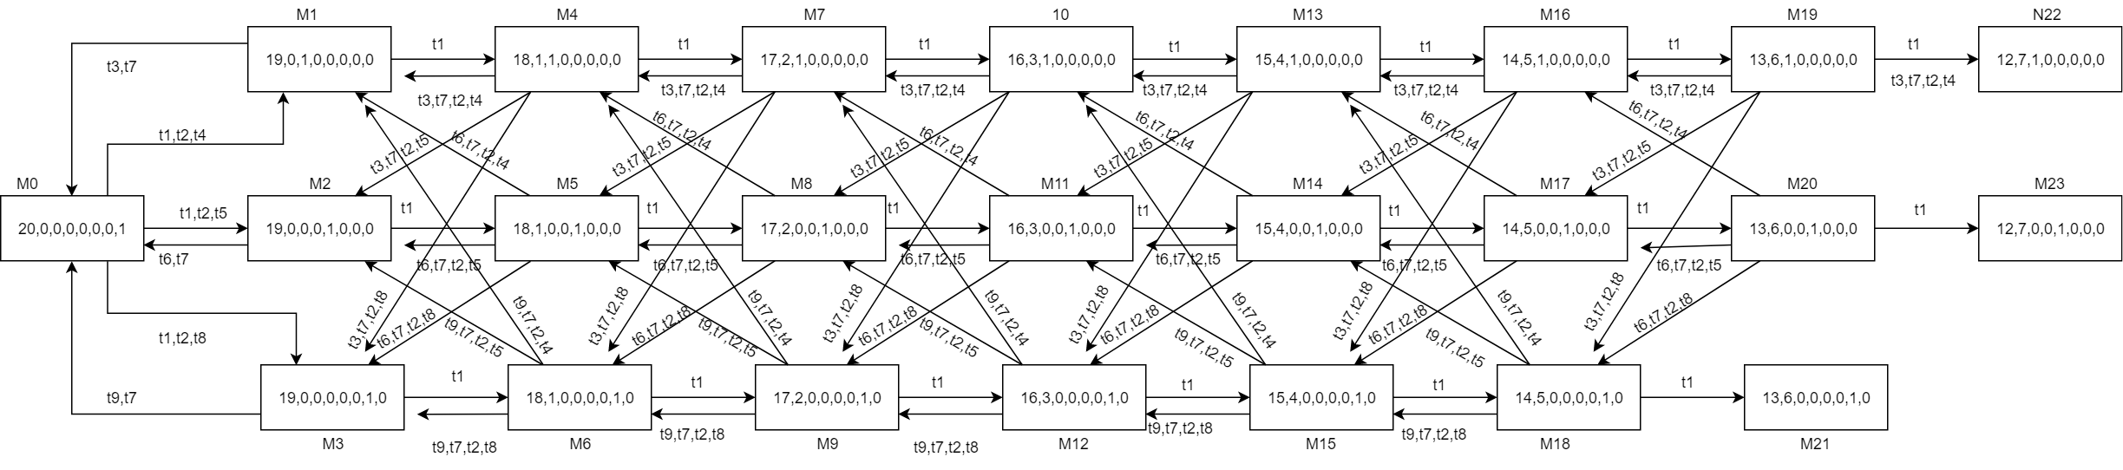M60 = [0,19,0,0,0,0,1,0] [t9,t7,t2,t4>M55;t9,t7,t2,t5>M56;t9,t7,t2,t8>M57;\\0.3;0.6;0.1;

1. 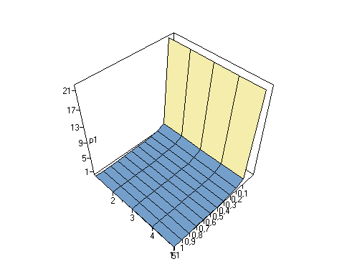**Timpul mediu de asteptare**

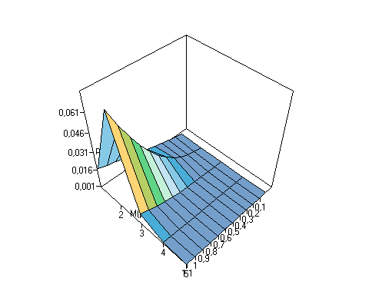****

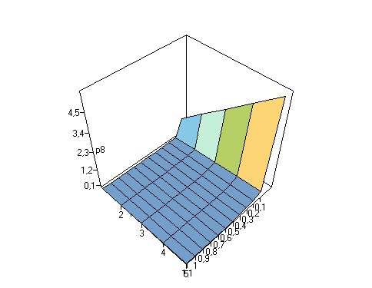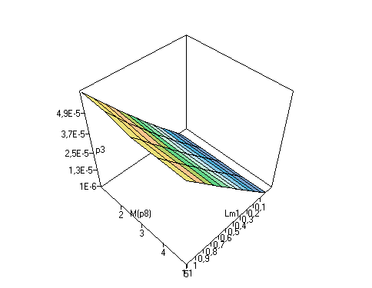

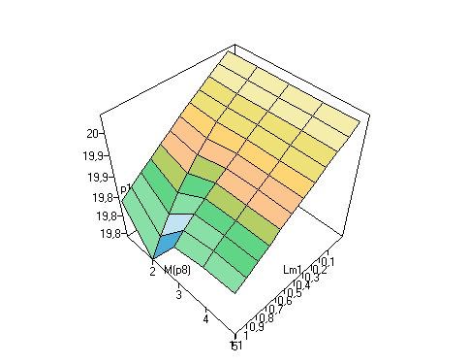**4. Numarul mediu de jetoane:**



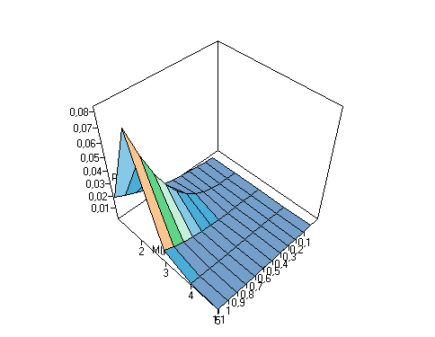

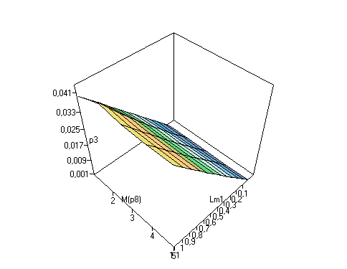

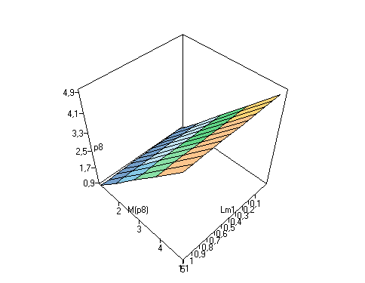

1. **SA: D/D1/k/n/N(FIFO,block).**
2. **Schema si lantul Markov**

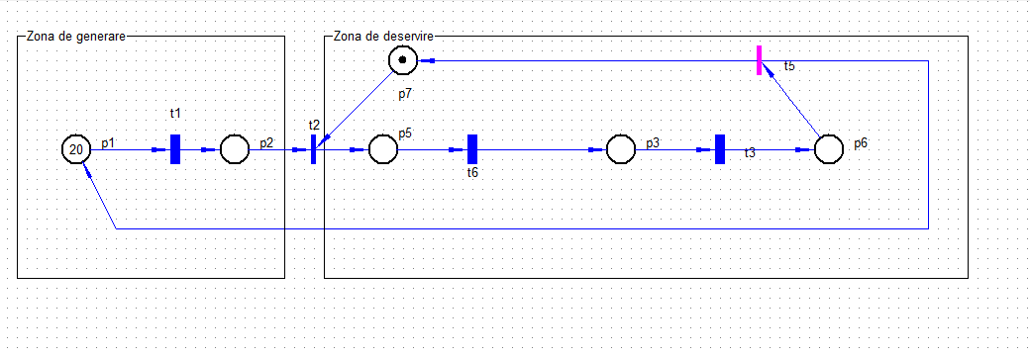

1. **Graficul de accesibilitate pentru M(P1)=8 ;**

Totally found markings number = 41

PositionsList: p1;p2;p3;p5;p6;p7;

M0 = [20,0,0,0,0,1] [t1,t2>M1;\\1;

M1 = [19,0,0,1,0,0] [t1>M2;t6>M3;\\1;1;

M2 = [18,1,0,1,0,0] [t1>M4;t6>M5;\\1;1;

M3 = [19,0,1,0,0,0] [t1>M5;t3,t5>M0;\\1;1;

M4 = [17,2,0,1,0,0] [t1>M6;t6>M7;\\1;1;

M5 = [18,1,1,0,0,0] [t1>M7;t3,t5,t2>M1;\\1;1;

M6 = [16,3,0,1,0,0] [t1>M8;t6>M9;\\1;1;

M7 = [17,2,1,0,0,0] [t1>M9;t3,t5,t2>M2;\\1;1;

M8 = [15,4,0,1,0,0] [t1>M10;t6>M11;\\1;1;

M9 = [16,3,1,0,0,0] [t1>M11;t3,t5,t2>M4;\\1;1;

M10 = [14,5,0,1,0,0] [t1>M12;t6>M13;\\1;1;

M11 = [15,4,1,0,0,0] [t1>M13;t3,t5,t2>M6;\\1;1;

M12 = [13,6,0,1,0,0] [t1>M14;t6>M15;\\1;1;

M13 = [14,5,1,0,0,0] [t1>M15;t3,t5,t2>M8;\\1;1;

M14 = [12,7,0,1,0,0] [t1>M16;t6>M17;\\1;1;

M15 = [13,6,1,0,0,0] [t1>M17;t3,t5,t2>M10;\\1;1;

M16 = [11,8,0,1,0,0] [t1>M18;t6>M19;\\1;1;

M17 = [12,7,1,0,0,0] [t1>M19;t3,t5,t2>M12;\\1;1;

M18 = [10,9,0,1,0,0] [t1>M20;t6>M21;\\1;1;

M19 = [11,8,1,0,0,0] [t1>M21;t3,t5,t2>M14;\\1;1;

M20 = [9,10,0,1,0,0] [t1>M22;t6>M23;\\1;1;

M21 = [10,9,1,0,0,0] [t1>M23;t3,t5,t2>M16;\\1;1;

M22 = [8,11,0,1,0,0] [t1>M24;t6>M25;\\1;1;

M23 = [9,10,1,0,0,0] [t1>M25;t3,t5,t2>M18;\\1;1;

M24 = [7,12,0,1,0,0] [t1>M26;t6>M27;\\1;1;

M25 = [8,11,1,0,0,0] [t1>M27;t3,t5,t2>M20;\\1;1;

M26 = [6,13,0,1,0,0] [t1>M28;t6>M29;\\1;1;

M27 = [7,12,1,0,0,0] [t1>M29;t3,t5,t2>M22;\\1;1;

M28 = [5,14,0,1,0,0] [t1>M30;t6>M31;\\1;1;

M29 = [6,13,1,0,0,0] [t1>M31;t3,t5,t2>M24;\\1;1;

M30 = [4,15,0,1,0,0] [t1>M32;t6>M33;\\1;1;

M31 = [5,14,1,0,0,0] [t1>M33;t3,t5,t2>M26;\\1;1;

M32 = [3,16,0,1,0,0] [t1>M34;t6>M35;\\1;1;

M33 = [4,15,1,0,0,0] [t1>M35;t3,t5,t2>M28;\\1;1;

M34 = [2,17,0,1,0,0] [t1>M36;t6>M37;\\1;1;

M35 = [3,16,1,0,0,0] [t1>M37;t3,t5,t2>M30;\\1;1;

M36 = [1,18,0,1,0,0] [t1>M38;t6>M39;\\1;1;

M37 = [2,17,1,0,0,0] [t1>M39;t3,t5,t2>M32;\\1;1;

M38 = [0,19,0,1,0,0] [t6>M40;\\1;

M39 = [1,18,1,0,0,0] [t1>M40;t3,t5,t2>M34;\\1;1;

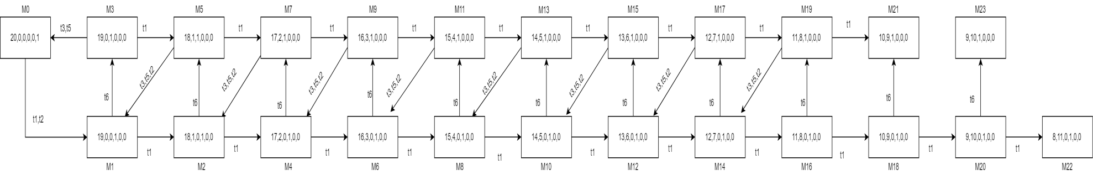M40 = [0,19,1,0,0,0] [t3,t5,t2>M36;\\1;

1. **Timpul mediu de asteptare**

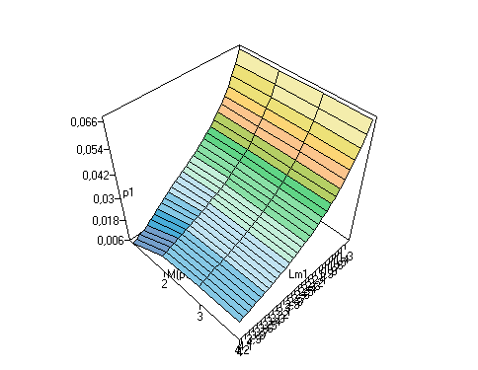

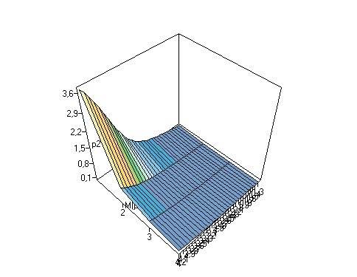

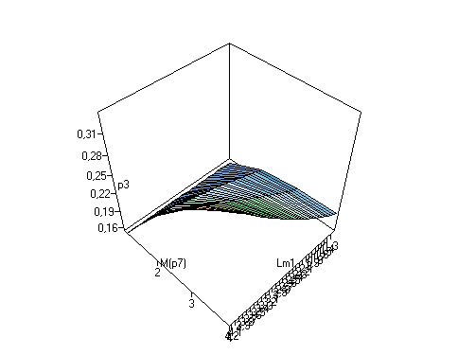

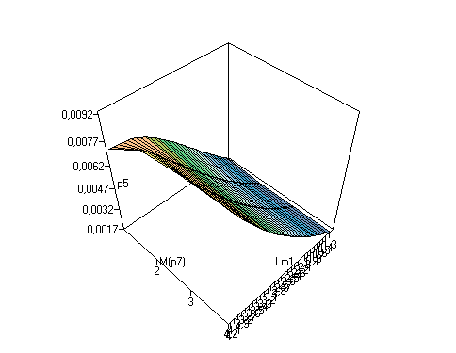

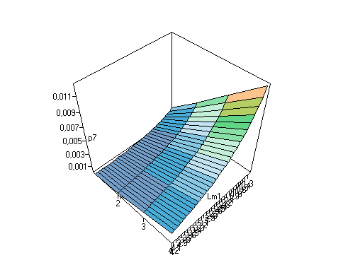

1. **Numarul mediu de jetoane:**

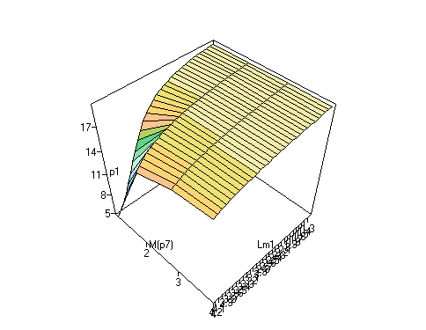

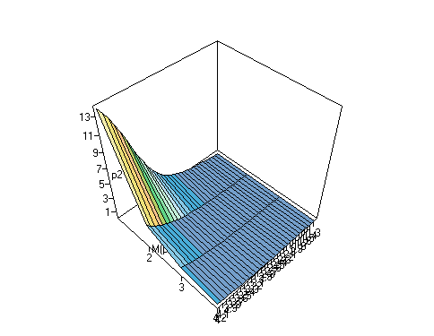

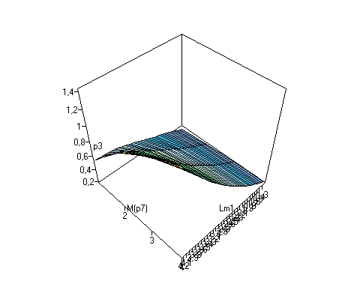

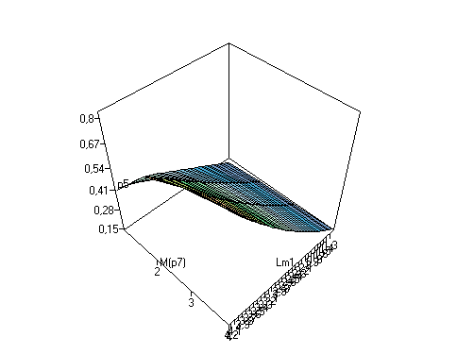

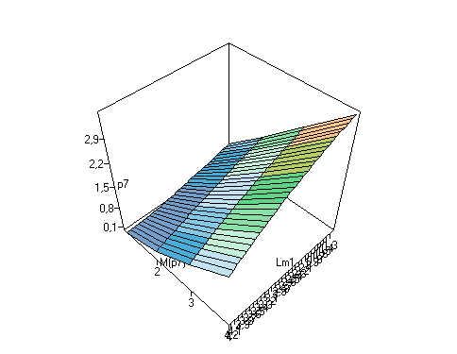

Concluzie: In urma efectuarii lucrarii date de laborator am putut sa implementez cunostintele accumulate la prelegeri, deoarece rezultatul final executat in VPNP nu este alt ceva decit un program ce executat pas cu pas dupa legile Retelei Petri. Graficele Timpului mediu de asteptare si numarului mediu de jetoane, variaza de la caz la caz si nu poate fi descris la caz general, avind fiecare caz individual. Lucrarea a fost usor de efectuat deoarece am avut suficiente resurse si materiale pe care le-am utilizat in VPNP.