**UNIVERSITATEA TEHNICĂ A MOLDOVEI**

**FACULTATEA CALCULATOARE, INFORMATICĂ ȘI MICROELECTRONICĂ**

[DEPARTAMENTUL INFORMATICĂ ŞI INGINERIA SISTEMELOR](https://utm.md/subdiviziuni-universitare/facultati/facultatea-calculatoare-informatica-si-microelectronica/catedra-calculatoare/)

**Raport**

**LUCRARE DE LABORATOR NR.1**

**Evaluarea performanțelor**

**A realizat:** St. gr. C-162, Nicolenco Eugeniu

**A verificat:** prof. univ. dr. hab., Emilian Guţuleac

**Chișinău 2018**

**Scopul lucrării:**

Evaluarea performantelor proceselor de calcul.

**Consideratii teoretice:**

Formarea sirurilor de asteptare si servirea cererilor in sistemul de asteptare de regula se fac dupa disciplina de servire FIFO. In unele cazuri, este nevoie de a asigura o alta disciplina de formare a sirurilor de asteptare in dependenta de urgenta cererii, avind o astfel de prioritate de deservire. Servirea cerererilor conform prioritatii relative presupune manifestarea prioritatii numai in momentul elierarii serverului si a selectarii, care va fi definita din sirul de asteptare, adica se va deservi cererea cu prioritate mai mare.

**Parametrii sistemului de asteptare :**

μi=9.75

μ0(P1)=15.97

λ35=0.015*(1+0.2*8)=0.039

1. **Schema si lantul Markov**



1. **Graficul de accesibilitate pentru**

PositionsList: p1;p2;p3;p4;p5;p6;p7;p8;p9;p10;p11;p12;p13;p14;p15;p16;p17;

M0 = [13,2,0,5,0,0,0,0,0,0,0,0,0,0,0,0,0] [t1,t2>M1;\\1;

M1 = [12,1,0,4,1,0,0,0,0,0,0,0,0,0,0,0,0] [t7>M0;t1,t2>M2;t1,t3>M3;\\1;0.5;0.5;

M2 = [11,0,0,3,2,0,0,0,0,0,0,0,0,0,0,0,0] [t1>M4;t7>M1;\\1;1;

M3 = [11,1,0,4,0,1,0,0,0,0,0,0,0,0,0,0,0] [t8>M1;t1,t2>M6;t1,t4>M7;\\1;0.5;0.5;

M4 = [10,0,1,3,2,0,0,0,0,0,0,0,0,0,0,0,0] [t1>M5;t7,t2>M2;t7,t3>M3;\\1;0.5;0.5;

M5 = [9,0,2,3,2,0,0,0,0,0,0,0,0,0,0,0,0] [t1>M8;t7,t2>M4;t7,t3,t2>M6;t7,t3,t4>M7;\\1;0.5;0.25;0.25;

M6 = [10,0,0,3,1,1,0,0,0,0,0,0,0,0,0,0,0] [t1>M9;t7>M3;t8>M2;\\1;1;1;

M7 = [10,1,0,4,0,0,1,0,0,0,0,0,0,0,0,0,0] [t9>M3;t1,t2>M12;t1,t5>M13;\\1;0.5;0.5;

M8 = [8,0,3,3,2,0,0,0,0,0,0,0,0,0,0,0,0] [t1>M10;t7,t2>M5;t7,t3,t2>M9;t7,t3,t4,t2>M12;t7,t3,t4,t5>M13;\\1;0.5;0.25;0.125;0.125;

M9 = [9,0,1,3,1,1,0,0,0,0,0,0,0,0,0,0,0] [t1>M11;t8>M4;t7,t2>M6;t7,t4>M7;\\1;1;0.5;0.5;

M10 = [7,0,4,3,2,0,0,0,0,0,0,0,0,0,0,0,0] [t1>M14;t7,t2>M8;t7,t3,t2>M11;t7,t3,t4,t2>M16;t7,t3,t4,t5,t2>M20;t7,t3,t4,t5,t6>M21;\\1;0.5;0.25;0.125;0.0625;0.0625;

M11 = [8,0,2,3,1,1,0,0,0,0,0,0,0,0,0,0,0] [t1>M15;t8>M5;t7,t2>M9;t7,t4,t2>M12;t7,t4,t5>M13;\\1;1;0.5;0.25;0.25;

M12 = [9,0,0,3,1,0,1,0,0,0,0,0,0,0,0,0,0] [t1>M16;t7>M7;t9>M6;\\1;1;1;

M13 = [9,1,0,4,0,0,0,1,0,0,0,0,0,0,0,0,0] [t10>M7;t1,t2>M20;t1,t6>M21;\\1;0.5;0.5;

M14 = [6,0,5,3,2,0,0,0,0,0,0,0,0,0,0,0,0] [t1>M17;t7,t2>M10;t7,t3,t2>M15;t7,t3,t4,t2>M19;t7,t3,t4,t5,t2>M25;t7,t3,t4,t5,t6,t2>M30;t7,t3,t4,t5,t6,t18>M31;\\1;0.5;0.25;0.125;0.0625;0.03125;0.03125;

M15 = [7,0,3,3,1,1,0,0,0,0,0,0,0,0,0,0,0] [t1>M18;t8>M8;t7,t2>M11;t7,t4,t2>M16;t7,t4,t5,t2>M20;t7,t4,t5,t6>M21;\\1;1;0.5;0.25;0.125;0.125;

M16 = [8,0,1,3,1,0,1,0,0,0,0,0,0,0,0,0,0] [t1>M19;t9>M9;t7,t2>M12;t7,t5>M13;\\1;1;0.5;0.5;

M17 = [5,0,6,3,2,0,0,0,0,0,0,0,0,0,0,0,0] [t1>M22;t7,t2>M14;t7,t3,t2>M18;t7,t3,t4,t2>M24;t7,t3,t4,t5,t2>M29;t7,t3,t4,t5,t6,t2>M36;t7,t3,t4,t5,t6,t18,t2>M42;t7,t3,t4,t5,t6,t18,t19>M43;\\1;0.5;0.25;0.125;0.0625;0.03125;0.015625;0.015625;

M18 = [6,0,4,3,1,1,0,0,0,0,0,0,0,0,0,0,0] [t1>M23;t8>M10;t7,t2>M15;t7,t4,t2>M19;t7,t4,t5,t2>M25;t7,t4,t5,t6,t2>M30;t7,t4,t5,t6,t18>M31;\\1;1;0.5;0.25;0.125;0.0625;0.0625;

M19 = [7,0,2,3,1,0,1,0,0,0,0,0,0,0,0,0,0] [t1>M24;t9>M11;t7,t2>M16;t7,t5,t2>M20;t7,t5,t6>M21;\\1;1;0.5;0.25;0.25;

M20 = [8,0,0,3,1,0,0,1,0,0,0,0,0,0,0,0,0] [t1>M25;t7>M13;t10>M12;\\1;1;1;

M21 = [8,1,0,4,0,0,0,0,1,0,0,0,0,0,0,0,0] [t11>M13;t1,t2>M30;t1,t18>M31;\\1;0.5;0.5;

M22 = [4,0,7,3,2,0,0,0,0,0,0,0,0,0,0,0,0] [t1>M26;t7,t2>M17;t7,t3,t2>M23;t7,t3,t4,t2>M28;t7,t3,t4,t5,t2>M35;t7,t3,t4,t5,t6,t2>M41;t7,t3,t4,t5,t6,t18,t2>M49;t7,t3,t4,t5,t6,t18,t19,t2>M55;t7,t3,t4,t5,t6,t18,t19,t20>M56;\\1;0.5;0.25;0.125;0.0625;0.03125;0.015625;0.0078125;0.0078125;

M23 = [5,0,5,3,1,1,0,0,0,0,0,0,0,0,0,0,0] [t1>M27;t8>M14;t7,t2>M18;t7,t4,t2>M24;t7,t4,t5,t2>M29;t7,t4,t5,t6,t2>M36;t7,t4,t5,t6,t18,t2>M42;t7,t4,t5,t6,t18,t19>M43;\\1;1;0.5;0.25;0.125;0.0625;0.03125;0.03125;

M24 = [6,0,3,3,1,0,1,0,0,0,0,0,0,0,0,0,0] [t1>M28;t9>M15;t7,t2>M19;t7,t5,t2>M25;t7,t5,t6,t2>M30;t7,t5,t6,t18>M31;\\1;1;0.5;0.25;0.125;0.125;

M25 = [7,0,1,3,1,0,0,1,0,0,0,0,0,0,0,0,0] [t1>M29;t10>M16;t7,t2>M20;t7,t6>M21;\\1;1;0.5;0.5;

M26 = [3,0,8,3,2,0,0,0,0,0,0,0,0,0,0,0,0] [t1>M32;t7,t2>M22;t7,t3,t2>M27;t7,t3,t4,t2>M34;t7,t3,t4,t5,t2>M40;t7,t3,t4,t5,t6,t2>M48;t7,t3,t4,t5,t6,t18,t2>M54;t7,t3,t4,t5,t6,t18,t19,t2>M61;t7,t3,t4,t5,t6,t18,t19,t20,t2>M66;t7,t3,t4,t5,t6,t18,t19,t20,t21>M67;\\1;0.5;0.25;0.125;0.0625;0.03125;0.015625;0.0078125;0.00390625;0.00390625;

M27 = [4,0,6,3,1,1,0,0,0,0,0,0,0,0,0,0,0] [t1>M33;t8>M17;t7,t2>M23;t7,t4,t2>M28;t7,t4,t5,t2>M35;t7,t4,t5,t6,t2>M41;t7,t4,t5,t6,t18,t2>M49;t7,t4,t5,t6,t18,t19,t2>M55;t7,t4,t5,t6,t18,t19,t20>M56;\\1;1;0.5;0.25;0.125;0.0625;0.03125;0.015625;0.015625;

M28 = [5,0,4,3,1,0,1,0,0,0,0,0,0,0,0,0,0] [t1>M34;t9>M18;t7,t2>M24;t7,t5,t2>M29;t7,t5,t6,t2>M36;t7,t5,t6,t18,t2>M42;t7,t5,t6,t18,t19>M43;\\1;1;0.5;0.25;0.125;0.0625;0.0625;

M29 = [6,0,2,3,1,0,0,1,0,0,0,0,0,0,0,0,0] [t1>M35;t10>M19;t7,t2>M25;t7,t6,t2>M30;t7,t6,t18>M31;\\1;1;0.5;0.25;0.25;

M30 = [7,0,0,3,1,0,0,0,1,0,0,0,0,0,0,0,0] [t1>M36;t7>M21;t11>M20;\\1;1;1;

...

M60 = [0,19,0,0,0,0,1,0,0] [t9,t10,t2>M52;\\1;

1. **Timpul mediu de asteptare**

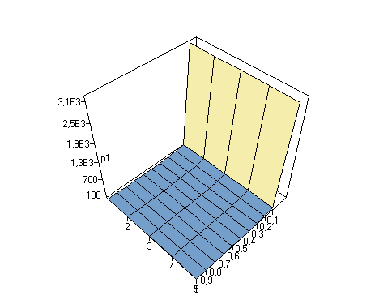



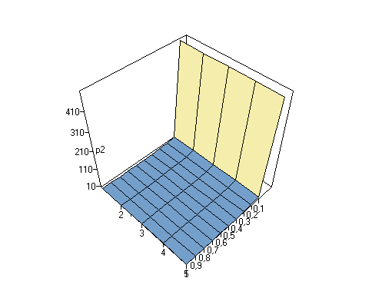

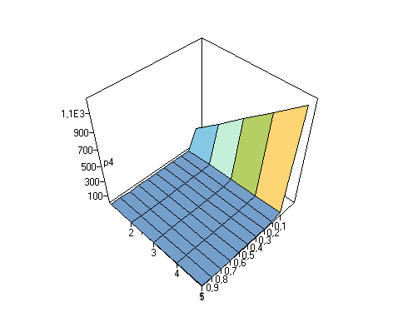

1. 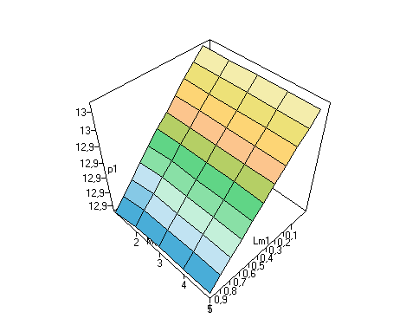**Numarul mediu de jetoane:**

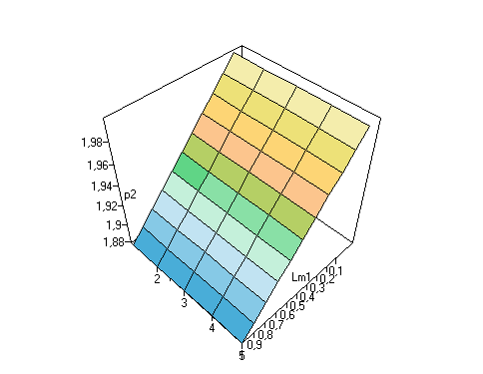

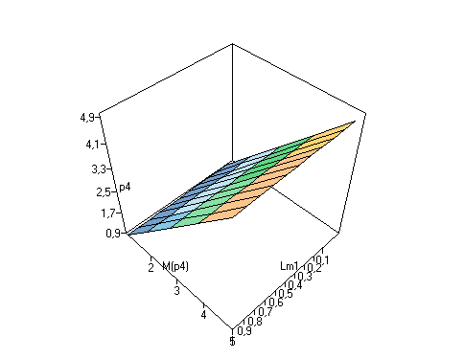

**2. Schema si lantul Markov**



**Timpul mediu de asteptare**

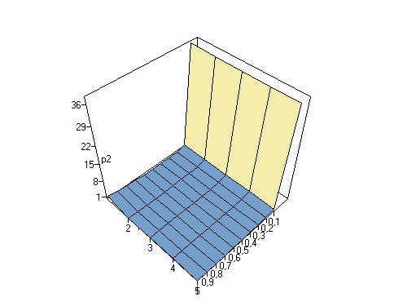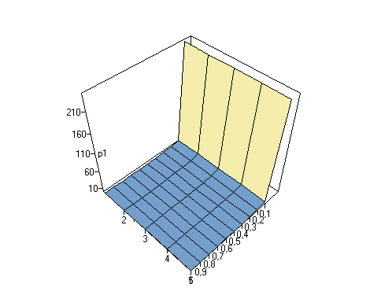

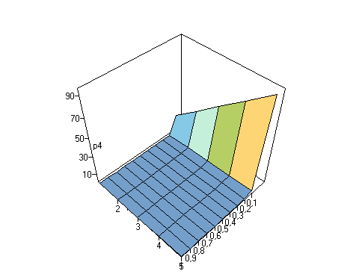

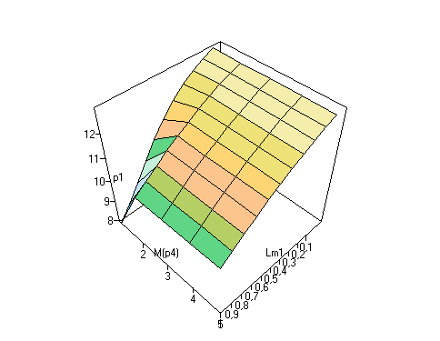**Numarul mediu de jetoane:**

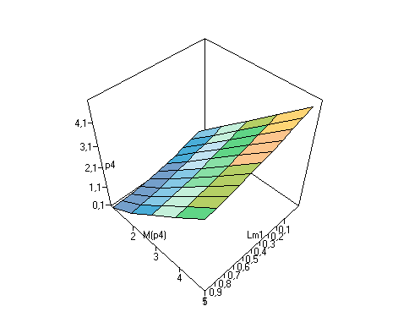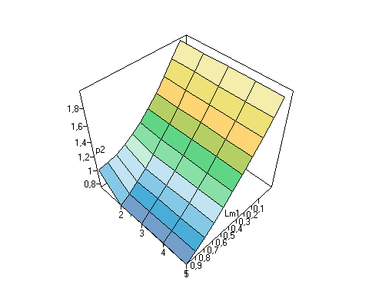

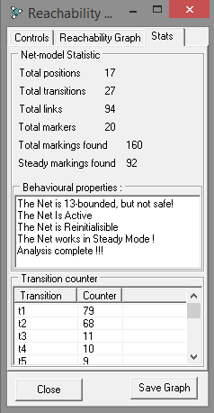

Concluzie: In urma efectuarii lucrarii date de laborator am putut sa implementez cunostintele accumulate la prelegeri, deoarece rezultatul final executat in VPNP nu este alt ceva decit un program ce executat pas cu pas dupa legile Retelei Petri. Am putut sa examinez evaluarea performantelor acestei retele si sa observ punctele slabe si puternice.