Digital Library Federation | 1755 Massachusetts Ave. NW Phone 202-939-4761  Suite 500 Fax 202-939-4765  Washington, DC 20036
DLF-Aquifer Services
Institutional Survey Report
Aquifer Services Working Group Report on the Institutional User-Services Survey Results

DLF Aquifer Services Working Group
Martin Halbert, Chair (Emory University)
John Butler (University of Minnesota)
Laine Farley (California Digital Library)
Mike Furlough (University of Virginia)
Liz Milewicz (Emory University)
Beth Sandore (University of Illinois – Urbana-Champaign)
John Walsh (Indiana University)

Last Revised January 31, 2006

Table of Contents
Executive Summary 3
Methodology 5
Preliminary Survey of DLF Aquifer Institutions 5
Online Survey of DLF Institutions 6
Analyzing Results 7
Results 10
Section 1: Assessing Use 10
Section 2: Actual & Desired Use 12
Section 3: Digital-Resource Support 17
Section 4: Open Questions & Comments 18
Additional User Studies Conducted by DLF Institutions 20
Metadata Harvesting & Searching Portals 20
Collection Aggregation & Display 21
Navigating and Using Digital Object Collections 22
Collecting & Analyzing Usage Data 24
Discussion of Findings 26
Assessing Services and Identifying Users 26
Developing Tools and Services That Support Meta-Searching 27
Developing Middleware Tools That Support Metadata Management 27
Developing Tools and Services That Help Integrate Digital Content into Teaching & Learning Services 27
Goals for Future DLF Studies 28
Appendix A: Survey of User Services for DLF Aquifer Institutions 29
Appendix B: Survey of User Services for Digital Collections 31
Introduction 31
Section 1 of 5: Assessing Use 31
Section 2 of 5: Actual & Desired Use 32
Section 3 of 5: Supporting Digital-Resource Use 34
Section 4 of 5: Open Questions and Comments 34
Section 5 of 5: Institutional Information 34
Thanks! 35
Appendix C: Survey Cover Letter 36
Appendix D: Qualitative Data from Survey 38
Section 1 of 5: Assessing Use 38
Section 2 of 5: Actual & Desired Use 38
Section 3 of 5: Supporting Digital-Resource Use 41
Section 4 of 5: Open Questions and Comments 45

Executive Summary
The Digital Library Federation (DLF) Aquifer Services Working Group (SWG) was charged by the Aquifer Director with recommending service specification and level policies to the DLF Aquifer Implementation Group, developing functional specifications for DLF Aquifer services, and designing processes to measure DLF Aquifer usability. As a first step towards meeting these goals, the group has undertaken a survey of DLF institutions in order to discover user-services assessment efforts and to assess what services are desired by end users and institutions and how the Aquifer project might potentially meet these needs. Several key findings emerged from this survey:
- Use of digital collections and services is often assessed at point of introduction or update, rather than systematically over time. An implication of this is that more is known about initial reactions to a technology, resource, or service, and how (or whether) it is integrated into regular research activity is not evaluated on an on-going basis.
- Searching is the most common way that digital collections are used. These resources are regularly used for locating content by searching metadata, searching full-text, and browsing unfamiliar archives. Though perhaps a somewhat obvious use, this finding serves to remind of the importance of metadata management to the maintenance and enhancement of digital collections and services and the potential value to users of searching enhancements (such as a single search interface for cross-resource searching).
- Metadata standardization is the most commonly reported strategy for supporting digital collections. Such metadata-management activities include assigning taxonomies, remediating and enhancing metadata, and migrating metadata into other formats, such as DC (Dublin Core), MODS (Metadata Object Description Schema), and METS (Metadata Encoding & Transmission Standard). Institutions also support these resources by integrating digital content into teaching and learning services and by developing single-search interfaces for multiple collections.
- Budgetary, time, and personnel constraints challenge the ability of institutions to develop needed services. Challenges posed by changing metadata formats, new technology, and the need to train patrons and personnel in the use of new services are confounded by the interrelated issues of maintaining a skilled staff, budgeting for the development and maintenance of new services, and allocating time for these activities.
- Institutions and users desire cross-resource discovery tools and greater ability to personalize service options. Meta-searching (whether across local collections or institutional collections) and personalization (such as creating personal collections or persistent baskets) ranked high among the identified gaps in current services, indicating shared interest in a “one-stop shopping” approach to providing digital resources and services and also highlighting the need for common and consistent high-quality metadata formats to support cross-resource searching. As one respondent put it, “Users want (and expect) much more in the way of "My Library" features, massively cross-collectional searching."
The qualitative and quantitative results of this survey, while more descriptive than statistically significant, point to some issues and considerations for the current and future work of DLF Aquifer, and suggest that there are several areas of need among DLF institutions that the Aquifer project could meet. The following are key issues and considerations that will inform the work of the DLF Aquifer Services Working Group:
- Developing a model for conducting usage assessments of the types of services and tools the DLF Aquifer project will develop. The model should demonstrate the complete phasing of assessment – from development through introduction, and follow-up over time in order to assess how well the service or tool is integrated into scholarly practice. Additionally, this model should help identify not simply who uses a tool or collection and how frequently but should also provide more detailed insight into scholarly practices (for example, which collections and services are typically used together, by whom, and for what purposes).
- Developing tools and services that support meta-searching. Institutions desire the ability to provide cross-resource searching. Focused crawling, metadata harvesting and aggregation, and similar services enable the development of single-interface searching of a range of collections.
- Developing middleware tools that support metadata management. Tools are needed for migrating metadata into a common and consistent format, remediating metadata, and enhancing metadata. The expressed desire among some scholars for the ability to annotate metadata records and institutions’ own desire to provide such services suggests a need for DLF Aquifer to investigate and develop tools supporting this type of metadata enhancement.
- Developing tools and services that enable the integration of digital content into course management systems. Digital collections should be seamlessly integrated into course management systems and other resources for collecting, organizing, and repurposing digital content for scholarly use. Such systems provide a foundation for tools that allow scholars to further personalize their research experience.

Methodology
The Services Working Group identified a gap in knowledge about how other DLF and DLF Aquifer institutions were meeting and assessing their patrons’ digital resource and service needs. Surveying presented itself as the quickest and most efficient way to gather this information and use it to guide the group’s efforts. During the summer of 2005 the group conducted a preliminary exploratory survey of DLF Aquifer institutions and then used those findings to inform the construction of an online survey, which was then distributed among all DLF institutions. In conducting these surveys, the Services Working Group hoped to discover user-services assessment efforts, determine current service offerings and perceived gaps, and identify the major service opportunities that the DLF Aquifer project would be well-positioned to take on.

Preliminary Survey of DLF Aquifer Institutions
In June 2005 the Services Working Group conducted an “environmental scan” of DLF Aquifer institutions. Questions for this survey were intentionally broad and open-ended, in an effort to obtain as much descriptive data as possible on current digital-library services and assessment efforts (see Appendix A).
Of the 12 institutions involved in the DLF Aquifer project, half were already represented by the members of the Services Working Group. The remaining six DLF Aquifer institutions were contacted for phone interviews, and of those, three participated. Participants were asked to review the questions in the survey instrument (see Appendix A), consult with others in their department as necessary to answer the questions, then schedule a conference call with members of the Services Working Group to deliver and discuss their answers.
Findings from this initial survey were incorporated in the interim report, prepared for the DLF Aquifer working groups’ meeting on June 28, 2005. In brief, conversations with DLF Aquifer institutions pointed toward a shared concern about the frequency and nature of assessment: who are the users of digital library services and collections? What do we know about their expectations and needs or of their sustained use of these technologies? Also common among these institutions were concerns about limited resources and their allocation, whether these resources were understood as trained personnel, money to budget for new development, or time to devote to new projects (all of which may be seen as highly dependent on each other). An appeal of the Aquifer project was its potential to pool limited resources and to help institutions avoid duplicating efforts. Services these respondents expressed an interest in developing, given adequate resources, were
- Registry of digital collections
- Cross-institutional searching of other digital collections
- Automated citation creation and plug-in with EndNote, Procite, or other bibliographic citation software
- Better integration of digital collection with OPAC
- Integration of multiple repositories and applications, using a common framework
The responses and conversations that emerged during these calls, along with the discussions among Services Working Group members, guided the development of the online survey.

Online Survey of DLF Institutions
Using the range of responses to the initial survey as a guide, the Services Working Group sought to create an online version which would address the same primary goals, allow participants to provide descriptive responses, and increase the number of institutions queried, yet take less time and planning to complete than scheduling conference calls and follow-ups. Additionally, this second survey sought to canvas the range of digital resources and services at all DLF institutions. A copy of this online survey is provided in Appendix B.

Participants
Our target audience was metadata and digital-services librarians at DLF institutions, preferably those with some oversight of digital initiatives at their respective institutions. Additionally, we sought out individuals with a history of active participation in DLF functions, who would thus have a sense of the provenance of the Aquifer project and the potential importance of its work for the larger DLF community. Names and contact information were culled from a DLF database of active members, then supplemented by information on digital library initiatives currently being undertaken at DLF institutions and recommendations made by DLF Aquifer working group members.
A copy of the survey URL was included in a cover letter emailed to two individuals at each institution, pre-identified as likely participants. This letter included background information on the DLF Aquifer project, description of the survey, instructions on completing the survey, and a request to pass the survey along to a more appropriate respondent, if deemed necessary. In an effort to control and more easily assess the data, we asked that each institution submit only one institutional response for the survey. A copy of the survey cover letter is included in Appendix C. Note that this cover letter introduced two separate information-gathering surveys that DLF Aquifer conducted. The Metadata Working Group’s (MWG) survey canvassed the range and extent of metadata formats used by DLF institutions and tools currently used and needed to work with metadata. A summary of the MWG’s survey results will be published separately.

Design
The survey was divided into five sections, with the first four sections addressing different aspects of user services and the last section requesting personal and institutional information for use in analyzing the results. The goals of sections were as follows:
- Section 1: Assessing Use
Determine how and when use of services is assessed at DLF institutions.
- Section 2: Actual & Desired Use
Identify gaps between actual use of services and patron’s desired services.
- Section 3: Digital-Resource Support
Discover tools and services institutions currently utilize to support patron services and those they would like to develop (and barriers to developing these services).
- Section 4: Open Questions & Comments
Provide an opportunity for participating institutions to supply other information, ideas, or questions that may not have been covered or fully explored in the survey, as well as to comment on the survey itself.
- Section 5: Institutional Information
Gather information on who participated in this survey, to use in analyzing the results and following up on responses if necessary.
As stated previously, the online survey was intended to canvass a broader audience and a broader range of questions while still allowing for less structured and more qualitative descriptions of DLF institutions’ perspectives. Balancing these separate and, in some cases, contradictory aims meant that the survey would limit answer choices in some areas (making responses easier to generate and tabulate) and keep answer choices open in others (making responses harder to generate and tabulate, but also allowing for more detailed and exact description of local conditions). A copy of the text of the online survey, with some screen captures, may be found in Appendix B. Note that the questions were fairly evenly divided between batteries (long lists of items for respondents to select) and open-ended or essay questions.

Format
The choice of an online survey format offered (1) the possibility of a faster turnaround time than we might reasonably expect with mailed paper questionnaires and (2) already digitized data, which could also decrease our time spent in analysis of the results.

Timeline
On August 3, 2005, URLs to the online survey were emailed to 34 DLF institutions. (A copy of the survey cover letter is available in Appendix C.) Participants were initially given two weeks to complete the online survey. A decision was made to extend the closing date an extra week when it became clear that many institutions could improve their responses by having more time to gather people and information necessary to complete the survey. The survey closed on August 26, 2005.

Analyzing Results
At the end of the survey period, the Services Working Group had collected 30 responses to the online survey. Initial passes through the data revealed some duplication and a few blank surveys. Comparing answers to institution-identifying questions allowed for quick identification of which surveys were posted more than once and which were simply accidental or incomplete postings. In the interest of producing an accurate data analysis while still including as many of the responses as possible, we reviewed and compared the responses in order to ensure that (1) each responding institution was represented by only one survey response, (2) the representative survey response was the most complete of the ones received, if more than one was received, and (3) responses that could not be reliably linked to a single institution were removed. For instance, two survey responses from the same institution were nearly identical, except that one response included more comments in the open-ended questions; in this case, the response with more comments was included and the other was omitted. In another instance, a survey response was partially completed but all questions querying the name of the institution were not answered; this response was omitted from analysis since it would not be possible to verify if it was a duplicate posting or not.
Removing duplicate, blank, and other erroneous responses resulted in 23 total responses to the survey, with an average of 18 responses to each question (since respondents did not always answer every question). Because of the small sample size of this survey, it was decided that, rather than omitting incomplete responses, an effort would be made to first determine that the response was the single and most complete response from the institution and then indicate in the analysis the number of respondents for each question.

Cleaning Data
In the interest of sharing survey findings with others without compromising the anonymity of respondents, information in the responses which could be used to identify an individual or institution was removed. The method for anonymizing survey data was straightforward: identifying items were removed and replaced with a generic description in square brackets. Items that could be used to identity an institution or an individual were broadly construed, encompassing the names of granting agencies and components of an institution’s technical infrastructure. The following generic descriptions were used in the data:
Generic Description | Data Replaced
[collection] | Name of a specific collection or holding at an institution
[funding agency] | Name of federal granting agency or other funding agency
[institution] | Name of an institution
[project] | Name of a specific grant project or local initiative
[software]  [CMS]  [digital repository]  [digital resource catalog]  [federated search]  [OpenURL] | Name of locally developed software tool or system or of common digital library tools like DLXS and Fedora that might help identify an institution--not ubiquitous tools like XML, Java, Perl, etc. More specific generic labels indicate the type of software; for example, [CMS] replaces the specific name of a Content Management System, such as Sakai, Blackboard, or WebCT, or a locally developed system.
[URL] | Web address
In addition, because most of the responding DLF institutions use American English spelling conventions, some words were re-spelled to fit this standard so that non-American institutions could not be easily identified. In all cases, if removing or altering information rendered the response unintelligible or uninformative, the entire response was omitted from the shareable data set. The cleaned qualitative survey responses are provided in Appendix D of this report. As mentioned previously, responses to questions specifically soliciting personal or institutional information are not provided or analyzed in this report.

Qualitative Data Analysis
The Aquifer Services survey contained nine open-ended questions and questions with pre-defined response categories with an open-ended "Other, please specify" option. Responses to these questions/options were plentiful and rich. In addition to listing these narrative responses in the survey report (see Appendix D for the anonymized qualitative responses), the decision was made to cluster them thematically and code them for quantitative presentation. This methodology involved a question-by-question reading of the narrative responses, followed by the synthesizing of response categories to represent all given responses to a specific question. Responses were then located in the synthesized response categories and tallied. As expected with any similar process, this coding process involved a fair amount of clustering and collapsing, which also leads to a certain level of generalizing of the original responses.
One of the challenges of this procedure involves the integration of coded narrative responses to "Other, please specify" options with the data from fixed response categories of the same survey question. Although this data frequently represents a statistically insignificant portion of the total responses, it provides primary and more specific information on what DLF institutions are doing (and potentially more accurate information than what is measured through checking pre-supplied and unelaborated categorical responses). Because of the differences in these types of data, and the difficulties in reliably conflating their findings, we decided to discuss the qualitative data alongside but distinctly separate from the quantitative results, acknowledging and clarifying any overlaps or conflicts between them. We attended carefully to the qualitative responses since this self-reported information potentially offered a more accurate representation of institutions’ experiences than the pre-supplied responses. This information also provided us with an opportunity to assess the usefulness of our survey instrument and consider ways of rewording or expanding pre-supplied responses for future surveys.

Results
The survey was divided into five sections, each addressing different aspects of user services and/or gathering institutional or individual information for administrative use. This section of the report summarizes qualitative and quantitative responses to survey questions. Responses to questions specifically requesting institution- or individual-identifying information are excluded from this report.

Section 1: Assessing Use
The first section of the survey sought information on DLF institutions’ assessment practices: how they assess the use of their digital collections and services and when, and what type of information they gather on this use. Quantitative data from the survey reveal interesting trends, most notably that the bulk of assessment (often involving the most descriptive methods) occurs when a new resource is introduced or updated. Figure 1 below illustrates this pattern, in which information on digital collections and services is gathered through focus groups, focused surveys, interviews, and participant observation primarily when the service is updated or introduced.
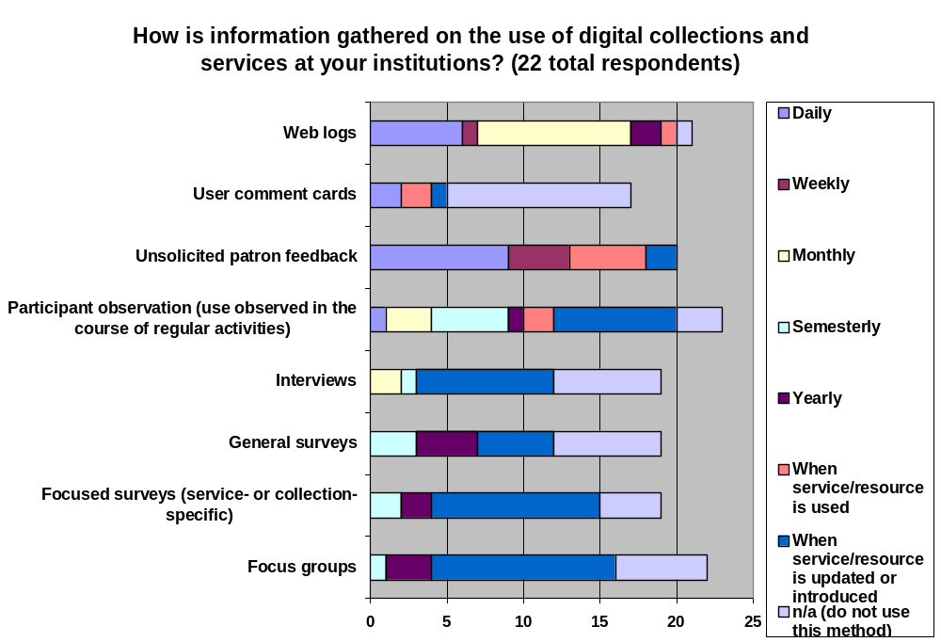
Figure 1: Assessment Practices of DLF Institutions
As shown in Figure 1, web logs accounted for the greatest frequency of assessment, primarily at the monthly and daily levels. In terms of frequency, unsolicited patron feedback offered the greatest daily assessment of digital collections and services. This form of assessment also accounted for the greatest portion of weekly assessment and, notably, assessment of the service when it was used. Otherwise, there were few reported instances of assessment at the point of use.
Among the DLF institutions that responded to this survey, most gathered information on frequency of use of digital collections and services, closely followed by information on what users desire or need (see Figure 2). But beyond this there is little evidence of a standard practice for assessing the use of digital collections and services.
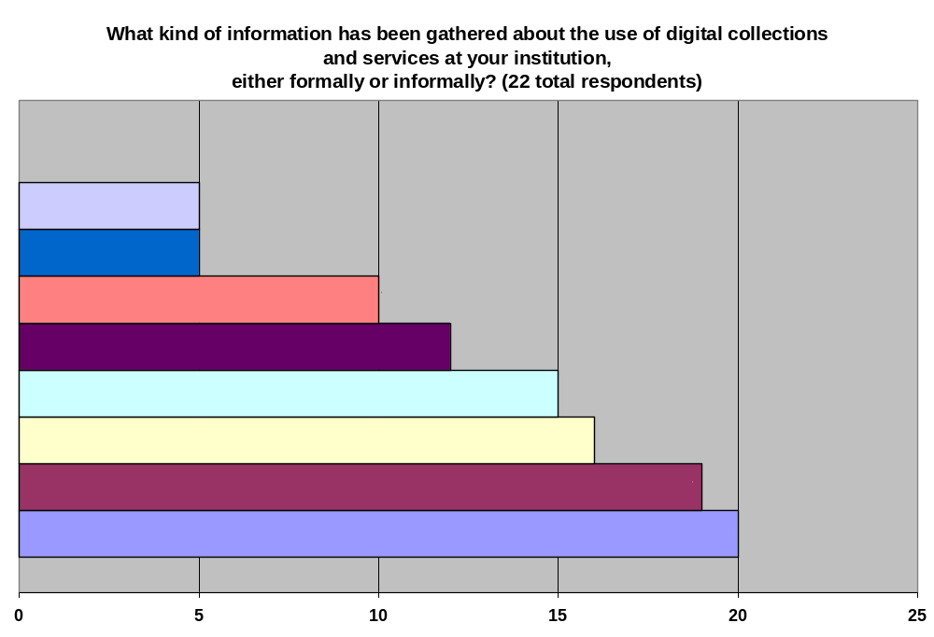
Figure 2: Types of Information Gathered on Digital Collection & Service Use
Roughly one-quarter of respondents to this question (5 of 22) also offered information for the “Other” option, which asked what other kinds of information an institution gathered on the use of digital collections and services (see Appendix D for complete responses). Responses to this question did not introduce types of information dramatically different from types suggested in the pre-supplied responses: for example, “end-user demographics” are a way of assessing the type of patrons who use a service or collection, and “use patterns” encompasses the specific usage information typified in the pre-supplied response (e.g., “Services or collections frequently used together,” “Reasons for using the service or collection,” and “Frequency of use of services or functionality/features”).
A question these findings raise is how desired features and functionality relate to (1) the type of patron who uses the digital collection or service and (2) how frequently s/he uses it. The structure of our survey did not allow for making this connection, though the responding DLF institutions may well control for this information in their own user studies. (See a later section of this report entitled “Additional User Studies Conducted by DLF Institutions.”) It is also interesting that, of the pre-supplied responses, “services or collections frequently used together” was assessed the least, particularly given the rising interest (evidenced in other responses to survey questions, below) in developing tools for cross-resource searching and personalization of services and collections.

Section 2: Actual & Desired Use
This section sought more detailed description of actual use (as opposed to assessment strategies) and consequently relied primarily on open-ended questions to gather information on how digital collections and services are used at different DLF institutions. Of the quantitative data collected, however, some patterns emerged (see Figure 3, below). Among the respondents who indicated frequency of actual use for the proposed uses of digital collections and services, locating digital content by searching metadata and searching full-text of digital content were the most frequent uses of digital collections and services, followed by browsing of unfamiliar research archives. In terms of overall use (whether every day or a few times a semester), searching metadata and searching full text still ranked highest, but browsing unfamiliar research archives ranked the same as exporting selected items into other software programs. This primary emphasis on searching and browsing underlines the need for quality metadata formats for describing and providing access to digital cultural heritage materials.
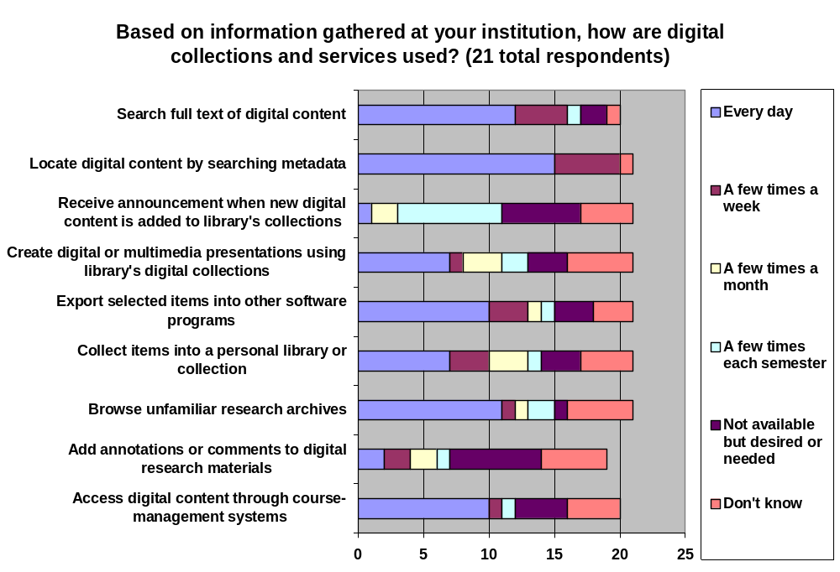
Figure 3: Actual Use of Digital Collections and Services
Annotation (“Add annotations or comments to digital research materials”) and alerting (“Receive announcement when new digital content added to library’s collection”) were ranked as services that occur infrequently. There are obvious explanations for this pattern: there are currently few tools that support annotation of digital materials, and updates of local collections are not likely to occur on a daily or even weekly basis. At the same time, the high number of responses that annotation and alerting services are “not available but desired or needed” suggests that institutions see these features as beneficial to users. This leaves open the question of whether users themselves perceive these services as useful to their work.
As stated previously, open-ended questions offered potentially more detailed understanding of actual use of digital collections and services at DLF institutions. There were twelve responses to the follow-up question “What are other uses of digital collections and services at your institution?” For this particular question, categorized results did not yield significant patterns but did highlight uses not captured in the pre-supplied responses.
- On-demand digitization services (for instructional, research purposes)
- Support of public relations and marketing/performances and exhibitions
- K-12 uses
- Electronic course reserves
- Streaming instructional media
- Ready reference/quick information lookups
- Access to local digital content through OPAC and national bibliographic utilities
- Provide use of open access resources
- Support creation of web pages, bibliographies, etc.
One observation that can be made about these “Other” uses is that a number relate to instructional use, whether academic or K-12. Following are instruction-related excerpts from the qualitative responses to our query about “Other” uses of digital collections and services:
“Other uses of digital collections and services”: college or K-12 instruction
Electronic reserves - used every day; Streaming video of [institution]-created instructional materials - used frequently while classes are in session
K-12 classroom use through a collaborative [funding agency] grant
Digitizing on demand for patrons by Special Collections and Archives staff members. This happens at least monthly. Digitizing articles, chapters, etc. for e-reserves (probably the most used resource on campus, every day)
Create a commons of openly-licensed shared knowledge open for contributions and use from anyone, anywhere, for use in teaching and learning
“Other” responses also note the role these collections and services play in providing reference information, whether through straightforward “virtual reference” or “Ask a librarian” services or through their use as “resources for quick, ‘look it up’ reference.”
Respondents were then asked to specify gaps in services currently offered at their institution. While this question necessarily resulted in a number of unique responses, coding and categorizing these results yielded some trends in identified needs, using categories developed during the quantifying process (see Figure 4, below).
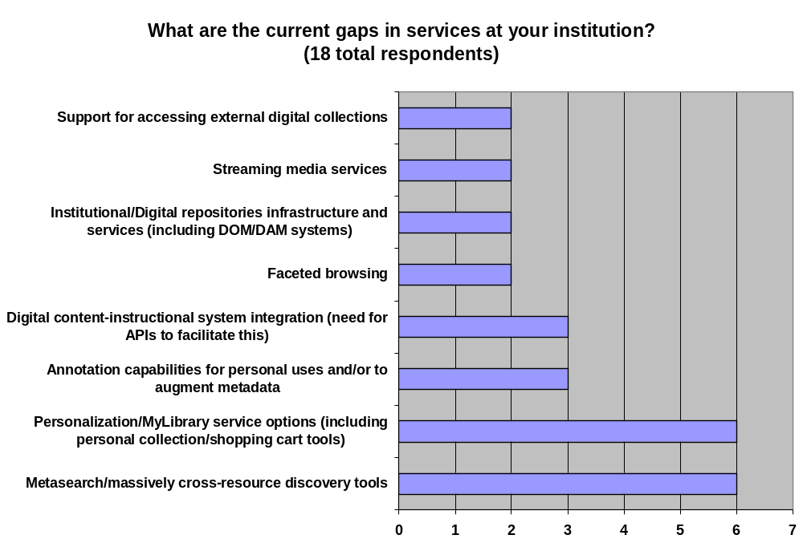
Figure 4: Current Gaps in Service
Among the 18 DLF institutions who responded to this question, ten identified gaps in their services that could be generalized as either meta-searching across resources (6 respondents) or personalizing service options (6 respondents). One respondent encapsulates both these services with the phrase “One Stop Shopping”: “users want (and expect) much more in the way of "My Library" features, massively cross-collectional searching, anything that will keep them from having to ‘go through all these steps’.” Other responses to this question reinforce the demand for meta-searching and personalization services and help further define their characteristics:
Descriptions of “Meta-Searching” type of service:
Massively cross-collectional searching
Federated searching of library databases
Cross-collection searching
Unified or common interface for different digital resources
Cross-Collection Searching; Combined Internet and Digital Library Searching

Descriptions of “Personalizing” type of service:
Ability to integrate user developed content with library developed content into personal collection tools or "shopping baskets"
More robust annotation and personalization services across all media types
"Shopping cart" with export
Personal Multimedia Collections
Basket (across session)
Three respondents to this question also identified annotation as a gap in their current service offerings. While two of these responses simply name annotation as a needed/desired option, one clarifies this gap as a need for “User annotation to augment metadata.”
Respondents also identified the following service gaps (in addition to those listed in the Figure 4 above):
- Institutional learning object repository and management system (campus-wide)
- Higher level of integration across digital repository components
- Online collaborative workspaces (e.g., wiki, other social tools)
- Large-scale digital production
- "Compare object" display capabilities
- Topic clustering/vocabulary crosswalks
- Normalized metadata
- Search tool for EAD finding aids
- On-demand digitization services
- Statistics and transactions to feed relevancy ranking
- Integration w/personal information management tools
When asked what “prevents or impedes the development of needed services at your institution,” respondents overwhelmingly identified a lack of time or the overextension of trained personnel, closely followed by budgetary constraints (see Figure 5, below). As noted previously, these three factors—time, money, and people—are closely related, and it may be that constraints in one area (i.e., lack of time) impinge upon or are caused by constraints in these other areas (i.e., insufficient number of trained personnel to do the work, or insufficient budgetary funds to pay for training or hire more workers).
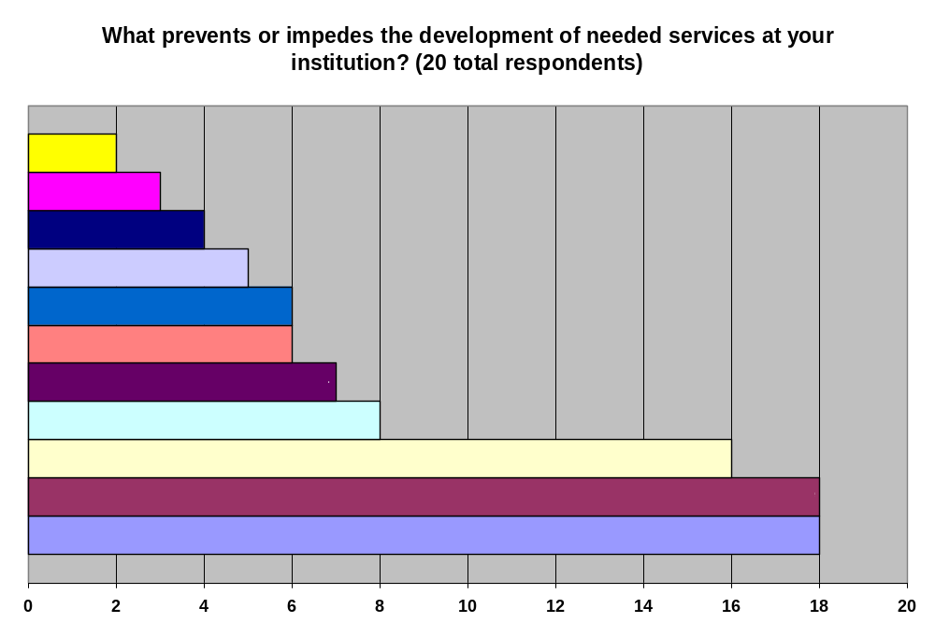
Figure 5: Barriers to Development of Needed Services
Asked to specify “Other” barriers to the development of needed services, two respondents (of the total six respondents to this open-ended option) reiterated that lack of time and personnel constrained their ability to enhance services.
Personnel constraints as a limit on the development of services
We have a very knowledgeable, but extremely small staff working on digital projects. Need more staff.
While metadata may indeed be a problem in some cases (as it certainly is for federated searching), the more pressing concern is the overabundance of new systems, software, etc. demanding the time/expertise of staff. An additional concern is, once a new resource/service is set up and in production, who is going to provide ongoing user support/training?
The second comment highlights the connection between lack of time and lack of staff (in this case, trained or knowledgeable personnel). It also draws attention to the issue of sustainability, as new users must continue to be trained and personnel must be available for troubleshooting, support, and back-end management. Another respondent commented that “changing user behavior and expectations” impedes the development of new services (though it is not clear from this statement whether the issue is one of training users or responding quickly enough to their rapidly evolving practices).
Other barriers respondents identified were the “need to provide large scale infrastructure and service support,” the fact that “organizational responsibility and budgets for IT infrastructure are distributed across various campus units,” and “copyright/intellectual property issues.”

Section 3: Digital-Resource Support
This section of the survey attempted to gauge what DLF institutions are currently doing or developing in order to support their digital collections and services. Respondents could check any of the pre-supplied responses, including identifying their efforts through the “Other” option. Figure 6 (below) illustrates the range of efforts currently underway.
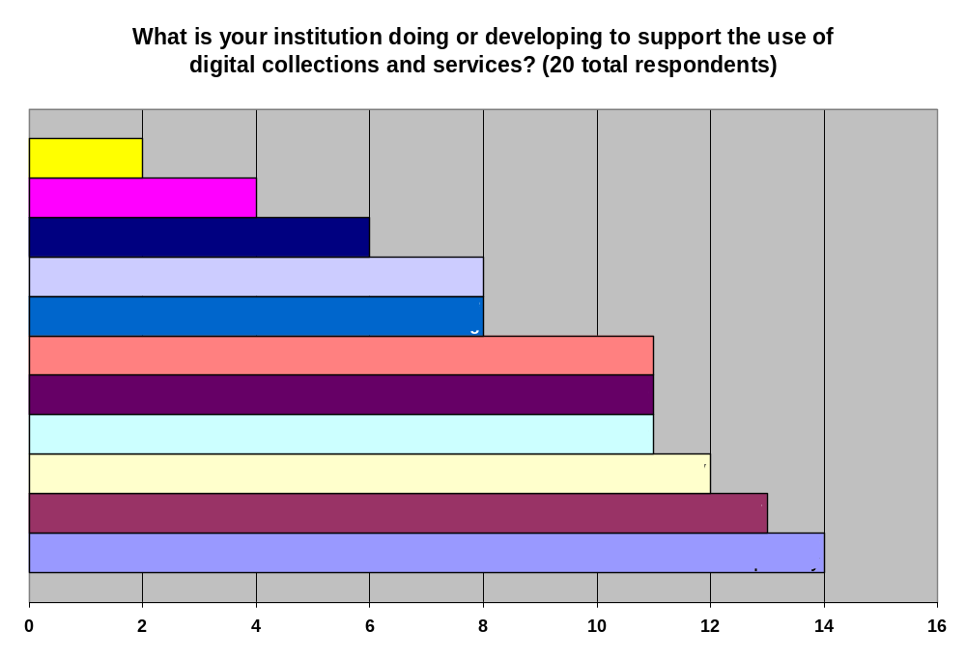
Figure 6: Current Efforts to Support Digital Collections & Services
A noteworthy pattern in this data is the high level of activity in the area of metadata migration which, combined with other metadata management activities, accounts for much of the current support for digital collections and services among DLF institutions. Among the various unique “Other” responses, a few suggested a similar effort: to develop institutional/digital repositories infrastructure and services, including digital-object management (DOM) and digital-asset management (DAM) systems.
Asked to expound on the support activities they identified, numerous institutions described efforts to integrate digital library content with course management systems or to enhance or remediate metadata (see Figure 7, below). For example, institutions report current or developing projects to feed local digital-collection metadata and content, electronic journals, and Insight image collections into Sakai, Blackboard, WebCT and other course-management systems. Others describe efforts to assign taxonomies to images, web content, and online journal articles, as well as efforts to migrate metadata into DC, MODS, and METS.
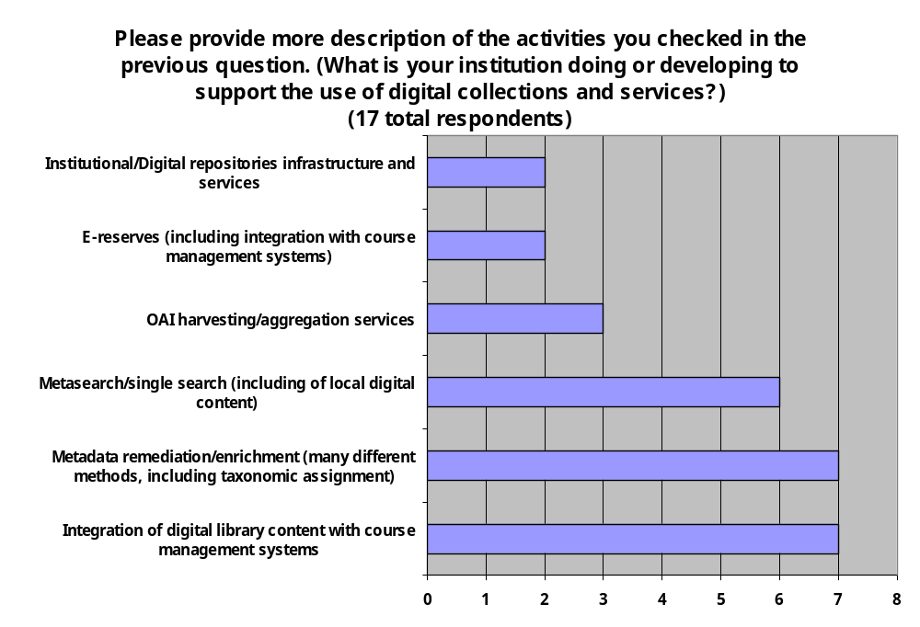
Figure 7: Description of Current Activities to Support Digital Collections & Services
These responses, combined with the quantitative data reflected in Figure 6, point toward three overarching pursuits of DLF institutions: to integrate digital collections into teaching and learning services, to provide a single search interface for multiple collections, and to manage metadata.

Section 4: Open Questions & Comments
At the end of the survey, respondents were invited to comment on any issues that were overlooked or not sufficiently addressed. The following concerns (with institution-specific information removed) were noted as important to individual institutions or to the future work of the DLF Aquifer project. (These comments are also found in Appendix D).
Responses to open request for questions & comments
Would like to have had more complete information in advance of filling out survey regarding institutional confidentiality - that is, whether answers provided by [institution] will be identifiable as coming from [institution]. Several persons involved in filling out survey commented upon some awkwardness in the structure of some questions.
* Important to be able to signal to the user what restrictions there are on which digital materials in terms of access & re-use. E.g. some DL materials are available freely to the world for access and re-use. Some, freely for access but not re-use. Some, only on campus.
The things mentioned previously are not complete and many more things are wanted and have been thought of. Thanks!
better use/presentation of information in finding aids; better support for rights management and ease of use for consumers; is user generated metadata a realistic goal, i.e., are they motivated to contribute it?; ways to integrate library resources with where users are searching--out of the library context

Additional User Studies Conducted by DLF Institutions
Many DLF institutions have already undertaken studies of users and analyses of what opportunities and needs for new digital library services exist. The DLF Aquifer SWG survey solicited volunteers to share findings from their own institutional studies. Of the studies that this request elicited, we have reviewed and summarized below those that seem particularly relevant to the Aquifer effort.

Metadata Harvesting & Searching Portals
Focus Group Summary: “Metadata Harvesting” tool. Halbert, Martin. (2002, April). Internal report for Emory University MetaScholar Initiative’s AmericanSouth.org project.
Abstract: Three separate focus-group sessions were conducted with researchers, faculty and staff members, students, librarians, and archivists representing different institutions and disciplines and possessing diverse research skills, in an effort to determine what users of a prototypical “Metadata Harvesting” tool would need. This investigation was conducted during the developmental phase of the project; thus, the goals were to discover the searching skills of users and their subsequent needs, so that the tool could support a range of searching expertise levels. A key finding was the different contextual features desired at the different levels of research ability: beginning researchers requested subject guides and tips on effective searching; intermediate researchers requested related links, information on where else a document had been cited, and comments/summaries to explain a wider body of material; and advanced researchers, archivists, and librarians requested prescriptive data, which would show how the material has been used.
UCLA European Integration Portal: Metasearch Assessment. Lee, Jane, and Felicia Poe. (2005, July 8). Internal report for California Digital Library’s UCLA European Integration Portal team.
http://www.cdlib.org/inside/assess/evaluation_activities/docs/2005/uclaMetasearchReport_june2005.pdf

Abstract: Working to develop a multidisciplinary search portal geared specifically to the needs of European Integration scholars, team members of the California Digital Library’s MetaSearch Infrastructure Project interviewed faculty and graduate students in this field of study in order to determine their research behaviors and needs. Five group interviews were conducted, each consisting of two to four scholars, one interviewer, and two observers. The assessment team identified a range of searching behaviors and needs among these interdisciplinary scholars (most of which are abstracted here). Research typically begins with a local and/or familiar database or catalog, with the goal of locating one good source that can be gleaned for other references. For this initial foray, researchers generally prefer basic search interfaces (with options for searching fields like keyword or author) and simple keyword searches which are used to “cast a wide net” (p. 5). A distinct difference in these researchers’ approach is that, unlike searchers looking for general information on a new topic, the interdisciplinary researchers “are looking for gems. Because of this, they are willing to sift through all of the returned results – even if they number in the hundreds” (p. 5). These researchers were very receptive to the possibility of metasearching (using one interface to search many different resources), though some observed that this type of searching seemed more appropriate for researchers who lacked familiarity with the subject area and needed to do topic searches. Regarding browsing, researchers were somewhat ambivalent: most felt that online browsing failed to produce the kinds of serendipitous discoveries that physical browsing of shelves produced; but JSTOR was noted as an exception to this rule, since it actually exceeded the possibilities of physical browsing by permitting perusal by journal title as well as discipline and by providing handy table-of-contents information. Finally, researchers acknowledged that they tend to over-rely on databases that they were familiar with, and they expressed interest in discovering new databases through some form of recommendation system (Amazon.com was proposed as a useful model). They also expressed a desire for more and better methods of managing information, especially tools like Endnote which help them collect and organize references to a variety of sources.
Usability Study Outcome Report: A Summary and Analysis of the Cognitive Walkthrough, Usability Study, and User Survey Performed on AmericanSouth.org. Watkins-Mormino, Kristina, Sharon Kennedy, Katherine Skinner, and Jason White. (2002-2003). Emory University MetaScholar Initiative’s report to the Andrew W. Mellon Foundation.
Abstract: As part of the usability testing and user surveying performed for the Mellon Foundation-funded AmericanSouth.org project, MetaScholar Initiative conducted individual tests of users’ ability to navigate the prototype web site, which harvested and aggregated metadata from several participating institutions and allowed searching and browsing of data in addition to several other added features (e.g., bookbag exports, annotation of records and articles, posting of user bios, and posting articles). Testing took place over five days, with a total of 21 participants from Emory University, pulled from humanities and social sciences graduate departments and the library and representing professors and graduate students, and librarians specializing in a variety of areas (e.g., archives, systems, cataloging, collection development, and so forth). In videotaped, individual sessions users were asked to complete a series of tasks on the web site, after first taking a few moments to try out and become familiar with the AmericanSouth.org web portal. These tasks aimed at uncovering areas of uncertainty or confusion with navigating the site, in an effort to make use of the site more intuitive. A key finding from this study was that users (particularly novice or less advanced researchers) struggled to distinguish between the different types of resources available on the site (archival records, original articles, and weblinks), which pointed to a need for portal designers to clearly indicate the types of resources produced by searches.

Collection Aggregation & Display
Librarians in the Wild: Attitudes and Experiences Concerning Online Exhibit Building. Lee, Jane, and Felicia Poe. (2005, May 31). Internal report for California Digital Library’s American West project team.
http://www.cdlib.org/inside/assess/evaluation_activities/docs/2005/librariansInWild_march2005.pdf

Abstract: As part of a three-year grant from the William and Flora Hewlett Foundation to assemble a virtual collection of American West resources from major research institutions, the California Digital Library is involved in both “big” curation (the creation of large-scale collections) and “little” curation (the creation of smaller, more focused collections) and the development of tools that support the processes and complexities involved in these two, quite different activities. In an effort to uncover the issues involved in “little” curation, particularly the development of online exhibits, the assessment team for the project sponsored a series of interviews with University of California librarians and curators in order to determine (1) how much and for what reasons libraries value online exhibit building; (2) what organizational and institutional barriers hinder online exhibit building; (3) what infrastructure currently supports academic libraries’ online exhibit building; and (4) what tools and systems academic libraries are currently using to build online exhibits. Five group interviews were conducted, consisting of one to five interviewees, an interviewer, and an observer who took notes. Though the assessment team began this study with the view that libraries would be more likely to build online exhibits if the tools were easier to use, the study’s findings indicate that reasons for building online exhibits are much more complicated, and involve considerations of an organization’s own view of its mission, copyright issues, resources constraints (notably personnel and funding shortages), and the long-term usability of tools. At the same time, the team noted that as libraries’ and museums’ roles are converging, both organizations are well positioned to mutually benefit from collaboratively building online exhibits.

Navigating and Using Digital Object Collections
Documenting the American West: User Interviews. Wright, Alex, Rosalie Lack, Robin Chandler, Ellen Meltzer, Brenda Bailey-Hainer, Steve Toub, and Roy Tennant. (2004, July 1). Final Report for the California Digital Library’s Documenting the American West project. http://www.cdlib.org/inside/assess/evaluation_activities/docs/2004/amWest_awFindings.pdf.
Abstract: In support of the Documenting the American West Project, the California Digital Library sponsored a series of interviews with professors, graduate students, librarians, and K-12 teachers in order to assess what they desired or required in the proposed digital collection. Key findings were the interviewees’ high valuation of primary source materials, the ability to interact with the content (through timelines, maps, etc.), a range of searching possibilities, the ability to export and personalize items collected through searching, and the desire to browse the collection geographically.
Topic Maps in Digital Humanities: Sure They're Cool, but Do They Make a Difference?, A User Study. Dalmau, Michelle, & John A. Walsh. (2006). Presentation for Digital Resources in the Humanities Conference, Lancaster, England. http://www.dlib.indiana.edu/~jawalsh/presentations/drh2005/topicmapuserstudy/.
Abstract: This research project explores the use of the XML-based Topic Map metadata format standard (Topic Maps XTM) to facilitate the navigation and exploration of complex textual resources described in TEI (Text Encoding Initiative). (A prototype of this interface may be viewed at http://algernon.dlib.indiana.edu:8888/tm4dh/index.html). The study’s authors applied the Topic Map standard to a collection of prose and poetry by Victorian writer, Algernon Charles Swinburne, then conducted a usability study to determine the utility of Topic Maps. For Victorian literature scholars, a Topic Map implementation that served solely as a separate (from the text collection), encyclopedic-type resource was not as useful as one integrated into the collection of texts itself. Further, rather than link from the Topic Map into the texts (as the prototype demonstrates), the texts should also link into the Topic Map (bi-directional linking), thereby maintaining the text itself as the central focus for innovative interpretations and new readings. Scholars also wanted to be able to contribute their own topics of interest to the pre-established “core” categories. In so doing, they can create their own access points into the texts that serve their particular research needs. All participants in this study acknowledged the utility of a topic map as a teaching tool. Lastly, scholars expressed concerns about the overhead required in building and maintaining topic maps. The development of intuitive topic map creation (automatic text indexing) and editing tools could alleviate this overhead. Currently, topic maps are largely created “by-hand” by domain experts.
IN Harmony: Sheet Music from Indiana. Indiana University Digital Library Program. (2004-ongoing). Project documentation, including usability reports.
http://www.dlib.indiana.edu/projects/inharmony/projectDoc/index.shtml.
Abstract: IN Harmony is an IMLS-funded grant project in the early stages of development (year one out of three). Although the usability studies available through this online project-documentation site focus on the design of a cataloging tool for sheet music, design recommendations for the end-user collection website also emerge. The IN Harmony project has thus far revealed that users search for image-based content in complex ways. While known-item searching for sheet music is prevalent, subject searching is far more complex depending on the need (e.g. cover art versus music for teaching or performance). Subject-related search strings are typically complex and often broadly thematic in nature (e.g. notions of patriotism in war and peace marches, or African American stereotypes on sheet music covers or in lyrics). Users recognized that categories such as genre, style and form are not mutually exclusive and that concepts can reside in multiple categories (poly-hierarchies). Further, search strategies weren’t always hierarchically or linearly structured. Users often took a “topic” or “concept map” approach to uncovering their information needs—that is to say, a more exploratory and radial approach to discovery. Faceted exploration of the website (browse/search and results set) is one way to support more flexible, thematic discovery of content.
DLP Art Image Delivery System Survey. Indiana University Digital Library Program. (2003). Internal report. http://dlib.indiana.edu/~mdalmau/DidoSurvey/toc.htm.
Abstract: As part of an ongoing study of Indiana University’s fine art image service, Digital Images Delivered Online (DIDO), the DLP Art Image Delivery System Survey was delivered to humanities departments at four Indiana University campuses in spring 2003. Forty-two faculty members responded, eighteen of whom were from art-related departments. The survey revealed that the use of digital images in the classroom was inhibited either by faculty’s trepidation in using new technology or by a lack of sufficient classroom technology; analog images are typically used in teaching, though the use of electronic resources for presenting images (e.g. PowerPoint or HTML) is increasing; digital images are acquired through downloading images or digitizing slides, which are then stored on one’s hard drive and reused for various classes and presentations; and faculty are either unaware of or rarely use licensed image collections or finding services.
Design Recommendations for DIDO2: Digital Images Delivered Online, Version 2. Dalmau, Michelle, Matt Dever, Andrew Stevens, & Charlene Wagner. (2003, December 16). Internal report for the Indiana University Digital Library Program. http://ella.slis.indiana.edu/~mdalmau/dido2.
Abstract: Several studies of Indiana University’s fine art image service, Digital Images Delivered Online (DIDO), have been conducted with teaching faculty. This report summarizes one of these studies: a usability study and an ethnographic Contextual Inquiry conducted with a small sample of Art History faculty. (A Spring 2004 DLF Forum presentation describing the Contextual Inquiry method and highlighting findings from this study is available online at http://dlib.indiana.edu/~mdalmau/dlf2004). Informed by a previous survey of teaching faculty’s use of digital images, this study (conducted in October-December 2003) focused more narrowly on Art History faculty’s use of digital images in the classroom, in order to identify what aspects of the existing service needed to be altered in order to better meet their needs. Six members of the Art History faculty participated in this study, in which they were either observed during lecture preparation and presentation (Contextual Inquiry component, with 4 participants) or observed using a prototype of the revised DIDO system (usability component, with 3 participants, one of whom also participated in the Contextual Inquiry). Findings from this study were numerous and varied; some highlights include the observation that among those lecturers who use digital images, Google is a primary resource for discovering images. Additionally, these digital-image users look for metadata and contextual information along with their images (to enable easy integration of these images into lectures), download these images onto their hard drive and rename them according to their own filing system, then browse these directories to find images for lectures (but often cannot locate them using their own system and rely on thumbnail images to identify the images they need). For these users, PowerPoint is a key means for presenting images in lectures and for presenting images for in-class exams, making the ability to batch download images from their directories highly desirable. Searching for colleagues’ PowerPoint or HTML presentations for use in their own class is also a common practice. Another important practice is integrating digital images and presentations into course-management systems. On the basis of this study, the authors concluded that new tools and services are necessary to support the use of digital images by teaching faculty, including (1) “cross-collection discovery feature that includes institutional fine art image repository, select licensed resources and personal collections,” (2) “visually driven, faceted browse/search based on the underlying metadata structure,” and (3) “support (expert) user (e.g. scholars) assignment/indexing of metadata to enhance discoverability,” among other suggested improvements to the typical services provided by digital library collections.
A Usability Evaluation of the Harvester Sheet Music Project: Assessing Needs of Sheet Music Users. Anderson, Teal. (2003, April 24). Report to the Andrew W. Mellon Foundation. http://ldp.library.jhu.edu/services/usability/documents/sheet_music_report.pdf
Abstract: The Andrew W. Mellon Foundation funded a usability evaluation of what is now known as the Sheet Music Consortium, http://digital.library.ucla.edu/sheetmusic/. The purpose of the evaluation was to learn how people access and use sheet music, as well as how they might use this particular online sheet music resource. Between November 2002 and March 2003, five focus groups and twenty-three scenario-based, think-aloud tests were held at UCLA, Indiana, Johns Hopkins, Duke, and Brown universities. The faculty, staff, and students who participated in these sessions represented a range of departments, including musicology, music performance, libraries or library science, history, engineering, philosophy, and economics. The usability specialist from the JHU Libraries developed questions with input from the project team and facilitated the sessions; local liaisons recruited participants and took notes during the sessions. The focus group participants identified many ways in which they use sheet music, including pop-culture and history course demonstrations, historical analysis of lyrics, vocal and instrumental performances, research on sheet music and dance or Civil War themes, curating physical and online pictorial exhibits, teaching students how to use online resources, and helping library patrons find what they need. The focus group participants commented on existing Sheet Music Consortium functionality (searching, browsing, displaying records and images, and saving results) and suggested the addition of a message board for questions about locating sheet music. The scenario-based tests revealed different approaches to finding sheet music, confusion about terminology and some other aspects of the interface, and requests for features that would make the interface more flexible and efficient to navigate.

Collecting & Analyzing Usage Data
Maximizing Library Investments in Digital Collections through Better Data Gathering and Analysis (MaxData). Tenopir, Carol, Donald W. King, Gayle Baker, Eleanor Read, and David Nicholas. (2005-2008). Online overview of project in progress. http://web.utk.edu/~tenopir/imls/
Abstract: Recognizing that e-journals constitute a substantial economic investment for libraries as well as a highly valued search tool among librarians and users, the leaders of this three-year grant project, funded by the Institute of Museum and Library Services (IMLS), are exploring how librarians can make best use of the usage log data available through electronic resources. In addition to developing “a better understanding of how different methods of usage data supplement or overlap with each other” and the potential role of usage log data in collection-development decisions, the authors of the study hope to identify areas where assessment is best pursued through direct surveys of users.

Discussion of Findings
We found this survey of DLF institutions to be extremely useful for informing our own work in the Aquifer effort and for revealing obstacles and issues common to members of the DLF wishing to develop better digital collections and services for their users. The qualitative responses in particular helped clarify the current state of digital collections and services development and assessment among DLF institutions and introduce issues not covered or considered in the DLF Aquifer Services Working Group survey. In short, the findings from this survey revealed the following trends in digital collections and services’ use, assessment, development, and support among DLF institutions:
- Assessment of services and collections at the point of their introduction or update, and little measurement of digital collections and services use over time;
- Frequent use of digital collections and services for searching metadata and full text and browsing unfamiliar archives;
- Metadata management as the most common activity for supporting digital collections and services, alongside efforts to integrate digital collections into teaching and learning services and to provide a single search interface for multiple collections;
- Budgetary, time, and staffing constraints on the development of new tools and services; and
- A collective desire to develop cross-resource discovery tools and personalization tools.
In light of these findings, the DLF Aquifer Services Working Group sees the following as realizable goals for the DLF Aquifer project which would clearly support the work and aims of DLF member institutions:
- Developing an assessment model that can capture the nature of scholarly practice and the long-term integration and use of digital services and resources;
- Developing tools and services that support meta-searching;
- Developing middleware tools to support such metadata management activities as migration, taxonomy assignment, and metadata enrichment; and
- Developing tools and services that enable and enhance the integration of digital content into course-management systems.

Assessing Services and Identifying Users
This survey revealed a heavy emphasis on assessment when a service is introduced or updated and a relative lack of ongoing assessment. While such labor intensive assessment practices as focus groups, participant observation, or contextual inquiry may not be feasible as frequent assessment techniques, the detailed and in-depth information they provide on scholarly habits and researching needs is invaluable. Further, tight focusing on individual users contributes to the development of realistic personas that may then guide the development of services.
In order to better understand how (and whether) digital collections and services are integrated into scholarly practices, we need a model for persistent assessment of their use. Such a model should attempt to gauge not simply the frequency of use but also the nature of use: who uses the collection, tool, or service, and for what purpose? A more comprehensive assessment of digital collections and services would also consider their interrelatedness, investigating which resources are typically used together and for what purposes. Though users may not always recognize the boundaries between content and service, institutions may better serve their patrons by locating common pathways between collections and services.
Standard practices in assessing usage would allow for more meaningful estimations of the value of services to local users. A goal of the DLF Aquifer project should be to develop models and standard practices for ongoing assessment of the use of digital collections and services.

Developing Tools and Services That Support Meta-Searching
Collective interest in cross-resource searching points to a need for tools and services that support meta-searching. Whether understood as the ability to search across local collections, cross-institutional searching, or searching across local, proprietary, and web content, meta-searching offers a “one-stop shopping” approach to digital-content research. Focused crawling, metadata harvesting and aggregation, and similar services enable the development of single-interface searching of a range of collections. Personalization tools, such as creating personal collections or persistent baskets, might also be incorporated into these tools and services.

Developing Middleware Tools That Support Metadata Management
The significant effort currently underway to manage metadata—to migrate metadata into other formats or to remediate or enhance existing metadata—indicates a real need among DLF institutions for tools that support this work and an opportunity for Aquifer to support these efforts. Simply sharing knowledge of existing tools (for example, through an online registry) could help institutions benefit from each others’ work and minimize the duplication of effort. The development of an online registry of tools has already been taken on by DLF Aquifer and others (e.g., SourceForge, http://sourceforge.net/softwaremap/trove_list.php).
The DLF Aquifer project can and should take on a greater role than information sharing. The results of this survey indicate that the Aquifer project can serve the needs of DLF institutions by developing middleware tools that support metadata management. For example, tools are needed that will enable the migration of metadata formats into a consistent standard, searchable through a single interface.

Developing Tools and Services That Help Integrate Digital Content into Teaching & Learning Services
Additionally, institutions would value tools and services that help them to integrate digital content into teaching and learning services. Many DLF institutions are already supporting the use of their digital collections and services in this way. Studies conducted by DLF institutions (summarized in this report) suggest that users want “one-stop shopping”: to be able to search several collections using a single search and to easily store and manipulate digital content for use in teaching or scholarship. Part of this desire may be met by meta-searching tools and services (discussed above), but the ability to integrate digital content into course-management or content-management systems could also help meet this desire for greater ability to use and manipulate digital content.

Goals for Future DLF Studies
Finally, this first survey of DLF member institutions served as a guide to developing future survey instruments. Issues introduced by individual respondents may be significant to other DLF institutions and could be fruitfully explored and measured for their value to member institutions and for their potential support by the DLF Aquifer project. For example, the use of digital collections and services to support performances and exhibitions was not addressed in the survey’s pre-supplied responses but may be significant to other DLF institutions and could be supported through the work of the DLF Aquifer project. Additionally, copyright/intellectual property issues may be of more widespread concern than this survey could capture.

Appendix A: Survey of User Services for DLF Aquifer Institutions
In an effort to determine what digital-object services are most desired and needed by Aquifer member institutions, the Aquifer Services Working Group is conducting this survey of library services. The following questions are intended as prompts for thinking about how users currently use digital collections, how that use might be improved, and what is needed in order to improve services. Questions in Part I focus on actual use of digital-object collections and services, particularly evidence that illustrates how different library patrons (faculty, students, and researchers) utilize digital-object collections and services. Questions in Part II focus on the library’s own assessment of current digital-object services, particularly gaps in service and what is needed to bring about improvements.

Please look over these questions and provide answers to as many as possible that are relevant to your institution’s situation.

Part I. PATRON USE OF DIGITAL-OBJECT SERVICES & COLLECTIONS

In this section, we are looking for evidence of patrons’ use of digital-object services and collections. Preferably, this information should come from formally conducted user studies of your library populations (faculty, students, and researchers) and user comments on library services; anecdotal or observational evidence is also useful.

- How are digital object collections used?
To the extent possible, please provide evidence for this use (i.e., statistics) and scenarios of typical use.
Our ideas on why and how people use the collections are not generally backed up with good evidence. We think that people use them for the same reasons they use print collections: seeking known items, reading longer passages or even entire books, and searching for keywords or names. Our systems are developed to support these activities.

- What digital-object services and functionalities do patrons think are necessary to support their work?
Consider both the services identified as necessary and specific functionalities of those services which make them necessary.
As suggested above:
- seek known items by searching bibliographic data
- perform keyword or phrase searches
- limit searches by title, author, date
- sort results in various ways
- have the ability to page through works
- speed, speed, speed—nothing is more of a research buzzkill than waiting for the system/network/internet

- What digital-object services and/or functionalities are desired by these populations?
More specifically, what digital-object services would patrons like to see added? And what functionalities would they like to see added to existing digital-object services? To the extent possible, please provide ideal-use scenarios that illustrate these desired enhancements.

I think people would prefer more content over added functionality, but that’s just a hunch.

- If available, please provide a report of your library’s most recently conducted assessment of services.

Part II. LIBRARY ASSESSMENT OF CURRENT DIGITAL-OBJECT SERVICES

In this section, we are interested in the library’s assessment of services: what services are needed or desirable, and what is necessary to develop those services? These could be end-user services or institutional services that support patrons’ use of digital objects.

- What unmet service needs have you identified?
These may be services, tools, or functionalities that could be added to existing services or tools. Also, consider whether these are gaps in end-user services or institutional services.
- What tools, services, or functionality have you not developed but would develop, given the time and resources?
Consider whether these developments would be utilized directly by the end-user or by institutions in the service of the end-user.

- Registry
- cross-institutional searching
- automated citation creation and plug-in with EndNote, Procite or other bibliographic citation software
- better integration with OPAC

- What prevents you from accomplishing your service goals?
Consider what factors constrain development of digital-object services (i.e., insufficiently trained personnel, outdated technology, budget allocations, etc.).

The usual: time and money. In addition, the lack of information and understanding about what users really want.
- What functional specifications for tools or services has your organization developed that you are willing to share with the Aquifer team, e.g., browse functionality, basket functionality, etc.?
We have a mature digital library system with a great deal of functionality. Happy to talk about sharing any/all of it.

Appendix B: Survey of User Services for Digital Collections

Introduction
Background: The DLF Aquifer project is an initiative of the Digital Library Federation to create scalable solutions that enable teaching, learning, and scholarship. Beginning with a collection of digital content in the area of American culture and life, DLF Aquifer will create a test-bed of tools for selecting, collecting and providing access to quality digital content. More information on the DLF Aquifer project is available through the Digital Library Federation's website: http://www.diglib.org/aquifer/.
Purpose of survey: The following brief survey is an attempt to assess how scholars at DLF institutions currently use digital collections, how that use might be improved, and what institutions need in order to develop and improve services. The results from this survey will provide a better understanding of the current landscape of services provided for digital collections, as well as an indicator of common and consistently valued services which benefit scholars and could potentially be implemented through the DLF Aquifer project. Questions regarding this survey may be directed to the chair of the Aquifer Services Working Group, Martin Halbert: mhalber@emory.edu.
Completing the survey: This survey should take 15-20 minutes to complete, depending on how much additional information you provide. There are 14 questions total, divided into 5 sections. Please feel free to consult with others at your institution who could provide useful feedback. This survey is open through August 17.
To start the survey, click "Next" (below). To move forward or backward through the survey, click the arrows at the bottom of each screen. If you'd like to leave the survey at any time, just click "Exit this survey" (upper right-hand corner of the screen). Your answers will be saved. In order to resume the survey where you left off, use the same computer to link to the survey URL. Thank you!

Section 1 of 5: Assessing Use
Background: Digital collections and services often pose a challenge to typical assessment practices, given the variety of ways they may be accessed and used. Among their populations, institutions may attempt to gauge use of these resources formally (i.e., user studies, web surveys, focus groups) or informally (i.e., conversations with patrons, observations, unsolicited user comments) in order to assess what current services and functionalities are most valued and what future services and functionalities are most desired.
The following questions attempt to gauge how such usage information is gathered at your institution.

1. How is information gathered on the use of digital collections and services at your institution? These assessments may be formal (i.e., annual user studies) or informal (i.e., daily casual observance of patrons using digital collections and services). Please indicate the type of assessment used and the frequency of its use by checking the appropriate boxes below.
(check all that apply)
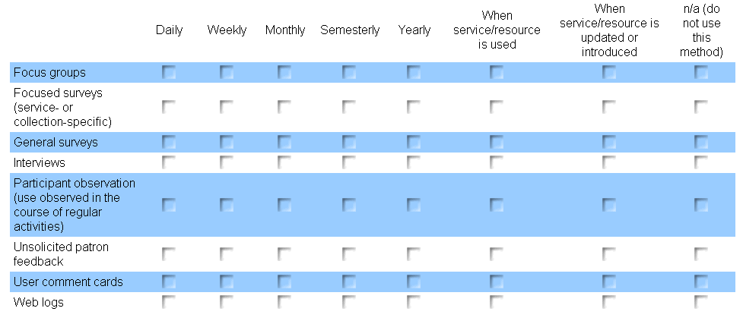

2. What kind of information has been gathered about the use of digital collections and services at your institution, either formally or informally?
(check all that apply)
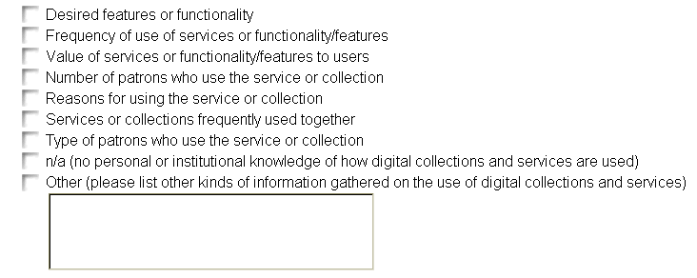

3. Is there a person, position, or department at your institution that is responsible for assessing use of digital collections and services? If so, please indicate the responsible party below.

4. If your institution has formally gathered information on the use of digital collections and services, would it be possible to share these findings with the Aquifer Services Working Group?

Section 2 of 5: Actual & Desired Use
Background: The following questions attempt to gauge current use of your institution's digital resources and services by professors, students, and researchers, as well as what is needed or desired in order to improve that use. These digital resources and services could be locally owned, shared through consortia, or commercial.
Note: The examples of use provided below are suggestions. You will likely want to add more examples in the open-ended questions.

5. Based on information gathered at your institution, how are digital collections and services used? While we are primarily interested in digital resources and services that are locally owned, these digital resources and services could also be consortially shared or commercial.
Indicate use that occurs at your institution by marking the frequency of use. If use does not currently occur but is desired or needed, mark the appropriate column. Select "Don't know" if there is insufficient information for answering the question.

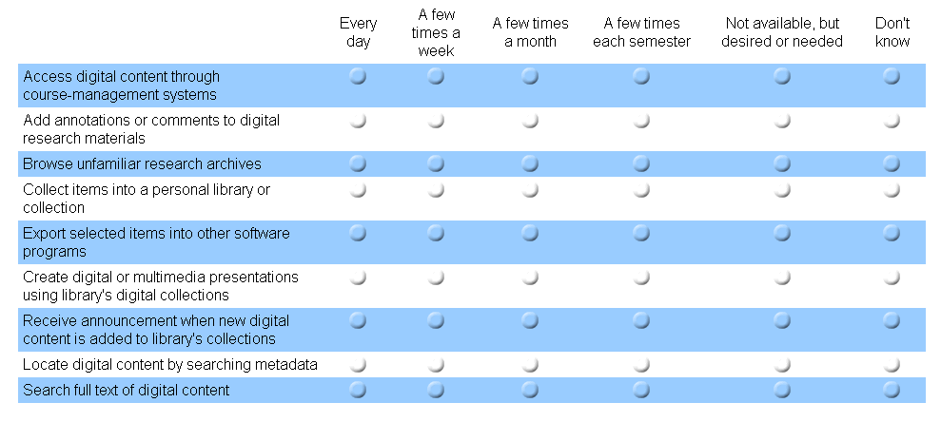

6. What are other uses of digital collections and services at your institution? While we are primarily interested in digital resources and services that are locally owned, these digital resources and services could also be consortially shared or commercial. If possible, please also indicate frequency of use.

7. What are the current gaps in services at your institution? These could be services specifically requested by users, or needs identified through formal and informal assessments.

8. What prevents or impedes the development of needed services at your institution?
(check all that apply)

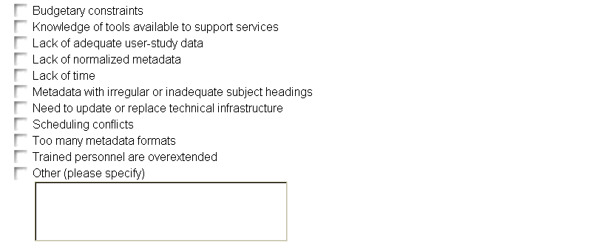

Section 3 of 5: Supporting Digital-Resource Use
Background: A range of tools and systems exist for supporting digital content. Institutions may even develop their own tools and processes to support digital collections and services for their users. The following questions attempt to gauge what institutions are currently doing and what digital library tools and processes they still need or desire in order to support scholars’ use of digital collections and services.
Note: The examples provided below represent only a few possible scenarios. You will likely want to add more examples in the open-ended questions.

9. What is your institution doing or developing to support the use of digital collections and services? The following examples range from routine practices to experimental projects.
(check all that apply)
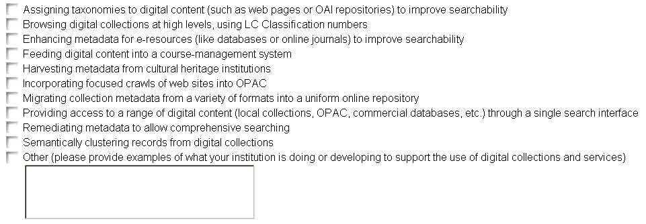

10. Please provide more description of the activities you checked in the previous question. For example, if you are "feeding digital content into a course-management system," indicate what type of content is being fed, into what system, using what tools or processes, and so forth. If available, please include a URL or citation that provides more information on this process.

11. What tools, services, or functionality would you develop, given the resources? Please indicate whether these developments would be utilized directly by the end-user or by institutions in the service of the end-user.

Section 4 of 5: Open Questions and Comments

12. We realize that there are other issues and possibilities for cultural-heritage digital-resource services that this survey may not address. If you have additional questions or comments that you feel are relevant, please bring them to our attention by mentioning them in the box below.

Section 5 of 5: Institutional Information
The following information will be used to determine how many DLF institutions participated in this survey, and to identify those willing to contribute further information or resources to the project. We appreciate your willingness to complete this survey, and hope we may rely on you to continue to assist us in this DLF endeavor.

13. Name of your institution:
[institution name selected from pull-down menu of DLF institutions]

14. May we contact you for follow-up questions or further information? If so, please enter your name and contact information below.
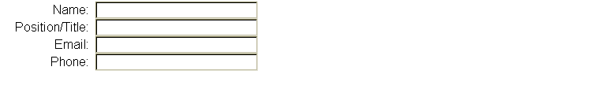

Thanks!
Thank you for your time. We appreciate your feedback. You are free to make changes to your survey response through August 17. To make changes to your response, link to the survey URL using the same computer.
If you have any questions about this survey, please contact the chair for the Aquifer Services Working Group, Martin Halbert: mhalber@emory.edu. Information and updates on the DLF Aquifer project are available through the DLF website: http://www.diglib.org/aquifer.

Appendix C: Survey Cover Letter
Greetings from the Digital Library Federation!
As an active DLF institution member, you are being asked to complete the following surveys addressing aspects of digital librarianship at your institution or to forward them to the person or group best qualified to respond. We seek one institutional response per survey.
Survey of MODS Use & Metadata Tools -
http://www.surveymonkey.com/s.asp?u=469551250385
Survey of User Services for Digital Collections –
http://www.surveymonkey.com/s.asp?u=514031250426
Responses to these surveys will inform the work of DLF Aquifer, an initiative of the DLF. We appreciate the time and consideration you give to our queries, and will share our findings once the survey analysis is complete. Please feel free to consult with others at your institution as you complete the survey. This survey is open through August 17. More information on DLF Aquifer and the surveys is included below.
Thank you for your active interest in the DLF. We look forward to your continued participation in its efforts, and in your prompt and considered response to these surveys.
Sincerely,
Katherine Kott
----------
BACKGROUND:
The Digital Library Federation (DLF) is currently engaged in a collaborative initiative to create scalable tools and services that enable teaching, learning, and scholarship. Called DLF Aquifer, this initiative seeks to improve and expand access to digital library content across institutions, particularly in the humanities and social sciences. More information on DLF Aquifer is available through the DLF website: http://www.diglib.org/aquifer/
Survey of MODS Use & Metadata Tools –
http://www.surveymonkey.com/s.asp?u=469551250385
PURPOSE: Gather information on metadata formats DLF institutions are currently using, tools used to manipulate and manage metadata, and use of MODS.
PARTICIPANTS: Anyone involved in developing or managing metadata for digital content, either in production or test environments. The URL for the survey may be forwarded to others within your institution who could provide useful feedback.
SCOPE: Nine questions are divided among five areas: 1) Descriptive Metadata Formats; 2) Use of MODS; 3) Metadata Tools & Processes; 4) Open Questions & Comments; and 5) Institutional Information.
CONTACT: Questions regarding this survey may be addressed to the Aquifer Metadata Working Group chair, Sarah Shreeves: <mailto:sshreeve@uiuc.edu>sshreeve@uiuc.edu.
Survey of User Services for Digital Collections –
http://www.surveymonkey.com/s.asp?u=514031250426
PURPOSE: Gather information on how scholars at DLF institutions currently use digital collections, how that use might be improved, and what is needed in order to improve services.
PARTICIPANTS: Anyone involved in assessing user services for digital collections, assisting users with digital collections and services, or supporting/developing digital collections and services. The URL for the survey may be forwarded to others within your institution who could provide useful feedback.
SCOPE: Fourteen questions are divided among five areas: 1) Assessing Use; 2) Actual & Desired Use; 3) Supporting Digital-Resource Use; 4) Open Questions & Comments; and 5) Institutional Information.
CONTACT: Questions regarding this survey may be addressed to the Aquifer Services Working Group chair, Martin Halbert: <mailto:mhalber@emory.edu>mhalber@emory.edu.

Appendix D: Qualitative Data from Survey
The following comments and information were offered in response to the open-ended questions in the survey (e.g., “Other” options at the bottom of a list of pre-formulated responses). This information was subsequently coded and classified to produce quantifiable data that could then be analyzed for patterns and displayed visually.
In order to preserve the anonymity of respondents, all references to specific institutions, individuals, programs, projects, etc. have been removed from the following raw responses; bracketed ellipses, words, or phrases indicate removed or substituted information. In addition, because most of the responding DLF institutions use American English spelling conventions, words were re-spelled to fit this standard so that non-American institutions could not be easily identified. The total number of responses and the number of responses omitted from the Appendix are provided for each question.

Section 1 of 5: Assessing Use

2. What kind of information has been gathered about the use of digital collections and services at your institution, either formally or informally?
(5 responses to this option, 1 skipped question)
- Authentication logs for demographics
- Individual collections have unique assessment policy
- Perception of ease of use and similar resources used.
- Usability and accessibility.
- barriers to use; missing content or corrections to data; work environment; other types of tools and services used (not library provided)

Section 2 of 5: Actual & Desired Use

6. What are other uses of digital collections and services at your institution? While we are primarily interested in digital resources and services that are locally owned, these digital resources and services could also be consortially shared or commercial. If possible, please also indicate frequency of use.
(12 responses, 11 skipped question)
- We have the feeling that users employ our digital resources for more than the "teaching" or "research" uses typically expected - that is, we think users employ our resources for quick, "look it up" reference - "How many feet are in a mile?" "How do you spell "Michelangelo?" etc.
- * Virtual reference - used every day * Virtual business library (includes shared/commercial resources)- used every day * Electronic reserves - used every day * Streaming video of [institution]-created instructional materials - used frequently while classes are in session * [institution] Digital Library content - accessed through OPAC and Natn'l bibliographic utilities - unsure how often *
- *Content is searched and used for public relations and marketing purposes.
- performances & exhibitions; K-12 classroom use through a collaborative [funding agency] grant
- I can only speak for a 2004 harvest of the [collection] that we have publically available on the web through a contractor. That is accessed every day by the general public.
- Digitization of library resources on request, e.g. special collections items, scanning for course management system. Customization of existing resources for instructional use
- N/A
- There is much use of the digital image collections by k-12 researchers.
- - printing out - panning/zooming - comparing two items side-by-side - searching transcriptions - programming and performing a concert of music found in the collection
- Digitizing on demand for patrons by Special Collections and Archives staff members. This happens at least monthly. Digitizing articles, chapters, etc. for e-reserves (probably the most used resource on campus, every day)
- Create a commons of openly-licensed shared knowledge open for contributions and use from anyone, anywhere, for use in teaching and learning.
- Create bibliographies (few times/semester); posting to web site (not via course management system) (few times/semester); posting via other communication tools (e.g, listservs, blogs); Ask a librarian service; searching/limiting by date and language; emailing selected results; browsing if there is enough information to simulate physical browsing;

7. What are the current gaps in services at your institution? These could be services specifically requested by users, or needs identified through formal and informal assessments.
(18 responses, 5 skipped question)
- One Stop Shopping: [institution] Libraries card sort study showed users want (and expect) much more in the way of "My Library" features, massively cross-collectional searching, anything that will keep them from having to "go through all these steps." People would like more "Browsing" capabilities -0 cover art for selection of videos, for example.
- * demand for institutional repository (Note that we will have an implementation available for limited use within the month) * streaming media services (for users to stream their own content). Now, only available on a limited basis. No campus-wide streaming solution yet in place. * online collaborative workspaces for scholars (e.g. enterprise wiki) * federated searching of library databases
- We have identified several collections for local digitization but need to determine methods for increasing digital production.
- *More robust annotation and personalization services across all media types. *Improved tools and services for integrating digital content with teaching and learning (e.g., lecture presentations and course management systems)
- need to establish more effective interaction between digital collection creators and public services librarians who work closely with a broad audience of undergraduates, graduate students, and faculty/staff
- Gaps are being addressed by ongoing [project] project.
- We have just published a strategy that describes our challenges and aims: [URL]. Priorities include: - enriching the user's experience - building a digital research environment - transforming search and navigation.
- Ability to compare several digital objects side by side. Cross-collection searching. For some collections, annotation capabilities.
- There is no campus-wide digital asset management infrastructure. There is currently a campus task force addressing this issue. There is also no campus-wide learning object repository environment. Lack tools for collection development re: facilitating (for campus customers) discovery and access with regard to external digital collections
- Limited integration of digital content across silos, i.e., we have more digital content than we have clear practices and workflows "Quick" ingestion of content into integrated content repository Ability to integrate user developed content with library developed content into personal collection tools or "shopping baskets"
- * User annotation to augment metadata * "Shopping cart" with export * APIs to facilitate interoperability between library and academic technology enterprise systems
- Programming assistance for digital scholarship projects.
- - streaming audio/video within AV department - search tool for EAD finding aids - unified or common interface for different digital resources - navigational tools - lack of normalized metadata
- Provision of digital content on demand (such as high-res copies of online photos); although, we are working on getting this implemented.
- There are many current gaps in services. A few we've identified are listed below: Personal Multimedia Collections Cross-Collection Searching Combined Internet and Digital Library Searching
- Meta searching
- Institutional Repository
- recommendations on where to search or more like this; basket (across session); stats and transactions to feed relevance ranking; easily clearing usage/reproduction rights; topic clustering; vocabulary crosswalks; faceted browsing; integration with learning management systems; integration with personal information management tools

8. What prevents or impedes the development of needed services at your institution?
(6 responses to this option, 3 skipped question)
- While metadata may indeed be a problem in some cases (as it certainly is for federated searching), the more pressing concern is the overabundance of new systems, software, etc. demanding the time/expertise of staff. An additional concern is, once a new resource/service is set up and in production, who is going to provide ongoing user support/training?
- Changing user behavior and expectations
- Organizational responsibility and budgets for IT infrastructure are distributed across various campus units
- Copyright/Intellectual Property issues
- We have a very knowledgeable, but extremely small staff working on digital projects. Need more staff.
- need to provide large scale infrastructure and service support

Section 3 of 5: Supporting Digital-Resource Use

9. What is your institution doing or developing to support the use of digital collections and services? The following examples range from routine practices to experimental projects.
(11 responses to this option, 3 skipped question)
- [Federated search] implementation underway. X-Server implementation underway. Linking to PtoP environment under test. Data sets in OPAC.
- * Created a separate gateway to a subset of e-content in the catalog, called the [collection] (selected by subject specialists) - allows users to search by broad subject terms combined with format (e.g. maps, images, primary text collections) * Implementing [software] as our Digital Library repository * e-reserves * to inform users of online materials, created [project] plus FAQ * Created [project] – [institution] community with questions about fair use can email the [project] (a group of knowledgeable faculty/administrators at [institution]). Answers to questions are frequently added to the FAQ
- workshops on using digital collections
- Implementing common digital library infrastructure/repository (e.g., [software])
- [project] project
- See - recently published strategy: [URL] - also three major current programs: to develop a Digital Object Management infrastructure; for Digitization; for Web Archiving.
- Incorporating sponsored links or "best bets" into the single search environment Seeding the web index with landing pages for specific resources or services
- [software]: [funding agency] service project to develop reader support through term identification and automated linking to relevant glossary, dictionary, etc. [software]: automated name authority control tool [software]: document analysis framework for non-standard OCR and music recognition applications
- Semantically clustering records created from focused crawls of websites
- Developing integrated digital collections that bring together different media types (XML, images, GIS maps) with research and teaching guides.
- focused crawls of web sites (NOT into OPACs); assigning persistent identifiers; developed a preservation repository; creating contextual content/essays for selected images; creating new derivatives for optimizing use; tools for curators/librarians to gather, customize, brand digital collections

10. Please provide more description of the activities you checked in the previous question. For example, if you are "feeding digital content into a course-management system," indicate what type of content is being fed, into what system, using what tools or processes, and so forth. If available, please include a URL or citation that provides more information on this process.
(17 responses, 6 skipped question)
- * [digital resource catalog]: [URL] * e-reserves: [URL]l * [project]: [URL] * Handbook FAQ: [URL]
- N/A
- *"Assigning taxonomies...": Assigned Thesaurus of Graphical Materials subject and genre headings to images in the [collection]. *"Feeding digital content...": We are embarking on a project to integrate online resources (e.g., online journals) with the Sakai course management system. *"Migrating collection metadata...": We do this by migrating metadata to DC and MODS for OAI publishing. *"single search interface": Our libraries have implemented [federated search] and our digital library program is developing SRW/SRU interfaces to our local DL content.
- E-Reserve reading lists are produced by the Library and fed into the campus CMS; In development: A campus portal (pilot phase) will provide hooks into the Library's online catalog searching, circulation functions, and federated search of commercial and locally-produced digital content; [institution] hosts several OAI metadata aggregation services focused on digital collections: [project] [URL]; [digital resource catalog] for cultural heritage digital collections from these institutions [URL]; [collection] for over 100 funded [funding agency] digitization projects since 1998 [URL];
- I don't know enough about [project] to comment.
- See information under 9 Other above.
- We are in the process of looking into [software] component of [federated search] to provide cross-searching of our local digital collections and will compare it to a locally developed solution.
- Currently integrating resources with [CMS] on a static basis; working on dynamic integration using the "My Courses" data stores Subject-based integration of resources via "Subject Browse" – [URL] Enhancing metadata: ranking databases within individual subjects (see Subject Browse) Enhancing metadata: deploying [software] - post-coordinate indexing of MARC catalog data Integrating resources with the "Quick Search" environment for single search discovery of resources and services - [URL]
- * Applying LC subject headings to image metadata * Implementation of [OpenURL]/[federated search]/[digital resource catalog] knowledge bases and datasets * Experimentation of RSS-enabling our library content management system * Experimental crawls for the [project] * Metadata aggregation for digital image collection * [federated search] * [OpenURL]-Google Scholar integration
- I think this is the question you're asking, all of our digital collections are cataloged and searchable through the Libraries OPAC. I have plans to implement the semantic clustering of records from digital collections and providing access to a range of digital content through a single search interface, but they are so nascent at this point that I hesitate to mention them.
- - search of local repository and externally mediated content (e.g., Project Muse) through [CMS] – [software]: student upload digital files into software app as part of Intro Bio field study assignments. Application doesn't feed digital content to CMS, but grades are fed to CMS - migrating MODS metadata into DSpace - configure [federated search] to enable searching commercial and local content with single interface
- We are feeding digital content into [CMS], working on creating an institutional repository, and implementing [federated search] with [OpenURL].
- Assigning taxonomies: please see [URL] Enhancing metadata: we are currently working on a tool to enable metadata creation and enhancement, starting with the cataloging of an open access journal, [project]. Feeding digital content: we are moving content from [software] to [CMS] and Powerpoint. Harvesting metadata: please see [URL], [URL] and [URL] Migrating collection metadata: the library is migrating metadata from local formats to Dublin Core, serving it through OAI providers, and the IT staff in the library is migrating metadata into Insight Remediating metadata: please see [URL] Semantically clustering: please see [URL]
- Feeding digital content into CMS -- using home grown database to manage digital content. Creating METS of content and allowing for METS to be fed into CMS. Working on using METS to facilitate searching of digital collections regardless of format type.
- Most activities under development rather than already deployed.
- Using the [digital repository] systems ([URL]) for course delivery and just starting to feed this content directly into [CMS] tool. The [project] ([URL]) is improving searchability through assigning taxonomies to digital collections.
- [URL] See esp. [project], [project], [project], [project] (esp [project]) [URL]

11. What tools, services, or functionality would you develop, given the resources? Please indicate whether these developments would be utilized directly by the end-user or by institutions in the service of the end-user.
(16 responses, 7 skipped question)
- * campus-wide media streaming solution for use by end-user or by staff in service centers on user's behalf (including technology, support infrastructure, legal guidelines on what can/can't be streamed, etc.) * infrastructure for online tutorials, podcasts, RSS feeds etc. developed by [institution] staff to communicate with users re. user services (e.g. audio or video tour of the library, online tutorial on how to use [CMS], etc.) * Tighter integration between various but complementary services so users could use scholarly content via whatever system best suited their needs, e.g. integrate [CMS], [digital repository], e-reserves, & data on a content management system.
- Institution - Tools so that non-technical librarians can harvest subject-specific OAI records and index as a service to patrons. End-user - More than ever, info seekers rely on Google as a primary discovery tool. It would be very beneficial to have the tools needed for easy exposure to Google indexing.
- We wish to develop, on top our digital library infrastructure, services that allow a wider range of users in the libraries and throughout the university to create, manage, publish, and preserve digital library content. One goal of this project is to allow more independence for users with less direct involvement from DLP staff. The common infrastructure will also facilitate cross collection searching and other services.
- [institution] is interested in metadata enrichment, metadata aggregation; collaborating with other institutions who have done more usability and interface work on the design of sorting, clustering and other data mining and filtering services.
- See strategy document: [URL]
- More tools for manipulating and saving results sets and images for online research and use in the classroom. In particular, developing side-by-side comparison features and image overlay features for comparing and analyzing differences between similar objects.
- Collection development tools for organizing and exposing external resources for discovery and use by campus users
- * User-annotated metadata * Feeds to portal and course management system
- The ones I mentioned above: Semantically clustering records from digital collections and Providing access to a range of digital content (local collections, OPAC, commercial databases, etc.) through a single search interface plus I would add: Assigning taxonomies to digital content (such as web pages or OAI repositories) to improve searchability
- - federated search of image collections (both) - streaming media of AV materials (end user)
- A library user portal to allow customization of library services (new book announcements, fines, etc.). Currently not easily done with our home-grown library system but we are pursuing a new integrated library system.
- XML importing capabilities for [software] (for institutions) Better tools for enhancing and remediating metadata (see Survey of MODS Use and Metadata Tools) (for institutions) Better interfaces for visualizing metadata facets, including GIS, temporal information, and subject clusters through graphical displays.
- Enhancement to existing database ([software]) to help collect and manage metadata in the easiest way possible to the staff. Provide way for end user to locate digital content without knowing collection or project it was created for. Provide way for end user to locate digital content in a subject area regardless of who owns it.
- Distributed metadata and content ingest tools.
- Seamless integration among different content repositories -- single search interface that can go across ejournals, ebooks, indices, and catalog records; ability to automatically pull diverse digital content into course management system (Sakai); easy creation of bibliographies; annotation, rating and collaboration tools (social bookmarking); automatic notification of relevant resources.
- vocabulary crosswalk and thesaurus manager (used by institutions); basket (used by end users); exhibit builder (used by end users or institutions); robust statistics reporting (used by institutions); web interface to tools and services in question 9 for institutions to configure ("dashboard" model); natural language processing in response to user questions/query refinement

Section 4 of 5: Open Questions and Comments

12. We realize that there are other issues and possibilities for cultural-heritage digital-resource services that this survey may not address. If you have additional questions or comments that you feel are relevant, please bring them to our attention by mentioning them in the box below.
(4 responses, 19 skipped question)
- Would like to have had more complete information in advance of filling out survey regarding institutional confidentiality - that is, whether answers provided by [institution] will be identifiable as coming from [institution]. Several persons involved in filling out survey commented upon some awkwardness in the structure of some questions.
- * Important to be able to signal to the user what restrictions there are on which digital materials in terms of access & re-use. E.g. some DL materials are available freely to the world for access and re-use. Some, freely for access but not re-use. Some, only on campus.
- The things mentioned previously are not complete and many more things are wanted and have been thought of. Thanks!
- better use/presentation of information in finding aids; better support for rights management and ease of use for consumers; is user generated metadata a realistic goal, i.e., are they motivated to contribute it?; ways to integrate library resources with where users are searching--out of the library context

