Comments on DLF MODS Implementation Guidelines
Amy Rudersdorf, NCSU
Received in email on 11-21-05

Hi Sarah:

I’m about halfway through the MODS document, and have some comments. Beyond the fact that I think it is an excellent document, I am sure that when we are ready to get to work with MODS this will be a valuable tool.

The only issues I’ve run into thus far are pretty minor -- a few areas
that may need more explanation, some wording changes, etc. Working in
Madison, I came into contact with lots of folks from small academic and
public libraries, whose questions about Dublin Core sometimes surprised
me. Because this is such a great document, I am sure that they will use
this as they attempt to implement MODS (there are so many people out
there desperate for something more descriptive than DC). So, I read the
document with them in mind.

a) pp 8-9 <partNumber> and <partName>
I think these elements are vague enough that they probably need to be
further defined. I keep thinking that in general (and unfortunately),
people aren’t going to read both your document and the MODS user
guidelines. They will find one and use it, whether they understand it
fully or not. I also know that a lot of folks who digitize materials at
institutions big and small aren’t catalogers. So, something along the
lines of “<partNumber> and <partName> may describe the section or
division titles of the digital object (e.g., a chapter title, or an
audio or video clip)” might be useful? If not the definition, then maybe
just the examples?

b) pp 12-13 <name><displayForm>
On page 12 in the <name><displayForm> subelement definition, it is
stated that <displayForm> is not recommended. On page 13 in the example,
however, you include <displayForm>. Working off the understanding that
many folks look at the examples, but don’t read the fine print, you may
want to remove <displayForm> from the example, if in fact, you don’t
want folks to use it.

c) pp 19-20 <originInfo><place><placeTerm> and <originInfo><publisher>
This comment might be a little “out there.” Just a warning.
One of the questions we often got at Wisconsin was, “if I make an analog
object available in digital form on the Internet, aren’t I, in effect,
publishing it? If so, shouldn’t our institution’s name and location go
in the DC.Publisher field?” A lot of that confusion came out of the
definition of DC.Publisher: “An entity responsible for making the
resource available.”

With that in mind, I read the MODS definition “place names associated
with the creation or issuance of a resource,” which could, I think, be
interpreted in the same way. If you are comfortable with this element
being used in the way I describe above, you might want to say so.
Alternatively, if you aren’t comfortable with this usage, you might also
want to make it explicit. It may seem proscriptive, but I really do
believe that folks want to do things “correctly,” and often appreciate
as much guidance as possible.

d) pp 21-22 <date>
The date element is very complicated and controversial for a lot of
folks. We talked a lot about DC.Date in Madison because it caused us so
much trouble. As I mentioned at the workshop, although it wasn’t the
most “human” friendly, we ended up using W3CDTF as our one and only date
format. Better to be normalized than not, we thought.

If you would like people to use the W3CDTF encoding scheme, you might
also provide some examples of how to make it work. We implemented this a
bit differently at Madison, but it might be useful to see the solution
that we came up with. (Note that instead of a “qualifier” attribute, we
created a “dateCertainty” attribute that contained the values “yes” or
“no.”)

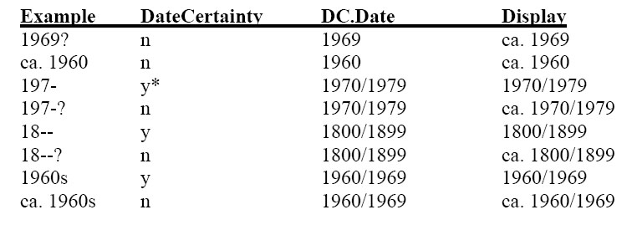

Conversely, if you do not want people to use ISO8601, you might want to
explain why. It came out at the workshop that some folks didn’t
understand the difference.

Beyond that, I found the description of the date attributes in the
<date> section somewhat confusing (especially “encoding” and “keyDate”).
But, when I got to the <subject><temporal> section (pp 41-42), I thought
the date description was more concise. It seems to me that the
descriptions should be the same, if the usage is the same, for elements
and subelements found throughout the schema.

I would also suggest more examples in this section. On page 22, you
provide a single date example. I think more example especially using
“keyDate” -- would be an important addition. And, I would suggest that
you use the same examples in both sections (<date> and
<subject><temporal>) to keep things a bit more consistent.

You mentioned that you would be creating some full record examples to go
at the end of the document, which will be very useful. But, the examples
that appear with the definitions are in many ways a lot more important.
Because some users tend to skim documents like these, the accompanying
examples help to solidify their understanding of the individual
elements. If they happen upon the full-record examples at the end, all
the better.

e) p 25 <physicalDescription> (and in other places)
In a few instances, the phrase “elsewhere in this profile” is used.
Because the document is so long and dense and because in some cases
people will skim not read all of the definitions, it seems important
to point folks directly to the location of the related information.

f) p 32 <targetAudience>
One wording suggestion under the heading “Summary of profile requirements.”

Change sentence to read “…elements when applicable, and a controlled
vocabulary when available.”

g) pp 41-42 <subject><temporal>
See point “d” above.

