Digital Library Federation | 1755 Massachusetts Ave. NW Phone 202-939-4761  Suite 500 Fax 202-939-4765  Washington, DC 20036
DLF-Aquifer Services
Institutional Survey Report
Aquifer Services Working Group Report on the Institutional User-Services Survey Results

Version 0.4

Table of Contents
Executive Summary 3
Methodology 4
Preliminary Survey of DLF Aquifer Institutions 4
Online Survey of DLF Institutions 5
Analyzing Results 6
Results 7
Additional User Studies Conducted by DLF Institutions 10
Type of Study Conducted Error! Bookmark not defined.
Discussion of Findings 13
Identifying Our Users 13
Pooling Our Resources 13
Refining Our Goals 13
Appendix A: Survey of User Services for DLF Aquifer Institutions 14
Appendix B: Survey of User Services for Digital Collections 16
Introduction 16
Section 1 of 5: Assessing Use 16
Section 2 of 5: Actual & Desired Use 17
Section 3 of 5: Supporting Digital-Resource Use 19
section 4 of 5: Open Questions and Comments 19
section 5 of 5: Institutional Information 19
Thanks! 20
Appendix C: Survey Cover Letter 21

Executive Summary
The DLF Aquifer Services Working Group (SWG) was charged with recommending service specification and level policies to the DLF Aquifer Implementation Group, developing functional specifications for DLF Aquifer services, and designing processes to measure DLF Aquifer usability. As a first step towards meeting these goals, the group has undertaken a survey of DLF institutions, to assess what services are desired by end users and institutions and how institutions see the Aquifer project potentially meeting these needs. Several key findings emerged from this survey:
- Use of digital collections and services is often assessed at point of introduction or update, rather than over time. An implication of this is that more is known about initial reactions to a technology, resource, or service, and little is known about how (or whether) it is integrated into regular research activity.
- point
- point
The results of this survey, while more descriptive than statistically significant, point to some issues and considerations for the current and future work of DLF Aquifer, and suggest that there are several areas of need among DLF institutions that the Aquifer project could meet. The following are key issues and considerations that will inform the work of the DLF Aquifer Services Working Group:
  - Developing a model for conducting usage assessments of the types of services and tools the DLF Aquifer project will develop.
  - issue/consideration
  - issue/consideration
  - issue/consideration

Methodology
The Services Working Group identified a gap in knowledge about how other DLF and DLF Aquifer institutions were meeting and assessing their patrons’ digital resource and service needs. Surveying presented itself as the quickest and most efficient way to gather this information and use it to guide the group’s efforts. During the summer of 2005 the group conducted a preliminary exploratory survey of DLF Aquifer institutions then used those findings to inform the construction of an online survey, which was then distributed among all DLF institutions. In conducting these surveys, the Services Working Group hoped to discover user-services assessment efforts, determine current service offerings and perceived gaps, and identify the major service opportunities that the DLF Aquifer project would be well-positioned to take on.

Preliminary Survey of DLF Aquifer Institutions
In June 2005 the Services Working Group conducted an “environmental scan” of DLF Aquifer institutions. Questions for this survey were intentionally broad and open-ended, in an effort to obtain as much descriptive data as possible on current digital-library services and assessment efforts (see Appendix A).
Of the 12 institutions involved in the DLF Aquifer project, half were already represented by the members of the Services Working Group. The remaining six DLF Aquifer institutions were contacted for phone interviews, and of those, three participated. Participants were asked to review the questions in the survey instrument, consult with others in their department as necessary to answer the questions, then schedule a conference call with members of the Services Working Group to deliver and discuss their answers.
Findings from this initial survey were incorporated in the interim report, prepared for the DLF Aquifer working groups’ meeting on June 28, 2005. In brief, conversations with DLF Aquifer institutions pointed toward a shared concern about the frequency and nature of assessment: who are the users of digital library services and collections? What do we know about their sustained use of these technologies? Also common among these institutions were concerns about limited resources and their allocation, whether these resources were understood as trained personnel, money to budget for new development, or time to devote to new projects (all of which may be seen as highly dependent on each other). An appeal of the Aquifer project was its potential to pool limited resources and to help institutions avoid duplicating efforts. Services these respondents expressed an interest in developing, given adequate resources, were
- Registry of digital collection
- Cross-institutional searching of other digital collections
- Automated citation creation and plug-in with EndNote, Procite, or other bibliographic citation software
- Better integration of digital collection with OPAC
- Integration of multiple repositories and applications, using a common framework
The responses and conversations that emerged during these calls, along with the discussions among Services Working Group members, guided the development of the online survey.

Online Survey of DLF Institutions
Using the range of responses to the initial survey as a guide, the Services Working Group sought to create an online version which would address the same primary goals, allow participants to provide descriptive responses, and increase the number of institutions queried, yet take less time and planning to complete than scheduling conference calls and follow-ups. Additionally, this second survey sought to canvas the range of digital resources and services at all DLF institutions.

Participants
Our target audience was metadata and digital-services librarians at DLF institutions, preferably those with some oversight of digital initiatives at their respective institutions. Additionally, we sought out individuals with a history of active participation in DLF functions, who would thus have a sense of the provenance of the Aquifer project and the potential importance of its work for the larger DLF community. Names and contact information were culled from a DLF database of active members, supplemented by information on digital library initiatives currently being undertaken at DLF institutions and recommendations made by DLF Aquifer working group members.
A copy of the survey URL was included in a cover letter emailed to two individuals at each institution, pre-identified as likely participants. This letter included background information on the DLF Aquifer project, description of the survey, instructions on completing the survey, and a request to pass the survey along to a more appropriate respondent, if deemed necessary. In an effort to control and more easily assess the data, we asked that each institution submit only one institutional response for the survey. A copy of the survey cover letter is included in Appendix C. Note that this cover letter introduced two separate information-gathering surveys that DLF Aquifer conducted. A summary of the Metadata Working Group’s survey results is published separately.

Design
As stated previously, the online survey was intended to canvass a broader audience and a broader range of questions while still allowing for less structured and more qualitative descriptions of DLF institutions’ perspectives. Balancing these separate and, in some cases, contradictory aims meant that the survey would limit answer choices in some areas (making responses easier to generate and tabulate) and keep answer choices open in others (making responses harder to generate and tabulate, but also allowing for more detailed and exact description of local conditions). A copy of the text of the online survey, with some screen captures, may be found in Appendix B. Note that the questions were fairly evenly divided between batteries (long lists of items for respondents to select) and open-ended or essay questions.

Format
The choice of an online survey format offered the possibility of a faster turnaround time than we might reasonably expect with mailed paper questionnaires and already digitized data, which could also increase our time spent in analysis of the results.

Timeline
On August 3, 2005, URLS to the online survey were emailed to 34 DLF institutions. Participants were initially given two weeks to complete the online survey. A decision was made to extend the closing date an extra week when it became clear that many institutions could improve their response by having more time to gather people and information necessary to complete the survey. The survey closed on August 26, 2005.

Analyzing Results
At the end of the survey period, the Services Working Group had collected thirty responses to the online survey. Initial passes through the data revealed some duplication and a few blank responses. Removing these erroneous responses resulted in 24 total responses to the survey, with an average of 27 responses to each question (since not all questions were answered).

Qualitative Data Analysis

Cleaning Data

Results
The survey was divided into sections, each addressing different aspects of user services: how, and how regularly, use of services is assessed; actual use of services compared to patron’s desired services; tools and services the institution itself utilizes in support of patrons, and those it would like to develop; and open questions and comments.

Section 1: Assessing Use
The first section of the survey sought information on DLF institutions’ assessment practices: how they assess the use of their digital collections and services and when, and what type of information they gather on this use. Survey results reveal interesting trends, most notably that the bulk of assessment (often involving the most descriptive methods) occurs when a new resource is introduced or updated. The chart below illustrates this pattern, in which information on digital collections and services is gathered through focus groups, focused surveys, interviews, and participant observation primarily when the services is updated or introduced.
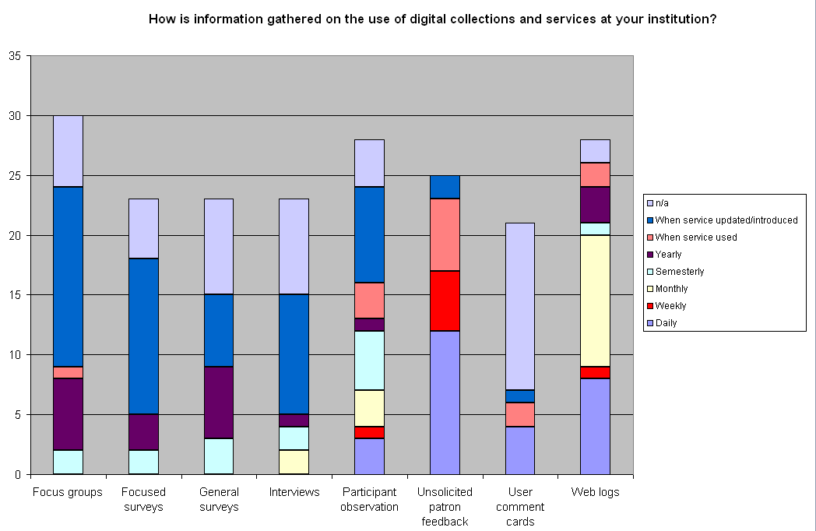
Perhaps unsurprisingly, web logs accounted for the greatest frequency of assessment, primarily at the monthly and daily levels. In terms of frequency, unsolicited patron feedback offered the greatest daily assessment of digital collections and services. This form of assessment also accounted for the greatest portion of weekly assessment and, notably, assessment of the service when it was used. Otherwise, there were few reported instances of assessment at the point of use.
Among the DLF institutions who responded to this survey, most gathered information on frequency of use of digital collections and services, closely followed by information on what users desire or need. [more here]
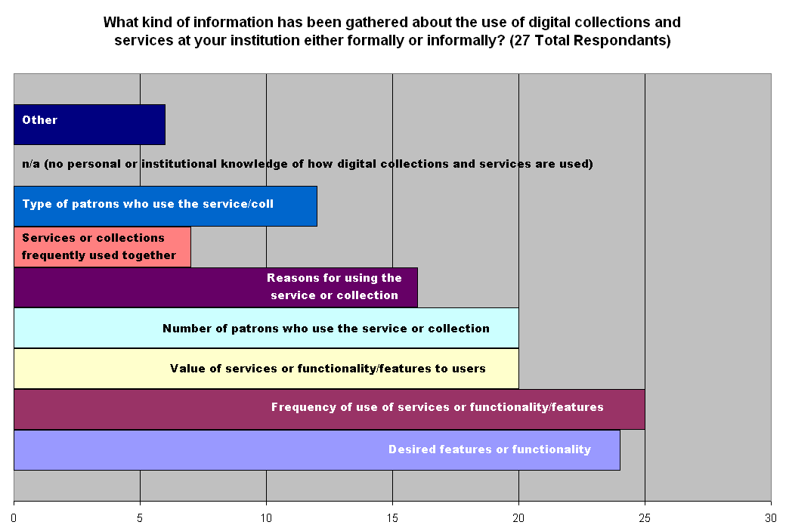
A question this raises is, how are desired features and functionality related to (1) the individual who uses the digital collection or service and (2) how frequently s/he uses it? The structure of our survey did not allow for making this connection, though the responding DLF institutions may well control for this information in their own user studies.

Section 2: Actual & Desired Use
This section sought more detailed description of use (as opposed to assessment strategies), and consequently relied on open-ended questions to help gather information on how digital collections and services are actually used at different DLF institutions. [summary of qualitative data] [charts showing patterns in qualitative data]
Example of qualitative data:
“quote from survey.”
When asked what “prevents or impedes the development of needed services at your institution,” respondents overwhelmingly identified a lack of time or the overextension of trained personnel, closely followed by budgetary constraints. As noted previously, these three factors—time, money, and people—are closely related, and it may be that constraints in one area (i.e., lack of time) impinge upon or are caused by constraints in these other areas (i.e., insufficient number of trained personnel to do the work, or insufficient budgetary funds to pay for training or hire more workers).
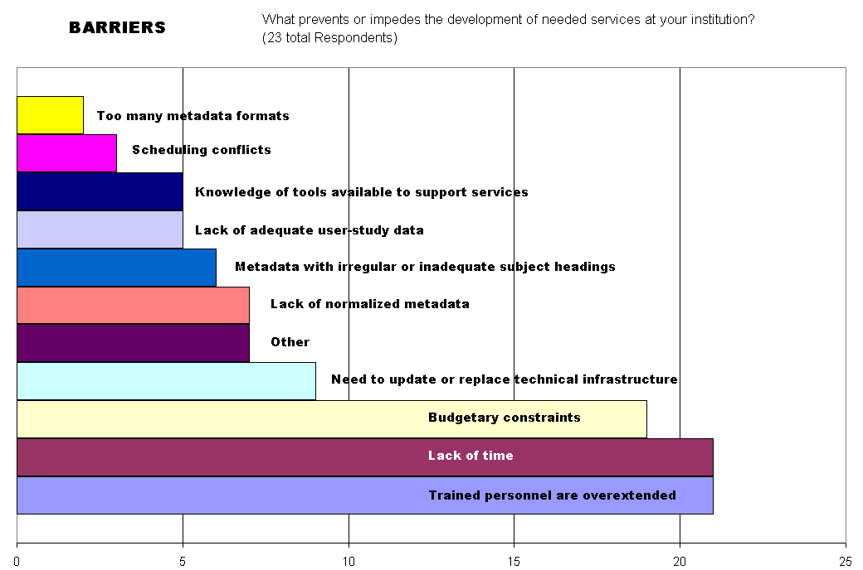

Section 3: Digital-Resource Support
This section attempted to gauge what tools DLF institutions are currently developing to support their digital collections and services. As with the previous section, qualitative data accounted for some of the most useful information gathered.

Section 4: Open Questions & Comments
The following are issues that surveyed institutions identified as important to them or to future work of the DLF Aquifer project:
- open comment
- open comment
- open comment
- open comment

Additional User Studies Conducted by DLF Institutions
Many DLF institutions have already undertaken studies of users and analyses of what opportunities and needs for new digital library services exist. The DLF Aquifer SWG survey solicited volunteers to share findings from their own institutional studies. Of the studies that this request elicited, we have reviewed and summarized below those that seem particularly relevant to the Aquifer effort.

Metadata Harvesting & Searching Portals
Focus Group Summary: “Metadata Harvesting” tool. Halbert, Martin. (2002, April). Internal report for Emory University MetaScholar Initiative’s MetaArchive project.
Abstract: Three separate focus-group sessions were conducted with researchers, faculty and staff members, students, librarians, and archivists representing different institutions and disciplines and possessing diverse research skills, in an effort to determine what users of a prototypical “Metadata Harvesting” tool would need. This investigation was conducted during the developmental phase of the project; thus, the goals were to discover the searching skills of users and their subsequent needs, so that the tool could support a range of searching expertise levels. A key finding was the different contextual features desired at the different levels of research ability: beginning researchers requested subject guides and tips on effective searching; intermediate researchers requested related links, information on where else a document had been cited, and comments/summaries to explain a wider body of material; and advanced researchers, archivists, and librarians requested prescriptive data, which would show how the material has been used.
Usability Study Outcome Report: A Summary and Analysis of the Cognitive Walkthrough, Usability Study, and User Survey Performed on AmericanSouth.org. Watkins-Mormino, Kristina, Sharon Kennedy, Katherine Skinner, and Jason White. (2002-2003). Emory University MetaScholar Initiative’s report to the Andrew W. Mellon Foundation.
Abstract: As part of the usability testing and user surveying required by the Mellon Foundation for the development of the AmericanSouth.org project, MetaScholar Initiative conducted individual tests of users’ ability to navigate the prototype web site, which harvested and aggregated metadata from several participating institutions and allowed searching and browsing of data in addition to several other added features (e.g., bookbag exports, annotation of records and articles, posting of user bios, and posting articles). Testing took place over five days, with a total of 21 participants from Emory University, pulled from humanities and social sciences graduate departments and the library and representing professors and graduate students, and librarians specializing in a variety of areas (e.g., archives, systems, cataloging, collection development, and so forth). In videotaped, individual sessions users were asked to complete a series of tasks on the web site, after first taking a few moments to try out and become familiar with the AmericanSouth.org web portal. These tasks aimed at uncovering areas of uncertainty or confusion with navigating the site, in an effort to make use of the site more intuitive. A key finding from this study was that users (particularly novice or less advanced researchers) struggled to distinguish between the different types of resources available on the site (archival records, original articles, and weblinks), which pointed to a need for portal designers to clearly indicate the types of resources produced by searches.
UCLA European Integration Portal: Metasearch Assessment. Lee, Jane, and Felicia Poe. (2005, July 8). Internal report for California Digital Library’s UCLA European Integration Portal team.
http://www.cdlib.org/inside/assess/evaluation_activities/docs/2005/uclaMetasearchReport_june2005.pdf

Abstract: Working to develop a multidisciplinary search portal geared specifically to the needs of European Integration scholars, team members of the California Digital Library’s MetaSearch Infrastructure Project interviewed faculty and graduate students in this field of study in order to determine their research behaviors and needs. Five group interviews were conducted, each consisting of two to four scholars, one interviewer, and two observers. The assessment team identified a range of searching behaviors and needs among these interdisciplinary scholars (most of which are abstracted here). Research typically begins with a local and/or familiar database or catalog, with the goal of locating one good source that can be gleaned for other references. For this initial foray, researchers generally prefer basic search interfaces (with options for searching fields like keyword or author) and simple keyword searches which are used to “cast a wide net” (p. 5). A distinct difference in these researchers’ approach is that, unlike searchers looking for general information on a new topic, the interdisciplinary researchers “are looking for gems. Because of this, they are willing to sift through all of the returned results – even if they number in the hundreds” (p. 5). These researchers were very receptive to the possibility of metasearching (using one interface to search many different resources), though some observed that this type of searching seemed more appropriate for researchers who lacked familiarity with the subject area and needed to do topic searches. Regarding browsing, researchers were somewhat ambivalent: most felt that online browsing failed to produce the kinds of serendipitous discoveries that physical browsing of shelves produced; but JSTOR was noted as an exception to this rule, since it actually exceeded the possibilities of physical browsing by permitting perusal by journal title as well as discipline and by providing handy table-of-contents information. Finally, researchers acknowledged that they tend to over-rely on databases that they were familiar with, and they expressed interest in discovering new databases through some form of recommendation system (Amazon.com was proposed as a useful model). They also expressed a desire for more and better methods of managing information, especially tools like Endnote which help them collect and organize references to a variety of sources.

Collection Aggregation & Display
Librarians in the Wild: Attitudes and Experiences Concerning Online Exhibit Building. Lee, Jane, and Felicia Poe. (2005, May 31). Internal report for California Digital Library’s American West project team.
http://www.cdlib.org/inside/assess/evaluation_activities/docs/2005/librariansInWild_march2005.pdf

Abstract: As part of a three-year grant from the William and Flora Hewlett Foundation to assemble a virtual collection of American West resources from major research institutions, the California Digital Library is involved in both “big” curation (the creation of large-scale collections) and “little” curation (the creation of smaller, more focused collections) and the development of tools that support the processes and complexities involved in these two, quite different activities. In an effort to uncover the issues involved in “little” curation, particularly the development of online exhibits, the assessment team for the project sponsored a series of interviews with University of California librarians and curators in order to determine (1) how much and for what reasons libraries value online exhibit building; (2) what organizational and institutional barriers hinder online exhibit building; (3) what infrastructure currently supports academic libraries’ online exhibit building; and (4) what tools and systems academic libraries are currently using to build online exhibits. Five group interviews were conducted, consisting of one to five interviewees, an interviewer, and an observer who took notes. Though the assessment team began this study with the view that libraries would be more likely to build online exhibits if the tools were easier to use, the study’s findings indicate that reasons for building online exhibits are much more complicated, and involve considerations of an organization’s own view of its mission, copyright issues, resources constraints (notably personnel and funding shortages), and the long-term usability of tools. At the same time, the team noted that as libraries’ and museums’ roles are converging, both organizations are well positioned to mutually benefit from collaboratively building online exhibits.

Studies in Progress
Some of the studies called to our attention were not yet complete but warranted inclusion in this report because of their relevance to the mission of the Services Working Group and the goals of the DLF Aquifer project. These studies are briefly outlined below.
Maximizing Library Investments in Digital Collections Through Better Data Gathering and Analysis (MaxData). Tenopir, Carol, Donald W. King, Gayle Baker, Eleanor Read, and David Nicholas. (2005-2008). http://web.utk.edu/~tenopir/imls/
Abstract: Recognizing that e-journals constitute a substantial economic investment for libraries as well as a highly valued search tool among librarians and users, the leaders of this three-year grant project, funded by the Institute of Museum and Library Services (IMLS), are exploring how librarians can make best use of the usage log data available through electronic resources. In addition to developing “a better understanding of how different methods of usage data supplement or overlap with each other” and the potential role of usage log data in collection-development decisions, the authors of the study how to identify areas where assessment is best pursued through direct surveys of users.

Discussion of Findings
We found this survey of DLF institutions to be extremely useful for informing our own work in the Aquifer effort and for revealing obstacles and issues common to members of the DLF wishing to develop better digital collections and services for their users.

Identifying Our Users
[need for better personas to guide development of services; need for more persistent assessment of use, beyond the introduction or updating of a service or collection]

Pooling Our Resources

Refining Our Goals

Appendix A: Survey of User Services for DLF Aquifer Institutions
In an effort to determine what digital-object services are most desired and needed by Aquifer member institutions, the Aquifer Services Working Group is conducting this survey of library services. The following questions are intended as prompts for thinking about how users currently use digital collections, how that use might be improved, and what is needed in order to improve services. Questions in Part I focus on actual use of digital-object collections and services, particularly evidence that illustrates how different library patrons (faculty, students, and researchers) utilize digital-object collections and services. Questions in Part II focus on the library’s own assessment of current digital-object services, particularly gaps in service and what is needed to bring about improvements.

Please look over these questions and provide answers to as many as possible that are relevant to your institution’s situation.

Part I. PATRON USE OF DIGITAL-OBJECT SERVICES & COLLECTIONS

In this section, we are looking for evidence of patrons’ use of digital-object services and collections. Preferably, this information should come from formally conducted user studies of your library populations (faculty, students, and researchers) and user comments on library services; anecdotal or observational evidence is also useful.

- How are digital object collections used?
To the extent possible, please provide evidence for this use (i.e., statistics) and scenarios of typical use.
Our ideas on why and how people use the collections are not generally backed up with good evidence. We think that people use them for the same reasons they use print collections: seeking known items, reading longer passages or even entire books, and searching for keywords or names. Our systems are developed to support these activities.

- What digital-object services and functionalities do patrons think are necessary to support their work?
Consider both the services identified as necessary and specific functionalities of those services which make them necessary.
As suggested above:
- seek known items by searching bibliographic data
- perform keyword or phrase searches
- limit searches by title, author, date
- sort results in various ways
- have the ability to page through works
- speed, speed, speed—nothing is more of a research buzzkill than waiting for the system/network/internet

- What digital-object services and/or functionalities are desired by these populations?
More specifically, what digital-object services would patrons like to see added? And what functionalities would they like to see added to existing digital-object services? To the extent possible, please provide ideal-use scenarios that illustrate these desired enhancements.

I think people would prefer more content over added functionality, but that’s just a hunch.

- If available, please provide a report of your library’s most recently conducted assessment of services.

Part II. LIBRARY ASSESSMENT OF CURRENT DIGITAL-OBJECT SERVICES

In this section, we are interested in the library’s assessment of services: what services are needed or desirable, and what is necessary to develop those services? These could be end-user services or institutional services that support patrons’ use of digital objects.

- What unmet service needs have you identified?
These may be services, tools, or functionalities that could be added to existing services or tools. Also, consider whether these are gaps in end-user services or institutional services.
- What tools, services, or functionality have you not developed but would develop, given the time and resources?
Consider whether these developments would be utilized directly by the end-user or by institutions in the service of the end-user.

- Registry
- cross-institutional searching
- automated citation creation and plug-in with EndNote, Procite or other bibliographic citation software
- better integration with OPAC

- What prevents you from accomplishing your service goals?
Consider what factors constrain development of digital-object services (i.e., insufficiently trained personnel, outdated technology, budget allocations, etc.).

The usual: time and money. In addition, the lack of information and understanding about what users really want.
- What functional specifications for tools or services has your organization developed that you are willing to share with the Aquifer team, e.g., browse functionality, basket functionality, etc.?
We have a mature digital library system with a great deal of functionality. Happy to talk about sharing any/all of it.

Appendix B: Survey of User Services for Digital Collections

Introduction
Background: The DLF Aquifer project is an initiative of the Digital Library Federation to create scalable solutions that enable teaching, learning, and scholarship. Beginning with a collection of digital content in the area of American culture and life, DLF Aquifer will create a test-bed of tools for selecting, collecting and providing access to quality digital content. More information on the DLF Aquifer project is available through the Digital Library Federation's website: http://www.diglib.org/aquifer/.
Purpose of survey: The following brief survey is an attempt to assess how scholars at DLF institutions currently use digital collections, how that use might be improved, and what institutions need in order to develop and improve services. The results from this survey will provide a better understanding of the current landscape of services provided for digital collections, as well as an indicator of common and consistently valued services which benefit scholars and could potentially be implemented through the DLF Aquifer project. Questions regarding this survey may be directed to the chair of the Aquifer Services Working Group, Martin Halbert: mhalber@emory.edu.
Completing the survey: This survey should take 15-20 minutes to complete, depending on how much additional information you provide. There are 14 questions total, divided into 5 sections. Please feel free to consult with others at your institution who could provide useful feedback. This survey is open through August 17.
To start the survey, click "Next" (below). To move forward or backward through the survey, click the arrows at the bottom of each screen. If you'd like to leave the survey at any time, just click "Exit this survey" (upper right-hand corner of the screen). Your answers will be saved. In order to resume the survey where you left off, use the same computer to link to the survey URL. Thank you!

Section 1 of 5: Assessing Use
Background: Digital collections and services often pose a challenge to typical assessment practices, given the variety of ways they may be accessed and used. Among their populations, institutions may attempt to gauge use of these resources formally (i.e., user studies, web surveys, focus groups) or informally (i.e., conversations with patrons, observations, unsolicited user comments) in order to assess what current services and functionalities are most valued and what future services and functionalities are most desired.
The following questions attempt to gauge how such usage information is gathered at your institution.

1. How is information gathered on the use of digital collections and services at your institution? These assessments may be formal (i.e., annual user studies) or informal (i.e., daily casual observance of patrons using digital collections and services). Please indicate the type of assessment used and the frequency of its use by checking the appropriate boxes below.
(check all that apply)
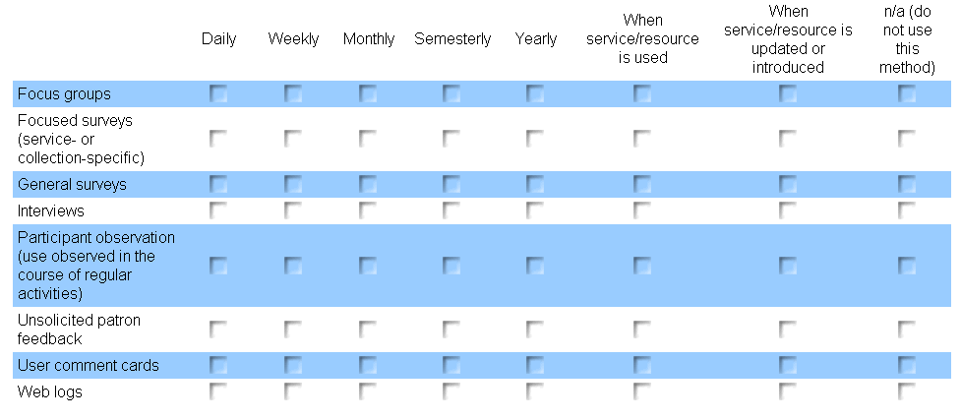

2. What kind of information has been gathered about the use of digital collections and services at your institution, either formally or informally?
(check all that apply)
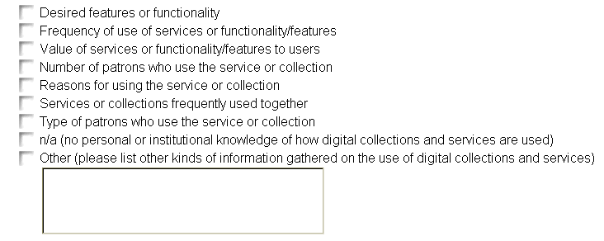

3. Is there a person, position, or department at your institution that is responsible for assessing use of digital collections and services? If so, please indicate the responsible party below.

4. If your institution has formally gathered information on the use of digital collections and services, would it be possible to share these findings with the Aquifer Services Working Group?

Section 2 of 5: Actual & Desired Use
Background: The following questions attempt to gauge current use of your institution's digital resources and services by professors, students, and researchers, as well as what is needed or desired in order to improve that use. These digital resources and services could be locally owned, shared through consortia, or commercial.
Note: The examples of use provided below are suggestions. You will likely want to add more examples in the open-ended questions.

5. Based on information gathered at your institution, how are digital collections and services used? While we are primarily interested in digital resources and services that are locally owned, these digital resources and services could also be consortially shared or commercial.
Indicate use that occurs at your institution by marking the frequency of use. If use does not currently occur but is desired or needed, mark the appropriate column. Select "Don't know" if there is insufficient information for answering the question.

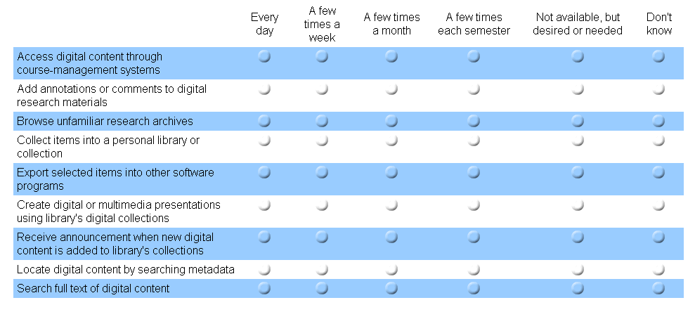

6. What are other uses of digital collections and services at your institution? While we are primarily interested in digital resources and services that are locally owned, these digital resources and services could also be consortially shared or commercial. If possible, please also indicate frequency of use.

7. What are the current gaps in services at your institution? These could be services specifically requested by users, or needs identified through formal and informal assessments.

8. What prevents or impedes the development of needed services at your institution?
(check all that apply)

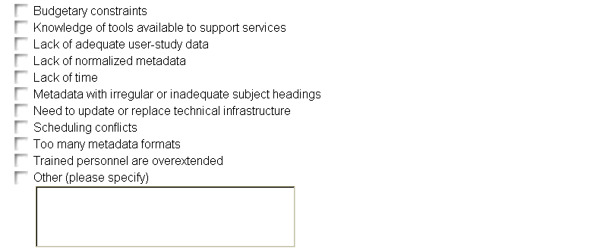

Section 3 of 5: Supporting Digital-Resource Use
Background: A range of tools and systems exist for supporting digital content. Institutions may even develop their own tools and processes to support digital collections and services for their users. The following questions attempt to gauge what institutions are currently doing and what digital library tools and processes they still need or desire in order to support scholars’ use of digital collections and services.
Note: The examples provided below represent only a few possible scenarios. You will likely want to add more examples in the open-ended questions.

9. What is your institution doing or developing to support the use of digital collections and services? The following examples range from routine practices to experimental projects.
(check all that apply)
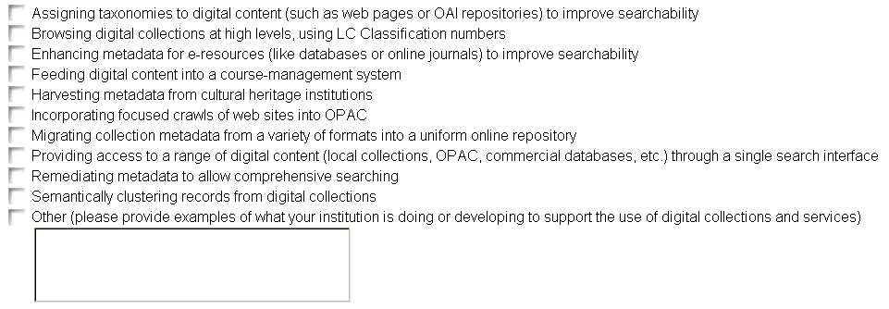

10. Please provide more description of the activities you checked in the previous question. For example, if you are "feeding digital content into a course-management system," indicate what type of content is being fed, into what system, using what tools or processes, and so forth. If available, please include a URL or citation that provides more information on this process.

11. What tools, services, or functionality would you develop, given the resources? Please indicate whether these developments would be utilized directly by the end-user or by institutions in the service of the end-user.

section 4 of 5: Open Questions and Comments

12. We realize that there are other issues and possibilities for cultural-heritage digital-resource services that this survey may not address. If you have additional questions or comments that you feel are relevant, please bring them to our attention by mentioning them in the box below.

section 5 of 5: Institutional Information
The following information will be used to determine how many DLF institutions participated in this survey, and to identify those willing to contribute further information or resources to the project. We appreciate your willingness to complete this survey, and hope we may rely on you to continue to assist us in this DLF endeavor.

13. Name of your institution:
[institution name selected from pull-down menu of DLF institutions]

14. May we contact you for follow-up questions or further information? If so, please enter your name and contact information below.
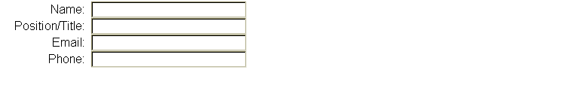

Thanks!
Thank you for your time. We appreciate your feedback. You are free to make changes to your survey response through August 17. To make changes to your response, link to the survey URL using the same computer.
If you have any questions about this survey, please contact the chair for the Aquifer Services Working Group, Martin Halbert: mhalber@emory.edu. Information and updates on the DLF Aquifer project are available through the DLF website: http://www.diglib.org/aquifer.

Appendix C: Survey Cover Letter
Greetings from the Digital Library Federation!
As an active DLF institution member, you are being asked to complete the following surveys addressing aspects of digital librarianship at your institution or to forward them to the person or group best qualified to respond. We seek one institutional response per survey.
Survey of MODS Use & Metadata Tools -
http://www.surveymonkey.com/s.asp?u=469551250385
Survey of User Services for Digital Collections –
http://www.surveymonkey.com/s.asp?u=514031250426
Responses to these surveys will inform the work of DLF Aquifer, an initiative of the DLF. We appreciate the time and consideration you give to our queries, and will share our findings once the survey analysis is complete. Please feel free to consult with others at your institution as you complete the survey. This survey is open through August 17. More information on DLF Aquifer and the surveys is included below.
Thank you for your active interest in the DLF. We look forward to your continued participation in its efforts, and in your prompt and considered response to these surveys.
Sincerely,
Katherine Kott
----------
BACKGROUND:
The Digital Library Federation (DLF) is currently engaged in a collaborative initiative to create scalable tools and services that enable teaching, learning, and scholarship. Called DLF Aquifer, this initiative seeks to improve and expand access to digital library content across institutions, particularly in the humanities and social sciences. More information on DLF Aquifer is available through the DLF website: http://www.diglib.org/aquifer/
Survey of MODS Use & Metadata Tools –
http://www.surveymonkey.com/s.asp?u=469551250385
PURPOSE: Gather information on metadata formats DLF institutions are currently using, tools used to manipulate and manage metadata, and use of MODS.
PARTICIPANTS: Anyone involved in developing or managing metadata for digital content, either in production or test environments. The URL for the survey may be forwarded to others within your institution who could provide useful feedback.
SCOPE: Nine questions are divided among five areas: 1) Descriptive Metadata Formats; 2) Use of MODS; 3) Metadata Tools & Processes; 4) Open Questions & Comments; and 5) Institutional Information.
CONTACT: Questions regarding this survey may be addressed to the Aquifer Metadata Working Group chair, Sarah Shreeves: <mailto:sshreeve@uiuc.edu>sshreeve@uiuc.edu.
Survey of User Services for Digital Collections –
http://www.surveymonkey.com/s.asp?u=514031250426
PURPOSE: Gather information on how scholars at DLF institutions currently use digital collections, how that use might be improved, and what is needed in order to improve services.
PARTICIPANTS: Anyone involved in assessing user services for digital collections, assisting users with digital collections and services, or supporting/developing digital collections and services. The URL for the survey may be forwarded to others within your institution who could provide useful feedback.
SCOPE: Fourteen questions are divided among five areas: 1) Assessing Use; 2) Actual & Desired Use; 3) Supporting Digital-Resource Use; 4) Open Questions & Comments; and 5) Institutional Information.
CONTACT: Questions regarding this survey may be addressed to the Aquifer Services Working Group chair, Martin Halbert: <mailto:mhalber@emory.edu>mhalber@emory.edu.

