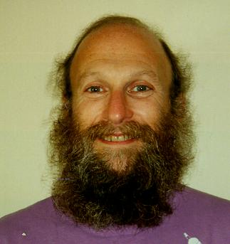

Stanley Moss is a senior, tenured faculty member of Center University’s English department. He is 60 years old, and for the last twenty years, the focus of his research has been in contemporary American literature. Stanley has been using a personal computer for about ten years. He communicates with colleagues all over the country using email and spends a lot of time looking for resources using his local OPAC, WorldCat, and various article databases. While Stanley appreciates the availability of online resources, he often feels overwhelmed by their sheer number. To combat this, he sticks to his list of familiar resources. He knows that he’s probably missing some good information by not being adventurous, and he hopes that he will get more adept at using online resources for his research with time.

Stanley relies on recommendations from colleagues for leads to new information sources. Occasionally, he will make a serendipitous discovery while following links. If he finds an interesting article or citation, Stanley will email it to himself. If there is no email option, then he will try to bookmark the page. Unfortunately, bookmarking doesn’t always work.

For his teaching, Stanley generally runs his courses the way he has throughout his career. He doesn’t have the technical knowledge or skills or the time to explore ways of integrating technology into his teaching practice. Stanley has used digital images that he’s found online in his undergraduate lectures, but it’s too much of a hassle to do it often. After saving the image to his desktop, he puts it into a PowerPoint presentation. But then he has to make arrangements for getting a projector into his classroom. More often than not, Stanley just adds the URL to the list of web resources he hands out with his syllabus.

Goals
- Further his research and publish two articles by next Fall
- Learn how to use online resources better
- Hire a graduate student instructor who can create a simple course website for him

