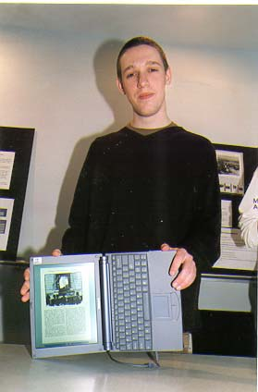

Will Gonzales is a typical nineteen-year-old sophomore. He takes school seriously, but not too seriously. He likes hanging out with his buddies and is constantly on the lookout for his next date. Like many of his cohorts, Will uses his laptop for staying connected with friends, playing games, music and movies, and, of course, doing schoolwork. Will loves being able to get answers to all his question online, which is why he gets frustrated when professors either don’t have a webpage at all or put up a crappy one that doesn’t have any information. He’s very comfortable using Google and Yahoo; and as far as he’s concerned, if he can’t find it on Google, it doesn’t exist.

Will is in his second year at Bearwood College. Will did pretty well his first year. His parents were satisfied with his grades, and his little brother called him a nerd. This year, Will wants to do even better, but he’s got all new courses and professors. Each semester, it’s the same story. It takes him a few weeks to figure out what the prof is looking for, and then it’s a matter of following directions. This semester, Will’s history professor is asking them to use “primary sources” in the paper that’s due in a few weeks. Will doesn’t really know what this means, yet. He could go to office hours and ask, but he’d rather do what he always does and look it up on the course website.

When Will gets around to looking at his history paper assignment online a week later, he discovers that his professor wants “a paper which poses and answers a historical question based on independent research using primary sources, including government documents, contemporary newspaper accounts diaries, personal narratives, and photographs.” Yikes. Will isn’t sure where to start. He didn’t have to use the library at all last year. He guesses that he could go to the library and look at some newspapers. Shouldn’t there be something like a primary source headquarters?

Will resorts to his old habits and googles “primary source.” To his relief, there are tons of websites that say they have primary sources. He starts browsing through them. When he finds something interesting, he either bookmarks it or saves it to his laptop. Sometimes, he comes across items that are just records and not the actual things that he wants. Will’s professor mentioned in the last class that they had to have at least two non-digital sources, so he copies those records so he can look for them later in the library.

It is now the day before the paper is due. Will has found some good sources and is working hard to finish his paper. He believes he is home free when he starts putting together his bibliography. “It’s only midnight,” he thinks.

2:30AM. Will is still working to put all of his citations in the correct format. “This is torture. There’s got to be a better way to do this.”

Goals
- Get good grades
- Have fun
- Finish this paper!

