Final Report on the Academic Image Exchange
Appendix C.

Features of the AIC Prototype

This appendix documents eleven features initially planned for the AIC software. Six of those features are available in the prototype software developed for the AIC by Carnegie Mellon University. Implemented features are exemplified with screen dumps.

Feature 1. Search the concordance. The feature enables users to locate images anywhere in the textbooks used to generate the AIC Core Concordance. It is demonstrated in the following screen dumps

SD1.1 Use browse facility to view textbooks
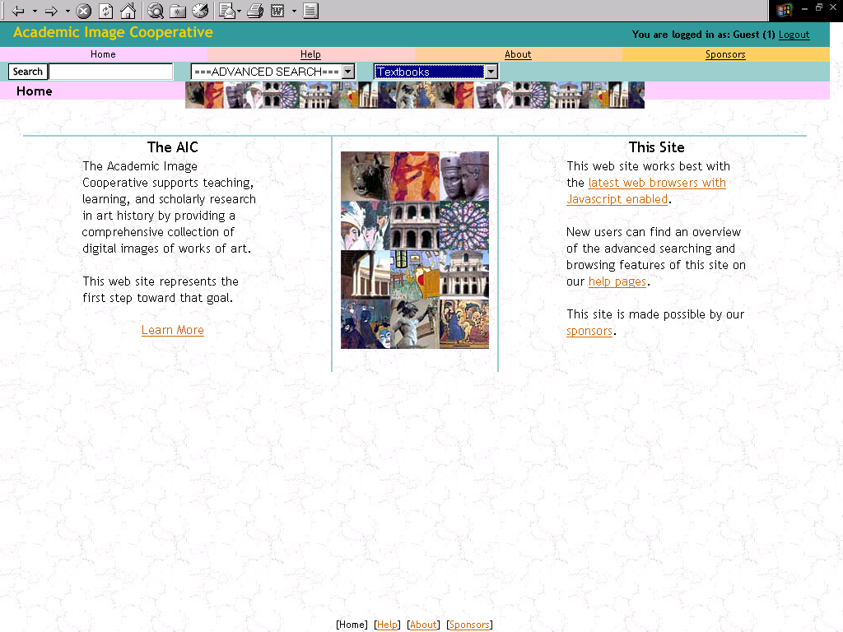
SD 1.2. Select a single textbook 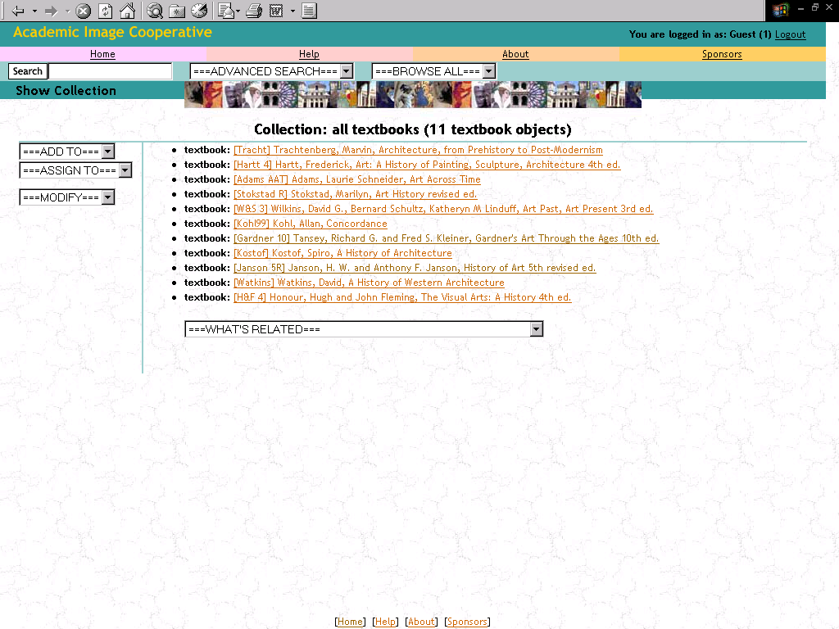

SD 1.3.Select part of textbook 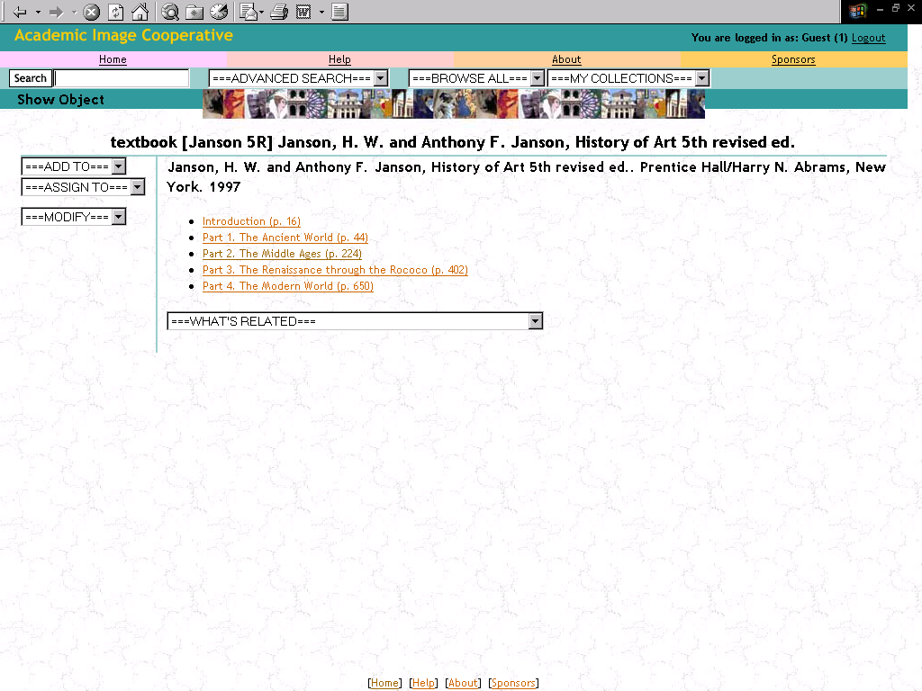
SD 1.4. Select chapter from part
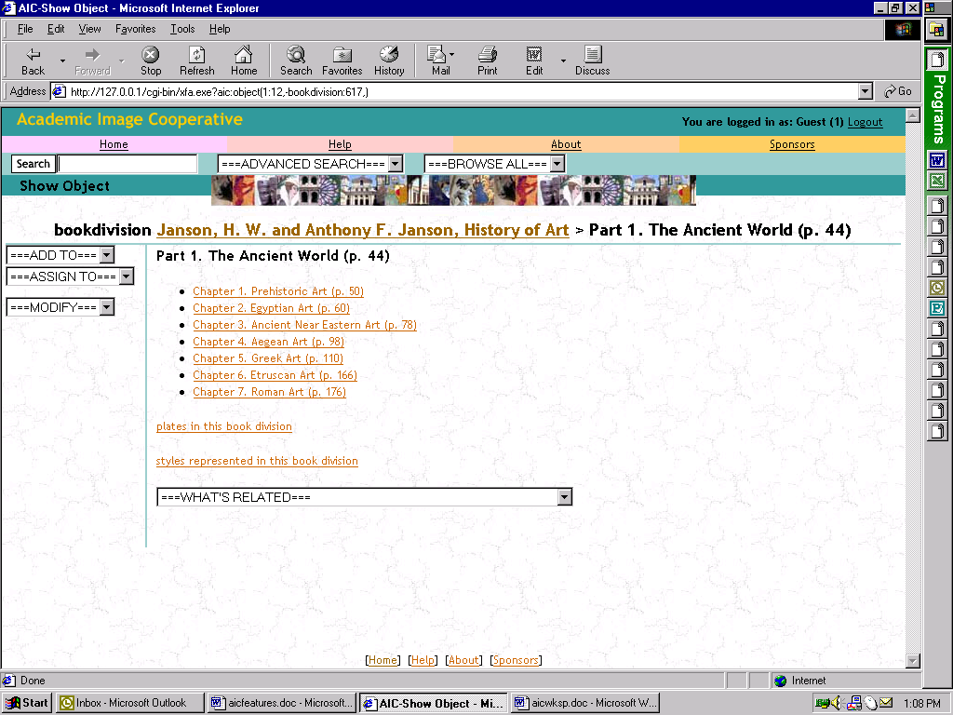
SD 1.5. Select sections in chapter (demonstrates how user is guided to related materials)
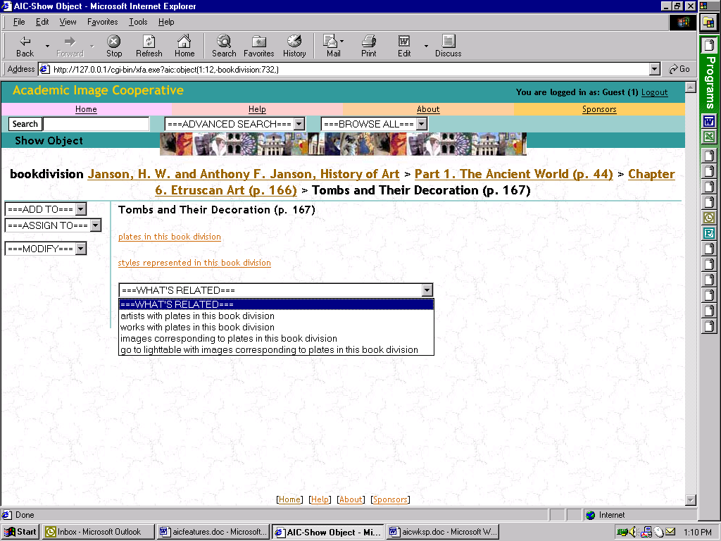
Feature 2. Simple Search Allows unfielded key-word searching

SD 2.1. Simple search for conques
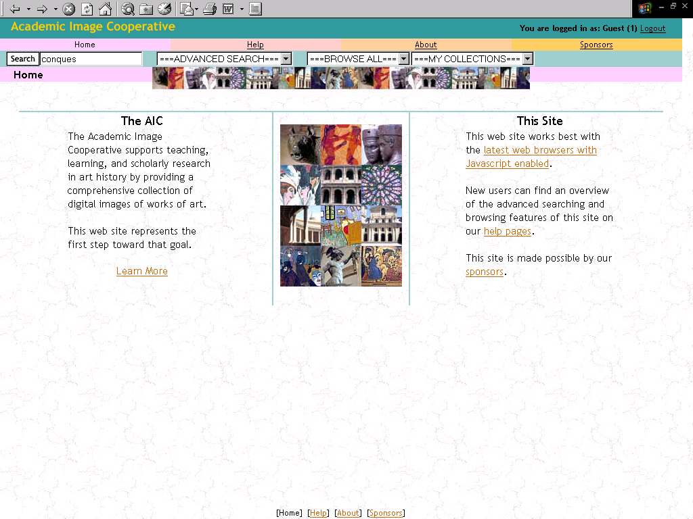
SD 2.2. Result set showing four works matching the search criteria and guidance to related materials
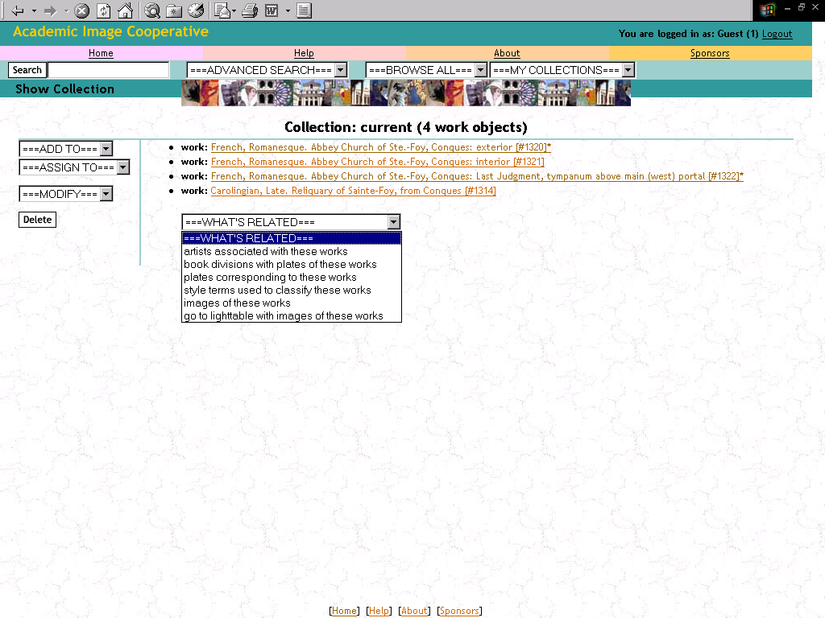
SD 2.3. Selection of single work showing thumb-nail image and ability to assign the image to a user-defined “collection”
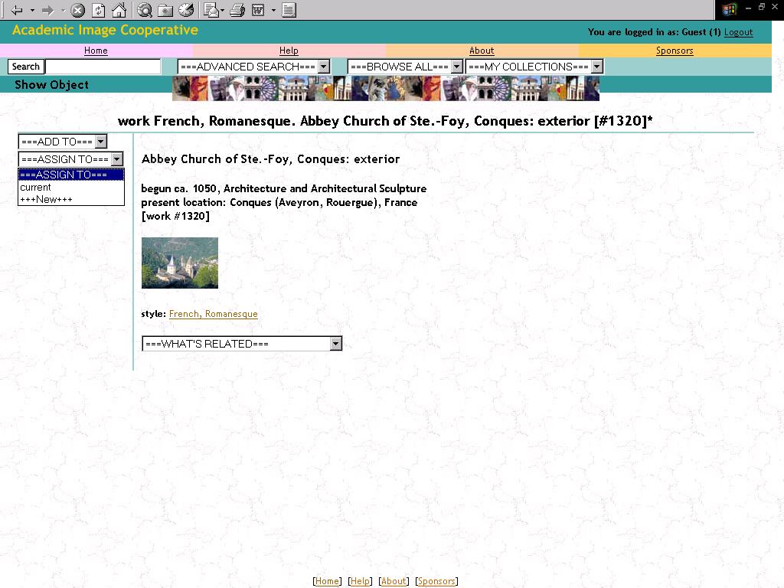

Feature 3. Advanced Search. Fielded keyword search operating across works; artists; styles; textbooks; book divisions; images; plates (X)

SD 3.1. Fielded search for works by Picasso
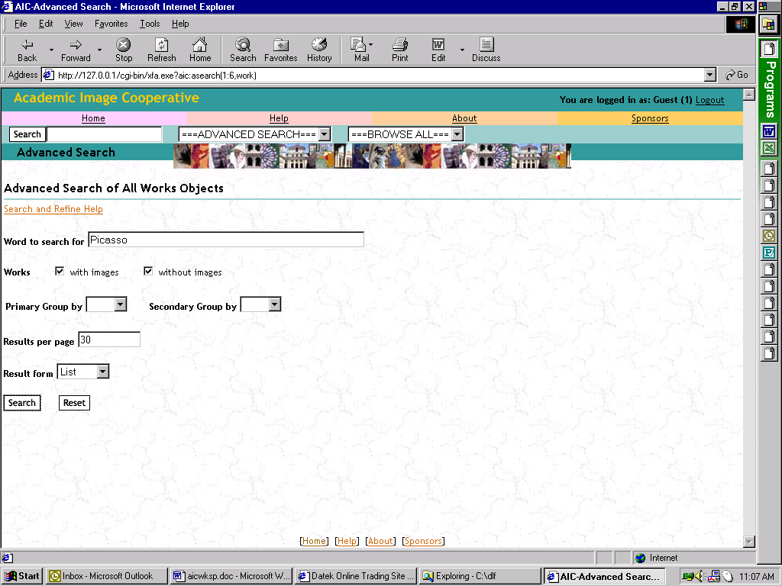
SD 3.2. Result set showing works by Picasso
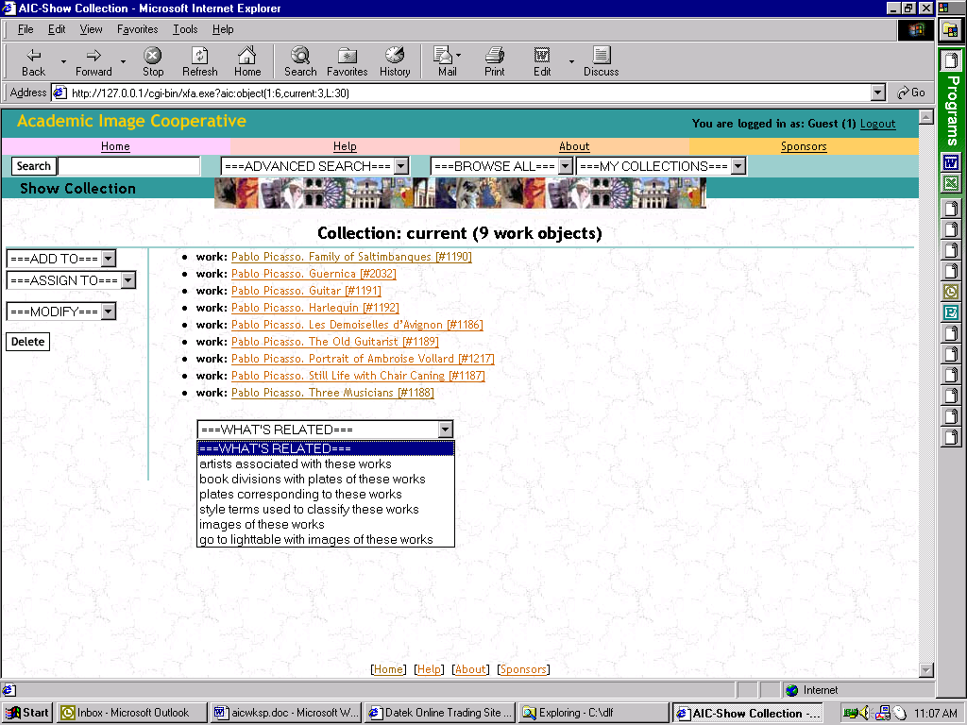
SD 3.3. Description of a single image by Picasso
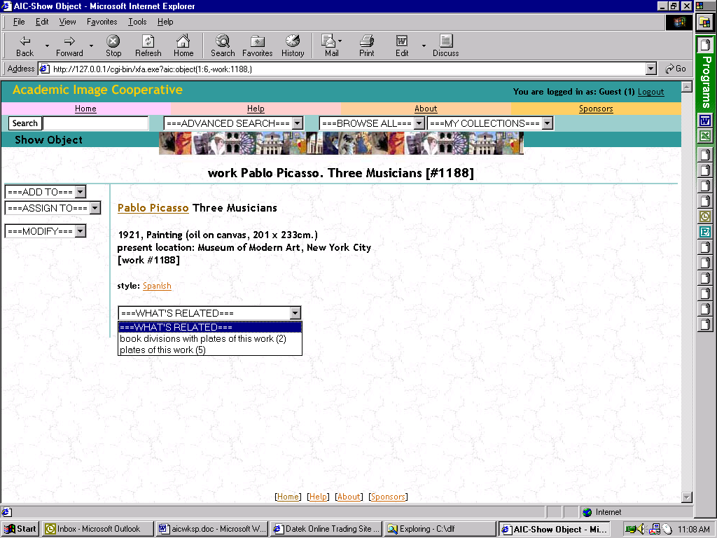
Feature 4. Browsing features. Provides ability to browse the database by works, artists, styles, textbooks, and images.

SD 4.1. Browse by style
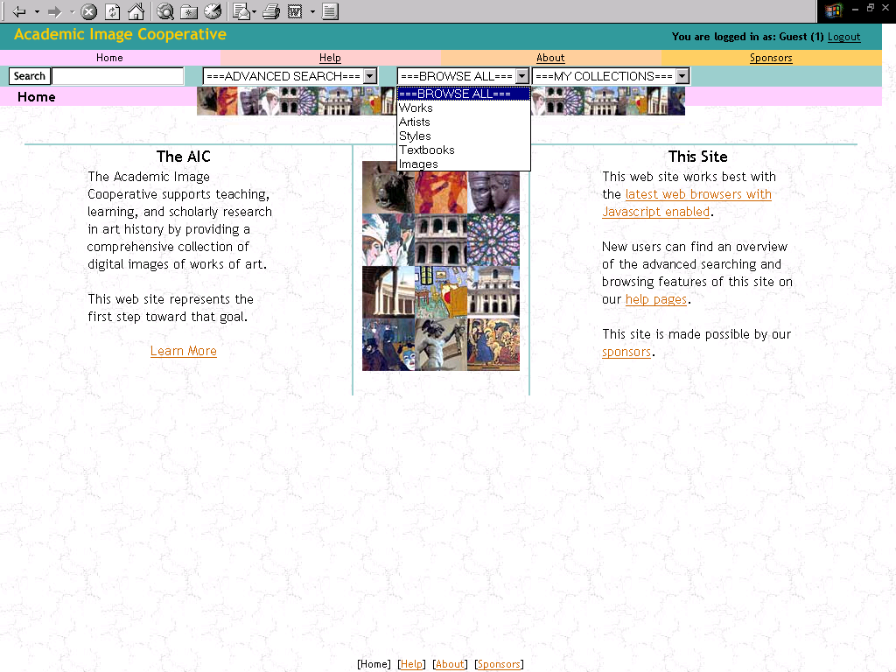
SD 4.2. Refine browse by style
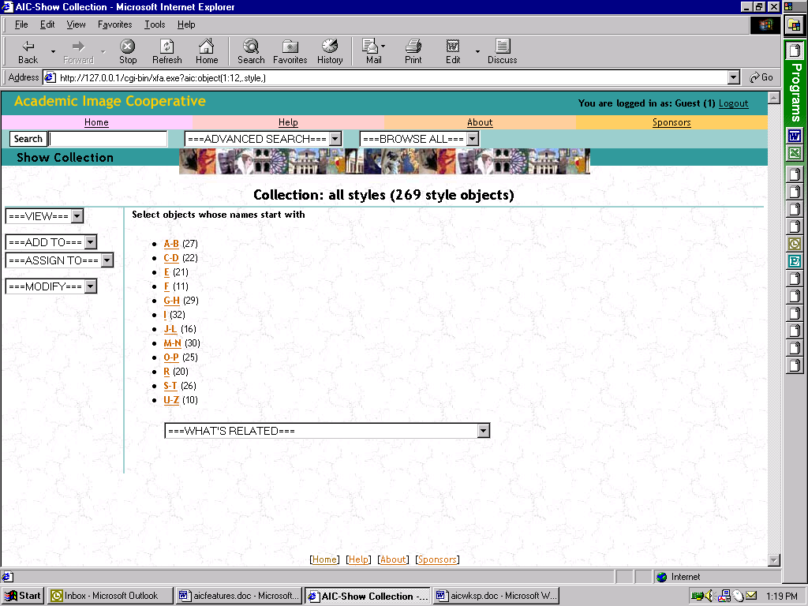
SD 4.3. Select a particular style
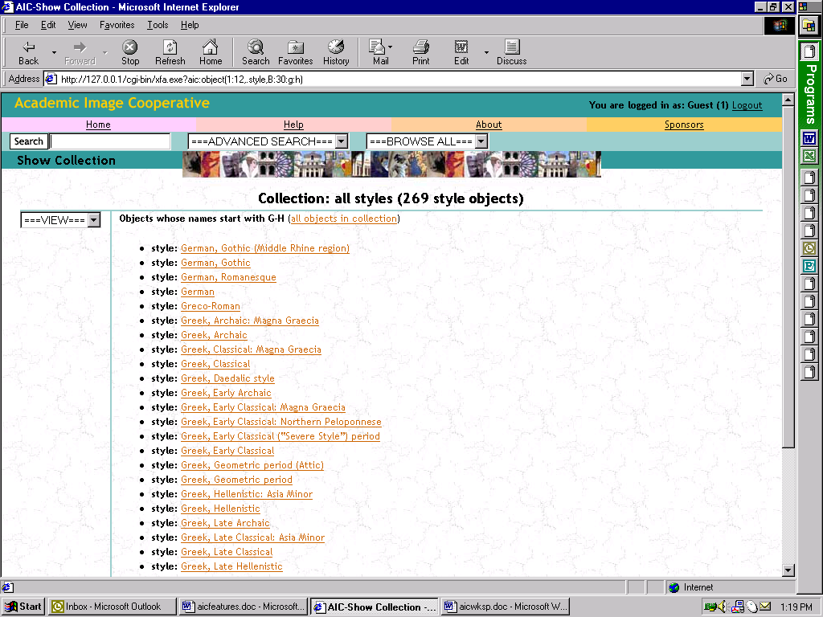
Feature 5. Light-table tool for selected images

SD 1.5 Light-table developed for pictures of a doorway at conques and demonstrating viewing options
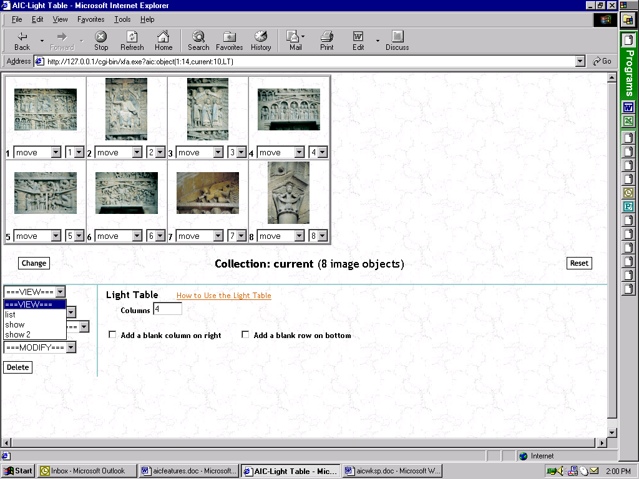

Feature 6. Dual projection tool for selected images

SD 6.1. Dual projection tool used with images from conques
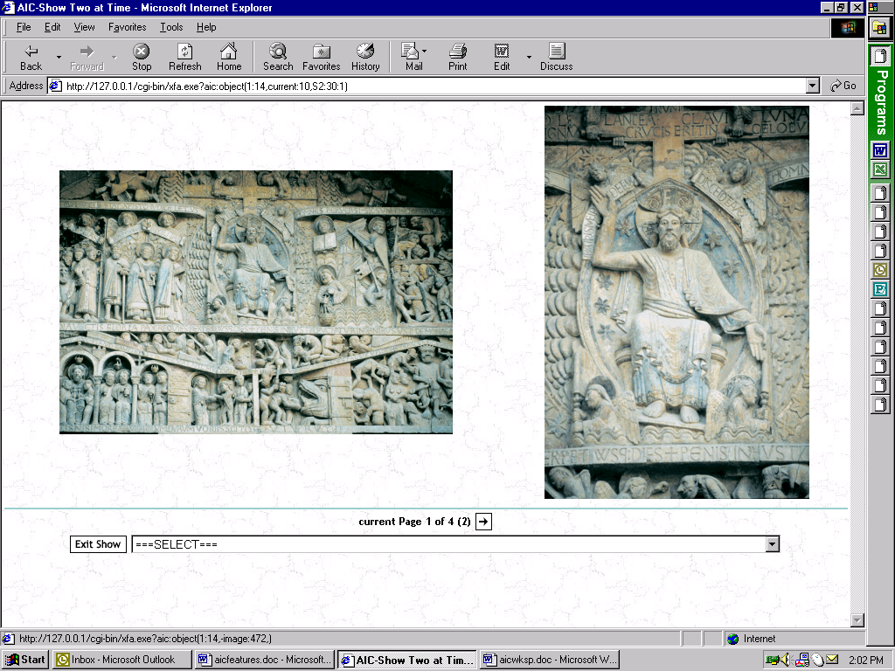

Feature 7. Ability to create want lists for the database to be distributed to contributors and/or for requesting contributions for specific courses. Not implemented in prototype.

Feature 8. Ability to either a) downloading or b) request a CD-ROM of images and data that would rely on a “market basket” feature. Not implemented in prototype.

Feature 9. Tools for donating images and for shared cataloging of images. Not implemented in prototype.

Feature 10. Rights management (e.g. authentication, authorization tools). Not implemented in prototype.

Feature 11. Membership management (e.g. patron database and associated user profiling and other features). Not implemented in prototype.

