DLF Registries. An overview

Paper circulated to members of the DLF Steering Committee at their meeting on 22 September 2000

D Greenstein
9/21/00

Executive summary
For some time, the DLF members have sought ways of informing one another about their various digital library policies, practices, collections and services. In response to this near-universal need, the DLF has developed two new information resources.
- Digital library policies and practices is a registry of policies, strategies, working papers, standards and other application guidelines, and technical documentation that members have developed to inform or reflect upon their own digital library development activities.
- Digital library collections is a registry of public-domain, web-accessible collections that are created in whole or in part from digital surrogates of objects held by member libraries.
The paper introduces these resources, provides an overview of their use and their limitations, and requests DLF members to:
- Review data pertaining to their institutions notifying the Director’s office of any changes that need to be made
- Notify the directors office of collections and digital library documents that are not included in the database
- Help the Directors’ office maintain the database by using twice-yearly newsletters to notify new documents and new collections
- Expose to harvesting services the item-level metadata content available from public-domain digital collections as a means of developing genuinely meaningful scholarly information resources
The construction of these databases would not have been possible without the help and perseverance of Novera King and Anne Marie Parsons. Our gratitude should also be expressed to Brian Sheppard and colleagues at the University of Michigan who have transformed the data into a web-searchable database.

1. Documenting the digital library

This database of policies, strategies, working papers, standards and other application guidelines, and technical documentation developed by DLF members to inform or reflect upon their digital library development activities, is available from http://www.hti.umich.edu/cgi/d/dlf/dlf-idx

1.1. Opening screen showing two search and three browse options
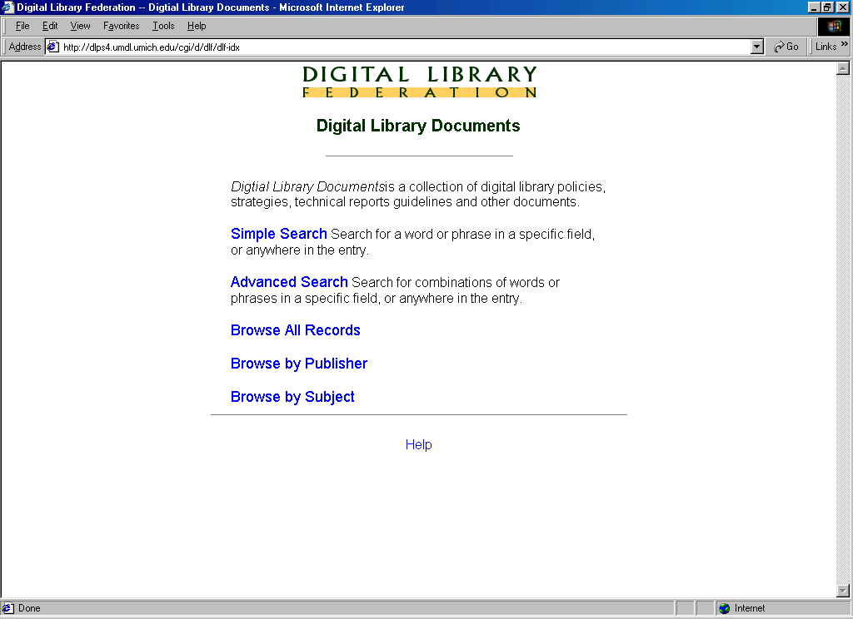

1.2. Simple (unfielded keyword) search for records containing the phrase “sgml”
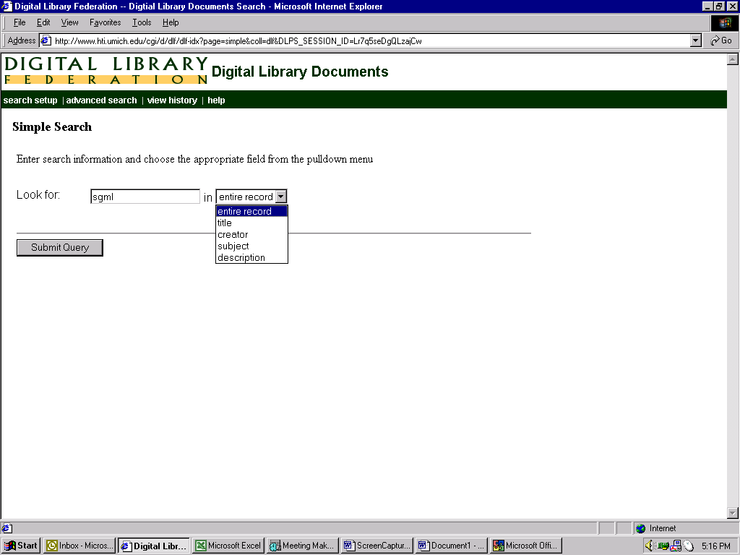
1.3. Result of “sgml” search
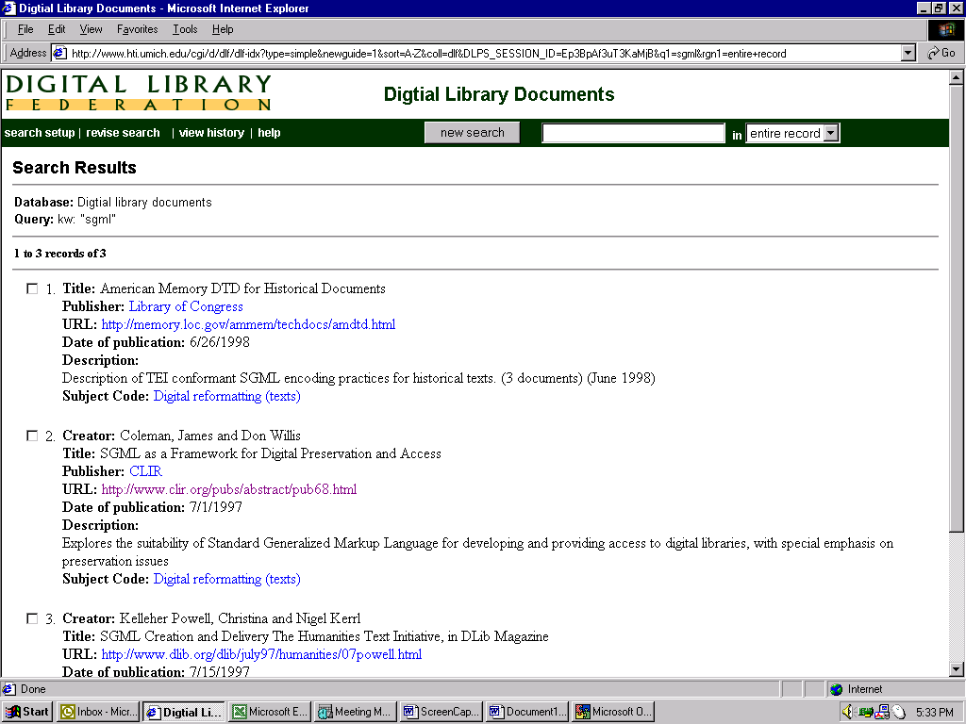1.4. Advanced (fielded) search for records containing the phrases “preservation” and “image” and demonstrating searchable fields and Boolean search syntax
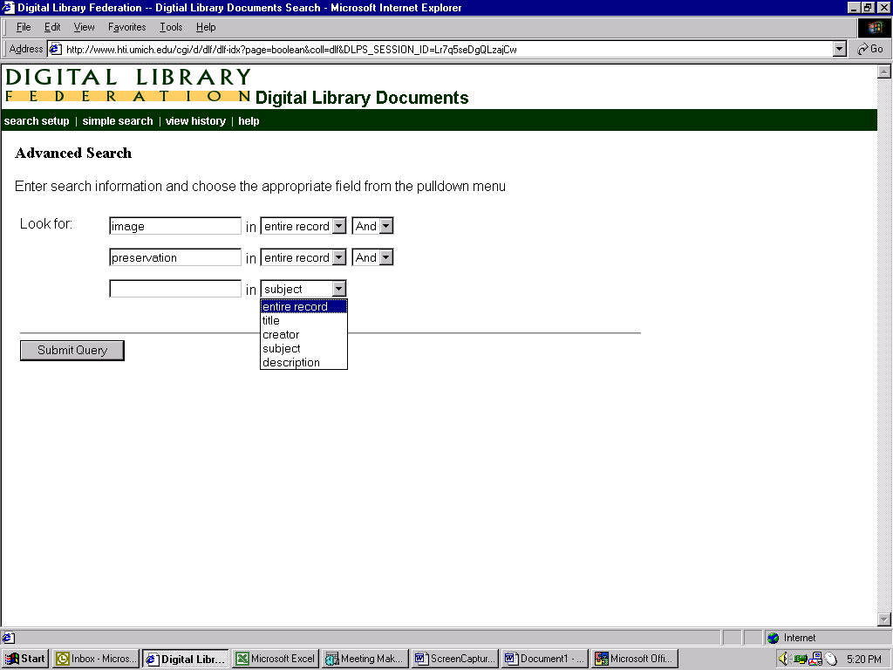

1.5. Result of advanced search.
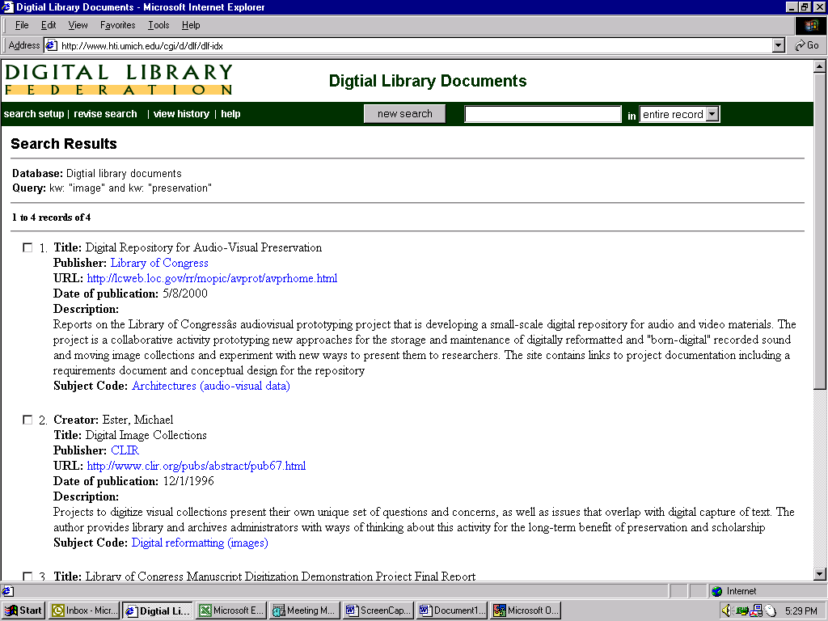

1.6. Browse option (by subject category)
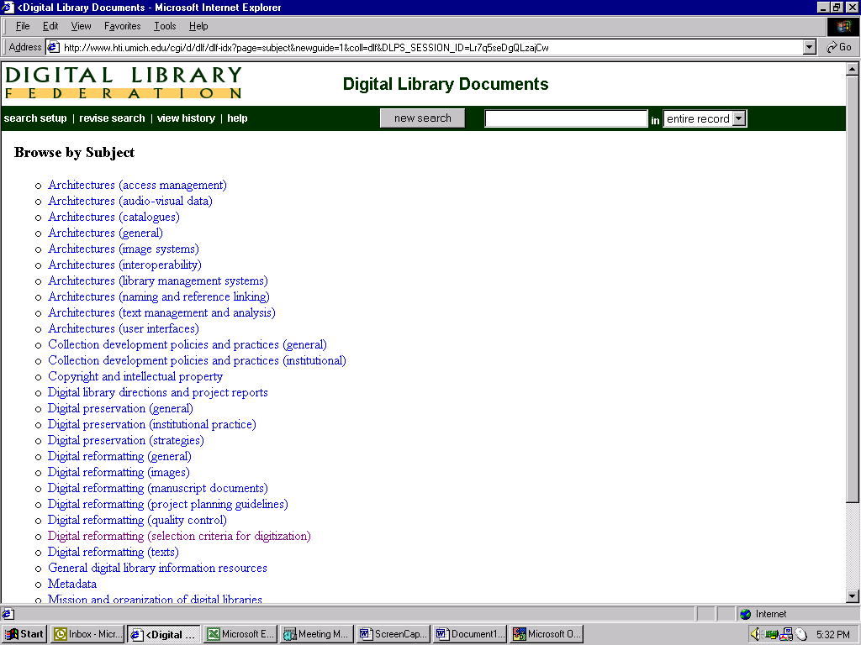
1.7. Result of subject browsing (Digital reformatting – selection criteria for digitization”)
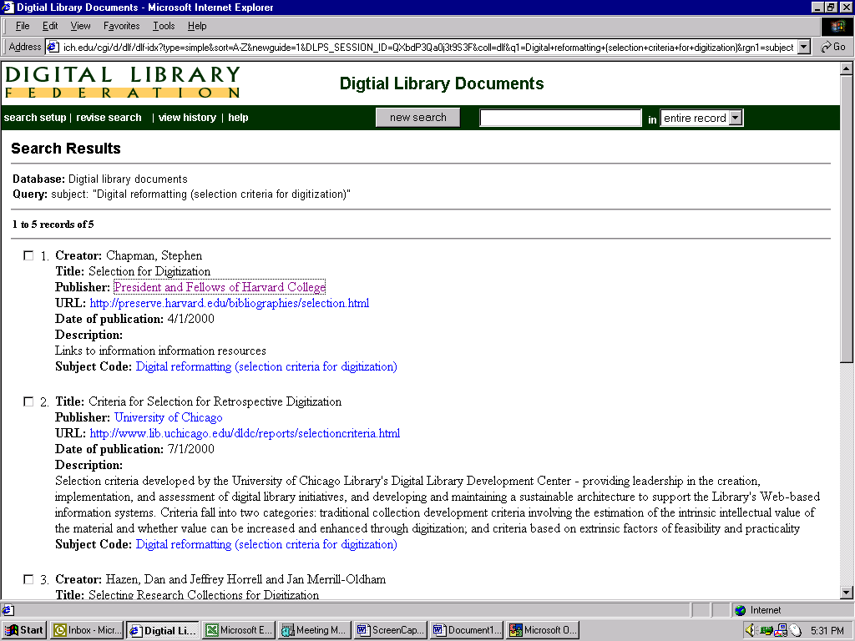
2. DLF Members’ digitally reformatted collections

This database serves as a registry of DLF members’ public access digitally reformatted collections. Our intentions are to expand the database to include OPACs and other online finding aids and indices. The database is available from http://www.hti.umich.edu/cgi/d/dlfcoll/dlfcoll-idx

2.1.Opening screen showing two search and two browse options

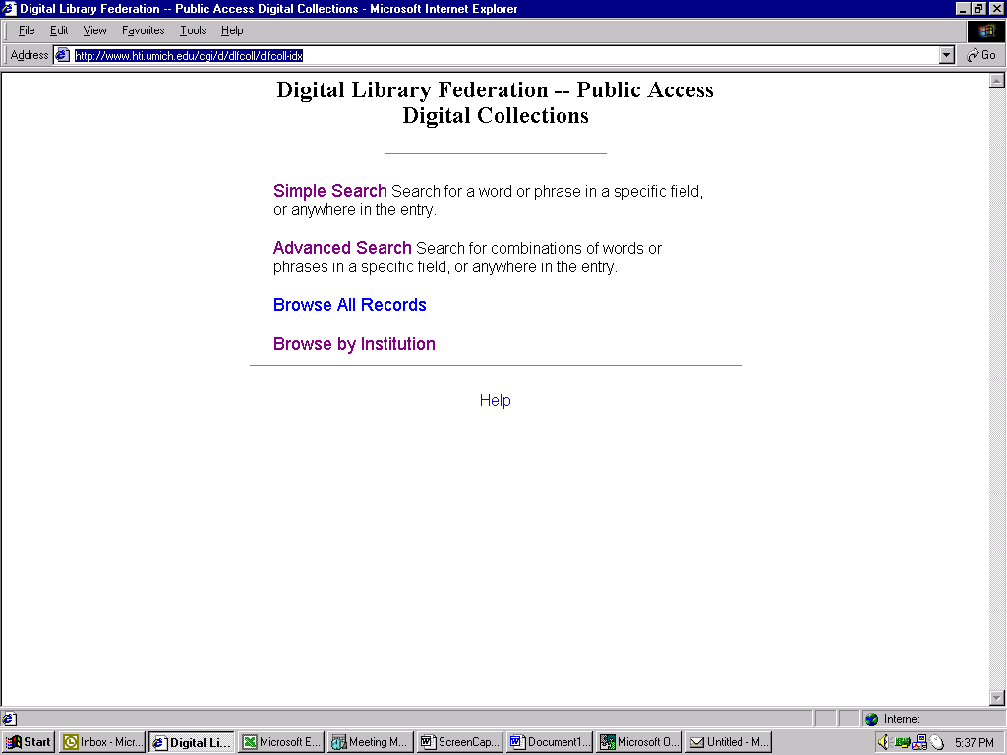

2.2. Simple search for records with “American” and showing fielded search options
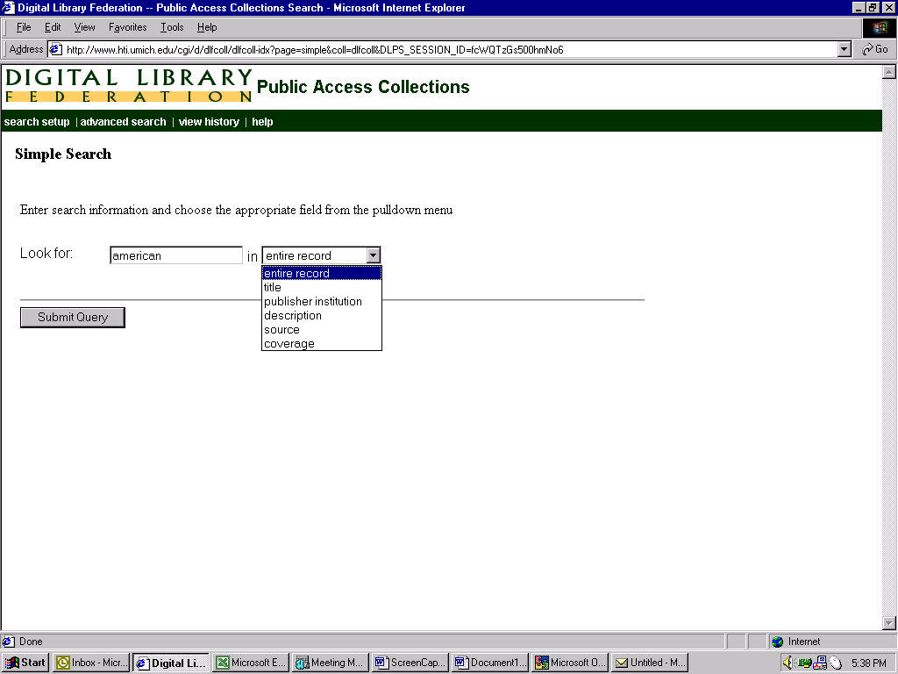

2.3. Results of simple search
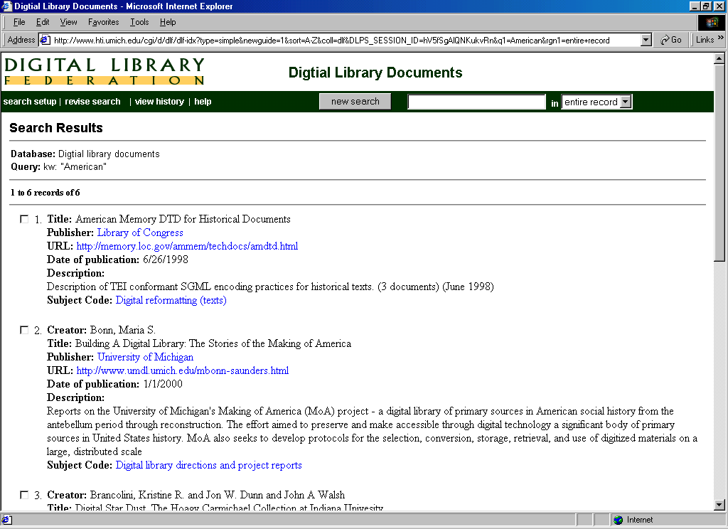

2.4 Link to listed collection
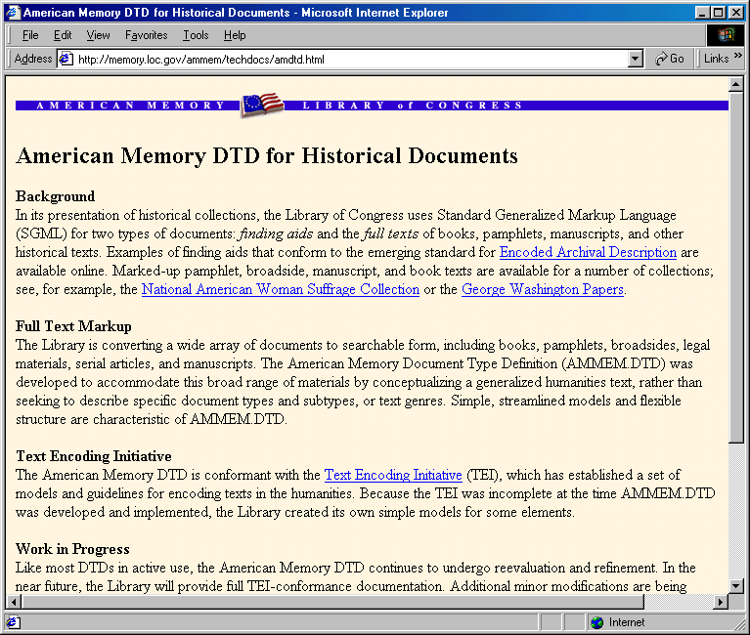

2.5. Advanced search for Americana showing search fields and Boolean syntax
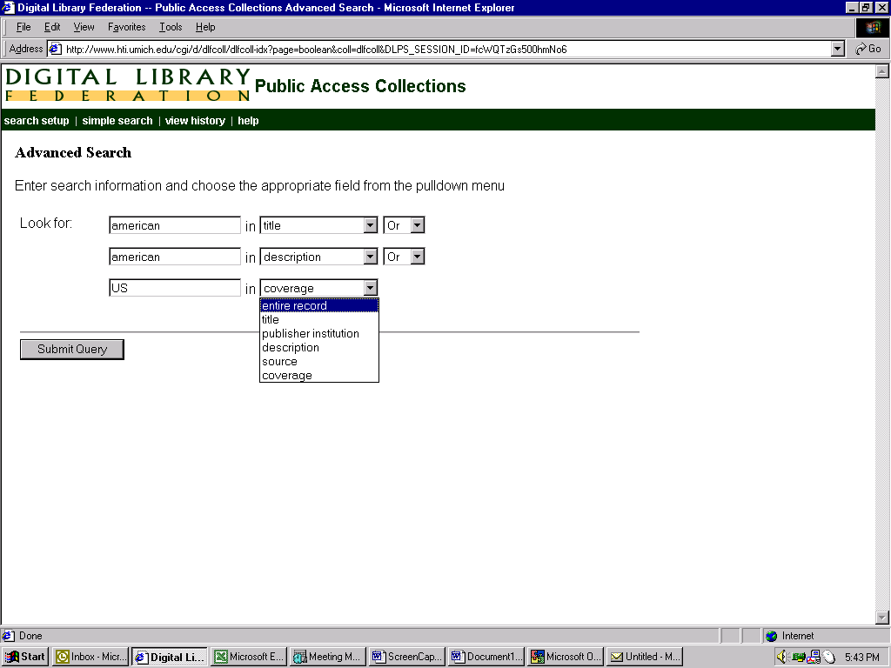
2.6. Results of advanced search for Americana
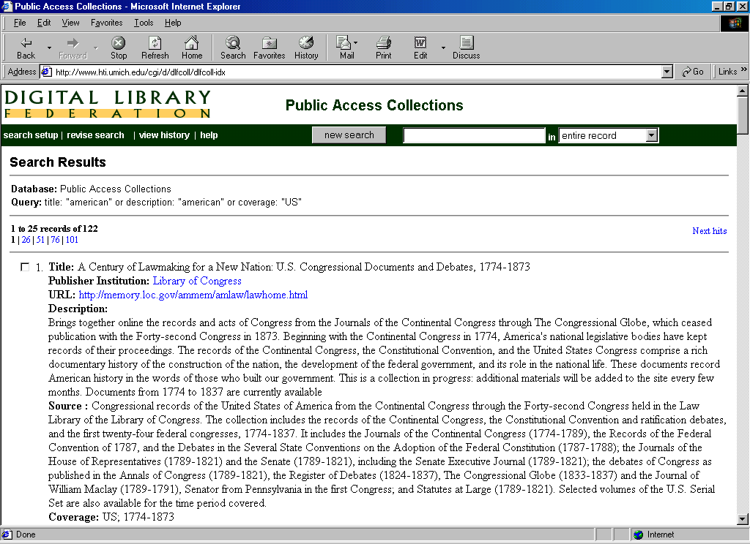

2.7. Browse capability, by “institution”
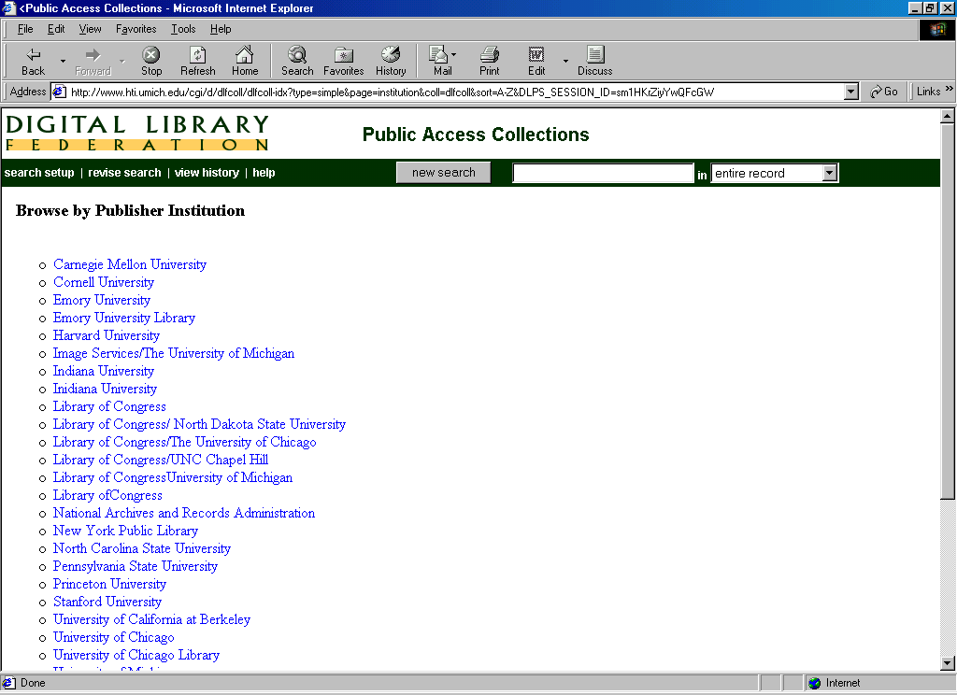
3. Limitations on registries built with collection level descriptions

This brief demonstration assumes the perspective of a scholar looking for information bearing on the life and times of Jack London. It demonstrates that registries built on collection level descriptions conceal from the scholar far more than they reveal. The demonstration is intended to make a strong case to the DLF that its mission to integrate access to its online information resources will fundamentally rely upon mechanisms that permit deep cross-searching of item-level records that are stored in local databases, OPACs, indices and other finding aids

3.1. Simple search for “Jack London”
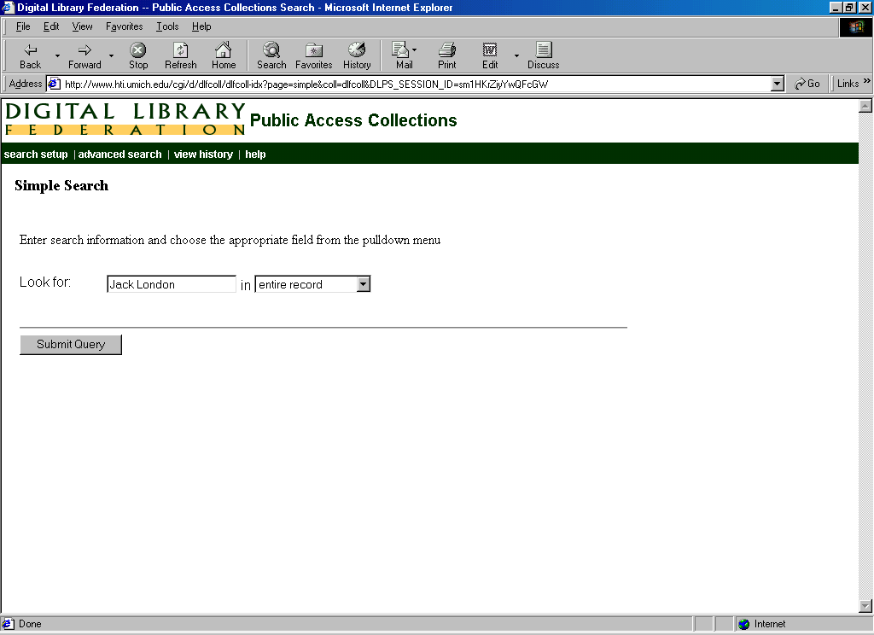

3.2. Result of simple search for Jack London
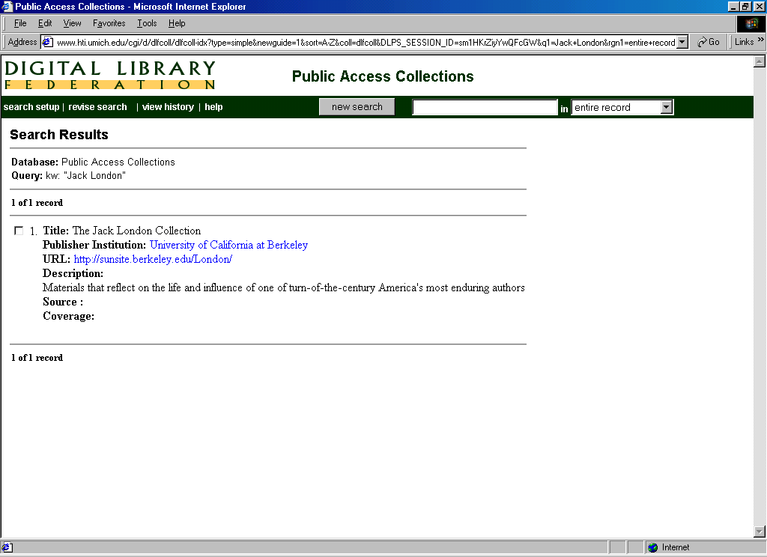

3.3. “Garden and Forest”, a collection with Jack London not captured by search
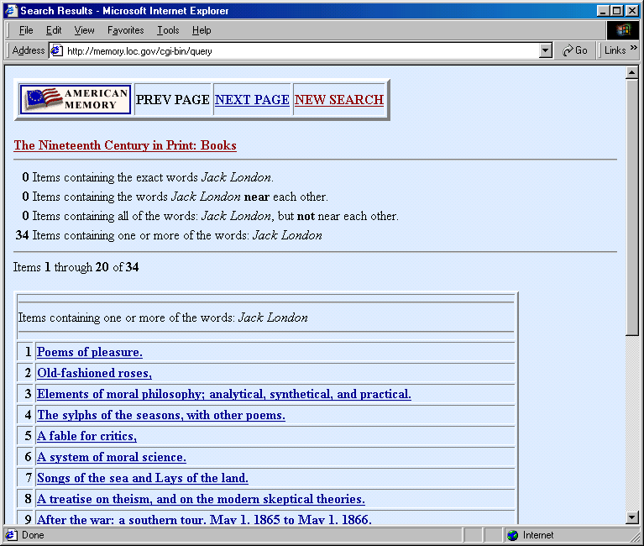
3.4. Making of America (Cornell). A collection with Jack London not captured by search 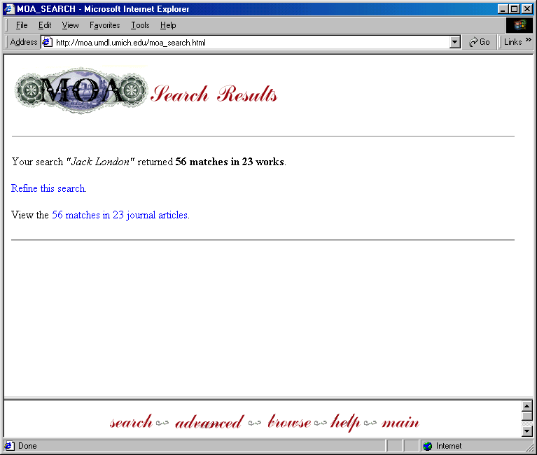

3.5. Making of America (Michigan). A collection with Jack London not captured by search
