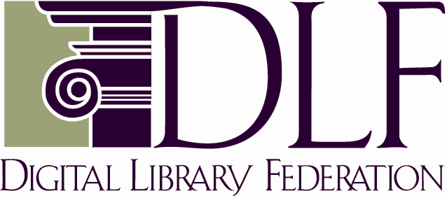

METS: The Metadata Encoding & Transmission Standard
A DLF Executive Summary

Summary

METS records the metadata needed to manage and share digital library objects. METS can record descriptive, administrative, and structural information about an object, and it can provide links to information held in separate metadata repositories.

METS gives us a stable, generalized, foundation on which we can build tools for delivery, management, and preservation. While many document standards (TEI, for example, or MPEG) encode structural metadata and provide links to other metadata, they are both too much (their structural metadata is specific to the needs of a particular user community) and too little (their facilities for connecting to other descriptive and administrative metadata are inadequate for library needs).

A METS package can include both metadata and content. Text, image, audio, and video files can be embedded within it, allowing METS to wrap up metadata and data in a single file. This can be a significant benefit for archiving or transmission.

METS is an XML document format developed as an initiative of the Digital Library Federation. The rapid adoption of METS suggests that it has filled a real practical need in the library community.

More Detailed Information

Use

Archives: METS can be used as a container to encapsulate all metadata and data for an object for placement in a digital archive (either online, or offline on tape).

Data Exchange: METS can be used as a format for exchanging digital library objects (or just their metadata) between different repositories. Some institutions are considering using it in conjunction with the Open Archives Initiative harvesting protocol for exchanging complex metadata between digital repository systems.

Performance: Some institutions wishing to improve the performance of digital library systems have used METS as a mechanism for taking complex metadata from databases and placing it in a single file which can be more quickly indexed, searched and retrieved for display.

Delivery: METS can also be used as a dissemination format. When used in conjunction with XSLT style sheets, METS provides a convenient format for presenting 'page-turned' objects to users, and some institutions (including the Library of Congress and NYU) are beginning to explore its use for presenting time-based media to users.

Scope

METS provides a format for encapsulating metadata and data for digital library objects composed of text, still images, audio, video, or any combination thereof. While it can be used for other classes of objects (e.g., social science data sets, executable files), such use exceeds the original design criteria.

The Structure of a METS record

There are seven major sections to a METS document:

- METS Header – metadata regarding the METS file itself, including creation date, creator, production status, etc.

- Descriptive Metadata – descriptive metadata regarding the digital library object

- Administrative Metadata – administrative metadata regarding the digital library object. Includes sections for technical details, intellectual property rights, source information , and digital preservation metadata

- File Inventory – a record of all of the files containing the content for the digital library object

- Structural Map – a description of the logical structure of the object that also indicates how content files, descriptive metadata and administrative metadata are associated with that structure

- Structural Links – a record of links between nodes in the logical structure contained within the structural map that is used to indicate hyper links between media files forming the digital library object

- Behaviors – a record of software behaviors necessary to access the METS object or any of its parts.

The Structural Map is the only mandatory section of a METS document; all others are optional.

METS is extremely flexible with regards to the forms of descriptive and administrative metadata which it will contain. As long as the metadata can be expressed in XML, it can be included within a METS document.

Links to XML schema for some common metadata sets (Dublin Core, MARC21) are available through the METS web site (http://www.loc.gov/standards/mets).

Editorial Board

The editorial board supports the long term development and maintenance of METS,, and develops documentation, hosts training sessions, works with other agencies to develop XML schema to use with METS, and develops mechanisms to ensure METS' interoperability among different institutions.

Jerome McDonough NYU (Chair)
Rick Beaubien University of California
Morgan Cundiff Library of Congress
Susan Dahl University of Alberta
Richard Gartner Bodleian Library at Oxford
Nancy Hoebelheirich Stanford University
Mark Kornbluh Michigan State University
Cecilia Preston Preston & Lynch
Merrilee Proffitt Research Libraries Group
Richard Rinehart Berkeley Art Museum/Pacific Film Archive
Mackenzie Smith Massachusetts Institute of Technology
Taylor Surface OCLC
Brian Tingle California Digital Library
Robin Wendler Harvard University

Web Site
http://www.loc.gov/standards/mets

Maintenance

The Library of Congress Network Development and MARC Standards Office is the maintenance agency for METS, providing the official web site for the standard as well as running public e-mail lists for discussion of METS' development.

Related Standards

METS is analogous to the Archival Information Package (AIP), Submission Information Package (SIP), and Dissemination Information Package (DIP) within the Open Archival Information System Reference Model: OAIS -- ISO 14721:2002.

*********************************

Jerome McDonough
Digital Library Development Team Leader,
Elmer Bobst Library, New York University
May 2003

