CIVE 650C – Assignment #2

Chenhui Liu

Part 1:

Do the following exercise on your ipython notebooks that were installed using Anaconda in class. Save the ipython notebooks as yourname.ipynb.

Numpy:

1)

a. Initialize a 2*2 numpy array with random values. Name this array as ‘x’

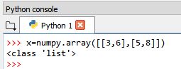

b. Display the contents of the x

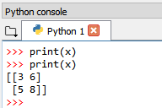

c. Display the type of the x

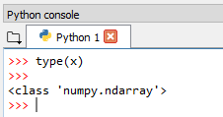

d. Display the size of the x

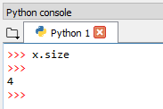

e. Display the data type of the array elements in x

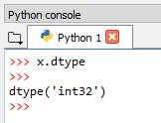

f. Force the data in the x to be converted to float type and display the elements

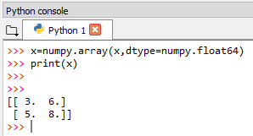

g. Create a new array ‘y’ and store the transpose of the above created 2*2 array (i.e. transpose of x)

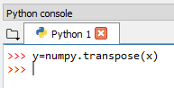

h. Do a matrix addition “x+y” and store it as a new array “a” and display the contents of a

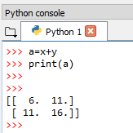

i. Do a matrix multiplication “x*y” and store it as a new array “b” and display the contents of b

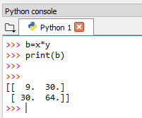

Part 2:

Matplotlib:

2)

a. Use subplot function to plot the following functions:

* y=sin(x)
* y=cos(x)
* y=tan(x)
* y=x

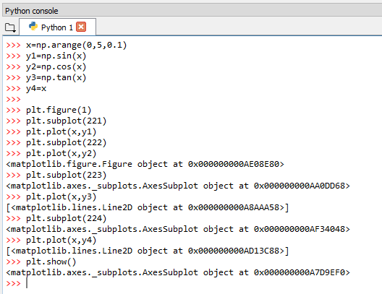

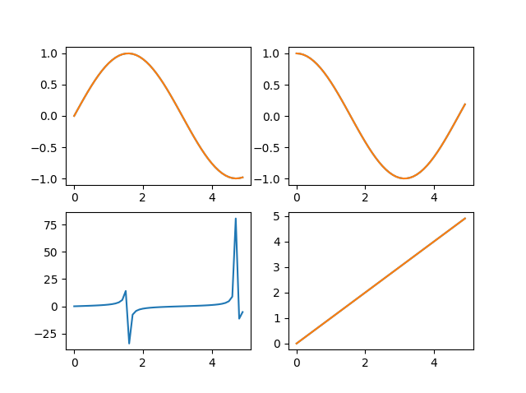

b. Plot the graphs for the above mentioned functions on the same figure using hold function. Assign different colour, thickness and linewidth for the different functions

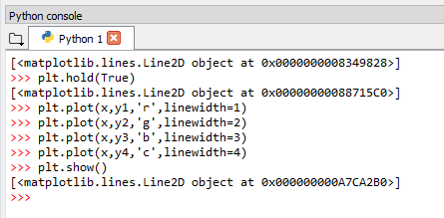

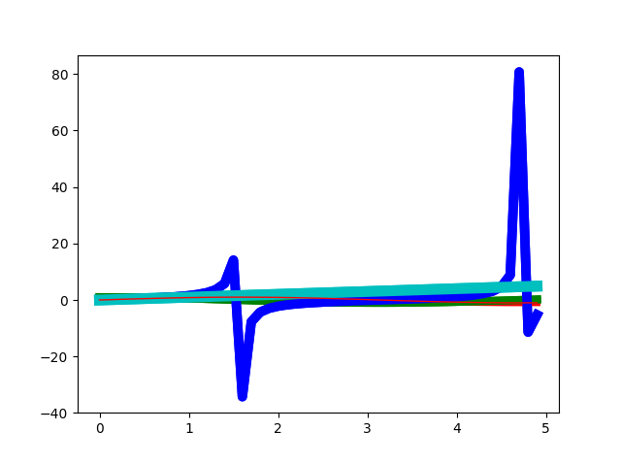

c. Download the monthly_temp_data.csv sheet attached with the homework

Import the above csv file using csv.reader

Read the file as a list

Store the values for temperature column and day in separate lists (remember to remove the headers)

Plot the graph for Date vs. Temperature with title for the plot as “Day vs. Temperature”, xlabel as Date and ylabel as Temperature

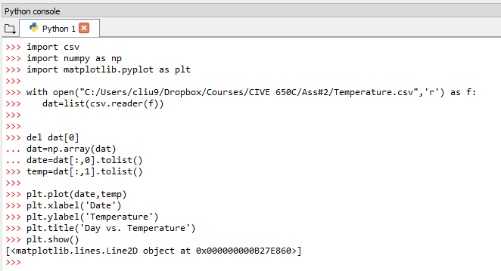

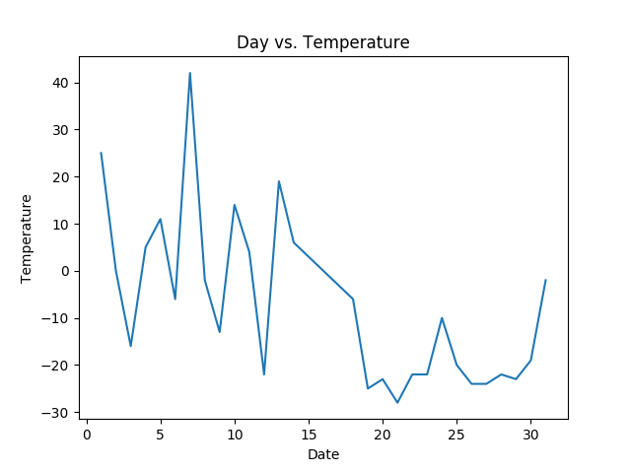

Submission Guidelines: Your submission should have the following files:

1) A word doc with the snapshots

2) Your yourname.ipynb ipython notebooks.