CE 650C – Chenhui Liu

1.

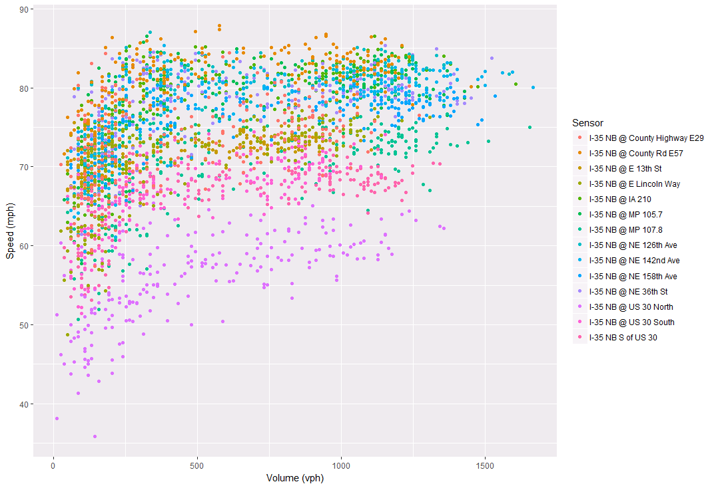

Figure 1: Speed vs Volume

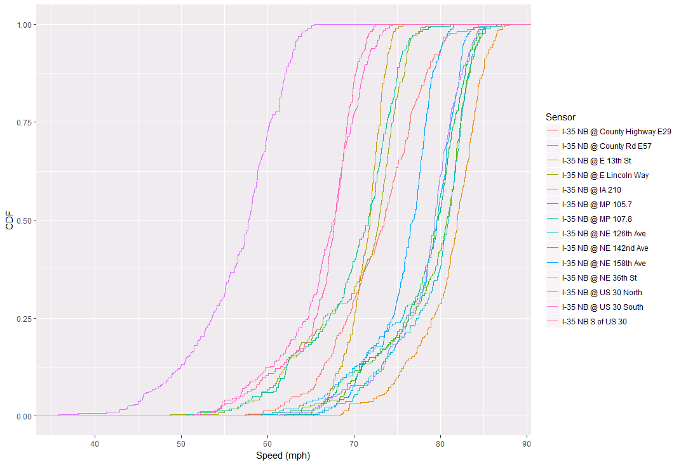

Figure 2: CDF of Speed

From Figure 1 and Figure 2, the sensor “I-35 NB @ US 30 North” behaves different from other sensors. It is clear that the average speeds on this sensor are generally lower than other sensors.