Progress summary 20171226

* Data cleaning

According to the research scope of the paper, the owner “Siebel” is a not a real human handler and should be excluded from the scope the paper. Meanwhile, the incident with only one handler should also be excluded as there is no handoffs.

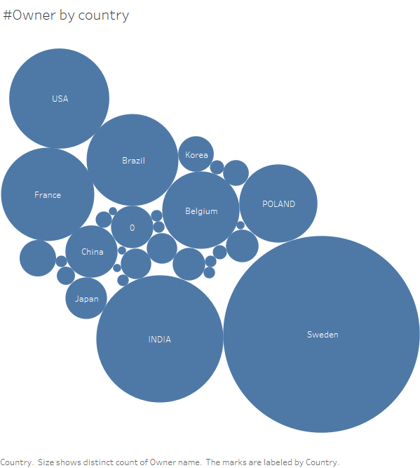*Data using currently with my work is cleaned in the way I mentioned above, attached as **cleaned_data.xlsx**

* First attempt, assess the demographic of

owners which reveals that owners from Sweden

are overwhelming, while owners from India,

USA, Brazil together with France and several

EU countries are quite similar in number. The

fact is actually not surprising as Sweden is

the headquarter of Volvo.

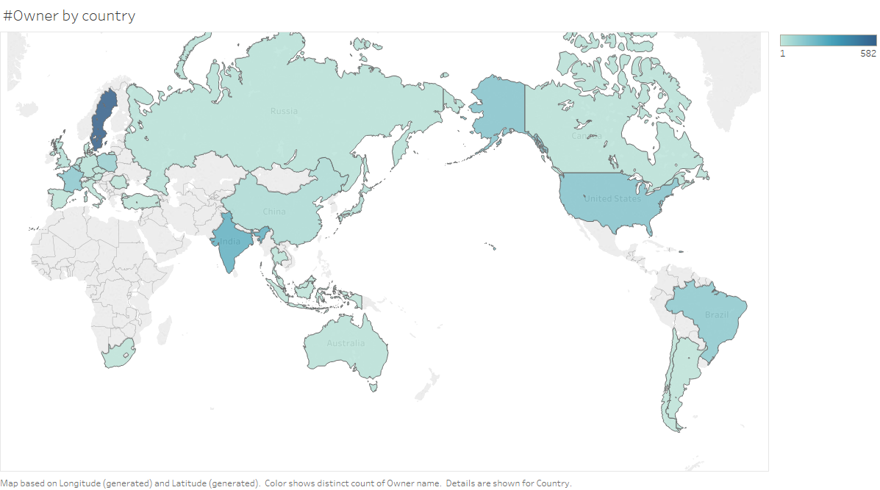

* As many international companies have different divisions and various functionalities across globe, a certain pattern might be corresponded to a certain country, in terms of productivity for example. Therefore, I tried to plot some graph to reveal the relationship between SR Number, Product and Owners.
* An interesting fact found is concerned with Poland: number of owners from Poland seems to be quite insufficient and disproportionate to the number of SR Numbers they need to handle. As a consequence, incidents involved with Poland might take a longer time to solve.

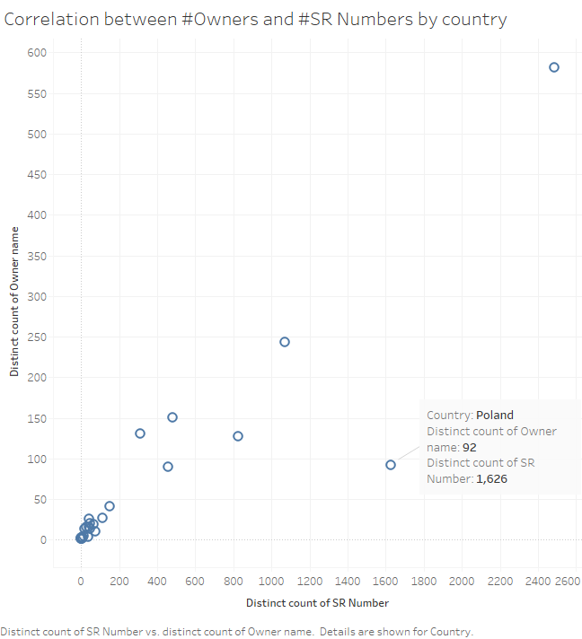

* To control factors affecting this issue, I also study the relationship between SR Numbers and Products country by country and plot the following graph, which the reveals that the positive correlation between SR Number and Products by country-wise is almost perfect:

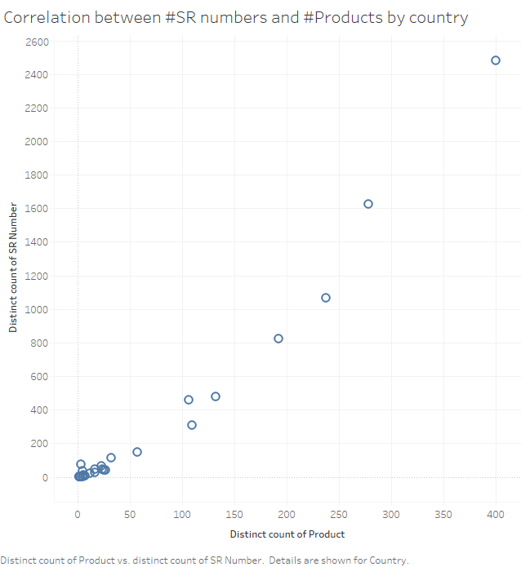

* Future work: after reading all four reviews from professionals, I’m also concerned with the completeness of the analysis. The quantitative analysis part is quite insufficient (almost only take the average time of the lifecycle of incidents for certain pattern). To many the analysis more complete, I suggest taking country factor into consideration as branches in different countries might have different characteristics. It would be great some issues in found in this data set can be mapped to Volvo’s annual reports, especially for various branch offices. In short, I think we need to make the story “told” by data sets more complete.