Progress summary 20180208

* I have been reading material we have in detail recent days, including the original paper, data set description and reviews, along with a brief walk-though of additional resource that can be useful. This report would include six parts: the first are ideas that I so far come up with, the following four summaries of the core material of this research, and the end are reviews, which I have taken some note on, marked out important sentence and improved the readability.
* Purposed researching direction:

1. Visualize *Support Organization Structure* for three categories of patterns, to show which route is most frequently visited.
2. Do demography analysis upon three patterns, too see if different countries have different distribution of three pattern. Try to find if there is any correlation with types of services that a certain country provides. (The demography should be based on action owner’s nationality).
3. Filter out period with big turbulence, to analyze handoff patterns during “normal time”. Compare this result with those turbulence time. Also try to dig out if there is news reported immediately after the turbulence time.
4. Purpose definition for “productivity” in this Volvo case and identify those skillful action owners.
5. Pinpoint potential human resource allocation problem reflected in the data set, such as efficiency of different service groups with same type.
6. Research annual reports, to figure out if the change claimed by Volvo can be reflected in data set, such as expansion in certain country might accompany with an increase in frequency of “straight pattern” within that country.
7. Plot graph about frequency of three patterns against time to draw statement about the distribution of patterns
8. Classify incidents according to priority, to correlation this with pattern distribution and number of owners and countries involved.
9. Present how these correlations or indicators can be useful for a company or department like human resource. Provide appropriate visualization, if applicable.

* Summary of current paper

1. Focus on only three patterns
2. Consider only time duration, pattern types and impact
3. Have statistics mentioned about frequency and average duration about pattern types (divided by two groups: low and medium impact)
4. Do a relatively comprehensive analysis to Prod424
5. Try to demonstrate number of owners involved is a better indicator of the duration of an incident, using OLS model
6. Conclude that frequent exchange could be potentially beneficial (shorter duration); however, the analysis is not concrete

* Summary of information in data set

*Handle Incidents Process*: as quickly as possible, while maintaining the quality.

Support Organization Structure:

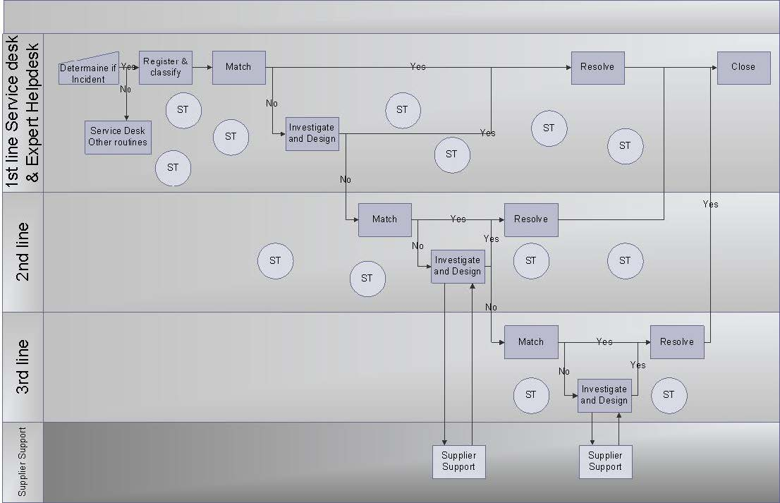

Impact: measure of the business criticality of an Incident often equal to the extent to which an Incident leads to degradation of agreed service levels. Category: Major/High/Medium/Low

Urgency: about the necessary speed of solving an Incident of a certain impact to the user. Category: High/Medium/Low

Priority: determined by the Impact on the business and the Urgency for which a Work Around or Solution is needed.

Priority Matrix:

|  |  |  |  |  |
| --- | --- | --- | --- | --- |
| **Priority** | Major Impact | High Impact | Medium Impact | Low Impact |
| High Urgency | - | 4 | 7 | 10 |
| Medium Urgency | - | 5 | 8 | 11 |
| Low Urgency | - | 6 | 9 | 12 |

*Note: Urgency and priority does not need to follow any rules during a Major Incident

It is **the responsibility of every action owner (ref. RACI)** in the support organization to identify reoccurring Incidents and initiate work to remove the cause of these Incidents.

Data set information:

1. Problem or SR number: The unique ticket number for a problem or incident
2. Problem change Date + time: Moment of status change
3. Problem Status: Queued, accepted, completed, closed
4. Problem sub-status: Assigned, awaiting assignment, cancelled, closed, in progress, wait, unmatched(?)
5. Impact: level of impact the problem creates for the customer (major, high, medium, low)
6. Organization (problem involved org line 3): the business area of the user reporting the problem to the helpdesk
7. Function division: The IT organization is divided into functions (mostly technology wise)
8. ST (support team): the actual team that will try to solve the problem
9. Country code: the location that takes the ownership of the support team
10. Action owner: the person that works in a support team that is working with the incident. An action owner can transfer an incident or problem to another action owner within the same support team, or he can escalate or return a problem to another ST (Support Team)

Extra notes in the data set (refined by Liu):

Problems had batter to be solved within the first front line to reduce the disturb to core work of the inner lines. The push to front works if the 1st line support team can set the SR to resolve without interference of a 2nd or 3rd line support team.

Knowing that there are a lot of KPI’s measuring the total resolution time of an incident people try to find workarounds that stop the clock from ticking. One way of doing this is manually giving an incident the sub-status “wait user”. Although there are guidelines not to use this sub-status (unless someone is really waiting for an end-user off course), some people (action owners) are breaking this guideline.

* Summary of the extra resources

Currently, I have considered the resource from the Volvo Group and some papers on Human Resource Allocation. I thought that to achieve more in depth of analysis, I need to get more familiar with incidents nature produce by Volvo Group. From my previous research, divided by country could be a potentially useful approach (for example, to do research on Volvo’s dealers’ distribution / demography). List of extra references founded by now:

1. Annual / corporate reports (2010, 2011, 2012)
2. Financial reports / ppts (2011, 2012)
3. Dealers’ distribution (it may take effort to find out historical data in 2011, 2012): <https://www.volvocars.com/en/find-a-dealer>
4. Human Allocation papers mentioned by reviews (see attachment named with Review 2-1.pdf and Review 2-2.pdf)

* Summary of the four reviews (original reviews along with the annotation available in appendix)

Overall speaking, these reviews towards the paper is quite negative. After a detailed study of reviews, I consider several aspects can be improved:

1. Provide more solid analysis on data set: control more variables to achieve more solid statements. For instance, we should identify certain features of an incident, based on not only the pattern, but also the pattern duration, owners and perhaps origin country (on this point, try to compare with the information with annual report).
2. As this is a real-world case study, purpose potential benefits of the analysis in handoffs. Try to some human resource allocation problems.
3. Language problem: grammar, the preciseness of word usage and probably more citations to consolidate statements or conclusions.

* Appendix: Reviews of the reviews by Liu

----------------------- REVIEW 1 ---------------------

PAPER: 146

TITLE: What Can We Learn From Actor Handoff Patterns?

AUTHORS: Akhil Kumar and Veeresh Thummadi

**Overall evaluation: -2 (reject)**

The paper "What Can We Learn From Actor Handoff Patterns?" is a study of mining and exploring the handoff patterns of business processes using the publicly available Volvo incident data.

The basic premise of the paper seems promising. However, in its current form, the paper is not convincing to me because it appears **to lack in both rigor and relevance**, as well as a positioning within *Design Science Research*.

Below, I summarize the two major issues that I have with the paper and give actionable advice to address these.

1. The motivation and positioning of the study. Your paper is lacking

(a) a clear gap in the literature and

(b) an explicit research question

Please explicate **who will care about your results, and why will they care**. Your approach is very exploratory, but you need nonetheless to position yourself clearly with a gap within the various literatures that you cite (e.g., BPM, organizational routines, ...). **It remains unclear why analyzing handoff patterns is needed or worthwhile.**

2. Your handling of the data and some of your conclusions. First, why did you remove the application system from the data? IT artifacts such as **application systems** **can be actors**, and it would be interesting to see how often they act. As such, your data may lose valid hand-off points.

Second, I do not find many of your conclusions convincing because they lack context information. For example: "This raises the question, why does an instance with one additional handoff take a shorter duration than without it?" This may be easily answered by several **contextual facts** that cannot be answered by only looking at the pattern of tasks: this could be, for instance, because

(1) a more experienced actor, or a deciding manager, was involved who solved this more quickly, or

(2) because the customer/client was a "top/valued" client and was treated with much more speed,

to give just two possible explanations. Your analysis completely disregards context.

----------------------- REVIEW 2 ---------------------

PAPER: 146

TITLE: What Can We Learn From Actor Handoff Patterns?

AUTHORS: Akhil Kumar and Veeresh Thummadi

**Overall evaluation: 0 (borderline paper)**

There are two major issues with this research in progress paper.

1. **Nowhere in the paper has been discussed about whether the incidents have been successfully resolved or not**. Imho *(lmho denotes to “Laughing My Head Off”)*, this is **crucial for the usability** of this paper’s findings. **I cannot see the benefits** of these patterns as they have **not been linked to some performance indicators** such as incident has been resolved vs. incident has not been resolved.

For instance, it would be interesting to see whether a ping pong pattern always occurs when an incident has not been resolved.

2. Typically, there are many decisive factors on whether an actor would perform tasks in a business process. These include among others the position of the actor, experience, skills, etc. These factors should be taken into consideration when undertaking this kind of research. **The work done in this paper is complementary to the work already published on human resource allocation in business processes**, which has not been taken into consideration. Please link your work with the following, and discuss how it relates to the state of the art:

*Cabanillas, Cristina, Manuel Resinas, and Antonio Ruiz-Cortés. "Defining and analysing resource assignments in business processes with ral." International Conference on Service-Oriented Computing. Springer Berlin Heidelberg, 2011 Cabanillas, Cristina, et al. "Priority-based human resource allocation in business processes." International Conference on Service-Oriented Computing. Springer Berlin Heidelberg, 2013.*

Some minor issues:

• Related to the 2nd major issue, the work presented in this short paper is not building up on prior research done on this topic. Also, **many statements have been made, without referencing prior research.**

E.g. Section 2, paragraph 1: “There is ample evidence …” reference is missing E.g. Section 2, paragraph 2: “Sequence analytics refers to …” reference missing …

• Discuss more on whether your approach can be generalized to business processes in general, or it only works on incident resolution process.

• Although the paper is easy to read, there are many typos and **grammatical mistakes** throughout the paper. The authors should double-check before submission.

• Also, some sentences are unclear or simply unfinished. E.g. on page 2, paragraph 2: “The example log above represents high variability because of the different action pattern sequences and since the actual tasks and the edit distances between the pairs are large.” I believe here the word “since” is incorrectly used which makes the sentence as a whole unclear.

• There is no consistency in introducing the abbreviations. Some abbreviations have been introduced without indicating what they stand for (e.g. BPM).

----------------------- REVIEW 3 ---------------------

PAPER: 146

TITLE: What Can We Learn From Actor Handoff Patterns?

AUTHORS: Akhil Kumar and Veeresh Thummadi

**Overall evaluation: 1 (weak accept)**

Throughout the paper, the authors report on a study conducted on the real-life incident management event log included in the BPIC 2013 dataset. In particular, they extract and analyze the hand-off patterns characterizing the cooperation of the actors involved in the execution of the process by their mutual transfer of work, hence tackling the automated process discovery problem from a resource perspective. The authors focus on straight, loop, and ping-pong patterns. Moreover, **they try to determine a correlation between the hand-offs and the duration of the process instances.** The analysis yields as interesting insights, a.o., that

(1) the straight patterns rarely lead to shorter execution times, and

(2) the number of participating actors (named owners in the paper) has an impact on the duration of the process more than the occurred hand-offs.

The research objective of the authors is interesting — especially for its long-term implications, where a new framework could be devised that is independent of the specific process under analysis. I invite the authors to make explicit from the very beginning of the paper that the presented research is a building block of a larger and more ambitious project, and also detail what the future directions are — the last paragraph of the conclusions is rather limited and not so indicative. This would help the reader (and the reviewer) not judge the quality of the reported research per se, but frame it in a broader perspective. As it is, the **depth of the analysis and the significance of the contribution are rather marginal**.

On the contrary, I request the authors to change the title of their contribution should it be accepted for publication, because it suggests a wide discourse about what can be learnt from actor hand-off patterns in a general sense, whilst the paper reports on a preliminary study conducted on a single event log.

Furthermore, one of the declared aims of the reported endeavor is to conduct a research that lies between the fields of BPM (process mining) and DSR (organizational routines), which is very much in line with the conference topics. However, the referenced literature sources seem not very balanced: The authors might want to position their work with respect to noticeable related papers in the field of BPM, including:

Schönig, S., Cabanillas, C., Jablonski, S., Mendling, J.: A framework for efficiently mining the organisational perspective of business processes. Decision Support Systems 89: 87-97 (2016) Schönig, S., Cabanillas, C., Di Ciccio, C., Jablonski, S., Mendling, J.: Mining team compositions for collaborative work in business processes. Software & Systems Modeling (2015): 1-19.

Ly, L.T., Rinderle, S., Dadam, P., Reichert, M.: Mining staff assignment rules from event-based data. In: BPM Workshops, pp. 177–190 (2006)

Moreover, passage on page 1 reads: “Much research in the BPM and workflow literature has been devoted to discovery of a process model from logs of actual execution instances of a process. This field of research is called process mining.” The automated process discovery is actually only one part of the full spectrum of process mining, encompassing also conformance checking and process enhancement. The authors should rephrase their statement accordingly.

From a registry perspective, I would avoid the usage of the adverb “simply” when defining the concepts used in the paper (see e.g. page 2: “A handoff is simply…”, “An action or task sequence pattern is simply…”, “By a pattern we simply mean”). It does not contribute to make the explained notion clearer. On the contrary, a reader might feel like an imbecile because s/he did not know what the concept meant, although it was supposed to be simple. It might be counterproductive for the perception of the paper in the long run.

On page 4, the last paragraph begins with: “Further analysis showed that there was a learning curve effect in the initial period.” What is the learning curve that the authors are referring to? Is it the learning curve of the actors, taking less and less time to resolve incidents? If so, what was the evidence showing it? In any case, the authors should clarify what they mean by such a concept.

To the benefit of the readability of their results, Tables 3 and 4 should be put side by side. This could be easily achieved by merging the column with the ranking and shrinking the size of columns — the width of which is currently enlarged to contain the headers rather than the content.

I also wonder why a whole paragraph is dedicated in Section 2 to outline some notions of sequence variety, as they seem not to be exploited in the reported work but rather kept for future research.

A short list of typos and grammar issues follows:

Page 1: “we find the certain loop” —> “we find that…”

Page 1: “devoted to discovery of a process model” —> “devoted to the discovery of process models”

Page 2: “An actor 1 might handoff to actor 2 for one piece of work and then after receiving a response, handoff to 3 for a second piece of the work, and then combining the pieces of work of 2 and 3” —> please rephrase Page 3: “based on average edit distance” —> “based on the average edit distance”

Page 3: “In contrast, to these two notions” —> “In contrast to these two notions”

Page 4: “For analysis, the dataset was loaded in a MySQL database” —> “The dataset was loaded in a MySQL database for the analysis.”

Page 5: “the latter takes a smaller duration” —> “the latter takes less time” or “the latter has/presents a smaller duration”

Page 7: “showed in Figs. 3-5.” —> “Tables 3-5”

Page 7: “This could simply mean handing of the incident to a previous actor or a new actor determined by an algorithm.” —> “This could suggest/denote/be caused by the handing of the incident…”

Page 8: “to improve understanding of” —> “to improve the understanding of”

Finally, the authors should make the style of the references in the bibliography uniform — there is a mixture of abbreviated names and full names for authors, and reference 5 reports only the first author name, whereas the others occur as “et al.”

----------------------- REVIEW 4 ---------------------

PAPER: 146

TITLE: What Can We Learn From Actor Handoff Patterns?

AUTHORS: Akhil Kumar and Veeresh Thummadi

**Overall evaluation: 1 (weak accept)**

This short meta-review summarizes the reviews. The paper presents an interesting perspective of mining patterns of hand offs in event log data. The reviewers in general appreciate the research outline and highlight some important directions for improvement. These are:

1) better coverage of relevant literature on mining resources of business processes, and

2**) more cautious reflection on the statements of positioning and interpretation**.

Also, it should be considered whether a more specific title might better capture the ambition of the paper.