Progress summary 20180220

* Current target (please ignore proposals on last report)

Based on the progress made by previous authors and comments of reviewers, I suppose we should reinforce the analysis on “pattern performance”, not only using number of logs as an indicator of length, but also duration. Beyond this, I suggest we should also take the change in status/sub-status into consideration, just like handoffs between people (change in action owners of an incident). Moreover, we should identify potential contributors or factors towards handoff patterns, for instance, action owners, their working location (by country), origin countries of incidents, impact level denoted.

The pipeline, by my suggestion, shall be: provide paper readers with compiling conclusions or remark based on general statistics (fast facts) about three types of handoff patterns (more detailed than the current paper); then propose some statements on these, followed with appropriate visualizations and the case study about certain product, several action owners or analysis of an office performance in a country (relevant information might be able to find from external resources, i.e. annual reports).

Drawing some insights from external resources is a great approach, but for now I think I has better to find some conclusion within dataset. After this, outsource information on Human Resources Allocation or Annual Reports as demonstrations on our conclusions and usefulness of the research work on handoff patterns.

* The data

During these days, I do a quite comprehensive analysis about the dataset to understand it better. For analysis on paperwork such as original paper, dataset information, please see my last report, a.k.a. “progress_handoffs_20180208”.

Contrary to the understanding of previous authors, the dataset is actually NOT spread from Mar 2010 to May 2012. ALL of incidents’ ending date is within Apr to May 2012. So I think that the dataset is a collection incidents closed in this period, explaining why turbulence in May 2012 is so violent (for details, see report 0114 this year). I wrote some SQL code to discover this:

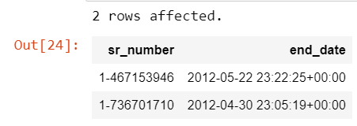

Data on Function Div, Org line and ST is quite not useful as there is not information about this terminology used by Volvo. However interestingly, the change of this parameters are usually involved with a change in status.

Graphs below demonstrate number of SR Numbers corresponding to these parameters (only show top 15):

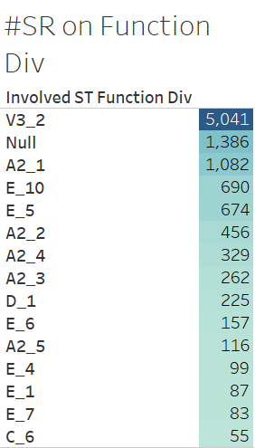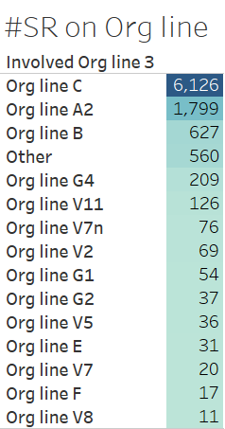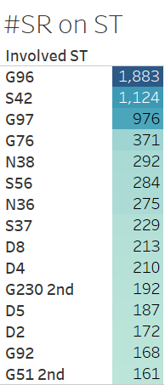

I also note that sub status is a more detailed description on status, so I try to categorize them, by numbers of logs. In this graph, we can find out sub-status like “Wait - User”, which is actually action owners trying to fulfill KPI with less effort.

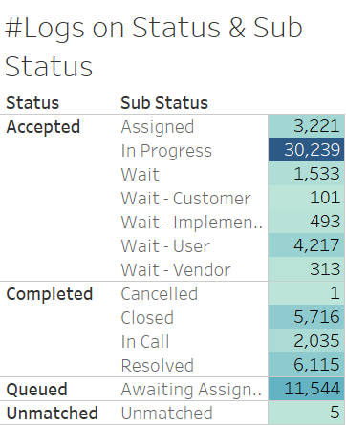

* Data visualization

1. Counties involved in problem management of Volvo

I have always been considering about the country’s role in handoff patterns. It’s quite common sense to think that a global company like Volvo would have different offices in different countries to deal with different incidents. As a consequence, conclusions made about countries are perhaps easier to find external resources to demonstrate this.

First, I notice that some incidents are solved by action owners from different countries. I projected that the impact of incidents might require different level of international collaboration (by number of countries involved):

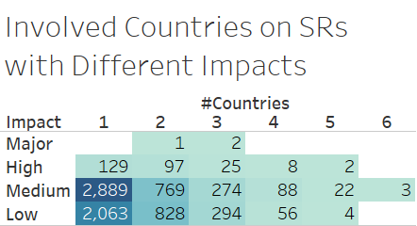

The result is a little bit surprising as many incidents with Low impact requires international collaboration as those with Medium impact. However, we can expect that in the same level of international collaboration, Low impact incidents would take more time. If not, we can then guess it’s because of the effect of international call-in center.

To see how active a country is in dealing with incidents, we can refer to the spectrum graph. In the graph, you can see the working pattern and how busy of a country. Each mark represents an event log.

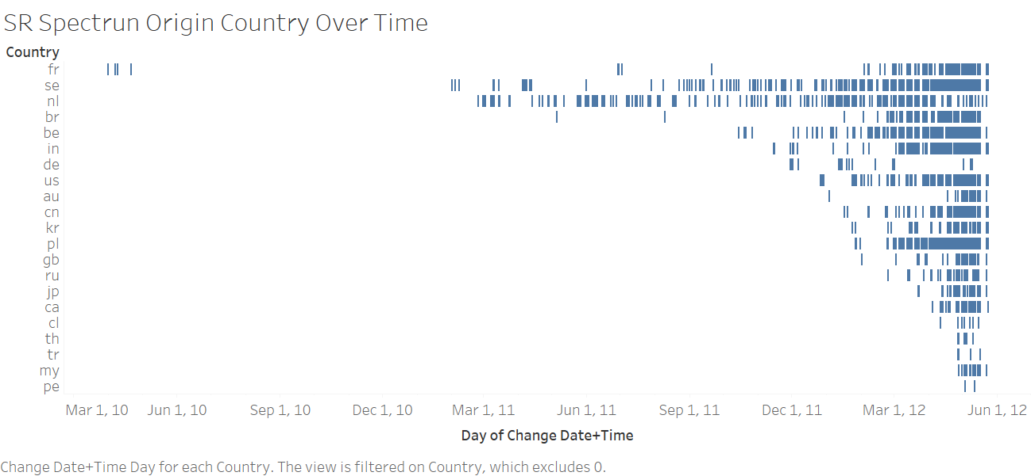

It is noticeable that each incident also has its origin country and I would like to see about how the relation between this country and countries of action owners who try to solve this incident.

I modeled this relation in a co-relation matrix, while the number represents the number of incidents originated in a certain country while participated by an action owner in another country.

In this graph, code represents incidents, while name represents owners:

(Note that I have excluded some owner countries with no corresponding with country codes of incidents, yet their presence is negligible)

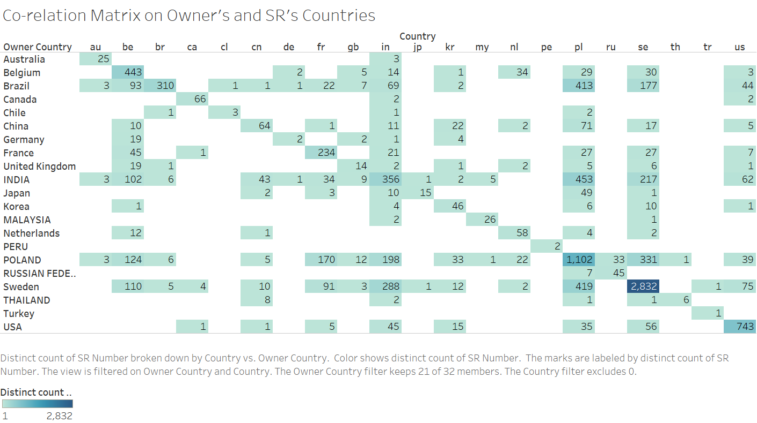

We can notice that the majority of incidents can be solved within same country. The graph can also reveal the internationalization of a county. Like India, Sweden and Poland are involved with almost all the countries, while Peru and Turkey only deal with incidents within themselves. We can project that Sweden is busy as the headquarter, Poland for major business in Europe and perhaps India for call-in center.

1. Products

For a company, some products might have more incidents than other due to the poor design or other issues. This also happens on Volvo: 22 products in over 700 take almost a half of the incidents:

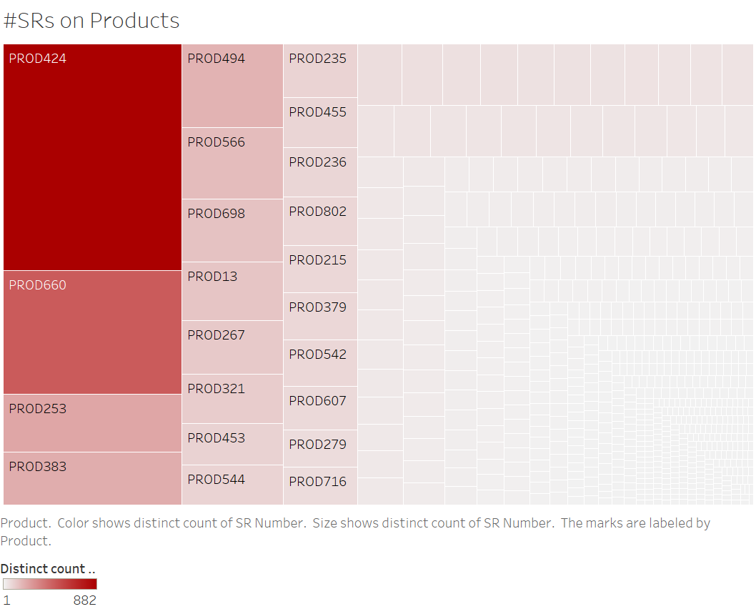

In future work, we can do a case study on PROD424 with its almost 900 incidents, to see if there is any pattern similarity. Also note down the date to search if there is any negative news about Volvo on that period, especially about products, such as recalls.

1. Status of incidents over time

Just like handoffs, the incident went through status change over time. In this way, I modeled a spectrum graph to see this change over time, with different colors representing status on beginning of the change.

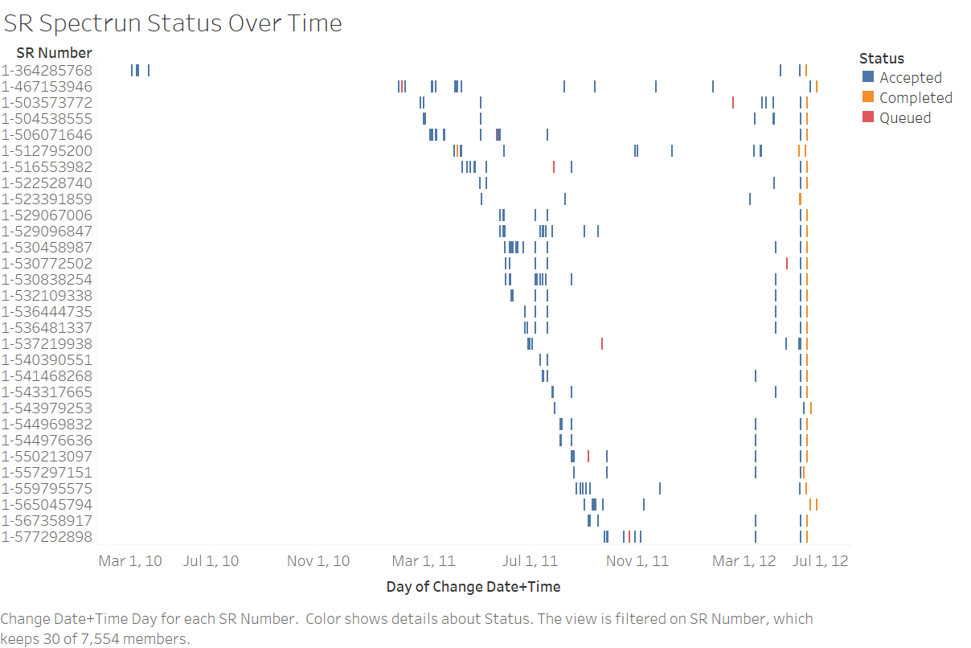

The graph illustrates the first 30 incidents’ “lifetime”. We can see that these incidents happened early usually had quite a busy time at the beginning and a long gap before resolved and closed. However, the graph is quite messy to draw more meaningful conclusions.

1. Owners with incidents on different impacts and status

I suppose that an owner is more skillful if he or she can handle more incidents and incidents with higher impact (or he might just be some like operator in call-in center).

In another way, the diligence of an owner might be revealed on the number of he “accepted” v.s. that he “queued”. The more “accept” status over “queue” might prove the hardworking of an owner, or he is like operator in call-in center that dealing work with light effort and time.

For these two postulates, I both use a stacked bar graph to represent, selecting the first 48 owners with most incident experience:

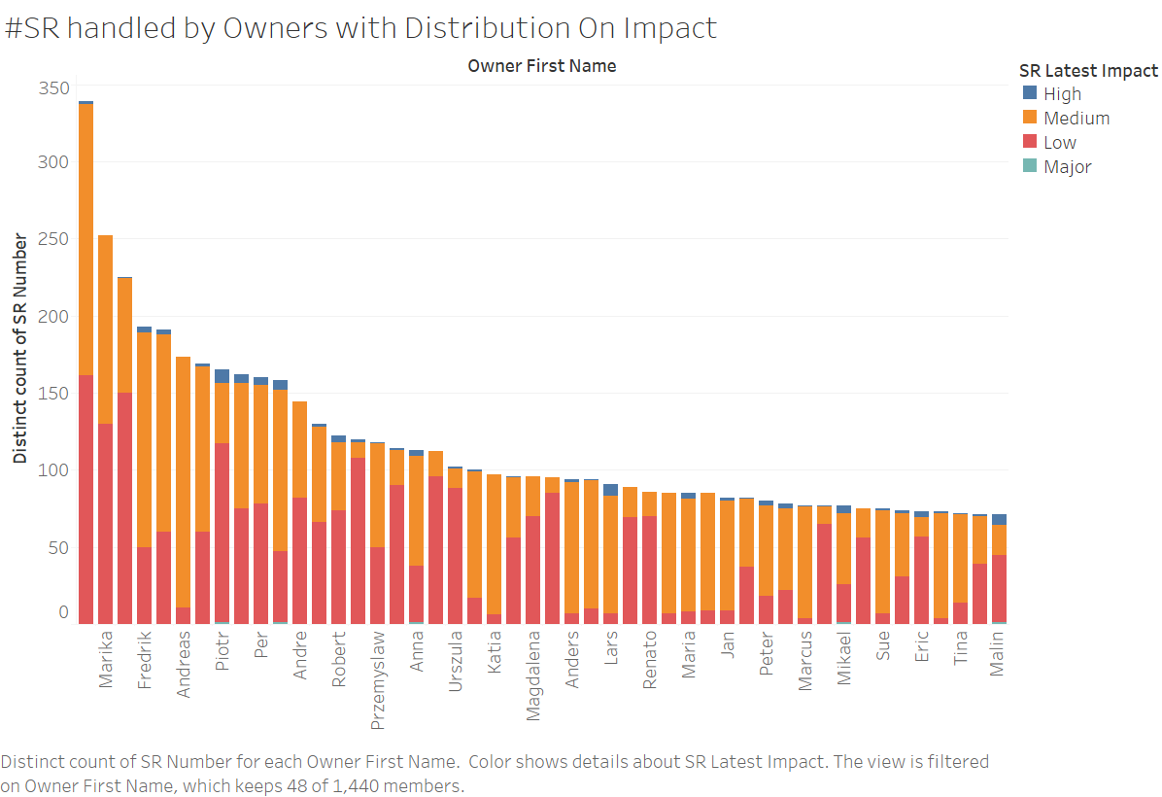

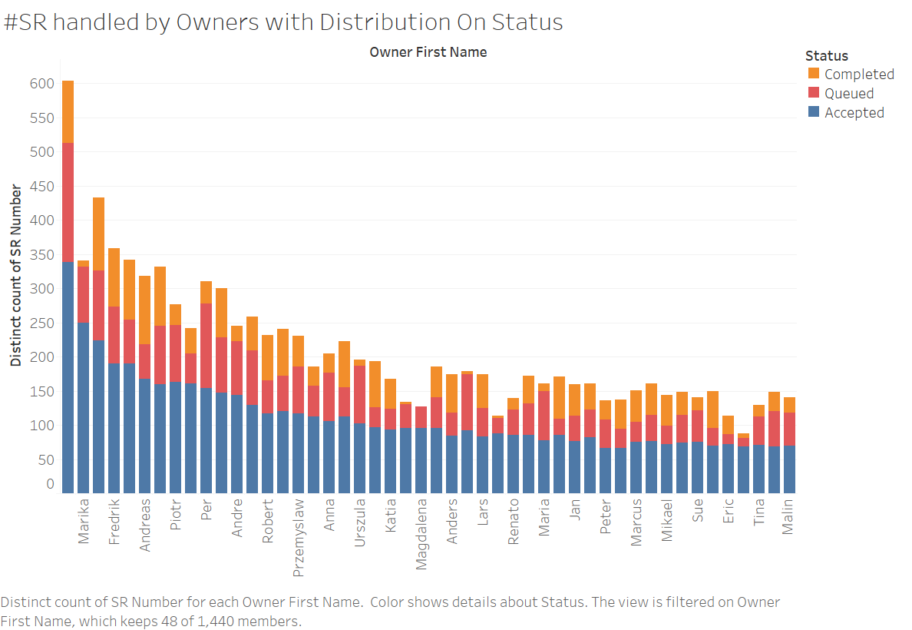

From the first graph, we can see that some owners seem to be solving all incidents with Low impact, while other with Medium impact. Yet still a lot of owners are doing this on half-half basis. For certain owners, a case study might be useful in drawing conclusions.

I also try to do spectrum graph on owners just like impact, which can reveal the handoffs directly (in theory). However, this is a failure as there is too many owners (only top 30):

