Progress summary 20180114

* Patterns of daily number of owners and SR numbers involved

The scope of the data set spread from Apr., 2010 to May, 2012, so I think that it would be interesting to see the fluctuation of different variables across this time scope. Therefore, I chose number of owners (distinct count) and number of SR

Number.

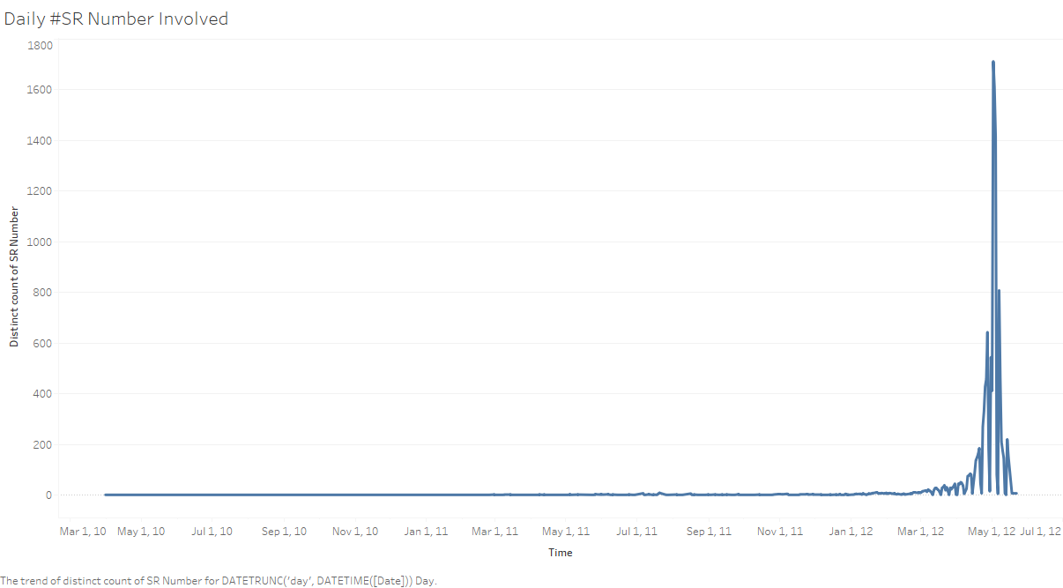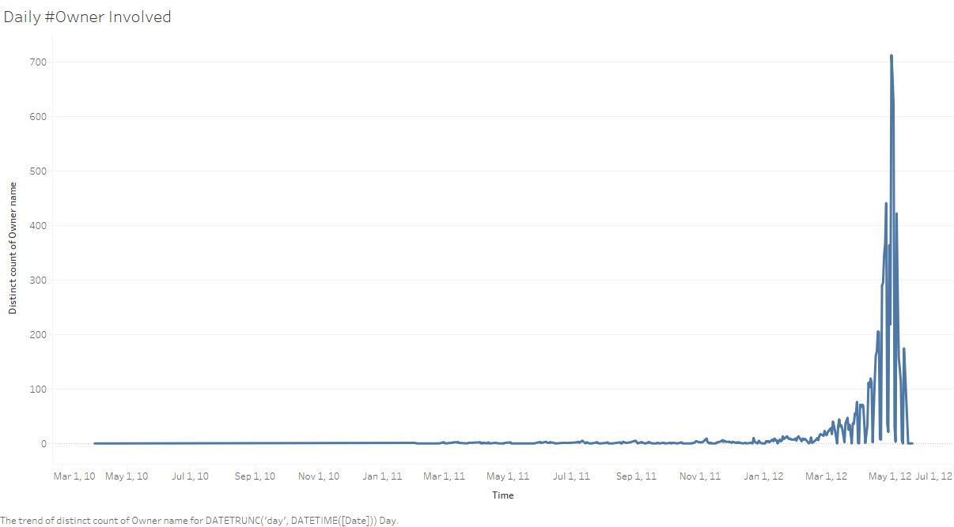

* Abnormality in May of 2012

Actually the chart surprised me by the overwhelming fluctuation in May 2012, as the #Owners and #SR Number had always been stable before May (I even use Ctrl + F in the Excel file to make sure I did not do anything wrong). Generally speaking, the #Owners involved every day are smaller than 5, while in May, hundreds or even thousands of owners are involved. So I drew the demography of #SR Number involved in 20120502, the peak to see if there is any interesting findings:

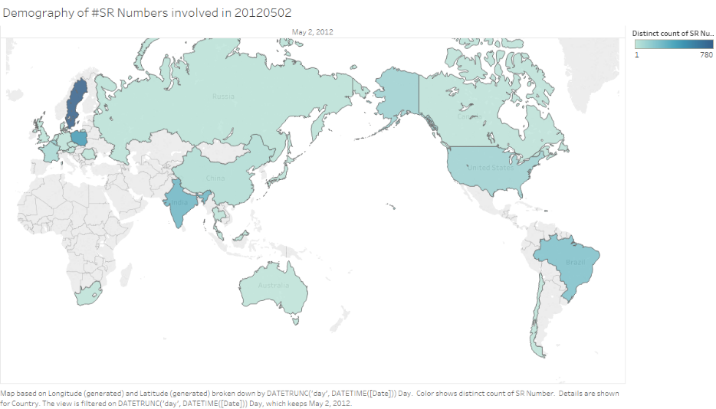

This chart suddenly reminded me about the demography of all owners appeared in the data, which I have drawn in the last progress report. So then I tried to find if there is any similarity between demography of owners involved in 20120502 with that all owners appeared in the data set:

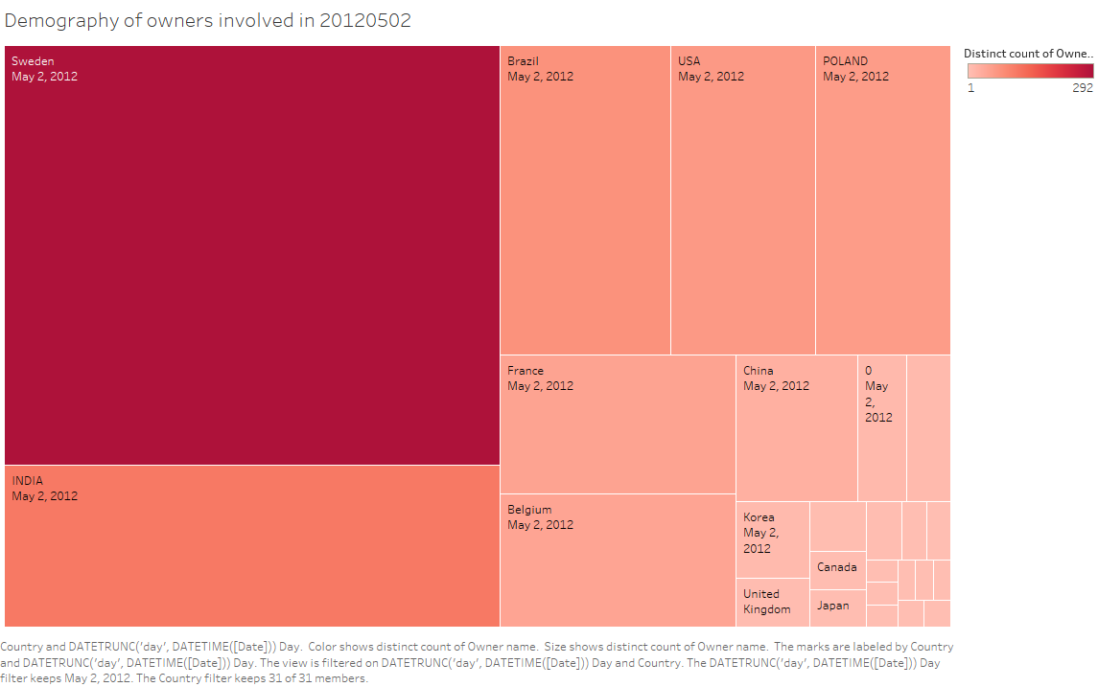

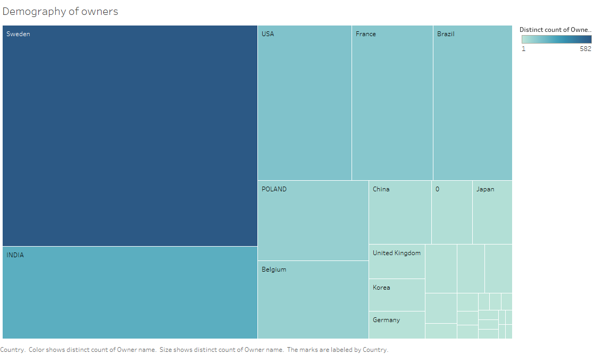

The similarity is in high level, based on major contributor countries. Consequently, it is natural to think that the company must undergo some systematic reform or crisis during May 2012.

Therefore, I checked about the financial report of the company in H1, 2012 and the result is not surprising: compared with H1, 2011, Operating cash flow drops from 3,618 to 280, while the new income (in millions of SEK) drops from 1,213 to -254 (negative), not to mention a branch of indicators with red signal.

\*Ref: P8 – 10, Financial Report Jan. – Jun., 2012, Volvo Car Group®

More investigation of what’s happening in May 2012 should be done, but it seems to deviate more from what we have been working currently, the Handoffs. So I temporarily suspended my work here.

* Demography of owners in data set compared with that of all Volvo employees:

As our data end on May of 2012, I started to read about the 2012 annual report at first, trying to find out if there is any clue linked with the data set.

The first corresponding I found out is the correlation of global employee distribution and the distribution of all owners appeared in the data set. By my statistic, there is 1400+ different owners appeared in the data set, while in fact Volvo had 98,000 + employees all across globe (Year 2011 - 2012). Surprisingly, the distribution is quite similar:

(All employees: Europe 54%, Asia 20%, North America 17%, South America 6%, Other 3%)

\*Ref: P35 – 37, Annual Report 2012, Volvo Car Group®

This fact could further prove that the turbulence in May 2012 might be a systematic issue all across the company.

* Further work:

I’m still reading the annual report, hoping to find out more correlation that can be demonstrated by the data set. However, I think that there is some deviation in the direction “Handoffs”. I’m wondering about whether the authors of the paper have made some further modification towards the paper, such that I can have a look? Also, it would be nice if I can get the data set with Handoffs pattern to facilitate my additional work here.