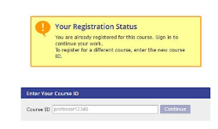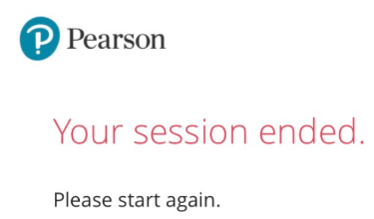

**If you are seeing any of the following errors, please use the tips below:**

* 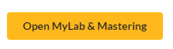Your Session Ended
* Prompted for a course ID
* Nothing happens when you click “Open”
* Or any other issue affecting your access to MyLabs, Mastering or Revel

1. First, try going to the site below, selecting your browser and then making the necessary setting adjustments:

<https://support.pearson.com/getsupport/s/article/Browser-Settings>

**2. MAC Issues - Session Timed Out Error**

The latest iOS version, there’s a new default called “**Prevent Cross-Site Tracking**“ that must be unchecked.

**Here’s how your correct the issue on an iPad:**

1. Go to your Settings on your iOS device.
2. Find Safari
3. Make sure all the following are *not* green. If they’re green, then slide them to the left.
   1. Block Pop-us
   2. Prevent Cross-Site Tracking (this is the new change)
   3. Block All Cookies
   4. Ask Websites Not to Track Me
   5. Fraudulent Website Warning

**Here’s how your correct the issue on a Mac:**

1. Go to Safari.
2. On the top left corner of your screen, there is an apple button.  Directly to the right of that should be the bold word ‘Safari’.  Select Preferences under Safari.
3. Click Privacy – deselect “Prevent cross-site tracking”, “Ask websites not to track me” and “Block all cookies”.

If the above steps do not fix your issues, then you need to contact technical support at the site below:

<https://support.pearson.com/getsupport/s/contactsupport>