Normal Big Bang Nucleosynthesis and the Primordial Lithium Problem
Hydrogen, helium and lithium production from standard-network controls to a qualified finite-temperature selective-transfer candidate
Authors: Clive Stewart Boyd; David Ng
Generated: 11 September 2026 | Melbourne, Australia
Computational assistance and reproducibility support: ChatGPT Codex sol 5.5

EVIDENCE STATUS: Qualification-audit passed for the full Planck PR4/NPIPE CMB nuisance gate; scientific promotion remains conditional.

Executive Summary
- Standard BBN remains successful for deuterium and helium at the adopted CMB-compatible baryon density, but predicts Li-7/H roughly three to four times above the warm metal-poor stellar plateau.
- The July 2026 investigations were negative: FR/clock-proxy changes, SU2-style expansion controls, reaction-rate pulls and network scans did not produce a joint D/H, helium and lithium solution.
- The August 2026 programme identified a selective post-BBN electromagnetic-transfer candidate. The candidate is narrow and mechanism-dependent, but it has passed the abundance, cascade, entropy, FIRAS and leading finite-temperature checks recorded so far.
- The new September 2026 result is important: the combined native Planck PR4/NPIPE nuisance audit passes every preregistered gate. The registered lithium cell is inside the joint 95% CMB posterior with Delta chi2 = 1.257.
- This does not prove the lithium problem is solved. It upgrades the evidence state from 'positive but ESS-limited' to 'CMB-gate audit-qualified'. Matched next-to-leading-order plasma physics, independent reproduction and an explicit particle/action-level model remain open.
TV index
Traceability item | Recorded value
Document update | Regenerated 11 September 2026 from local post-process and combined qualification audit outputs.
Authors | Clive Stewart Boyd; David Ng.
Computational support | ChatGPT Codex sol 5.5 referenced as the project computational-assistance environment.
Primary new gate | Full Planck PR4/NPIPE native nuisance audit: PASS.

Current Claim Boundary
The current result should be described as an audit-qualified candidate for a selective electromagnetic pathway through the cosmological lithium problem. The analysis does not yet constitute a discovery claim, a completed microscopic model, or a replacement for standard BBN. It does show that the registered August candidate is not excluded by the native Planck PR4/NPIPE CMB nuisance posterior under the applied gates.
Table 2. Evidence ladder status
Evidence layer | Status on 11 September 2026 | Interpretation
Standard BBN reproduction | Pass | The ordinary D/H and helium success, plus lithium excess, was reproduced.
July global-modification controls | Fail for solution | Useful negative controls; no D+He+Li pass.
Selective mass-7 threshold window | Pass as sanity gate | Photons near the Be-7 threshold can affect mass-7 more selectively than late neutrons.
ACROPOLIS/LINX/FIRAS candidate | Pass at frozen candidate | Abundance and distortion gates are satisfied in the recorded candidate cell.
Full Planck nuisance CMB gate | Pass after ESS top-up | Combined chain passes split, ESS, registered density and nuisance stability gates.
Matched NLO plasma calculation | Open | Needed before strong physics promotion.
Independent reproduction | Open | Needed before external paper-strength claim.

Chronological Development and Test History
Table 1. Investigation chronology
Date | Investigation stage | Result status
16-17 July 2026 | Standard BBN, FR/clock-proxy, neutron-lifetime, reaction-rate and SU2-style expansion controls with LINX validation. | Negative result: no joint D/H, helium and Li-7 solution. This is the explicit failure boundary for the preliminary July programme.
17-18 July 2026 | Hierarchical and surrogate follow-up tests, plus strict matrix validation. | Useful for scoping but not a solution. Lithium could be moved only at the cost of other abundance or CMB gates.
20-21 August 2026 | Selective post-BBN electromagnetic-transfer hypothesis. Threshold screen, ACROPOLIS cascade tests, frozen LINX priors and production modelling. | Positive candidate emerged: a narrow MeV-scale window can reduce mass-7 while preserving D/H, Y_p, He3/D, entropy and FIRAS gates.
21 August 2026 | Full Planck PR4/NPIPE CMB nuisance-likelihood protocol launched using Cobaya/CAMB and native Planck likelihoods. | Initial status pending. The goal was to replace a compressed CMB Gaussian gate with a native spectrum-level posterior.
2 September 2026 | Main full CMB nuisance chain completed and post-processed. | Positive but not yet fully qualified: Cobaya convergence was reported, but the stricter independent audit found autocorrelation ESS below the preregistered 1000 gate for some nuisance parameters.
2-11 September 2026 | ESS top-up chain run after the main chain to strengthen nuisance-tail sampling. | Computer reset stopped the top-up, but not before adding enough samples for the combined audit.
11 September 2026 | Combined main plus ESS top-up qualification audit. | Pass: all preregistered audit gates passed, including split-chain stability, autocorrelation-aware ESS, nuisance stability, half-chain stability and registered-cell posterior density.

TV index
Traceability item | Recorded value
Chronology source | July 2026 local BBN/Li outputs, August full CMB nuisance folder, September combined qualification audit.
Failure boundary | July preliminary programme failed to solve lithium while preserving D/H, helium and CMB-compatible baryon density.
Positive boundary | August selective-transfer candidate became positive only after moving from global expansion/clock controls to a narrow post-BBN electromagnetic mechanism.

Scientific Background
BBN predicts light-element abundances from the baryon density, the radiation content, neutron-proton conversion, nuclear reaction rates and the expansion history. The same framework that gives successful deuterium and helium predictions leaves a persistent Li-7 excess when compared with warm metal-poor halo-star plateaux. Most primordial Li-7 is produced first as Be-7, so a selective mechanism can target mass-7 after ordinary nucleosynthesis without needing to disrupt all light nuclei.

Core Equations
Table 3. Formula cross-reference
Label | Expression | Use
E1 | eta10 = 273.78 omega_b | CMB-to-BBN baryon-density conversion for T_CMB = 2.7255 K.
E2 | dY_i/dt = sum_j N_ij Gamma_j(Y,T) | Network abundance evolution in schematic form.
E3 | Li discrepancy factor = (Li-7/H)_BBN / (Li-7/H)_plateau | Measures the anomaly scale.
E4 | E_gamma approximately m_phi / 2 | Two-photon decay energy for the mediator candidate.
E5 | Delta chi2 = (x - mu)^T C^-1 (x - mu) | Registered-cell density test in the CMB posterior.
E6 | C = L L^T; C^-1 = L^-T L^-1 | SPD covariance cache used for the Planck PR4/NPIPE likelihood.

TV index
Traceability item | Recorded value
Physics boundary | Equations are diagnostic and model-selection support. A full Lagrangian/action is still required for theory-level promotion.
Symmetry boundary | The BBN-Li mediator model is not currently claimed as a Noether-derived symmetry result.

August Candidate Cell
The August candidate moved away from broad changes to the expansion law and toward a selective post-BBN transfer. Its working idea is simple: an electromagnetic injection can be tuned to interact with mass-7, principally Be-7, more efficiently than with deuterium, provided the spectrum and timing remain narrow enough.
Table 4. ACROPOLIS/LINX candidate and CMB comparison
Quantity | Value
mediator_mass_MeV | 4.44
photon_energy_MeV | 2.22
lifetime_s | 1.584893e+05
n_phi_over_n_gamma_at_10MeV | 1.211528e-06
g_phi_gamma_GeV_inv | 9.767274e-11
D_H_times_1e5 | 2.493161
Yp | 0.246735
Li7_H_times_1e10 | 1.488554
He3_D | 0.415242
eta10_CMB | 6.096517
Neff_CMB | 3.044601
mu_distortion | 1.476434e-09
joint_pass_probability | 0.650158
delta_log_evidence_vs_standard | 105.206012
Planck bestfit eta10 | 6.105374
Planck bestfit nnu | 2.84265
Planck bestfit YHe | 0.282034
Planck bestfit chi2__CMB | 10971.285

TV index
Traceability item | Recorded value
Candidate source | Post-process report and local resummed ACROPOLIS/LINX candidate values.
Abundance anchor | Li-7/H = 1.488554e-10 in candidate units table, with D/H and Y_p retained inside gates.
Spectral-distortion anchor | mu_distortion = 1.476434e-09, below the adopted FIRAS-style gate.

Full Planck PR4/NPIPE CMB Nuisance Gate
The full CMB gate replaced the earlier compressed Gaussian approximation with a native spectrum-level Planck likelihood. It samples eta10 through omega_b, samples N_eff and Y_p independently, and includes the Planck high-l CamSpec TTTEEE likelihood, low-l TT, low-l EE and PR4 lensing, plus foreground and calibration nuisance parameters.
Table 5. Planck likelihood stack
Component | Role
Planck PR4/NPIPE CamSpec TTTEEE | High-multipole CMB spectra and covariance.
Planck 2018 low-l TT | Large-scale temperature likelihood.
Planck 2018 low-l EE | Large-scale polarisation likelihood.
Planck PR4 lensing | Lensing reconstruction constraint.
Foreground/calibration nuisance block | Native amplitudes, tilts and calibration parameters left free under their likelihood priors.

Table 6. Main full CMB nuisance posterior summary
Parameter | Mean | Std | Median | 68% interval | 95% interval
ombh2 | 0.02219 | 1.9507e-04 | 0.02219 | 0.021995 to 0.022381 | 0.021809 to 0.022573
nnu | 2.81855 | 0.2532 | 2.81194 | 2.569554 to 3.062147 | 2.343549 to 3.327882
YHe | 0.262427 | 0.0186 | 0.262668 | 0.244057 to 0.280933 | 0.225078 to 0.298364
eta10 | 6.075084 | 0.0534 | 6.075231 | 6.021877 to 6.127459 | 5.97098 to 6.179927
H0 | 66.210921 | 1.5058 | 66.164438 | 64.706901 to 67.68329 | 63.421067 to 69.23348
omegam | 0.31734 | 0.0087 | 0.317346 | 0.308729 to 0.326008 | 0.300514 to 0.334223
sigma8 | 0.803256 | 0.0095 | 0.803151 | 0.793847 to 0.812604 | 0.784934 to 0.822145
S8 | 0.826006 | 0.0111 | 0.826026 | 0.814952 to 0.837015 | 0.804369 to 0.847849
chi2__CMB | 10984.919918 | 7.9961 | 10984.146 | 10979.26564 to 10990.31448 | 10975.553 to 10997.627775

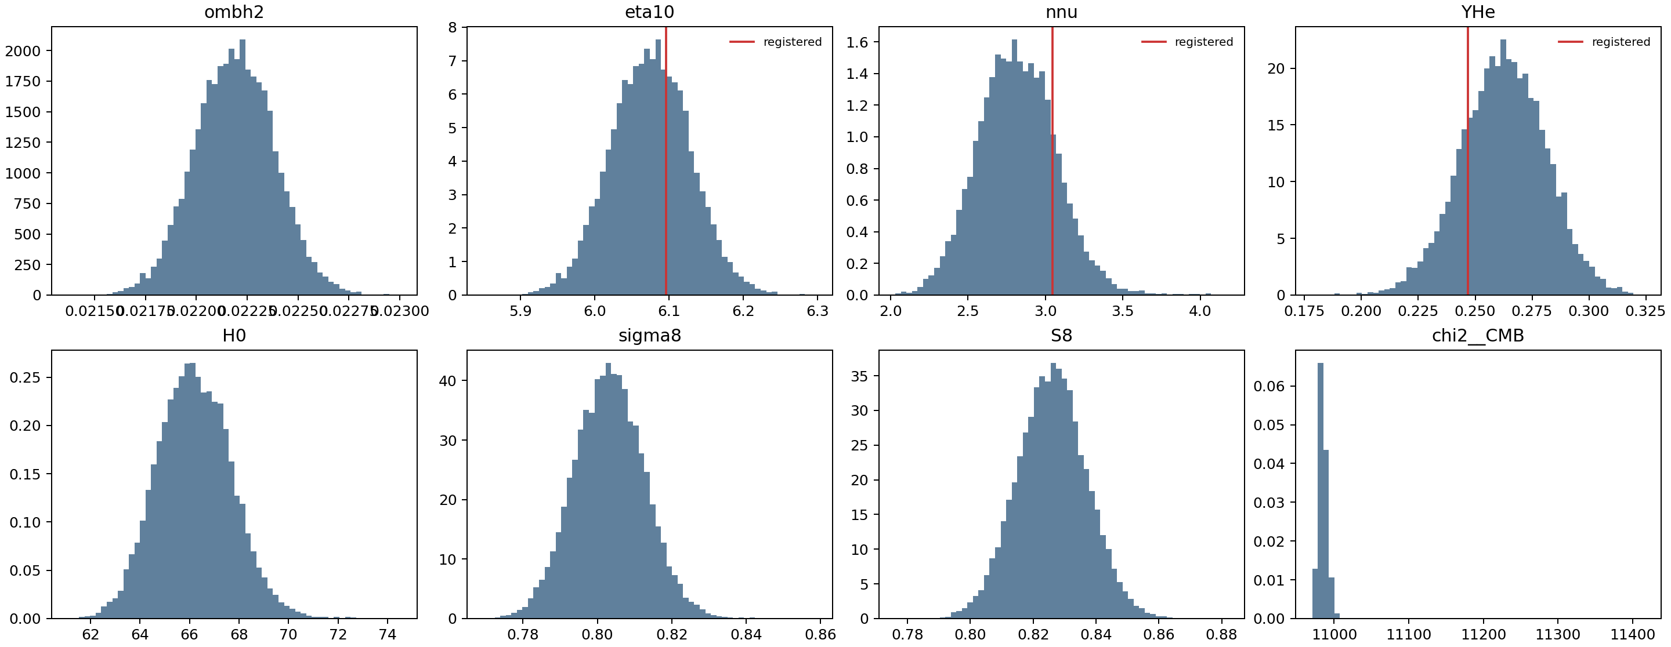
Figure 1. Key posterior summaries from the Planck PR4/NPIPE nuisance run.
TV index
Traceability item | Recorded value
Protocol | C:\Users\clive\Documents\Codex\2026-07-14\ok-continu\outputs\bbn_lithium_full_cmb_nuisance_20260821\full_cmb_nuisance_protocol_2026-08-21.md
Post-process | C:\Users\clive\Documents\Codex\2026-07-14\ok-continu\outputs\bbn_lithium_full_cmb_nuisance_20260821\postprocess\planck_pr4_full_nuisance_postprocess_report.md
Native-likelihood caveat | This is not a Planck map-level reanalysis and does not include ACT or SPT.

September Qualification Audit
The September audit combines the completed main chain with the ESS top-up chain. It uses a stricter gate set than the initial post-process: split-chain posterior summaries, autocorrelation-aware ESS, registered-cell posterior density, nuisance-parameter stability, all-row versus last-half comparison and explicit pass/fail scoring.
Table 7. Preregistered qualification gates
Gate | Threshold | Observed | Pass
Cobaya split-chain mean R-1 | <= 0.03 | 0.0293 | True
Independent split R-1 max over ombh2, nnu, YHe, nuisance | <= 0.03 | 0.0021 | True
Autocorrelation ESS min over ombh2, nnu, YHe, nuisance | >= 1000 | 1449.0004 | True
Registered lithium cell joint posterior density | delta-chi2 <= 7.814728 | 1.2574 | True
Nuisance split stability diagnostic | max split mean shift <= 1 sigma | 0.0838 | True
First-half vs second-half stability diagnostic | max mean shift <= 1 sigma | 0.0926 | True

Table 8. Selected audit metrics
Parameter | Split R-1 | Autocorr ESS | tau_int | Half-shift sigma | Status

Table 9. Registered lithium cell in the combined CMB posterior
Quantity | Value
posterior mean eta10 | 6.074645
posterior mean N_eff | 2.814036
posterior mean Y_p | 0.262997
registered eta10 | 6.096365
registered N_eff | 3.044709
registered Y_p | 0.246733
registered Delta chi2 | 1.25743
Mahalanobis distance | 1.121352
density ratio to posterior peak | 0.533277
posterior mass inside equal-density contour | 0.261374
joint 95 gate pass | True
weighted kNN density ratio | 0.601247

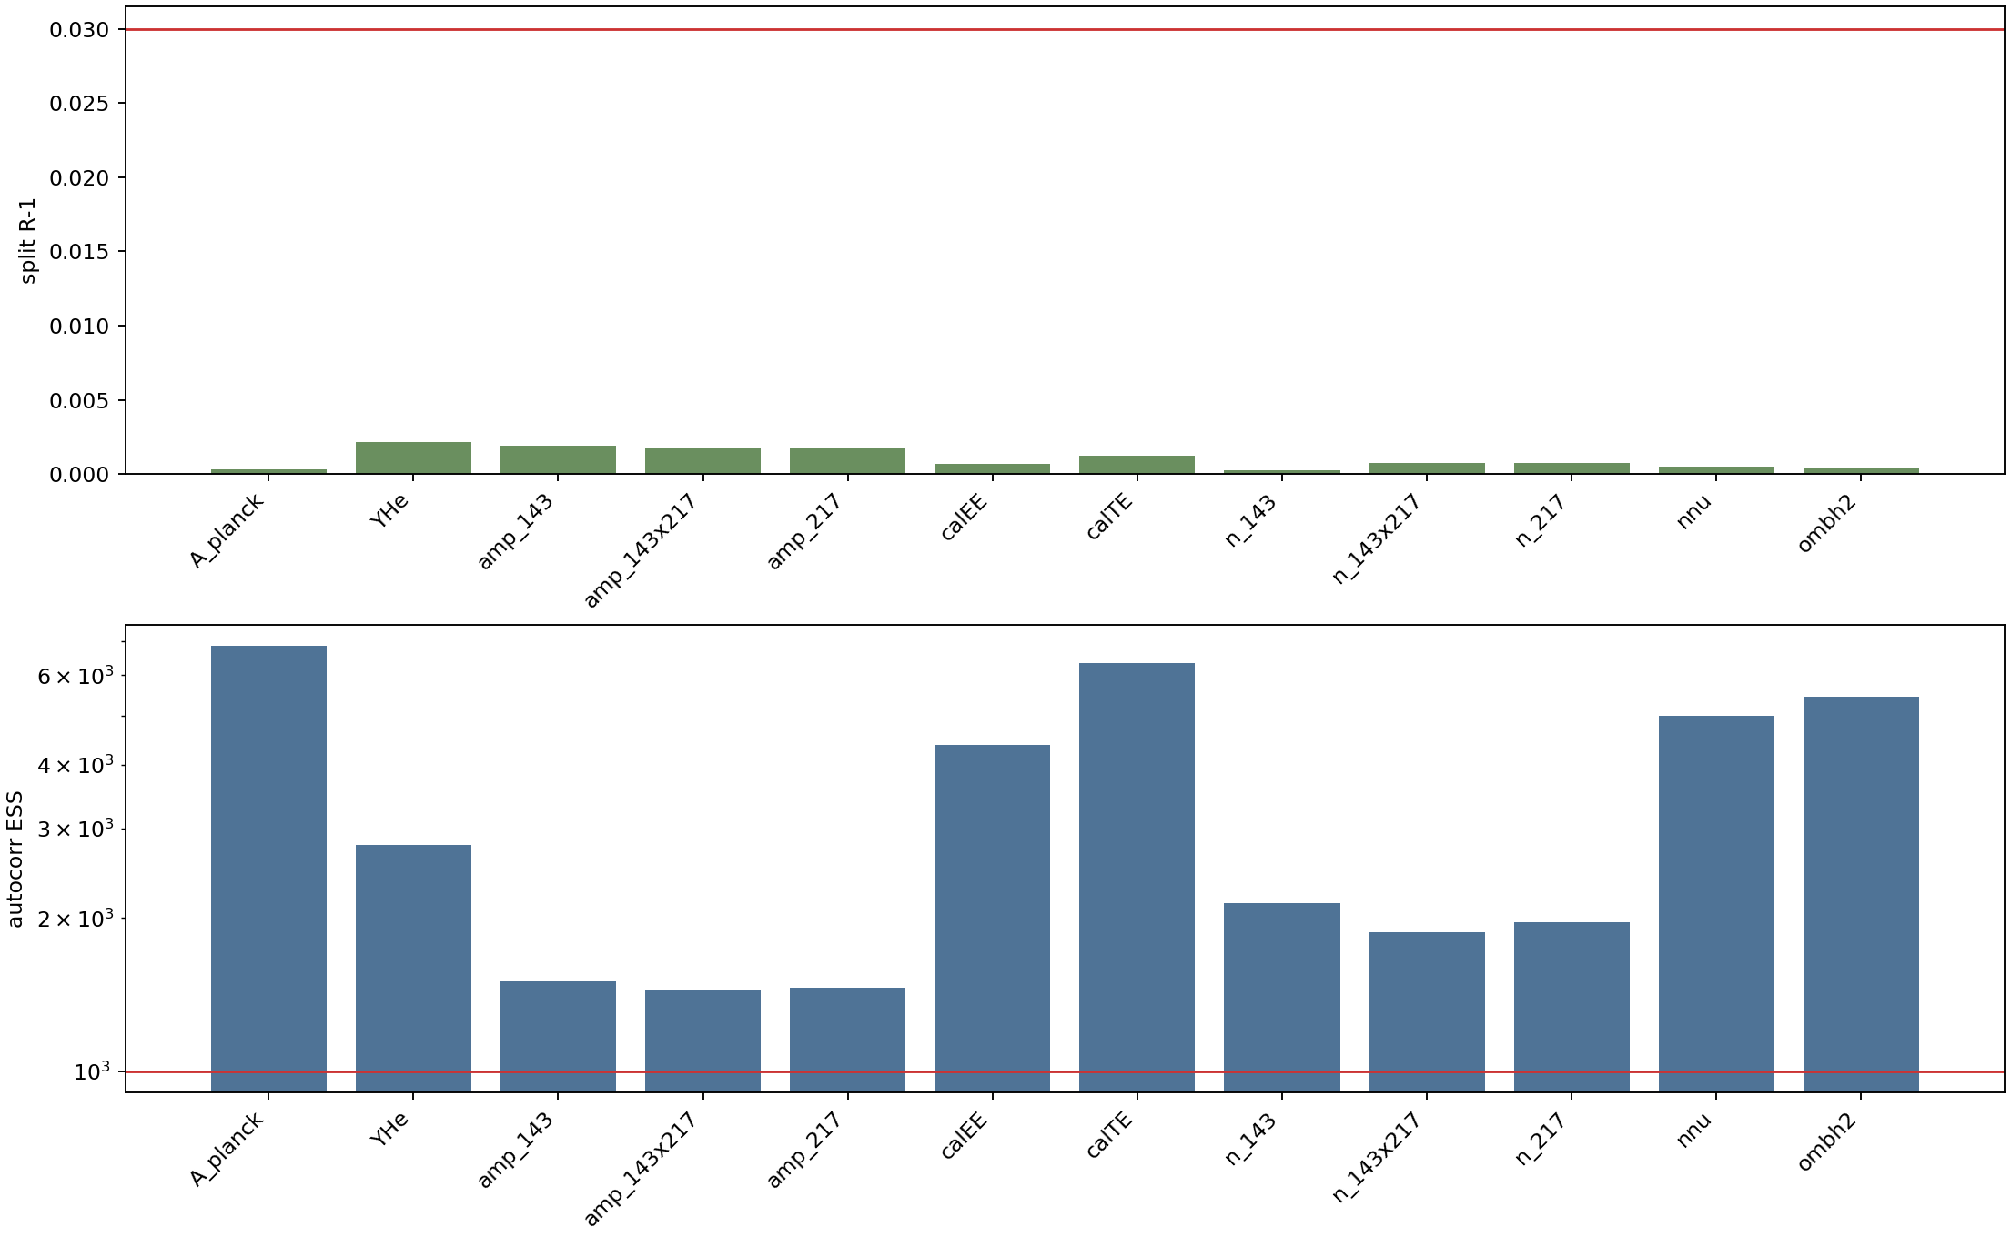
Figure 2. Qualification gate readout for the combined main plus ESS top-up chain.
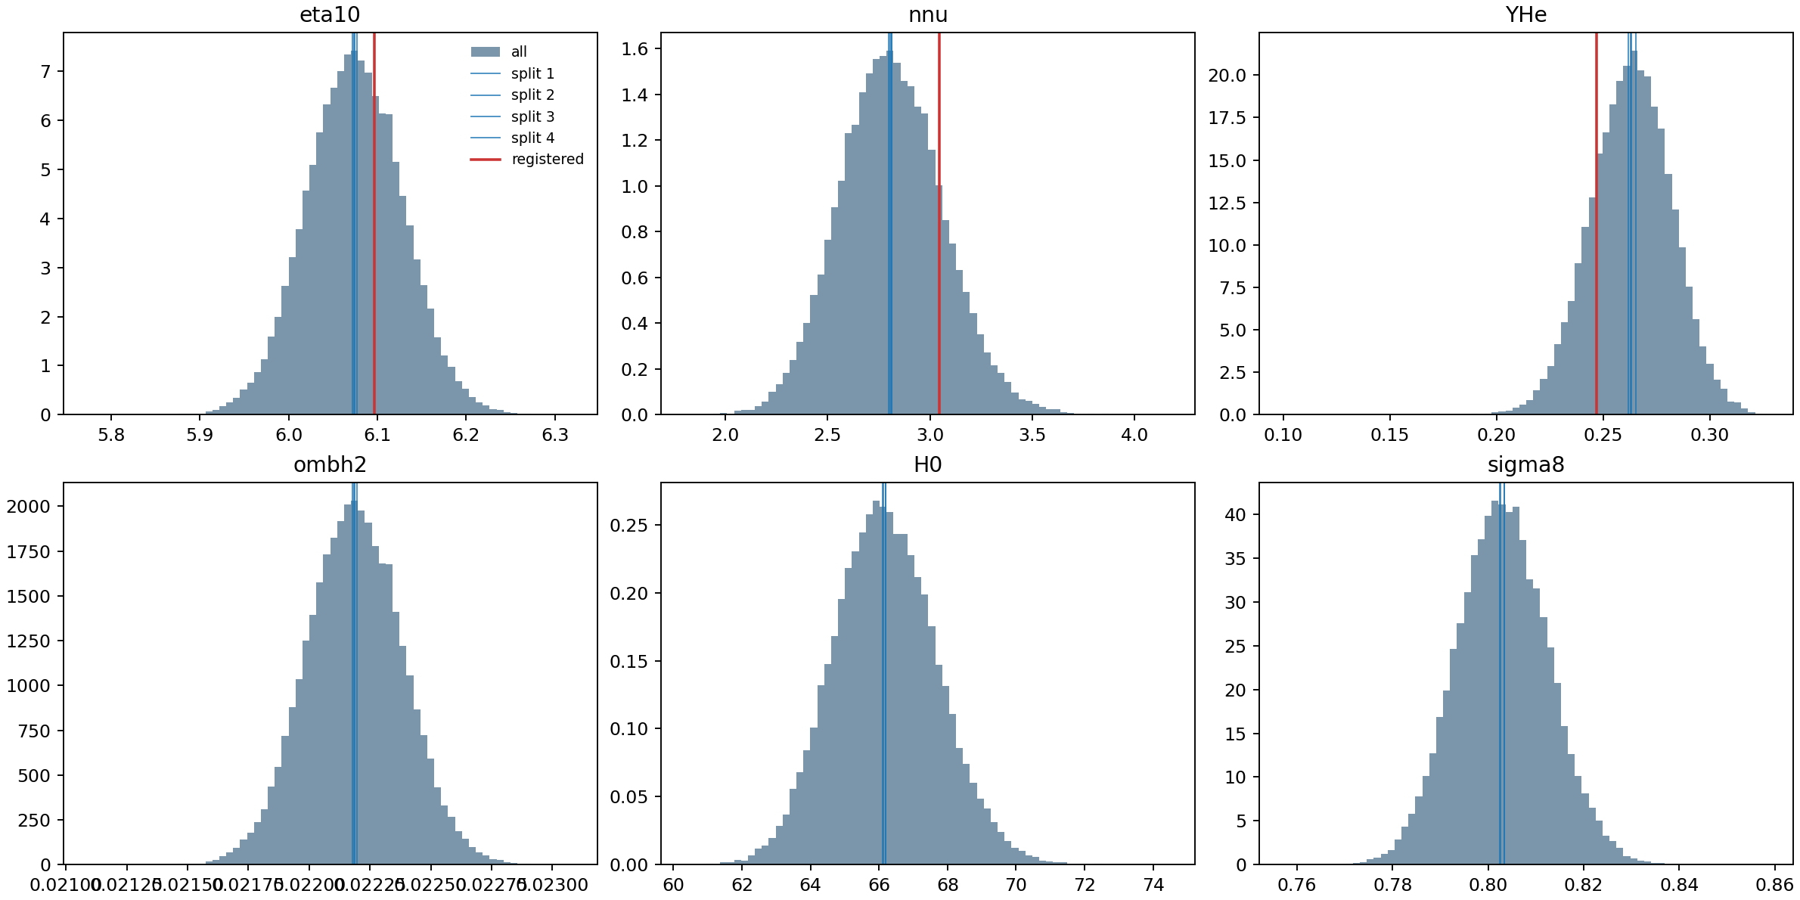
Figure 3. Split-chain posterior overlay used to audit stability.
TV index
Traceability item | Recorded value
Combined chain | C:\Users\clive\Documents\Codex\2026-07-14\ok-continu\outputs\bbn_lithium_full_cmb_nuisance_20260821\chains_combined\planck_pr4_full_nuisance_main_plus_ess_topup.1.txt
Audit report | C:\Users\clive\Documents\Codex\2026-07-14\ok-continu\outputs\bbn_lithium_full_cmb_nuisance_20260821\qualification_audit_combined_ess_topup\planck_pr4_full_nuisance_qualification_audit.md
Headline | overall_pass=True; min autocorrelation ESS=1449; max split R-1=0.002143; registered Delta chi2=1.257.
Caveat | Cobaya log R-1 line is inherited from the main run log; independent split R-1 and ESS are recomputed from the combined chain.

Interpretation
The main interpretation has changed since 28 August 2026. At that stage the Planck nuisance gate was still pending. After the main chain completed on 2 September 2026 it was positive but not fully qualified because the stricter autocorrelation-aware ESS gate failed for some nuisance directions. The ESS top-up, combined with the main chain and audited on 11 September 2026, removes that immediate technical objection.
The data therefore support the statement that the registered lithium candidate lies in an acceptable part of the native Planck PR4/NPIPE posterior for eta10, N_eff and Y_p. This is narrower than claiming the mediator exists. It is nevertheless materially stronger than the August status because it passes the spectrum-level CMB nuisance treatment rather than relying on a compressed CMB approximation.

Future Research and Test Options
- Matched next-to-leading-order thermal calculation for the same mediator point, including pole-cut consistency and thermal self-energy treatment.
- Independent reproduction of the ACROPOLIS/LINX abundance chain and the Planck nuisance posterior audit on a separate machine or environment.
- Sensitivity analysis over nuclear-rate choices, stellar plateau assumptions, D/H observational anchors and helium determinations.
- Explicit action-level particle model: specify the field content, Lagrangian, production mechanism, decay channel, symmetries and conservation laws.
- External CMB and spectral tests: ACT/SPT consistency, improved FIRAS-style spectral-distortion treatment and future PIXIE-like sensitivity projection.
- Publication-grade reproducibility package: frozen manifests, file hashes, environment locks, CSV tables and figure regeneration commands.

Appendix A. Acronyms
Table A1. Acronym glossary
Acronym | Meaning
ACROPOLIS | Public electromagnetic-cascade framework used for BBN photodisintegration constraints.
AIC | Akaike Information Criterion; lower is preferred after a penalty of 2 parameters.
BBN | Big Bang Nucleosynthesis.
BIC | Bayesian Information Criterion; lower is preferred with a stronger log(N) parameter penalty.
CAMB | Code for Anisotropies in the Microwave Background.
CMB | Cosmic microwave background.
Cobaya | Cosmological Bayesian analysis package used for the Planck nuisance MCMC.
D/H | Deuterium-to-hydrogen abundance ratio.
ESS | Effective sample size; here the autocorrelation-aware number of effectively independent posterior samples.
FIRAS | Far Infrared Absolute Spectrophotometer on COBE.
LINX | Fast differentiable BBN package used for abundance calculations and validation.
MCMC | Markov-chain Monte Carlo.
NPIPE | Planck reprocessing pipeline used for PR4 products.
PR4 | Planck public release 4.
SPD | Symmetric positive definite; used for covariance handling and Cholesky/LAPACK inversion.
TV index | Traceability/validation index. The reports place it after each investigation section.

Appendix B. Variables
Table B1. Variable glossary
Variable | Meaning
eta10 | 10^10 times the baryon-to-photon ratio eta; converted from omega_b using eta10 = 273.78 omega_b for T_CMB = 2.7255 K.
omega_b / ombh2 | Physical baryon density Omega_b h^2.
omega_c / omch2 | Physical cold dark matter density Omega_c h^2.
N_eff / nnu | Effective relativistic species count inferred independently in the CMB nuisance chain.
Y_p / YHe | Primordial helium-4 mass fraction; sampled independently in the full CMB likelihood.
D/H | Deuterium abundance anchor; required to remain within the adopted observational gate.
Li-7/H | Lithium-7 abundance. Most primordial mass-7 is produced as Be-7 and later decays to Li-7.
m_phi | Mediator mass in MeV for the selective electromagnetic-transfer candidate.
E_gamma | Characteristic photon energy, approximated as m_phi/2 for two-photon decay.
tau_phi | Mediator lifetime in seconds.
n_phi/n_gamma | Mediator abundance relative to photons at T = 10 MeV.
g_phi_gamma | Effective mediator-photon coupling in GeV^-1.
mu | CMB spectral-distortion chemical-potential style readout.
R-1 | Convergence diagnostic used by Cobaya and the split-chain audit.
chi2 | Goodness-of-fit statistic; lower values indicate a better fit for the same data and model complexity.

Appendix C. Program and Data Manifest
Table C1. Principal programs
Program or path | Role in the investigation
analyze_bbn_lithium_linx_fr_network_2026-07-16.py | July LINX/FR network controls; reproduced the lithium problem and did not identify a D+He+Li pass.
analyze_su2_bbn_lithium_gate_2026-07-17.py | July SU2-style expansion/thermal gate for lithium; part of the negative control phase.
validate_bbn_lithium_linx_matrix_2026-07-17.py | Strict July validation matrix for the BBN lithium controls.
audit_bbn_lithium_linx_fr_scan_2026-07-17.py | Audit layer for the July LINX/FR scan.
run_cobaya_spd_cache_builder_2026_08_21.py | Built the validated SPD cache for the Planck PR4/NPIPE CamSpec likelihood.
postprocess_planck_pr4_full_nuisance.py | Post-processed the native full CMB nuisance chain and compared the registered lithium cell with the CMB posterior.
audit_planck_pr4_full_nuisance_qualification.py | Strict qualification audit: split chains, autocorrelation-aware ESS, registered-cell density, nuisance stability and half-chain stability.
start_planck_pr4_full_nuisance_background.ps1 | Background launcher for the native Planck PR4 full nuisance MCMC.
start_planck_pr4_full_nuisance_ess_topup_background.ps1 | Background launcher for the ESS top-up chain.
build_bbn_li_reports_20260911.py | This reproducible DOCX report generator.

Table C2. Repository and output cross-reference
Object | Path or URL
Local output root | C:\Users\clive\Documents\Codex\2026-07-14\ok-continu\outputs\bbn_lithium_full_cmb_nuisance_20260821
Combined qualification audit | C:\Users\clive\Documents\Codex\2026-07-14\ok-continu\outputs\bbn_lithium_full_cmb_nuisance_20260821\qualification_audit_combined_ess_topup
Post-process folder | C:\Users\clive\Documents\Codex\2026-07-14\ok-continu\outputs\bbn_lithium_full_cmb_nuisance_20260821\postprocess
GitHub project | https://github.com/cliveboyd/Cosmology
GitHub BBN code | https://github.com/cliveboyd/Cosmology/tree/main/github_export/code/bbn_lithium
GitHub papers | https://github.com/cliveboyd/Cosmology/tree/main/github_export/docs/papers

Appendix D. References
1. Particle Data Group, Big-Bang Nucleosynthesis review, Review of Particle Physics (2024).
2. B. D. Fields, The Primordial Lithium Problem, Annual Review of Nuclear and Particle Science 61, 47 (2011).
3. R. H. Cyburt, B. D. Fields and K. A. Olive, A Bitter Pill: The Primordial Lithium Problem Worsens, JCAP 11, 012 (2008), arXiv:0808.2818.
4. R. H. Cyburt et al., Big Bang Nucleosynthesis: 2015, Rev. Mod. Phys. 88, 015004.
5. B. D. Fields et al., Big-Bang Nucleosynthesis After Planck, JCAP 03 (2020) 010.
6. C. Pitrou, A. Coc, J.-P. Uzan and E. Vangioni, Precision Big Bang Nucleosynthesis with Improved Helium-4 Predictions, Phys. Rep. 754, 1-66 (2018).
7. F. Spite and M. Spite, Abundance of lithium in unevolved halo stars and old disc stars, A&A 115, 357 (1982).
8. M. Spite and F. Spite, Lithium abundance at the formation of the Galaxy, Nature 297, 483-485 (1982).
9. L. Sbordone et al., The metal-poor end of the Spite plateau. I. Stellar parameters, metallicities, and lithium abundances, A&A 522, A26 (2010).
10. S. G. Ryan, A critique of the Spite Plateau and the astration of primordial lithium, MNRAS 522, 1358-1376 (2023).
11. R. J. Cooke et al., One percent determination of the primordial deuterium abundance, ApJ 855, 102.
12. M. L. Giannotti et al., LINX: A Fast, Differentiable and Extensible Big Bang Nucleosynthesis Package (2024).
13. Joint LINX collaboration, Cosmological Parameter Estimation with a Joint-Likelihood Analysis of the CMB and BBN (2024).
14. P. F. Depta et al., ACROPOLIS: A generic Framework for Photodisintegration of Light elements, JCAP 03 (2021) 061.
15. P. F. Depta et al., Updated BBN constraints on electromagnetic decays of MeV-scale particles (2020).
16. K. Langhoff et al., New insights into axion freeze-in, JHEP 11 (2024) 166.
17. E. Braaten and D. Segel, Neutrino energy loss from the plasma process at all temperatures and densities, Phys. Rev. D 48, 1478.
18. D. J. Fixsen et al., The Cosmic Microwave Background Spectrum from the Full COBE FIRAS Data Set, ApJ 473, 576.
19. R. Khatri and R. A. Sunyaev, Creation of the CMB spectrum: precise analytic solutions for the blackbody photosphere, JCAP 06 (2012) 038.
20. Planck Collaboration, Planck 2018 results. VI. Cosmological parameters, A&A 641, A6 (2020).
21. G. Efstathiou and S. Gratton, A detailed description of the CamSpec likelihood pipeline and a reanalysis of the Planck high frequency maps, MNRAS 496, L91 (2020); PR4 update.
22. J. Carron et al., Planck 2018 CMB lensing reconstruction from the final NPIPE data release.
23. Spectroxide project implementation, numerical thermalisation and spectral-distortion framework (2026).

