CHAPTER THREE

SYSTEM ANALYSIS AND DESIGN

3.1 Introduction.
This chapter presents the system analysis and design of UsafiLink, a proximity-based exhauster service management system. It is an overview of how the system is structured, designed and prepared for implementation. The chapter also outlines the methodologies, tools and techniques used in developing the system to ensure they meet functional and non-functional requirements.
Furthermore, the chapter examines the process of user requirements elicitation, designing system architecture, and modelling system components. It highlights how the integration of a Haversine proximity dispatch algorithm and M-Pesa payment infrastructure enhances efficiency, transparency and accessibility of exhauster service management. This chapter therefore serves as the blueprint for the implementation of the project.

3.2 System Development Methodology.
UsafiLink was developed using the Agile System Development Methodology, specifically the Scrum framework. Agile was selected because the system involves multiple interdependent components — the React and Vite web application frontend, the Django REST Framework backend, the SQLite development database, the Celery asynchronous task queue, and third-party API integrations including IntaSend for payments, Africa's Talking for SMS notifications, and GoogleAuth for authentication — each of which benefits from incremental development, continuous testing, and iterative refinement based on user feedback.
The development was organised into two-week sprints, each producing a working and testable increment of the system. The Agile methodology encompasses the following iterative phases:
- Requirements – identifying and defining the system's functionalities through stakeholder engagement with an exhauster driver and customers.
- Plan – organising gathered requirements into sprints, setting objectives, and estimating time and resources needed for each cycle.
- Design – creating the system architecture and design specifications including database structure, user interfaces, and the proximity dispatch module.
- Development – divided into five sprints each focusing on specific features: authentication, GPS dispatch, M-Pesa integration, dashboards, and testing.
- Release – deploying working increments to stakeholders for evaluation and feedback at the end of each sprint.
- Track and Monitor – continuously observing system performance, collecting feedback and identifying improvements.
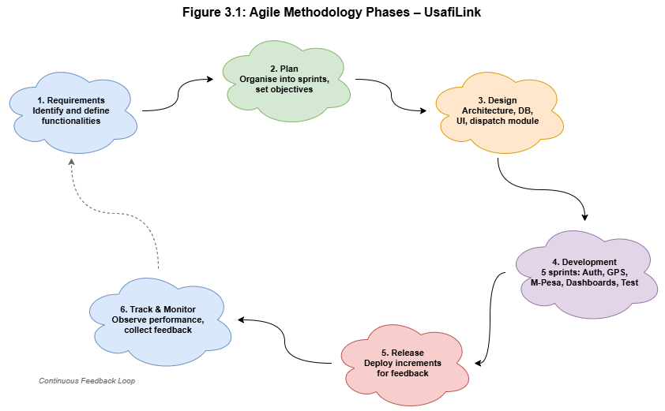
Figure 3.1: Agile Methodology Phases – UsafiLink

3.2.1 Advantages of Agile Methodology
- Adaptability – when new requirements emerge (e.g., changes to the Haversine dispatch algorithm based on testing), they can be incorporated without disrupting overall development.
- Agile promotes continuous testing – ensuring errors are identified and resolved early, guaranteeing the reliability and security of the proximity dispatch and payment modules.
In summary, Agile provides a flexible, efficient, and user-centred approach to developing UsafiLink, ensuring a quality system and successful project delivery.

3.3 Feasibility Study.
A feasibility study was conducted to assess the viability of UsafiLink across five dimensions: technical, economic, legal, operational, and social feasibility. The aim was to determine whether the system is practical and achievable within the constraints of an eight-month development timeline and the available resources.

3.3.1 Technical Feasibility
Technical feasibility assesses whether the required technology and resources are available to successfully develop and implement the system. UsafiLink utilises the following modern, well-documented, and freely available technologies: React and Vite for the Progressive Web Application frontend, Django and Django REST Framework for the backend API, and SQLite for development with PostgreSQL for production deployment. External services handle critical infrastructure: IntaSend manages M-Pesa STK Push payments and driver B2C payouts; Africa's Talking powers SMS dispatches; Clerk and Google Auth manage identity verification; and Celery with Redis handles asynchronous task management including the ten-second driver timeout. All technologies are compatible and integration is achievable.

3.3.2 Economic Feasibility
Economic feasibility evaluates whether UsafiLink is financially viable by comparing initial costs against the expected benefits.
Initial Costs:
- Development costs – include hardware (computers and internet access), open-source software (Django, React, Celery, PostgreSQL carry no licence fees), and developer time.
- Operational costs – recurring costs after deployment include cloud hosting, Africa's Talking SMS charges per message, and IntaSend transaction fees per payment.
- Training costs – minimal, as the interface is designed for users with basic smartphone literacy.

Expected Benefits:
- Faster service coordination – eliminates phone-based booking delays, reducing average customer wait times.
- Digital payments – removes cash handling risks through M-Pesa integration.
- Transparent pricing – distance-based fare estimation eliminates pricing disputes.

Type of Cost | Nature | Impact
Development | One-time | Moderate
Operational (hosting, SMS, API fees) | Recurring | Low to Moderate
Expected Benefits (efficiency, adoption) | Long-term | High
Table 3.1: Cost-Benefit Evaluation – UsafiLink
This means the system will provide a positive return on investment (ROI) over a short period; therefore it is economically feasible.

3.3.3 Legal Feasibility
Legal feasibility assesses whether UsafiLink complies with relevant laws, regulations and policies governing data usage, privacy and digital transactions in Kenya. The system adheres to data protection principles by ensuring sensitive user information — including GPS coordinates, phone numbers and M-Pesa transaction records — is securely stored and accessible only to authorised parties. HTTPS, JWT authentication and PBKDF2/bcrypt password hashing protect data integrity. IntaSend payment callbacks are validated through IP whitelisting and payload signature verification to prevent unauthorised financial transactions. The system is legally feasible as it complies with applicable data protection and security requirements.

3.3.4 Operational Feasibility
Operational feasibility examines how well UsafiLink will function within its intended environment. The target users — an exhauster driver and customers in peri-urban towns in Kiambu County — demonstrate high rates of smartphone ownership and mobile internet usage. M-Pesa is embedded in daily financial transactions, reducing adoption barriers. The decision to implement UsafiLink as a responsive Progressive Web Application (PWA) rather than a native Android application is operationally appropriate given the storage space and data cost considerations of the target population. The system is therefore operationally feasible within the defined deployment context.

3.3.5 Social Feasibility
UsafiLink is socially feasible as it is user-friendly, accessible and directly addresses key challenges faced by exhauster service users: unclear pricing, service delays, and cash-only payments. It enhances trust and transparency among drivers, customers, and service administrators. Although there may be initial resistance due to unfamiliarity with digital service platforms, the minimal three-tap driver interface and familiar M-Pesa payment flow will promote acceptance. The system is expected to be widely adopted and beneficial to the target communities.

3.3.6 Conclusion of the Feasibility Study
Based on the feasibility analysis conducted, UsafiLink is feasible across all five dimensions. The system is practical and achievable; therefore the project is suitable for development and successful implementation.

3.4 Requirements Elicitation
Requirements elicitation is the process of gathering and analysing information from stakeholders to understand the needs and expectations for the proposed system. For UsafiLink, data was collected from actively operating an exhauster driver and customers in Nairobi and its peri-urban zones. The main purpose of data collection was to identify the challenges faced in the current exhauster service coordination process and to derive the requirements for the UsafiLink system.

3.4.1 Data Collection Methods

(i) Interviews
Semi-structured interviews were conducted with an exhauster driver to gather qualitative data on operational workflows, navigation practices, job coordination methods and attitudes towards digital service management tools. Each interview lasted approximately twenty minutes. The interview questions focused on:
- The current process of booking and coordinating exhauster service jobs.
- Challenges faced in service coordination and payment collection.
- Navigation and route planning practices during active jobs.
- Expectations and concerns about a digital service management platform.

(ii) Questionnaires
Structured questionnaires were administered to exhauster customers and drivers to collect quantitative data on current service coordination processes, typical response times, frequency of job conflicts, and payment preferences. The questionnaires aimed to collect information on:
- Current methods of finding and booking exhauster services.
- Challenges faced with existing coordination processes.
- Payment preferences and M-Pesa usage patterns.
- Willingness to use a web-based service management application.
The questionnaires were distributed in person using Google Forms to reach the required participants.

3.4.2 Sampling Techniques
A purposive (judgmental) sampling technique was employed. Participants were selected based on their direct involvement in exhauster service operations. These included actively operating an exhauster driver in Kiambu County and regular exhauster service customers in the Juja, Ruiru and Kimbo areas. These groups were chosen because they possess relevant experience and insights regarding the challenges of current exhauster service coordination.

3.4.3 Sample Size Determination
The sample size was determined based on the targeted stakeholders involved in exhauster service operations. Since purposive sampling was adopted, the sample was not derived using statistical formulas but based on the assessment of individuals with relevant knowledge and experience. The final sample consisted of:
- Exhauster drivers: 3 respondents, representing both independent operators and drivers affiliated with small exhauster service companies.
- Exhauster service customers: 5 respondents, residing in the peri-urban zones of Kiambu County.
This gave a total sample size of 8 respondents, considered adequate for requirements elicitation in this context.

3.4.4 Relevance of Collected Data to the Research
The collected data was directly aligned with the objectives of the research, which focus on improving exhauster service coordination efficiency, payment transparency and response time through proximity-based digital dispatch. The findings revealed key issues such as:
- Lack of structured booking systems — 66.7% of drivers use no structured booking method.
- Unclear pricing — 60% of customers cited unclear pricing as the biggest service challenge.
- No digital payment options — 100% of customers use M-Pesa but report no digital payment option for exhauster services.
- Service delays — 40% of customers cited delays as a major concern.

3.4.5 Conclusion
The requirements elicitation process successfully gathered relevant and reliable data necessary for designing UsafiLink. The use of multiple data collection methods ensured comprehensive coverage of stakeholder needs, providing a solid foundation for system development.

3.5 Data Analysis
The data collected from questionnaires and interviews was analysed using frequency counts and percentages (quantitative) and thematic coding (qualitative). A total of five customers and three an exhauster driver participated in the survey. The key findings are summarised in Table 3.1 and illustrated in Figures 3.1(a)–3.1(f) below, which present the survey response data collected via Google Forms.
Table 3.1 – Summary of Key Findings from Requirements Elicitation
Challenge Identified | Frequency (n=8) | Implication for System
Unclear pricing as the biggest service challenge | 5/5 customers (60% cited unclear pricing) | Transparent distance-based fare estimation required
Service delays (40% of customers) | 2/5 customers (40% cited delays) | Proximity-based auto-dispatch required to reduce wait times
No digital payment option available; all cash-based | 5/5 customers (100% use M-Pesa) | M-Pesa STK Push payment integration required
Payment security as primary concern with new system | 5/5 customers (100% cited payment security) | Secure payment gateway and transaction audit logging required
Willingness to use a web app for exhauster services | 5/5 customers (100% said Yes) | Web-based service request and tracking interface required
Drivers operate with no structured booking system | 2/3 drivers (66.7% use no structured method) | Digital booking management and route optimisation tools required
Table 3.1: Summary of Key Findings from Requirements Elicitation

Section 1: Customer Survey Results
Figure 3.1(a): Biggest challenge with current services; Figure 3.1(b): Comfort using mobile apps. Figure 3.1(c): Feature usefulness ratings; Figure 3.1(d): Main concern about the proposed system.
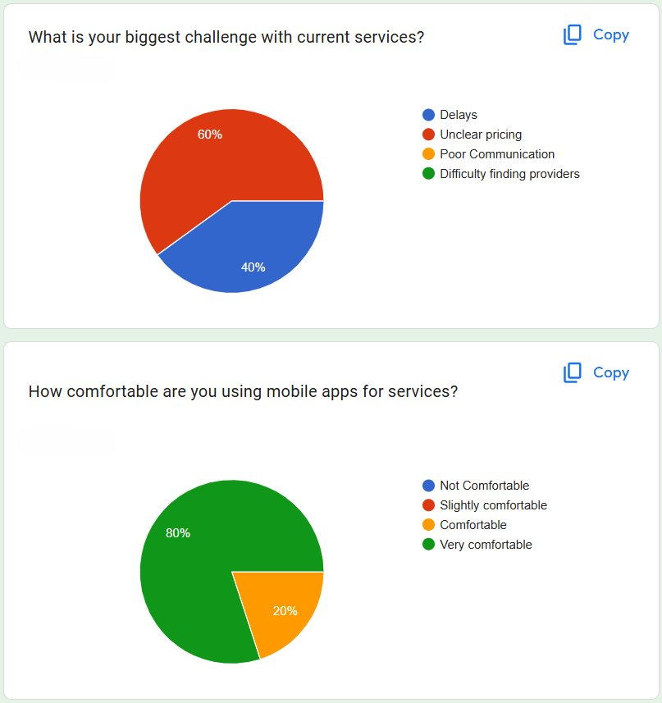
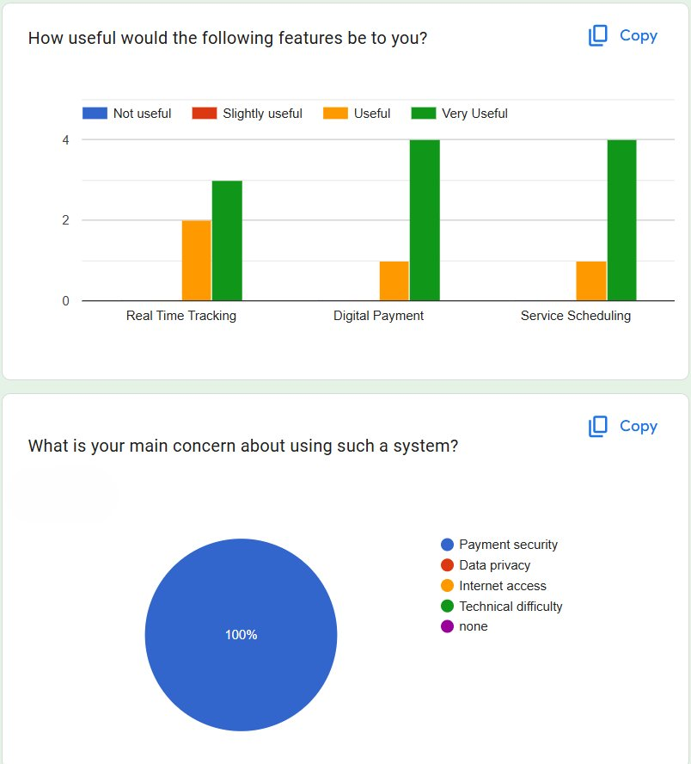
Figure 3.1(c)–(d): Feature usefulness ratings and main system concerns.
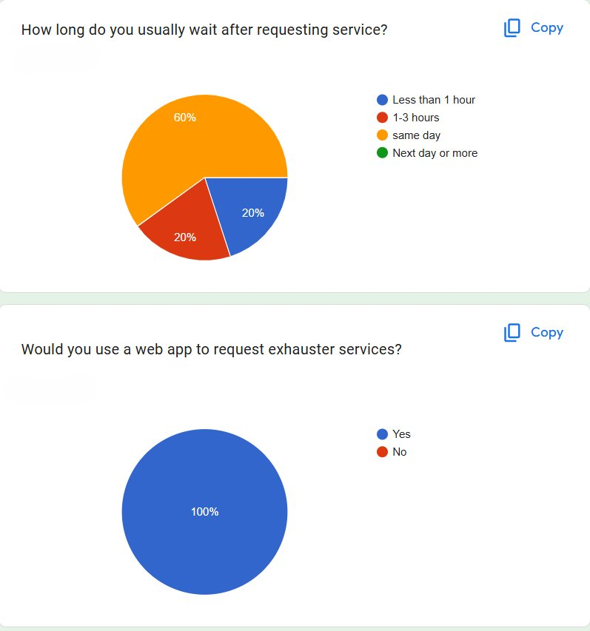

Section 1 (cont.): Service Wait Times, App Adoption & Payment Preferences
Figure 3.1(e): Service wait times and willingness to use a web app. Figure 3.1(f): M-Pesa usage and driver booking management methods.
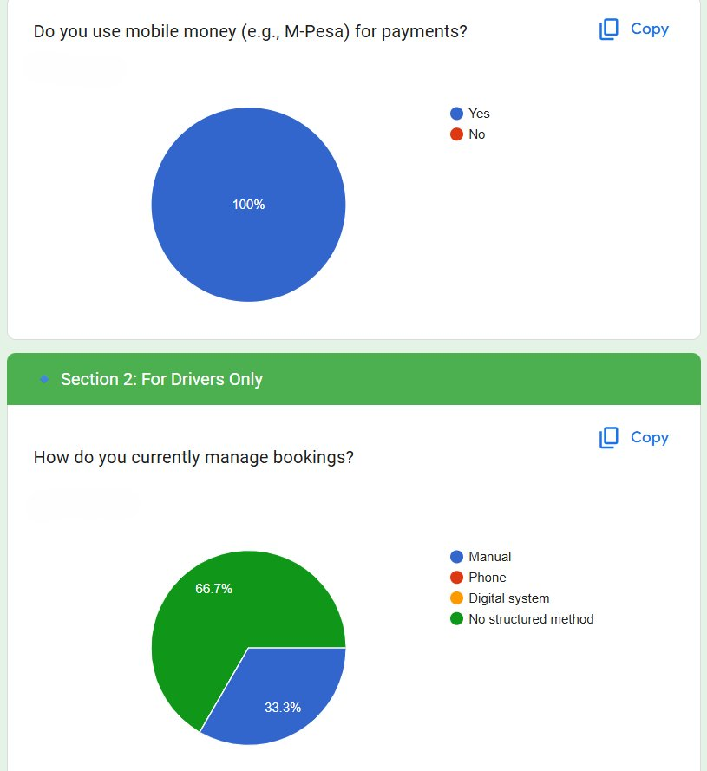

Section 2: Driver Survey Results
Figure 3.1(g): Current booking management methods; most useful features for drivers; and driver perception of UsafiLink’s impact on service efficiency.
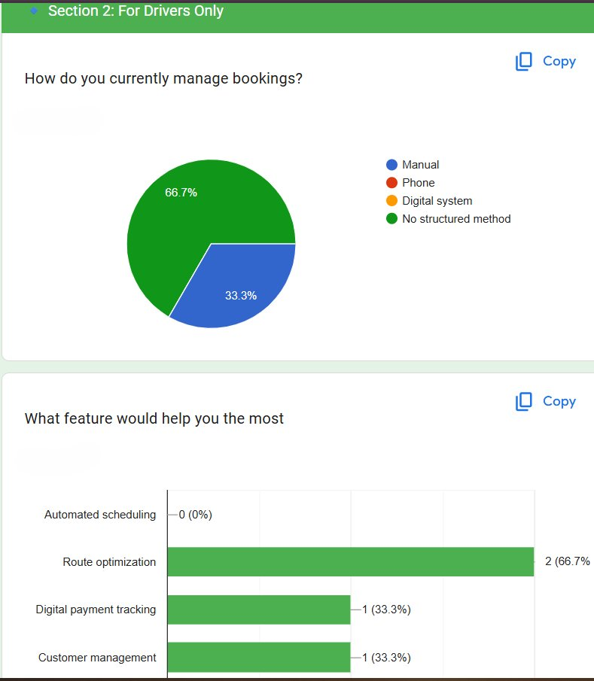
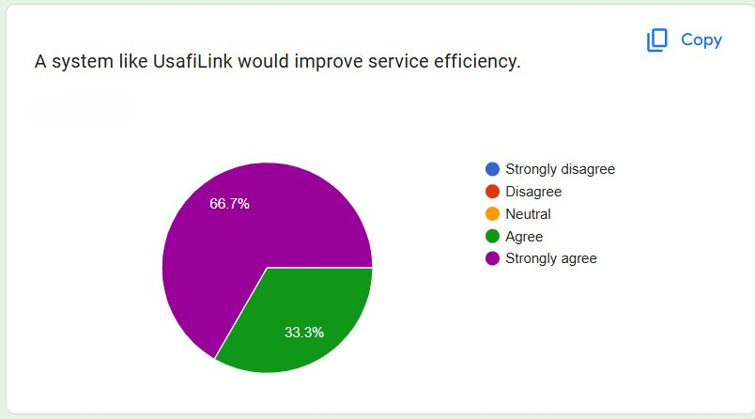

3.5.1 Analysis of Interview Responses
Interviews with an exhauster driver revealed that the current service coordination is entirely informal, relying on phone calls and word-of-mouth for job acquisition. Drivers report frequent route inefficiencies, payment disputes caused by cash-only transactions, and difficulty managing multiple job requests simultaneously. All interviewed drivers expressed strong interest in a digital platform providing structured job dispatch and digital payment collection.

3.5.2 Analysis of Questionnaire Responses

3.5.2.1 Current Methods of Exhauster Service Booking
Most customers rely on personal contacts or referrals to find exhauster services, with no standardised booking mechanism. This contributes to long search times and inconsistent pricing.

3.5.2.2 Challenges Faced During Service Coordination
The majority of respondents indicated unclear pricing and unpredictable wait times as the primary challenges. Service delays are compounded by the absence of a dispatch system, with customers often waiting over 30 minutes for a driver to confirm availability.

3.5.2.3 Expected Features in the Proposed System
Respondents indicated that the most important expected features are: automatic driver dispatch, M-Pesa payment integration, live driver tracking, transparent fare estimation, and SMS notifications for driver assignment.

3.5.3 Acceptance of the Proposed System
All five customer respondents and all three driver respondents expressed willingness to use a web-based exhauster service management system. Drivers prioritised digital payment collection and route efficiency tools, while customers emphasised transparent pricing and real-time driver tracking.

3.5.4 Conclusion
Through data analysis, significant limitations in the current informal exhauster service coordination process are confirmed. The proposed UsafiLink system addresses the identified challenges by providing automated proximity-based dispatch, transparent M-Pesa payment integration, and real-time driver tracking.

3.6 System Specification
The requirements of the proposed UsafiLink system are derived from data analysis findings. The requirements are categorised into functional and non-functional requirements.

3.6.1 Functional Requirements

FR No. | Module | Requirement
FR01 | Authentication | The system shall allow users to register using Email/Password, , or Google OAuth.
FR02 | Authentication | The system shall authenticate users and manage sessions using JWT access and refresh tokens.
FR03 | Authentication | The system shall send a one-time password (OTP) to the user's email address during registration.
FR04 | Authentication | The system shall support two-factor authentication (2FA) using a TOTP authenticator app.
FR05 | Service Request | The system shall automatically capture the customer's GPS coordinates upon service request submission.
FR06 | Dispatch | The system shall compute the Haversine distance between the customer's GPS coordinates and all available drivers and dispatch the nearest one automatically.
FR07 | Notifications | The system shall send an SMS notification to the assigned driver via Africa's Talking API.
FR08 | Dispatch | The system shall notify the assigned driver of a new job and allow accept or reject within a 10-second timeout enforced by Celery.
FR09 | Live Tracking | The system shall display the assigned driver's GPS location in real time, updated every 5 seconds during active jobs.
FR10 | Payment | The system shall initiate an M-Pesa STK Push payment prompt via the IntaSend API upon job completion.
FR11 | Payment | The system shall support IntaSend B2C payouts to disburse driver earnings to their registered M-Pesa number.
FR12 | Audit | The system shall maintain a transaction audit log recording all payment events, status changes, and M-Pesa callback responses.
FR13 | Driver Status | The system shall allow drivers to toggle their availability status, preventing dispatch to unavailable drivers.
FR14 | Ratings | The system shall allow customers to submit a star rating (1–5) for the driver upon job completion.
FR15 | Admin | The system shall allow the administrator to view all service requests, job assignments, completion records, and payment histories.
Table 3.1: Functional Requirements – UsafiLink

3.6.2 Development Methodology Diagrams
Figure 3.1 – Scrum Sprint Schedule
The table below summarises the deliverables produced in each two-week sprint across the Agile development cycle.
Sprint | Deliverables
Sprint 1 (Weeks 1–2) | User authentication, Clerk & Google Auth integration, OTP, 2FA/TOTP setup
Sprint 2 (Weeks 3–4) | GPS service request module, proximity-matching dispatch algorithm, Celery driver timeout management, Africa’s Talking SMS alerts
Sprint 3 (Weeks 5–6) | IntaSend API for M-Pesa STK Push customer payments and driver payout integration
Sprint 4 (Weeks 7–8) | Driver rating system, transaction audit logging, administrative web dashboard
Sprint 5 (Weeks 9–10) | Integration testing, dispatch algorithm performance evaluation, user acceptance testing
Figure 3.2: UsafiLink Scrum Sprint Schedule
Figure 3.2 – Project Gantt Chart
The Gantt chart below illustrates the planned schedule of all project activities across the eight-month development timeline.
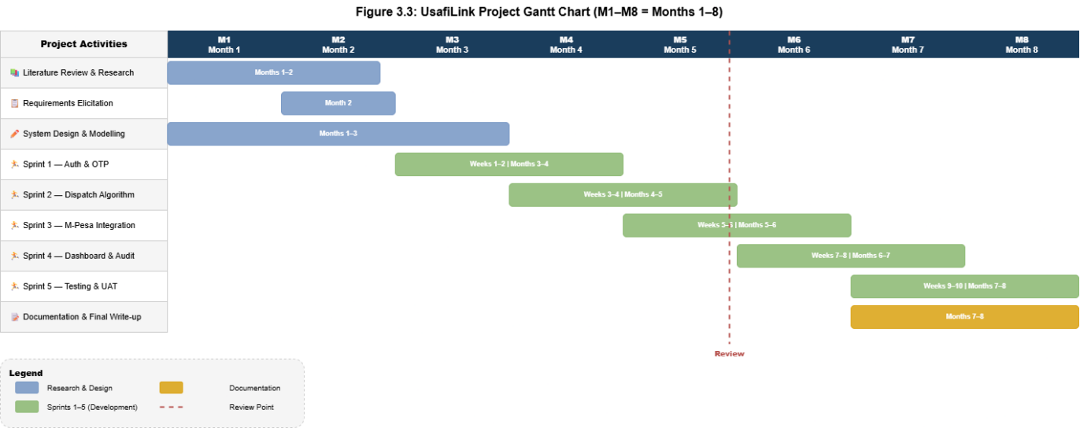
Figure 3.3: UsafiLink Project Gantt Chart (M1–M8 = Months 1–8)

3.6.2 Non-Functional Requirements
Security Requirements
All API endpoints are secured via HTTPS and JWT bearer tokens. Passwords are stored as PBKDF2/bcrypt hashes. IntaSend callbacks are validated via IP whitelisting and payload signature verification.
Performance Requirements
The proximity dispatch algorithm shall compute and assign the nearest driver within 3 seconds of a service request. Driver GPS location updates shall synchronise to the server at intervals of no more than 5 seconds during active jobs.
Reliability Requirements
The backend API shall target an uptime of 99% during the pilot deployment period. Celery with Redis ensures asynchronous task reliability with retry mechanisms.
Scalability Requirements
The database schema shall accommodate growth in registered drivers and customers without structural changes. Celery worker processes shall be scalable horizontally.
Usability Requirements
The mobile web application shall be operable by a driver with basic smartphone literacy within a maximum of 3 taps to accept a job.
Maintainability Requirements
The use of modular Django REST Framework apps and well-documented API endpoints will facilitate future improvements and debugging.

3.6.3 System Users
- Customers – users who request exhauster services, make payments, and rate drivers.
- An exhauster driver – service providers who receive job assignments, navigate to customers, and collect digital payments.
- Administrators – responsible for monitoring fleet operations, managing driver records, and auditing financial transactions.

3.6.4 Conclusion
The system requirements outlined above provide a clear description of the expected functionalities and performance of UsafiLink, serving as the foundation for the system design and implementation phases.

3.7 Requirements Analysis and Modelling

3.7.1 Requirements Analysis
Requirements analysis involves examining system requirements to identify relationships, dependencies, constraints and possible solutions. Several issues were identified in the current informal exhauster service coordination process: absence of structured booking mechanisms, cash-only payment vulnerabilities, pricing opacity, and lack of proximity-based driver dispatch. UsafiLink addresses these by introducing a secure, automated and transparent service request and fulfilment platform.
Dependencies Identified:
- Authentication dependency – all system operations depend on successful user authentication via Clerk, Google OAuth, or Email/OTP.
- Dispatch dependency – the Haversine algorithm depends on drivers having current GPS coordinates and active availability status.
- Payment dependency – M-Pesa STK Push initiation depends on successful job completion confirmation by the driver.
- Audit dependency – transaction logging depends on successful IntaSend callback receipt and validation.
Proposed Solutions:
- Implement a simple and intuitive PWA interface optimised for mobile browsers.
- Use Celery asynchronous processing to minimise dispatch latency without blocking the main API thread.
- Provide clear feedback and error messages to guide users through the service request and payment flow.

3.7.2 Requirements Structuring
The requirements structuring is based on system users and their respective system functionalities.
Customer Functions:
- Register and securely log in via Google OAuth, or Email/OTP/2FA.
- Submit a GPS-tagged service request and receive automatic driver dispatch confirmation.
- Track the assigned driver in real time and complete payment via M-Pesa STK Push.
Driver Functions:
- Register with vehicle details, toggle availability status, and receive SMS/in-app job notifications.
- Accept or reject a job within 10 seconds, navigate to the customer, and mark the job complete.
Administrator Functions:
- Monitor active driver locations on a live fleet map and access job history and payment records.
System Functions:
- Compute Haversine distances and dispatch the nearest available driver.
- Enforce 10-second driver timeout via Celery and trigger M-Pesa STK Push on job completion.

3.7.3 Requirements Modelling
The system requirements were modelled using appropriate UML and analysis diagrams.

Use Case Diagram
The Use Case Diagram illustrates interactions between system actors (Customer, Exhauster Driver, Administrator) and secondary actors (Africa's Talking API, IntaSend API, Celery Worker, Google Maps API) and the UsafiLink system.
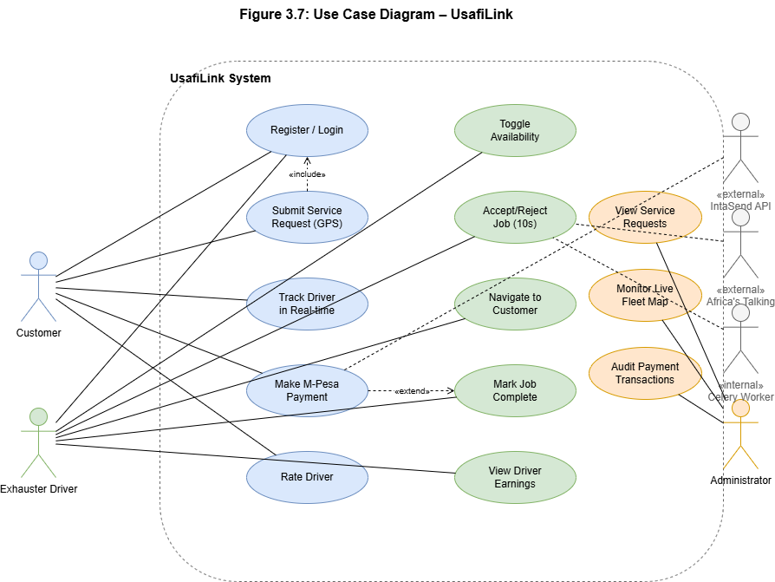
Figure 3.7: Use Case Diagram – UsafiLink

Data Flow Diagram
The Context-Level Data Flow Diagram (Level 0) illustrates the overall data flows between UsafiLink and its external entities: the Customer, the Exhauster Driver, the Administrator, IntaSend, Africa's Talking, and the Celery task broker.
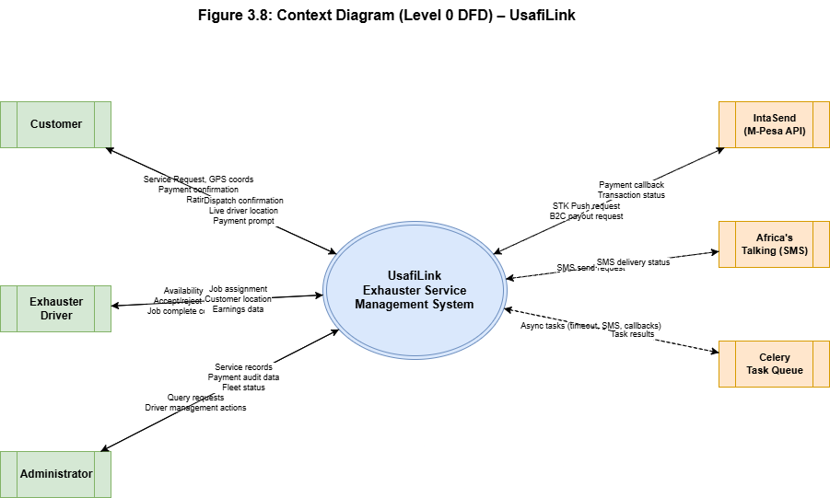
Figure 3.8: Context Diagram (Level 0 DFD) – UsafiLink

Level 1 Data Flow Diagram
The Level 1 DFD decomposes the system into its core processes: User Authentication, Service Request and Dispatch, Live Tracking, Payment Processing, and Audit Logging. It shows data flows between these processes and the underlying data stores: Users, Drivers, ServiceRequests, Jobs, Payments, and TransactionLogs.
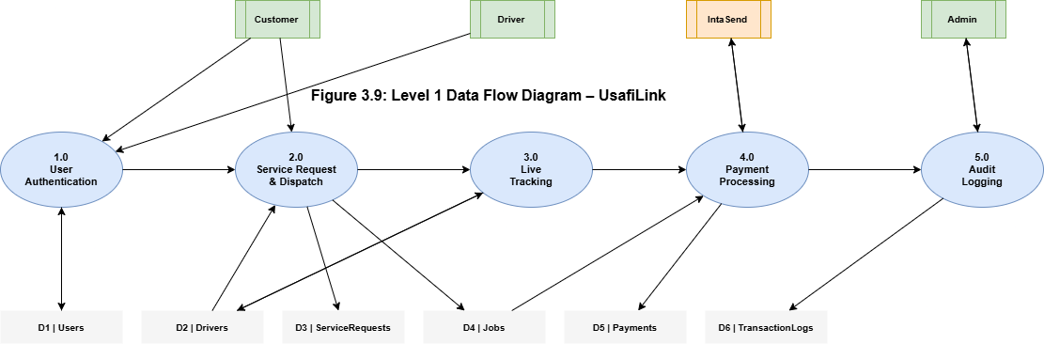
Figure 3.9: Level 1 Data Flow Diagram – UsafiLink

Class Diagram
The UML Class Diagram shows the core entity classes of UsafiLink, their attributes, key methods, and relationships. The primary classes are User, Driver (extends User), ServiceRequest, Job, Payment, Rating, DriverLocation, and TransactionLog.
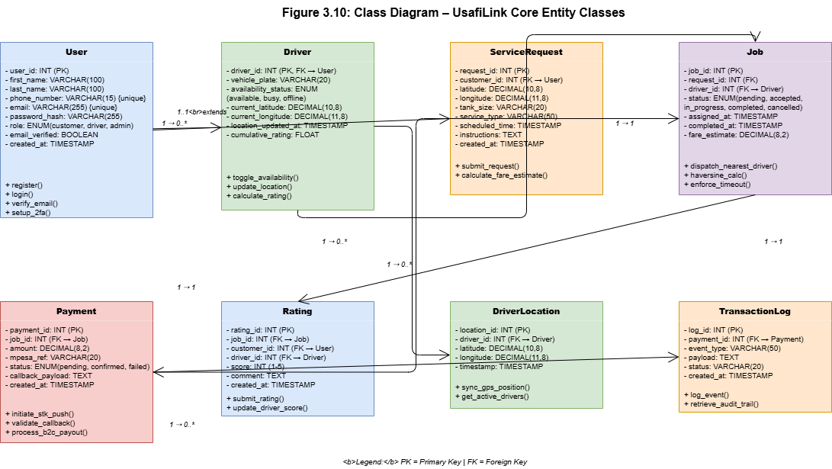
Figure 3.10: Class Diagram – UsafiLink Core Entity Classes

3.8 Logical Design

3.8.1 System Architecture
UsafiLink follows a three-tier Client-Server architecture with a RESTful API middleware layer, clearly separating the presentation layer from the business logic layer and the data layer, making the system modular, testable and maintainable:
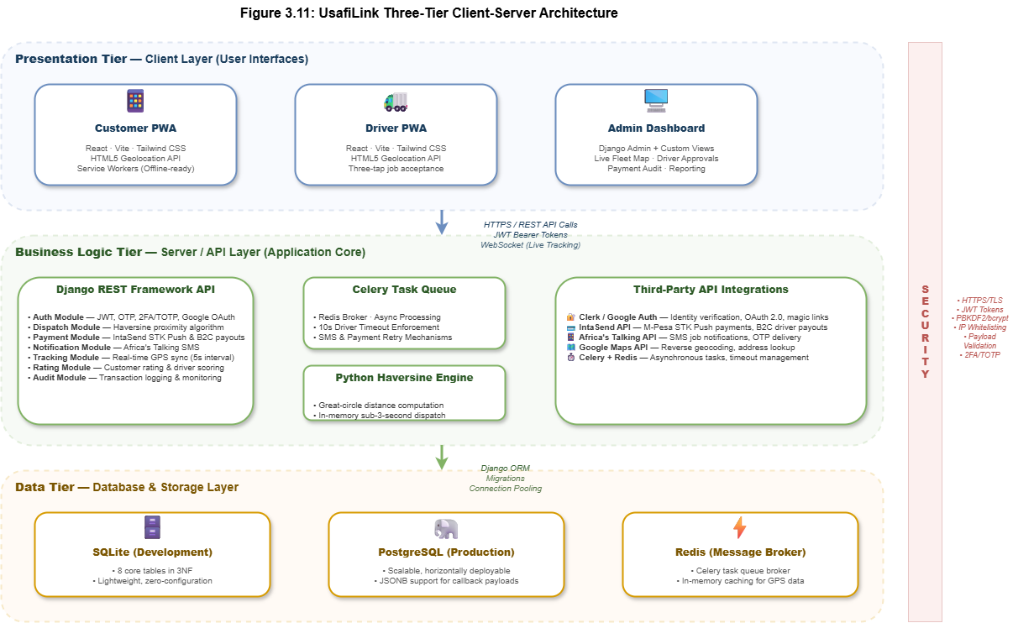
Figure 3.11: UsafiLink Three-Tier Client-Server Architecture Diagram

3.8.2 Control Flow and Process Design
The core process flow centres on the service request and proximity dispatch cycle. When a customer submits a service request, the browser captures GPS coordinates via the HTML5 Geolocation API and transmits them to the Django backend. The Haversine algorithm queries available drivers, computes great-circle distances, and dispatches the nearest driver. An SMS notification is simultaneously triggered via Africa's Talking. A Celery task enforces the ten-second response timeout. Upon completion, an IntaSend M-Pesa STK Push is triggered, the audit log is updated, and the driver's status resets to available.
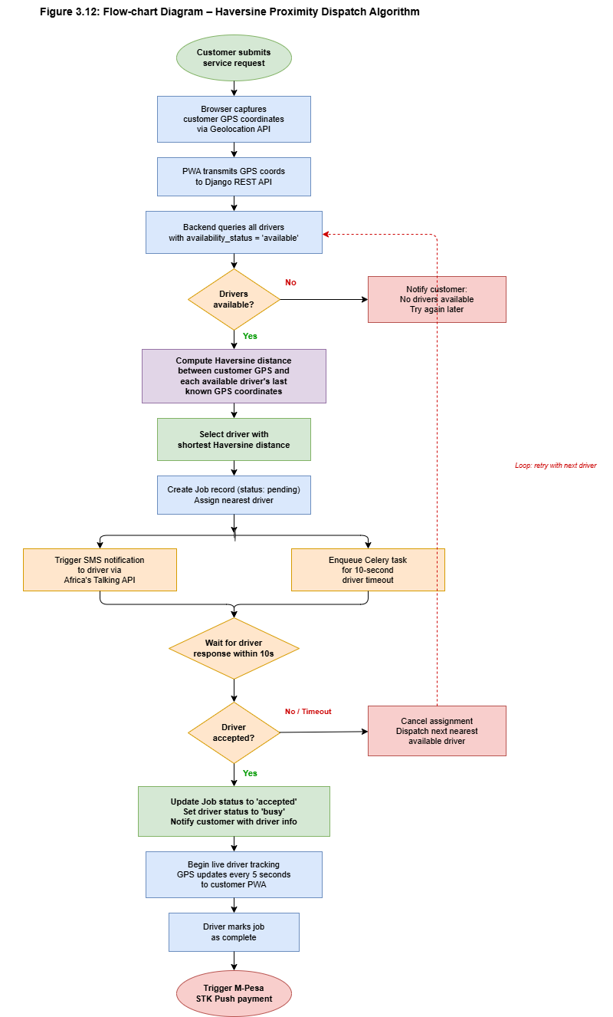
Figure 3.12: Flow-chart Diagram – Haversine Proximity Dispatch Algorithm

3.8.3 Design of Non-Functional Requirements
- Security – all API endpoints are secured via HTTPS and JWT. Passwords are PBKDF2/bcrypt hashed. IntaSend callbacks validated via IP whitelisting.
- Performance – Haversine dispatch runs as an in-memory Python operation ensuring sub-3-second assignment. GPS polling is a lightweight GET request every 5 seconds.
- Reliability – Celery with Redis ensures asynchronous task reliability with retry mechanisms for failed SMS dispatches and payment callbacks.
- Scalability – stateless REST API design allows load balancing without session affinity.

3.9 Physical Design

3.9.1 Database Design
The UsafiLink SQLite development database is organised around eight core tables, designed in Third Normal Form (3NF) to eliminate data redundancy and ensure referential integrity.

Entity Relationship Diagram
The ERD below illustrates all entities, their primary and foreign key relationships, and cardinality notation.
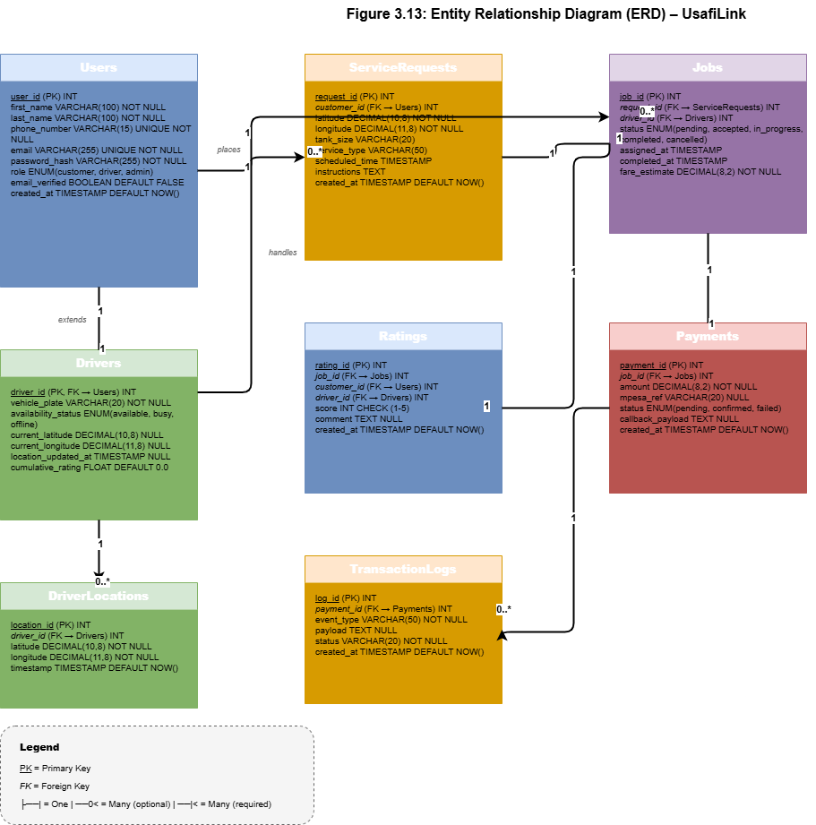
Figure 3.13: Entity Relationship Diagram (ERD) – UsafiLink

Logical Database Structure
The logical database structure for each core table is presented below.

Field | Data Type | Constraint | Description
user_id | INT | PK, AUTO_INCREMENT | Unique user identifier
first_name | VARCHAR(100) | NOT NULL | User's first name
last_name | VARCHAR(100) | NOT NULL | User's last name
phone_number | VARCHAR(15) | UNIQUE, NOT NULL | M-Pesa registered phone number
email | VARCHAR(255) | UNIQUE, NOT NULL | Email for OTP or SSO identity
password_hash | VARCHAR(255) | NOT NULL | PBKDF2 hashed password
role | ENUM(customer, driver, admin) | NOT NULL | User role for access control
email_verified | BOOLEAN | DEFAULT FALSE | Email OTP or OAuth verification status
created_at | TIMESTAMP | DEFAULT NOW() | Account creation timestamp
Table 3.4: Logical Database Structure – Users Table

Field | Data Type | Constraint | Description
driver_id | INT | PK, FK → Users | Links to Users table
vehicle_plate | VARCHAR(20) | NOT NULL | Exhauster truck registration plate
availability_status | ENUM(available, busy, offline) | DEFAULT 'offline' | Current driver availability
current_latitude | DECIMAL(10,8) | NULL | Last known GPS latitude
current_longitude | DECIMAL(11,8) | NULL | Last known GPS longitude
location_updated_at | TIMESTAMP | NULL | Timestamp of last GPS update
cumulative_rating | FLOAT | DEFAULT 0.0 | Average customer rating score
Table 3.5: Logical Database Structure – Drivers Table

Field | Data Type | Constraint | Description
job_id | INT | PK, AUTO_INCREMENT | Unique job identifier
request_id | INT | FK → ServiceRequests | Linked service request
driver_id | INT | FK → Drivers | Assigned driver
status | ENUM(pending, accepted, in_progress, completed, cancelled) | NOT NULL | Current job lifecycle status
assigned_at | TIMESTAMP | NULL | Time driver was dispatched
completed_at | TIMESTAMP | NULL | Time job was marked complete
fare_estimate | DECIMAL(8,2) | NOT NULL | Calculated fare at time of dispatch
Table 3.6: Logical Database Structure – Jobs Table

Field | Data Type | Constraint | Description
payment_id | INT | PK, AUTO_INCREMENT | Unique payment identifier
job_id | INT | FK → Jobs | Associated job
amount | DECIMAL(8,2) | NOT NULL | Payment amount (KES)
mpesa_ref | VARCHAR(20) | NULL | IntaSend/M-Pesa transaction reference
status | ENUM(pending, confirmed, failed) | NOT NULL | Payment confirmation status
callback_payload | TEXT | NULL | Raw IntaSend callback JSON
created_at | TIMESTAMP | DEFAULT NOW() | Payment initiation timestamp
Table 3.7: Logical Database Structure – Payments Table

3.9.2 User Interface Design
The user interface for UsafiLink is designed around three distinct user journeys: the Customer journey on the responsive Progressive Web Application, the Driver journey on the responsive PWA, and the Administrator journey on the Django-powered web dashboard. All interface designs were developed in Figma and represent the final UI design as deployed in the pilot.

Unauthenticated Users Pages
The Login Page (Figure 3.14) provides entry points for user authentication via Google OAuth, Email/Password, or magic link. It also links to the registration flow for new users.
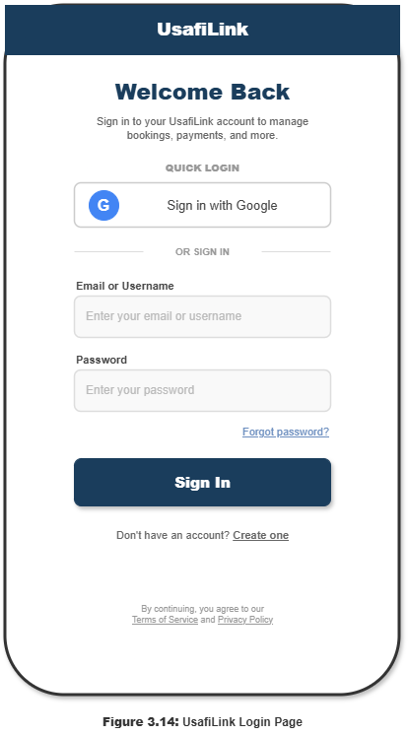
Figure 3.14: Illustration of the UsafiLink Login Page

Customer Pages
The Customer Dashboard (Figure 3.15) presents the user's booking statistics, upcoming bookings summary, quick action buttons for booking a new service, and a payment attention section. The driver tracking panel activates when a job is in progress.

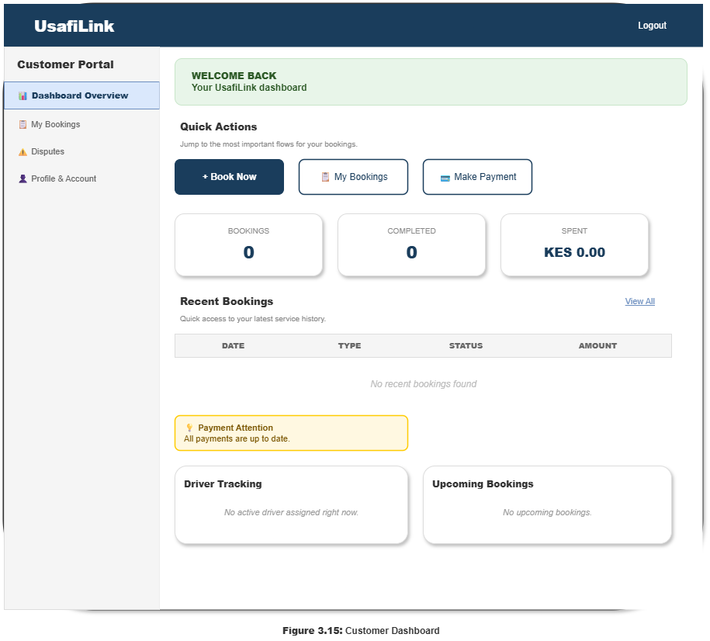
Figure 3.15: Illustration of the Customer Dashboard

The New Booking Form (Figure 3.16) guides the customer through scheduling an exhauster service in four steps: Location Details, Service Details, Date and Time Selection, and Additional Instructions. A live price estimate panel calculates the fare dynamically based on tank size and distance.

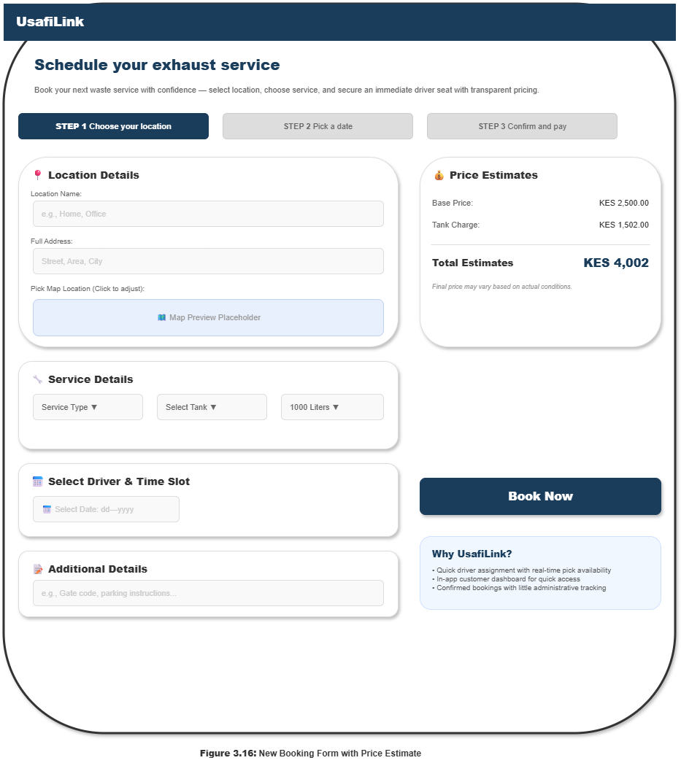
Figure 3.16: Illustration of the New Booking Form with Price Estimate

Driver Pages
The Driver Portal Dashboard (Figure 3.17) presents Today's Summary (jobs completed, earnings, hours worked), Today's Report (ratings and total earned), sections for Active Jobs, Assigned Jobs, Available Jobs, and a Performance Stats breakdown showing earnings per job type.

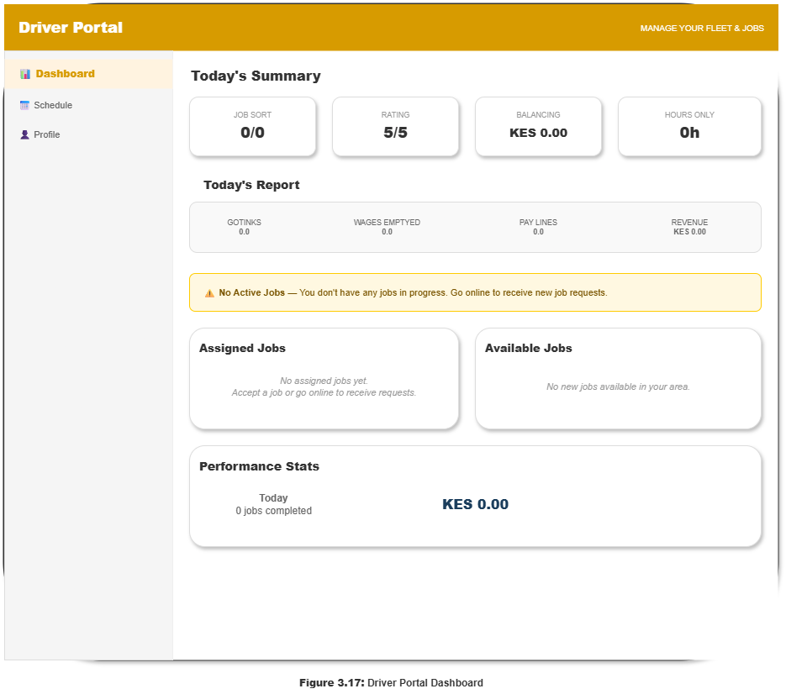
Figure 3.17: Illustration of the Driver Portal Dashboard

Admin Pages
The Admin Dashboard (Figure 3.18) provides a high-level operational overview including total revenue (KES), active drivers, pending driver approvals, average platform rating, pending bank transfers, weekly revenue trend chart, and a driver approvals panel.

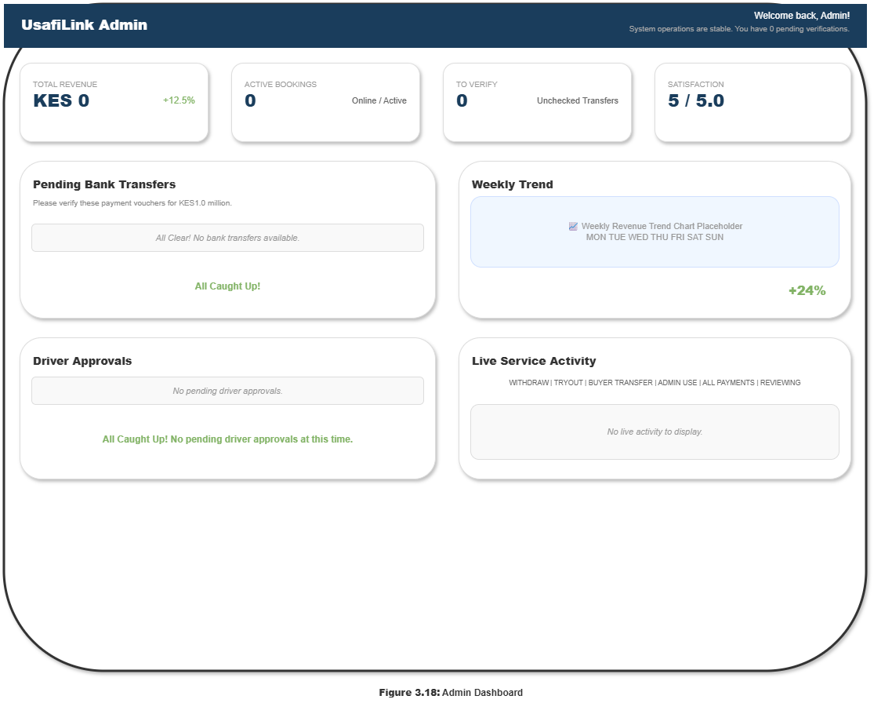
Figure 3.18: Illustration of the Admin Dashboard

The Admin Customer Management page (Figure 3.19) presents a filterable customer registry with total customer counts by status (Active, Inactive, Banned), searchable table with customer names, emails, status badges, and inline action buttons (View, Edit, Ban/Unban).

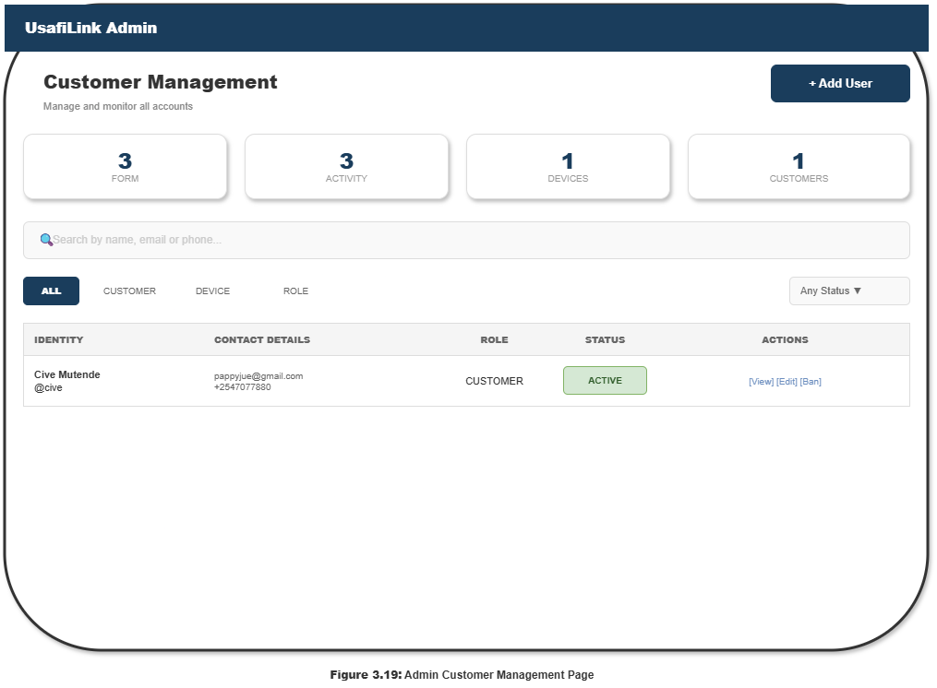
Figure 3.19: Illustration of the Admin Customer Management Page

The Admin Driver Management page with live map view (Figure 3.20) shows fleet statistics (total drivers, active, online), a live GPS map displaying driver positions, and a driver list panel beneath the map showing each driver's real-time availability status.

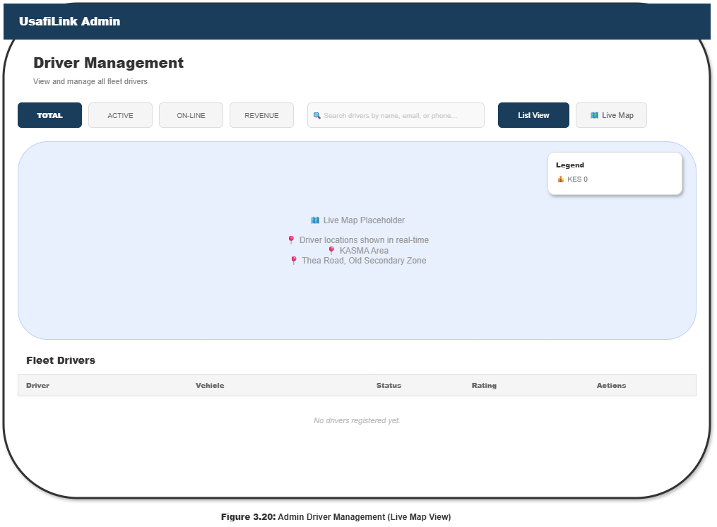
Figure 3.20: Illustration of the Admin Driver Management (Live Map View)

The Admin Fleet Management page (Figure 3.21) provides a vehicle-level registry showing each vehicle's registration plate, type, capacity (e.g., 9.0L), current status (Registration Approved / Pending), and associated driver details. Administrators can add new vehicles or update vehicle records from this page.

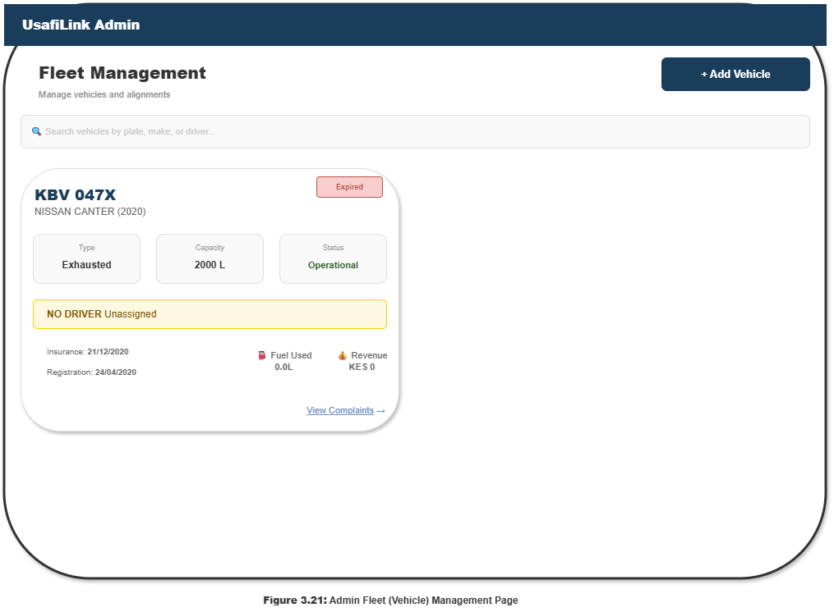
Figure 3.21: Illustration of the Admin Fleet (Vehicle) Management Page

