1.)

% Your code goes below...
R_ned2b = eulerToRotationMatrix(phi,theta,psi);

% compute wind vector in body frame (wind_ned is an input)
wind_b = R_ned2b*wind_ned;

% compute airspeed Va, angle-of-attack alpha, side-slip beta
[Va, alpha, beta] = makeVaAlphaBeta(vg_b - wind_b);

% Longitudinal Aero Coefficients
C_L = P.C_L_0 + (P.C_L_alpha * alpha) + (P.C_L_q*P.c/2/Va*q) + (P.C_L_delta_e*delta_e);
C_D = P.C_D_0 + abs(P.C_D_alpha*alpha) + abs(P.C_D_q*P.c/2/Va*q) + abs(P.C_D_delta_e*delta_e);
C_m = P.C_m_0 + (P.C_m_alpha*alpha) + (P.C_m_q*P.c/2/Va*q) + (P.C_m_delta_e*delta_e);

% Lateral Aero Coefficients
C_Y = P.C_Y_0 + (P.C_Y_beta*beta)+(P.C_Y_p*P.b/2/Va*p) + (P.C_Y_r*P.b/2/Va*r) + (P.C_Y_delta_a*delta_a) + (P.C_Y_delta_r*delta_r);
C_ell = P.C_ell_0 + (P.C_ell_beta*beta) + (P.C_ell_p*P.b/2/Va*p) + (P.C_ell_r*P.b/2/Va*r) + (P.C_ell_delta_a*delta_a) + (P.C_ell_delta_r*delta_r);
C_n = P.C_n_0 + (P.C_n_beta*beta) + (P.C_n_p*P.b/2/Va*p) + (P.C_n_r*P.b/2/Va*r) + (P.C_n_delta_a*delta_a) + (P.C_n_delta_r*delta_r);

% Create and combine Forces
f_grav_ned = P.mass * [0; 0; P.gravity]; % Newtons

f_grav_b = R_ned2b*f_grav_ned;
f_aero_b = 0.5*P.rho*Va*Va*P.S_wing*[-C_D*cos(alpha) + C_L*sin(alpha);C_Y;-C_D*sin(alpha)-C_L*cos(alpha)];
f_prop_b = [P.rho * P.C_prop * P.S_prop * (Va+delta_t*(P.k_motor - Va)) * (delta_t*(P.k_motor - Va));0;0];
f_b = f_grav_b + f_aero_b + f_prop_b;

% Create and combine Moments
m_aero_b = 0.5 * P.rho * Va * Va * P.S_wing * [P.b*C_ell;P.c*C_m; P.b*C_n];
m_prop_b = [-P.k_Tp*((P.k_omega*delta_t)^2);0;0];
m_b = m_aero_b + m_prop_b;

2.)
(a)

******************************************************************
Trim condition found, Jcost = 2.591968e-25
Longitudinal trim: alpha=4.8229 deg, de=-3.6654 deg, dt=0.3138
******************************************************************

(b) Vehicle is trimmed. See attached plots

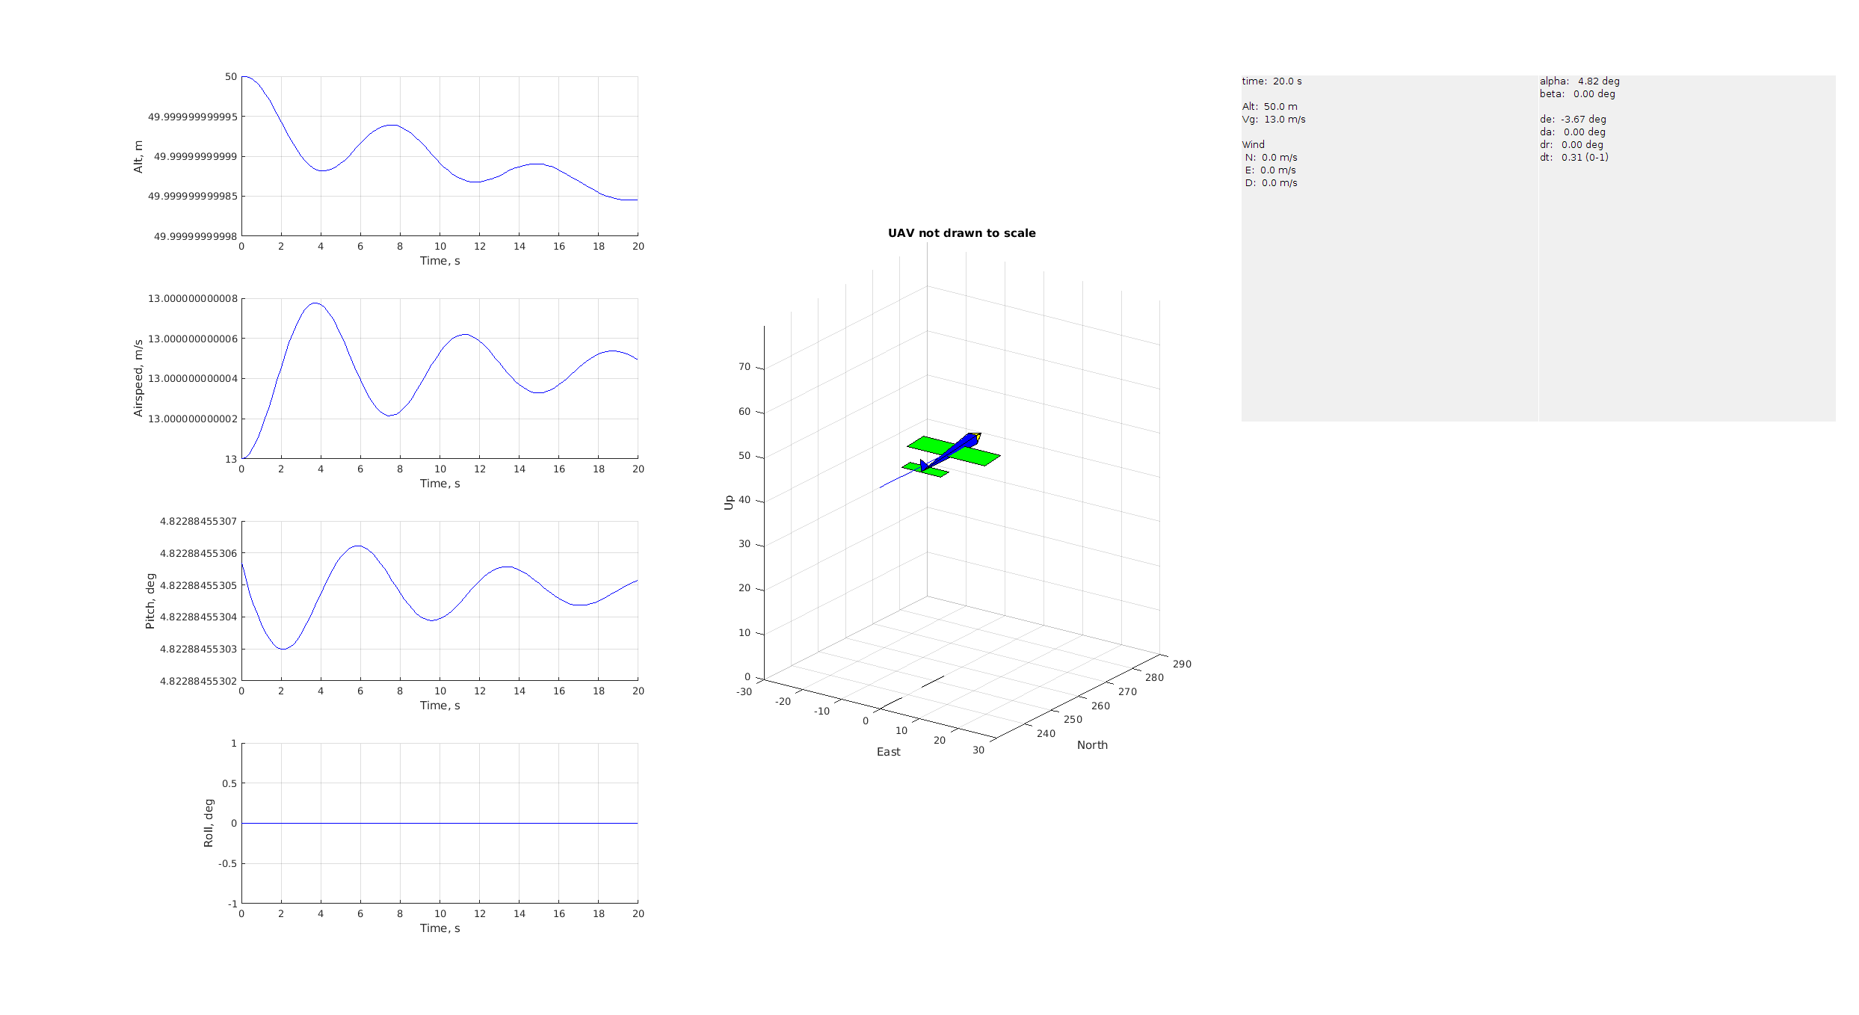
3.)
min air speed 6.8 m/s
******************************************************************
Trim condition found, Jcost = 5.904148e-25
Longitudinal trim: alpha=29.8534 deg, de=-22.6886 deg, dt=0.2351
******************************************************************
max air speed 17.9 m/s
******************************************************************
Trim condition found, Jcost = 5.786942e-25
Longitudinal trim: alpha=0.1936 deg, de=-0.1471 deg, dt=0.9691
******************************************************************

At the slower min air speed of 6.8 m/s the vehicle gains and loses altitude, but mostly tries to maintain altitude. At the higher max air speed of 17.9 m/s the vehicle is trimmed.

4.)
load_uavsim;P.k_Tp = 5e-6;

trimmed_da = 0.0;
curr_min_cost = 100000000.0;
for da = linspace(-P.delta_a_max, P.delta_a_max, 100)
P.delta_a0 = da;

[~, trim_solution] = compute_longitudinal_trim(P);
if trim_solution.valid && (trim_solution.cost < curr_min_cost)
disp('======================================')
disp(['trim_solution.valid = ' num2str(trim_solution.valid)] )
disp(['da = ' num2str(da)] )
disp('======================================')
trimmed_da = da;
curr_min_cost = trim_solution.cost;
end
end

P.delta_a0 = trimmed_da;
trimmed_da
end

5.)

a.)
A_lon =

-0.1596 0.8507 -1.0930 -9.7719 0
-1.1004 -4.8392 12.9540 -0.8245 0
0.3909 -4.6327 -7.2717 0 0
0 0 1.0000 0 0
-0.0841 0.9965 0 -13.0000 0

B_lon =

3.6463 3.6463
-6.3799 -6.3799
-79.5245 -79.5245
0 0
0 0

A_lat =

-1.3407 0.8400 -12.9540 9.7719 0
-3.1183 -4.8908 2.5778 0 0
4.4056 0.2346 -4.3912 0 0
0 1.0000 0.0844 0 0
0 0 1.0036 0 0

B_lat =

-3.0234 -3.0234
63.7429 63.7429
7.0128 7.0128
0 0
0 0

b.) Spot checks

udot_over_theta =
-9.7719

M_q =
-7.2717

M_de =
-79.5245

c.) de/q Transfer Function, zpk form

-79.525 s (s+4.293) (s+0.3157) (s^2 + 0.175s + 0.7104)^2 (s^2 + 12.1s + 95.67)^2
--------------------------------------------------------------------------------
(s^2 + 0.175s + 0.7104)^3 (s^2 + 12.1s + 95.67)^3

d.) dr/r Transfer Function, zpk form

7.0128 (s+8.231) (s+5.014)^2 (s+0.01746)^2 (s^2 - 1.767s + 51.24) (s^2 + 5.592s + 64.79)^2
------------------------------------------------------------------------------------------
(s+5.014)^3 (s+0.01746)^3 (s^2 + 5.592s + 64.79)^3

6)
a.)

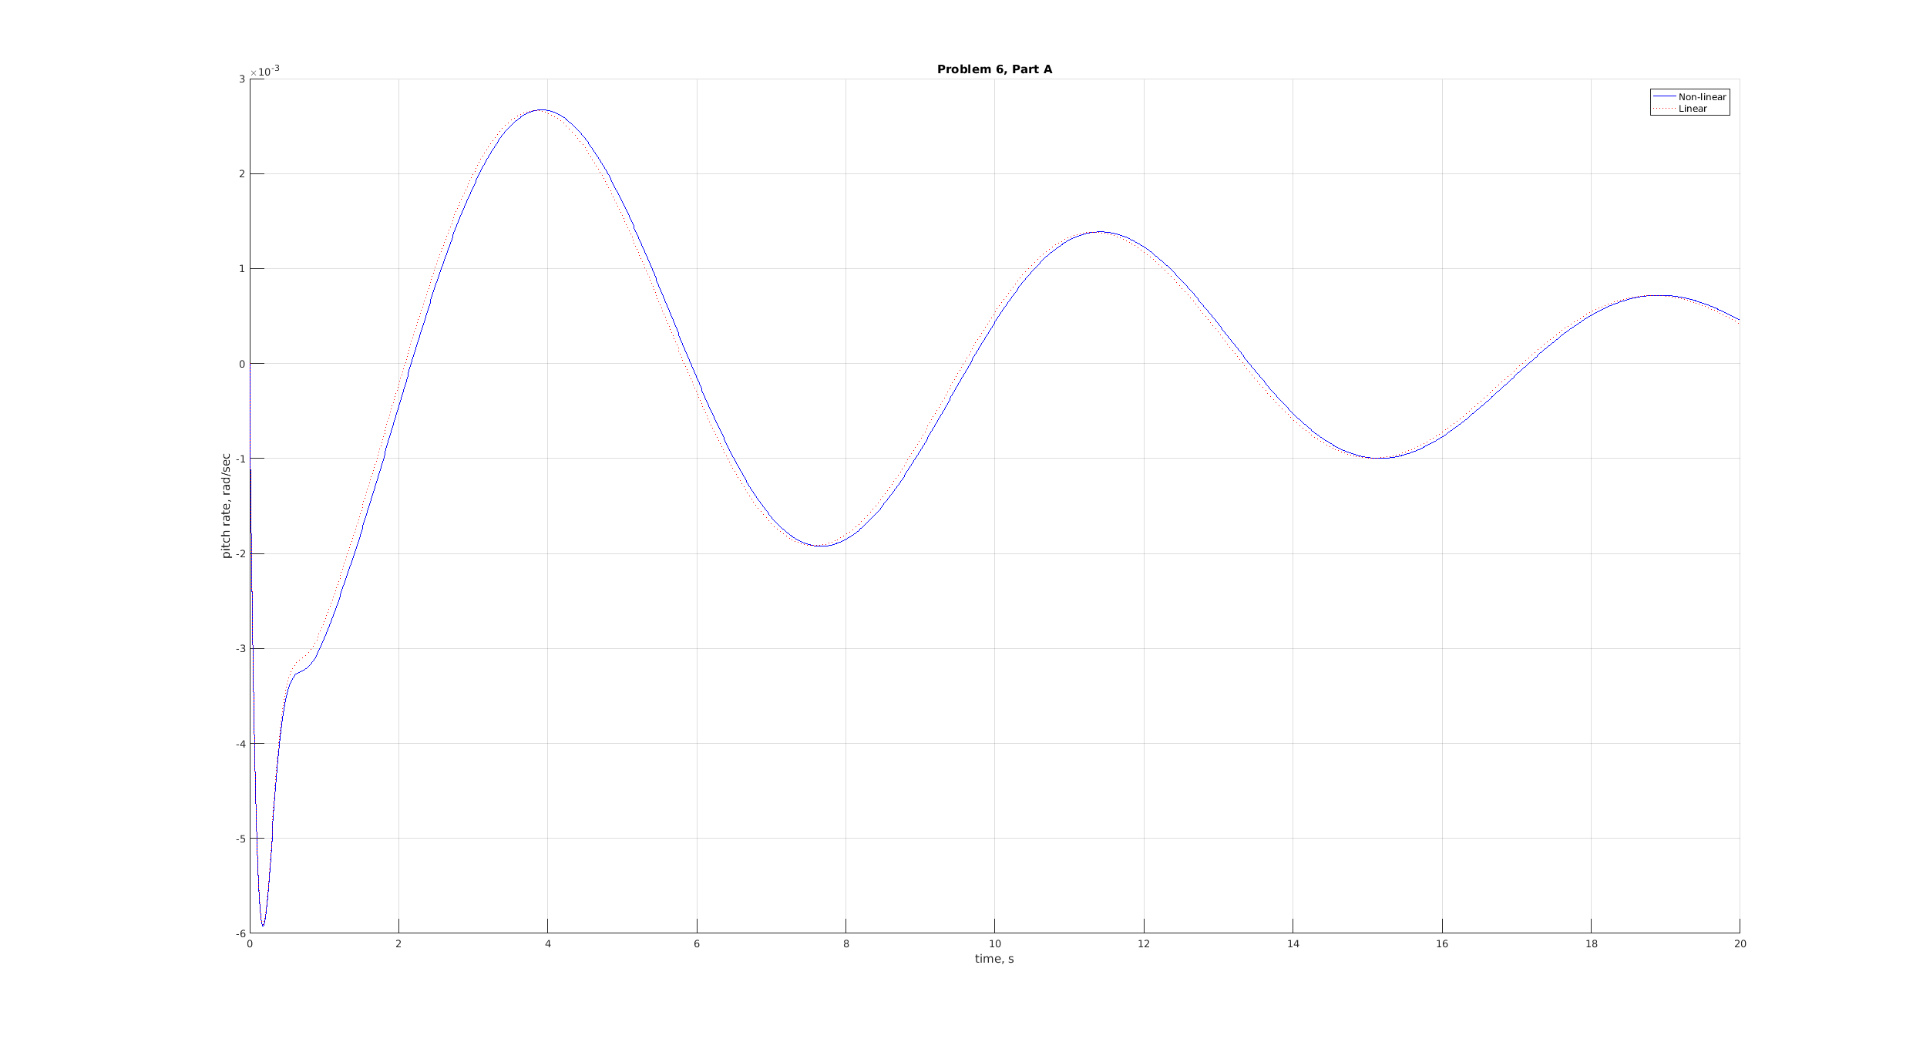

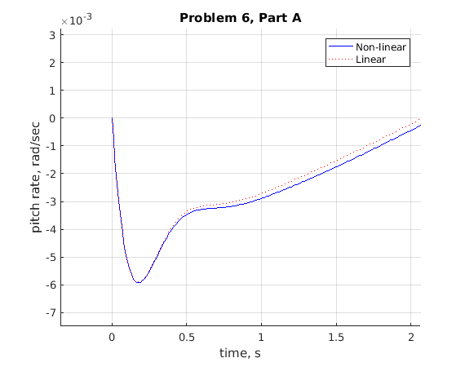
b.) Estimate fugoid mode

c.) Vehicle starts off climbing but starts to level off. Appears to be in a phugoid mode.

7)
a.)

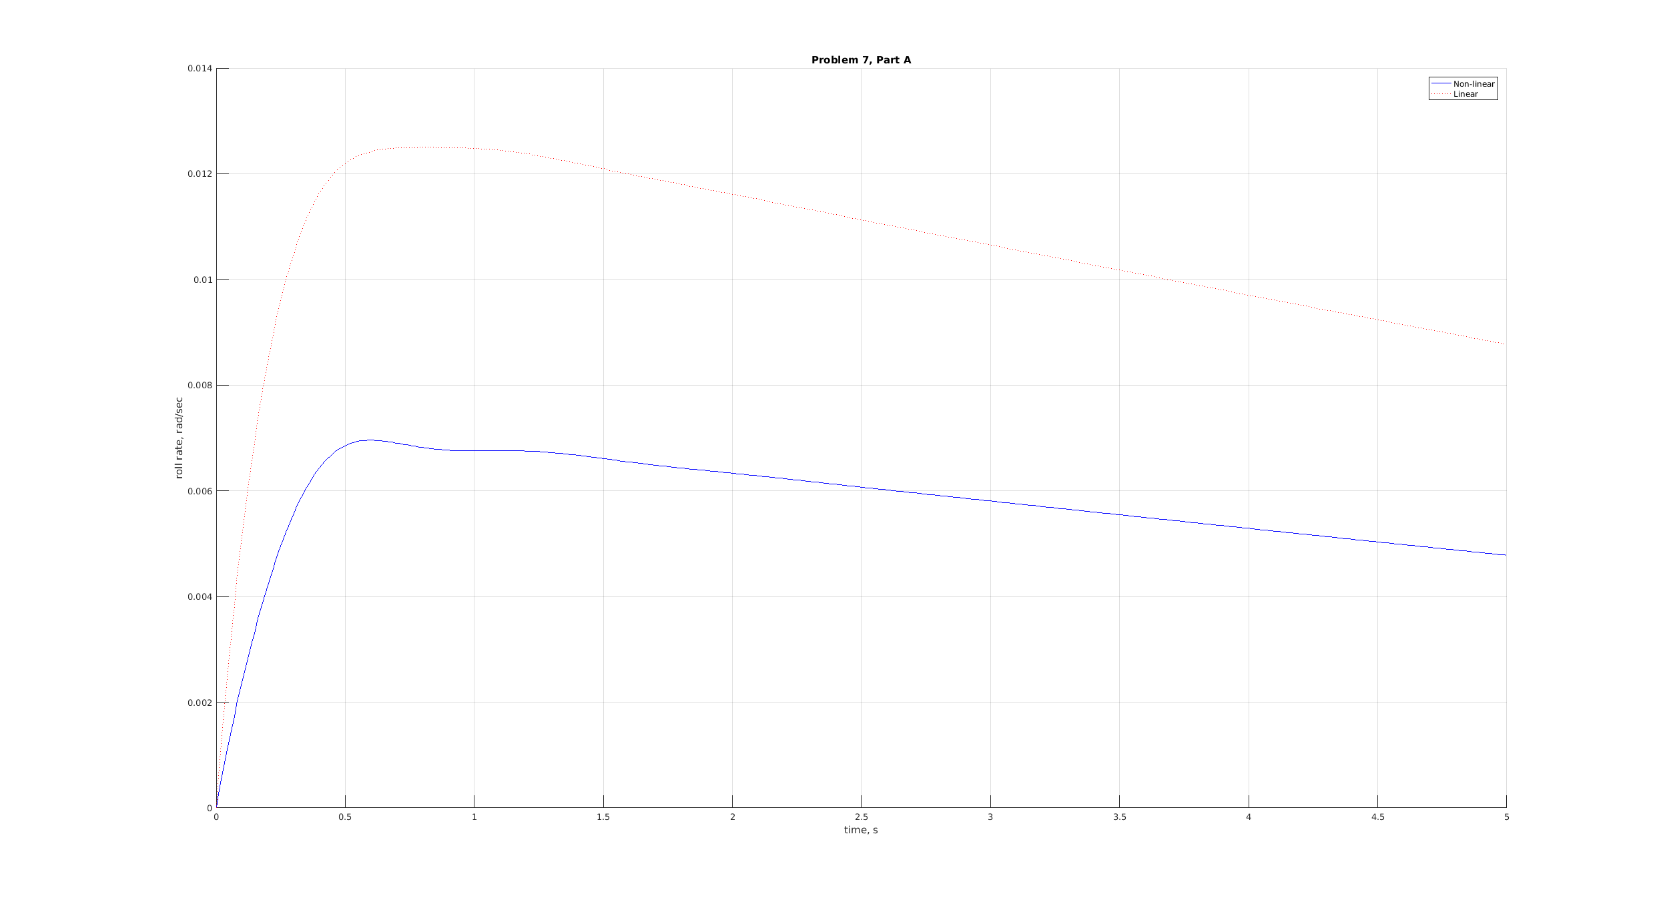
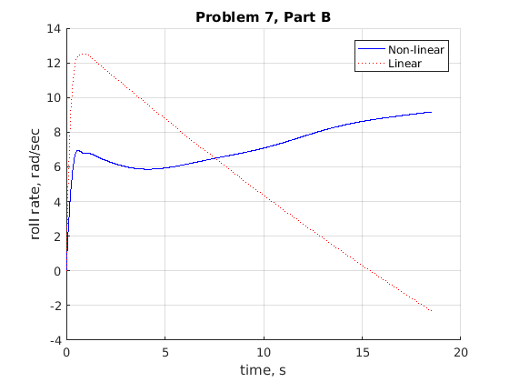

c.)
