1.b)

zeta_course = 2.1;

W_course = 30;

w_course = omega_n_phi/W_course;

Vg = P.Va0;

gravity = P.gravity;

P.course_kp = 2*zeta_course*w_course*Vg/gravity;

P.course_ki = w_course*w_course*Vg/gravity;

P.course_kd = 0.0;

1.c)

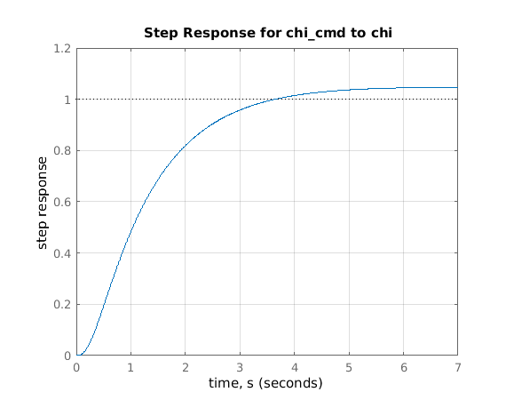

1.d)

function u = PIR_course_hold(chi_c, chi_hat, not_used, init_flag, P)

% Set up PI with rate feedback

y_c = chi_c; % Command

y = chi_hat; % Feedback

y_dot = not_used; % Rate feedback % This was zero

kp = P.course_kp;

ki = P.course_ki;

kd = P.course_kd;

u_lower_limit = -P.phi_max;

u_upper_limit = +P.phi_max;

% Initialize integrator (e.g. when t==0)

persistent error_int;

if( init_flag )

error_int = 0;

end

% Perform "PI with rate feedback"

error = mod(y_c - y + pi, 2*pi) - pi; % Error between command and response

error_int = error_int + P.Ts*error; % Update integrator

u = kp*error + ki*error_int - kd*y_dot;

% Output saturation & integrator clamping

% - Limit u to u_upper_limit & u_lower_limit

% - Clamp if error is driving u past limit

if u > u_upper_limit

u = u_upper_limit;

if ki*error>0

error_int = error_int - P.Ts*error;

end

elseif u < u_lower_limit

u = u_lower_limit;

if ki*error<0

error_int = error_int - P.Ts*error;

end

end

end

1.e)

