2.b)

e_theta_max = 30*pi/180;

zeta_pitch = 0.9;

P.pitch_kp = P.delta_e_max/e_theta_max*sign(models.a_theta3);

P.pitch_ki = 0.0;

omega_n_theta = sqrt(models.a_theta2 + P.pitch_kp*models.a_theta3);

P.pitch_kd = (2*zeta_pitch*omega_n_theta - models.a_theta1)/models.a_theta3;

P.K_theta_DC = P.pitch_kp*models.a_theta3/(models.a_theta2 + P.pitch_kp*models.a_theta3);

2.c)

kp =

-1.5000

ki =

0

kd =

-0.2120

k_dc =

0.6637

2.d)

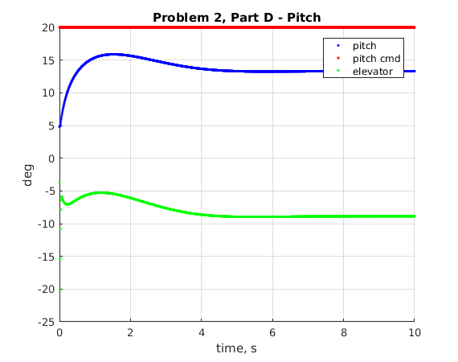

2.e) ss_pitch = 20*P.K_theta_DC

ss_pitch =

13.2743 (This is about where the blue line above levels off to)