4.b.)

zeta_V = 1.0;

W_V = 40;

omega_n_V = omega_n_theta/W_V;

P.airspeed_throttle_kp = (2*zeta_V*omega_n_V - models.a_V1) / models.a_V2;

P.airspeed_throttle_ki = omega_n_V*omega_n_V/models.a_V2;

P.airspeed_throttle_kd = 0.0;

4.c.)

kp =

0.1469

ki =

0.0361

kd =

0

4.d.)

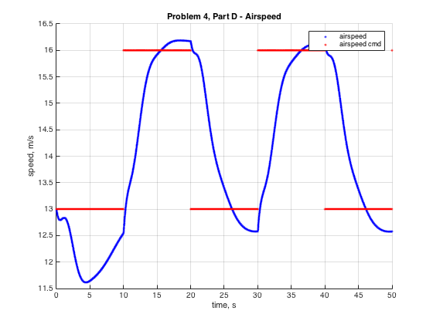

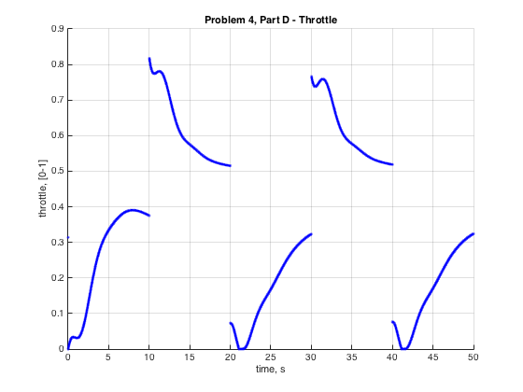

4.e.)

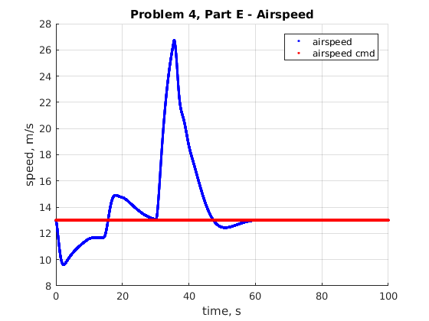

The airspeed here is a little high, especially gains were calculated assuming an airspeed of 13 m/s.

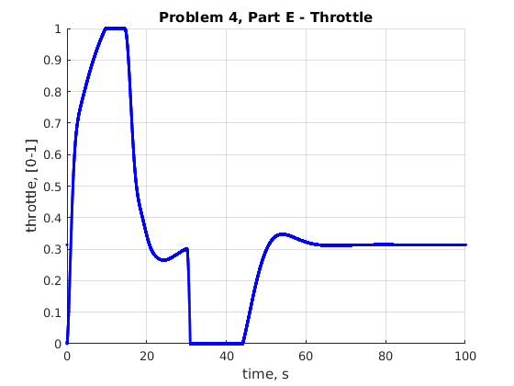

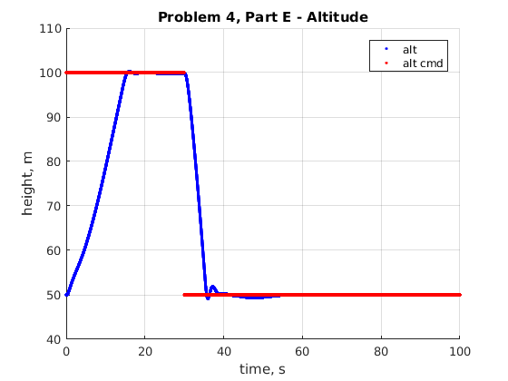

This seems like a steep dive. Maybe it would be better to come down more slowly and avoid that undershoot.