5.b.)

W_V2 = 40;

omega_n_V2 = omega_n_theta/W_V2;

zeta_V2 = 1;

P.airspeed_pitch_kp = (models.a_V1 - 2*zeta_V2*omega_n_V2)/P.K_theta_DC/P.gravity;

P.airspeed_pitch_ki = -omega_n_V2*omega_n_V2/P.K_theta_DC/P.gravity;

P.airspeed_pitch_kd = 0.0;

kp =

0.1469

ki =

0.0361

kd =

0

5.c.)

if(firstTime)

PIR_pitch_hold(0,0,0,firstTime, P);

PIR_alt_hold_using_pitch(0,0,0,firstTime, P);

PIR_airspeed_hold_using_throttle(0,0,0,firstTime, P);

PIR_airspeed_hold_using_pitch(0,0,0,firstTime, P);

end

h_hold = 5;

if h_hat < h_hold

% Climb Logic

delta_t = 1;

theta_c = PIR_airspeed_hold_using_pitch(Va_c, Va_hat, 0.0, firstTime, P);

elseif h_hat > h_c + h_hold

% Descend Logic

delta_t = 0;

theta_c = PIR_airspeed_hold_using_pitch(Va_c, Va_hat, 0.0, firstTime, P);

else

% Altitude Hold Logic

delta_t = PIR_airspeed_hold_using_throttle(Va_c, Va_hat, 0.0, firstTime, P);

theta_c = PIR_alt_hold_using_pitch(h_c, h_hat, 0, firstTime, P);

end

5.d.)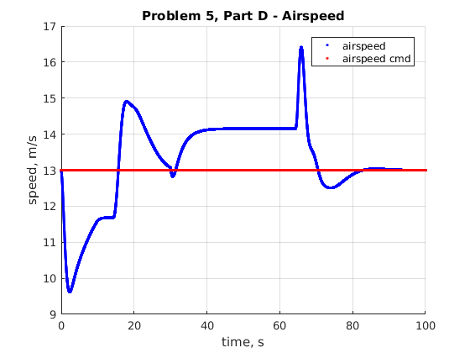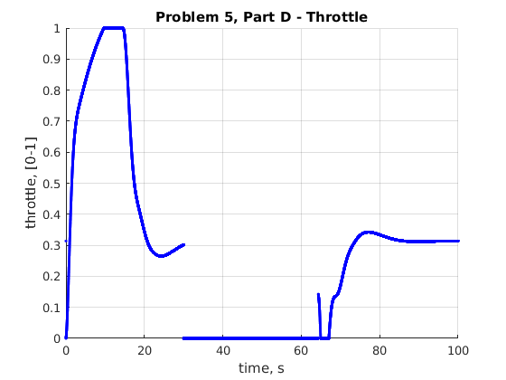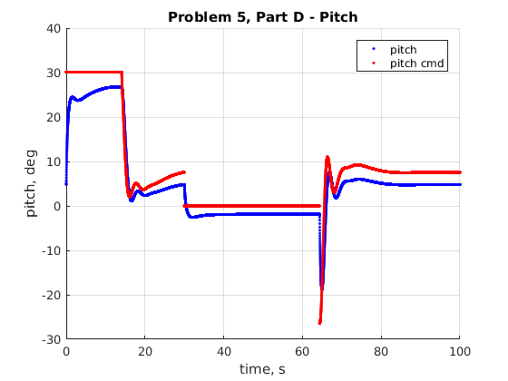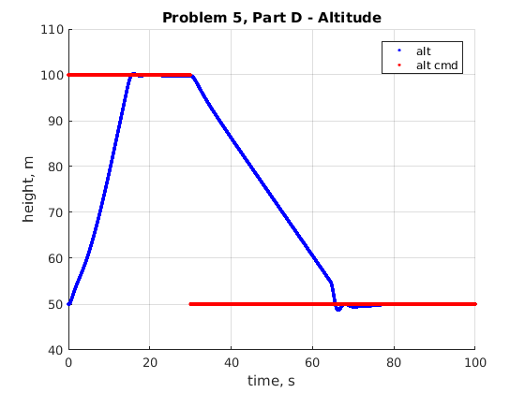

5.e.)

I would make sure there is no undershoot when going vehicle is commanded to go down in altitude.